**SCS2208 Rapid Application Development**

Labsheet 07

*Index number: 21000557*

* Github Repository: <https://github.com/ItsAeox/UCSC_RAD_labsheet_07>
* Screenshots of the code are given below.

1. A screen shot of a computer program

   Description automatically generated
2. A computer screen shot of a program

   Description automatically generated
3. A computer screen shot of a program

   Description automatically generated
4. A screen shot of a computer program

   Description automatically generated
5. A screenshot of a computer

   Description automatically generated
6. A screen shot of a computer program

   Description automatically generated
7. 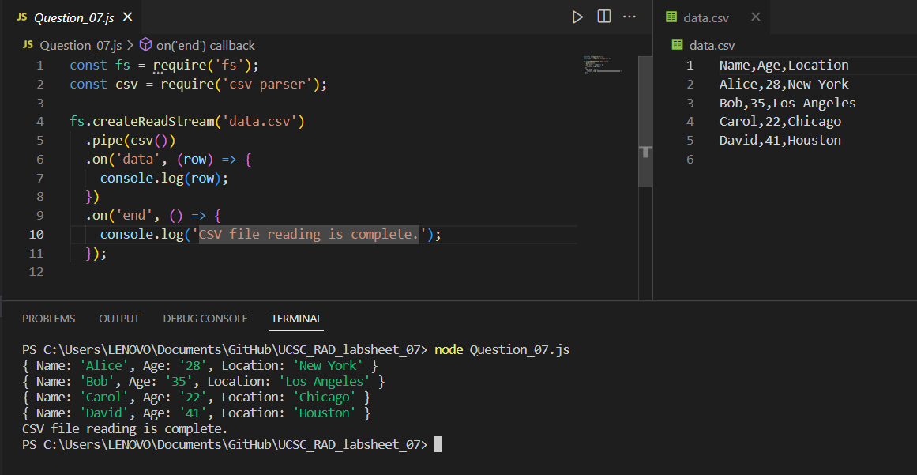
8. A screen shot of a computer program

   Description automatically generated