IT3091 Machine Learning
Group Assignment: Final Report
Predicting hotel booking cancellations at the moment of booking
Field | Detail
Group | 2026-AI-46
Lab group | Y3.S1.WD.AI.0101
Specialisation | Artificial Intelligence, Year 3, Semester 1
Track | Guided Data Track, code 6: Tourism & Hospitality
Dataset | Hotel Booking Demand (Antonio, Almeida & Nunes, 2019)
Primary lens | Cancellation risk (no secondary lens)
Final model | XGBoost: test PR-AUC 0.770, catches 77% of cancellations
Demo video | YouTube link to be added
Code repository | github.com/ItsAloka/hotel-booking-cancellation-ml
Submission deadline | Monday 12 October 2026, 11:59 PM

Ref | Student ID | Name
M1 | IT24101147 | Warnakulasinhage S.N.A
M2 | IT24102629 | Nawodya K.P.G.P
M3 | IT24100509 | Fonseka W. P. L
M4 | IT24101027 | Seelarathna G.P.B

Contents
1. Problem framing
1.1 Problem framing canvas
2. Dataset and data dictionary
2.1 Source and fingerprint
2.2 Data dictionary
3. Workflow
4. Data understanding: EDA insight log
5. Preprocessing and feature log
5.1 Rubric items
5.2 New features
5.3 Kaggle notebook features that did not help
6. Models and comparison
6.1 Baseline and five models
6.2 Why XGBoost
6.3 Check: class weighting (notebook 09)
6.4 Check: ensemble (notebook 10)
6.5 Why the ceiling is about 0.76–0.77
7. Evaluation on the test set
7.1 Which cancellations are missed?
7.2 What drives the prediction
8. Decision log
8.1 Data and cleaning (notebook 01)
8.2 Features and preprocessing (notebook 02, scripts)
8.3 Models (notebooks 03–08)
8.4 Ensemble (notebook 10)
9. Recommendation, risks and limitations
9.1 What the hotel should do
9.2 What to expect
9.3 Where the model is weak
9.4 Risks and fairness
9.5 Limitations
9.6 Next steps for the hotel
10. Reproducibility
11. AI use and contributions
11.1 AI-use declaration
11.2 Contributions
11.3 References
Appendix A. Personal Learning Journeys
A1 Warnakulasinhage S.N.A
A2 Nawodya K.P.G.P
A3 Fonseka W. P. L
A4 Seelarathna G.P.B
Section titles are links: click one to jump to it.

1. Problem framing
A hotel chain wants to improve booking reliability, revenue planning and customer management (assignment brief, code 6). When a guest cancels, a room that was counted as sold can end up empty. If the hotel knows which bookings are likely to cancel, it has time to act.

1.1 Problem framing canvas
Box | Our answer
Stakeholder | The hotel revenue manager: decides how many rooms to sell, when to overbook, and which guests to contact.
Decision need | Which new bookings should we follow up? e.g. a friendly reminder, a deposit request, or counting the booking as "at risk" when planning overbooking.
Primary lens | Cancellation risk.
Secondary lens | None. The initial submission kept booking segmentation as an optional secondary lens, to be used only if it made the recommendation clearer. It did not, so it was dropped: extra analysis without a clear link to the decision earns no marks.
Why this lens | 27.7% of bookings are cancelled after cleaning. An empty "sold" room is lost revenue, and early warning gives the hotel time to act.
Unit of analysis | One booking, scored at the moment it is made. One row of the data = one booking.
ML task | Binary classification: cancelled (1) or not cancelled (0). Target: is_canceled.
Output | A cancellation probability (0 to 1) and a yes/no flag: "high risk" when the probability is 0.335 or more.
Success metric | PR-AUC (how well the model ranks cancelled bookings above the rest) as the main score, with recall (share of real cancellations caught).
Why not accuracy | Always answering "not cancelled" is already 72.25% accurate and catches no cancellations. PR-AUC shows this; accuracy hides it. The no-skill PR-AUC is 0.2775.
Constraint: inputs | Only information known when the booking is made. Columns filled in later are removed, even though they would add +0.0407 PR-AUC.
Constraint: data | Two hotels in Portugal (City and Resort), arrivals July 2015 – August 2017.
Constraint: people | Every member must be able to explain every step simply, so the simpler option wins when scores are equal.

2. Dataset and data dictionary

2.1 Source and fingerprint
Field | Value
Dataset | Hotel Booking Demand, listed on Kaggle by Jesse Mostipak
Original study | Antonio, N., de Almeida, A. & Nunes, L. (2019). Hotel booking demand datasets. Data in Brief, 22, 41–49. doi:10.1016/j.dib.2018.11.126
Local copy | data/raw/hotel_bookings.csv, downloaded 2026-09-03 from the TidyTuesday mirror
Size | 16,855,599 bytes · 119,390 rows · 32 columns
SHA-256 | 7c2ae42a7353905ea136e5c2287f17c92c5435826598bfbb8491c6f0c7b1fc06
Licence | The original article is CC BY 4.0. Attribution is kept; the mirror licence was not independently verified (see data/raw/SOURCE.md).

What one row means. One row is one hotel booking, with the arrival date, stay length, party size, how and where it was booked, the price, and whether it was cancelled. After cleaning: 84,969 bookings and 25 input features (15 numeric, 10 categorical).

2.2 Data dictionary
All 32 raw columns (reports/data_dictionary.csv). "Used?" says whether the column is an input to the final models, and why not if it is not.
Column | Type | Meaning | Missing | Unique | Used?
hotel | text | Resort Hotel or City Hotel | 0 | 2 | Yes
is_canceled | integer | 1 if the booking was cancelled or a no-show, else 0 | 0 | 2 | Target (what we predict)
lead_time | integer | days between the booking date and the arrival date | 0 | 479 | Yes
arrival_date_year | integer | year of the scheduled arrival | 0 | 3 | No: partial years (2015, 2017)
arrival_date_month | text | month name of the scheduled arrival | 0 | 12 | Yes
arrival_date_week_number | integer | ISO week number of the scheduled arrival | 0 | 53 | No: 0.995 correlated with month
arrival_date_day_of_month | integer | day of month of the scheduled arrival | 0 | 31 | Yes
stays_in_weekend_nights | integer | nights booked on Sat/Sun | 0 | 17 | Yes
stays_in_week_nights | integer | nights booked Mon-Fri | 0 | 35 | Yes
adults | integer | number of adults on the booking | 0 | 14 | Yes
children | decimal | number of children on the booking | 0 | 5 | Yes
babies | integer | number of babies on the booking | 0 | 5 | Yes
meal | text | meal package (BB/HB/FB/SC; Undefined means SC, no meal) | 0 | 5 | Yes
country | text | ISO country of origin of the guest | 0.41% | 177 | Yes
market_segment | text | sales segment the booking came through | 0 | 8 | Yes
distribution_channel | text | distribution channel the booking came through | 0 | 5 | Yes
is_repeated_guest | integer | 1 if the guest has stayed before | 0 | 2 | Yes
previous_cancellations | integer | bookings this guest cancelled before this one | 0 | 15 | Yes
previous_bookings_not_canceled | integer | bookings this guest honoured before this one | 0 | 73 | Yes
reserved_room_type | text | room type the guest reserved (anonymised code) | 0 | 10 | Yes
assigned_room_type | text | room type actually given (set at or near check-in) | 0 | 12 | No: known only after booking
booking_changes | integer | number of amendments made after the booking | 0 | 21 | No: known only after booking
deposit_type | text | No Deposit / Non Refund / Refundable | 0 | 3 | Yes
agent | decimal | ID of the travel agency that made the booking | 13.69% | 333 | Yes
company | decimal | ID of the company or entity that paid for the booking | 94.31% | 352 | No: 94.3% empty
days_in_waiting_list | integer | days the booking sat on the waiting list | 0 | 128 | No: known only after booking
customer_type | text | Transient / Transient-Party / Contract / Group | 0 | 4 | Yes
adr | decimal | average daily rate = lodging revenue / total nights | 0 | 8879 | Yes
required_car_parking_spaces | integer | parking spaces requested | 0 | 5 | No: known only after booking
total_of_special_requests | integer | number of special requests (e.g. high floor) | 0 | 6 | Yes
reservation_status | text | final status: Check-Out / Canceled / No-Show | 0 | 3 | No: records the outcome (leak)
reservation_status_date | text | date that final status was set | 0 | 926 | No: records the outcome (leak)

Three features were built in notebook 01: total_nights (weekend + week nights), total_guests (adults + children + babies) and is_family (children or babies > 0).

3. Workflow
The whole project from raw data to recommendation. The test set (red) is split off in step 3 and is not used to tune any model, choose the threshold or pick the winner. It is opened once, in notebook 08.
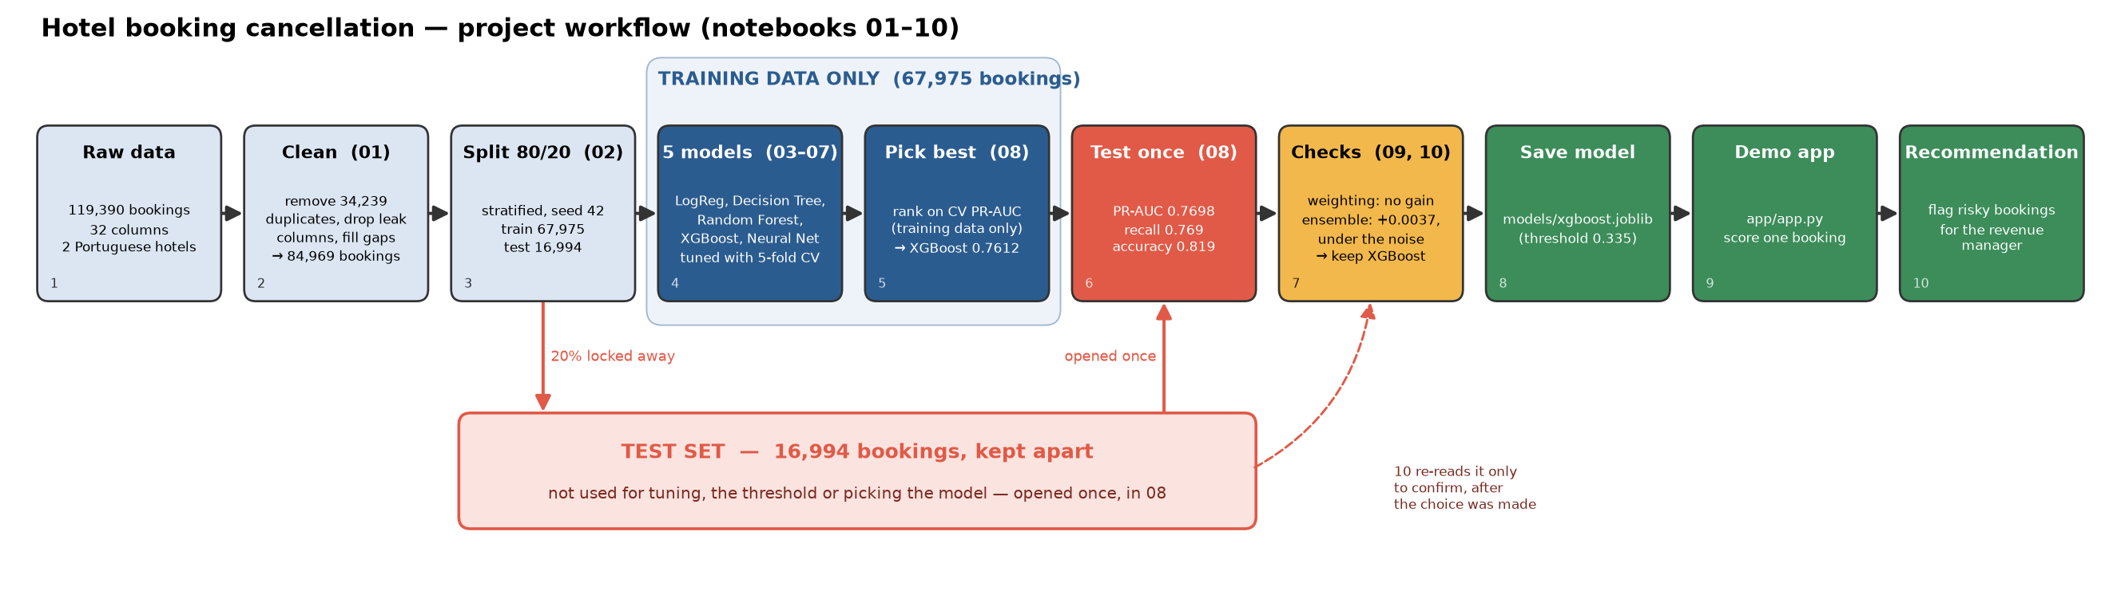
Figure 1. Project workflow (drawn by scripts/make_workflow_diagram.py).
# | Step | Notebook / file | What happens | Key number
1 | Raw data | data/raw/hotel_bookings.csv | Two Portuguese hotels, arrivals July 2015 – Aug 2017 | 119,390 rows, 32 columns
2 | Clean | 01_eda_cleaning | Fill missing values, remove impossible rows, drop leak columns, remove exact duplicates, explore the data | 84,969 bookings; cancel rate 37.1% → 27.7%
3 | Split | 02_preprocessing | 80% training / 20% test, stratified, seed 42. Test set saved and not opened until step 6 | train 67,975 · test 16,994
4 | Five models | 03–07 | Each model tuned with 5-fold cross-validation (CV) on the training set only; each picks its threshold from training data | CV PR-AUC 0.6470 – 0.7612
5 | Pick the best | 08_model_selection | Rank on CV PR-AUC; compare with a no-skill baseline | XGBoost 0.7612 (baseline 0.2775)
6 | Test once | 08_model_selection | Retrain XGBoost on all training rows, score the test set one time, threshold already fixed | PR-AUC 0.7698
7 | Extra checks | 09_class_weighting, 10_ensemble | Class weighting: no gain. Ensemble: +0.0037, under the 0.0080 noise; same result on test | XGBoost stays
8 | Save model | models/xgboost.joblib | Every trained model saved with joblib | 3 MB
9 | Demo app | app/app.py | Streamlit app: enter one booking, get the probability and flag | threshold 0.335
10 | Recommendation | Section 9 | What the hotel should do with the flags, and where the model is weak | catches 77%

4. Data understanding: EDA insight log
What we saw, the evidence, a likely reason, and what we did about it. Numbers from notebooks/01_eda_cleaning.ipynb (section in brackets) unless another source is named; rates are on the 84,969 cleaned bookings. These are associations, not causes.
# | Observation | Evidence (where) | Possible reason | What we did
1 | Many exact duplicate rows | 34,239 exact copies; 55.9% of them cancellations (§5) | No booking ID, so repeated exports or group bookings look identical | Removed. Cancel rate 37.1% → 27.7%. Keeping them gives PR-AUC 0.9225 vs 0.7660: the model memorises copies (ablation.csv arm 7)
2 | Missing values in four columns | company 94.3% empty, agent 13.7%, country 488 rows, children 4 rows. Mode PRT cancels 56.6%, rows with no country only 13.7% (§2) | Empty agent = booked without an agent (46.7% Direct, 33.9% Corporate) | company dropped; agent → 0 ("no agent"); country → own Unknown level (not the mode); children → 0
3 | Impossible values | 180 bookings with zero guests; prices of −6.38 and 5,400 (next highest 510) (§3) | Data entry errors | Removed only these 182 rows; no percentile cut, because expensive peak-season bookings are real
4 | Parking is "too good" | 7,409 bookings asked for parking and 0 cancelled; about 2,747 expected (§4.1) | Parking is recorded when the guest arrives, so it means "the guest turned up" | Dropped with the other post-booking columns. Keeping them would add +0.0407 PR-AUC (ablation.csv arm 6)
5 | Two time columns mislead | 2015 has 6 months, 2017 has 8, so the rate "rises" 20.8% → 26.6% → 32.1%; week number vs month correlation 0.995 (notebook 02 §2) | Year trend comes from which months each year covers; week and month say the same thing | Dropped arrival_date_year and arrival_date_week_number
6 | Classes are imbalanced | 27.7% cancelled; always "not cancelled" is 72.3% accurate (§6.1) | Most guests do arrive | Ranked on PR-AUC, stratified the split, chose a threshold instead of 0.5
7 | Longer lead time → more cancellations | 16.5% (0–30 days) → 35.3% (91–180) → 42.9% (366+); median 79 vs 37 days (§6.3) | A booking a year ahead is cheap to abandon | Kept lead_time; 2nd most important input (0.137)
8 | City Hotel cancels more | 30.3% vs 23.7% for Resort Hotel (§6.2) | City trips are easier to change than holidays | Kept hotel
9 | Non Refund deposits: high rate, tiny group | 94.9% cancel, but only 990 of 84,969 bookings (§6.4) | Unclear from the data; the group is too small for a general rule | Kept; removing it costs only −0.0040 (ablation.csv arm 13)
10 | Online travel agents riskiest large segment | Online TA 35.3% (51,081 bookings) vs Offline TA/TO 15.0%, Direct 14.7%, Corporate 12.1% (§6.5) | Easy to book and cancel online | Kept market_segment
11 | Special requests → fewer cancellations | 33.8% with none, 10.8% with four (§6.6); holds in every lead-time band (§4.2) | A guest who asks for something plans to come | Kept; removing it costs −0.0530, the largest single effect (ablation.csv arm 14)
12 | Home guests cancel more | 88.5% European; Portuguese 35.9% vs rest of Europe 22.5% (§6.8, §6.10) | A domestic trip is cheaper to cancel than one with flights | Kept country (rare countries share one column). Strongest input, so a fairness point (section 9.4)

Checked on training rows only. Notebook 02 §5.1 redraws the four charts that drove decisions on the 67,975 training rows. Every large group moves by less than half a percentage point, so no decision depended on the test data.
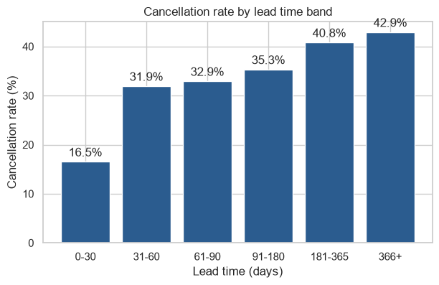
Figure 2. Cancellation rate by lead time band (notebook 01 §6.3).
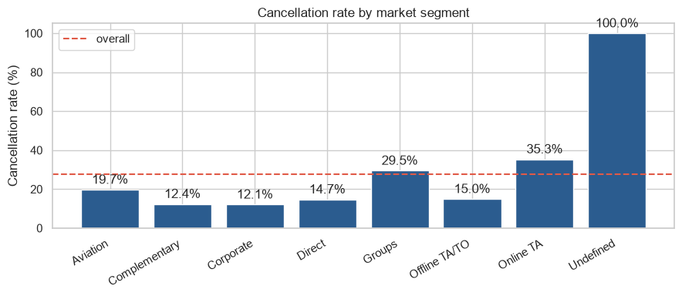
Figure 3. Cancellation rate by market segment (notebook 01 §6.5).

5. Preprocessing and feature log
For each issue: the options, what we chose, and the evidence. Feature tests use scripts/ablation.py (results in reports/results/ablation.csv): add or remove something and score XGBoost on the same 5 training folds. Noise rule: the baseline is PR-AUC 0.7660 ± 0.0071, so a change only counts if it moves the score by more than that.

5.1 Rubric items
Issue | Options considered | What we chose | Evidence
Missing values | (a) drop rows (b) fill with the most common value (c) one rule per column | (c): company dropped; agent → 0; country → Unknown; children → 0; meal "Undefined" → "SC" | Missing agent = no agent. Filling country with PRT would mislabel rows that cancel 13.7% as a 56.6% country (01 §2)
Outliers | (a) cut top/bottom 1% (b) remove only impossible values | (b): 180 zero-guest rows and 2 impossible prices | "Extreme" is not "wrong"; a percentile cut removes real peak-season bookings (01 §3)
Duplicates | (a) keep (b) remove exact copies | (b): 34,239 removed → 84,969 bookings | Keeping them: PR-AUC 0.9225 vs 0.7660, from memorising copies (arm 7). Limitation: some copies may be real
Categories | (a) one-hot all levels (b) frequency encoding (c) one-hot with rare levels grouped | (c): OneHotEncoder(min_frequency=100, handle_unknown='infrequent_if_exist'); agent as text | 142 countries and 277 agents have < 100 bookings (2.7% / 5.0% of rows). Frequency encoding: −0.0010 (arm 8)
Unseen categories | crash / zeros / "infrequent" column | "infrequent" column | The Undefined market segment appears only in the test set (02 §5.1)
Scaling | (a) scale for all (b) only where needed | (b): StandardScaler for Logistic Regression and the Neural Network | lead_time goes to 737, is_family is 0/1; trees are not affected by scale
Fitted on training data only | fit on whole table / inside the model pipeline | Encoder and scaler inside each model's Pipeline | Test rows never influence the encoding
Class imbalance | (a) nothing (b) class weighting (c) SMOTE (d) move the threshold | (d) + stratified split. Weighting and SMOTE rejected | Weighting: −0.0100 to −0.0008, never helped (notebook 09). SMOTE invents impossible bookings from categorical data. Threshold 0.335 raises out-of-fold F1 0.673 → 0.698
Leakage: outcome columns | keep / drop reservation_status* | Dropped | reservation_status is the target written again (01 §4)
Leakage: post-booking columns | keep / drop parking, assigned room, booking changes, waiting list | Dropped | Known only after booking. Putting them back: +0.0407 (0.8067, arm 6), a fake gain
Other dropped columns | keep / drop | arrival_date_year, arrival_date_week_number dropped | Partial years; 0.995 correlated with month (02 §2)
Train/test split | other ratios; unstratified | 80/20 stratified, seed 42 | 67,975 / 16,994, both 27.75% cancelled

5.2 New features
Feature | How it is built | Kept? | Evidence
total_nights | weekend + week nights | Kept | Readable length of stay; importance 0.008
total_guests | adults + children + babies | Kept | Party size in one number
is_family | children > 0 or babies > 0 | Kept | Families cancel 34.2% vs 27.0%; adds almost nothing on top (0.0001) but no harm
room_changed | reserved room ≠ assigned room | Rejected | Works (+0.0144, arm 5) but needs the room given at check-in: a leak

5.3 Kaggle notebook features that did not help
Candidate feature | Change in PR-AUC
prev_cancel_ratio + total_previous_bookings | −0.0007
long_lead_time (lead time > 90 days) | −0.0001
arrival_quarter | +0.0018
booked_by_company | −0.0001
adr_per_person | −0.0008
booked_by_company + adr_per_person | −0.0011
Frequency encoding for country and agent | −0.0010
First three together | +0.0026

None beats the ±0.0071 noise: they repeat what lead_time, previous_cancellations, arrival_date_month and market_segment already say. The 97–99% accuracy seen in Kaggle notebooks comes from keeping leak columns and/or duplicates, not from these features.
No automatic feature selection: it promotes required_car_parking_spaces, a leak. All 25 features go to every model. Permutation importance (shuffle one column and see how much PR-AUC drops; training data, 5 folds): country 0.173, lead_time 0.137, agent 0.128, total_of_special_requests 0.107 (feature_importance.csv).

6. Models and comparison
Every model uses the same 67,975 training bookings, the same 5 folds, the same preprocessing and the same metric, so the comparison is fair. Settings are tuned with cross-validation inside the training set; the threshold is chosen from out-of-fold predictions (each booking scored by a model that did not see it).

6.1 Baseline and five models
Model | Why it is in the comparison | CV PR-AUC | Chosen settings
Guessing baseline | Always predicts the cancel rate; the floor any model must beat | 0.2775 | —
Logistic Regression (03) | Simple, readable baseline; tests whether straight-line effects are enough | 0.6470 ± 0.0095 | C = 1
Decision Tree (04) | Transparent non-linear model | 0.7079 ± 0.0102 | depth 20, min leaf 100
Random Forest (05) | Many trees averaged; handles interactions | 0.7548 ± 0.0079 | 400 trees, depth 20
XGBoost (06) | Boosted trees; strong on tabular data | 0.7612 ± 0.0090 | 600 trees, depth 10, learning rate 0.05
Neural Network (07) | A different learning method for contrast | 0.7426 ± 0.0111 | layers (128, 64), alpha 0.001
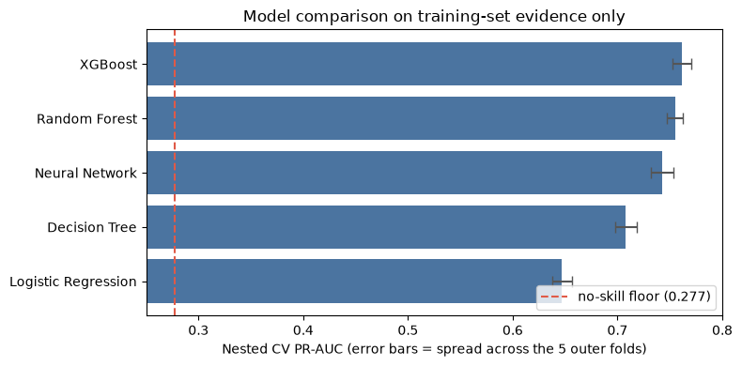
Figure 4. Model comparison on training data only; error bars show the fold-to-fold spread (notebook 08).

6.2 Why XGBoost
- Best CV score (0.7612), more than 2.7× the guessing baseline.
- Random Forest is close (0.7548): the gap of 0.0064 is inside the 0.0090 fold spread, so the two are not clearly different.
- XGBoost wins on practical grounds: about 12× faster to train and a 16× smaller file (3 MB vs 48 MB).
- Logistic Regression is clearly weaker (0.6470): cancellation depends on combinations of factors that a straight-line model cannot capture.

6.3 Check: class weighting (notebook 09)
Model | Without weighting | With weighting | Change
XGBoost | 0.7612 | 0.7604 | −0.0008
Neural Network | 0.7426 | 0.7390 | −0.0036
Decision Tree | 0.7079 | 0.7026 | −0.0053
Logistic Regression | 0.6470 | 0.6370 | −0.0100

Weighting never helped PR-AUC (weighted_comparison.csv). Moving the threshold does the same job more simply. (Random Forest was not re-run: about 54 minutes for one row.)

6.4 Check: ensemble (notebook 10)
Soft voting averages the probabilities of Random Forest, XGBoost and the Neural Network.
 | XGBoost alone | Ensemble
PR-AUC, 5 training folds | 0.7660 | 0.7696
PR-AUC, test set | 0.7698 | 0.7694
F1, test set | 0.7019 | 0.7019
Model file size | 3 MB | 52 MB

The ensemble is ahead in all 5 folds, but only by +0.0037, less than half of XGBoost's normal 0.0080 wobble, and on the test set there is no gain. The three models' predictions are already 92–94% correlated, so averaging has little to fix. XGBoost stays.
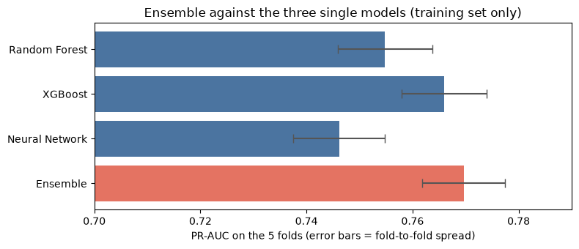
Figure 5. Ensemble vs the three single models on the training folds (notebook 10).

6.5 Why the ceiling is about 0.76–0.77
Three strong models within one fold spread of each other, extra features +0.0026, weighting never helped, ensemble +0.0037. The only big "gains" were leakage: post-booking columns (+0.0407) and duplicates (0.9225). The limit is the information known when the booking is made, not the model.

7. Evaluation on the test set
The test set (16,994 bookings, 4,715 cancellations) was opened once, in notebook 08, after the model and threshold were fixed.
Metric | Value | In plain words
PR-AUC | 0.7698 | Ranking quality for cancellations (guessing = 0.2775)
ROC-AUC | 0.8924 | A cancelled booking scores higher than a kept one 89% of the time
Recall | 0.7692 | Catches about 3 in 4 cancellations
Precision | 0.6454 | About 65% of flagged bookings really cancel
F1 | 0.7019 | Balance of precision and recall
Accuracy | 0.8187 | For completeness only: always "not cancelled" gets 72.25%

Honest check. The test PR-AUC (0.7698) landed inside the CV estimate made on training data only (0.7612 ± 0.0090). The CV estimate was a fair prediction.
Threshold. At the default 0.5, recall is 0.6259 and F1 0.6733. At 0.335 (chosen on training data), recall rises to 0.7692 and F1 to 0.7019.
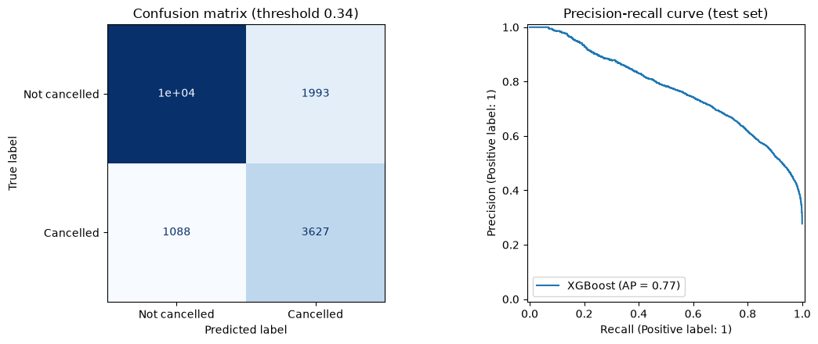
Figure 6. Confusion matrix at threshold 0.34 (top-left cell = 10,286) and precision–recall curve on the test set (notebook 08).
 | Predicted: not cancelled | Predicted: cancelled
Actually not cancelled | TN 10,286 | FP 1,993 (false alarm)
Actually cancelled | FN 1,088 (missed) | TP 3,627 (caught)

Per 1,000 new bookings (the confusion matrix scaled from 16,994 to 1,000): about 277 cancel; the model flags about 331, of which 213 are real cancellations and 117 false alarms; it misses about 64.

7.1 Which cancellations are missed?
Missed cancellations were booked a median of 42 days ahead, against 92 days for caught ones. They are also more often Direct bookings (20.9% of missed vs 3.8% of caught). At booking time, a short-notice booking that will be cancelled looks almost the same as one that will be kept.

7.2 What drives the prediction
Permutation importance on the test set (notebook 08 §4): country 0.177, lead_time 0.142, agent 0.133, total_of_special_requests 0.105, market_segment 0.075. The same top four as on the training folds (section 5.3).

8. Decision log
One row per decision: what we chose, what else we considered, why, and what it does not solve (reports/decision_log.md).

8.1 Data and cleaning (notebook 01)
Decision | Alternatives | Evidence / reason | Limitation
Remove exact duplicate rows (34,239) | Keep them | Keeping them gives PR-AUC 0.9225 vs 0.7660 because the model memorises copies | Some copies may be real separate bookings; no booking ID
Remove zero-guest rows (180) and the 2 impossible prices | Delete outliers by percentile | Only rows that cannot be a real stay are removed | Other odd values stay in
Missing country → Unknown, agent → 0 (text), children → 0 | Fill with the most common value | Missing agent means "no agent"; an unknown country should not be guessed | children = 0 is an assumption for 4 rows
Drop leak columns | Keep them for a higher score | Known only after booking; together +0.0407 PR-AUC, which would be leakage | The CSV cannot prove every kept column was fixed at booking time
Drop company, arrival_date_year, arrival_date_week_number | Keep them | 94.3% empty / partial years / 0.995 correlated with month | —

8.2 Features and preprocessing (notebook 02, scripts)
Decision | Alternatives | Evidence / reason | Limitation
Add total_nights, total_guests, is_family | Raw columns only | Easy to read; no measured harm | is_family adds almost nothing (0.0001)
Do not add the Kaggle notebooks' extra features | Add them all | All together +0.0026, below the 0.0071 noise | Tested with one model only
80/20 stratified split, seed 42 | Other ratios | Keeps the 27.7% cancel rate on both sides | 93 test bookings look identical to a training booking
One-hot encoding, rare categories (< 100) share one column | Frequency encoding | Frequency encoding scored −0.0010 | Threshold 100 was chosen, not tuned
Scale numbers only for Logistic Regression and the Neural Network | Scale for all | Tree models are not affected by scale | —
No class weighting, no SMOTE (notebook 09) | Weighting, SMOTE | Weighting lowered PR-AUC in every model (−0.0100 to −0.0008); SMOTE invents impossible bookings | Imbalance handled by the threshold instead

8.3 Models (notebooks 03–08)
Decision | Alternatives | Evidence / reason | Limitation
Rank models on PR-AUC | Accuracy | Always "not cancelled" already scores 72% accuracy; PR-AUC focuses on the cancelled class | Harder to explain than accuracy
Tune and score on separate folds inside the training set | Tune and score on the same folds | The comparison score is not the one used for tuning, so it is not flattered | Slower (Random Forest ~25 min)
Threshold chosen by best F1 on out-of-fold training predictions | Default 0.5 | Raises XGBoost F1 from 0.673 to 0.698 | F1-best is not cost-best
Final model: XGBoost (0.7612 ± 0.0090) | Random Forest (0.7548) | Best score; RF within the noise but 12× slower and 16× bigger | Margin over RF not significant
Test set used once for the final model (notebook 08) | — | Test score (0.7698) lands inside the CV spread, so the estimate was honest | —
Save every trained model to models/ with joblib | Retrain when needed | A saved model scores new bookings straight away | Random Forest file is 48 MB

8.4 Ensemble (notebook 10)
Decision | Alternatives | Evidence / reason | Limitation
Try soft voting of RF + XGBoost + NN | Add LR and DT too | LR and DT are clearly weaker and would pull the average down | Only one ensemble type tried
Keep XGBoost, do not adopt the ensemble | Adopt the ensemble | +0.0037 on training folds (5/5 better) is under the 0.0080 noise; test 0.7694 vs 0.7698, same F1; 52 MB vs 3 MB | Test set read a second time, after the decision

9. Recommendation, risks and limitations

9.1 What the hotel should do
Score every new booking with the XGBoost model when it is made. If the cancellation probability is 0.335 or higher, flag it as high risk. For flagged bookings:
Action | Why it fits
Friendly reminder before arrival (confirm the dates) | Cheap, polite, harmless if the flag is wrong
Ask for a deposit or offer a small incentive to confirm, where policy allows | Turns a loose booking into a firmer one
Plan overbooking around the flagged total | Uses flags as numbers for planning, not as judgements about one guest

The model is decision support: a person decides what to do; the model only ranks bookings.

9.2 What to expect
- Catches about 77% of cancellations (recall 0.769).
- About 65% of flagged bookings really cancel; about 1 in 3 flags is a false alarm.
- About 16% of guests who will arrive get a reminder they did not need (1,993 of 12,279), which is why the actions are friendly ones.

9.3 Where the model is weak
Short-notice bookings (missed cancellations: median lead time 42 days vs 92 for caught) and Direct bookings. "Not flagged" does not mean "safe".

9.4 Risks and fairness
- `country` is the strongest input (0.173). Portuguese guests cancel more (35.9%) than other Europeans (22.5%). The hotel must not use the flag to treat guests from some countries worse (refusing bookings, worse prices, harder conditions). Use it only for planning and friendly reminders.
- A flag is a probability, not a fact. Harsh actions on a flag alone would hurt real guests.
- Personal data. The model uses booking details, not names; any real use must follow the hotel's data-protection rules (e.g. GDPR in Portugal).
- Drift. Travel habits changed after 2020; a model trained on 2015–2017 may be less accurate today.

9.5 Limitations
- The test set was looked at more than once. Notebook 10 reads it a second time (after the decision), so the test score is not a perfectly untouched estimate.
- 93 test bookings have an identical profile in training. A random split cannot keep look-alike bookings on one side.
- The threshold is slightly optimistic. It was chosen on out-of-fold predictions from settings picked using all training rows.
- No time-based test. We did not train on older and test on newer bookings; the arrival date is not the booking date.
- Scope. Two Portuguese hotels, 2015–2017, before 2020.
- Best-F1 is not best-for-business. The threshold maximises F1, not money.
- Booking-time data cannot be fully proven. The source does not guarantee kept columns (e.g. adr, deposit_type) were never updated after booking.

9.6 Next steps for the hotel
- Set the threshold from real costs (cost of contacting a guest vs value of a saved room).
- Retrain on newer data with the real booking date, and test on the most recent months.
- Collect a booking ID so real duplicates can be told apart.
- Start with a small trial (reminders only) and measure whether cancellations fall.
- Monitor fairness: check that flags do not lead to different treatment by country.

10. Reproducibility
What | Where
Code repository | github.com/ItsAloka/hotel-booking-cancellation-ml
Notebooks (run in order) | notebooks/01_eda_cleaning → 02_preprocessing → 03–07 (one per model) → 08_model_selection → 09_class_weighting → 10_ensemble
Environment | Project .venv (has xgboost); packages pinned in requirements.txt; fixed random seed 42
Data | Raw: data/raw/hotel_bookings.csv (fingerprint in section 2.1, details in data/raw/SOURCE.md). Cleaned and split files in data/processed/
Results | CSV outputs of every notebook in reports/results/ (leaderboard.csv, final_model.csv, ensemble.csv, ablation.csv, …)
Saved models | models/*.joblib (final model: models/xgboost.joblib)
Feature tests | scripts/ablation.py, scripts/feature_importance_check.py, scripts/weight_sweep.py
Demo app | streamlit run app/app.py, then open http://localhost:8501
Demo video | YouTube link to be added

Every number in this report comes from a notebook output or a CSV in reports/results/ and can be checked by re-running the notebooks in order.

11. AI use and contributions

11.1 AI-use declaration
We used Claude (Anthropic), through Claude Code, a coding assistant working inside our project folder.
Area | What the AI did
Code | Drafted code for notebooks 01–10, the scripts in scripts/ and the demo app
Notebook text | Drafted the explanations under the charts and tables
Reviewing | Reviewed the shared foundation and pointed out risks (leak columns, duplicate rows)
Checks | Ran the feature tests and the importance check and reported the numbers
Documents | Drafted the evidence documents in reports/ and this report from the notebook outputs

How we checked it: every decision was reviewed and accepted by a person; every number comes from running the code, not from AI text; suggested changes were measured and kept only if they beat the noise (most did not); the 97–99% Kaggle accuracy claims were checked and explained (leakage, duplicates) instead of copied.

11.2 Contributions
As planned in the initial submission (section 5.2), each member owned one part of the data work (notebooks 01 and 02) and one model, and is the person who explains that part. The Neural Network (07), model selection (08), class weighting (09) and the ensemble (10) were shared work; the Neural Network and the ensemble were added beyond the four planned models.
Ref | Student ID | Name | Model owned | What they did
M1 | IT24101147 | Warnakulasinhage S.N.A | Logistic Regression | Notebook 02 in full: features and target, the encoding plan (one-hot, rare levels grouped), the stratified 80/20 split, the 5 cross-validation folds and the PR-AUC metric. Notebook 03: Logistic Regression (baseline). Coordination: workflow diagram, decision log, model comparison (08), report assembly and the demo video.
M2 | IT24102629 | Nawodya K.P.G.P | Decision Tree | Notebook 01 sections 1 to 3 and 5: loading and first look, the data dictionary for all 32 columns, and the data-quality pass (missing values, impossible rows and outliers, duplicate rows). Notebook 04: Decision Tree.
M3 | IT24100509 | Fonseka W. P. L | Random Forest | Notebook 01 sections 4 and 6.1 to 6.6: the leakage check and the dropped columns, class balance, and the EDA on booking drivers (hotel type, lead time, deposit and customer type, market segment, guest history and special requests). Notebook 05: Random Forest.
M4 | IT24101027 | Seelarathna G.P.B | XGBoost | Notebook 01 sections 6.7 to 9: seasonality, country of origin, price, correlation and scope, the key findings, feature engineering (total_nights, total_guests, is_family), the stress tests and saving the clean data. Notebook 06: XGBoost.

We confirm this declaration is accurate, that we understand every part of the submitted work, and that each member can explain their own part without AI help.

11.3 References
- Antonio, N., de Almeida, A. & Nunes, L. (2019). Hotel booking demand datasets. *Data in Brief*, 22, 41–49. https://doi.org/10.1016/j.dib.2018.11.126
- Mostipak, J. Hotel Booking Demand (Kaggle dataset). https://www.kaggle.com/datasets/jessemostipak/hotel-booking-demand
- Kaggle notebooks consulted for structure (features measured, not copied): Dalileh Oladzadeh, "Hotel Booking Cancellation Prediction / EDA + 6 ML"; Aamir, "Hotel Cancellation Prediction using ANN"; Kushal, "HotelBookingCancellationAnalysis-V1"; Hazem Alanany, "Hotel Booking"; Ahmed Baqa, "Hotel Booking Cancellation Analysis / Python".
- scikit-learn and XGBoost documentation.

Appendix A. Personal Learning Journeys
One A4 page per member, written by that member in their own words. Each page supports the assessment of that member's individual contribution.

A1 Warnakulasinhage S.N.A (IT24101147)
M1 · Project Lead
What I did
As project lead, I built notebook 02: the stratified train/test split, the encoding of the categories, the 5 cross-validation folds and the PR-AUC metric that every model was scored with. I also built the baselines: a guessing baseline (PR-AUC 0.2775) and Logistic Regression (0.6470). I put together the workflow diagram, the decision log, the model comparison, this report and the demo video, and I ran every notebook from start to end to check that the numbers in the report match.
What I learned
Cleaning data means thinking about the real world. The raw data had 119,390 bookings, but 34,239 were exact copies. With the copies in, the model scored 0.92, but only because it memorised them. The parking column looked perfect: 7,409 bookings asked for parking and none cancelled. Then I understood that parking is recorded when the guest arrives, so it gives the answer away. We removed it and the other "after booking" columns, even though our score dropped. An honest lower score is better than a fake high one.
Accuracy can lie. Only 27.7% of bookings are cancelled, so a model that always says "not cancelled" is 72% accurate and useless. That is why we used PR-AUC and a stratified split. We tested class weighting (it lowered the score in every model) and rejected SMOTE (it invents bookings that never happened). Moving the decision threshold to 0.335 worked better.
A baseline gives every number a meaning. Without it, "0.77" means nothing. With it, I could show XGBoost is 2.7 times better than guessing, and that extra features and the ensemble added only noise.
Every dataset has a ceiling. Three different models all stopped at about 0.76–0.77. The limit was the information in the data, not the model. The 97–99% results online come from leaks and duplicates.
A model has limits. Ours comes from two Portuguese hotels, 2015–2017, with mostly European guests. It should not be used everywhere, and it must never be used to treat guests from some countries worse.
What was hard
Accepting lower but honest scores, stopping at the ceiling instead of trying endless models, and planning the whole project under a tight deadline.
What I would do differently
Test on newer bookings (a time-based split), choose the threshold from real hotel costs, and set clear team checkpoints from the first week.

A2 Nawodya K.P.G.P (IT24102629)
M2 · Decision Tree
What I did
[Write in your own words: your part of the project (see section 11.2), the notebook sections and the model you are responsible for.]
What I learned
[Write in your own words: 2–4 things you learned, each with a real number from the project as proof.]
What was hard
[Write in your own words: what was difficult and how you dealt with it.]
What I would do differently
[Write in your own words: what you would change next time.]

A3 Fonseka W. P. L (IT24100509)
M3 · Random Forest
What I did
[Write in your own words: your part of the project (see section 11.2), the notebook sections and the model you are responsible for.]
What I learned
[Write in your own words: 2–4 things you learned, each with a real number from the project as proof.]
What was hard
[Write in your own words: what was difficult and how you dealt with it.]
What I would do differently
[Write in your own words: what you would change next time.]

A4 Seelarathna G.P.B (IT24101027)
M4 · XGBoost
What I did
[Write in your own words: your part of the project (see section 11.2), the notebook sections and the model you are responsible for.]
What I learned
[Write in your own words: 2–4 things you learned, each with a real number from the project as proof.]
What was hard
[Write in your own words: what was difficult and how you dealt with it.]
What I would do differently
[Write in your own words: what you would change next time.]

