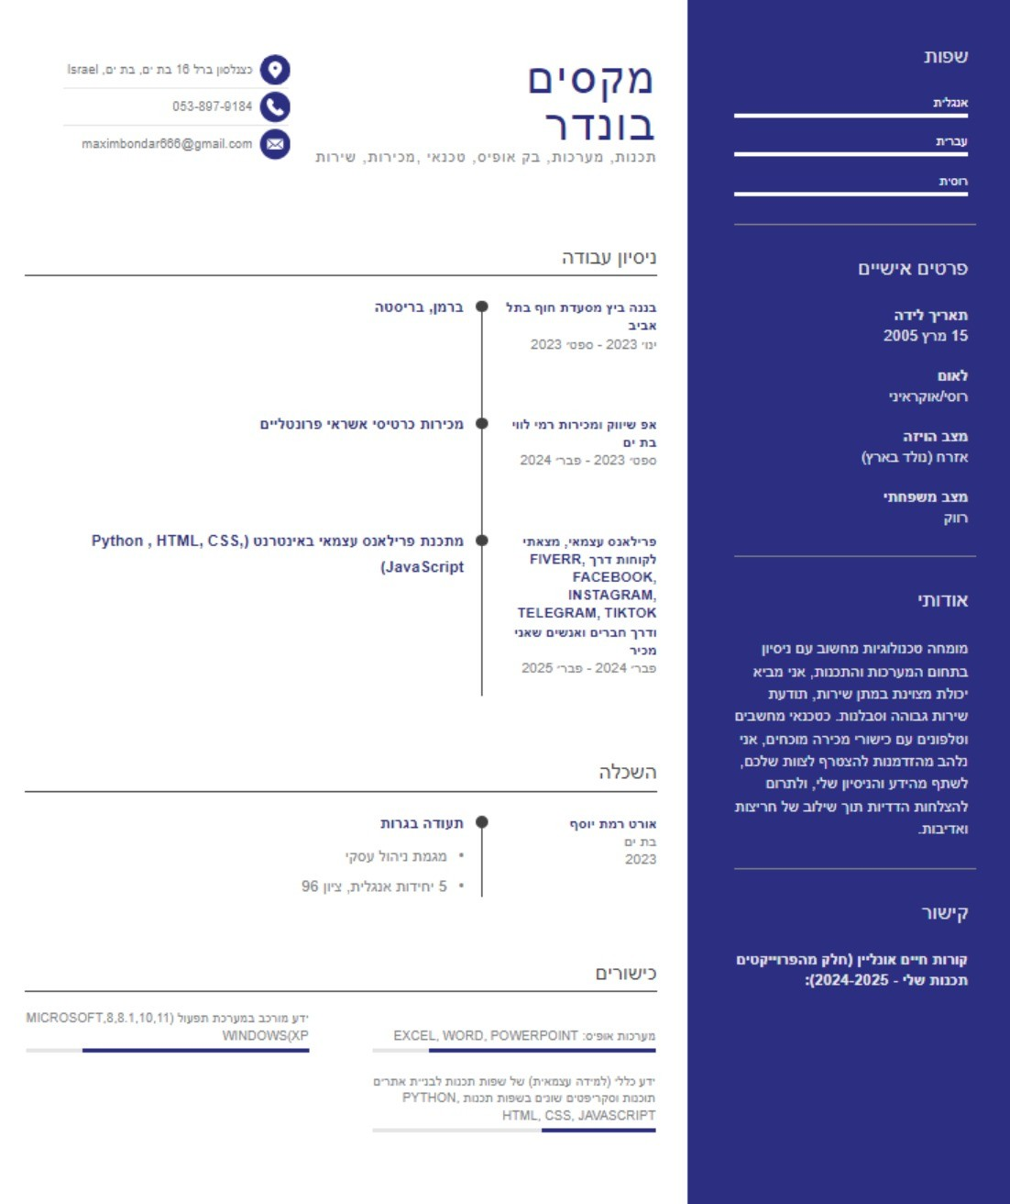

https://itsaxy.github.io/Resume2025/