Availability Monitor Details:
We used SiteMonitorLite.ps1 (a custom PowerShell implementation) running via a Jenkins Cron schedule
(H/5 * * * *) to ping our application every 5 minutes.

What we monitored: We monitored the public ngrok endpoint
(https://silk-spore-huskiness.ngrok-free.dev/daniel-yuval-bar-chany-shani/index.jsp) to assert it
returned an HTTP 200 OK status code.
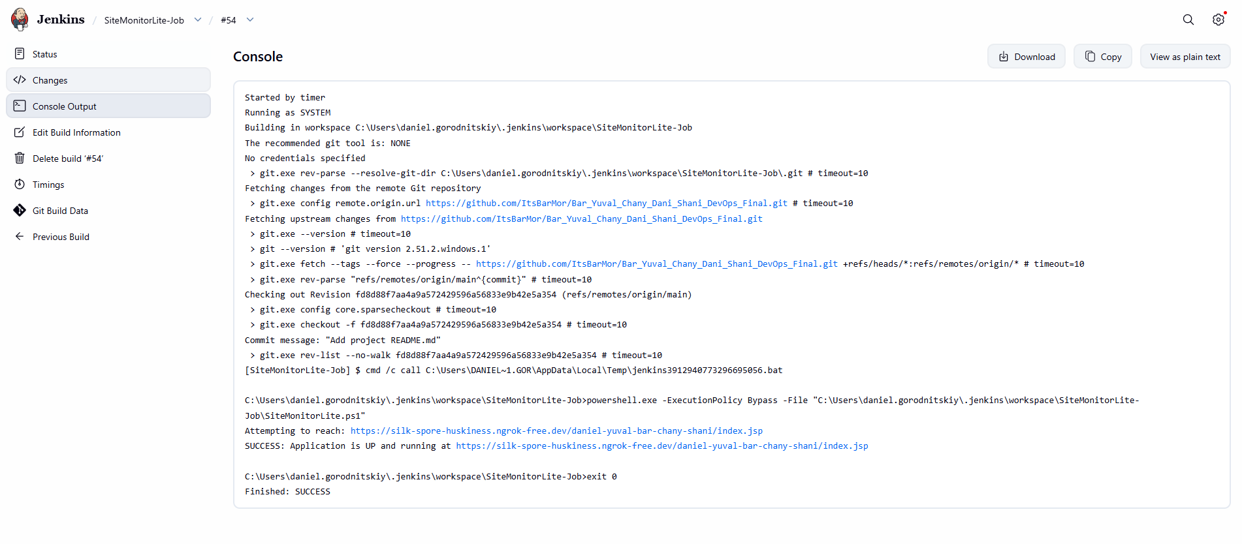

Started by timer
Running as SYSTEM
Building in workspace C:\Users\daniel.gorodnitskiy\.jenkins\workspace\SiteMonitorLite-Job
The recommended git tool is: NONE
No credentials specified
> git.exe rev-parse --resolve-git-dir C:\Users\daniel.gorodnitskiy\.jenkins\workspace\SiteMonitorLite-Job\.git # timeout=10
Fetching changes from the remote Git repository
> git.exe config remote.origin.url https://github.com/ItsBarMor/Bar_Yuval_Chany_Dani_Shani_DevOps_Final.git # timeout=10
Fetching upstream changes from https://github.com/ItsBarMor/Bar_Yuval_Chany_Dani_Shani_DevOps_Final.git
> git.exe --version # timeout=10
> git --version # 'git version 2.51.2.windows.1'
> git.exe fetch --tags --force --progress -- https://github.com/ItsBarMor/Bar_Yuval_Chany_Dani_Shani_DevOps_Final.git +refs/heads/*:refs/remotes/origin/* # timeout=10
> git.exe rev-parse "refs/remotes/origin/main^{commit}" # timeout=10
Checking out Revision fd8d88f7aa4a9a572429596a56833e9b42e5a354 (refs/remotes/origin/main)
> git.exe config core.sparsecheckout # timeout=10
> git.exe checkout -f fd8d88f7aa4a9a572429596a56833e9b42e5a354 # timeout=10
Commit message: "Add project README.md"
> git.exe rev-list --no-walk fd8d88f7aa4a9a572429596a56833e9b42e5a354 # timeout=10
[SiteMonitorLite-Job] $ cmd /c call C:\Users\DANIEL~1.GOR\AppData\Local\Temp\jenkins3912940773296695056.bat

C:\Users\daniel.gorodnitskiy\.jenkins\workspace\SiteMonitorLite-Job>powershell.exe -ExecutionPolicy Bypass -File "C:\Users\daniel.gorodnitskiy\.jenkins\workspace\SiteMonitorLite-Job\SiteMonitorLite.ps1"
Attempting to reach: https://silk-spore-huskiness.ngrok-free.dev/daniel-yuval-bar-chany-shani/index.jsp
SUCCESS: Application is UP and running at https://silk-spore-huskiness.ngrok-free.dev/daniel-yuval-bar-chany-shani/index.jsp

C:\Users\daniel.gorodnitskiy\.jenkins\workspace\SiteMonitorLite-Job>exit 0
Finished: SUCCESS

