Selenium IDE Validations Explanation:
(Screenshot of the passed run is attached)
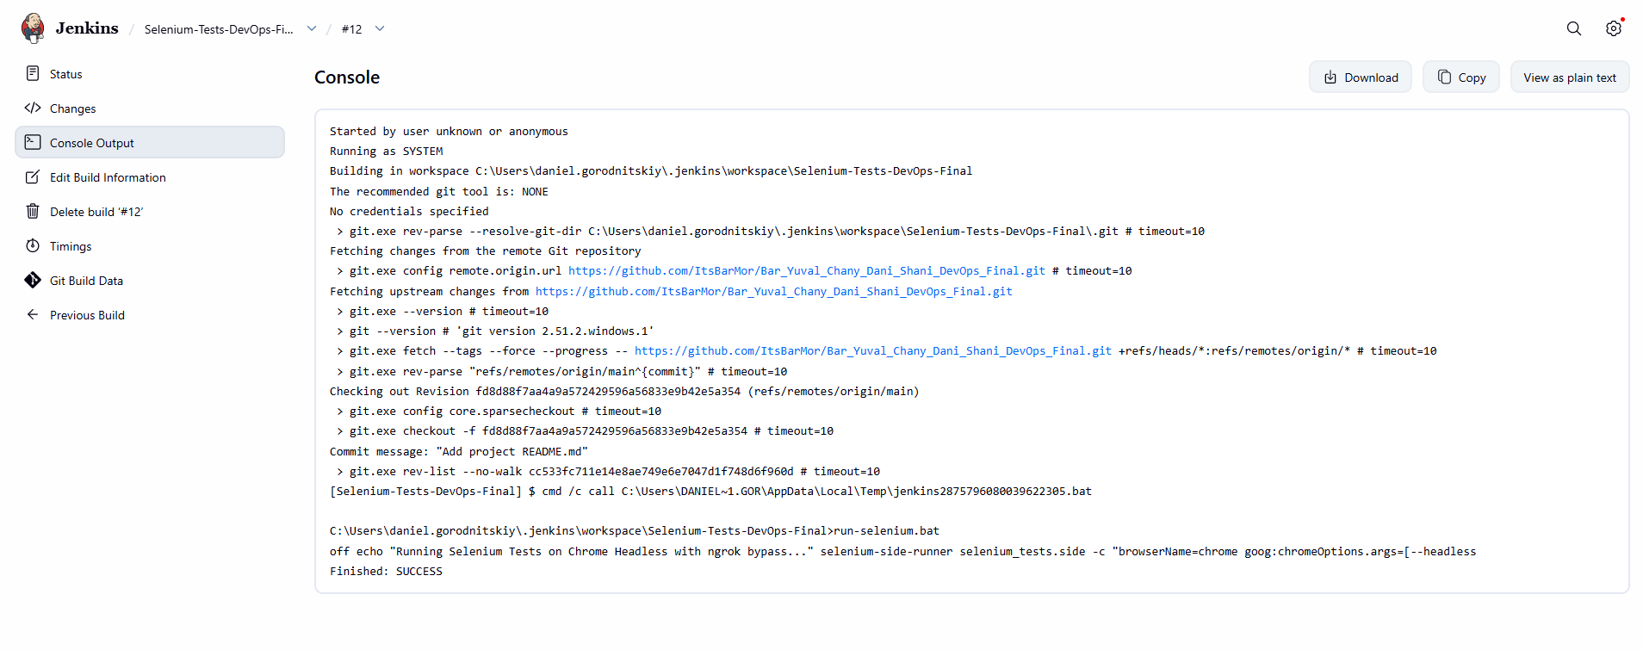

We implemented 5 distinct validations against our public ngrok URL:
https://silk-spore-huskiness.ngrok-free.dev/daniel-yuval-bar-chany-shani/index.jsp
- Verify (לינק קיים): We used verifyElementPresent to ensure the GitHub link loaded properly.
We used verify instead of assert here so the test wouldn't immediately hard-fail if the external link took an extra second to render.
- Assert (טקסט מופיע): We used assertText to strictly validate that our team members' names rendered correctly.
We used assert because this is critical content; if it's missing, the test should fail immediately.
- Positive Test (הכנסת שם תקין): We used type to enter a valid string
("Valid DevOps Name") into the textbox.
4. Click (button עובד): We used click on the submit button, followed by a waitForElementPresent, and validated that the correct dynamic success message appeared.
5. Negative Test (textbox ריק): We reloaded the page, submitted an empty form, and used assertElementNotPresent. We used this validation to confirm that the server correctly rejected the empty input and did not display a success message.

Console
DownloadCopyView as plain text
Started by user unknown or anonymous
Running as SYSTEM
Building in workspace C:\Users\daniel.gorodnitskiy\.jenkins\workspace\Selenium-Tests-DevOps-Final
The recommended git tool is: NONE
No credentials specified
> git.exe rev-parse --resolve-git-dir C:\Users\daniel.gorodnitskiy\.jenkins\workspace\Selenium-Tests-DevOps-Final\.git # timeout=10
Fetching changes from the remote Git repository
> git.exe config remote.origin.url https://github.com/ItsBarMor/Bar_Yuval_Chany_Dani_Shani_DevOps_Final.git # timeout=10
Fetching upstream changes from https://github.com/ItsBarMor/Bar_Yuval_Chany_Dani_Shani_DevOps_Final.git
> git.exe --version # timeout=10
> git --version # 'git version 2.51.2.windows.1'
> git.exe fetch --tags --force --progress -- https://github.com/ItsBarMor/Bar_Yuval_Chany_Dani_Shani_DevOps_Final.git +refs/heads/*:refs/remotes/origin/* # timeout=10
> git.exe rev-parse "refs/remotes/origin/main^{commit}" # timeout=10
Checking out Revision fd8d88f7aa4a9a572429596a56833e9b42e5a354 (refs/remotes/origin/main)
> git.exe config core.sparsecheckout # timeout=10
> git.exe checkout -f fd8d88f7aa4a9a572429596a56833e9b42e5a354 # timeout=10
Commit message: "Add project README.md"
> git.exe rev-list --no-walk cc533fc711e14e8ae749e6e7047d1f748d6f960d # timeout=10
[Selenium-Tests-DevOps-Final] $ cmd /c call C:\Users\DANIEL~1.GOR\AppData\Local\Temp\jenkins2875796080039622305.bat

C:\Users\daniel.gorodnitskiy\.jenkins\workspace\Selenium-Tests-DevOps-Final>run-selenium.bat
off echo "Running Selenium Tests on Chrome Headless with ngrok bypass..." selenium-side-runner selenium_tests.side -c "browserName=chrome goog:chromeOptions.args=[--headless
Finished: SUCCESS

