Title: Gauteng City College - Payroll System Documentation
Name: Bhekithemba Mecson
Student ID: 0512145197087
GitHub Link: https://github.com/ItsBk14/PayrollSystem-Bhekithemba-Mecson

1. Variable List:
- numEmployees (int) - how many workers
- empId (int) - employee ID
- empName (string) - employee name
- basicSalary (double) - money
- department (string) - IT/Sales/HR
- rating (int) - performance 1-5
- years (int) - years of service

2. Logic:
- For loop: repeats for each employee
- if-else: checks rating for perf bonus + checks years for loyalty
- switch: checks department first letter for dept bonus (my rule: Sales=R2000)
- Error handling: if salary <0 skip employee

3. Screenshots:

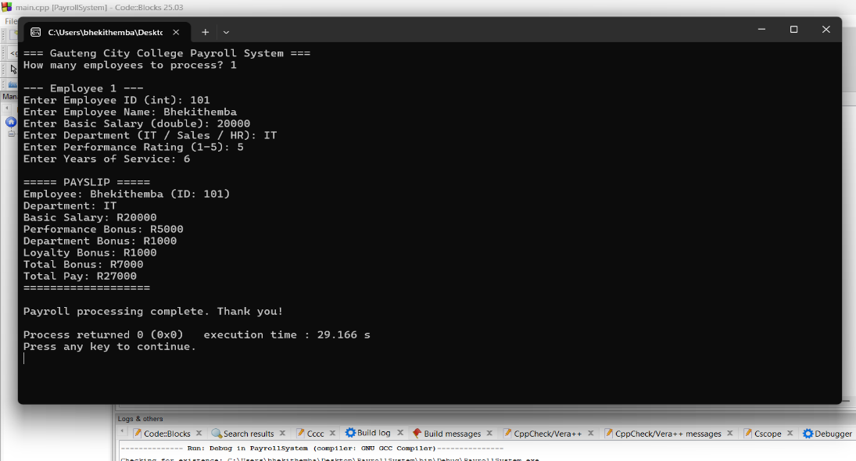
Label: Valid test - R20000, IT, 5 stars, 6 years = R27000 total

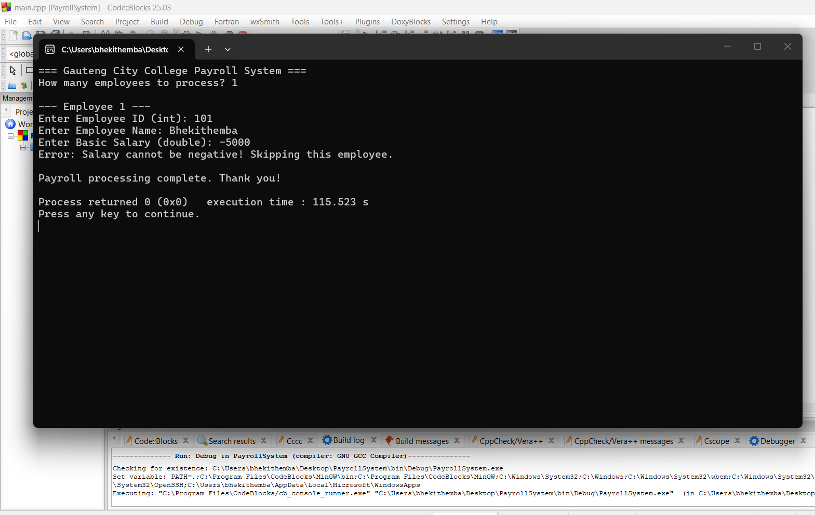
Label: Invalid test - salary -5000 shows error message

