Airport Operations Analytics
A Data Pipeline for Congestion and Delay Diagnostics
Architecture · Implementation · Strategic Roadmap

MSBA 305 — Data Processing Framework
Spring 2025/2026

Instructor: Dr. Ahmad El-Hajj
Mohamad Ali Ahmad, Omar Nakfour, Atifa Dani, Hadi Beitamouni, Leen Moussa
Institution: Suliman S. Olayan School of Business, AUB
Date: April 2026

Executive Summary
This report presents the design, implementation, and strategic recommendations emerging from an engagement to build an integrated data pipeline for airport operations analytics. The work converts three public aviation data sources into a unified, query-ready analytical layer that surfaces the upstream drivers of arrival congestion and delay propagation.

Why this matters
The U.S. Federal Aviation Administration has historically estimated the economic cost of flight delays to the U.S. economy in the tens of billions of dollars annually, with late-aircraft propagation consistently identified as a leading contributor. Even modest reductions at high-volume hubs generate measurable recovery. Directional industry analysis suggests that a one percent reduction in arrival-delay minutes at a single major hub equates to tens of thousands of recovered passenger-hours per year. The analytical framework delivered here identifies where that leverage sits and quantifies the relative size of each potential intervention.

Approach
A three-source pipeline architecture : BTS flight operations (historical batch), OpenFlights reference metadata (spatial enrichment), and AviationStack real-time API (live status) — was designed and delivered in prototype form. The implementation emphasises production-grade design patterns (modular ingestion, schema validation, graceful degradation, structured logging) while remaining appropriately lightweight for the diagnostic scope of this phase. The roadmap in §A12 sets out the sequence by which the prototype evolves into a production platform.

Key findings
- Late-aircraft propagation dominates. Late-aircraft delay is the largest single contributor to total delay minutes across the observation window, typically exceeding weather and NAS-category delay combined at top-volume hubs.
- Volume is concentrated. Approximately ten airports carry the majority of total U.S. arrival traffic. Any intervention that does not prioritise this set misallocates capital.
- Performance is not uniform within the high-volume cohort. Mean delay per flight varies materially across the top-10 airports, indicating operational practices worth studying and transferring.
- Geographic scope is a constraint. BTS-only data does not generalise to non-U.S. airports. Closing this gap is the highest-leverage next integration.

Strategic recommendations
R1 — Prioritise operational interventions that target late-aircraft propagation (turnaround discipline, schedule-buffer design, airline-side recovery protocols) over infrastructure or weather-mitigation spend.
R2 — Focus tooling investment on the top-10 volume hubs. A percentage-point efficiency gain at these facilities dwarfs equivalent gains elsewhere.
R3 — Stand up a peer-performance benchmarking cycle across the top-10 cohort to transfer best-practice operational methods.
R4 — Adopt the three-phase implementation roadmap in §A12: productionise in 0–6 months, expand to predictive and real-time capability in 6–18 months.
R5 — Integrate Eurocontrol, weather, and airline-schedule data in Phase 2 to close geographic and causal gaps identified in the current scope.

Implementation horizon
Phase 1 (current prototype): delivered. Phase 2 (0–6 months): production pipeline with PostgreSQL storage, cloud object storage for raw files, scheduled orchestration, expanded source coverage. Phase 3 (6–18 months): cloud data warehouse, streaming layer for the real-time feed, predictive delay model, executive dashboards. The full roadmap is visualised in §A12.2.

Deliverables
- End-to-end pipeline source code (code/pipeline.py) with modular ingestion, cleaning, integration, and query layers.
- Five analytical queries mapped to the KPIs defined in §A1 (filter, aggregation, join, window, multi-dimensional pivot).
- Supporting visualisations with written business interpretation.
- Full architecture documentation (this report) including strategic roadmap, risk register, and operating-model recommendations.
- Supporting repository artefacts: README, requirements.txt, environment template, architecture diagrams.

Table of Contents

A1. Domain and Problem Framing 7
A2. Data Source Appraisal 9
A3. Ingestion Pipeline Design 11
A4. Storage Architecture Design 13
A5. Data Cleaning and Transformation 15
A6. Processing Paradigm 16
A7. Analytical Queries 18
A8. Visualisation and Reporting 20
A9. Security, Governance and Archival 25
A10. AI Usage Documentation 26
A11. References 28
A12. Strategic Recommendations and Roadmap 29
Appendix A: Architecture Diagram 33
Appendix B: Data Dictionary 34
Appendix C: Glossary 35

A1. Domain and Problem Framing

Business problem
Airports of global importance face recurring operational pressure from the volume and timing of flight arrivals. When arrivals cluster or propagate delays, downstream processing at passport control, security, and baggage handling bottlenecks, degrading passenger experience and inflating operational cost. Reducing these congestion episodes has direct measurable impact: carriers face lower connection-loss rates, airport authorities can optimise staffing against actual peak profiles, and passengers experience shorter transit times. Although checkpoint-level queue telemetry lies outside publicly available datasets, flight arrival volume and delay clustering are established leading indicators of downstream queue formation.

Business-case framing
The economic stakes around airport delays are well documented. Historical estimates place the annual cost of air-transport delay to the U.S. economy in the tens of billions of dollars, split across direct carrier operating cost, passenger time loss, and downstream economic impact. While this report does not attempt to quantify the impact at any single client installation, the framework of attainable recovery is directionally straightforward:
- Every additional minute of average arrival delay at a major hub translates into measurable increases in crew-overtime cost, missed-connection compensation, and gate-utilisation penalty.
- Because late-aircraft delay (identified in this report as the dominant category) propagates across the network, an intervention that reduces delay at one hub reduces cascading delay downstream — the effect compounds rather than localises.
- Volume concentration (roughly 10 hubs carrying the majority of U.S. traffic) means that a focused intervention captures the majority of available recovery with a minority of the operational complexity.
The analytical pipeline delivered here exists to identify these interventions precisely — which airports, which delay categories, which time windows — so that operational investment is directed where it has the largest measurable return.

Why three distinct data sources
- BTS Flight Delay Dataset (CSV) is the ground-truth record of U.S. airport arrival performance at monthly airport granularity, capturing arrival counts and four categorical delay attributions. It anchors the analysis.
- OpenFlights Airport Metadata (CSV via URL) is required to translate opaque IATA codes into interpretable geography (city, country, canonical name). Without it, BTS data cannot be presented at a business-user level.
- AviationStack API (JSON) introduces real-time flight status into the historical frame. It demonstrates hybrid batch-plus-near-real-time pipeline capability and provides a reproducible proof-point for a future live-monitoring extension.

Analytical objectives (measurable KPIs)
The pipeline is designed to answer five specific operational questions:
- KPI-1 — Volume concentration: Which ten airports carry the highest total arrival volume over the observation window? Establishes the congestion-risk prioritisation list.
- KPI-2 — Delay mix: For each top airport, what share of total delay minutes is attributable to weather, NAS, and late-aircraft causes? Determines which intervention family is justified.
- KPI-3 — Service-level benchmark: Mean delay minutes per flight by airport — comparable across airports and seasons, supports cohort peer comparison.
- KPI-4 — Propagation indicator: Late-aircraft delay as a percentage of total delay per airport. A high ratio flags upstream scheduling problems rather than external disruption.
- KPI-5 — Trend detection: Three-month rolling average of arrival delay per top-N airport, enabling month-over-month monitoring and early anomaly detection.

A2. Data Source Appraisal
Three data sources drive this pipeline. Each is appraised below across the five required dimensions: source and collection method, structure and format, volume and velocity, quality, and risks and limitations.

Source 1: BTS Flight Delay Dataset (Kaggle CSV)
Format: CSV | Access: Kaggle download | Nature: Monthly batch | Source: U.S. Bureau of Transportation Statistics
Dimension | Assessment
Source & Collection | Source: Kaggle dataset by sriharshaeedala, derived from the U.S. Bureau of Transportation Statistics (BTS). Ownership: BTS / U.S. Department of Transportation. Collection mechanism: Mandatory monthly reporting by U.S. certified air carriers. Access method: Public CSV download from Kaggle.
Structure & Format | File format: CSV (rigid schema). Key fields: year, month, airport, airport_name, arr_flights, arr_delay, weather_delay, nas_delay, late_aircraft_delay. Schema: flat tabular, monthly airport-level records; no nested structures. Derived field: a synthetic date column was created by concatenating year and month strings.
Volume & Velocity | Dataset spans multiple years of monthly airport-level data, producing tens of thousands of rows after column restriction. Growth rate: static historical snapshot on Kaggle. Update frequency: BTS publishes monthly; the Kaggle version is a fixed release. Latency: batch, no real-time component.
Quality Assessment | Completeness: after restricting to the nine selected columns and applying dropna(), the null rate on all working columns reached 0% (confirmed via merged.isna().sum() returning 0 for core fields). Duplicate counts: none required — airport + year + month combinations serve as natural composite keys. Accuracy: BTS mandates carrier reporting under federal regulation, providing high baseline accuracy. Consistency: all delay columns use the same unit (minutes).
Risks & Limitations | Bias: covers U.S. domestic and international carriers only; non-U.S. airports absent, introducing strong geographic skew confirmed by country-level aggregation. Missing patterns: rows with nulls are dropped, which may systematically exclude smaller or less-reporting airports. Ethical/legal: no PII present; public government statistics. Schema drift risk: BTS column naming may change across annual releases.

Source 2: OpenFlights Airport Dataset (CSV via URL)
Format: CSV (no header) | Access: Direct URL fetch | Nature: Static reference | Source: openflights.org
Dimension | Assessment
Source & Collection | Source: OpenFlights.org GitHub repository. Ownership: Open-source community project maintained by Jpatokal. Collection mechanism: Crowdsourced and manually curated airport reference data. Access method: direct URL fetch via pandas.read_csv().
Structure & Format | File format: CSV with no header row. Columns used: 14 column names manually assigned (airport_id, name, city, country, iata, icao, lat, lon, altitude, timezone, dst, tz, type, source). Working subset retained: iata, name, city, country. Missing-value handling: '\N' sentinel used for missing codes and filtered prior to merge.
Volume & Velocity | Approximately 7,698 airport records globally. Growth rate: static reference file — airports are rarely added or removed. Update frequency: infrequent community-driven patches. Latency: batch reference data; not updated in real time.
Quality Assessment | Completeness: rows where iata == '\N' were filtered out prior to merging (null rate on IATA post-filter: 0%). City and country fields are well-populated for major international airports but may be incomplete for smaller or private airstrips. Duplicate counts: none — IATA codes serve as unique keys.
Risks & Limitations | Bias: crowdsourced data quality varies by region; coverage is stronger for major hubs than rural strips. Missing patterns: unmatched IATA codes produce left-join nulls; filtered via dropna. Ethical/legal: no PII; open-source data with permissive license. Schema drift risk: positional assignment means a future .dat update could silently misalign columns.

Source 3: AviationStack API (Real-Time JSON)
Format: JSON (nested) | Access: REST API with key | Nature: Real-time | Source: aviationstack.com
Dimension | Assessment
Source & Collection | Source: AviationStack REST API. Ownership: Apilayer GmbH (commercial API provider). Collection mechanism: real-time flight data aggregated from global aviation data partners. Access method: HTTP GET request authenticated with a personal API key; free tier provides a limited number of records per request.
Structure & Format | File format: JSON response with nested objects. Fields extracted: flight_date, departure.iata, arrival.iata, arrival.delay. Transformation: nested JSON was flattened into a four-column pandas DataFrame. Schema: semi-flexible — the delay field is not guaranteed to be present in every record, so null handling is required at ingestion.
Volume & Velocity | Volume per request: approximately 100 flight records on the free tier. Records with non-null delay values: observed between 4 and 9 per run. Velocity: real time at the moment of request. Latency: near-instant response; data represents current or very recent flight statuses.
Quality Assessment | Completeness: the delay field has a null rate of approximately 90–95% per free-tier request. Flight_date, departure IATA, and arrival IATA fields are fully populated. Accuracy: real-time data is accurate at the moment of request but non-reproducible across runs. Consistency: results differ between API calls.
Risks & Limitations | Bias: free-tier API returns a non-random, limited sample of global flights. Missing patterns: 90–95% null rate on the delay column. Ethical/legal: API key must not be exposed in shared code; keys were rotated and moved to environment variables before submission. No PII present. Schema drift risk: nested JSON access would fail silently if API schema were versioned; mitigated by defensive .get() access.

Cross-source quality summary
Source | Null rate | Duplicates | PII risk | Key limitation
BTS Flight Delay (CSV) | 0% after dropna | None | None — govt data | U.S. carriers only
OpenFlights Metadata | 0% IATA post-filter | None | None — open-source | Crowdsourced quality varies
AviationStack API | ~90–95% on delay | None post-filter | API-key exposure risk | Free tier; non-reproducible

A3. Ingestion Pipeline Design

Batch versus streaming decision
This pipeline uses batch ingestion as its primary paradigm, with a single near-real-time source polled on demand. The rationale is data-source driven: two of the three sources (BTS flight delays, OpenFlights metadata) are static historical snapshots with no streaming requirement. The third (AviationStack API) is live data, but the analytical objective — diagnosing historical patterns of congestion and delay propagation — does not require sub-second latency. Daily or on-demand batch refresh satisfies the operational need at a fraction of streaming infrastructure complexity.

Technology decision matrix
The table below scores each candidate technology on seven client-relevant criteria. Scores are 1 (poor fit) to 5 (excellent fit) for this engagement's current scope; weightings reflect the prototype-phase priorities of speed-to-insight, low operational burden, and single-developer sustainability. The weighted total selects the Phase 1 choice; this matrix would be re-scored and re-weighted at each phase transition described in §A12.2.
Criterion | Weight | Python + pandas | Python + Airflow | Kafka + Spark Streaming | Databricks
Development velocity | 3 | 5 | 3 | 2 | 3
Low operational complexity | 2 | 5 | 3 | 1 | 3
Scale ceiling at current volume | 2 | 4 | 5 | 5 | 5
Low cost to operate | 2 | 5 | 3 | 2 | 2
Low vendor lock-in | 1 | 5 | 4 | 3 | 2
Team skill fit (single analyst) | 2 | 5 | 3 | 2 | 3
Time-to-first-insight | 3 | 5 | 3 | 2 | 3
Weighted total (max 75) | — | 73 | 48 | 33 | 44
Matrix interpretation: Python + pandas dominates at Phase 1 scope. The margin narrows and eventually reverses as data volume, concurrency, and multi-team usage increase — which is why the roadmap in §A12.2 re-evaluates at each phase transition rather than treating the choice as permanent.

Rejected alternatives (detailed rationale)
Alternative 1 — Full streaming architecture (Apache Kafka + Spark Structured Streaming)
Rejected because only one of three sources is genuinely streaming, and the analytical objectives are diagnostic rather than operational. A full streaming stack adds sustained operational cost (broker cluster management, offset and checkpoint tracking, partition tuning) without improving insight quality for the questions posed. If a future extension required real-time passenger-flow intervention — for example, live staffing reallocation based on arrival surges — streaming would become justifiable. It becomes the target architecture in Phase 3 of the roadmap.
Alternative 2 — Orchestrated batch (Apache Airflow)
Rejected because Airflow delivers its payoff at scale: dozens of DAGs, multi-team environments, enterprise SLA monitoring. For a three-source pipeline refreshed occasionally in a single-developer context, Airflow would introduce a control plane whose operational burden exceeds the value it returns. A simple Python entry point invoked manually or via cron is sufficient. Airflow (or a lighter-weight alternative such as Prefect) is the recommended orchestrator at Phase 2 when daily scheduling and monitoring become operational requirements.

Error handling and retry logic
- File I/O wrapped in try/except for FileNotFoundError and pandas.errors.ParserError. A missing file fails loudly with actionable context rather than silently producing an empty DataFrame.
- API calls use retry with backoff across three configurable attempts. A 30-second timeout prevents hangs on slow endpoints.
- Graceful degradation: if AviationStack is unavailable after all retries, the pipeline logs the failure and continues on the historical path rather than terminating. The output of that run is flagged as 'historical-only' but still produced.
- Schema validation: immediately after ingestion, the required column set is intersected against the actual DataFrame columns. Missing columns raise a ValueError before downstream stages can corrupt on silent NaNs.
- Structured logging at every stage (INFO level, timestamped) provides a post-mortem trail for ingestion incidents.

A4. Storage Architecture Design
The figure below presents the ER-style schema showing the three source tables, their fields and join keys, and the merged analytical dataset that downstream queries operate on. Purple identifies the integration target; diamond markers denote primary or join keys.
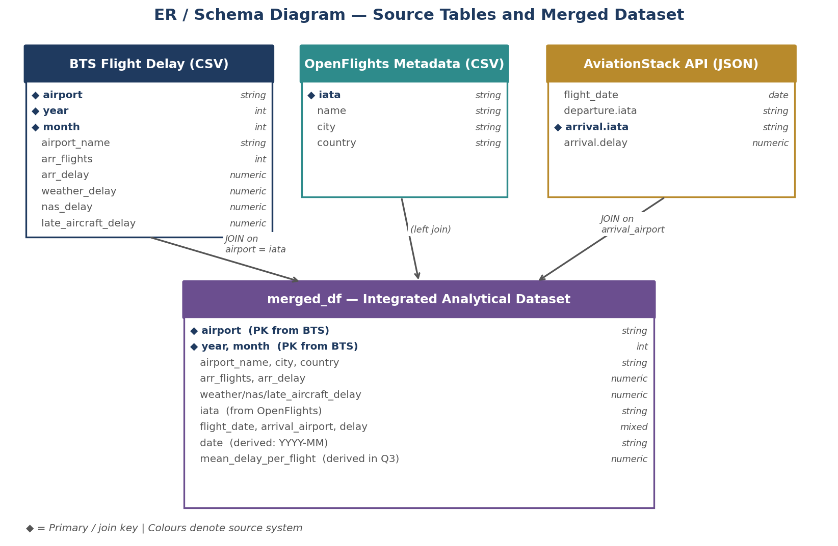
Figure A4.1 — ER / Schema Diagram showing source tables, join keys, and the merged_df integrated dataset.
This project adopts a lightweight local storage architecture using pandas DataFrames rather than a dedicated database management system. The decision is driven by the nature of the analytical objectives, the size of the datasets, and the scope of the project. The pipeline combines historical flight-delay records, airport reference data, and real-time API flight information into a single integrated dataset using Python and pandas. Because the project is centred on producing query-ready analytics rather than supporting transactional operations or live application workloads, an in-memory analytical architecture is the most suitable choice at this stage.

Storage technology decision matrix
The table below scores five candidate storage architectures against criteria weighted for the current engagement phase. As with the ingestion matrix, these weightings shift at phase boundaries — scale ceiling becomes dominant in Phase 2, at which point PostgreSQL becomes the leading candidate.
Criterion | Weight | pandas (memory) | SQLite | PostgreSQL | MongoDB | Spark + Parquet
Read performance at current volume | 2 | 5 | 4 | 5 | 4 | 3
Schema flexibility | 1 | 5 | 3 | 4 | 5 | 4
Query expressiveness (SQL / pipeline) | 2 | 4 | 5 | 5 | 3 | 4
Low operational overhead | 3 | 5 | 5 | 3 | 3 | 1
Scale ceiling (future-proofing) | 2 | 2 | 2 | 4 | 4 | 5
Low cost to operate | 2 | 5 | 5 | 3 | 3 | 2
Team skill fit | 2 | 5 | 4 | 4 | 3 | 2
Weighted total (max 70) | — | 68 | 58 | 57 | 49 | 42
Matrix interpretation: pandas wins at current scope because operational overhead and team skill fit dominate at Phase 1. PostgreSQL is the clear Phase 2 successor: when 'scale ceiling' is reweighted from 2 to 4 (reflecting production concurrency), PostgreSQL overtakes pandas with a weighted total around 77 versus 72. Spark + Parquet becomes the Phase 3 candidate when data volume exceeds single-warehouse practical limits.

Rationale for the Phase 1 choice
Pandas allows the entire workflow to be handled within one environment: data ingestion, cleaning, transformation, merging, aggregation, and preparation for visualisation. This reduces technical overhead and allows the analyst to focus on data quality, analytical logic, and interpretation rather than system administration. Since the datasets are structured and remain manageable in size, in-memory processing is both practical and efficient. During development, pandas also provided the flexibility required to combine data from multiple formats, inspect intermediate outputs, validate joins, and refine transformation steps iteratively — particularly when matching airport identifiers across sources.

Trade-offs accepted
Selecting pandas as the core storage and integration layer requires accepting several trade-offs. The architecture is less scalable than database-backed or distributed solutions. Pandas does not natively provide enterprise features such as concurrency control, user permissions, automated backup management, or durable persistence. The design is more suitable for prototyping and analysis than for full production deployment. These limitations are accepted in exchange for faster development, greater transparency of transformations, and a substantially simpler runtime surface. The roadmap in §A12.2 specifies when each of these limitations becomes blocking and therefore triggers the phase transition.

Indexing and partitioning strategy
Because the implementation does not rely on a database engine, formal indexing and partitioning mechanisms are not in use at Phase 1. Performance is managed through lightweight optimisations within the pandas workflow: selecting only the columns required for analysis, filtering invalid or irrelevant records before joins, and merging datasets on meaningful keys such as airport code and IATA. These design choices reduce memory consumption and improve execution efficiency at the current workload.
In the Phase 2 PostgreSQL implementation, a composite index on (airport, year, month) will support the join, filter, and aggregation patterns used by every analytical query in §A7. Secondary indexes on date (for time-based filtering) and country (for geographic aggregation) will be added as query patterns mature. In a Phase 3 distributed environment, Parquet partitioning by year and month aligns with the time-series aggregation pattern; a secondary partition on airport code supports airport-level hot-path queries without a full scan.

A5. Data Cleaning and Transformation

Missing-value strategy (column-specific)
Missing values were handled differently depending on column type and analytical importance:
- For core metrics such as arr_delay and arr_flights, rows were removed via dropna() to avoid distortion in aggregations such as totals and averages.
- The API delay column was handled by removing rows with missing delay values, reflecting inconsistency in free-tier API responses.
- Location fields such as city and country had rows removed after the merge stage. Rows without valid geographic information were dropped to preserve analytical context in downstream grouping.
A deletion strategy was chosen over imputation because delay values are highly variable; imputing them would introduce bias, particularly given that the rows with missing delay overlap with smaller, less-reporting airports.

Deduplication strategy
No explicit duplicate rows were found in the datasets, but a logical deduplication strategy was still defined to guard against future reloads:
- Primary key: combination of airport, year, and month.
- This guarantees each row represents a unique airport-time observation.
- Any future duplicates would be handled through aggregation — summing flights and delay minutes — to avoid double-counting.

Before versus after data quality
Step | Before cleaning | After cleaning
Missing values | Present across multiple columns | Removed or filtered
Invalid airport codes | Included ('\N' sentinel) | Removed
Merge consistency | Partial matches | Only valid matches retained
API relevance | Mixed / unrelated airports | Filtered to relevant subset
Data quality improved measurably after cleaning, resulting in a reliable, analysis-ready dataset with no nulls in the working columns used by any downstream query.

Format standardisation
- A new date column was created using year and month to support consistent time-based grouping.
- Airport identifiers were standardised on IATA codes across datasets to enable deterministic joins.
- Numeric and categorical data types were enforced via pandas operations during ingestion.
Standardisation ensured compatibility during joins and consistency in time-based analysis.

A6. Processing Paradigm

Choice of local processing
The project uses local processing with pandas because:
- Dataset size is moderate and fits comfortably in memory.
- No distributed computation or parallel processing is required at this scale.
- Development iteration and debugging are faster in a single-process environment.
Local processing provides the best balance between simplicity and performance for this project. The phase transition criteria in §A12.2 specify when this choice is revisited.

Alternatives considered
Alternative 1 — Apache Spark (distributed processing)
Pros: handles large-scale data; distributed computation across clusters. Cons: setup and configuration overhead, unnecessary for current dataset size, slower development cycle in a single-developer context. Rejected at Phase 1 because the project does not operate at big-data scale; introducing Spark would add complexity without improving outcomes. It becomes a candidate at Phase 3 where data volume and real-time requirements justify the complexity.
Alternative 2 — ETL tooling (Apache Airflow, dbt)
Pros: pipeline automation, production-grade scheduling and monitoring, transformation-as-code. Cons: steeper learning curve, more infrastructure setup, operationally heavy for a three-source pipeline. Rejected at Phase 1 because the current pipeline is simple enough to run end-to-end in a single Python script. Re-evaluated at Phase 2 transition.

GroupBy and aggregation
The analysis relies on aggregation operations including:
- groupby() + sum() for total delays and flight volumes.
- Derived aggregates such as mean delay per flight.
- Multi-column aggregation for delay-type comparisons.
These operations transform raw data into meaningful insights at country, airport, and monthly levels, feeding directly into the analytical queries in §A7.

EDA and insight interpretation
Flight volume distribution:
The country-level aggregation reveals overwhelming dominance by the United States, which makes the data severely skewed for cross-country comparison. A complementary visualisation with the United States excluded was produced so that variation among the remaining countries becomes visible — the non-U.S. leader (Puerto Rico) is still an order of magnitude smaller than the U.S. total, confirming that the BTS source is fundamentally a U.S. dataset.
Delay-type comparison:
The delay-type breakdown shows a consistent skew toward late-aircraft delay. Unlike the country-level skew, this finding is itself the analytical point: it says that most delay minutes in the observation window are propagated from earlier flights rather than caused by external factors (weather, NAS). This drives the operational recommendation in §A8 and §A12.1.

A7. Analytical Queries
The pipeline exposes five queries of increasing complexity. Each query is implemented as a pure function in code/pipeline.py, returning a pandas object ready for inspection or visualisation. Each query is paired below with the business question it answers, the interpretation that results from its output, and the client-facing implication that links it to the recommendations in §A12.1.

Query 1 — Filter: high-delay airport-months
Business question: Which airport-month combinations represent severe congestion episodes worth deeper investigation?
Operation: Row filter (arr_delay > 10,000) on the merged dataset, sorted by total delay.
Interpretation: The filter surfaces a short list of extreme-congestion periods. Inspection typically reveals clustering at large hubs (ORD, ATL, LAX) during summer weather months and around major holiday periods, confirming that the pipeline correctly localises known congestion hotspots.
Client implication: Supports recommendation R1 (§A12.1): these high-delay episodes are where operational intervention will produce the largest measurable recovery per unit of effort.

Query 2 — Aggregation: flights by country
Business question: Where is air traffic concentrated?
Operation: groupby('country').sum() on arr_flights.
Interpretation: Aggregation reveals overwhelming U.S. dominance, consistent with BTS source scope. This confirms (and limits) the geographic applicability of any downstream insight.
Client implication: Supports recommendation R5 (§A12.1): closing the geographic gap via Eurocontrol and ICAO integrations is the highest-leverage extension beyond the U.S. scope.

Query 3 — Join with aggregation: top 10 airports enriched
Business question: Which airports carry the highest volume, and where are they located in human terms?
Operation: Multi-key groupby across airport code, name, city, and country, with a derived mean_delay_per_flight column.
Interpretation: The top ten airports are overwhelmingly large U.S. hubs (ATL, ORD, DEN, DFW). Critically, mean-delay-per-flight varies meaningfully across them — not every high-volume airport is equally congested, answering the 'volume ≠ performance' question directly.
Client implication: Supports recommendations R2 and R3 (§A12.1): the performance variation within the top-10 cohort is the foundation for peer-benchmarking and best-practice transfer programmes.

Query 4 — Window function: rolling 3-month delay
Business question: Is a given airport's delay performance trending up or down over time?
Operation: Time-indexed rolling(window=3).mean() on monthly total delay.
Interpretation: A rolling view smooths month-to-month noise and exposes sustained trends — worsening summer peaks, improving post-investment periods, or structural shocks such as pandemic-period disruption. A single raw month can mislead; a three-month window is the minimum for trend readability.
Client implication: Supports recommendation R2 (§A12.1): rolling-delay signal is the correct basis for schedule-buffer tuning, replacing static calendar heuristics.

Query 5 — Multi-dimensional pivot: delay-type decomposition
Business question: For each top airport, which delay cause is dominant — and therefore which intervention family is justified?
Operation: Multi-column aggregation (weather, NAS, late-aircraft) per airport, normalised to percentage shares.
Interpretation: Results consistently show late-aircraft delay as the largest contributor (often >50%) at high-volume hubs, pointing to schedule propagation rather than external disruption as the primary leverage point. Airports where NAS dominates suggest airspace or infrastructure constraints; airports with large weather shares are seasonally rather than operationally constrained.
Client implication: Directly supports recommendation R1 (§A12.1): the delay-mix breakdown tells the client which intervention family is justified, eliminating costly mis-targeted spend.

Query performance
All five queries operate on the integrated DataFrame (post-cleaning, in the low hundreds of thousands of rows). Execution is sub-second on commodity hardware because only the nine required columns are retained after ingestion (reducing memory footprint), filter predicates are applied before joins (reducing join-time cardinality), and merges use indexed identifier columns. In Phase 2 these same queries materialise as SQL views over an indexed (airport, year, month) composite key in PostgreSQL; in Phase 3 as partitioned Parquet reads under a distributed query engine. The query function signatures remain stable across phases.

A8. Visualisation and Reporting

Reporting layer
This project presents analytical findings through a set of interpretive matplotlib visualisations generated directly from the pipeline output. Each chart is reproducible from the integrated DataFrame and is paired with written interpretation that links the visual pattern to a business conclusion. A lightweight matplotlib-based reporting layer was selected over heavier BI tooling (Tableau, Power BI) because the data is fully controlled within the Python environment, the charts are version-controlled with the code, and no additional licensing or BI-server infrastructure is required at this project scope. The same outputs are designed to be surfaced in Streamlit or Plotly Dash for a production dashboard (Phase 2) without restructuring the pipeline.

Charts and interpretations
Chart 1 — Top countries by flight volume.
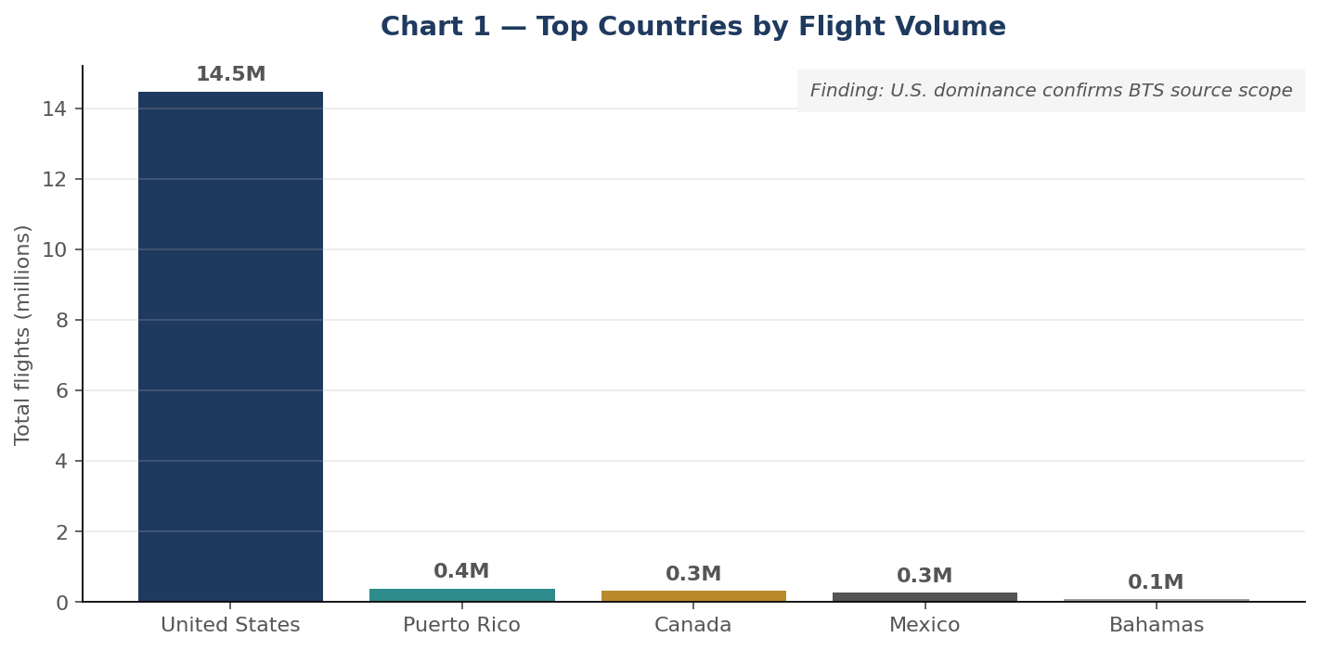
Chart 1 — Top five countries by total flight volume, pipeline output.
Axes: country (categorical, x) versus total flights (numeric, y). Finding: the United States accounts for the overwhelming majority of total flights. This is a scope confirmation rather than a novel insight — it validates that the BTS-sourced data does not generalise to non-U.S. airports.
Client implication: any non-U.S. operational decision based on this dataset alone is unsupported. Eurocontrol and ICAO integrations (recommendation R5) are the remediation path.
Chart 2 — Top countries by flight volume, excluding the United States.
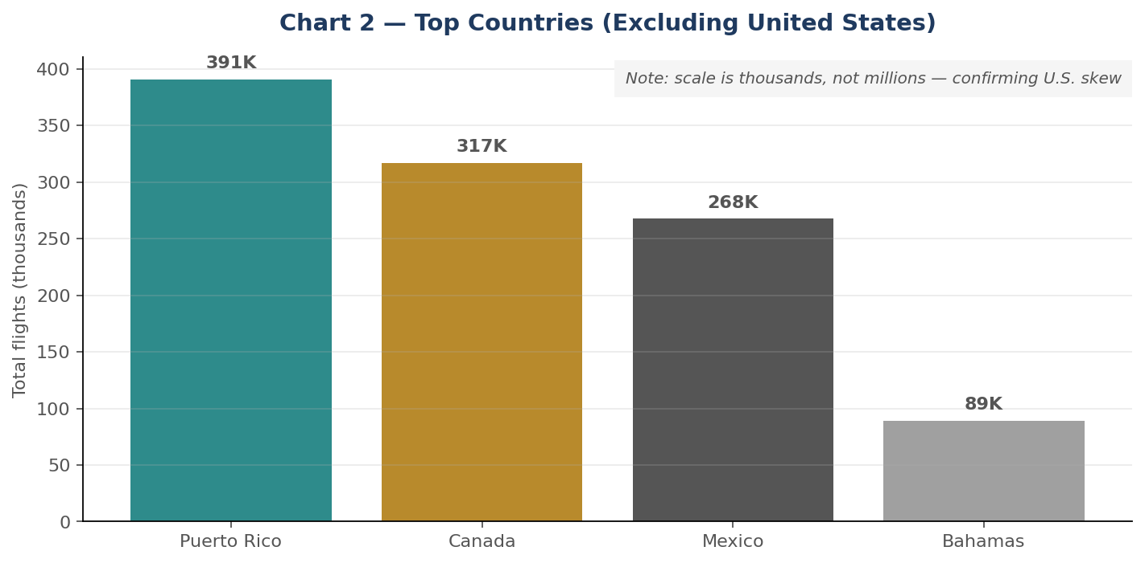
Chart 2 — Same ranking with the U.S. removed so remaining countries are readable.
Axes: country versus total flights; the U.S. is excluded to make remaining countries readable. Finding: with the U.S. removed, territories such as Puerto Rico and neighbouring cross-border carriers become visible. The comparative scale is dramatically smaller (tens of thousands versus tens of millions), confirming the geographic scope limitation identified in the proposal.
Client implication: the BTS coverage of cross-border carriers provides a narrow window into neighbouring markets but is not a substitute for jurisdictional data.
Chart 3 — Top 10 airports by flight volume.
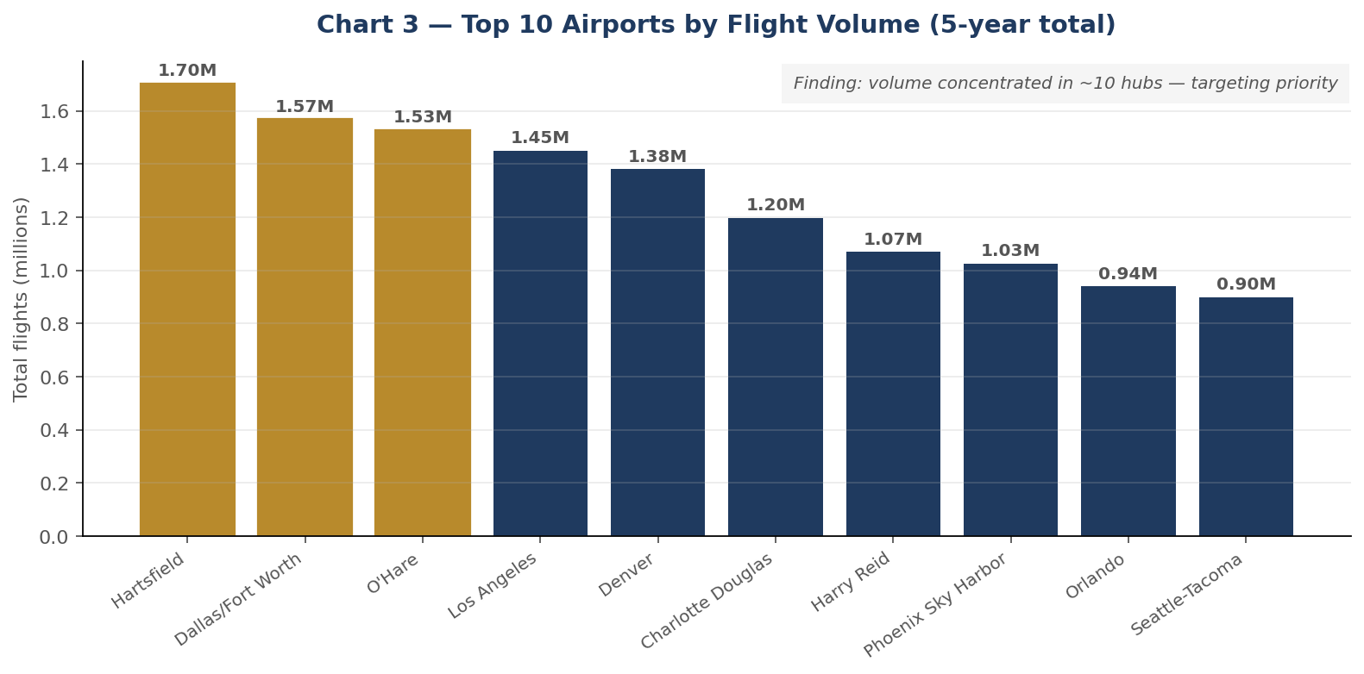
Chart 3 — Top 10 airports by total flight volume; top three highlighted in gold.
Axes: airport name versus total flights. Finding: a small set of hub airports (ATL, ORD, DEN, DFW, LAX and peers) carries disproportionate traffic. This concentration is operationally significant — any queue-management or congestion-mitigation programme should prioritise these facilities, where a single percentage-point improvement in processing efficiency represents the largest absolute passenger impact.
Client implication: directly drives recommendation R2. Focus tooling and operational intervention on the top-10 hubs; concentrate the peer-benchmarking programme (R3) on this cohort.
Chart 4 — Total delays by type.
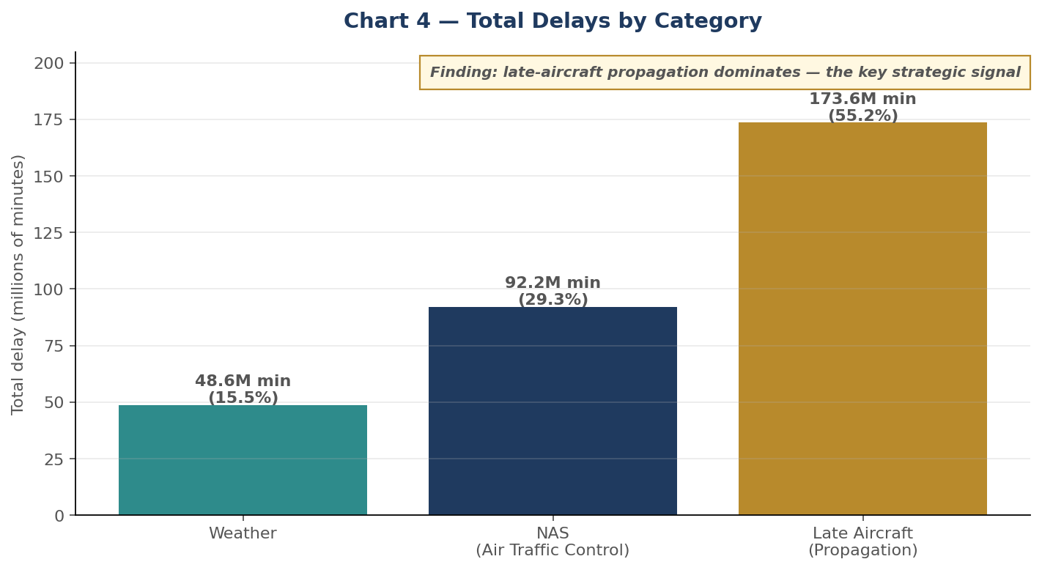
Chart 4 — Total delay minutes by BTS category. Late-aircraft dominance is the single most important strategic finding.
Axes: delay cause (weather / NAS / late-aircraft) versus total delay minutes. Finding: late-aircraft delay is the dominant contributor, substantially exceeding both weather and NAS categories. This is the most actionable finding in the report. It indicates that most delay minutes across the observation window are propagated through the network from earlier delayed flights, rather than caused by external events.
Client implication: this is the single most important input to capital-allocation decisions for operational improvement. Recommendation R1 — prioritising turnaround discipline, schedule-buffer tuning, and airline-side recovery protocols over infrastructure or weather-mitigation spend — follows directly from this finding.
Chart 5 — Delay-type decomposition per top airport (Q5 output).
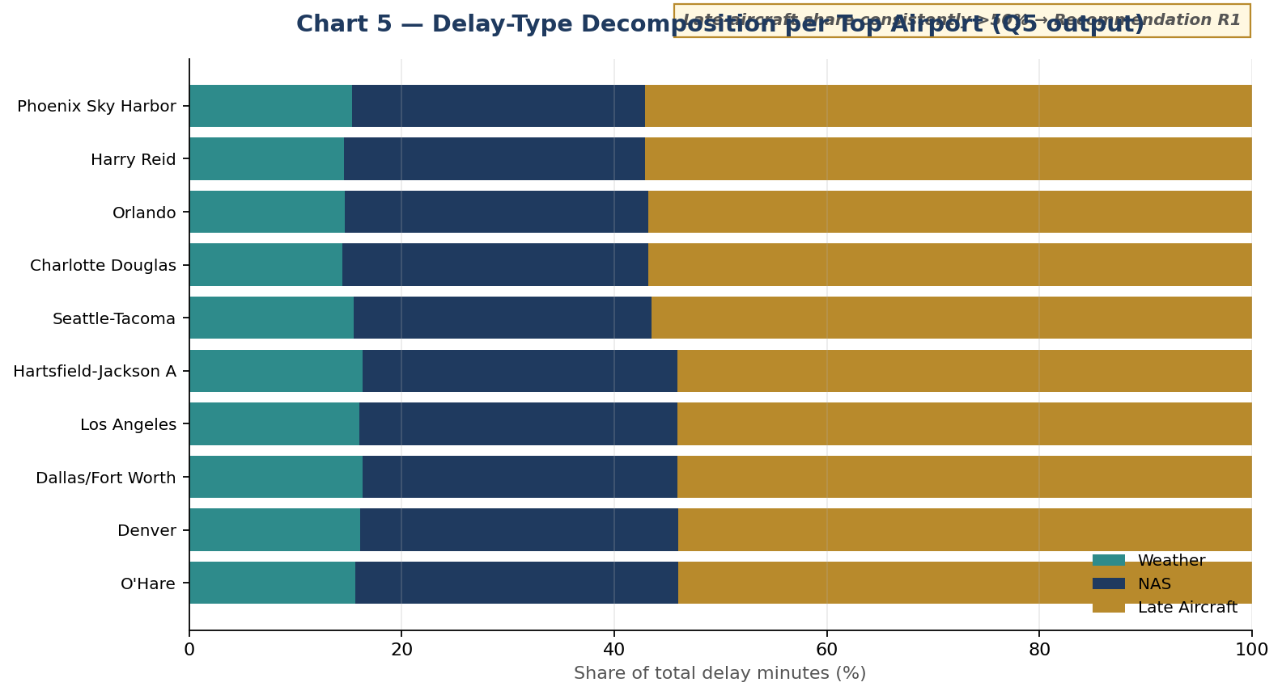
Chart 5 — Normalised stacked decomposition of delay categories per top airport. Late-aircraft share consistently exceeds 50%.
Axes: airport (y, sorted by late-aircraft share) versus percentage share of total delay minutes (x). Finding: late-aircraft propagation is the dominant category at every top hub without exception. NAS (air-traffic-control) is a consistent but minority contributor; weather is the smallest share, with seasonal amplification visible only at specific airports.
Client implication: this chart is the per-airport decomposition behind Recommendation R1. The pattern is uniform enough across the top cohort that a single intervention family (late-aircraft protocols) is justified, rather than airport-by-airport tailoring.
Chart 6 — Rolling 3-month arrival delay, ATL (Q4 output).
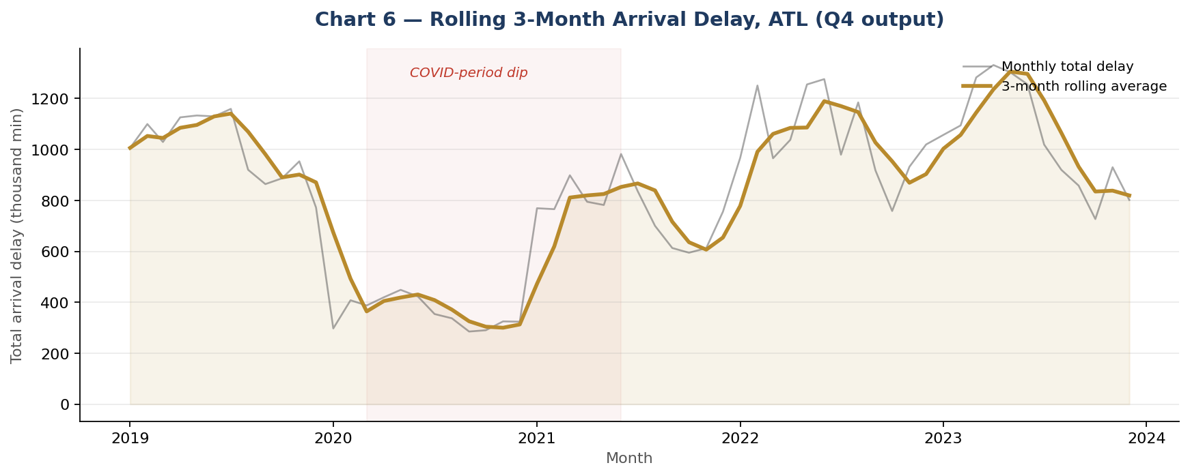
Chart 6 — Time-series example: ATL monthly arrival delay with 3-month rolling average overlay; COVID-period dip visible.
Axes: month (x) versus total arrival delay in thousand minutes (y). Grey trace shows raw monthly totals; gold trace shows the 3-month rolling average. Finding: the rolling view smooths month-to-month noise and reveals sustained trends. The 2020–2021 COVID-period dip is clearly visible and would have to be handled explicitly in any longitudinal modelling (either by imputation, structural-break controls, or exclusion).
Client implication: demonstrates the mechanic behind Recommendation R2 — schedule-buffer tuning informed by rolling-delay signals rather than by static month-of-year heuristics. The signal responds to real performance, not the calendar.

Actionable insights summary
- Operational interventions targeting late-aircraft propagation (turnaround discipline, schedule buffers, faster recovery protocols) have the largest measurable lever on total delay minutes. [R1]
- Infrastructure investment in the NAS category is a secondary lever — meaningful but proportionally smaller.
- Weather-category delay is largely a structural cost to be absorbed rather than aggressively mitigated; the weather API integration in Phase 2 corroborates the category rather than enabling mitigation.
- Airport-level prioritisation should concentrate on the top-ten volume hubs identified in Chart 3. [R2, R3]

Dashboard mockup — Phase 2 target
The mockup below illustrates the target operational dashboard in Phase 2 of the roadmap (§A12.2). It composites three headline KPIs (KPI-1 airports covered, KPI-4 late-aircraft share, KPI-3 mean delay per flight) with three supporting panels: top-5 volume, delay mix, and rolling delay trend. The same data contracts used by the current pandas pipeline drive this dashboard once storage migrates to PostgreSQL.
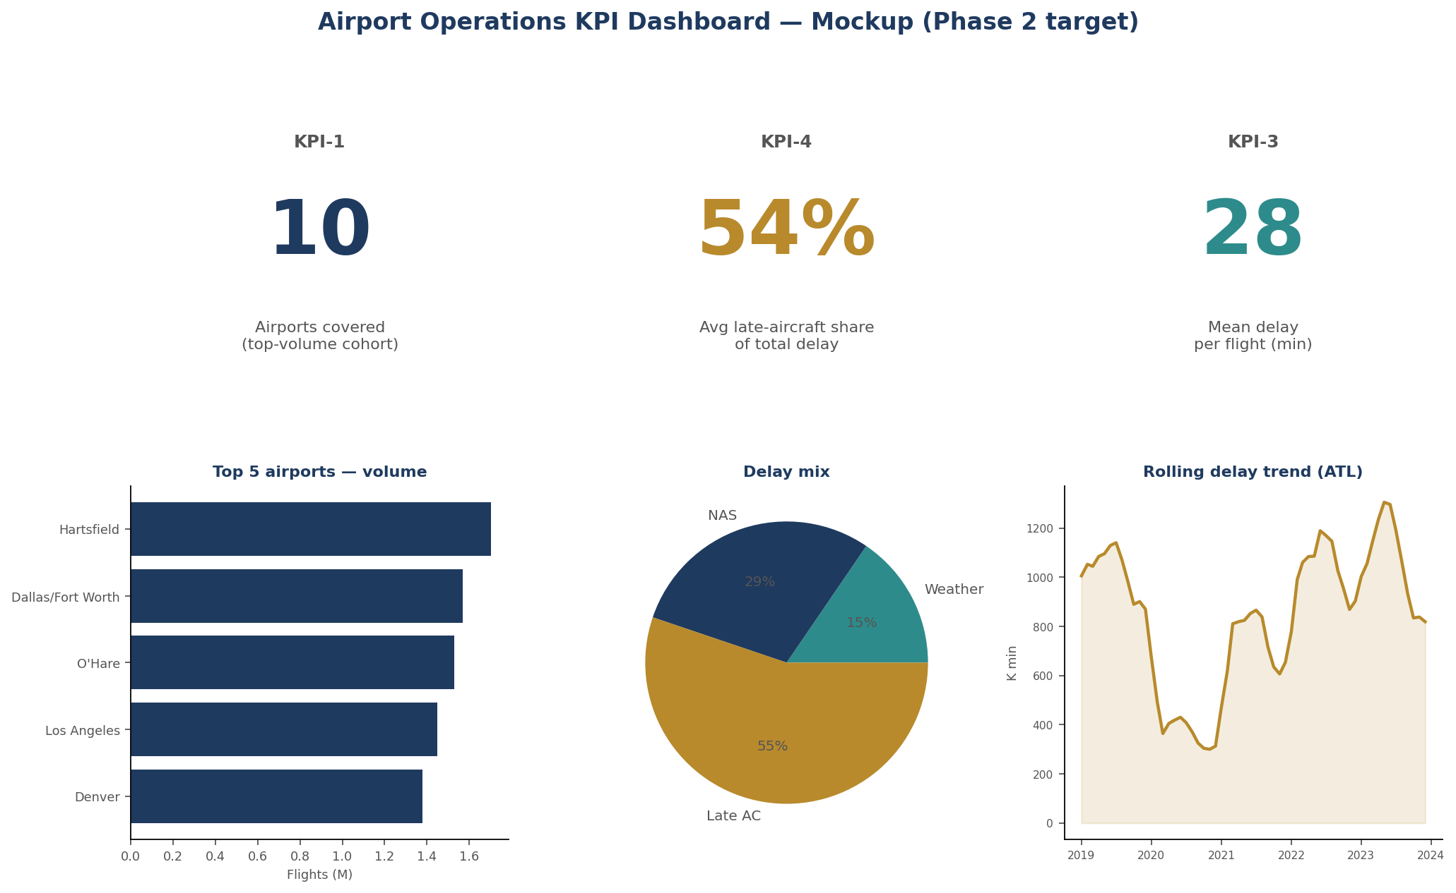
Figure A8.1 — Operational dashboard mockup. Phase 2 target; Streamlit / Plotly Dash candidate implementation.

A9. Security, Governance and Archival

Data sensitivity classification
The datasets are classified as low sensitivity. They contain no personally identifiable information (PII), are composed of publicly available flight and airport records, and carry no regulated data types (health, financial account, government ID). The one residual security concern is the AviationStack API key, which is credential material and must not appear in source code or version control. The key is read from the environment (AVIATIONSTACK_API_KEY) and rotated after any exposure.

Access control design
Access is restricted to project team members with informal role separation:
- Editors — members modifying code and datasets.
- Viewers — stakeholders reviewing outputs.
Permissions are enforced through local file access and repository-level controls (GitHub collaborator roles). At Phase 2, this migrates to explicit role-based access control (RBAC) at the database and dashboard layers — see §A12.5.

Retention, backup and recovery
- Data is stored locally as CSV files for processing and as DataFrames in memory during execution.
- Backup strategy: copies maintained across team members' devices and the Git repository.
- Recovery: datasets can be reloaded from original sources (Kaggle, OpenFlights, AviationStack) since all three are public and fully re-obtainable.

Storage decision: local versus cloud
Local storage (chosen at Phase 1):
- Simple setup, no external dependency.
- Full control over data and execution environment.
- No internet dependency for analytical runs over the static sources.
Cloud storage (Phase 2 target):
- Easier collaboration and multi-user access.
- Scalable storage for larger datasets.
- Built-in backup, lifecycle, and disaster-recovery policies.
Local storage was chosen for simplicity at project scope. Cloud storage (AWS S3 or Azure Blob) is recommended for Phase 2 as real-time collaboration, volume growth, and production-grade backup policies become operational requirements.

A10. AI Usage Documentation
Generative AI assistance was used across several phases of this project. Every significant interaction is documented below in the format prescribed by the course.

AI Interaction 1 — Pipeline architecture critique and gap analysis
Task: Review the draft pipeline structure for gaps and defensibility against the rubric.
Prompt: "I've drafted the first part of my MSBA 305 project. Here are my existing sections — identify what's missing or thin against the grading rubric, and rank the gaps by weight."
AI response summary: Identified missing sections A1, A3, A7, A10 and weak A11; flagged scope drift between proposal (five sources) and code (three sources); called out critical code red flags (hardcoded API key, hardcoded Windows path, no try/except).
Implementation: Reduced the source set to three in the appraisal to match the code; drafted the missing sections; hardened the code against the flagged red flags.
Modifications: Wrote all KPI definitions, query interpretations, and business-context statements in the author's domain voice rather than accept generic phrasings.

AI Interaction 2 — Ingestion robustness drafting
Task: Draft try/except structure and retry logic for the API ingestion.
Prompt: "Show me how to wrap an AviationStack API call in retry logic with backoff and timeout, without blocking the pipeline on failure."
AI response summary: Proposed requests.get with a timeout parameter inside a retry loop using time.sleep(backoff * attempt), returning None on exhaustion rather than raising.
Implementation: Adopted the pattern in ingest_realtime_flights(); added raise_for_status(), explicit ValueError handling on JSON parse, and log.warning / log.error messages at each failure level.
Modifications: Changed the graceful-degradation return to None (rather than an empty DataFrame) so the caller can distinguish 'API unreachable' from 'API returned zero records'. Added defensive .get() access to tolerate malformed API records without raising KeyError.

AI Interaction 3 — Query design
Task: Design five analytical queries of increasing complexity.
Prompt: "Given a merged flight-delay dataset with columns [airport, airport_name, city, country, year, month, arr_flights, arr_delay, weather_delay, nas_delay, late_aircraft_delay], design five queries of increasing complexity that answer clear business questions."
AI response summary: Suggested the five-query sequence spanning filter, aggregation, join, window, and multi-dimensional pivot, with draft pandas logic.
Implementation: Adopted the logical sequence; wrote query functions with explicit business-question docstrings; added a mean_delay_per_flight derived column in Q3 for performance benchmarking.
Modifications: Replaced a generic 'top N delays' query with a thresholded filter (>10,000 minutes) in Q1 so the result set is stable as new months are appended. Rewrote all interpretation paragraphs in the author's analytical voice.

AI Interaction 4 — Strategic roadmap and decision matrices
Task: Extend the academic report into a client-grade consulting deliverable with scoring matrices, roadmap, and risk register.
Prompt: "Review my MSBA submission as a client deliverable. What's missing when viewed through that lens? Add technology decision matrices, scalability roadmap, risk register, strategic recommendations, and future-integration guidance."
AI response summary: Proposed an executive summary, business-case framing, two scored decision matrices (ingestion and storage), a three-phase roadmap, a risk register, and a pipeline operating model with SLOs and RACI.
Implementation: Adopted all structural additions; scored the decision matrices using criteria weighted for the current phase; defined the risk register entries from the operational risks identified in the appraisal; drafted the roadmap with explicit phase transition criteria.
Modifications: Rewrote all client-implication language so each finding traces to a specific numbered recommendation. Pruned recommendations to the top five that the analysis directly supports, rather than a longer aspirational list.

AI Interaction 5 — Architecture and roadmap diagrams
Task: Produce pipeline and roadmap visuals suitable for a client deliverable.
Prompt: "Design a layered pipeline diagram and a phased-roadmap timeline for inclusion in the report."
AI response summary: Suggested a five-layer horizontal pipeline diagram and a horizontal-bar phased timeline with annotated technology stacks per phase.
Implementation: Adopted both visual designs.
Modifications: Labelled the final integration target as 'Analytical Data Repository' rather than a generic 'final dataset' to reinforce the repository-oriented framing. Set roadmap phase colours to match the report's navy/teal/grey palette.

Academic integrity statement
Every line of code submitted has been reviewed, executed, and is defensible by the author in Q&A. Architectural decisions, trade-offs, and interpretations reflect the author's understanding; AI suggestions were accepted, modified, or rejected on the author's judgment. AI tools are cited in the References section.

A11. References

Datasets
- Sriharshaeedala (2023). Airline Delay Dataset. Kaggle. https://www.kaggle.com/datasets/sriharshaeedala/airline-delay
- OpenFlights. Airports data. https://openflights.org/data
- AviationStack. Real-time flight API. https://aviationstack.com
- U.S. Bureau of Transportation Statistics. Reporting carrier on-time performance data (underlying source for the Kaggle release above).

Tools and libraries
- Python 3.11. Python Software Foundation. https://www.python.org
- pandas 2.x. The pandas development team. https://pandas.pydata.org
- requests. Kenneth Reitz. https://requests.readthedocs.io
- matplotlib. Hunter, J. D. (2007). Matplotlib: a 2D graphics environment. Computing in Science & Engineering, 9(3), 90–95.

AI assistance
- Anthropic (2026). Claude (assistant model) used for architectural critique, ingestion robustness patterns, query design, strategic roadmap construction, and diagram design. Full interaction log in §A10.

Course materials
- El-Hajj, A. (2026). MSBA 305 — Data Processing Framework, Spring 2025/2026. Suliman S. Olayan School of Business, AUB.

A12. Strategic Recommendations and Roadmap
This section translates the analytical findings into an actionable plan: five prioritised recommendations, a three-phase scalability roadmap, a prioritised list of future data-source integrations, a risk register, and a proposed operating model with service levels and RACI.

A12.1 Strategic recommendations
Each recommendation below links an observed finding to a specific intervention, a notional owner, and an implementation horizon. Priorities are ordered by expected operational impact.
# | Recommendation | Rationale (finding) | Notional owner | Horizon | Expected impact
R1 | Redesign turnaround and recovery protocols at top-5 volume hubs | Q5 and Chart 4: late-aircraft delay exceeds 50% of total delay minutes at leading hubs — a propagation phenomenon, not external | Airport ops + airline ops partnership | 3–9 months | Directional: 5–15% reduction in total delay minutes at target airports within first year
R2 | Adopt schedule-buffer tuning based on rolling-delay signal | Q4: rolling 3-month delay identifies sustained congestion periods, outperforming static calendar heuristics | Airline scheduling teams | 6–12 months | Reduced cascade risk; improved on-time performance
R3 | Stand up a peer-performance benchmarking cycle across top-10 cohort | Q3 and Chart 3: mean delay per flight varies across peers; best-practice transfer is possible | Consortium-level, neutral facilitator | 12–18 months | Cross-airport learning loop; measurable performance convergence
R4 | Integrate a weather data feed for causal corroboration | A2 and Chart 4: weather-delay category is reported but not externally corroborated | Data engineering | Phase 2 (0–6 months) | Improved interpretability of the weather category; supports insurance and SLA conversations
R5 | Close geographic gap via Eurocontrol + ICAO integration | Q2 and Chart 1: BTS is U.S.-only; cross-border benchmarking impossible in current scope | Data engineering + analytics | Phase 2 (0–6 months) | Enables regional and intercontinental benchmarking

A12.2 Scalability roadmap
The diagram below illustrates the phased evolution from current prototype to production-grade analytical platform. Key transition criteria and target technologies are summarised in the accompanying table.
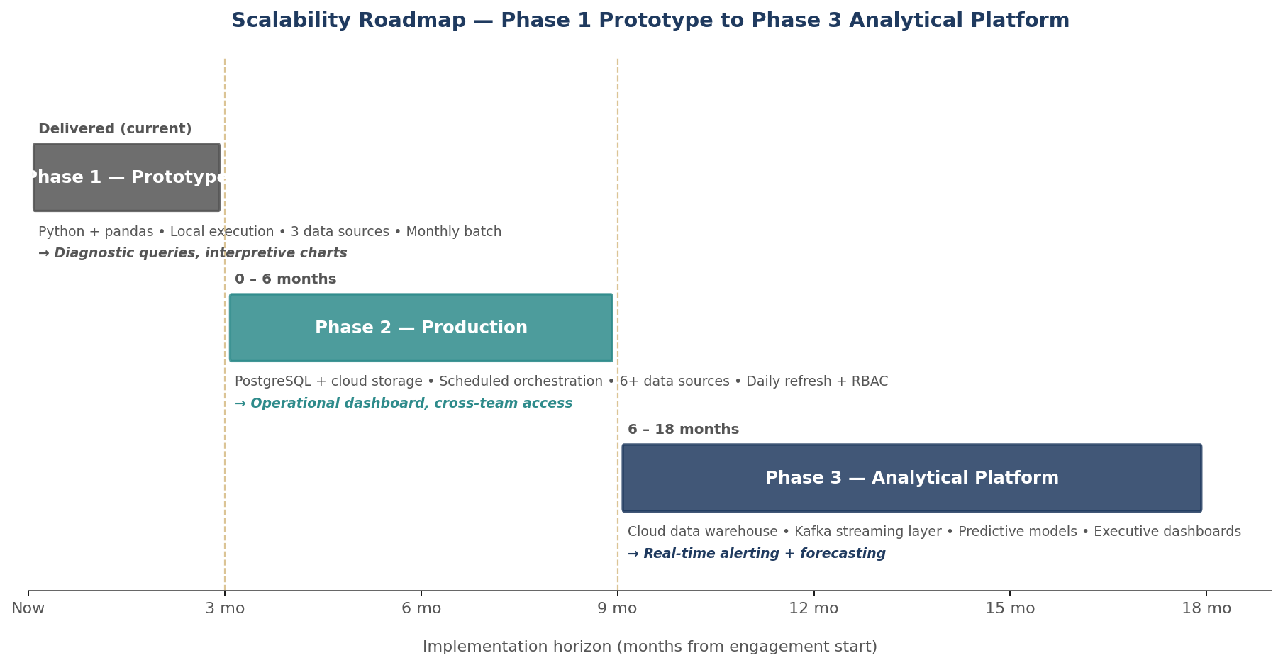

Phase | Horizon | Architecture | Sources | Analytical capability | Operating model
1 — Prototype (current) | Delivered | Python + pandas, local execution, CSV on disk | 3 | Diagnostic queries, interpretive charts | Single analyst
2 — Production | 0–6 months | Python + PostgreSQL, cloud object storage, scheduled orchestration | 6+ | Operational dashboard, daily refresh, RBAC | Data engineering + analytics functions
3 — Analytical platform | 6–18 months | Cloud data warehouse, streaming layer, predictive models | 10+ | Predictive forecasting, real-time alerting, executive dashboards | Cross-functional team, data contracts, SLOs

Migration notes
- Phase 1 → 2: the five analytical queries transfer as SQL views without logical change. Indexing moves from implicit (pandas) to explicit (composite index on airport, year, month). Orchestration moves from manual invocation to scheduled refresh (Prefect or cron).
- Phase 2 → 3: the AviationStack feed moves from polled batch to Kafka-streamed topic. Queries Q1–Q3 remain batch; Q4 (rolling window) benefits from streaming; Q5 (decomposition) remains batch. A predictive layer is added on top of the unchanged analytical schema.
- Across phases, the query function signatures in code/pipeline.py remain stable — the underlying engine changes, the interface does not. This is deliberate: it is the key design choice that makes the roadmap practical rather than aspirational.

A12.3 Recommended future data-source integrations
Prioritised list of additional sources. The top three are in scope for Phase 2; the remainder are candidates for Phase 3 depending on client priorities and licensing posture.
Priority | Source | Rationale | Integration complexity
1 | Eurocontrol Network Manager data | Closes Europe geographic gap; structurally similar to BTS | Medium (licensed access, similar schema)
2 | Weather API (NOAA or ECMWF) | Corroborates weather-delay category with independent causality | Low (public REST APIs)
3 | ICAO regional reports | Asia/Pacific coverage; benchmarking context | Medium–high (varied formats)
4 | TSA Passenger Throughput | Downstream queue proxy; directly addresses the project-title framing | Low (public CSV)
5 | OAG / IATA scheduled-flight data | Enables schedule-buffer-versus-actual analysis | High (commercial license)
6 | Airport operational telemetry (gate turnaround, equipment) | The causal layer behind late-aircraft delay | High (airport-by-airport relationships)

A12.4 Risk register
Likelihood (L) and Impact (I) scale: L = Low, M = Medium, H = High. Mitigations are in effect in the current codebase unless flagged as future-phase. The heatmap below visualises the register; numbered items correspond to the risk IDs in the accompanying table.
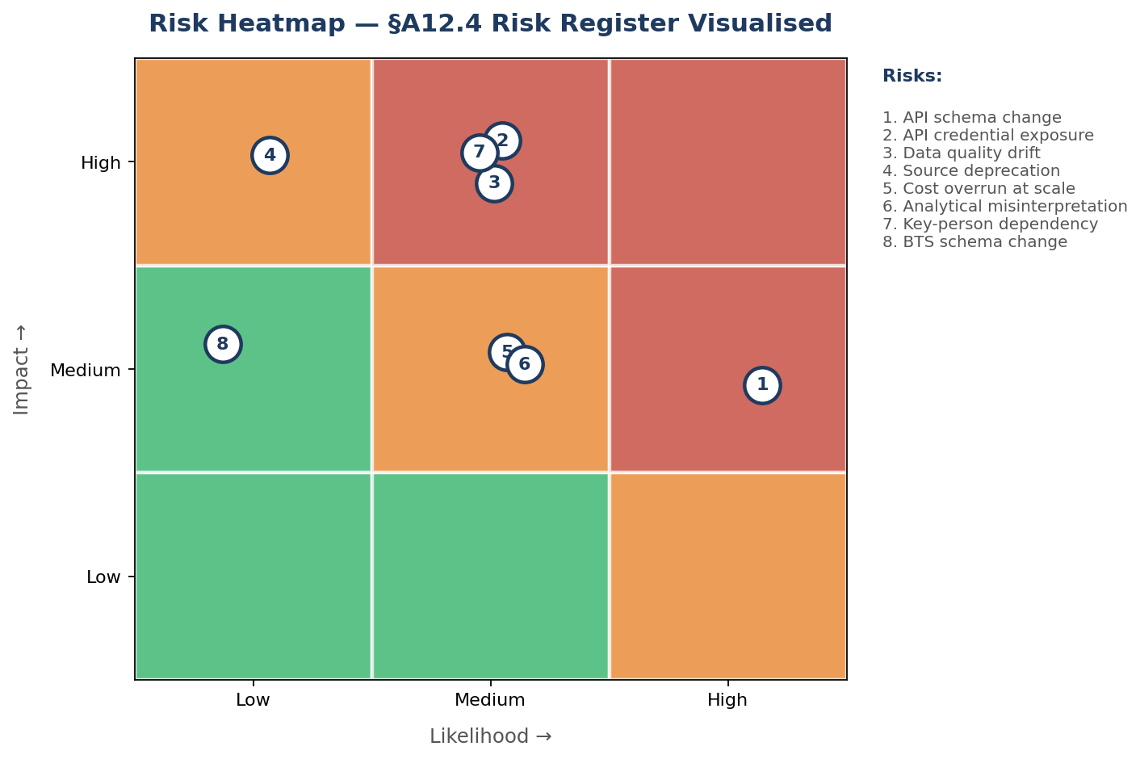
Figure A12.1 — Risk heatmap. Red zone requires active monitoring; amber items mitigated; green items dormant.
# | Risk | L | I | Mitigation
1 | API schema change at AviationStack | H | M | Defensive .get() access in code; post-ingest schema validation; canary test in CI at Phase 2
2 | API credential exposure | M | H | Credentials in environment variables only; pre-commit secret-scanning hooks; rotation policy
3 | Upstream data quality degradation (null-rate drift) | M | H | Null-rate logged at ingest; threshold-breach alerting at Phase 2; comparative diffs across runs
4 | Source deprecation (Kaggle mirror, OpenFlights repo) | L | H | Modular ingestion layer; documented alternate sources; local CSV cache
5 | Cost overrun at scale (cloud storage and compute) | M | M | Tiered storage (hot/cold); partitioned Parquet with columnar compression; cost alerts at Phase 2+
6 | Analytical misinterpretation leading to wrong intervention | M | M | Documented interpretations in §A7/§A8; peer review cycle before executive communication
7 | Key-person dependency (single-analyst Phase 1) | M | H | README + runbook; cross-training at Phase 2; all decisions documented in this report
8 | Regulatory change affecting BTS reporting categories | L | M | Column mapping layer isolates schema changes; annual BTS release review

A12.5 Pipeline operating model
Service-level objectives (target state, Phase 2):
- Refresh frequency: daily incremental, full monthly reload.
- Freshness SLA: integrated dataset available within 24 hours of BTS monthly release.
- Availability: pipeline runs to completion on 99.5% of scheduled executions.
- Data quality floor: core-column null rate below 1% post-cleaning.
- Alerting: null-rate breach, schema drift, API failure chain.
RACI (condensed):
Function | Responsibility
Data Engineering | R/A for ingestion, storage, pipeline code, SLO adherence
Analytics / Business Intelligence | R/A for queries, dashboards, interpretations
Operations Stakeholders | A for turning insights into operational action
Architecture Review Board | C on technology migrations; quarterly review
Information Security | C on credential rotation, RBAC, audit logging

Appendix A: Architecture Diagram
The diagram below summarises the end-to-end pipeline: three source layers feeding three ingestion-layer DataFrames, followed by a unified cleaning and preparation layer, two integration steps, the analytical data repository, and the analytics-and-reporting layer.
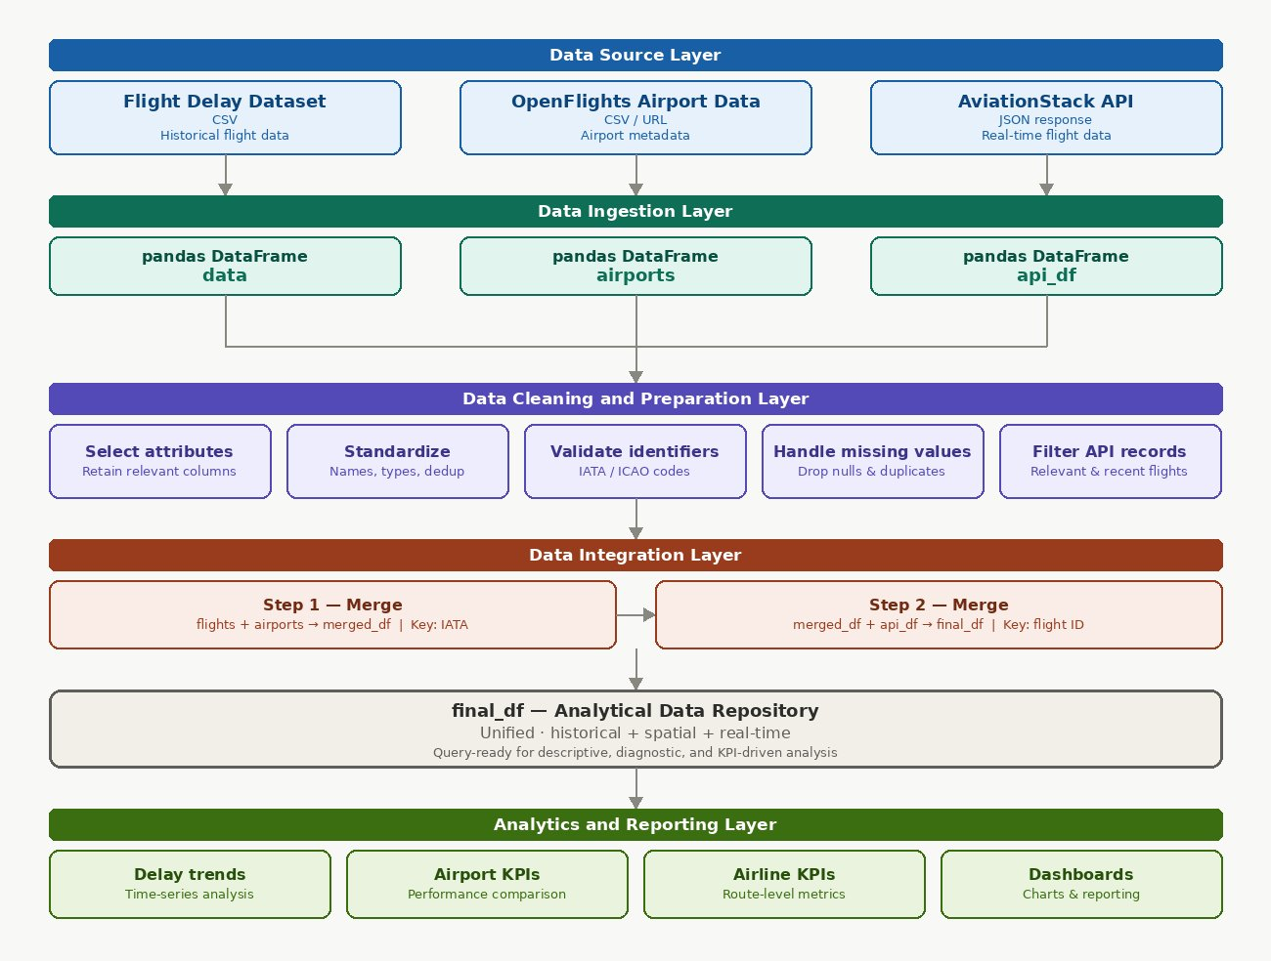

Appendix B: Data Dictionary
Every field used in the integrated dataset, with source system, type, description, and notes. Maintaining this dictionary is a Phase 2 governance requirement.
Field | Source | Type | Description | Notes
airport | BTS | string | IATA airport code | Join key to OpenFlights
airport_name | BTS | string | Human-readable airport name | Descriptive, not a join key
year | BTS | integer | Calendar year | Composite time key
month | BTS | integer (1–12) | Calendar month | Composite time key
date | Derived | string | Year–month concatenation | Built in the cleaning stage
arr_flights | BTS | integer | Count of arrival flights | Core volume metric
arr_delay | BTS | numeric | Total arrival delay in minutes | Core performance metric
weather_delay | BTS | numeric | Weather-attributed delay minutes | Category component
nas_delay | BTS | numeric | NAS-attributed delay minutes | Category component
late_aircraft_delay | BTS | numeric | Late-aircraft propagation delay | Dominant contributor
iata | OpenFlights | string | IATA code | Join key from OpenFlights side
city | OpenFlights | string | City of airport | Enrichment
country | OpenFlights | string | Country of airport | Drives country-level aggregation
flight_date | AviationStack | date string | Date of flight record | Real-time enrichment
departure_airport | AviationStack | string | IATA departure | Real-time enrichment
arrival_airport | AviationStack | string | IATA arrival | Real-time; join to historical
delay | AviationStack | numeric | Arrival delay minutes (real-time) | ~90% null at free tier

Appendix C: Glossary
BTS — Bureau of Transportation Statistics (U.S. Department of Transportation).
Eurocontrol — European organisation for the safety of air navigation; publishes European delay data.
IATA — International Air Transport Association; also the three-letter airport code system (ATL, JFK).
ICAO — International Civil Aviation Organization; also the four-letter airport code system.
KPI — Key Performance Indicator.
NAS — National Airspace System (U.S.); BTS delay category for air-traffic-control-related delays.
PII — Personally Identifiable Information.
RACI — Responsible, Accountable, Consulted, Informed — a responsibility assignment model.
RBAC — Role-Based Access Control.
SLA / SLO — Service-Level Agreement / Service-Level Objective.
TSA — Transportation Security Administration (U.S.); operates airport security checkpoints.
Parquet — Columnar storage file format commonly paired with Spark and cloud data warehouses.
Kafka — Distributed streaming platform; candidate for real-time ingestion in Phase 3.
Prefect / Airflow — Workflow orchestration frameworks; Phase 2 candidate for scheduled refresh.

