File Analysis Report
Total Words: 12
Unique Words: 10
Most Frequent Word: is (2)
Emails: ['example@test.com']
Numbers: ['9876543210']
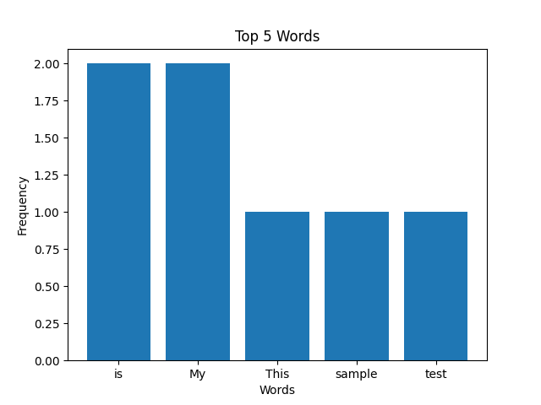
Generated using Python File Analyzer Tool

