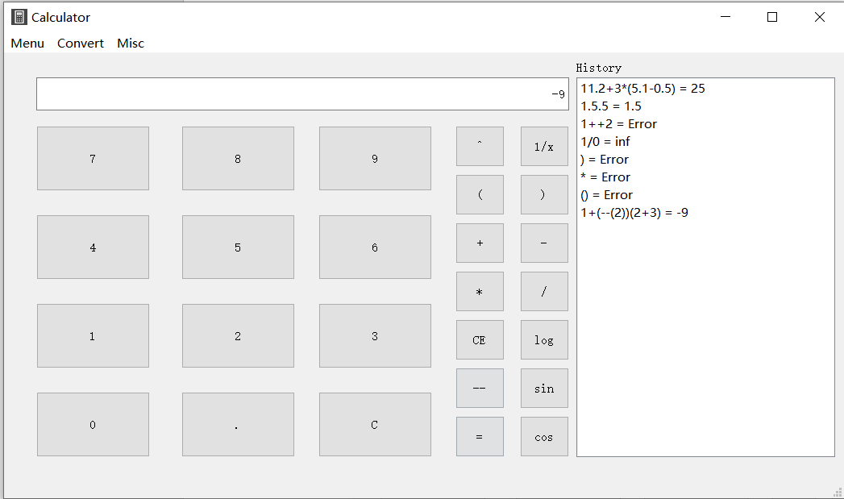

Basic Calculator

Supports:

+,-,\*,/,decimal,numeric,brackets,negatives,log,sin,cos,tan,cot,hex conversion,history log,Ans

Included technology:

Stack

Bracket Matching Algorithm

Hex Conversion Algorithm

Basic error checking

Comprehensive error checking

