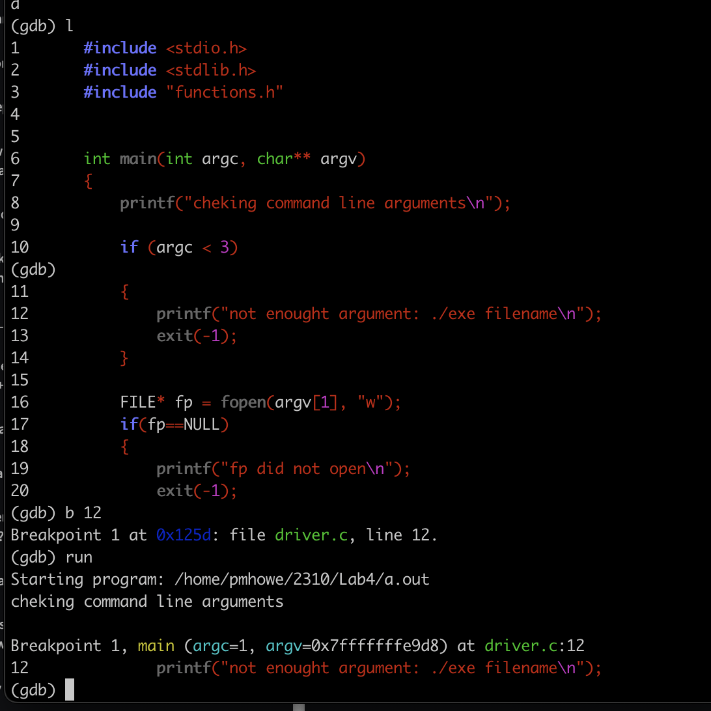

Error making the code go in to the if (argc < 3 ) block. Changed the value to 2



This line got changed to R because w was overwriting everything

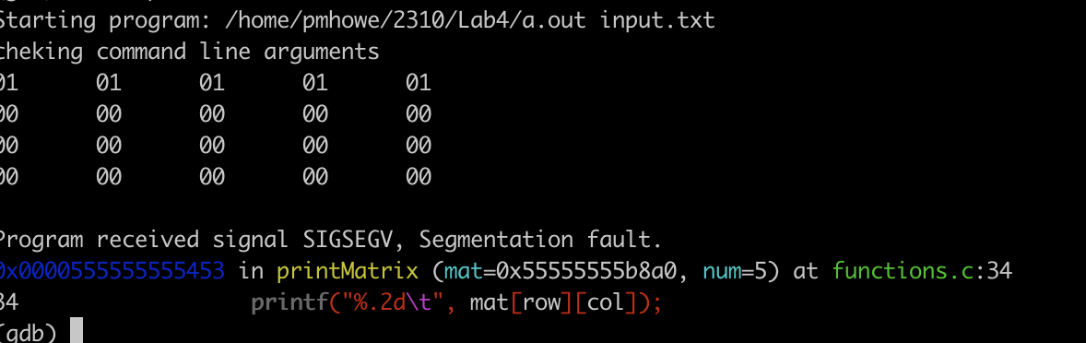

The program seg faults in the functions.c file at the printf on line 34. The last row also does not print this is likely do to memory allocation.

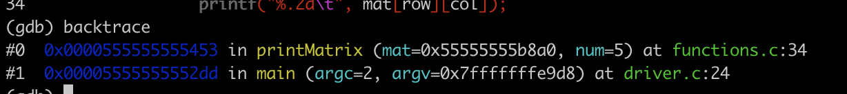

Backtrace shows me what functions were called



Listhing the function I can see an error at the memory allocation. I am going to make the int a int\*. I was only storing enough memory for a int not a int pointer.

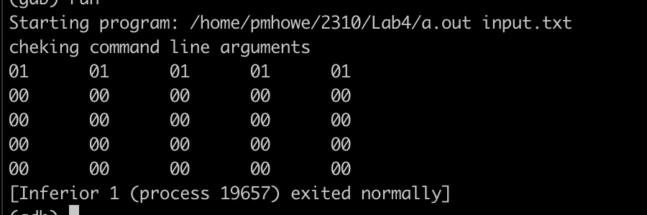  
I now see the issue is fixed. By changing it to use the right size the memory error is gone.