** ROLE-BASED SCHOOL MANAGEMENT SYTEM**

Capstone Project Presented to

CEDAR College, Inc.

National Highway

Cadiz City, Negros Occidental

In Partial Fulfillment of the

Requirements for the Degree of

Bachelor of Science in Information Technology

Michelle A. Campos

Jonna Mae C. Condes

Kathrine Mel P. Labandilo

Mark Anthony R. Salazar

March 2025

**TABLE OF CONTENTS**

**CHAPTER 1**

**Introduction…………………………………………………………………………………….…1**

Project Context…………………………………………………………………………………..…1

Project Description…………………………………………………………………………………1

Objectives……………………………………………………………………………….…………2

Scope and Limitation……………………………………………………………………...….……2

Definition of Terms…………………………………………………………………………...……3

Review of Related Literature……………………………………………………………………....5

Conceptual Framework………………………………………………………………….…………………….10

**CHAPTER II**

**Methodology…………………………………………………………………………………..…14**

Research Design………………………………………………………………………………..…14

Local of the Study………………………………………………………………………………...14

Theoretical Framework…………………………………………………………………………...15

Use Case Diagram………………………………………………………………..……………….18

Requirement Cost…………………………………………………………………………………19

Gantt Chart………………………………………………………………………………………..20

System Prototype…………………………………………………………………………………21

Data Flow Diagram……………………………………………………………………………….23

Data Flow Diagram Level 0………………………………………………………………………24

ER Diagram………………………………………………………………………………………24

System Architecture………………………………………………………………………………25

Project Evaluation and Review Technique……………………………………………………….26

Critical Path Method……………………………………………………………………………...26

Cost-Benefit Analysis…………………………………………………………………………….27

Return of Investment…………….……………………………………………………..…………28

**CHAPTER III**

**Treatment of Data……………………………………………………………………………….29**

**CHAPTER IV**

**Conclusion……………………………………...………………………………………………..37**

Recommendation…………………………………………………………………………………38

References………………………………………………………………………………………...39

**CHAPTER I**

**INTRODUCTION**

**Project Context**

The "Role-Based School Management System" is a web-based platform designed to streamline school operations, including student admissions, teacher management, attendance tracking, and notice distribution. The system ensures secure, role-based access, allowing users to interact with features specific to their role, improving efficiency and organization. By automating administrative tasks and maintaining clear workflows, the system enhances transparency and simplifies school management.

**Project Description**

The system is structured around three main user roles: Teachers, Students, and Admins. Teachers are added by the admin, and after their account is approved, they can access their dashboard to take attendance for any class, view past attendance records, and publish notices, such as assignment deadlines, to students. Students sign up for admission, and once their account is approved by the admin, they can access their dashboard to view their personal details, including attendance records. However, students cannot access other students’ data or post announcements. Admins have full control, managing the approval or rejection of teacher and student applications, updating user details, and posting school-wide notices. Each role has access only to the features necessary for their specific responsibilities.

**Objectives**

The main goal of the "Role-Based School Management System" is to enhance school management through a web-based platform for teachers, students, and administrators. The specific objectives are:

1. To upload activities, view and add students, take attendance, and post task reminders after admin approval.
2. To register, log in, view personal dashboards, and access attendance, activities, and announcements after admin approval.
3. To manage teacher and student applications, update user details, post announcements, and review teacher evaluations from students.

**Scope and Limitations**

The system streamlines school operations with role-based functionalities for teachers, students, and admins. Teachers can take and edit attendance, upload activities, and publish notices after admin approval. Students can register, view and update personal details, and access attendance and announcements once approved by the admin. Admins manage applications, update user information, and post notices for both teachers and students.

However, teachers cannot directly communicate with students via the platform, and students can only update their own information, without modifying attendance records or announcements. Admins handle all approvals and updates. The system is designed for use within a single school, focusing on teacher and student data management, without supporting multi-school configurations.

**Definition of Terms**

1. **Teacher**

A teacher is an individual responsible for educating students, providing lessons, and managing classroom activities.

Operationally, a teacher in this system is an individual who applies through the platform, is approved by the admin, and can manage their dashboard, take attendance, upload activities, and post reminders once authorized.

1. **Student**

A student is a person enrolled in an educational institution who participates in academic activities and assessments.

Operationally, a student is an individual who registers through the system, is approved by the admin, and can access personal dashboards, view attendance, activities, and announcements, with the ability to update their own details.

1. **Admin**

An administrator is a person responsible for managing and overseeing the operations of a system, including approving users and managing content.

Operationally, an admin is an individual who has the authority to approve or reject teacher and student applications, update user information, post announcements, and review teacher evaluations.

1. **Attendance**

Attendance refers to the record of students’ presence or absence in a class or activity. Operationally, attendance in this system is a record that teachers can mark and edit through their dashboard, tracking student presence during classes and activities.

1. **Announcement**

An announcement is an official statement or notification intended to inform individuals about important information or events.

Operationally, an announcement in this system is a message posted by the admin, visible to all authorized users (teachers and students) through their dashboards.

1. **Role-Based Access**

Role-based access control is a security mechanism that restricts system access based on a user's role or responsibilities within an organization.

Operationally, role-based access in this system ensures that teachers, students, and admins have access only to the features relevant to their roles, such as attendance management for teachers and personal dashboard access for students.

1. **Dashboard**

A dashboard is a user interface that provides an overview of relevant information and features.

Operationally, a dashboard in this system is a personalized page that displays information such as attendance records, activities, and announcements based on the user's role and privileges.

1. **Task Reminder**

A task reminder is a notification to prompt a user about upcoming assignments or responsibilities.

Operationally, a task reminder in this system is a message that teachers can post, visible to students to notify them of assignments or deadlines once approved by the admin.

1. **Application Process**

The application process refers to the steps involved in submitting a request to join an institution or system.

Operationally, the application process in this system involves teachers and students submitting their information for approval by the admin, who decides whether to grant access to the platform.

1. **Approval**

Approval is the formal acceptance or consent to proceed with a request or application.

Operationally, approval in this system refers to the admin’s action of reviewing and accepting or rejecting teacher and student applications, granting them access to the platform.

**Review of Related Literature**

According to the study by Arar and Nasra (2020), using a sample of 300 Arab teachers in Israel, a model was developed to analyze how school-based management impacts school effectiveness, both directly and indirectly through motivation. The findings indicate a positive relationship between all dimensions of self-management (decision-making, resource and personnel management, availability of resources, and organizational structure) and school effectiveness. Additionally, motivation fully mediates the relationship between resource management, personnel, organizational structure, and school effectiveness. The study provides theoretical contributions, managerial implications, and suggestions for future research.

According to the study by Warlizasusi (2019), the article discusses how to optimize school-based management (SBM) by incorporating information technology and communication (ICT). It highlights the evolving role of education in the 21st century, emphasizing the need for ICT and media literacy skills, critical thinking, effective communication, and collaborative skills. SBM is introduced as a management model that grants autonomy to schools in determining policies, aiming to improve the quality, efficiency, and equity of education. The study suggests that the integration of ICT into SBM could enhance educational management and address the demands of modern education, thereby transforming traditional systems into more effective ones. The use of ICT is seen as a key solution to improving school management and fostering educational development.

According to the study by Cheng (2022), this new edition of a renowned classic book presents a comprehensive framework based on the latest perspectives and findings, addressing gaps in ongoing research, policy, and practice, and re-engineering a school-based mechanism for managing school development initiatives. The book discusses how school-based management (SBM) and school effectiveness should be aligned with the new paradigm in education and the third wave of global education reforms. It is organized into four parts and 12 chapters, covering school effectiveness, SBM theories and implementation, leadership for change, and future developments. The framework aims to assist policymakers, educators, change agents, researchers, and other stakeholders in addressing the challenges of ongoing education reforms worldwide.

According to the study by Cisneros-Cohernour (2021), the results of three research studies conducted in southeastern Mexico identify critical issues for teacher leadership and professionalism. The findings reveal that over twenty years of educational reforms have not fully addressed the sociocultural and economic contexts of schools, nor the preparation needs of key school stakeholders. The traditional power structure within schools has also affected the success of reforms promoting teacher participation and leadership. The study highlights the need to improve the preparation of school administrators and supervisors, as they significantly influence in-service teacher training and the implementation of new practices and policies. Furthermore, enhancing in-service teacher preparation is crucial to fostering teacher leadership. The study identifies key factors that can support teacher leadership and professionalism, including a sense of ownership among stakeholders, leadership that drives change, strong discipline policies, emphasis on student success across academics, music, and sports, and professional development that focuses on both teaching improvement and student personal development. The lessons underscore the important role of context and the influence of authorities, administrators, and supervisors in facilitating or hindering teacher leadership and professionalism.

According to the study by Sergeev et al. (2021), the ubiquity of the Internet has changed the ways knowledge is transferred and communicated, with a growing focus on social interactions. Educational institutions now have access to various online platforms and tools for organizing online learning. However, it is increasingly important to develop online educational platforms tailored to the specific needs of these institutions. The article analyzes the concept of "online educational platforms" and their features, discussing how educational institutions can organize training processes in the context of networking growth. The study presents the capabilities of an online educational platform, which includes functions for creating online courses, solving administrative tasks, and fostering interaction among participants. The platform is user-friendly for teachers across disciplines, allowing them to quickly adjust and supplement their courses, organize effective training, facilitate student-teacher interaction, implement knowledge control, and share pedagogical experiences.

According to the study by Torrevillas (2019), School-Based Management (SBM) is a system of public education that decentralizes authority and responsibility to schools for making decisions related to school operations within a centrally determined framework of goals, policies, curriculum, standards, and accountabilities. The study aimed to evaluate the implementation of SBM and its correlation with the academic performance of selected public high schools. Using a descriptive research method with a correlation type, the researcher assessed the respondents' impressions of SBM and the results of the National Achievement Test from the 2010-2013 school years. The findings revealed significant differences in the SBM dimensions, particularly in Leadership and Governance, as well as in the relationships between various stakeholders such as principals, department heads, faculty, alumni, parents, and the community, in relation to the SBM dimension of Curriculum and Learning.

According to the study by Grepon, Baran, Gumonan, Martinez, and Lacsa (2021), colleges and universities are established to provide educational services, and like any other organization, schools have processes and procedures for admissions, data processing, and report generation. These processes are supported by a centralized system for storing, processing, and retrieving data. The absence of a computer system and the complexity of managing student records motivated the development of the School Management Information System (SMIS) for a community college in Northern Mindanao. The study discusses the major functionalities and modules of the system, its implementation using the Agile Model, and its impact on the college's operations. The system was evaluated based on the ISO 25010 quality model and showed very good performance, with high scores for functionality, usability, and reliability. The study recommends future enhancements, including smartphone-based attendance monitoring and a kiosk for grades and schedules.

According to the study by Pepugal (2022), the goal of school-based management (SBM) is to empower school personnel to improve, innovate, and foster ongoing professional development in schools. The study aimed to evaluate the levels of perception on SBM implementation at San Luis National High School, San Luis District-I, Division of Agusan del Sur, Philippines. Using a descriptive-correlational survey research design, the study involved teachers from the school, revealing that 64.15% of respondents were female and 35.85% were male. The findings indicated a moderate perception of SBM implementation, with an overall mean rating of 3.37. The dimensions of SBM such as leadership and governance, curriculum and learning, accountability and continuous improvement, and management of resources all scored higher than the minimum standard. The Pearson correlation coefficient of 0.541, with an r² of 0.365, confirmed a positive correlation between SBM implementation and teachers' perceptions. The study concluded that SBM implementation exceeded the minimum standard.

According to Gerola and Meimban (2023), their study on Educational ManagementPractices Among Secondary SchoolAdministrators in the Province of Pangasinan during the 2020–2021 school year focused on the educational management practices of school administrators, including core behavioral and leadership competencies. The study examined the administrators' profiles based on factors such as age, sex, educational attainment, years of experience, number of teachers supervised, training and seminars attended, and OPCRF ratings. The findings revealed that most administrators were aged 31-40, with their management practices being rated as "Very Extensive," with an overall weighted mean of 4.51. The study concluded that the administrators' management practices were influenced by their educational level and the number of training sessions attended. The authors recommended that school administrators pursue higher educational degrees, particularly doctoral degrees, and continue professional development through advanced training. They also suggested further research to explore the performance of administrators from different perspectives.

According to Lubrica et al. (2019), their study on School-Based Management (SBM) in Benguet, Philippines aimed to determine the effect of SBM on the governance of secondary school heads. The study used both quantitative (structured survey) and qualitative (focus group discussions and interviews) methods. The results showed that SBM is a key factor in effectively running the school system, with school heads demonstrating very satisfactory application of SBM knowledge and skills in governance, even with minimal support from superiors. Additionally, the study found that the school heads' ability to apply SBM knowledge and skills positively influenced their governance capabilities. However, the school heads identified developmental needs to further enhance their management skills. The study concluded that SBM implementation is contributing to quality improvement in secondary schools, aligning with institutionalized quality measures in school systems.

**CONCEPTUAL FRAMEWORK**

|  |  |  |
| --- | --- | --- |
| INPUT   * Teacher Data * Student Data * Admin Data * System Requirements * Interaction Requests | PROCESS   * User Registration and Approval * Role-Based Access * Attendance Management * Notice Publication * Data Access   Control | OUTPUT   * Teacher Output * Student Output * Admin Output |

**Input:**

This section encompasses the essential data and information provided by teachers, students, and admins to manage user accounts, approve registrations, access and manage all user data, and post notices to all users within the school management system.

* Teacher Data: Teachers provide personal details (e.g., name, contact), professional background, qualifications, and other relevant information, which are used to create profiles and assign roles.
* Student Data: Students provide their personal information, admission details, and enrolled subjects, which are used to create their profiles and manage their academic records.
* Admin Data: The admin provides login credentials and manages access rights. Admin access is crucial because it allows them to oversee the entire system, including teacher and student data management.
* System Requirements: This includes the system’s functional specifications, such as user roles (Teacher, Student, Admin) and core features like attendance management, notice posting, and data access control, essential for its effective operation.
* Interaction Requests: Teachers and students can make requests, such as logging in, viewing attendance, updating data, or posting notices, which trigger the system’s corresponding processes.

**Process:**

The Process section explains how the data is handled within the system. This includes the operations performed based on the inputs provided and the system's functionalities.

* User Registration & Approval: Teachers and students must submit registration forms for access, which the admin will review to approve or reject; approved accounts are then activated, granting users access to the system’s features.
* Role-Based Access: Teachers are responsible for marking and updating student attendance in their classes, and the system stores this data for future reference and tracking.
* Attendance Management: Teachers are responsible for marking and updating attendance in their classes, with the system storing the data for future reference.
* Notice Publication: Teachers and the admin can publish notices (e.g., assignment deadlines, announcements) to students. Teachers can send subject-specific notices, while the admin can post general school-wide notices.
* Data Access Control: The system ensures that students can only view their own records, teachers can manage data for their classes, and admins have full access to all user data.

This process ensures that teacher and student profiles are created based on their provided personal information, admission details, and relevant academic data, allowing the system to assign roles, manage user access, and effectively organize and track essential records for both teachers and students.

**Output:**

The Output section details the results or actions each user (Teacher, Student, Admin) will experience based on the system’s processing of the inputs.

* Teacher Output: Teachers can mark and track attendance, publish notices for students, and view relevant data, including attendance and academic information.
* Student Output: Students can view their attendance records, personal details, task activities, and receive reminders from teachers about assignments and deadlines, while admins can view and manage student attendance records and post notices.
* Admin Output: Admins have full access to manage and approve teacher and student accounts, review all user data, and post notices to the entire school, ensuring smooth system operation and data flow.

The Output section details the results or actions each user (Teacher, Student, Admin) will experience based on the system’s processing of the inputs.

**CHAPTER II**

**METODOLOGY**

**Research Design**

The research design for the Holy Infant Academy Role-Based School Management System employs a qualitative approach to explore the experiences of teachers, students, and administrators using the system. Data will be gathered through semi-structured interviews, focus groups, and observations to understand how users interact with features like attendance management, notice publication, and role-based access control. The study will identify challenges faced by users and assess the system's effectiveness in supporting daily school operations, with the goal of understanding how it can be improved to better serve the needs of teachers, students, and administrators.

**Locale of the Study**

The system will be conducted at Holy Infant Academy in Cadiz City, Negros Occidental, to improve the management of school activities. It will provide a role-based platform for teachers, students, and administrators, helping to automate attendance, manage applications, enhance efficiency and organization within the school.

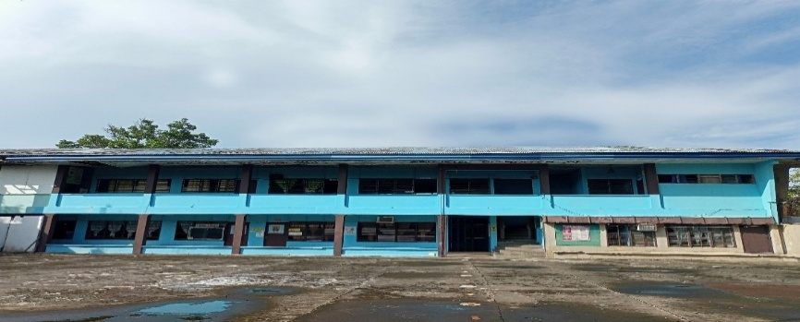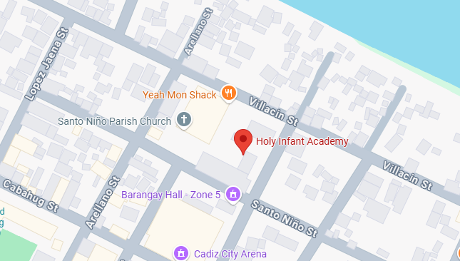

**Theoretical Framework**

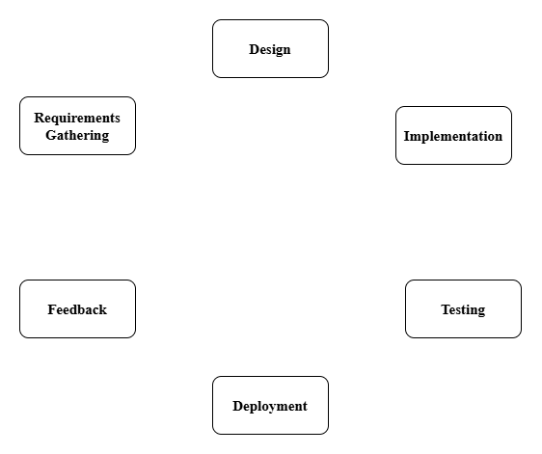

The Iterative model was chosen for the development of the “Role-Based School Management System" due to its flexibility, adaptability, and the need for continuous improvement throughout the project lifecycle. This model allows for gradual refinement of the system with each iteration, ensuring that the product evolves based on regular feedback and testing.

1. Requirements Gathering The team meets with stakeholders to understand the needs of the school. They list all the features the system should include, such as role-based access for admins, teachers, and students, tracking attendance, and generating reports. They gather details about how users interact with the system and determine the tools required for development.

2. Design The team creates a blueprint for the system, designing user interfaces (UI) for each role, including the admin dashboard, teacher tools, and student portal. They plan the flow of data between system components and define the structure of the database to ensure efficient functionality.

3. Implementation The actual system will be built in this phase. Developers will write the code for the login page, dashboards, and features like attendance tracking and report generation. They will connect the backend database to store and retrieve information. This is when the design will be transformed into a working system.

4. Testing The team will test the system to make sure everything works correctly. They will check features like login, role-based access, attendance tracking, and the accuracy of reports. Any bugs or issues will be fixed to ensure the system works as intended.

5. Deployment Once the system is ready, it will be deployed to a server so users can start using it. The team will configure the system to work in the actual environment, such as a school network or the internet. A final check will be conducted to confirm the system is running smoothly.

6. Feedback After deployment, users like admins, teachers, and students will share their feedback about the system. The team will use this feedback to identify improvements and will update or fix any issues to make the system better.

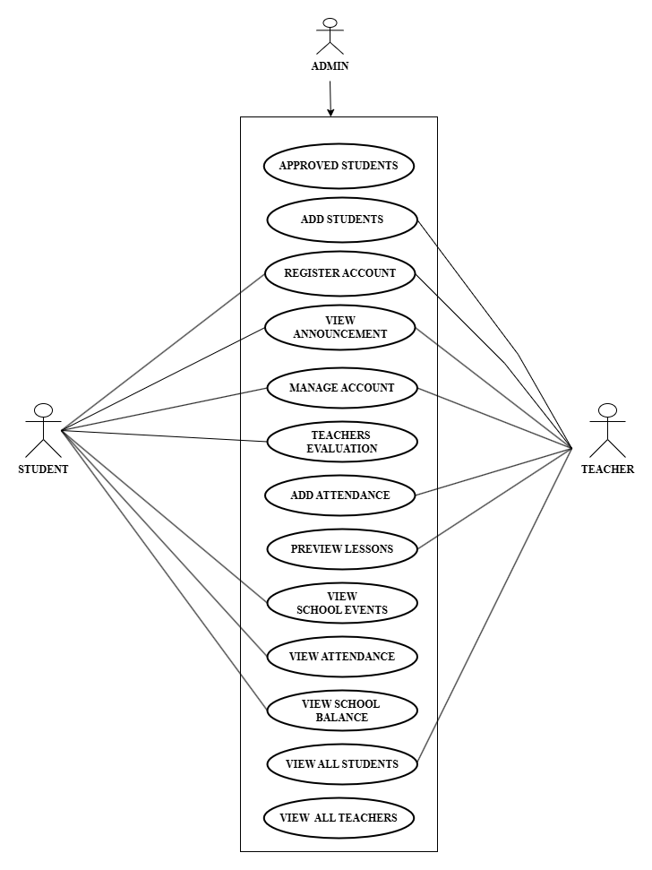**Use Case Diagram**

**REQUIREMENTS COST**

**admin user**

**HARDWARE REQUIREMENTS**

Processor: (AMD Ryzen 5 7520U with Radeon Graphics) ₱18,000

Storage: (500GB SSD) ₱5,000

RAM: (8GB) ₱4,000

Laptops (acer extensa 215-23) ₱26,000

Smartphones: (Android) ₱ 15,000

**SOFTWARE REQUIREMENTS**

Operating System: (Windows 11 Home) ₱7,000

Database: (MySQL 8.0.x) ₱0

Version Control: (GitHub) ₱0

Web Browser: (Google Chrome) ₱0 ₱0

Xampp Control Panel (version 8.2.12) ₱0

**NETWORK REQUIREMENTS**

Converge ICT (200 Mbps Monthly) ₱1,500

**INTEGRATION REQUIREMENTS**

Authentication Services (Google OAuth) ₱0

Notification Services: (SendGrid) ₱2,500

Single Sign-On (SSO) ₱5,000

**_____________ ____________**

₱ 69,000 ₱ 15,000

**Labor Cost**

Programmer (Full Stack) ₱40,000

Maintenance ₱5,000

System Analyst ₱20,000

**_____________ ____________**

**TOTAL** ₱ 65,000

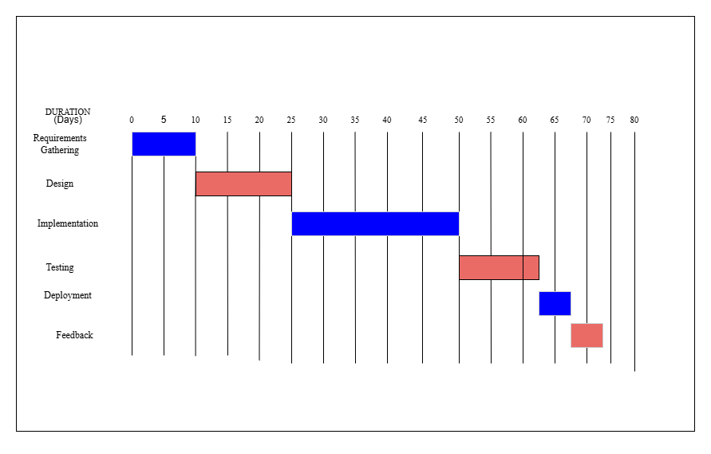**Gant Chart**

**SYSTEM PROTOTYPE**

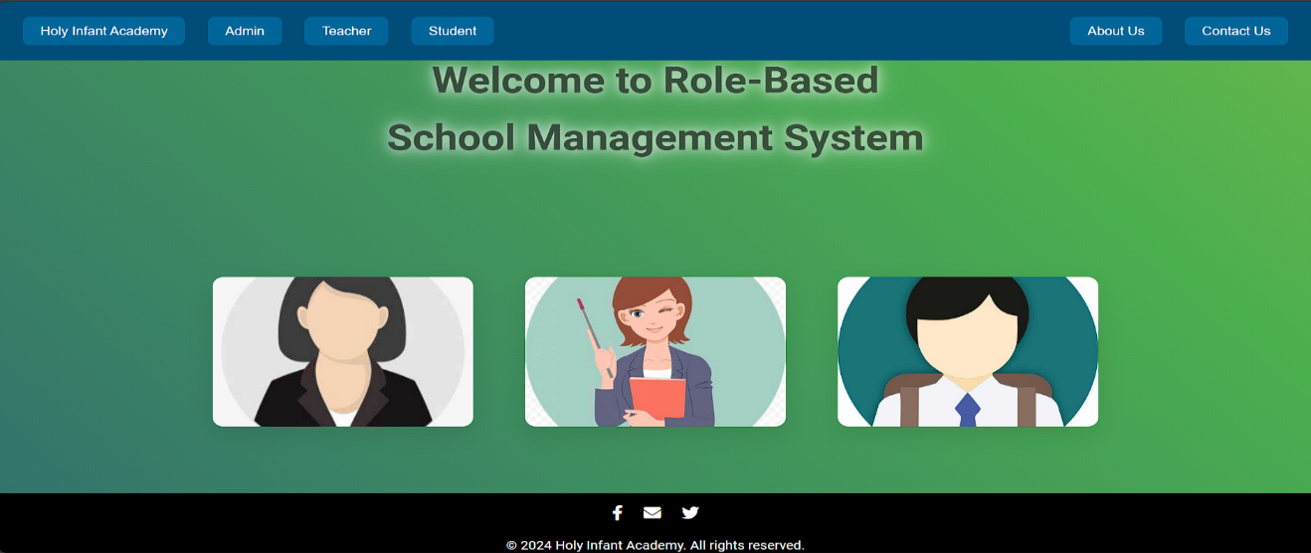**HOMEPAGE**

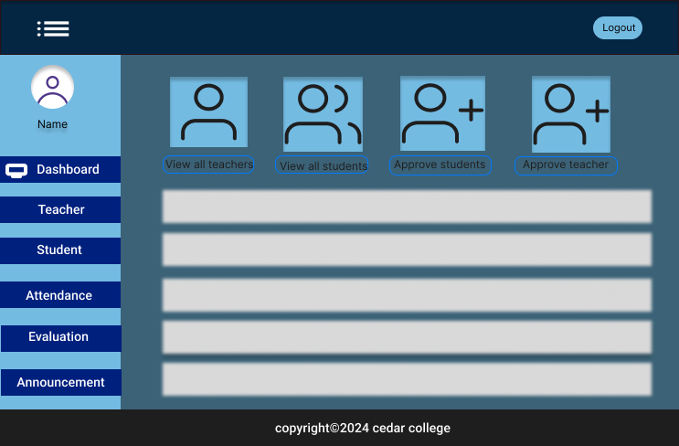**ADMIN DASHBOARD**

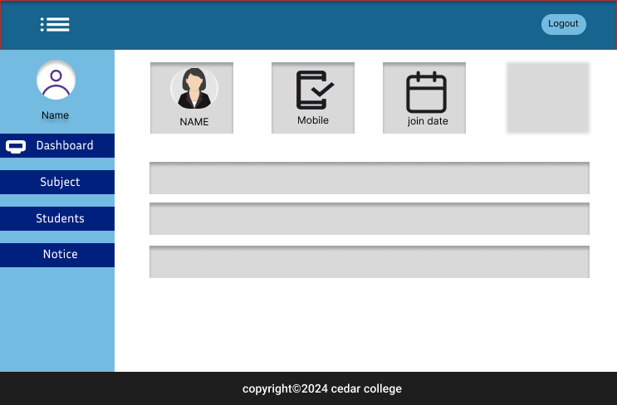**TEACHER DASHBOARD**

**STUDENT DASHBOARD**

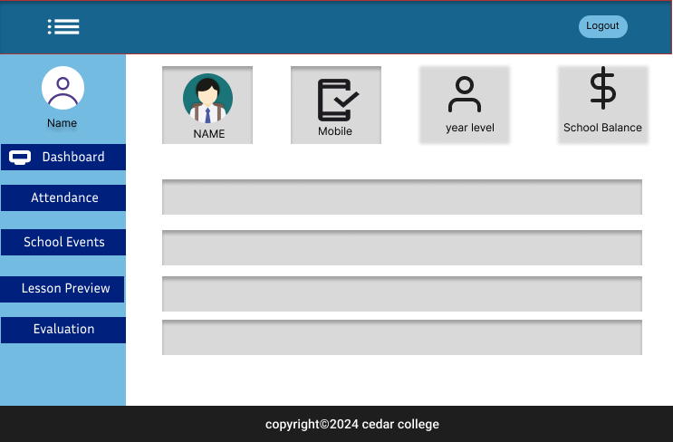

**Data Flow Diagram**

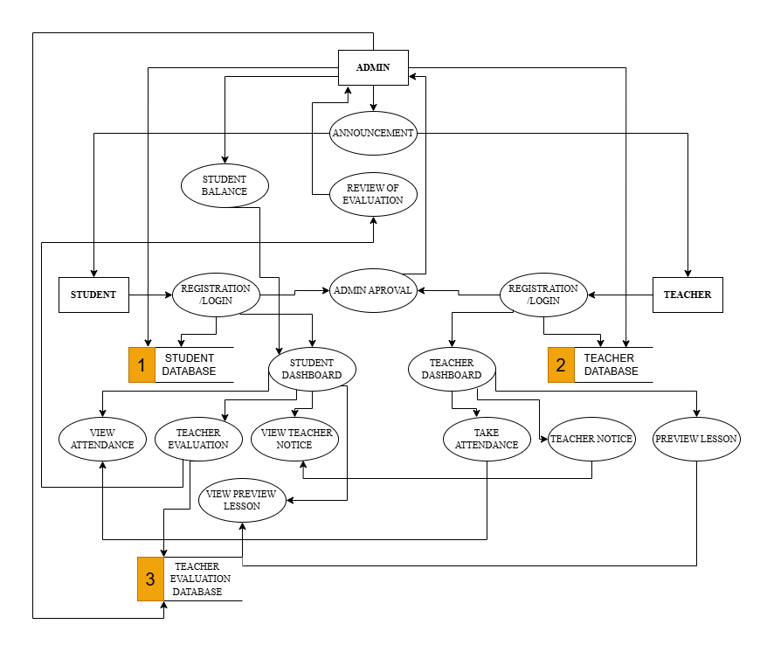

**Data Flow Diagram Level 0**

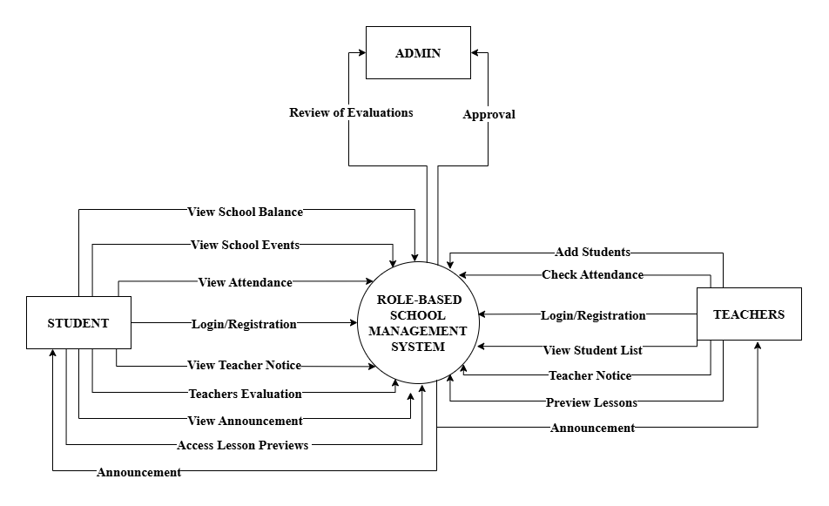

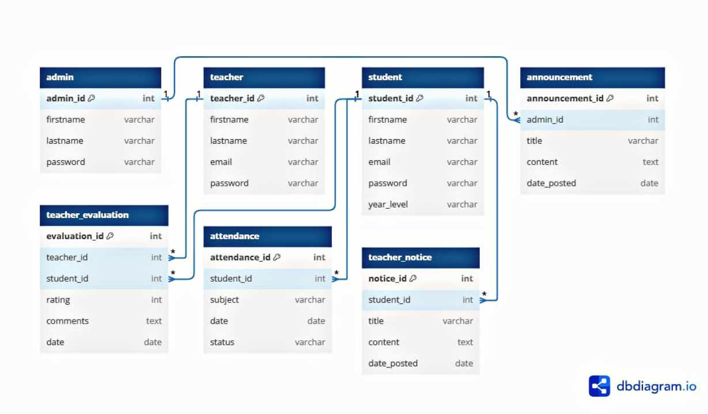**ER Diagram**

**System Architecture**

**Three-tier Architecture**

Role-Based School Management System employs three-tier architecture because it organizes the system into the presentation, business logic, and data layers. This separation ensures better security, easier maintenance, and a user-friendly experience for admins, teachers, and students.

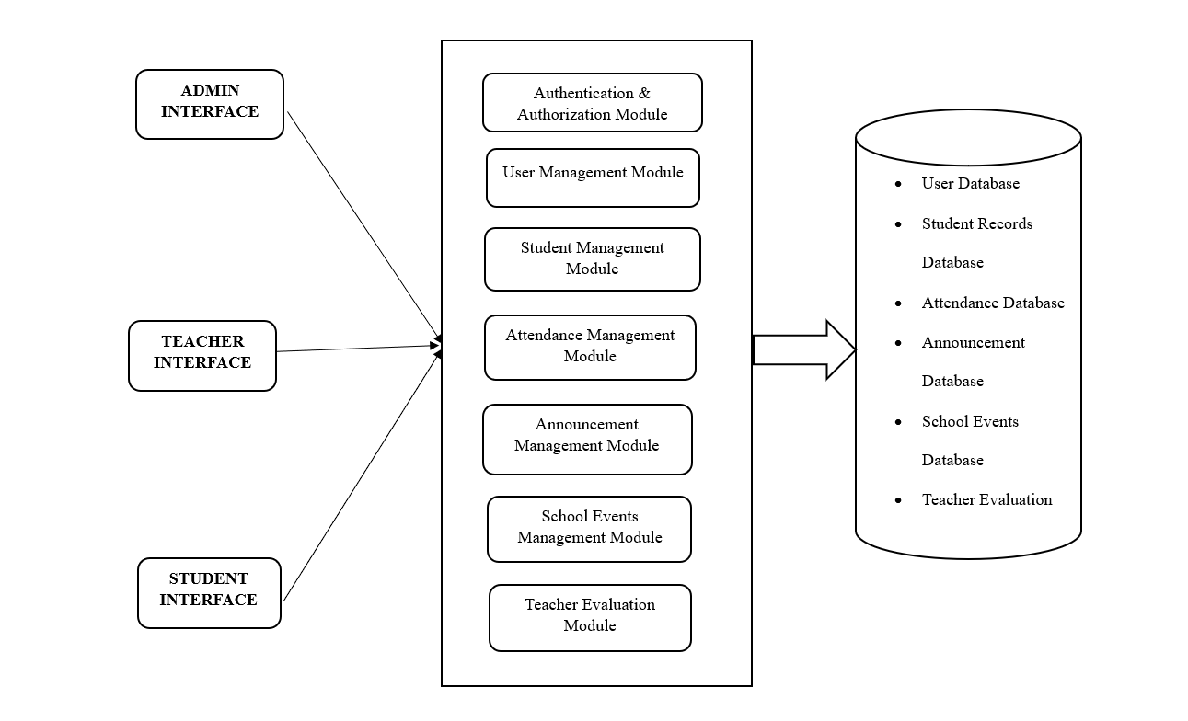

**Client Application Server Data Source**

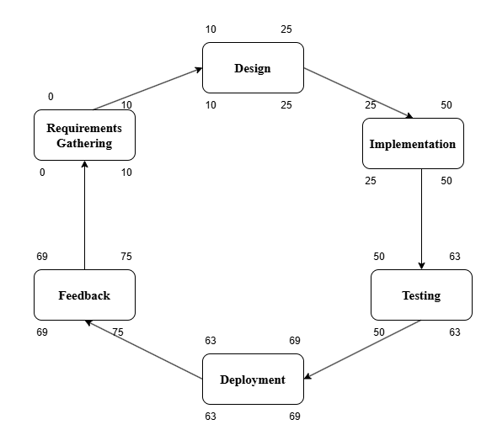**PERT**

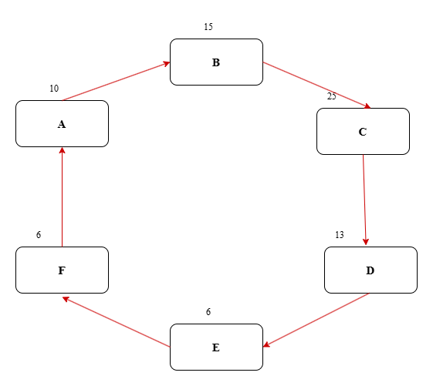**Critical Path Method**

**Total No. of Days = 70**

**Critical Path = A, B, C, D, E, F, G, H**

**COST-BENEFIT ANALYSIS**

|  |  |  |  |  |  |  |  |  |
| --- | --- | --- | --- | --- | --- | --- | --- | --- |
| ITEM | Year 0 | Year 1 | Year 2 | Year 3 | Year 4 | Total Cost | Total Benefits | Net Benefit/Cost |
| Development Cost | ₱122,500 | - | - | - | - | ₱122,500 | - | - |
| Operational Cost | - | ₱18,000 | ₱18,000 | ₱18,000 | ₱18,000 | ₱72,000 | - | - |
| Maintenance Cost |  | ₱5,000 | ₱5,000 | ₱5,000 | ₱5,000 | ₱20,000 | - | - |
| **Total Cost** | ₱122,500 | ₱23,000 | ₱23,000 | ₱23,000 | ₱23,000 | ₱214,500 | - | - |
| PV Factor (10%) | 1.000 | 0.909 | 0.826 | 0.751 | 0.683 | - | - | - |
| Present Value | ₱122,500 | ₱20,807 | ₱18,998 | ₱17,273 | ₱15,709 |  | ₱195,287 | - |
| **TOTAL BENEFITS** | - | ₱60,000 | ₱75,000 | ₱90,000 | ₱105,000 | ₱330,000 | - | - |
| PV Factor (10%) | 1.000 | 0.909 | 0.826 | 0.751 | 0.683 | - | - | - |
| Present Value |  | ₱54,540 | ₱61,950 | ₱67,590 | ₱71,715 |  | ₱255,795 | - |
| Net Cash Flow | -₱122,500 | ₱33,733 | ₱42,952 | ₱50,317 | ₱56,006 | - | ₱60,508 | ₱60,508 |

**Return of Investment**

Present Value Benefits ₱ 255,795

Initial Value Cost ₱ 195,287

Formula for Calculating the ROI:

ROI% = 0.3098 x 100

30.98%

Return of Investment =

**CHAPTER III**

**FINDINGS AND PROJECTIONS**

**Findings**

**Figure 1. Survey response on the system has the features needed to complete tasks.**

As shown in the figure above, a significant 67% of users agree that the system has the necessary features to complete tasks, with 20% strongly agreeing. This indicates a positive perception of the system's functionality, while 13% remain neutral, suggesting a minor portion of users may feel uncertain about the system’s capabilities.

Focusing on enhancing and expanding features could further increase user satisfaction.

**Figure 2. Survey response on the system allows users to easily perform their assigned tasks (e.g., taking attendance, viewing data).**

As shown in the figure above, while 53% agree that the system allows easy task performance, 27% strongly agree, indicating a generally favorable view. However, 20% are neutral, suggesting some users may have experienced challenges.

Improving the user interface design could help convert neutral responses into agreement.

**Figure 3**. **Survey response on** **the system operates without delays.**

As shown in the figure above, 60% of users agree that the system operates without delays, while 20% remain neutral, indicating that some users may have encountered delays.

Continued optimization of system performance could enhance user experience and reduce the number of neutral responses.

**Figure 4. Survey response on the system works well even with a large amount of data.**

As shown in the figure above, only 47% of respondents agree that the system works well with large amounts of data, with a significant 40% being neutral, indicating uncertainty about performance under load. 13% strongly agree, suggesting a minority of users have positive experiences in this area.

Addressing performance issues when handling large datasets could significantly improve user perceptions.

**Figure 5. Survey response on the system works well on different devices (e.g., phone, computer).**

As shown in the figure above, a strong 60% agree that the system works well on various devices, suggesting good adaptability. 27% are neutral, indicating potential areas for improvement. 13% strongly agree, which emphasizes satisfaction among some users.

Continued testing and optimization on different devices could further enhance user satisfaction.

**Figure 6. Survey response on the system integrates with other tools used by the school.**

As shown in the figure above, 53% agree that the system integrates well with other tools used by the school, while 27% are neutral, indicating room for improvement in integration capabilities. 20% strongly agree, reflecting a solid level of confidence among some users.

Enhancing integration features could strengthen user confidence and satisfaction.

**Figure 7. Survey response on the system is easy to navigate.**

As shown in the figure above, 47% agree that the system is easy to navigate, but with 33% neutral, there is an opportunity for improvement in the user interface. 20% strongly agree, indicating that a portion of users finds navigation satisfactory.

Improving user navigation design could help reduce neutral feedback and enhance the overall experience.

**Figure 8. Survey response on the instructions within the system are clear and easy to understand.**

As shown in the figure above, a strong 67% agree that instructions within the system are clear and easy to understand, indicating effective communication. 20% strongly agree, which is a positive indicator of user experience. 13% are neutral, suggesting a minor portion of users may have questions.

Maintaining this clarity and possibly enhancing it further can continue to boost user satisfaction.

**Figure 9. Survey response on the system is easy to learn without needing much help.**

As shown in the figure above, an impressive 80% agree that the system is easy to learn without needing much help, which is a strong positive indicator. Only 7% are neutral, and 13% strongly agree, highlighting a significant level of satisfaction regarding the learning curve.

Continued focus on user-friendly design will likely help maintain this trend.

**Figure 10. Survey response on the system works correctly most of the time.**

As shown in the figure above, 57% agree that the system works correctly most of the time, but 40% are neutral, suggesting some users experience issues. 13% strongly agree, indicating a minority are very confident in the system's functionality.

Addressing and reducing errors could significantly improve user confidence.

**Figure 11. Survey response on the system does not frequently crash or have errors.**

As shown in the figure above, 47% agree that the system does not frequently crash or have errors, but 33% remain neutral, indicating uncertainty regarding stability. 20% strongly agree, reflecting a positive experience for some users.

Reducing crashes and improving system stability could convert neutral responses into positive feedback.

**Figure 12. Survey response on the system keeps personal information secure**.

As shown in the figure above, a total of 100% of users feel confident that the system keeps personal information secure, with 60% agreeing and 40% strongly agreeing. This indicates a high level of trust in the system’s data protection measures.

Ongoing investment in security measures is essential to maintain and enhance user trust in data protection.

**Figure 13. Survey response on only authorized individuals can access sensitive data.**

As shown in the figure above, 53% strongly agree that only authorized individuals can access sensitive data, indicating effective access control measures. 7% remain neutral, suggesting some uncertainty among users.

Continued security training for users can reinforce these access control measures.

**Figure 14. Survey response on the system is easy to update or fix when needed**.

As shown in the figure above, 53% agree that the system is easy to update or fix, while 20% remain neutral, indicating potential uncertainty in the update process. 27% strongly agree, reflecting satisfaction among a portion of users.

Clear communication about update procedures could help reduce neutral responses.

**Figure 15. Survey response on the system is easy to maintain and troubleshoot**.

As shown in the figure above, 40% strongly agree that the system is easy to maintain and troubleshoot, with 20% neutral, suggesting areas for improvement in support resources.

Providing maintenance resources and support could help improve user confidence and reduce neutral feedback.

**CHAPTER IV**

**CONCLUSION AND RECOMMENDATIONS**

The Role-Based School Management System (RBSMS) marks a significant step forward in improving the efficiency and effectiveness of school operations by providing a structured, secure, and user-friendly platform tailored to the needs of administrators, teachers, and students. Its main purpose is to streamline administrative tasks, enhance communication, and promote better management of academic and non-academic activities, ultimately creating a more organized and collaborative educational environment.

**CONCLUSION**

The system streamlines essential school processes, allowing administrators to manage applications, maintain accurate records, and oversee operations with greater ease and precision. Teachers benefit from features such as automated attendance tracking, activity management, and task monitoring, enabling them to focus more on teaching and less on administrative tasks. Students gain transparency and accountability through easy access to their attendance and task updates, helping them stay informed and organized.

With its role-based access control, the system ensures data security by restricting users to information relevant to their roles, reducing the risk of unauthorized access. The structured design promotes efficiency, accuracy, and organization, while positive feedback highlights the system’s user-friendly interface and its potential to simplify school management. However, the long-term success of the system will depend on its scalability, continuous updates, and the ability to adapt to the evolving needs of the institution. Security measures, such as data encryption and secure logins, will also play a critical role in protecting sensitive school data.

**RECOMMENDATIONS**

To optimize the Role-Based School Management System for maximum efficiency and user satisfaction, the following specific recommendations are provided to address the needs of administrators, teachers, and students. These suggestions aim to improve functionality, security, and usability within the system.

The administrator dashboard should be designed to streamline the management of user registrations, approvals, and role assignments. Administrators should be able to generate and review detailed reports on attendance, student enrollment, and academic performance, ensuring efficient school operations. Security features, such as two-factor authentication and automatic data backups, should be implemented to protect sensitive data. Administrators should receive comprehensive training on managing user roles, approving registrations, generating reports, posting announcements, and updating system settings. A feedback system should be introduced to allow administrators to gather insights from teachers and students for continuous system improvements.

Teachers should have access to a user-friendly interface that enables them to upload activities, track student attendance, and post task reminders, with each post subject to admin approval. The teacher dashboard should highlight essential tasks, deadlines, and any feedback or announcements from administrators. The system should also provide tools for generating performance reports to help teachers monitor student progress and make informed decisions. Teachers should be provided with training on effectively using the system for activity management, attendance tracking, and analyzing student performance, ensuring they can utilize the platform to support their instructional responsibilities.  
Students should have a personalized dashboard that allows easy access to their attendance, activities, and announcements, with timely notifications for task reminders and upcoming deadlines. The system should offer an intuitive interface that enables students to track their progress on assignments and view grades. Orientation sessions should be provided to help students understand how to navigate the platform, access learning materials, and communicate with teachers. Ensuring students are fully comfortable using the system will improve engagement and help them stay on top of their academic responsibilities.

By implementing these specific recommendations, the Role-Based School Management System will effectively support the needs of administrators, teachers, and students, promoting seamless school management and improving the overall user experience.

**REFERENCES**

* Arar, K., & Nasra, M. A. (2020). *Linking school-based management and school effectiveness: The influence of self-based management, motivation and effectiveness in the Arab education system in Israel*. Educational Management Administration & Leadership, *48*(1), 186-204.

Retrieve From: https://doi.org/10.1177/1741143218775428

Date Access: December 6, 2024

* Warlizasusi, J. (2019, August). *The Optimalization School Based Management by Applying Information Technology and Communication (ICT)*. In Padang international conference on educational management and administration *(PICEMA 2018)* (pp. 27-34). Atlantis Press.

Retrieve From: https://doi.org/10.2991/picema-18.2019.6

Date Access: December 6, 2024

* Cheng, Y.C. (2022). *School Effectiveness and School-Based Management: A Mechanism for Development* (2nd ed.). Routledge.

Retrieve From: https://doi.org/10.4324/9781003267980

Date Access: December 6, 2024

* Cisneros-Cohernour, E. J. (2021). *The key role of administrators in supporting teacher leadership and professionalism in southern Mexico.* *Research in Educational Administration & Leadership, 6*(1), 313-340.

Retrieve From: https:// doi: 10.30828/real/2021.1.10

Date Access: December 6, 2024

* Sergeev, A., Kulikova, N., Danilchuk, E., & Borisova, N. (2021). Online Educational Platform as a Web Content Management System in the Organization of Student-Teacher Interaction. In R. Silhavy, P. Silhavy, & Z. Prokopova (Eds.), *Data Science and Intelligent Systems. CoMeSySo 2021* (Lecture Notes in Networks and Systems, vol. 231, pp. 835-847). Springer, Cham.

Retrieve From: https://doi.org/10.1007/978-3-030-90321-3_70

Date Access: December 6, 2024

* Torrevillas, A. (2019). *SCHOOL BASED MANAGEMENT (SBM) AS CORRELATES TO ACADEMIC PERFORMANCE OF SECONDARY SCHOOLS IN QUEZON CITY.* *Luz y Saber, 13*(4).

Retrieve From: https://www.ejournals.ph/article.php?id=15801

Date Access: December 6, 2024

* Grepon, B. G. S., Baran, N. T., Gumonan, K. M. V., Martinez, A. L. M., & Lacsa, M. L. E. (2021*). Designing and Implementing e-School Systems: An Information Systems Approach to School Management of a Community College in Northern Mindanao, Philippines.*

Retrieve From: https://doi.org/10.48550/arXiv.2109.00198

Date Access: December 6, 2024

* T. Pepugal, E. (2022). Levels of Perception on School-Based Management Implementation in San Luis National High School, Philippines *American Journal of Multidisciplinary Research and Innovation*, *1*(4), 26–34.

Retrieve From: https://doi.org/10.54536/ajmri.v1i4*.516*

Date Access: December 6, 2024

* *Gerola, C., & Meimban, L. (2023). Educational Management Practices Among Secondary School Administrators.*Psychology and Education: A Multidisciplinary Journal, *10*(5), 1-1.

Retrieve From: http://doi.org/10.5281/zenodo.8126327

Date Access: December 6, 2024

* Lubrica, P. A., Parcasio, I. G., Cuevas, J. P., Alvaro, M. N., Gallardo, A. V. G., & Batani, R. S. (2019). School-Based Management in Benguet, Philippines. *Mountain Journal of Science and Interdisciplinary Research (formerly Benguet State University Research Journal)*, *79*(2 Supp 1), 152-163.

Retrieve From: http://103.125.149.70/index.php/BRJ/article/view/244

Date Access: December 6, 2024