Skill + Job Matching System (Web Application)
Project Overview
The Skill + Job Matching System is a web-based application developed using Python and Flask framework. The main purpose of this system is to help users identify suitable job roles based on their existing skills.
The system allows users to register, log in, and enter their skills. It then compares these skills with predefined job roles and calculates a match percentage. Additionally, the system highlights missing skills required for a particular job, helping users improve their profile.
This project serves as a prototype for modern recruitment and career guidance systems.

Problem Statement & Proposed Solution
Problem in the Current Market
In today’s competitive job market, many students and job seekers face difficulty in identifying the right job roles according to their skills. Most candidates apply for jobs without clearly understanding whether their skills match the job requirements.
As a result:
- Students often apply for irrelevant job roles
- Lack of awareness about required skills for specific jobs
- Difficulty in identifying skill gaps
- No proper guidance on how to improve their profile
- Manual comparison of skills and job requirements is time-consuming
Additionally, many online job portals only list job openings but do not provide detailed insights into how well a candidate fits a particular role.

Proposed Solution
To solve these problems, we developed the Skill + Job Matching System, a web-based application that helps users analyze their skills and match them with suitable job roles.
The system works as follows:
- Users enter their skills into the system
- The system compares these skills with predefined job roles
- It calculates a match percentage for each job
- It clearly shows:
  - Skills the user already has
  - Skills required for the job
  - Missing skills
This helps users:
- Understand which job suits them best
- Identify areas for improvement
- Focus on learning relevant skills
- Make better career decisions
Thus, the system provides a simple, efficient, and automated solution for skill-based job matching and career guidance.

Objectives
- To develop a web-based application using Flask
- To match user skills with job requirements
- To calculate job match percentage
- To identify missing skills for improvement
- To track user progress over time
- To provide an interactive and user-friendly interface

System Structure
skill_job_match/
│
├── app.py # Main Flask application
├── jobs.py # Job roles and required skills
├── database.db # SQLite database
├── requirements.txt # Dependencies
│
├── static/
│ └── uploads/ # Uploaded CV files
│
├── templates/
│ ├── base.html
│ ├── login.html
│ ├── register.html
│ └── dashboard.html
System Architecture
Frontend Layer
- Built using HTML, CSS, and Bootstrap
- Provides user interface for interaction
- Displays results such as job matches and skill gaps
Backend Layer
- Developed using Flask (Python framework)
- Handles application logic and routing
- Processes user input and performs calculations
Database Layer
- SQLite database is used
- Stores user details, skills, and scores
Working of the System
- User registers using name, email, and password
- User logs into the system
- User enters or updates skills
- System compares user skills with job roles stored in jobs.py
- Match percentage is calculated:
Match % = (Matched Skills / Total Required Skills) × 100
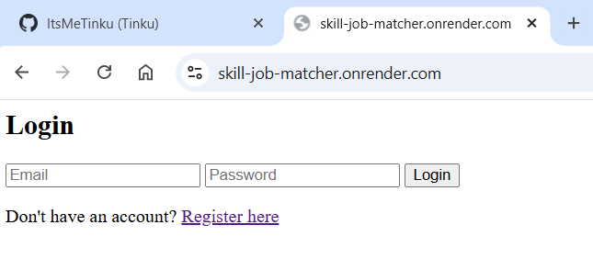
Figure 1: User Login Page
This screen allows registered users to log into the system using their email and password. It ensures secure authentication before accessing the dashboard.

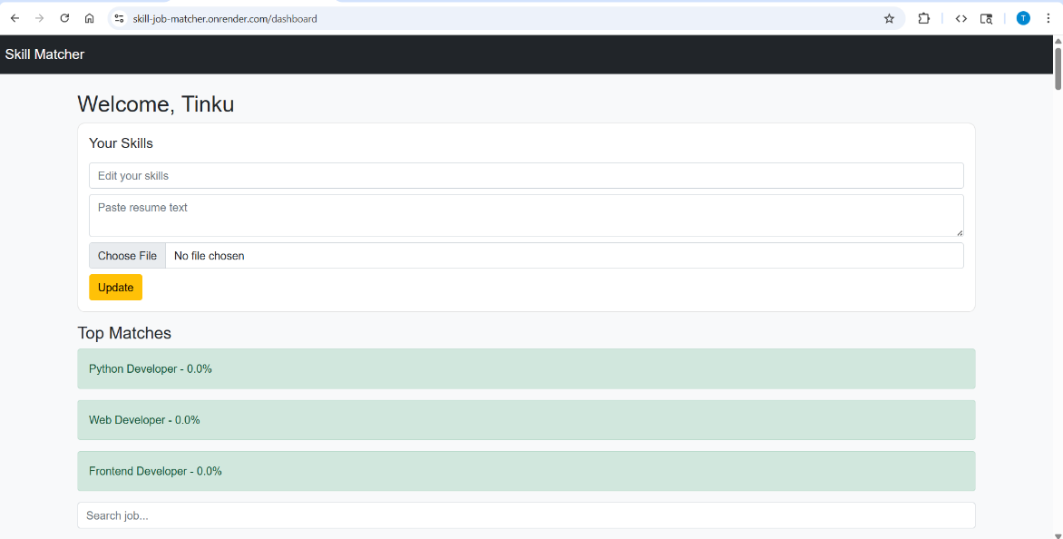
Figure 2: User Dashboard
The dashboard displays user profile information and current skills. It provides options to update skills, upload CV, and view job matching results.

System displays:
  - Job match percentage
  - Skills the user has
  - Skills required for the job
  - Missing skills
- User can update skills and track improvement

System Elements
- Authentication System (Login/Register)
- Skill Input Module
- Job Matching Engine
- Database System
- CV Upload Module
- Dashboard Interface

Attributes (Database Fields)
Table: users
- id (Primary Key)
- name
- email (Unique)
- password (Hashed)
- skills (Text)
- previous_score (Float)
- current_score (Float)
- file_name (Uploaded CV)

Features
- Secure User Authentication
- Skill Entry and Editing Option
- Job Matching Algorithm
- Match Percentage Display
- Skills Comparison (Have vs Needed)
- Missing Skills Suggestion
- CV Upload (PDF/JPG/PNG)
- Job Search Filter
- Improvement Tracking
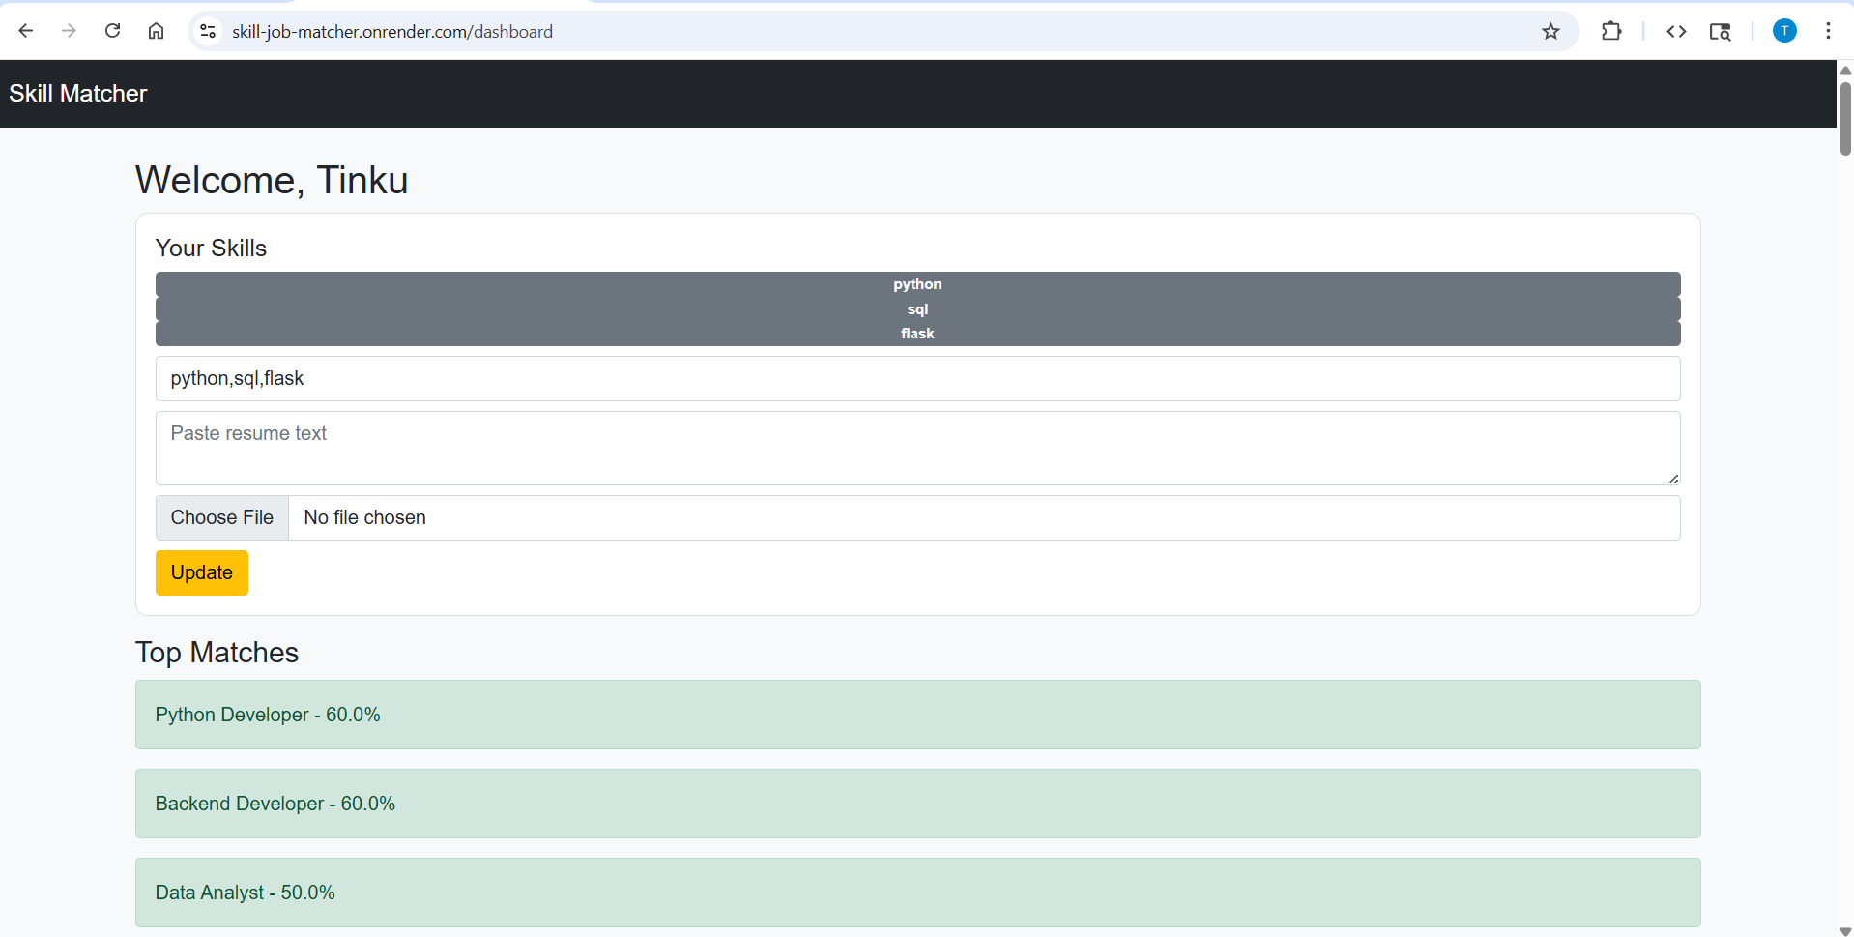
Figure 3: Job Matching Results
This screen shows different job roles along with match percentage based on user skills. It also highlights missing skills required for each job.

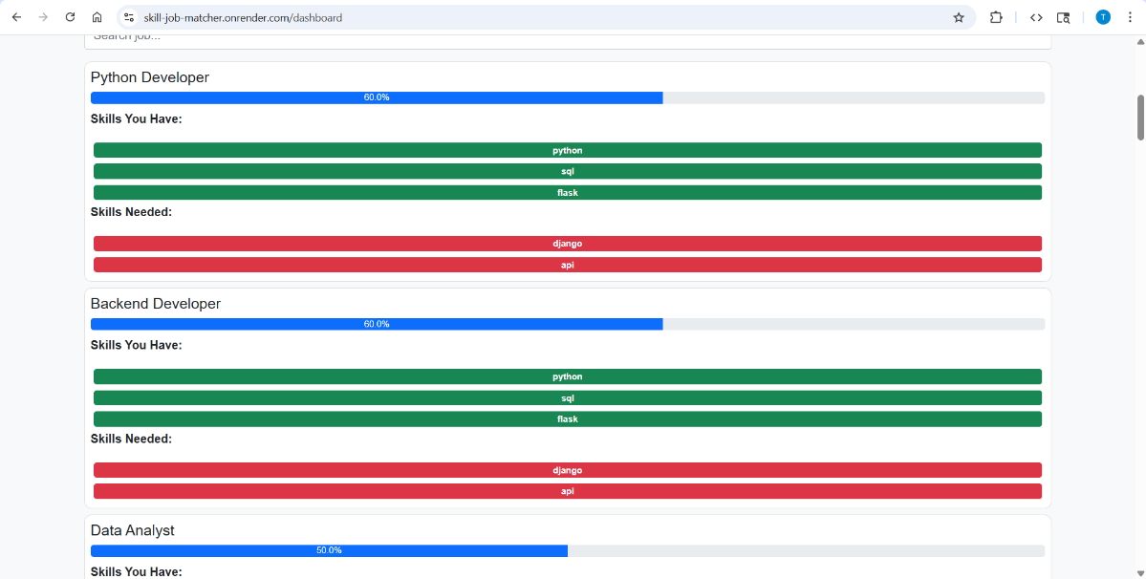
Figure 4: Skills Comparison
This section displays the skills the user already has and the skills required for a specific job. It helps users clearly identify skill gaps.
Libraries and Technologies Used
1. Flask
- Lightweight Python web framework
- Used to build backend and handle routing
2. SQLite3
- Lightweight database
- Stores user information
3. Werkzeug
- Used for password hashing
- Provides security features
4. OS Module
- Used for file handling and path management
5. Gunicorn
- Production server used for deployment
6. Bootstrap
- Used for responsive frontend design

Installation & Setup
Step 1: Install Python
Download and install Python (version 3.8 or above)
Step 2: Clone the Repository
git clone https://github.com/YOUR_USERNAME/skill-job-matcher.git
cd skill-job-matcher
Step 3: Install Required Libraries
pip install -r requirements.txt
OR manually:
pip install flask
pip install gunicorn
Step 4: Run the Application
python app.py
Step 5: Open in Browser
http://127.0.0.1:5000
11. Deployment
The application is deployed on Render.
Deployment Steps:
- Upload project to GitHub
- Connect GitHub to Render
- Set build command: pip install -r requirements.txt
- Set start command: gunicorn app:app
Live Website:
https://skill-job-matcher.onrender.com
GitHub Repository
Source Code:
https://github.com/ItsMeTinku/skill-job-matcher

Limitations
- SQLite supports limited concurrent users
- Free hosting causes server sleep mode
- Job data is static (not real-time)
- Basic resume parsing

Future Scope
- Integration with real-time job APIs
- Use of PostgreSQL database
- AI-based resume analysis
- Advanced analytics dashboard
- Mobile application version

Real-World Applications
- Online job portals
- Career guidance platforms
- Skill assessment tools
- Educational institutions

Conclusion
The Skill + Job Matching System is a functional and efficient prototype that helps users identify suitable job roles based on their skills. It provides insights into missing skills and helps improve career readiness. The system can be enhanced further for real-world applications.

