**Shopping Cart**

**Executive Summary**

Internet is the rapidest growing media during the past decade. Especially, online shopping is a rapidly growing e-commerce area. Online stores are usually available 24 hours a day, and many consumers have Internet access both at work and at home. A successful web store is not just a good looking website with dynamic technical features, listed in many search engines. This study aims to establish a preliminary assessment, evaluation and understanding of the characteristics of online shopping. Although the benefits of online shopping are considerable, when the process goes poorly it can create a thorny situation.

**Problem Statement**

Purpose of website is established fact that Internet users are increasing today and the fact that though there are many websites for e-shopping they offer different kind of services and there is a lack of relationship between retailers and customers and hence we are establishing that relationship by caring and serving all customer in same manner that they wish to be served.

Since there will be many users visiting the site we require a strong and reliable frontend which can withhold the users on our site. Since the data is considered very important that can help everyone and hence we need a strong database.

**Description**

E-commerce is fast gaining ground as an accepted and used business paradigm. More and more business houses are implementing web sites providing functionality for performing commercial transactions over the web. It is reasonable to say that online shopping system project report the process of shopping on the web is becoming commonplace.

The objective of this online shopping system project project is to develop a general purpose e-commerce store where any product (such as books, CDs, computers, mobile phones, electronic items, and home appliances) can be bought from the comfort of home through the Internet.

However, for implementation purposes, this online shopping system project paper will deal with an onlinebook store.

An online store is a virtual store on the Internet where customers can browse the catalog and select products of interest. The selected items may be collected in a shopping cart. At checkout time, the items in theshopping cart will be presented as an order. At that online shopping system project report time, moreinformation will be needed to complete the transaction. Usually, the customer will be asked to fill or select a billing address, a shipping address, a shipping option, and payment information such as credit card number. An e- mail notification is sent to the customer as soon as the order is placed.

**Findings**

In the article, they discuss how many shoppers use the shopping cart to make final purchase decisions. Therefore,  you should provide features to accommodate this behavior in order to increase conversion rates and reduce bounce rates.

Some of the key features that your shopping cart should utilize are:

1. **Provide Access to a Full Shopping Cart.** Some sites utilize a mini-shopping cart page, which drops down from a Cart button near the header. Clicking the Checkout button from this drop down skips a full Shopping Cart Page and jumps the user into the checkout process. These “minicarts” prevent a user from doing the types of decision making they want to do on a full Shopping Cart Page, such as comparison shop, adjust quantities and review product details.
2. **List Product Details:** Many sites list products on the Shopping Cart Page without providing any details such as the size and color of the product that the user selected on the Product Detail Page (PDP). This can frustrate the user and prevent them from making a purchase decision.
3. **The product image is essential:** Not only is it essential to display the product image, it is equally as important to display the product image large enough so that the user can actually see the details about the product they added to the cart.
4. **Link Users to Full Product Details:** It is important to link both the product name and image back to the PDP so users can easily access more details about the product that will help them make their purchase decision.
5. **Let Users Easily Remove Items:** Because so many users use the cart to help them make a final purchase decision, it is essential to provide them with a quick and easy way to remove items from their cart.

**Implementation**

The implementation of the project was through the making of the ER-Diagram wherein the relation and the various attributes for each entity was been taken into the consideration and the then the formation of the project was been executed.

The language used to implement this project was: HTML, CSS BOOTSRAP JSP SERVLET JDBC

Software Requirements:

Operating System: Windows,MacOs, and linux.

IDE: My Eclipse and intellij ultimate edition

Web Server: Tomcat

Database: MySql8.0

Development Tool kit: Eclipse Java Enterprise Edition

**Discussion**

The features that can be included in shopping web app system are as follows:

**Registration/Login Page:** The customer who comes up first time on the website need to register itself in order to be updated in order to get great discount and other customer friendly things.

**Add/Remove Product To Cart:** Customer can add and remove products from cart.

**Proceed to checkout:** Customer has an option to checkout and pay for the purchases.

**Home Page:**  It contains all the items that are in stocks.

**Input Study**

The discussion which we did gave us the input study as:

1-Check for login

2-User Registration

3-Check availability

4-Proceed to checkout

5-Add/Remove products to cart

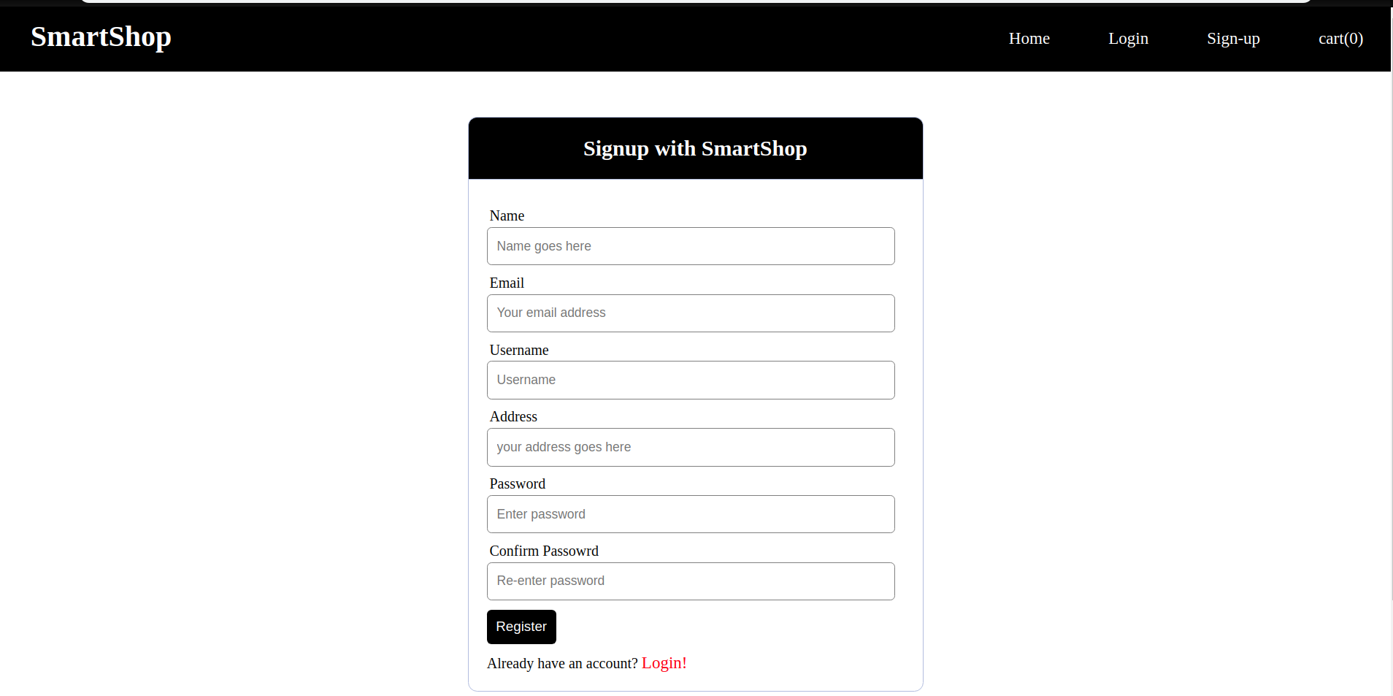

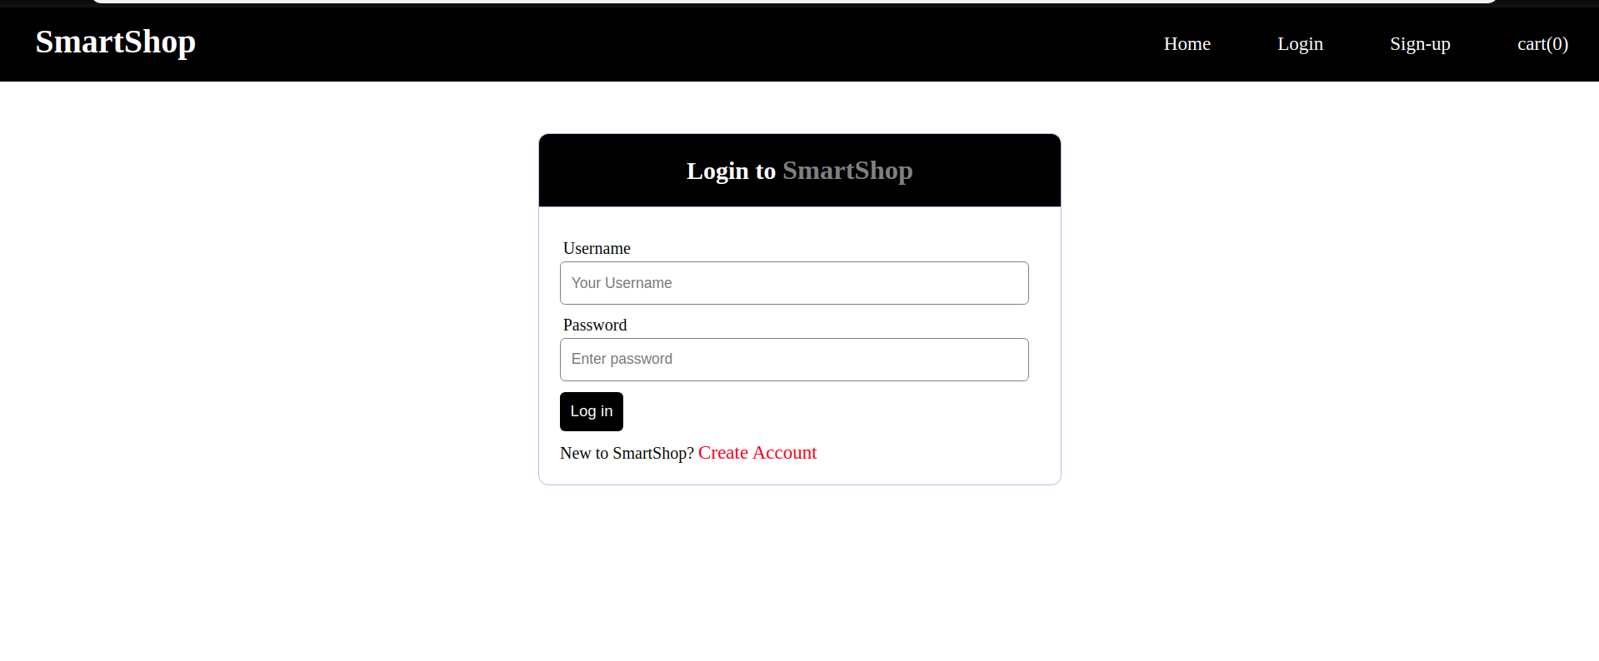

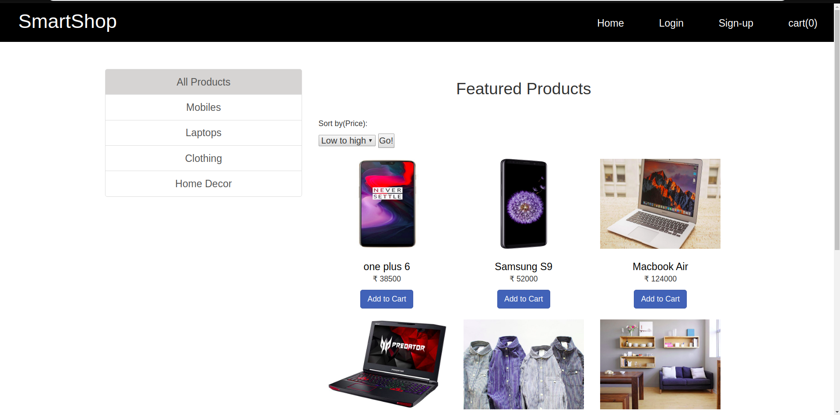

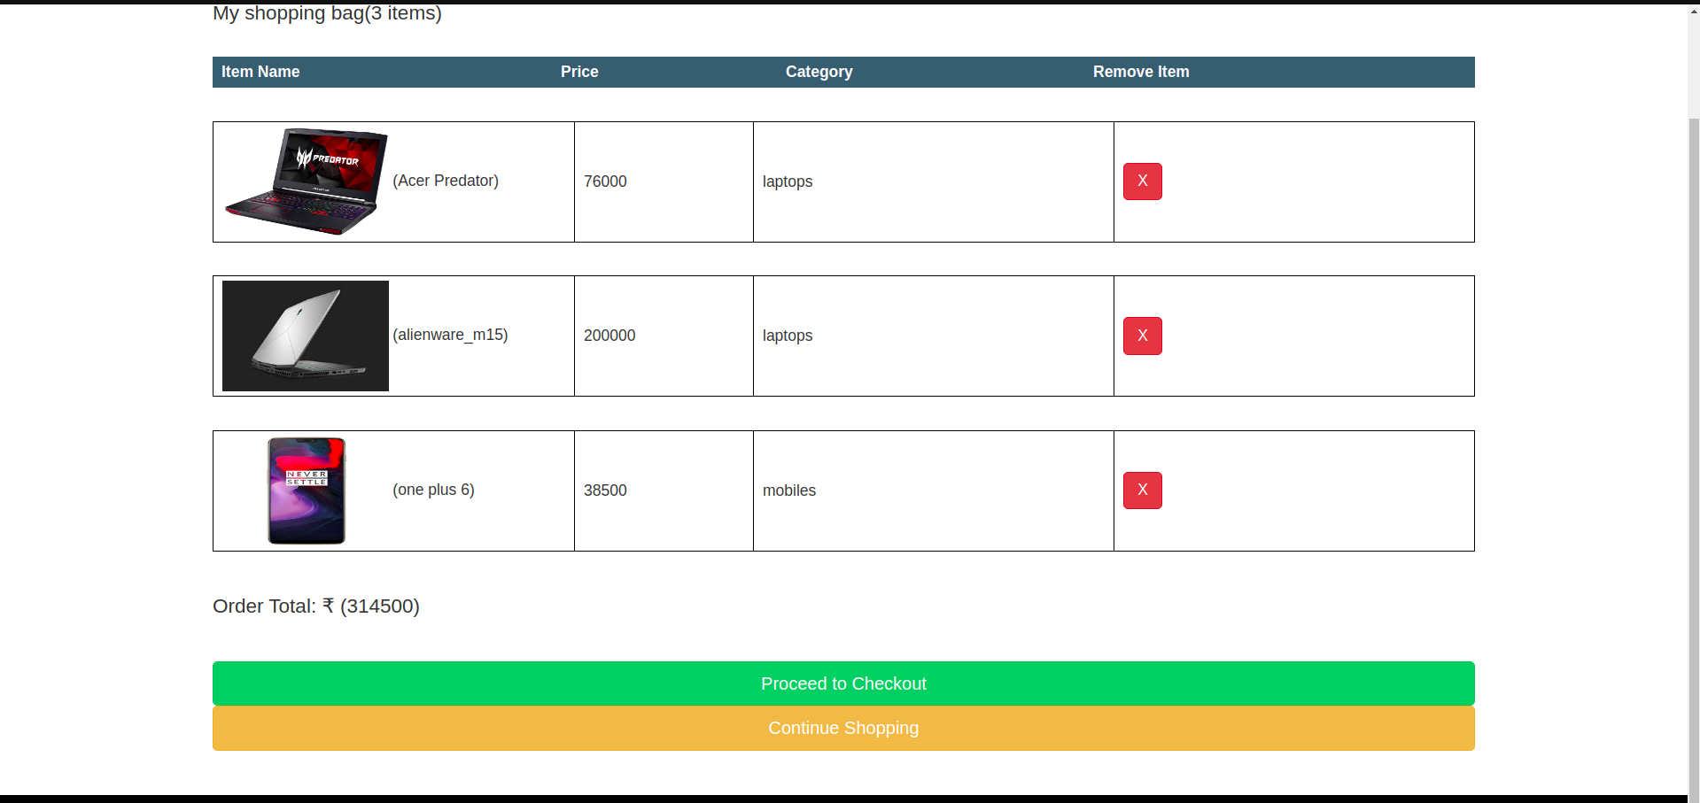

**Conclusion**

Technology has made significant progress over the years to provide consumers a better online shopping experience and will continue to do so for years to come.  With the rapid growth of products and brands, people have speculated that online shopping will overtake in-store shopping.  While this has been the case in some areas, there is still demand for brick and mortar stores in market areas where the consumer feels more comfortable seeing and touching the product being bought.  However, the availability of online shopping has produced a more educated consumer that can shop around with relative ease without having to spend a large amount of time.  In exchange, online shopping has opened up doors to many small retailers that would never be in business if they had to incur the high cost of owning a brick and mortar store.  At the end, it has been a win-win situation for both consumer and sellers.

prepared by:

varun mewada(18-ITA59-22)

sakshi(18-ITA67-22)

hinal(18-ITA59-22)