CDAC

MUMBAI

Concepts of Operating System

Assignment 2

**Part A**

What will the following commands do?

1. echo "Hello, World!" - Prints "Hello, World!" to terminal.

2. name="Productive" - Sets variable name.

3. touch file.txt - Creates empty file file.txt.

4. ls -a - Lists all files (including hidden).

5. rm file.txt - Removes file.txt.

6. cp file1.txt file2.txt - Copies file1.txt to file2.txt.

7. mv file.txt /path/to/directory/ - Moves file.txt to directory.

8. chmod 755 script.sh - Sets rwx for owner, rx for others on script.sh.

9. grep "pattern" file.txt - Finds "pattern" in file.txt.

10. kill PID - Kills process with ID PID.

11. mkdir mydir && cd mydir && touch file.txt && echo "Hello, World!" > file.txt && cat file.txt - Creates dir, cds in, creates file, writes, and shows content.

12. ls -l | grep ".txt" - Lists .txt files.

13. cat file1.txt file2.txt | sort | uniq - Concats, sorts, and shows unique lines.

14. ls -l | grep "^d" - Lists directories.

15. grep -r "pattern" /path/to/directory/ - Recursively searches for "pattern".

16. cat file1.txt file2.txt | sort | uniq -d - Shows duplicate lines.

17. chmod 644 file.txt - Sets rw for owner, r for others.

18. cp -r source_directory destination_directory - Copies directory recursively.

19. find /path/to/search -name "*.txt" - Finds .txt files in path.

20. chmod u+x file.txt - Adds execute for owner on file.txt.

21. echo $PATH - Prints PATH variable.

**PART B**

Identify True or False:

1. ls is used to list files and directories in a directory.

Ans: True

1. mv is used to move files and directories.

Ans: True

1. cd is used to copy files and directories.

Ans: False

1. pwd stands for "print working directory" and displays the current directory.

Ans: True

1. grep is used to search for patterns in files.

Ans: True

1. chmod 755 file.txt gives read, write, and execute permissions to the owner, and read and execute permissions to group and others.

Ans: True

1. mkdir -p directory1/directory2 creates nested directories, creating directory2 inside directory1 if directory1 does not exist.

Ans: True

1. rm -rf file.txt deletes a file forcefully without confirmation.

Ans: True

Identify the Incorrect Commands:

1. chmodx is used to change file permissions.

Ans: Incorrect : Correct - chmod.

1. cpy is used to copy files and directories.

Ans: Incorrect : Correct - cp.

1. mkfile is used to create a new file.

Ans: Incorrect: Correct - touch.

1. catx is used to concatenate files.

Ans: Incorrect: Correct - cat.

1. rn is used to rename files.

Ans: Incorrect: Correct - mv.

**Part C**

Question 1: Write a shell script that prints "Hello, World!" to the terminal.

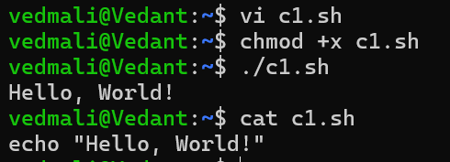

Question 2: Declare a variable named "name" and assign the value "CDAC Mumbai" to it. Print the value of the variable.

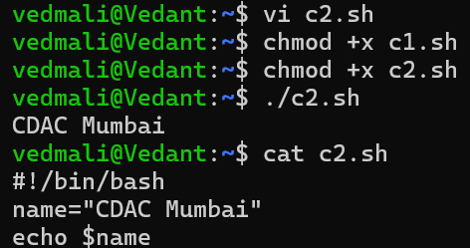

Question 3: Write a shell script that takes a number as input from the user and prints it.

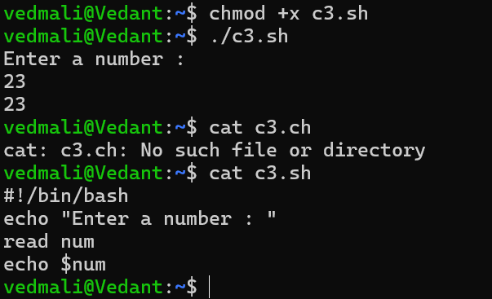

Question 4: Write a shell script that performs addition of two numbers (e.g., 5 and 3) and prints the result.

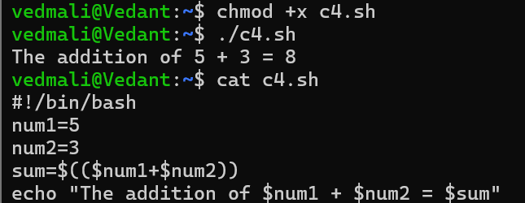

Question 5: Write a shell script that takes a number as input and prints "Even" if it is even, otherwise prints "Odd".

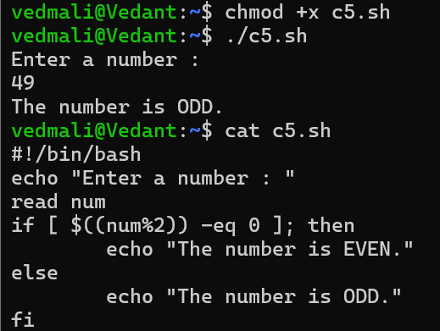

Question 6: Write a shell script that uses a for loop to print numbers from 1 to 5.

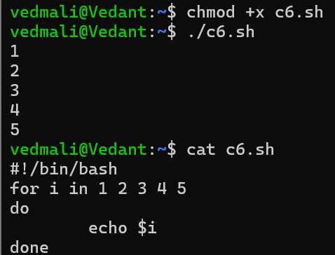

Question 7: Write a shell script that uses a while loop to print numbers from 1 to 5.

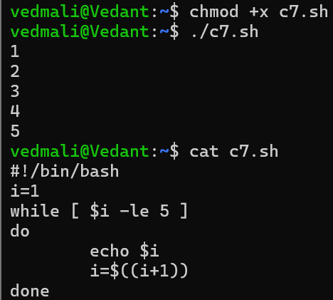

Question 8: Write a shell script that checks if a file named "file.txt" exists in the current directory. If it does, print "File exists", otherwise, print "File does not exist".

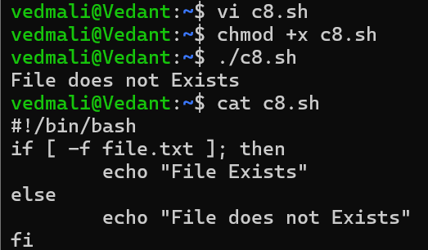

Question 9: Write a shell script that uses the if statement to check if a number is greater than 10 and prints a message accordingly.

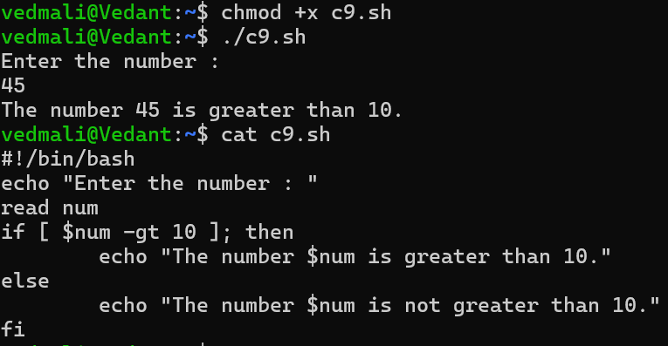

Question 10: Write a shell script that uses nested for loops to print a multiplication table for numbers from 1 to 5. The output should be formatted nicely, with each row representing a number and each column representing the multiplication result for that number.

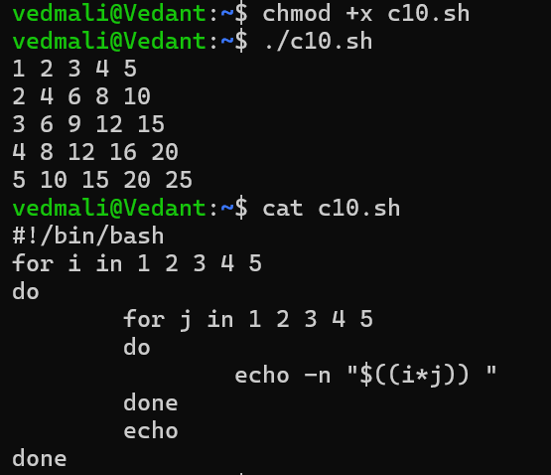

Question 11: Write a shell script that uses a while loop to read numbers from the user until the user enters a negative number. For each positive number entered, print its square. Use the break statement to exit the loop when a negative number is entered.

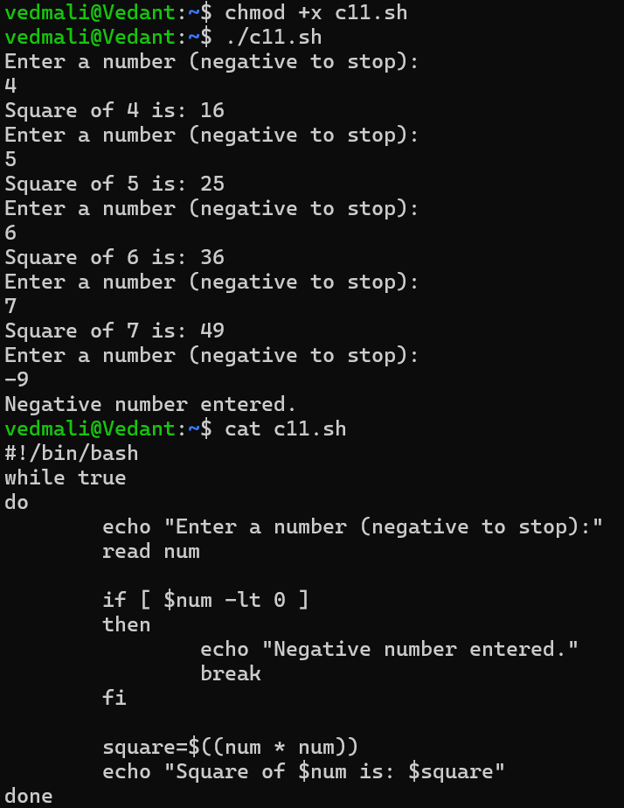

**Part D**

Common Interview Questions (Must know)

1. What is an operating system, and what are its primary functions?

An operating system (OS) is a software layer that acts as an intermediary between computer hardware and the user applications. It manages hardware resources and provides a set of services for application programs. The primary functions of an operating system include:

1.Process Management: The OS handles the creation, scheduling, and termination of processes. It ensures that each process gets enough CPU time and manages the execution of multiple processes simultaneously.

2.Memory Management: The OS manages the computer's memory, including RAM and cache. It keeps track of each byte in a computer's memory and allocates memory to processes as needed while ensuring that they do not interfere with each other.

3.File System Management: The OS provides a way to store, retrieve, and organize files on storage devices. It manages file permissions, directories, and the overall structure of the file system.

4.Device Management: The OS manages device communication via drivers. It acts as a bridge between the hardware devices (like printers, disk drives, and network interfaces) and the applications that use them.

5.User Interface: The OS provides a user interface (UI), which can be command-line based or graphical. This allows users to interact with the computer and its applications.

1. Explain the difference between process and thread.

Process: A process is an independent program in execution, which includes the program code, its current activity, and a set of resources such as memory, file handles, and security attributes. Each process has its own memory space.

Thread: A thread is the smallest unit of execution within a process. A process can contain multiple threads that share the same memory space and resources but can execute independently.

Memory and Resources:

Process: Each process has its own memory space, which includes the code, data, and stack segments. Processes are isolated from each other, which enhances security and stability.

Thread: Threads within the same process share the same memory space and resources, such as open files and global variables. This allows for efficient communication and data sharing between threads.

Overhead:

Process: Creating and managing processes involves more overhead due to the need for separate memory allocation and context switching. Switching between processes is generally slower.

Thread: Threads have less overhead since they share the same memory space. Context switching between threads is faster compared to processes.

**4. Difference between Multiprogramming, Multitasking, and Multiprocessing**

* **Multiprogramming**: This is a technique where multiple programs are loaded into memory and executed by the CPU. The OS switches between programs to maximize CPU utilization, but only one program is executed at a time.
* **Multitasking**: This is an extension of multiprogramming where the OS allows multiple tasks (processes) to run concurrently. The CPU switches between tasks rapidly, giving the illusion that they are running simultaneously. This can be either preemptive or cooperative.
* **Multiprocessing**: This involves the use of multiple CPUs or cores to execute multiple processes simultaneously. Each CPU can run a separate process, improving performance and throughput.

**5. What is a File System, and What are its Components?**

A file system is a method and data structure that the operating system uses to manage files on a storage device. Its components include:

* **Files**: The basic unit of storage, containing data or information.
* **Directories**: Structures that organize files into a hierarchy, allowing for easier navigation and management.
* **File Control Blocks (FCBs)**: Data structures that store metadata about files, such as file size, permissions, and location on disk.
* **Access Methods**: The methods used to read and write files, such as sequential or random access.

**6. What is a Deadlock, and How Can It Be Prevented?**

A deadlock is a situation in a multi-process system where two or more processes are unable to proceed because each is waiting for the other to release resources. Deadlocks can be prevented by:

* **Resource Allocation Graph**: Using a graph to detect cycles that indicate potential deadlocks.
* **Avoidance Algorithms**: Implementing algorithms like Banker's Algorithm to ensure that resource allocation does not lead to a deadlock.
* **Timeouts**: Setting time limits for resource requests, after which the process is aborted.

**7. Difference between a Kernel and a Shell**

* **Kernel**: The core component of an operating system that manages system resources, including memory, CPU, and I/O devices. It operates in a privileged mode and handles low-level tasks.
* **Shell**: A user interface that allows users to interact with the operating system. It can be command-line based (CLI) or graphical (GUI) and provides a way to execute commands and manage files.

**8. What is CPU Scheduling, and Why is it Important?**

CPU scheduling is the method by which the operating system decides which process will use the CPU at any given time. It is important because:

* It maximizes CPU utilization and system responsiveness.
* It ensures fair allocation of CPU time among processes.
* It affects overall system performance and user experience.

**9. How Does a System Call Work?**

A system call is a mechanism that allows user-level processes to request services from the operating system's kernel. The process typically involves:

* The user process invokes a system call using a specific API.
* The call is translated into a software interrupt, which switches the CPU to kernel mode.
* The kernel executes the requested service and returns the result to the user process.

**10. Purpose of Device Drivers in an Operating System**

Device drivers are specialized software components that allow the operating system to communicate with hardware devices. Their purposes include:

* Abstracting hardware details from the OS and applications.
* Providing a standard interface for device operations.
* Managing device-specific operations and error handling.

**11. Role of the Page Table in Virtual Memory Management**

The page table is a data structure used by the operating system to map virtual addresses to physical addresses in memory. Its role includes:

* Keeping track of which virtual pages are loaded into physical memory.
* Storing information about page status (e.g., present, modified).
* Facilitating efficient address translation during memory access.

**12. What is Thrashing, and How Can It Be Avoided?**

Thrashing occurs when a system spends more time swapping pages in and out of memory than executing processes, leading to severe performance degradation. It can be avoided by:

* Implementing a good page replacement algorithm.
* Increasing the amount of physical memory.
* Reducing the number of active processes.

**13. Concept of a Semaphore and Its Use in Synchronization**

A semaphore is a synchronization primitive used to control access to shared resources in concurrent programming. It can be:

* **Binary Semaphore**: Can take values 0 or 1, used for mutual exclusion.
* **Counting Semaphore**: Can take non-negative integer values, used to manage a pool of resources. Semaphores help prevent race conditions and ensure safe access to shared resources.

**14. How Does an Operating System Handle Process Synchronization?**

The operating system handles process synchronization using various mechanisms, including:

* **Mutexes**: To ensure mutual exclusion when accessing shared resources.
* **Semaphores**: To signal between processes about resource availability.
* **Monitors**: High-level synchronization constructs that encapsulate shared data and the operations that can be performed on it.

**15. Purpose of an Interrupt in Operating Systems**

An interrupt is a signal to the processor emitted by hardware or software indicating an event that needs immediate attention. Its purposes include:

* Allowing the CPU to respond to asynchronous events (e.g., I/O operations).
* Enabling multitasking by allowing the OS to regain control of the CPU.
* Facilitating communication between hardware devices and the OS.

**16. Concept of a File Descriptor**

A file descriptor is a non-negative integer that uniquely identifies an open file or I/O resource within a process. It is used by the operating system to manage file operations, such as reading, writing, and closing files.

**17. How Does a System Recover from a System Crash?**

A system can recover from a crash using:

* **Backup and Restore**: Regular backups of data and system states.
* **Journaling File Systems**: Keeping a log of changes to ensure data integrity.
* **Crash Recovery Protocols**: Implementing algorithms to restore the system to a consistent state after a crash.

**18. Difference between a Monolithic Kernel and a Microkernel**

* **Monolithic Kernel**: A single large kernel that includes all the necessary services (e.g., device drivers, file system management) in one program. It offers high performance but can be complex and less secure.
* **Microkernel**: A minimal kernel that provides only the essential services (e.g., communication, basic scheduling). Other services run in user space, leading to better modularity and security but potentially lower performance due to increased context switching.

**19. Difference between Internal and External Fragmentation**

* **Internal Fragmentation**: Occurs when memory blocks are allocated but not fully utilized, leading to wasted space within allocated memory (e.g., allocating 10 KB when only 8 KB is needed).
* **External Fragmentation**: Occurs when free memory is split into small, non-contiguous blocks, making it difficult to allocate larger blocks of memory even though there is enough total free memory.

**20. How Does an Operating System Manage I/O Operations?**

The operating system manages I/O operations through:

* **Device Drivers**: To communicate with hardware devices.
* **Buffering**: Temporarily storing data in memory to accommodate speed differences between the CPU and I/O devices.
* **I/O Scheduling**: Prioritizing and managing multiple I/O requests to optimize performance.

**21. Difference between Preemptive and Non-Preemptive Scheduling**

* **Preemptive Scheduling**: The operating system can interrupt a currently running process to allocate CPU time to another process. This allows for better responsiveness and fairness.
* **Non-Preemptive Scheduling**: Once a process is allocated CPU time, it runs until it voluntarily yields control (e.g., completes execution or waits for I/O). This can lead to issues like starvation.

**22. What is Round-Robin Scheduling, and How Does It Work?**

Round-robin scheduling is a preemptive scheduling algorithm that assigns a fixed time slice (quantum) to each process in the ready queue. When a process's time slice expires, it is moved to the back of the queue, and the next process is given the CPU. This continues in a circular manner, ensuring fair CPU time allocation among processes.

**23. Describe the Priority Scheduling Algorithm. How is Priority Assigned to Processes?**

Priority scheduling assigns a priority level to each process, and the CPU is allocated to the process with the highest priority. Priorities can be assigned based on:

* **Static Priority**: Assigned at process creation and remains constant.
* **Dynamic Priority**: Adjusted during execution based on factors like aging (to prevent starvation).

**24. What is the Shortest Job Next (SJN) Scheduling Algorithm, and When is it Used?**

Shortest Job Next (SJN) is a non-preemptive scheduling algorithm that selects the process with the smallest execution time next. It is used in batch systems where the execution time of processes is known in advance, optimizing average waiting time.

**25. Explain the Concept of Multilevel Queue Scheduling**

Multilevel queue scheduling divides the ready queue into several separate queues, each with its own scheduling algorithm. Processes are assigned to a queue based on their characteristics (e.g., priority, type). Each queue can have different scheduling policies, allowing for more efficient management of diverse workloads.

**26. What is a Process Control Block (PCB), and What Information Does It Contain?**

A Process Control Block (PCB) is a data structure used by the operating system to store information about a process. It contains:

* Process ID (PID)
* Process state (e.g., running, waiting)
* CPU registers
* Memory management information
* I/O status information
* Accounting information (e.g., CPU usage, process priority)

**27. Describe the Process State Diagram and the Transitions Between Different Process States**

The process state diagram illustrates the various states a process can be in and the transitions between them. Common states include:

* **New**: The process is being created.
* **Ready**: The process is waiting to be assigned to the CPU.
* **Running**: The process is currently executing.
* **Waiting**: The process is waiting for an event (e.g., I/O completion).
* **Terminated**: The process has finished execution.

Transitions occur due to events like process creation, CPU allocation, I/O requests, and process termination.

**28. How Does a Process Communicate with Another Process in an Operating System?**

Processes can communicate using:

* **Inter-Process Communication (IPC)** mechanisms such as:
  + **Pipes**: Allow data to flow in one direction between processes.
  + **Message Queues**: Allow processes to send and receive messages.
  + **Shared Memory**: Allows multiple processes to access the same memory space for communication.
  + **Sockets**: Used for communication over a network.

**29. What is Process Synchronization, and Why is it Important?**

Process synchronization is the coordination of concurrent processes to ensure correct execution and data integrity. It is important because:

* It prevents race conditions where multiple processes access shared resources simultaneously.
* It ensures that processes execute in a predictable order, maintaining data consistency.

**30. Explain the Concept of a Zombie Process and How It is Created**

A zombie process is a process that has completed execution but still has an entry in the process table. It occurs when the parent process has not yet read the exit status of the terminated child process. The zombie process remains in the system until the parent calls **wait()** to retrieve the exit status, allowing the OS to remove the process entry from the process table.

**31. Difference between Internal Fragmentation and External Fragmentation**

* **Internal Fragmentation**: This occurs when memory blocks are allocated but not fully utilized, leading to wasted space within allocated memory. For example, if a process requests 10 KB of memory but is allocated a 12 KB block, the 2 KB of unused space is considered internal fragmentation.
* **External Fragmentation**: This occurs when free memory is split into small, non-contiguous blocks, making it difficult to allocate larger blocks of memory even though there is enough total free memory. For instance, if there are several small free blocks scattered throughout memory, a large process may not be able to find a contiguous block of memory to allocate.

**32. What is Demand Paging, and How Does It Improve Memory Management Efficiency?**

Demand paging is a memory management scheme that loads pages into memory only when they are needed, rather than loading all pages of a process at once. This improves memory management efficiency by:

* Reducing the amount of memory used, as only the necessary pages are loaded.
* Decreasing the startup time for processes, as they can begin execution without waiting for all pages to load.
* Allowing the system to run larger applications than would fit in physical memory by utilizing disk space for pages that are not currently in use.

**33. Explain the Role of the Page Table in Virtual Memory Management**

The page table is a crucial data structure in virtual memory management that maps virtual addresses to physical addresses. Its role includes:

* Keeping track of which virtual pages are currently loaded into physical memory and their corresponding physical frame numbers.
* Storing status information about each page, such as whether it is present in memory, modified, or accessed.
* Facilitating efficient address translation during memory access, allowing the operating system to quickly determine the physical address corresponding to a virtual address.

**34. How Does a Memory Management Unit (MMU) Work?**

The Memory Management Unit (MMU) is a hardware component responsible for translating virtual addresses to physical addresses. It works as follows:

* When a process accesses memory, the virtual address is sent to the MMU.
* The MMU uses the page table to look up the corresponding physical address.
* If the page is not in memory (a page fault), the MMU signals the operating system to handle the page fault and load the required page from disk.
* Once the page is loaded, the MMU can complete the address translation, allowing the process to access the desired memory location.

**35. What is Thrashing, and How Can It Be Avoided in Virtual Memory Systems?**

Thrashing occurs when a system spends more time swapping pages in and out of memory than executing processes, leading to severe performance degradation. It can be avoided by:

* **Increasing Physical Memory**: Adding more RAM to reduce the frequency of page faults.
* **Optimizing Page Replacement Algorithms**: Using efficient algorithms that minimize page faults, such as Least Recently Used (LRU).
* **Limiting the Number of Active Processes**: Reducing the number of processes that can run concurrently to ensure that each has enough memory.

**36. What is a System Call, and How Does It Facilitate Communication Between User Programs and the Operating System?**

A system call is a mechanism that allows user-level programs to request services from the operating system's kernel. It facilitates communication by:

* Providing a controlled interface for user programs to access hardware and system resources.
* Allowing programs to perform operations such as file manipulation, process control, and communication through a defined API.
* Enabling the transition from user mode to kernel mode, allowing the OS to execute privileged operations on behalf of the user program.

**37. Describe the Difference Between a Monolithic Kernel and a Microkernel**

* **Monolithic Kernel**: A single large kernel that includes all the necessary services (e.g., device drivers, file system management) in one program. It offers high performance due to direct communication between components but can be complex and less secure due to the large codebase.
* **Microkernel**: A minimal kernel that provides only the essential services (e.g., communication, basic scheduling). Other services run in user space, leading to better modularity and security. However, this can result in lower performance due to increased context switching and inter-process communication overhead.

**38. How Does an Operating System Handle I/O Operations?**

The operating system handles I/O operations through:

* **Device Drivers**: Software components that provide an interface between the OS and hardware devices, managing device-specific operations.
* **Buffering**: Temporarily storing data in memory to accommodate speed differences between the CPU and I/O devices, improving efficiency.
* **I/O Scheduling**: Prioritizing and managing multiple I/O requests to optimize performance and ensure fair access to devices.

**39. Explain the Concept of a Race Condition and How It Can Be Prevented**

A race condition occurs when two or more processes or threads access shared resources concurrently, and the outcome depends on the timing of their execution. This can lead to inconsistent or incorrect results. Race conditions can be prevented by:

* **Mutual Exclusion**: Using locks or semaphores to ensure that only one process can access the shared resource at a time.
* **Atomic Operations**: Ensuring that certain operations are completed without interruption.
* **Condition Variables**: Using synchronization mechanisms to signal between processes when a resource is available or a condition is met. Login to continue using

**40. Describe the Role of Device Drivers in an Operating System**

Device drivers are specialized software components that allow the operating system to communicate with hardware devices. Their roles include:

* **Abstraction**: Providing a standard interface for the OS and applications to interact with hardware, hiding the complexities of the hardware implementation.
* **Control**: Managing device-specific operations, such as reading from or writing to devices, and handling device-specific commands.
* **Error Handling**: Detecting and managing errors that occur during device operations, ensuring that the OS can respond appropriately.
* **Resource Management**: Allocating and deallocating resources for devices, ensuring that multiple processes can share devices without conflicts.

**41. What is a Zombie Process, and How Does It Occur? How Can a Zombie Process Be Prevented?**

A zombie process is a process that has completed execution but still has an entry in the process table. It occurs when the parent process has not yet read the exit status of the terminated child process. This can happen if the parent does not call the **wait()** system call after the child terminates.

To prevent zombie processes:

* **Use wait()**: The parent process should always call **wait()** or **waitpid()** to read the exit status of its child processes.
* **Signal Handling**: Implement signal handlers for **SIGCHLD** to automatically clean up terminated child processes.

**42. Explain the Concept of an Orphan Process. How Does an Operating System Handle Orphan Processes?**

An orphan process is a process whose parent has terminated before it has finished executing. In Unix-like operating systems, orphan processes are automatically adopted by the **init** process (PID 1), which becomes their new parent. This ensures that orphan processes can still be managed and terminated properly, preventing them from becoming zombie processes.

**43. What is the Relationship Between a Parent Process and a Child Process in the Context of Process Management?**

In process management, a parent process is one that creates one or more child processes. The relationship includes:

* **Creation**: The parent process uses system calls like **fork()** to create child processes.
* **Hierarchy**: Child processes inherit certain attributes from the parent, such as environment variables and open file descriptors.
* **Termination**: The parent can wait for the child to finish execution and can also terminate the child if necessary.

**44. How Does the fork() System Call Work in Creating a New Process in Unix-like Operating Systems?**

The **fork()** system call creates a new process by duplicating the calling (parent) process. The new process is called the child process. The steps involved are:

* The OS allocates a new process control block (PCB) for the child.
* The child process receives a unique process ID (PID).
* The child inherits a copy of the parent's memory space, file descriptors, and other attributes.
* The **fork()** call returns a value of 0 to the child process and the child's PID to the parent process, allowing them to differentiate their execution paths.

**45. Describe How a Parent Process Can Wait for a Child Process to Finish Execution**

A parent process can wait for a child process to finish execution using the **wait()** or **waitpid()** system calls. When the parent calls **wait()**, it blocks until one of its child processes terminates. The parent can then retrieve the child's exit status, allowing it to determine how the child terminated (normally or abnormally).

**46. What is the Significance of the Exit Status of a Child Process in the wait() System Call?**

The exit status of a child process indicates how the process terminated. It can provide information such as:

* **Normal Termination**: A status of 0 typically indicates successful completion.
* **Abnormal Termination**: Non-zero values indicate errors or signals that caused the process to terminate unexpectedly. The parent process can use this information to make decisions based on the child's execution outcome.

**47. How Can a Parent Process Terminate a Child Process in Unix-like Operating Systems?**

A parent process can terminate a child process using the **kill()** system call, specifying the child's PID and the signal to send (e.g., **SIGTERM** for a graceful termination or **SIGKILL** for an immediate termination). The parent must have the appropriate permissions to send signals to the child process.

**48. Explain the Difference Between a Process Group and a Session in Unix-like Operating Systems**

* **Process Group**: A collection of one or more processes that can be managed together. Process groups are used for job control, allowing signals to be sent to all processes in the group simultaneously.
* **Session**: A session is a collection of one or more process groups, typically associated with a terminal. A session allows for managing multiple process groups and provides a way to control terminal access and job control.

**49. Describe How the exec() Family of Functions is Used to Replace the Current Process Image with a New One**

The **exec()** family of functions replaces the current process image with a new process image specified by the function's arguments. When a process calls **exec()**, the following occurs:

* The current process's memory space is replaced with the new program's code and data.
* The process ID remains the same, but the execution context (code, data, stack) is replaced.
* The new program starts executing from its entry point, and the original program's execution is terminated.

**50. What is the Purpose of the waitpid() System Call in Process Management? How Does it Differ from wait()?**

The **waitpid()** system call allows a parent process to wait for a specific child process to terminate, providing more control than **wait()**. It can:

* Wait for a specific child process by specifying its PID.
* Use options to control its behavior (e.g., non-blocking wait). In contrast, **wait()** waits for any child process to terminate and does not allow for specifying which child to wait for.

**51. How Does Process Termination Occur in Unix-like Operating Systems?**

Process termination in Unix-like operating systems occurs through several steps:

* The process executes the **exit()** system call, which performs cleanup operations (e.g., closing file descriptors, releasing resources).
* The process sends a termination signal to its parent (if applicable).
* The process is removed from the process table, and its exit status is made available to the parent process.
* If the parent does not call **wait()**, the process becomes a zombie until the parent retrieves its exit status.

**52. What is the Role of the Long-Term Scheduler in the Process Scheduling Hierarchy? How Does it Influence the Degree of Multiprogramming in an Operating System?**

The long-term scheduler, also known as the job scheduler, is responsible for selecting processes from the job pool and loading them into memory for execution. Its role includes:

* Controlling the degree of multiprogramming by determining how many processes are in memory at any given time.
* Balancing the load on the system by selecting processes based on their resource requirements and priorities. By managing which processes are admitted to the ready queue, the long-term scheduler influences overall system performance and resource utilization.

**53. How Does the Short-Term Scheduler Differ from the Long-Term and Medium-Term Schedulers in Terms of Frequency of Execution and the Scope of Its Decisions?**

* **Short-Term Scheduler**: Also known as the CPU scheduler, it makes decisions about which process in the ready queue should be allocated CPU time. It operates frequently (milliseconds) and focuses on short-term decisions to maximize CPU utilization and responsiveness.
* **Long-Term Scheduler**: Operates less frequently (seconds to minutes) and makes decisions about which processes to admit to the ready queue from the job pool, influencing the degree of multiprogramming.
* **Medium-Term Scheduler**: Operates at an intermediate frequency and is responsible for swapping processes in and out of memory to manage the mix of processes in the ready queue, balancing memory usage and CPU load.

**54. Describe a Scenario Where the Medium-Term Scheduler Would Be Invoked and Explain How It Helps Manage System Resources More Efficiently.**

A scenario where the medium-term scheduler would be invoked is when the system is experiencing high memory pressure, and many processes are in the ready queue, but not all can fit in physical memory. In this case, the medium-term scheduler may:

* Select some processes to swap out to disk (suspend them) to free up memory for other processes that need to run.
* This helps manage system resources more efficiently by ensuring that active processes have enough memory to operate effectively, reducing thrashing and improving overall system performance.

**Part E**

