FINDIT: SMART LOST-AND-FOUND
A PROJECT REPORT
BY
TEAM NO. 7


SPARSH KUMAR (S24CSEU0428)
AKSHAT MADAN (S24CSEU0294)
HARSH RAJ (S24CSEU0765)
SAMAGRA GULATI (S24CSEU0451)

SUBMITTED TO

SCHOOL OF COMPUTER SCIENCE ENGINEERING AND TECHNOLOGY, BENNETT UNIVERSITY
GREATER NOIDA, 201310, UTTAR PRADESH, INDIA

12th APRIL 2026

DECLARATION

We hereby declare that the work which is being presented in the report entitled “Findit: Smart

Lost-And-Found” is an authentic record of our own work carried out during the period from JAN

2026 to April 2026 at the School of Computer Science and Engineering and Technology,

Bennett University, Greater Noida.

The matters and the results presented in this report have not been submitted by us for the award of any other degree elsewhere.
Signature of Candidate
SPARSH KUMAR
(Enrollment No: S24CSEU0428)

AKSHAT MADAN
(Enrollment No: S24CSEU0294)
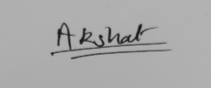
HARSH RAJ
(Enrollment No: S24CSEU0765)

SAMAGRA GULATI
(Enrollment No: S24CSEU0451)


ACKNOWLEDGEMENT
We would like to take this opportunity to express our deepest gratitude to our mentor Prof.
Priyanka Gupta, Assistant Professor SCSET for helping us throughout the project. We were
extremely fortunate to have her as our mentor as she provided insightful solutions to problems
faced by us thus contributing immensely towards the completion of this capstone project.

We would also like to express our deepest gratitude to VC, DEAN, HOD, faculty members and
friends who helped us in successful completion of this capstone project.
Signature of Candidate
SPARSH KUMAR
(Enrollment No: S24CSEU0428)
AKSHAT MADAN
(Enrollment No: S24CSEU0294)
HARSH RAJ
(Enrollment No: S24CSEU0765)

SAMAGRA GULATI
(Enrollment No: S24CSEU0451)


TABLE OF CONTENTS
LIST OF TABLES vi
LIST OF FIGURES vii
LIST OF ABBREVIATIONS viii
ABSTRACT ix
1. INTRODUCTION 1
1.1. Problem Statement 1
2. Background Research 2
2.1. Proposed System 4
2.2. Goals and Objectives 4
3. Project Planning 4
3.1. Project Lifecycle 4
3.2. Project Setup 5
3.3. Stakeholders 5
3.4. Project Resources 5
3.5. Assumptions 6
4. PROJECT TRACKING 6
4.1. Tracking 6
4.2. Communication Plan 6
4.3. Deliverables 8
5. SYSTEM ANALYSIS AND DESIGN 8
5.1. Overall Description 8
5.2. Users and Roles 9
5.3. Design diagrams/Architecture/ UML diagrams/ Flow Charts/ E-R diagrams 9
5.3.1. Product Backlog Items 9
5.3.2. Architecture Diagram 10
5.3.3. Use Case Diagram 11
5.3.4. Class Diagram 12
5.3.5. Activity Diagrams 13
5.3.6. Sequence Diagram 14
5.3.7. Data Architecture 15
6. User Interface 15
6.1. UI Description 15
6.2. UI Mockup 16
7. Algorithms/Pseudo Code OF CORE FUNCTIONALITY 19
8. Project Closure 21
8.1. Goals / Vision 21
8.2. Delivered Solution 21
8.3. Remaining Work 21
• REFERENCES 22

LIST OF TABLES
Table Page
Table 1: Goal and Objectives 4
Table 2: Project Setup Decisions 5
Table 3: Stakeholders 5
Table 4: Project Resources 5
Table 5: Assumptions 6
Table 6: Information Tracking 6
Table 7: Regularly Scheduled Meetings 6
Table 8: Information To Be Shared Within Our Group 6
Table 9: Information To Be Provided To Other Groups 7
Table 10: Information Needed From Other Groups 7
Table 11: Deliverables 8
Table 12: Users and Roles 9

LIST OF FIGURES
Figure Page
Figure 1: Architecture Diagram 10
Figure 2: Use Case Diagram 11
Figure 3: Class Diagram 12
Figure 4: Activity Diagram 13
Figure 5: Sequence Diagram 14
Figure 6: Data Architecture 15
Figure 7: Website Home Page 16
Figure 8: Dashboard 16
Figure 9: Found Items 17
Figure 10: Matched Items 17
Figure 11: Login Page 18
Figure 12: Sign Up Page 18

LIST OF ABBREVIATIONS
Abbreviation | Explanation of the Abbreviation
AI | Artificial Intelligence
API | Application Programming Interface
CSS | Cascading Style Sheets
ML | Machine Learning
NLP | Natural Language Processing
ORM | Object-Relational Mapping
SQL | Structured Query Language
UI | User Interface
UX | User Experience

ABSTRACT
This project is about a lost-and-found system called FindIt. FindIt helps people find the things
they lost easily and quickly. We often lose things like our wallets, mobile phones, bags and
documents in our daily life. It is hard to find these things because there is no way to share
information about lost and found things.

The main goal of this project is to make a system that can understand what people say about the
things they lost and match them in a way. The system uses a kind of computer model to
understand what people write about their lost things. This model does not just look for words it
tries to understand what the words mean. So even if people use words to describe the same thing
the system can still match them.

Here is how the system works. First people write about the things they lost. Then the system
turns this writing into numbers. Compares it to other writings about lost things. The system
suggests matches between lost and found things based on how similar they are. This way the
system is more accurate and better, than systems that just look for exact words.

The FindIt system is made to be fast and easy to use. Anyone can use it without getting confused.
The results show that using this computer model makes it easier to match lost things and find
them faster.

Overall this project shows how computers can help solve problems. It helps people find the
things they lost and makes it easier to use every day. The FindIt system is an example of how
artificial intelligence can be used to make our lives better.
- INTRODUCTION
Bennett University sees crowds of students and teachers flowing through lecture halls, study zones, and shared spaces every single day. Belongings - phones, USB drives, ID cards, notebooks - often get left behind without warning. Right now, tracking them down means hopping between scattered Facebook posts, checking in with office workers at different counters, or scanning paper notices tacked to walls. No unified method exists, so messages vanish into silence, names go unmatched with objects. Lost things linger unseen, while those searching circle back again and again with nothing new. A tool called FindIt steps in here, built quietly beneath the noise - a live network that tracks each item from loss to return. Its job? Turn chaos into quiet order, one found thing at a time.
  - Problem Statement
Out here on campus, tracking down missing stuff means sifting through cluttered messages and endless scrolling. One moment it's mentioned in a chat, then buried under noise - gone without a trace. When someone finds something, good luck getting it back; nobody sees the post at the right time. What kicks in now? A scattered mess instead of one clear place to look. Imagine if every report linked up automatically - the moment a match appears, both sides get alerted. Hidden patterns in timing, location, even item type could connect dots humans miss. Security matters too - no handing things over blindly, verification built into each step. Instead of shouting into the void, people would actually find what they lost. Not magic. Just smarter flow.

- Background Research
Out of nowhere, gaps in old-style lost-and-found setups sparked a closer look at how stuff goes missing on college grounds. From that point on, digging through past studies became key - especially those touching digital facility tools and smart search methods. One thing led to another when machine learning entered the picture, showing how meaning in text could be matched without heavy manual work. Instead of sticking to rigid systems, the idea grew to blend live web frameworks with responsive AI tricks. After a while, it became clear: tying these pieces together might just handle the chaos of crowded campuses better than anything before.
The Inefficiencies of Traditional and Fragmented Recovery Systems
On big college grounds, losing things like phones or student IDs happens all the time. Instead of one central spot, found items go to different places - like libraries, admin buildings, or security posts - spread out across campus. Because each location handles things separately, there's no shared system to track what’s been turned in (“Lost And Found Management System,” 2026). People looking for their stuff usually have to walk around checking each desk by hand. This takes effort. For smaller losses, many students just give up early since it feels too slow and scattered.
When students can’t reach each other in person, they often scatter across separate online spots - like messy WhatsApp chats, random Facebook posts, or small Discord corners. Yet research shows vital details vanish fast in nonstop message flows (Soumya et al., 2024). A note about something missing gets swamped just minutes later by off-topic chatter, making follow-ups nearly impossible. Without one clear place to log these things digitally, forgotten items pile up around campus. Space goes unused. People grow annoyed.
Limitations of Early Digital Solutions and Lexical Text Matching
First tries to move lost-and-found work online started with simple websites using database setups. Reports came in through forms, then searches ran using basic SQL or word-by-word comparisons to find matches. Tools like the Jaccard index popped up early, counting shared words between two texts divided by total unique terms. Fast and lean on processing power, those methods worked only when wording lined up exactly. Trouble is, small changes in how people describe things broke the whole process - meaning stayed hidden even if descriptions were close. Understanding phrasing differences? That part never stood a chance.
One person sees a thing one way. A student could call something they lost a black leather billfold. Someone else who finds it may write down dark wallet instead. Words shift meaning depending on who speaks. Matching systems that only check shared words miss connections like this. These tools count terms or weigh them by rarity. They see different phrases as unrelated. The link between similar ideas stays hidden. That gap causes missed matches. An item remains unclaimed because labels do not align (TF-IDF vs. Embeddings: From Keywords to Semantic Search - PyImageSearch, n.d.). Simple word-by-word checks cannot handle how people really talk. Relying just on keywords breaks the process before it starts.

Evolution of Information Retrieval: Machine Learning and Semantic Embeddings
Fixing word mismatch issues has pushed new tools in language tech beyond simple keywords toward meaning-based comparisons. Because of breakthroughs in how machines interpret sentences, systems now grasp full contexts at once instead of piece by piece. While past methods read line by line, current designs take in whole phrases together. These newer models build richer views of structure and sense through parallel analysis. Their power comes largely from architectural shifts introduced by transformer networks (Vaswani et al., 2017).
Today’s software often uses transformer models to turn written text into complex number patterns called embeddings. Instead of words, these become points in space so programs can measure how alike they are - usually through angles via Cosine Similarity. Even if two phrases share zero identical terms, their numeric forms may sit right next to each other; consider “black leather billfold” sitting near “dark wallet.” Research on real-world natural language processing shows such learned representations greatly boost accuracy when linking messy, freeform entries made by people (Reimers & Gurevych, 2019). Systems tapping into this method spot strong matches automatically, cutting out manual checks altogether.
Scalable Web Architecture and Secure Verification
Away from how matches are made, running a tool across an entire campus needs software that handles many users at once without breaking or exposing data. Recent writings about building websites today point out splitting the visual part from hidden services helps systems grow smoothly (A Jartarghar et al., 2022). Pairing Next.js with React brings server-rendered pages into play, cutting down load times - a key factor when pushing instant alerts through spotty phone connections.
Staying on top of who owns what means guarding every bit of info like it matters - because it does. Anyone trying to grab something they should not have needs to hit a wall right away. Proving someone is really who they say requires tight rules: strong password handling, layers of checks, plus eyes-on approval before anything changes hands. Tools like Drizzle help organize how people, reports, claims, and messages link together behind the scenes. Running that setup on solid cloud-backed databases such as Supabase keeps everything running without leaks or lapses (Fathima Sanjeetha et al., 2025).
Motivation for the Project
This research shaped how FindIt came together. Not seeing useful results from scattered methods pushed us toward a single hub using Next.js at Bennett University. Keyword searches often miss what people really mean - so we added a modern ML transformer model that captures intent through semantic patterns. Trust matters when returning lost items - which is why tools like NextAuth guard user data without slowing down smart matches.

  - Proposed System
Something called FindIt runs on Next.js and handles every step of finding lost things without help. When people report something missing or discovered, they add pictures and details. Right after sending that in, the system turns descriptions into smart codes using a powerful language model. These codes get compared behind the scenes, spotting likely matches in moments. If a match looks strong, rightful owners prove ownership securely. Then, finders and owners talk straight through built-in messages to return what was lost.

  - Goals and Objectives
Table 1: Goal and Objectives
# | Goal or Objective
1 | Centralize all campus lost-and-found reports into a single, highly searchable database.
2 | Automate the matching process using machine learning semantic text embeddings to reduce manual searching.
3 | Ensure security and prevent false claims by implementing robust user authentication (NextAuth) and claim verification protocols.
4 | Provide a seamless, responsive, and intuitive user interface using modern React and Tailwind CSS frameworks.

- Project Planning
  - Project Lifecycle
Week by week, progress unfolded through short cycles of work lasting fourteen days. Starting with visuals and user flows, then moving to how data would be structured behind the scenes. Next came building the main parts - what users see plus the systems that power it. Afterward, tools that learn from data were woven into the structure. Testing for safety happened last, before everything went live.
  - Project Setup
Table 2: Project Setup Decisions
# | Decision Description
1 | Frontend: Next.js 16, React 19, Tailwind CSS 4, shadcn/ui
2 | Backend: Next.js API Routes, NextAuth v5 for Authentication
3 | Database: PostgreSQL managed via Drizzle ORM, hosted on Supabase
4 | Version Control: Git & GitHub for collaborative development

  - Stakeholders
Table 3: Stakeholders
Stakeholder | Role
Prof. Priyanka Gupta | Mentor
Sparsh Kumar | Project Lead / Full-Stack & Architecture
Akshat Madan | Backend Developer / Security & Auth
Harsh Raj | Frontend Developer / UI Integration
Samagra Gulati | DevOps & Testing / Query Engine
University Students | End Users

  - Project Resources
Table 4: Project Resources
Resource | Resource Description | Quantity
Supabase | Cloud PostgreSQL Database and Backend Services | 1
Vercel | Global Frontend Edge Deployment Platform | 1
Dev Workstations | Laptops for local coding, testing, and deployment | 4

  - Assumptions
Table 5: Assumptions
# | Assumption
A1 | Users possess smartphones or computers to access the web application.
A2 | Users will provide honest and reasonably detailed descriptions of items.
A3 | The initial deployment will be restricted to the Bennett University campus ecosystem.

- PROJECT TRACKING
  - Tracking
Table 6: Information Tracking
Information | Description
Code Storage | Source code versioning and collaboration managed via GitHub Repository.
Communication | Internal team messaging via WhatsApp/Discord; formal updates via Email.

  - Communication Plan
Table 7: Regularly Scheduled Meetings
Meeting Type | Frequency/Schedule | Who Attends
Team Sync | Bi-Weekly | Project Team
Mentor Review | Weekly | Project Team and Mentor

Table 8: Information To Be Shared Within Our Group
Who? | What Information? | When? | How?
Project Team | Task assignments & sprint progress | Weekly | Team meetings & WhatsApp group
Project Team | Code commits and pull requests | As needed | GitHub repository
Project Team | UI/UX mockups and database schemas | Start of sprint | Figma and draw.io links

Table 9: Information To Be Provided To Other Groups
Who? | What Information? | When? | How?
Mentor (Prof. Priyanka Gupta) | Weekly progress reports & blockers | Weekly | In-person meeting or Email
Mentor (Prof. Priyanka Gupta) | Final project deliverables | End of semester | Email, GitHub link, and Live Demo

Table 10: Information Needed From Other Groups
Who? | What Information? | When? | How?
Mentor (Prof. Priyanka Gupta) | Feedback on architecture and UI design | Start of each phase | In-person meeting
Mentor (Prof. Priyanka Gupta) | Final approval of project report | End of semester | Email / Document review

  - Deliverables
This section identifies the major deliverables that the FindIt project team is expected to produce by the end of the development lifecycle.
Table 11: Deliverables
# | Deliverable
1 | Fully functional and deployed FindIt web application
2 | Complete source code hosted on GitHub
3 | Final Project Report (Word Document)
4 | Final Project Presentation (PowerPoint)
5 | Video demonstration of the working application

- SYSTEM ANALYSIS AND DESIGN
  - Overall Description
Right away, once someone signs in and files a report - marked either Lost or Found - the system saves everything into PostgreSQL. FindIt runs on an ongoing loop of connected data transfers. Right after storage, the Next.js API kicks off a silent task: a transformer model reviews the written details and records its findings. At that same moment, comparisons begin. The Custom Similarity Engine measures how closely this new entry matches older ones, assigning match likelihoods each time. Data keeps moving without pause. When a match shows up, the system adds it to the matches table, sending live alerts straight to both users. From there, the person who lost the item starts a claim by proving they own it - like answering secret questions. That info goes to the finder, who checks it carefully before saying yes. Communication happens through the messages table, setting up when and where they meet in person.

  - Users and Roles
Table 12: Users and Roles
User | Description
User (Finder) | Reports an item they have found on campus, sets verification security questions, and reviews claims.
User (Loser) | Reports an item they have lost, receives algorithmic match alerts, and submits claims to recover items.
System Admin | Maintains the database, monitors the ML pipeline, and manages platform security.

  - Design diagrams/Architecture/ UML diagrams/ Flow Charts/ E-R diagrams
    - Product Backlog Items
- As a student, I want to report a lost item with a photo so that others can easily identify it.

- As a finder, I want to set a verification question so that I can ensure I return the item to the true owner.

- As a user, I want the system to automatically notify me if a matching item is found so that I don't have to check the app every day.

    - Architecture Diagram
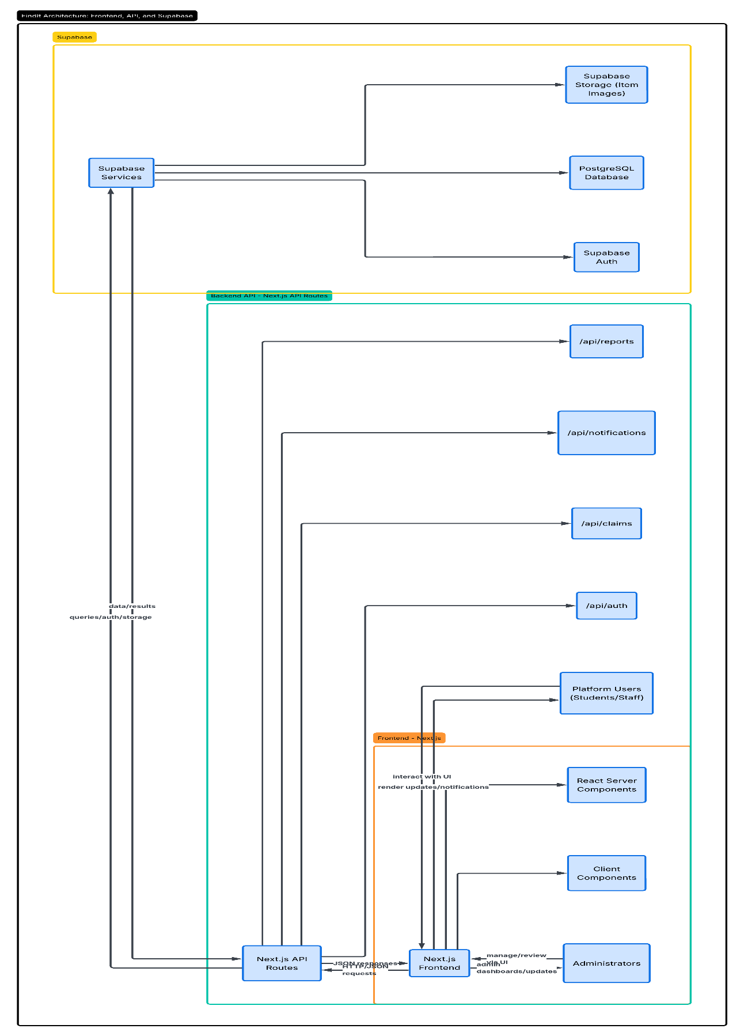
Figure 1: Architecture Diagram
    - Use Case Diagram
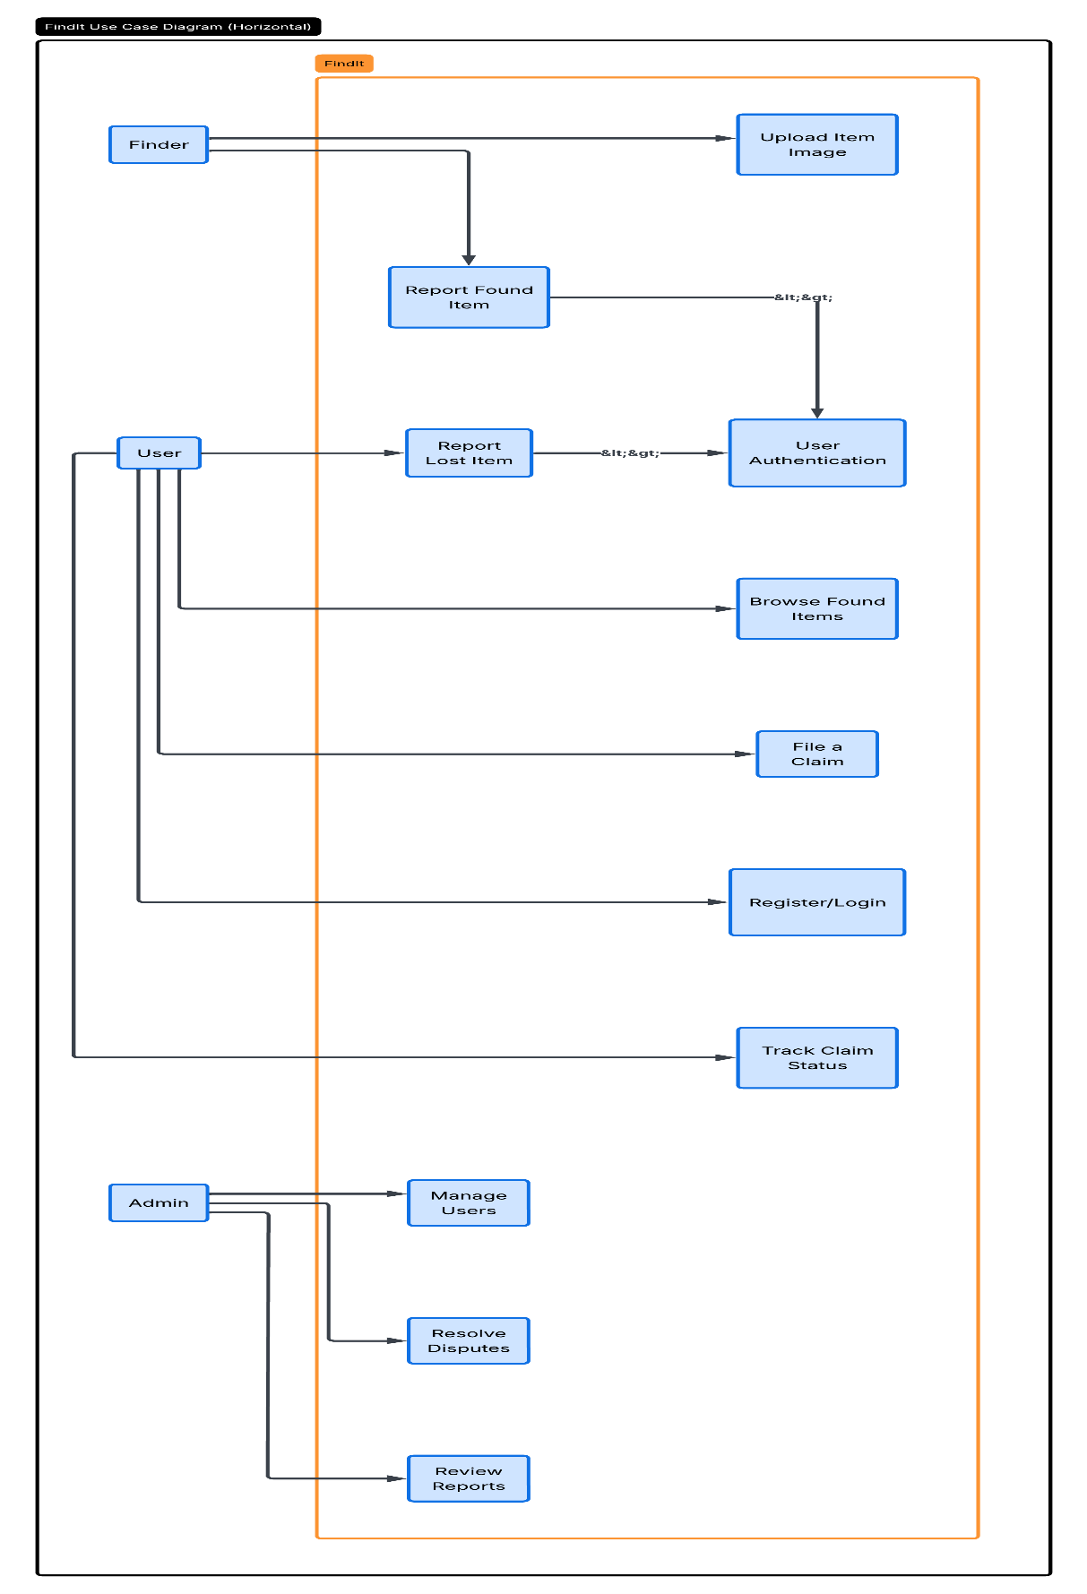
Figure 2: Use Case Diagram
    - Class Diagram
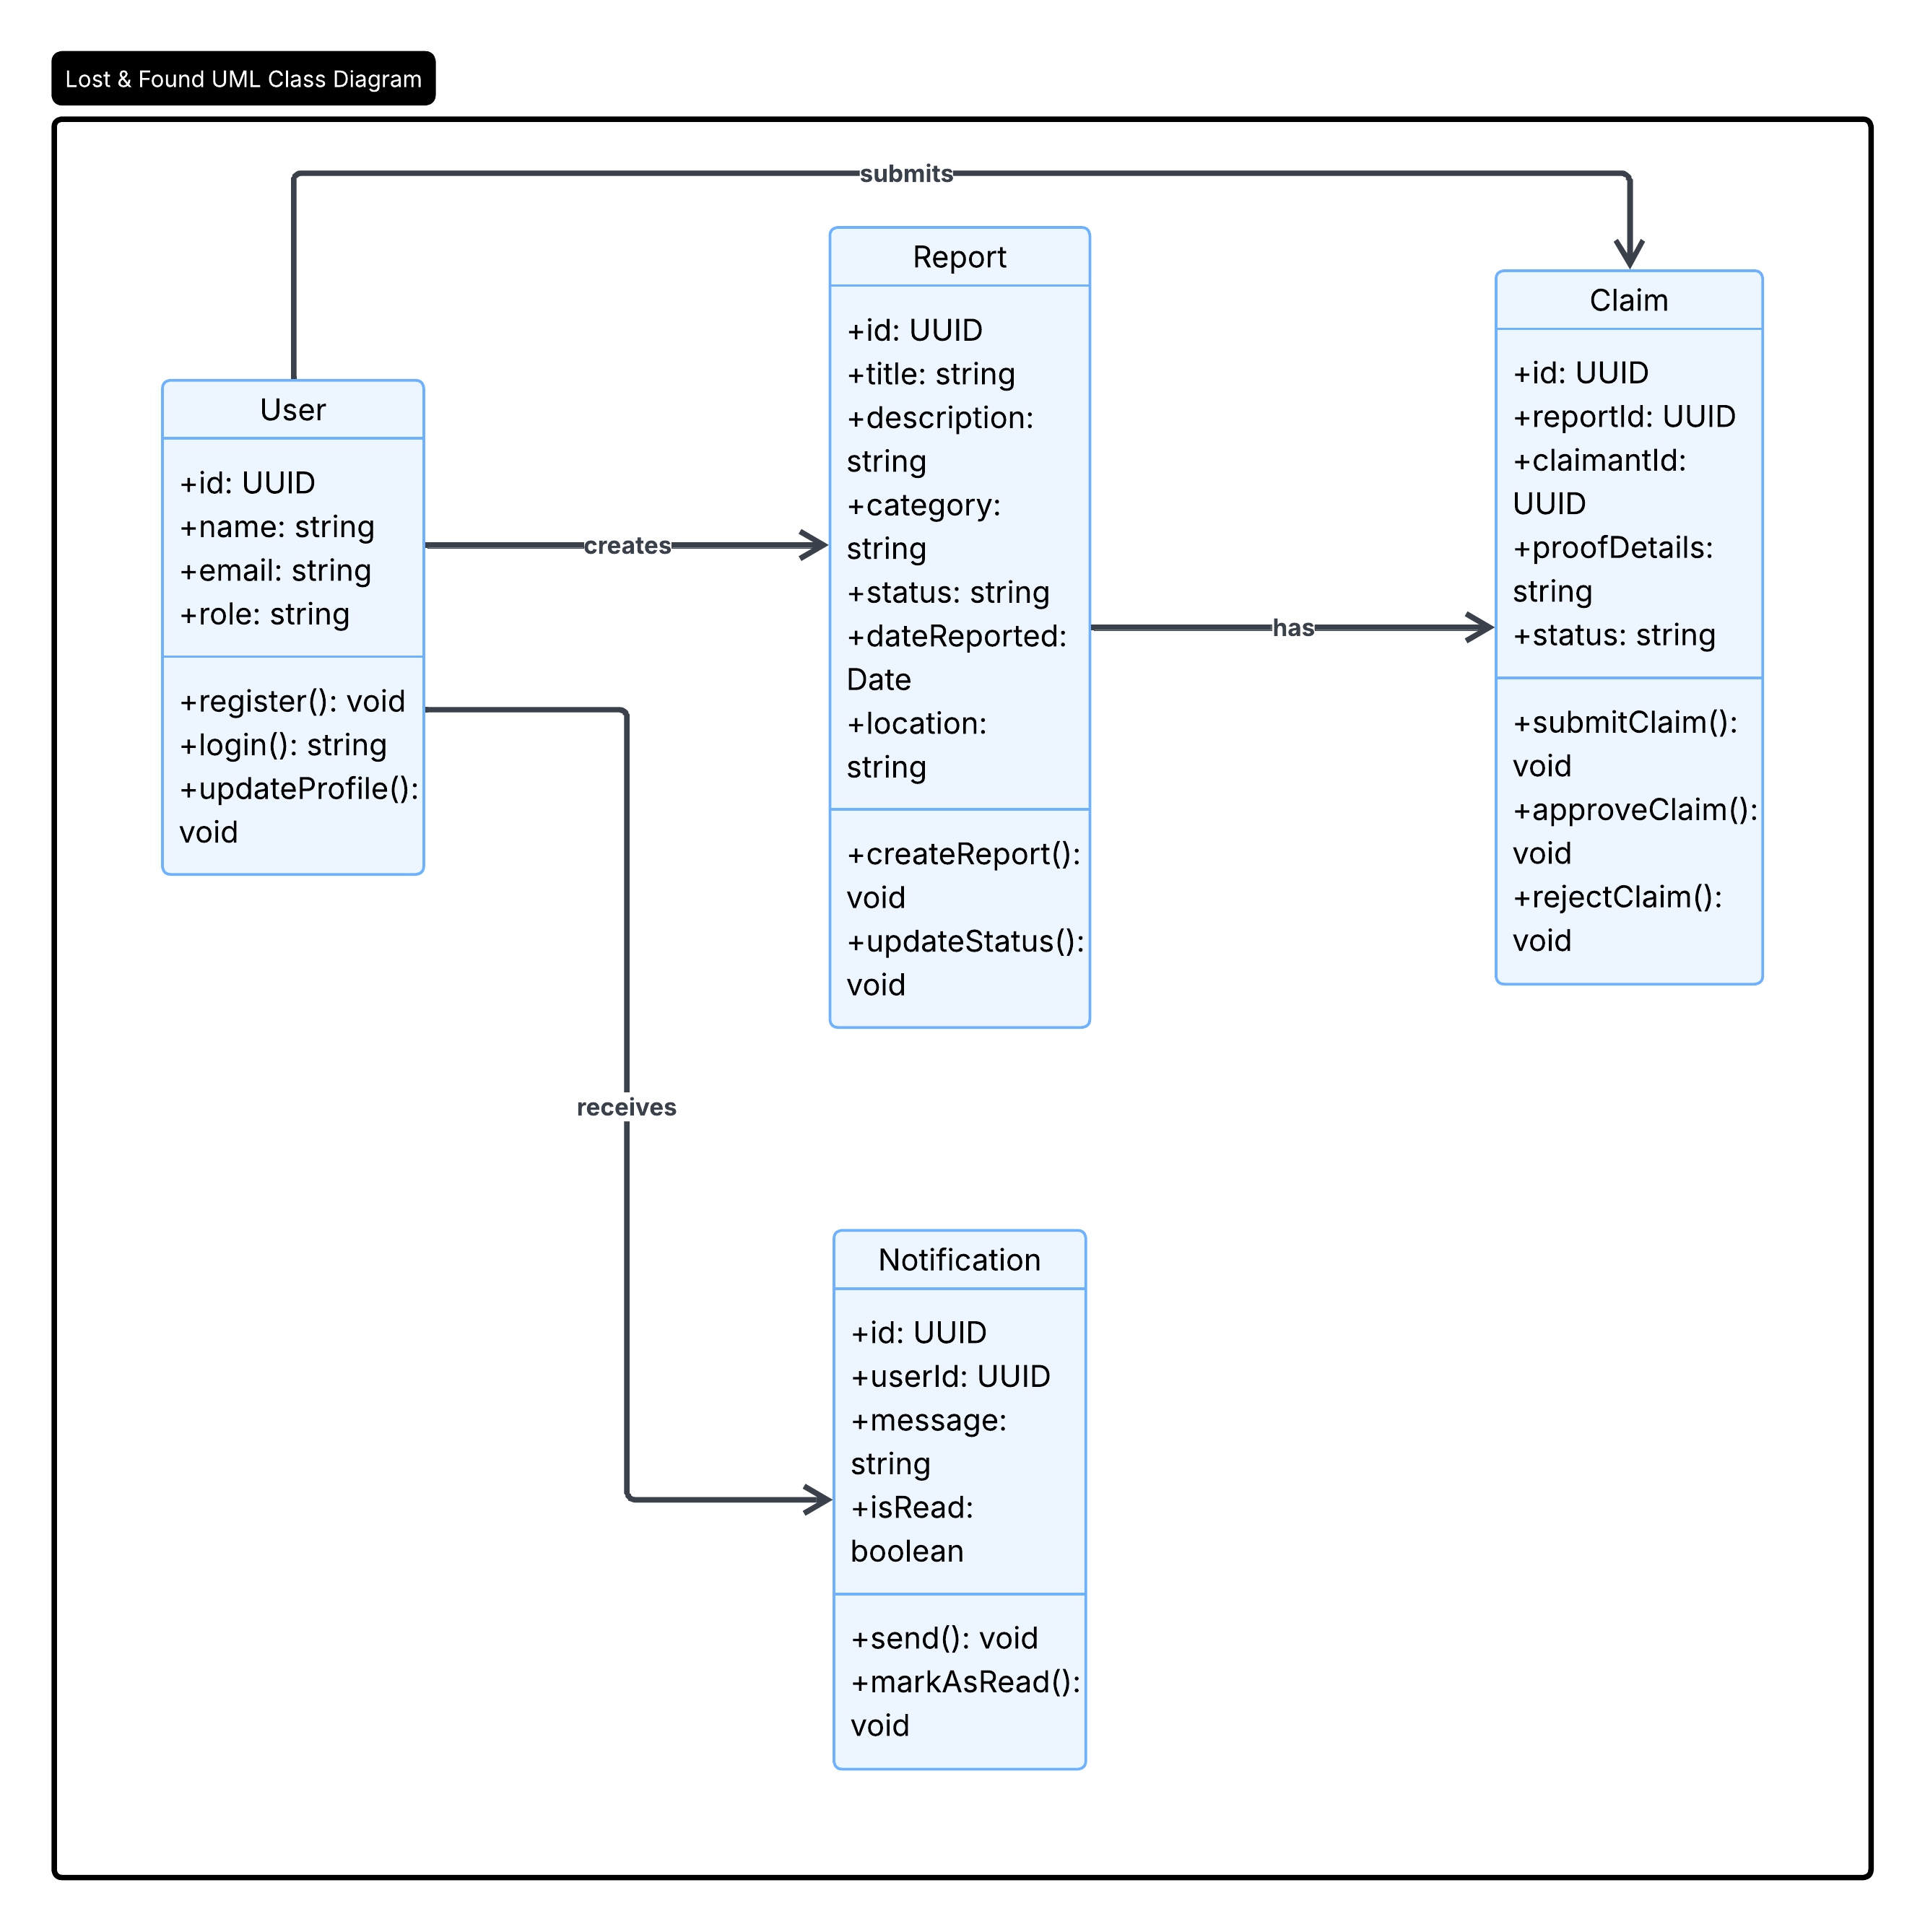
Figure 3: Class Diagram

    - Activity Diagrams
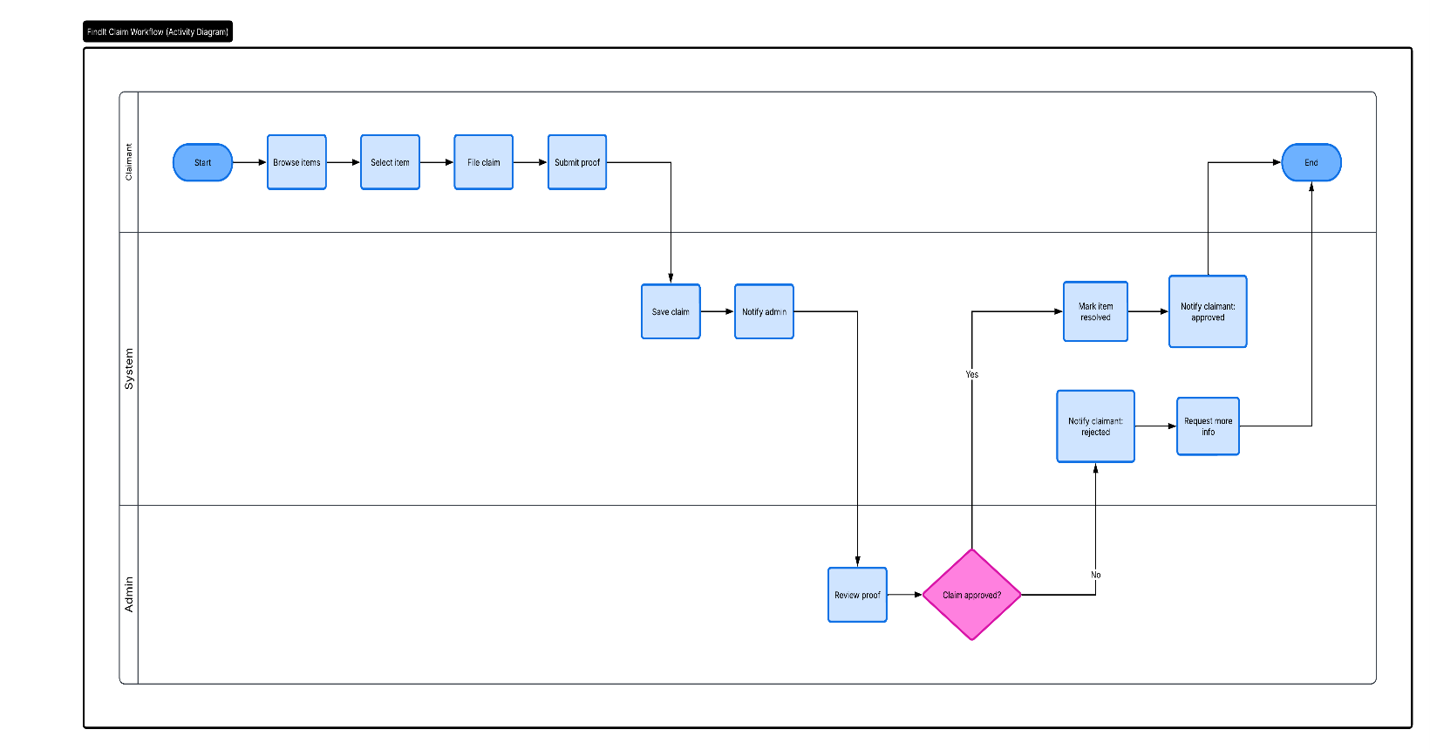
Figure 4: Activity Diagram

    - Sequence Diagram
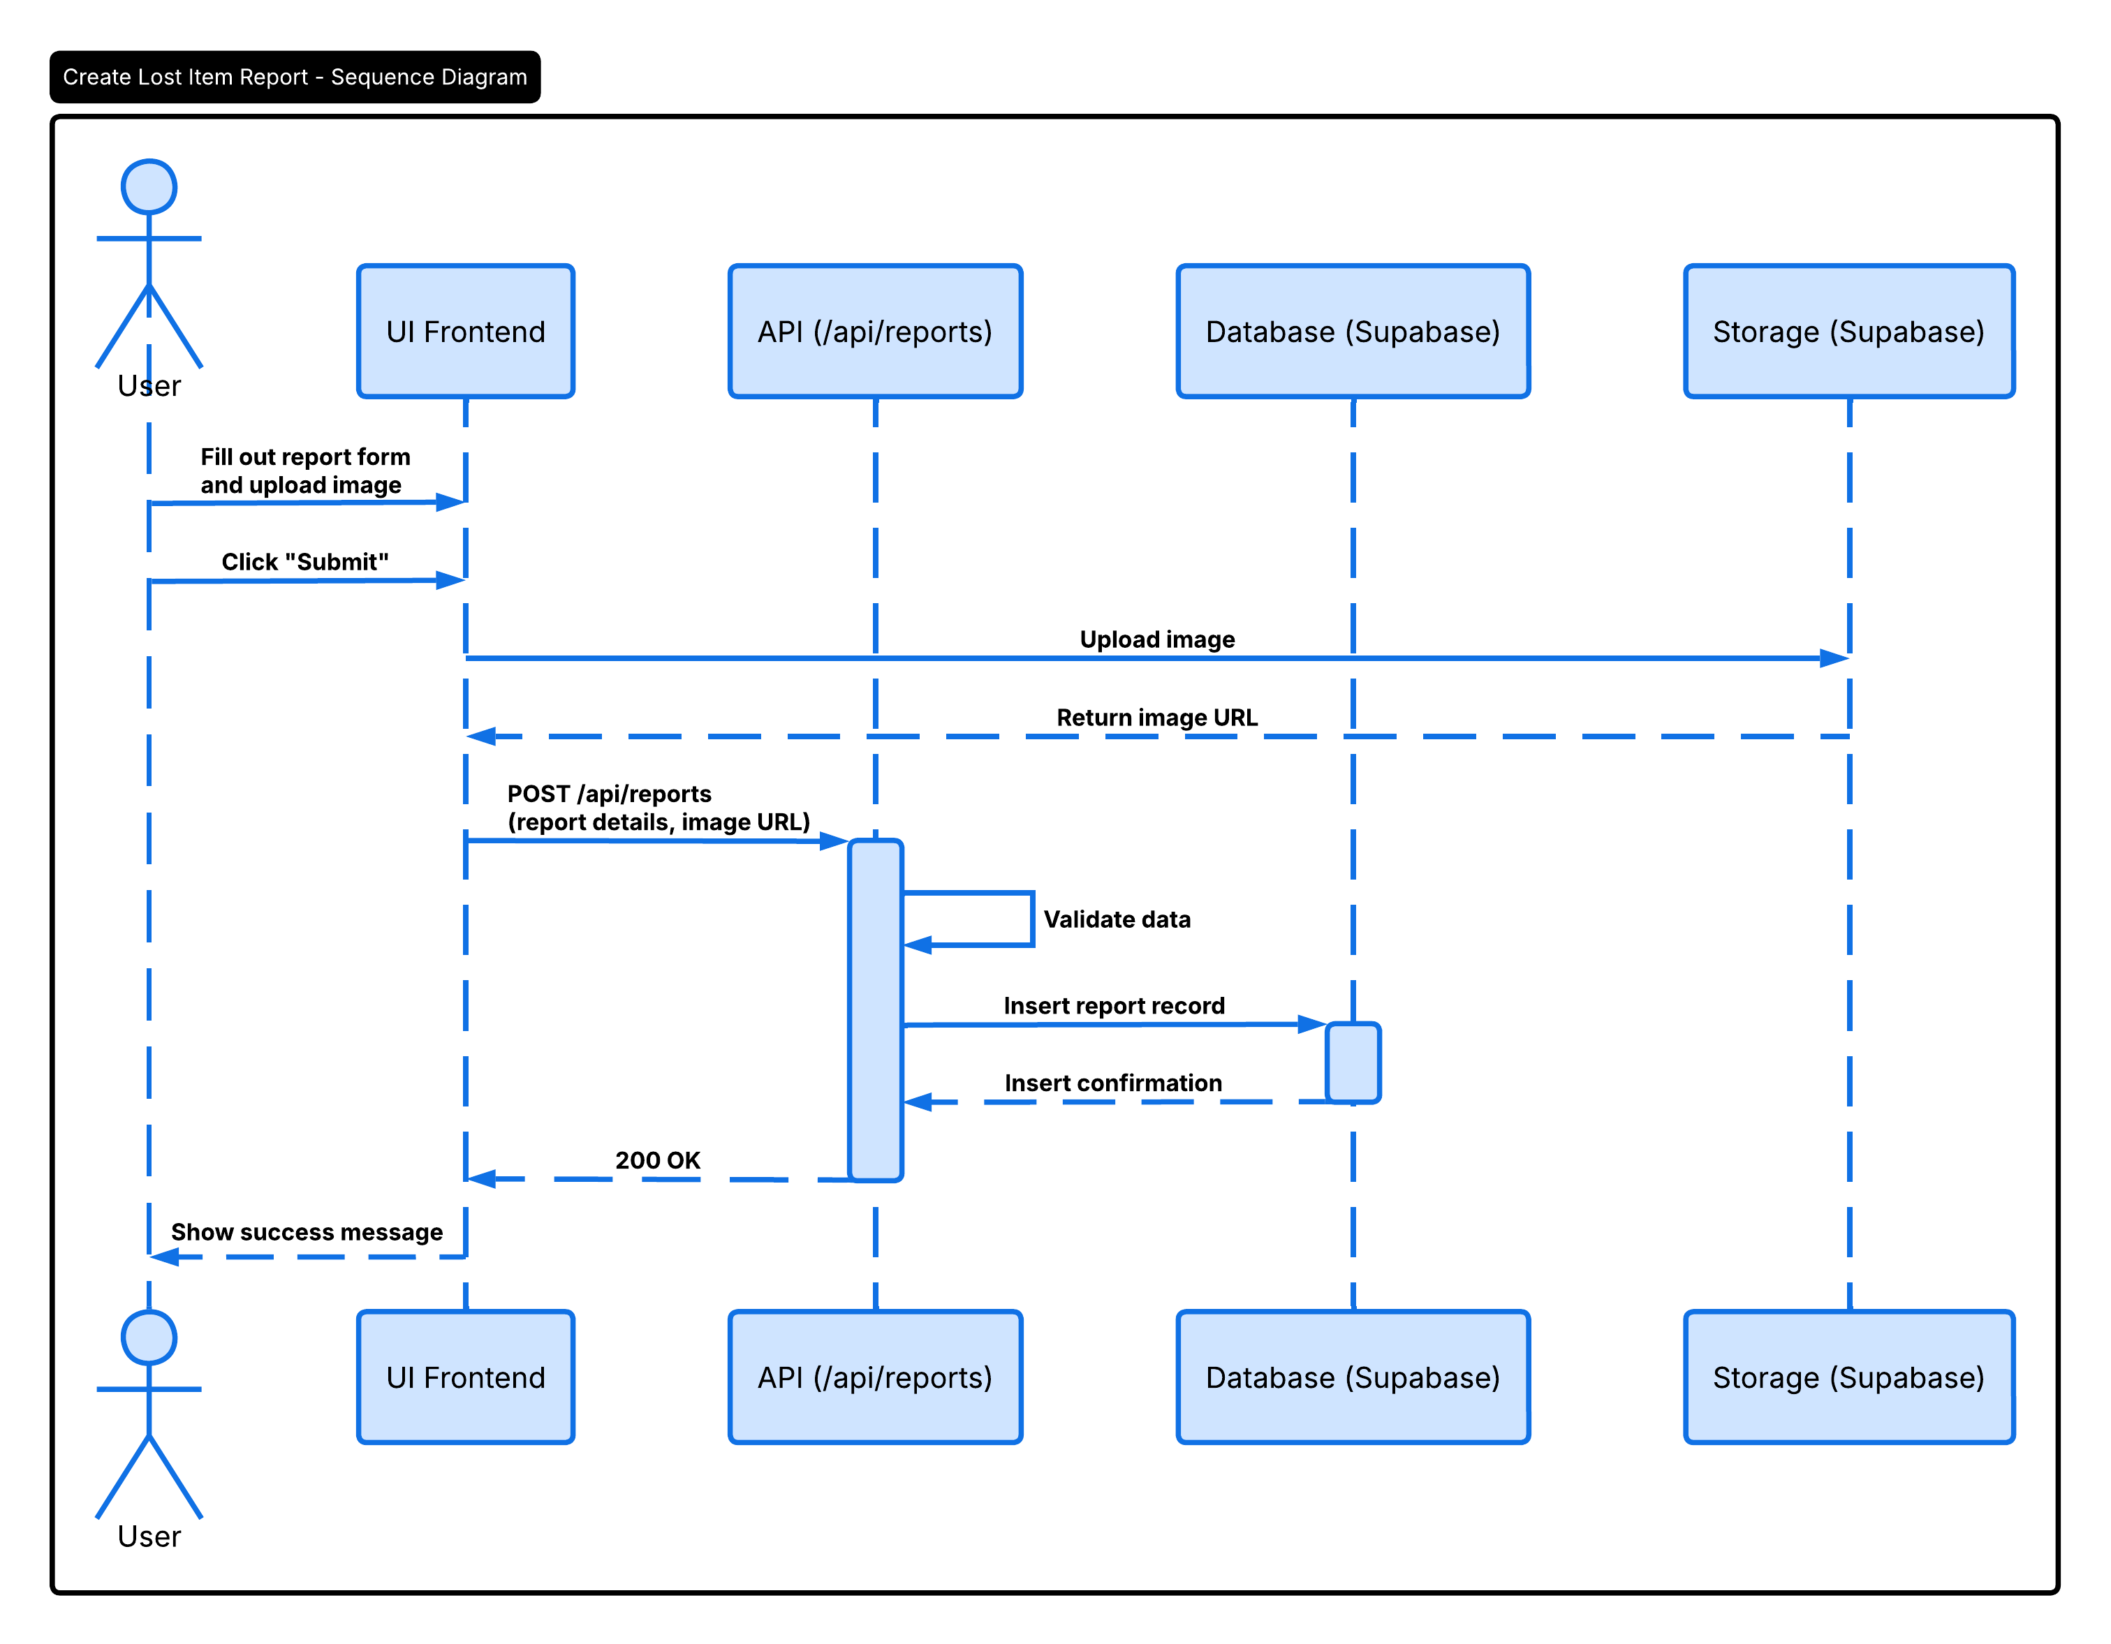
Figure 5: Sequence Diagram

    - Data Architecture
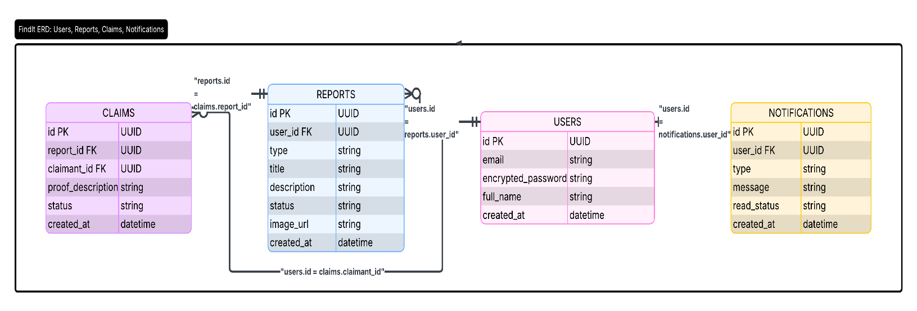
Figure 6: Data Architecture

- User Interface
  - UI Description
Speed and clear layout shape how FindIt looks and works, following clean, current design ideas. Running on Next.js 16 and React 19, it takes form through Tailwind CSS paired with shadcn/ui parts. On phones or computers, everything adjusts smoothly, no matter the screen. Access begins at a protected sign-in point, built for safety first. Reporting something lost unfolds through smart forms - pick types that shift as needed, drop photos right into place. Each person gets their own space to watch over submitted requests, updated in real time. Elsewhere, a shared view lays out discovered objects in a scrollable lineup, open to all who look.
  - UI Mockup
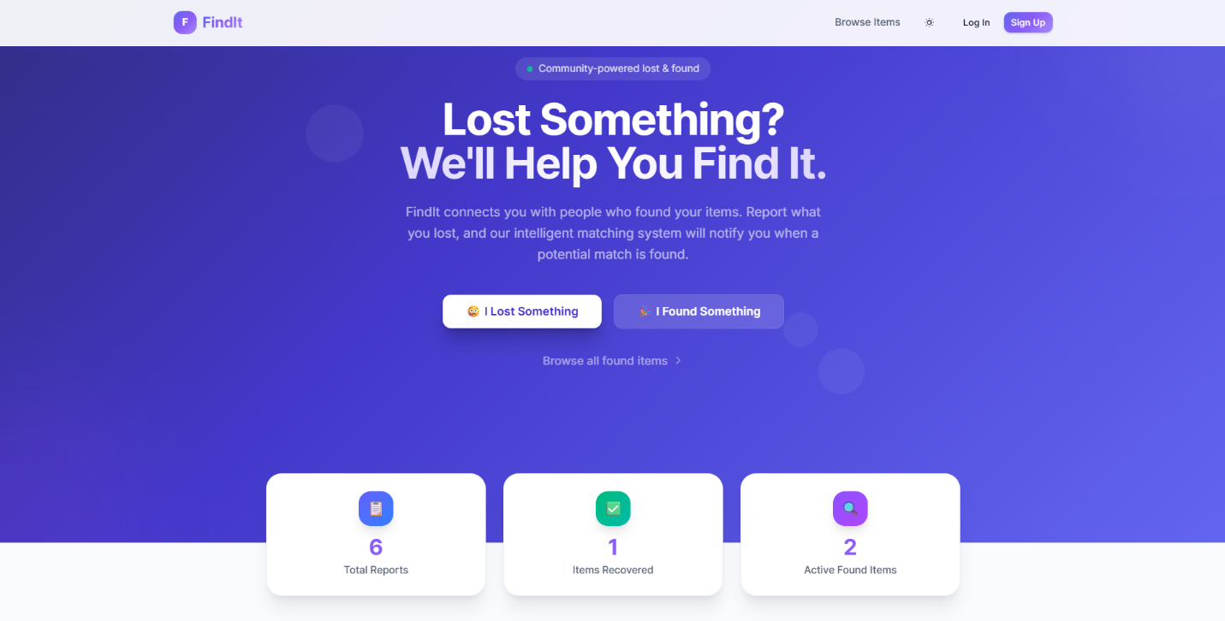
Figure 7: Website Home Page
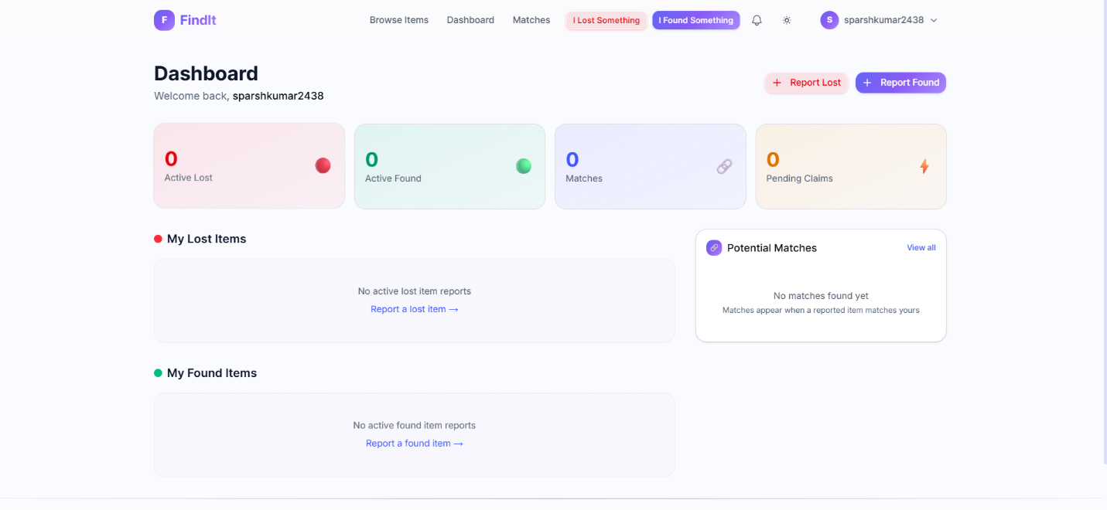
Figure 8: Dashboard

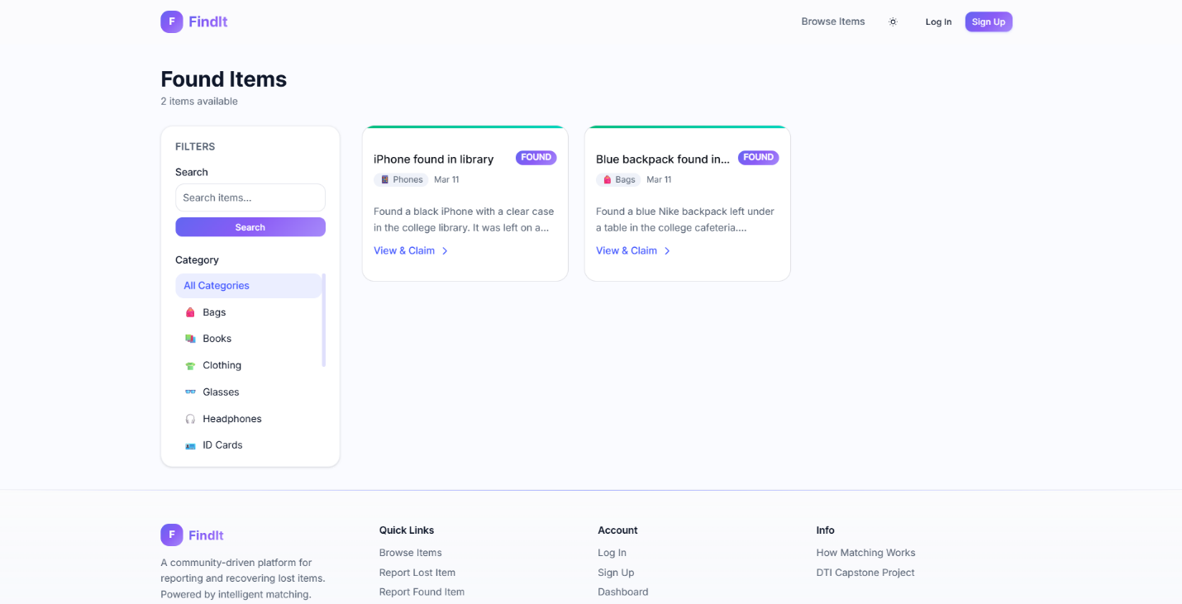
Figure 9: Found Items
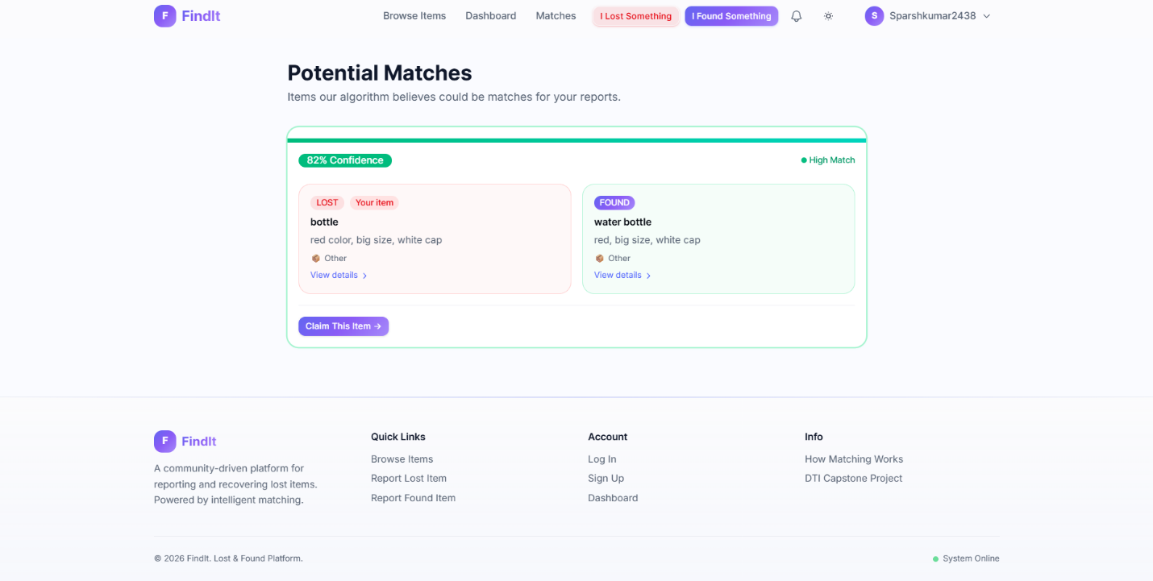
Figure 10: Matched Items
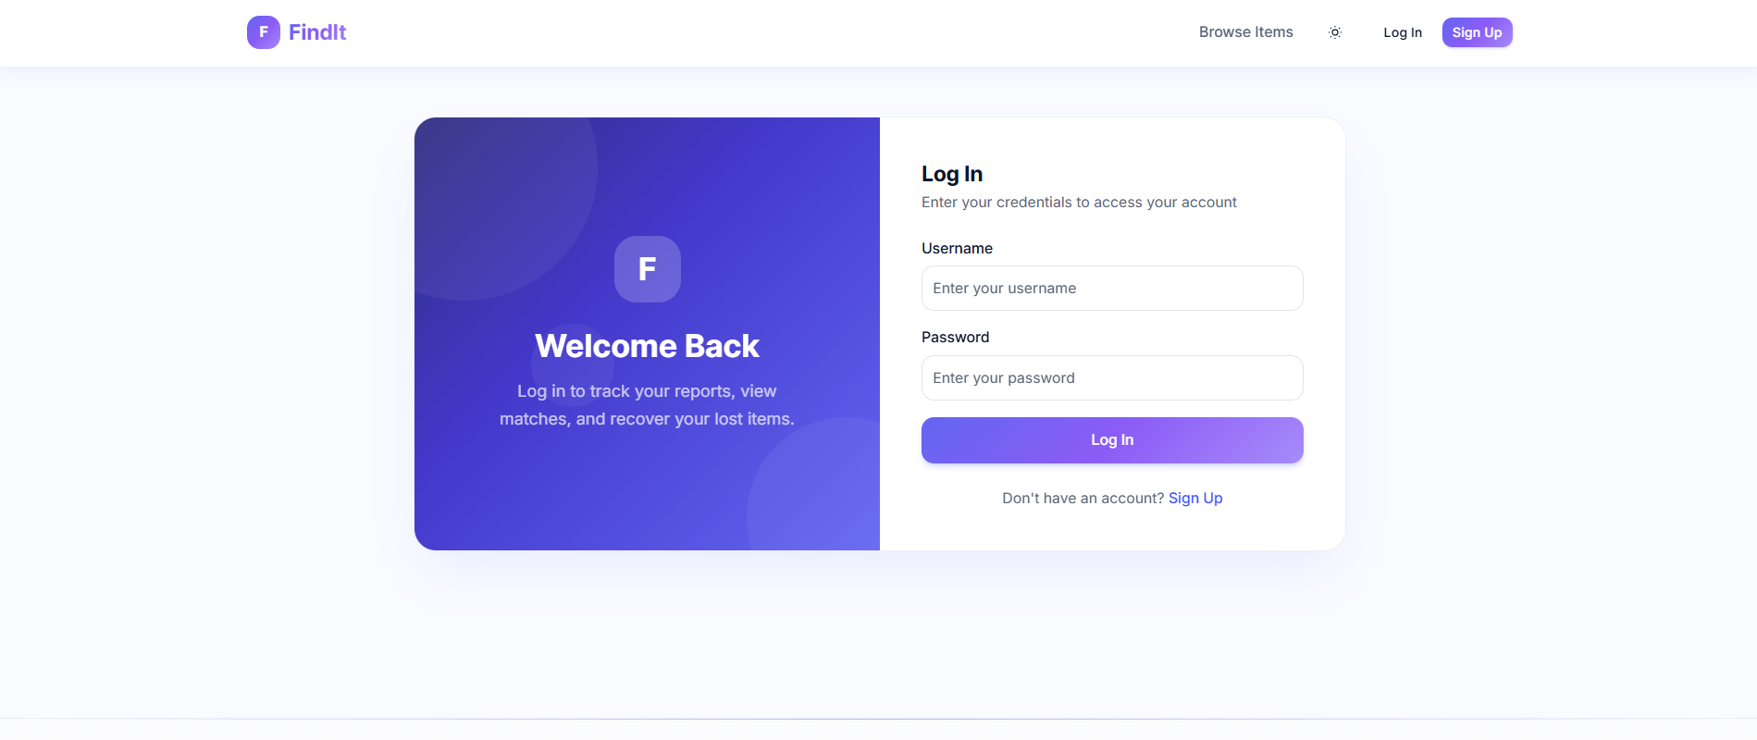
Figure 11: Login Page
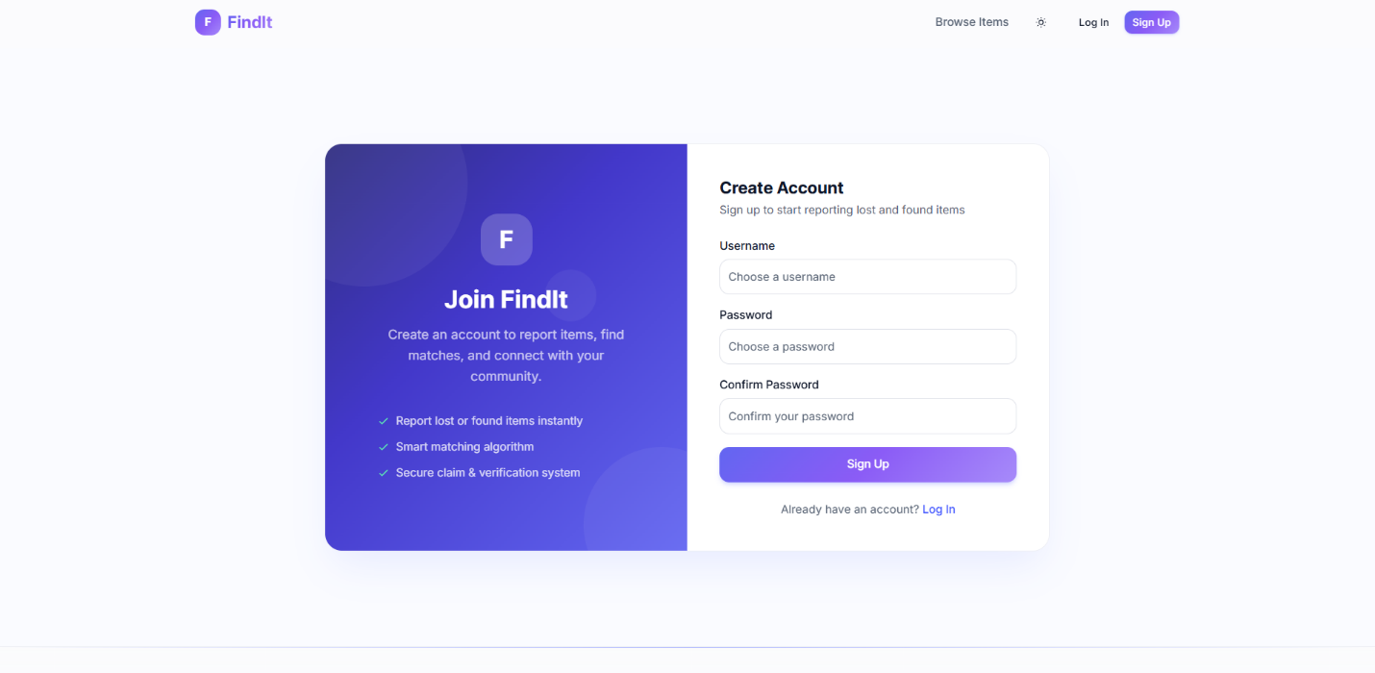
Figure 12: Sign Up Page

- Algorithms/Pseudo Code OF CORE FUNCTIONALITY
Matching Algorithm
report = load report by id
if report missing or status != ACTIVE: return
oppositeType = report.type == LOST ? FOUND : LOST
candidateReports = load active reports where type == oppositeType
reportEmbedding = parse JSON(report.embedding) if present
for each candidate in candidateReports:
score = calculateMatchScore(report, candidate, reportEmbedding)
if score >= 50:
lostReportId = report.type == LOST ? report.id : candidate.id
foundReportId = report.type == FOUND ? report.id : candidate.id
upsert matches table:
lostReportId, foundReportId, confidenceScore = score
createNotification(to report.userId, MATCH, message)
createNotification(to candidate.userId, MATCH, message)

Match Scoring
categoryScore = reportA.categoryId == reportB.categoryId ? 30 : 0
if reportAEmbedding exists:
reportBEmbedding = parse JSON(reportB.embedding) if available
if reportBEmbedding exists:
cosine = cosineSimilarity(reportAEmbedding, reportBEmbedding)
similarityScore = round(max(0, cosine) * 55)
else:
similarityScore = round(jaccardSimilarity(textA, textB) * 55)
else:
similarityScore = round(jaccardSimilarity(textA, textB) * 55)
timeDiffDays = abs(reportA.lostFoundDate - reportB.lostFoundDate) in days
timeScore =
15 if days <= 1
10 if days <= 3
5 if days <= 7
2 if days <= 14
0 otherwise
return categoryScore + similarityScore + timeScore

- Project Closure
  - Goals / Vision
What started as an idea - turning old bulletin boards into something digital - turned real. Not just stored online, each found object gets matched through smart automation instead of waiting around. Built with careful code logic, the system runs mostly on its own. Matching happens behind the scenes, quietly, without needing constant oversight. A quiet engine powers it, not flash or noise. What matters is that things get back where they belong.
  - Delivered Solution
Out of nowhere, the group shipped a full-stack app that grows without breaking. Built right into it sits safe logins using bcryptjs and NextAuth. A strong PostgreSQL setup runs through Drizzle for data storage. Up front, users find their way around easily on a clean dashboard. Hidden underneath, smart matches form automatically thanks to text embeddings guided by machine learning. Jaccard similarity helps fine-tune those connections behind the scenes.
  - Remaining Work
Later versions might wrap the web app in a mobile layer, using tools like React Native or Flutter, so alerts go straight to phones. Pushing past basic features, deeper category systems could take shape - giving structure to more kinds of data. On top of that, school managers may get broad overview screens, showing activity across the entire campus. These additions sit quietly but stretch how far the system can reach.
- REFERENCES
- A Jartarghar, H., Rao Salanke, G., A.R, A. K., G.S, S., & Dalali, S. (2022). React Apps with Server-Side Rendering: Next.js. Journal of Telecommunication, Electronic and Computer Engineering (JTEC), 14(4), 25–29. https://doi.org/10.54554/JTEC.2022.14.04.005

- Fathima Sanjeetha, M. B., Sumathipala, P., Miurusari Siriwardane, M. S., & Prabhashini Kumari Rajakaruna, R. J. (2025). Database-as-a-Service (DBaaS) in Cloud Computing: Security Issues and Policies. Asian Journal of Computer Science and Technology, 14(1), 16–20. https://doi.org/10.70112/ajcst-2025.14.1.4322

- Lost And Found Management System. (2026). International Journal of Research in Engineering and Science (IJRES) ISSN, 14, 96–103. www.ijres.org

- Reimers, N., & Gurevych, I. (2019). Sentence-BERT: Sentence Embeddings using Siamese BERT-Networks. EMNLP-IJCNLP 2019 - 2019 Conference on Empirical Methods in Natural Language Processing and 9th International Joint Conference on Natural Language Processing, Proceedings of the Conference, 3982–3992. https://doi.org/10.18653/v1/D19-1410

- Soumya, M., Zoya Mehak, S., Vinod Chandra, V., Saamrat, P., & Bandi, S. (2024). Campus Lost: Connect and Recover. International Journal of Engineering Technology and Management Sciences Website: Ijetms.in Issue, 3. https://doi.org/10.46647/ijetms.2024.v08i03.018

- TF-IDF vs. Embeddings: From Keywords to Semantic Search - PyImageSearch. (n.d.). Retrieved April 14, 2026, from https://pyimagesearch.com/2026/02/09/tf-idf-vs-embeddings-from-keywords-to-semantic-search/

- Vaswani, A., Brain, G., Shazeer, N., Parmar, N., Uszkoreit, J., Jones, L., Gomez, A. N., Kaiser, Ł., & Polosukhin, I. (2017). Attention Is All You Need. 1. https://arxiv.org/pdf/1706.03762

