**Appendix -A**

**CERTIFICATE**

This is to certify that **Mr. Akshay Dashrath Gitte, Mr. Harsh Moreshwar Kale, Mr. Omanand Prashant Swami, Mr. Prathmesh Santosh Bavage** from Shri Vishweshwarayya Abhiyantriki Padvika Mahavidyalaya, Almala Institute having Enrollment No: 2110950049, 2110950051, 2110950050, 2110950062 has completed projectof finalyearhaving title **“VPolyServer – An Integrated Platform for Polytechnic Education.”** During the academic year 2023-2024. The project completed in a group consisting of **04** personsunder the guidance of the Faculty Guide.

Name & Signature of Guide:

**Mr. Sugre D.D.**

**Appendix-B**

**PROGRESSIVE ASSESSMENT (PA) OF CAPSTONE PROJECT – EXECUTION**

**AND REPORT WRITING**

**Evaluation Sheet (ESC) For Internal Assessment**

**Name of Student: Mr. Akshay Dashrath Gitte, Mr. Harsh Moreshwar Kale, Mr. Omanand Prashant Swami, Mr. Prathmesh Santosh Bavage** .

**Name of Program: -** Computer Engineering. **Semester:** Sixth

**Course Title and code: -** Capstone Project: Execution and Report Writing **Code:22060.**

**Title of the Capstone Project:** “**VPolyServer – An Integrated Platform for Polytechnic Education**”

1. **POs addressed by the Capstone Project (Mention only those predominant POs)**
2. Computer Software and Hardware Usage: Use state-of-the-art technologies for operation and application of computer Software and Hardware.
3. Computer Engineering Maintenance: Maintain computer engineering related software and hardware system.
4. Project Management: Use engineering management principles individually, as a team member or a leader to manage projects and effectively communicate about well-defined engineering activities.
5. **COs addressed by the Capstone Project (Mention only those predominant POs)**
6. Select, collect and use required information/knowledge to solve the problem/complete the task.
7. Considered the ethical issues related to the project.
8. Assess the impact of the project on society.
9. Prepare ‘Project Proposals’ with action plan and time duration scientifically before beginning of project.
10. Write the problem/task specification in existing systems related to the occupation.
11. **Other learning outcomes achieved through this project**
12. **Unit Outcomes (Cognitive Domain)**
    1. Knowledge:

Students will be able to recall the key functionalities and features of VPolyServer.

Students will demonstrate knowledge of software development methodologies and techniques relevant to VPolyServer.

Students will be able to identify the components and modules of VPolyServer and their respective roles.

* 1. Comprehension:

Students will understand the principles of user interface design and apply them effectively in designing VPolyServer.

Students will comprehend the requirements and specifications of VPolyServer, translating them into actionable development tasks.

* 1. Evaluation:

Students will be able to evaluate the effectiveness of different software development approaches and select the most suitable one for VPolyServer.

Students will judge the significance of various features and functionalities for VPolyServer based on user needs and market demands.

Students will assess the quality and reliability of VPolyServer through comprehensive testing and evaluation processes.

* 1. Analysis:

Students will analyze the requirements and constraints of VPolyServer to identify potential challenges and risks in the development process.

Students will break down complex functionalities of VPolyServer into smaller, manageable components for efficient implementation.

1. **Practical Outcomes (in Psychomotor Domain)**
   1. Adaptation- the ability to modify learned skills to meet new or special requirements.
   2. Organization- the ability to create new movement for a specific situation or problem.
   3. C) Guided response- able to learn the skill and involves limitation and trial and error.
2. **Affective Domain Outcomes**
   * 1. Ability to see the value or worth of something and express it.
     2. Putting together different values, information and ideas then relating them to already held beliefs create unique value system
     3. Actively participating in learning process.

|  |  |  |
| --- | --- | --- |
| **PROGRESSIVE ASSESSMENT (PA) Sheet** | | |
| **Sr.**  **No.** | **Criteria** | **Marks** |
| **1** | Project Proposal / Identification | **10** |
| **2** | Punctuality and overall contribution |
| **3** | Project Diary |
| **4** | Execution of Plan during sixth semester |
| **5** | Report writing including Documentation. | **10** |
| **6** | Presentation | **05** |
| **Total** | | **25** |

**Appendix-B**

**Suggest Rubric for Capstone Project – Execution and Report Writing**

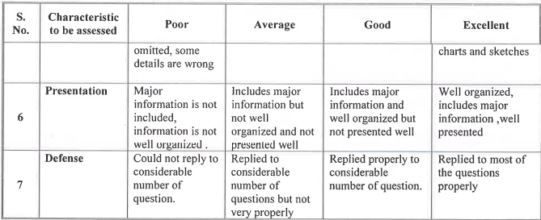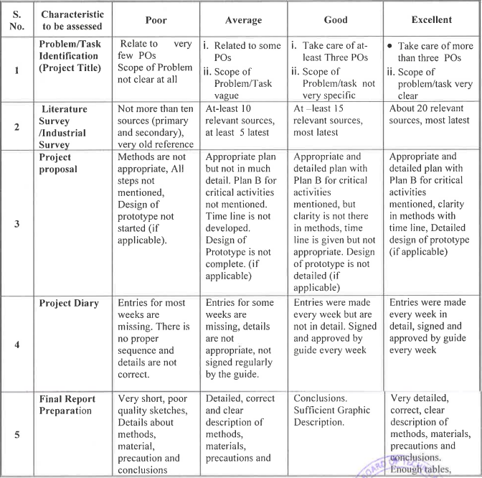

**Appendix-C**

**Suggestive Projects Dairy Format**

|  |
| --- |
| Week no: 1 Date: 17/07/2023 to 22/07/2023 |
| Activities planned:  Define project scope, objectives, and requirements.  Conduct market research and competitor analysis.  Develop a detailed project plan including timelines, milestones, and resources. |
| Activities Executed:  Defined project scope, objectives, and high-level requirements based on initial discussions.  Started preliminary research on market trends and potential competitors.  Initiated discussions with stakeholders to gather input for the project plan. |
| Reason for delay if any: |
| Corrective measures adopted: |
| Remark and Signature of the Guide: |

**INFORMATION ABOUT COMPONENTS**



**React:** React is a JavaScript library for building user interfaces. It enables developers to create interactive, component-based UIs with ease. React's declarative syntax and virtual DOM make it efficient for rendering dynamic data and updating the UI in response to user actions. React is often used for building single-page applications (SPAs) and dynamic web interfaces.

**MongoDB:** MongoDB is a NoSQL database that stores data in a flexible, JSON-like format. It is well-suited for handling large volumes of structured, semi-structured, and unstructured data. MongoDB's document-based model allows for easy scalability and high performance.

**Express.js:** Express.js is a minimalist web application framework for Node.js. It provides a robust set of features for building web servers and APIs. With Express, developers can define routes, handle HTTP requests and responses, and manage middleware to enhance functionality and security.

**Node.js:** Node.js is a runtime environment for executing JavaScript code outside the browser. It uses Google's V8 JavaScript engine to run JavaScript code on the server-side. Node.js allows developers to build scalable and efficient server-side applications, including web servers, APIs, and microservices.







|  |
| --- |
| Week no: 2 Date: 24/07/2023 to 29/07/2023 |
| Activities planned:  Define project plan based on initial research findings and feedback.  Document project requirements and specifications for each module.  Finalize project milestones and deliverables. |
| Activities Executed:  Refined the project plan based on feedback received from stakeholders.  Documented detailed requirements and specifications for the Attendance System module.  Finalized project milestones and deliverables for VPolyServer. |
| Reason for delay if any: |
| Corrective measures adopted: |
| Remark and Signature of the Guide: |

|  |
| --- |
| Week no: 3 Date: 31/07/2023 to 05/08/2023 |
| Activities planned:  Start designing the user interface and user experience for the Attendance System module.  Create wireframes and mockups to visualize the layout and flow of the system.  Gather feedback from stakeholders and iterate on design concepts. |
| Activities Executed:  Initiated the design process for the Attendance System module's user interface.  Developed initial wireframes and mockups to visualize key functionalities.  Scheduled meetings with stakeholders to gather feedback on design concepts. |
| Reason for delay if any: |
| Corrective measures adopted: |
| Remark and Signature of the Guide: |

|  |
| --- |
| Week no: 4 Date: 07/08/2023 to 12/08/2023 |
| Activities planned:  Finalize the design for the Attendance System module based on feedback received.  Begin designing the user interface for the MCQ Web App module.  Develop wireframes and mockups for the quiz creation and quiz-taking interfaces. |
| Activities Executed:  Incorporated feedback from stakeholders to finalize the design of the Attendance System module.  Started designing the user interface for the MCQ Web App module.  Created wireframes and mockups for the quiz creation and quiz-taking interfaces. |
| Reason for delay if any: |
| Corrective measures adopted: |
| Remark and Signature of the Guide: |

|  |
| --- |
| Week no: 5 Date: 14/08/2023 to 19/08/2023 |
| Activities planned:  Set up the development environment.  Begin coding the foundational structure of each module.  Implement basic functionalities such as user authentication and data storage. |
| Activities Executed:  Established the development environment for VPolyServer, including setting up necessary tools and frameworks.  Began coding the foundational structure of the Attendance System module, focusing on user authentication.  Implemented basic database schema to store user information and system configurations. |
| Reason for delay if any: |
| Corrective measures adopted: |
| Remark and Signature of the Guide: |

|  |
| --- |
| Week no: 6 Date: 21/08/2023 to 26/08/2023 |
| Activities planned:  Continue coding the Attendance System module, focusing on core features like attendance tracking and reporting.  Begin integrating frontend and backend components of the module.  Conduct initial testing of basic functionalities to ensure they are working as expected. |
| Activities Executed:  Continued development of the Attendance System module, implementing core features such as attendance tracking.  Started integrating frontend and backend components to enable seamless interaction.  Conducted initial testing of basic functionalities to identify any potential issues or bugs. |
| Reason for delay if any: |
| Corrective measures adopted: |
| Remark and Signature of the Guide: |

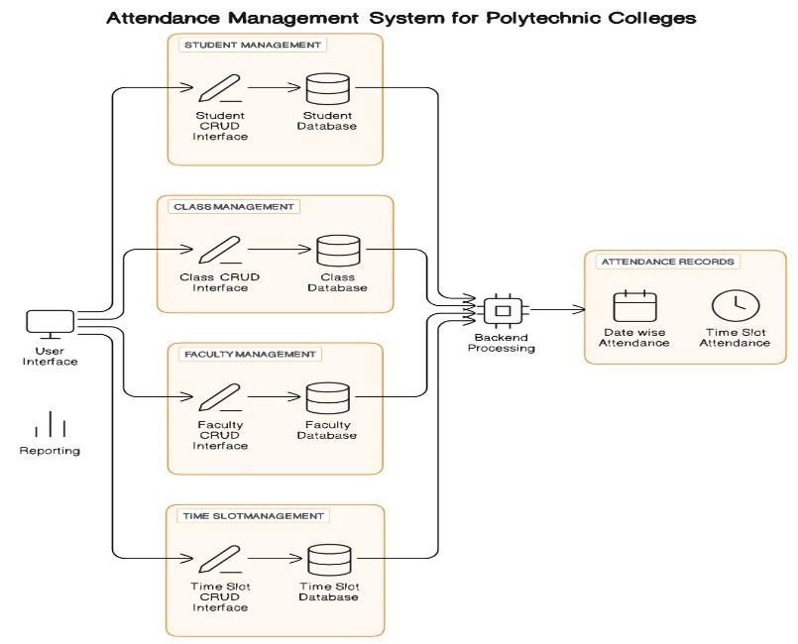

|  |
| --- |
| Week no: 7 Date: 28/08/2023 to 02/09/2023 |
| Activities planned:  Develop additional features for the Attendance System module.  Implement user roles and permissions to control access to attendance data.  Test new features and functionalities to identify and fix any issues. |
| Activities Executed:  Developed additional features for the Attendance System module.  Implemented user roles and permissions to restrict access to sensitive attendance data.  Conducted testing of new features to ensure they function correctly and meet requirements. |
| Reason for delay if any: |
| Corrective measures adopted: |
| Remark and Signature of the Guide: |

|  |
| --- |
| Week no: 8 Date: 04/09/2023 to 09/09/2023 |
| Activities planned:  Refine the Attendance System module based on user feedback and testing.  Begin development of the MCQ Web App module:  Implement features for creating, editing, and taking multiple-choice quizzes.  Design the user interface for a seamless quiz-taking experience. |
| Activities Executed:  Incorporated feedback from initial testing to refine and improve the Attendance System module.  Enhanced user interface elements to improve usability and accessibility.  Conducted thorough testing of the module to identify and address any remaining issues or bugs. |
| Reason for delay if any: |
| Corrective measures adopted: |
| Remark and Signature of the Guide: |

|  |
| --- |
| Week no: 9 Date: 11/09/2023 to 16/09/2023 |
| Activities planned:  Begin developing the MCQ Web App module, starting with backend functionalities such as quiz creation and management.  Design database schemas to store quiz questions, options, and user responses.  Implement APIs for creating, editing, and deleting quizzes. |
| Activities Executed:  Started development of the MCQ Web App module, focusing on backend functionalities for quiz management.  Designed database schemas to efficiently store quiz-related data such as questions and user responses.  Implemented APIs to enable basic CRUD (Create, Read, Update, Delete) operations for quizzes. |
| Reason for delay if any: |
| Corrective measures adopted: |
| Remark and Signature of the Guide: |

|  |
| --- |
| Week no: 10 Date: 18/09/2023 to 23/09/2023 |
| Activities planned:  Continue developing the MCQ Web App module, focusing on frontend components like the quiz-taking interface.  Integrate backend APIs with frontend components to enable seamless interaction.  Test basic functionalities of the module to ensure they are working correctly. |
| Activities Executed:  Continued development of the MCQ Web App module, focusing on implementing the quiz-taking interface.  Integrated backend APIs with frontend components to enable users to interact with quizzes.  Conducted testing of basic functionalities to verify their correctness and identify any issues. |
| Reason for delay if any: |
| Corrective measures adopted: |
| Remark and Signature of the Guide: |

|  |
| --- |
| Week no: 11 Date: 25/09/2023 to 30/09/2023 |
| Activities planned:  Integrate the Attendance System module with the existing VPolyServer system.  Ensure proper communication between different modules and components.  Conduct integration testing to identify and resolve any compatibility issues. |
| Activities Executed:  Integrated the Attendance System module with VPolyServer, ensuring seamless communication between components.  Conducted integration testing to verify the functionality and compatibility of the integrated system.  Addressed any compatibility issues that arose during testing to ensure smooth operation. |
| Reason for delay if any: |
| Corrective measures adopted: |
| Remark and Signature of the Guide: |

Appendix D

Suggestive Project Diary format

|  |
| --- |
| Week no: 12 Date:02/10/2023 to 07/10/2023 |
| Activities planned: Integrate the MCQ Web App module with VPolyServer.  Test the integrated system for end-to-end functionality, including attendance tracking and quiz management.  Address any issues or bugs that arise during integration testing. |
| Activities Executed:  Integrated the MCQ Web App module with VPolyServer, ensuring proper communication between modules.  Conducted end-to-end testing of the integrated system to verify functionality and identify any issues.  Addressed and resolved any issues or bugs discovered during integration testing to ensure a stable system. |
| Reason for delay if any: |
| Corrective measures adopted: |
| Remark and Signature of the Guide: |

|  |
| --- |
| Week no: 13 Date: 09/10/2023 to 14/10/2023 |
| Activities planned:  Conduct comprehensive testing of all modules to identify bugs and usability issues.  Prioritize and address identified issues, focusing on critical functionalities first.  Perform performance testing to optimize system speed and responsiveness. |
| Activities Executed:  Conducted comprehensive testing of all modules to identify and prioritize bugs and usability issues.  Addressed critical issues and bugs to ensure core functionalities were functioning correctly.  Performed performance testing to optimize system speed and responsiveness, making necessary improvements. |
| Reason for delay if any: |
| Corrective measures adopted: |
| Remark and Signature of the Guide: |

|  |
| --- |
| Week no: 14 Date: 16/10/2023 to 21/10/2023 |
| Activities planned:  We Finalize documentation for all modules including user manuals and technical guides.  Prepare for deployment by configuring servers and databases.  Deploy VPolyServer to production environment and ensure smooth operation.  Conduct user training sessions if required a dummy module of the project. |
| Activities Executed:  Finalized documentation for VPolyServer, including user manuals and technical guides, ensuring comprehensive coverage of system functionality and usage instructions.  Configured servers and databases according to production requirements, optimizing performance and security measures.  Deployed VPolyServer to the production environment, ensuring a smooth transition from development to live operation. |
| Reason for delay if any: |
| Corrective measures adopted: |
| Remark and Signature of the Guide: |

