# TASK 1: Empathize and observe to identify a problem that is facing the world.

Empathy is the foundation of a human-centred design process. To empathize, you:

* **Observe.** View users and their behaviour in the context of their lives.
* **Engage.** Interact with and interview users through both scheduled and short ‘intercept’ encounters.
* **Immerse.** Experience what your user experiences.

d.School bootcamp bootleg reference guide for design thinking: <https://goo.gl/uzr3lj>

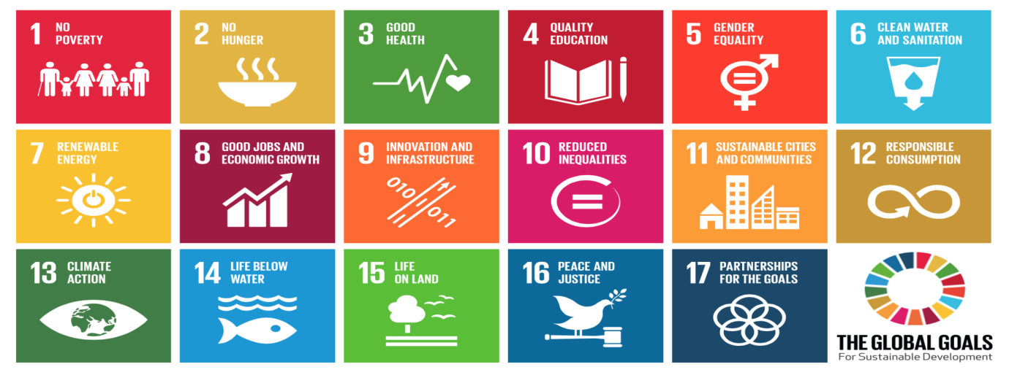

UN Sustainable Development Goals: <http://www.un.org/sustainabledevelopment/sustainable-development-goals/>

* 1. Empathise and observe to **select the area of focus** for your innovation. Preferably from the UN’s Sustainable Development Goals:

|  |
| --- |
| Eight good jobs and economic growth |
|  |

* 1. Synthesise your learnings and observations to **Identify/define a problem** that you are to address with your design.

|  |
| --- |
| The problem that I am trying to address is the wastage of unused electronics by wealthy families who have the means to purchase the latest devices. My idea would involve channelling these unused electronics to youth and other people who are being educated to help them better perform in school. If these products are unusable or damaged in any way, they can be donated to a local electronic recycling company so they can be broken up into spare parts and used for other purposes. |
|  |
|  |
|  |
|  |

# task 2: Define a Vision Statement for your company.

2.1. Write down the **vision statement** for your company.

|  |
| --- |
| 1. One man’s waste is another child’s education |
|  |
|  |
|  |
|  |

# TASK 3: Identify or create a product/ service

3.1. **Identify or create a product, service or process** that address the identified problem.

|  |
| --- |
| An online marketplace where people who have access to multiple devices (e.g. phones, computers) of which they may not use will have the option to donate it to help with a child’s education. The system will function as follows. A donator will apply to donate an electronic device to a student and will be asked questions such as how old he device is and if it is in a usable condition. If it is usable the device will be sent to a donation agency who will in turn send it out to a child. If the device is not in a usable condition, then it will be sent to a recycling agency to be broken down into spare parts and recycled. |
|  |
|  |
|  |
|  |

# task 4: Identify and justify the STRATEGY you will adopt

4.1. **Identify and justify** the **strategy** you will adopt in order to be adaptive and sustainable? Refer to the Porter's Generic Competitive Strategies.

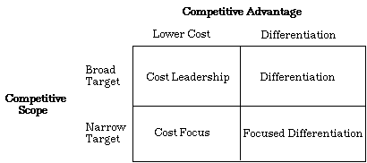

***Porter's Generic Competitive Strategies***

|  |
| --- |
| **Source of competitive advantage justification:** |
| Lower cost because the people who are donating aren’t going to be charged for donating items. Another reason for this is that the beneficiaries of the devices won't be charged for receiving the goods. |
|  |
|  |
|  |
| **Competitive scope justification:** |
| Broad scope because anybody is allowed to donate so long as they have spare electronic devices that they are willing to donate. |
|  |
|  |
|  |
| **Strategy: Cost leadership** |

Additional Resource: <https://youtu.be/V14kuqYEsxE?t=1m15s> <https://www.mindtools.com/pages/article/newSTR_82.htm>

# task 5: Identify and justify a vital process

5.1. **Identify and justify** a **vital process or processes** to create the product or deliver the service.

|  |
| --- |
| Donating devices - allows customers to fill out a form that will describe the product that they are donating, this is important as the platform is useless if no devices are sent in. |
| Delivering device - after the device is picked up and sent to our local warehouse, each device will be checked to determine the usability of the devices that are received. The devices will either be donated to a charity which will distribute the devices or sent to a recycling firm where the goods will have their parts extracted and recycled. This is also important because if the goods aren't delivered to a charity, it defeats the initial purpose of the online platform. |
|  |
|  |
|  |

# TASK 6: Identify key performance indicators

6.1. Identify **key performance indicators** that will help you to monitor how well the process is being executed.

A set of quantifiable measures that a company or industry uses to gauge or compare performance in terms of meeting their strategic and operational goals. KPIs vary between companies and industries, depending on their priorities or performance criteria. Also referred to as "key success indicators (KSI)”.

For example:

**Shipping and Logistics**. The main five KPI’s in shipping and logistic industries are:

Sales forecasts, Inventory, Procurement and suppliers, Warehousing, Transportation**.**

**Infrastructure sector.** The main five KPI’s in Infrastructure sector are:

Client Satisfaction, Construction Time & Cost, Productivity, Defects, Profitability.

|  |
| --- |
| **Key Performance Indicators (KPIs)**: |
| Amount of devices that are donated, amount of people who received donated devices, amount of devices recycled to another purpose |
|  |
|  |
|  |
|  |

# D7.1 Identify the key transactions **and their** routes, roles and rules.

|  |  |
| --- | --- |
| **Transaction Name:** | Give Electronics |
| **Routes** | The donor will fill out an online form which will include the type of device, age and whether it is usable or not. The system will then add the data to the online database, where a recipient will also be determined. This recipient is one of two main options of recycling agency and charity for the child to receive a device. |
| **Rules** | Name, address, age of device, device type, pickup time and phone number are mandatory fields and cannot be left blank  Pick up time must be in the future  Email or phone must be verified to activate account  Must have an account to donate  Goods must be electronic and in working condition to be sent to a child e.g. computer, tablet, phone and not washing machine, if not sent to be recycled  Goods must be located within a nearby vicinity e.g. the same country of the same city as the pickup location |
| **Roles** | Donator, admin, system |

|  |  |
| --- | --- |
| **Transaction Name:** | Pickup electronics |
| **Route** | Goods are picked up and sent to a local warehouse where they are checked if they are usable by a team of device testers. If they are deemed usable to a certain standard, they are sent to a local electronics charity to be sent to a student. If the goods are not deemed usable they are sent to an electronics recycling firm where they will be dismantled into spare parts and repurposed. |
| **Rules** | Unusable goods must be sent to recycling  Usable goods must be sent to charity  Goods |
| **Roles** | Admin, system, charity, recyclers |

# D7.2 Model the **workflow** of the **process.**

First model the workflow of the process using Pen and Paper. Once it is finalised, create the model using on the free tools online or Microsoft Visio. You can use any other tool you are familiar with.   
Lucid Chart: <https://www.lucidchart.com/> OR Draw.io: <http://draw.io/> OR Microsoft Visio

The main objective is that you understand the process of modeling: Event, Function, Organisation Unit, Database, AND, OR and XOR operators.

