### Submitter Details

UPI: Kfri750

ID: 246378566

Name: Owusu Frimpong

### Task 1 - Scope selection/definition

1. **Stakeholder:** Product team

**The goal in using the DW:** Increase market share by extending product availability.

## How the DW should aid decision making:

* + Which products are the most profitable and should be made widely available?
  + Which products are the least profitable?
  + What are the most/least popular products? How do these correlate to revenue/cost?

Answered in Task 5

### Task 2 - DW Design (schema/ERD)

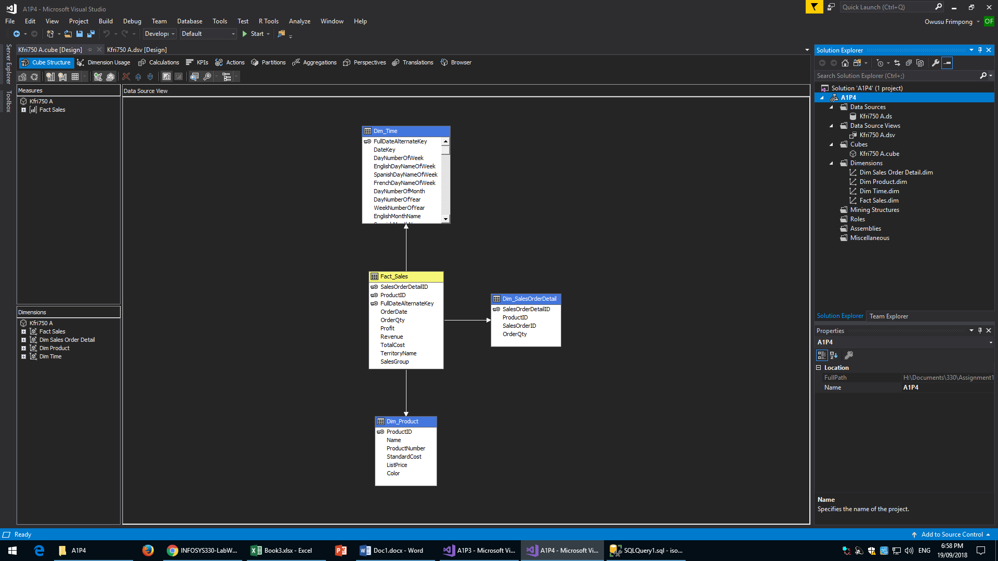

### Task 3 - ETL (SSIS)

#### Dim_SalesOrderDetail

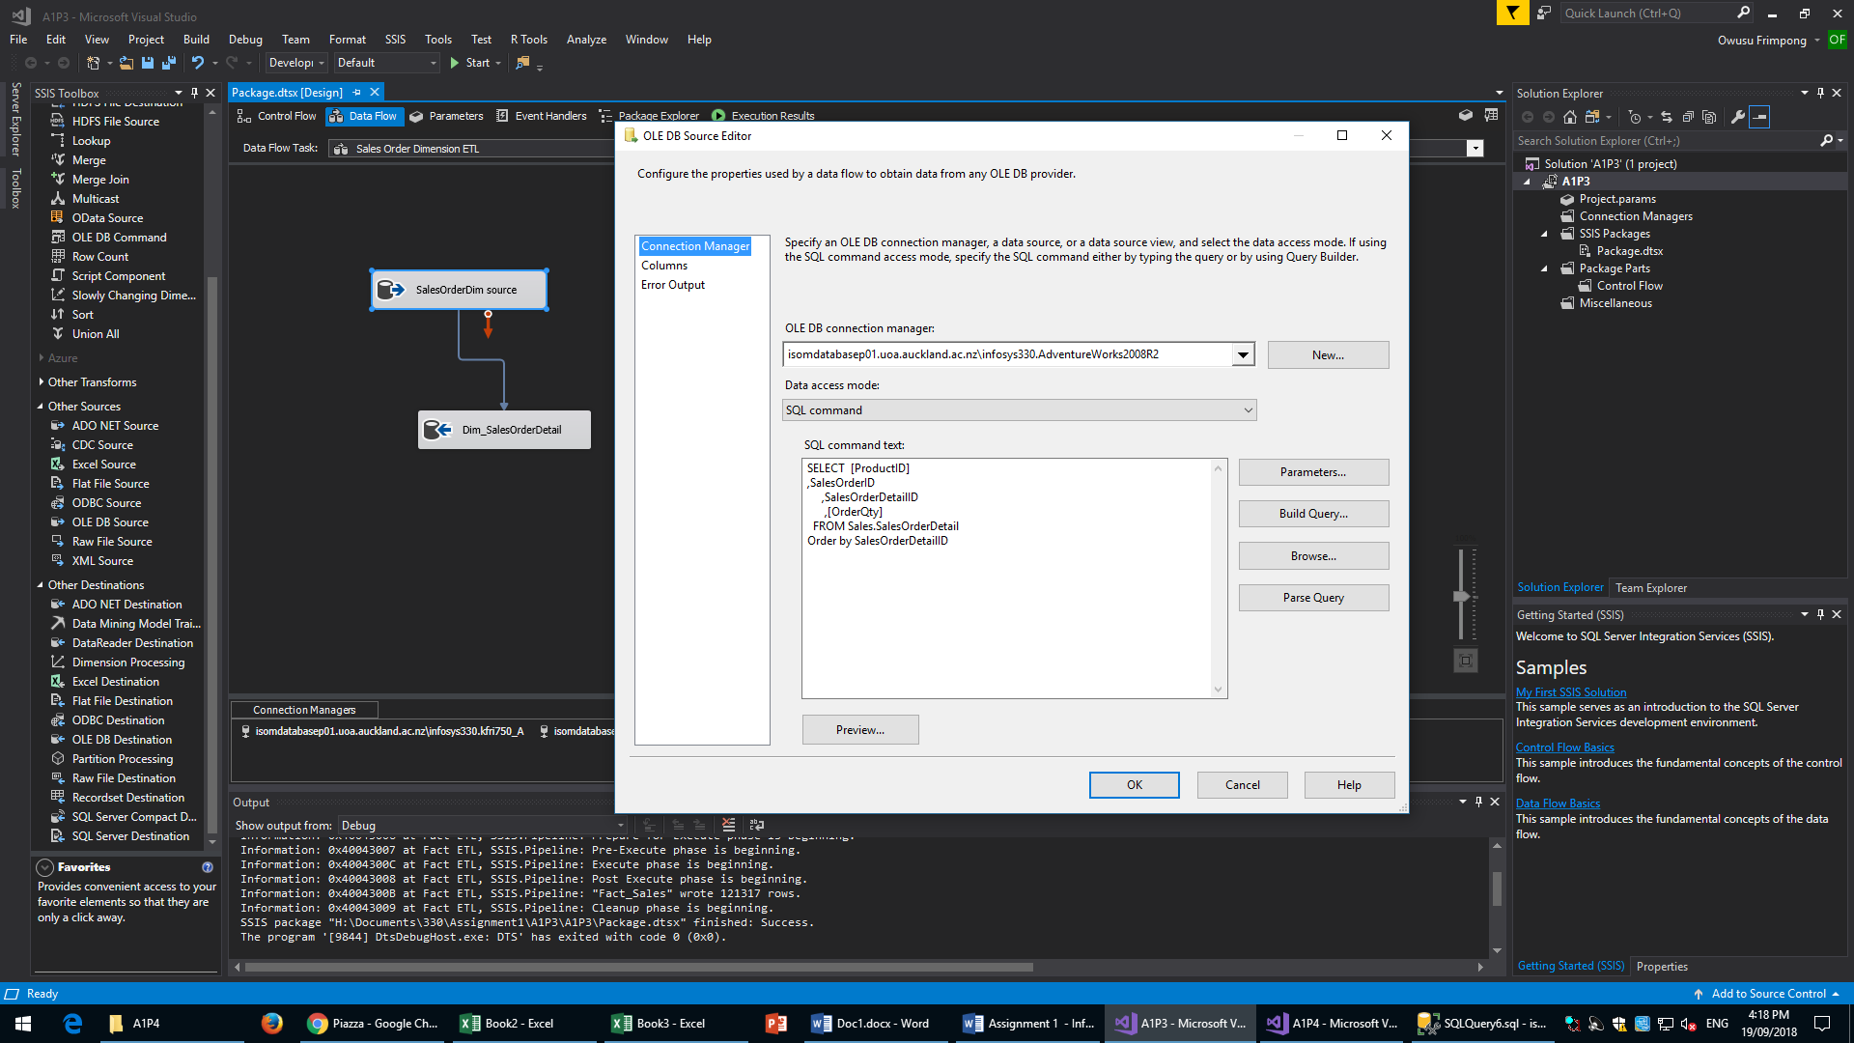



This is the SQL code I used to extract and transform the Dim_SalesOrderDetail table. No transformations were done on this dimension table; it has only been restricted to show relevant tables. This is followed by the OLE DB source and OLE DB destination used for this ETL.

#### Dim_Product

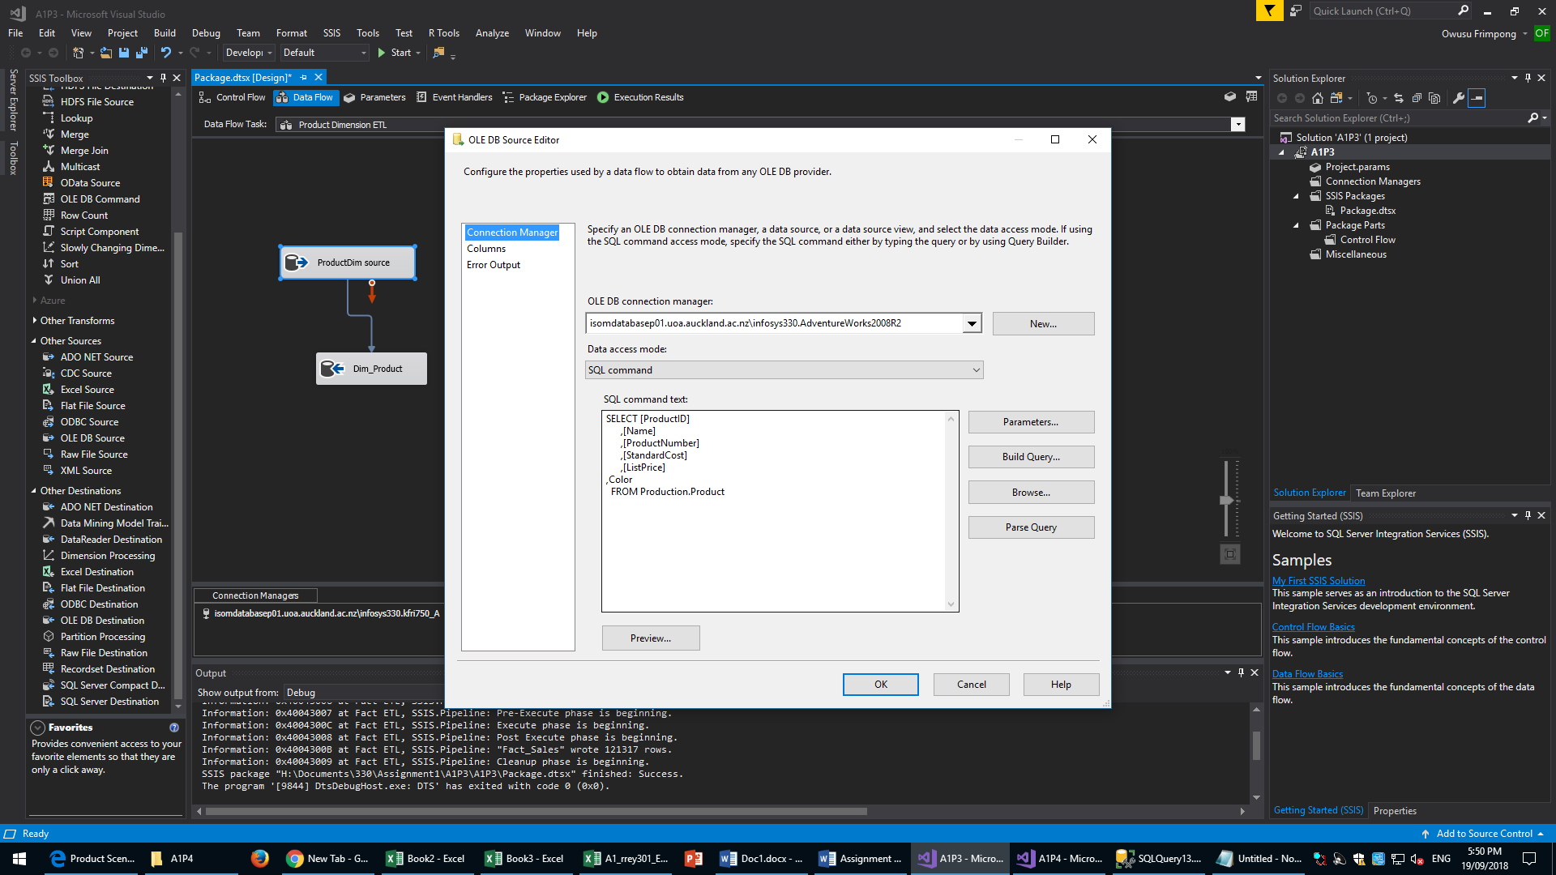



This is the SQL code I used to extract and transform the Dim_Product table. No transformations were done on this dimension table; it has only been restricted to show relevant tables. This is followed by the OLE DB source and OLE DB destination used for this ETL.

#### Fact_Sales

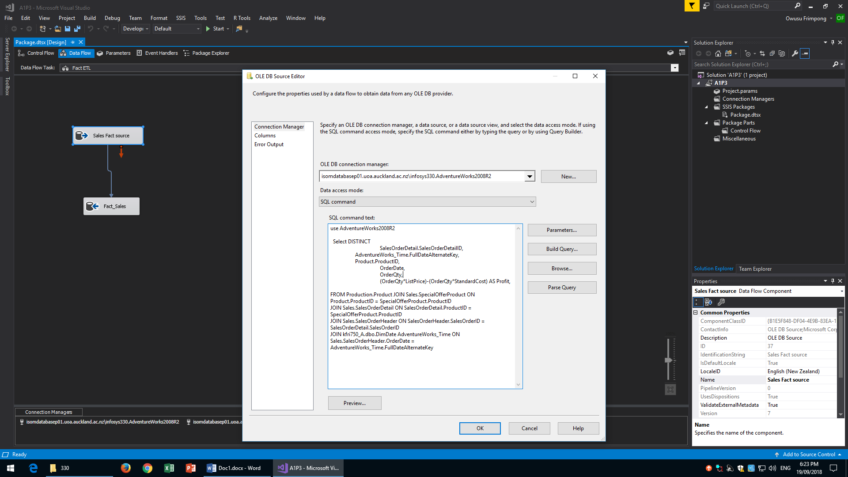



This is the SQL code I used to extract and transform the Fact_Sales table.

The transformations used here were a join between the Production.Product, Sales.SpecialOfferProduct, Sales.SalesOrderDetail, Sales.SalesOrderHeader and the DimDate tables.

This is followed by the OLE DB source and OLE DB destination used for this ETL.

This was necessary as this is a fact table. Without these joins the comparison of data between the various dimension tables would be impossible.

#### SSIS Final Run

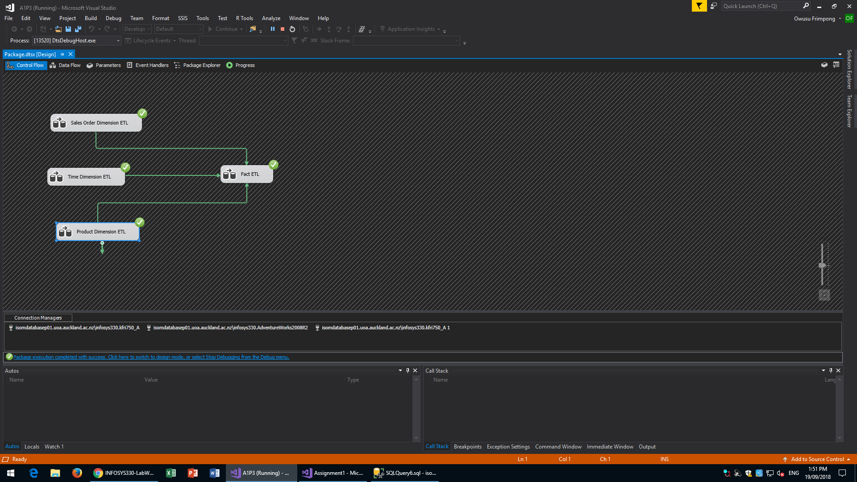

This is a screenshot of the successful run of the SSIS

### Task 4 - Cubes (SSAS)



A screenshot of the Data Source View/Cube Structure

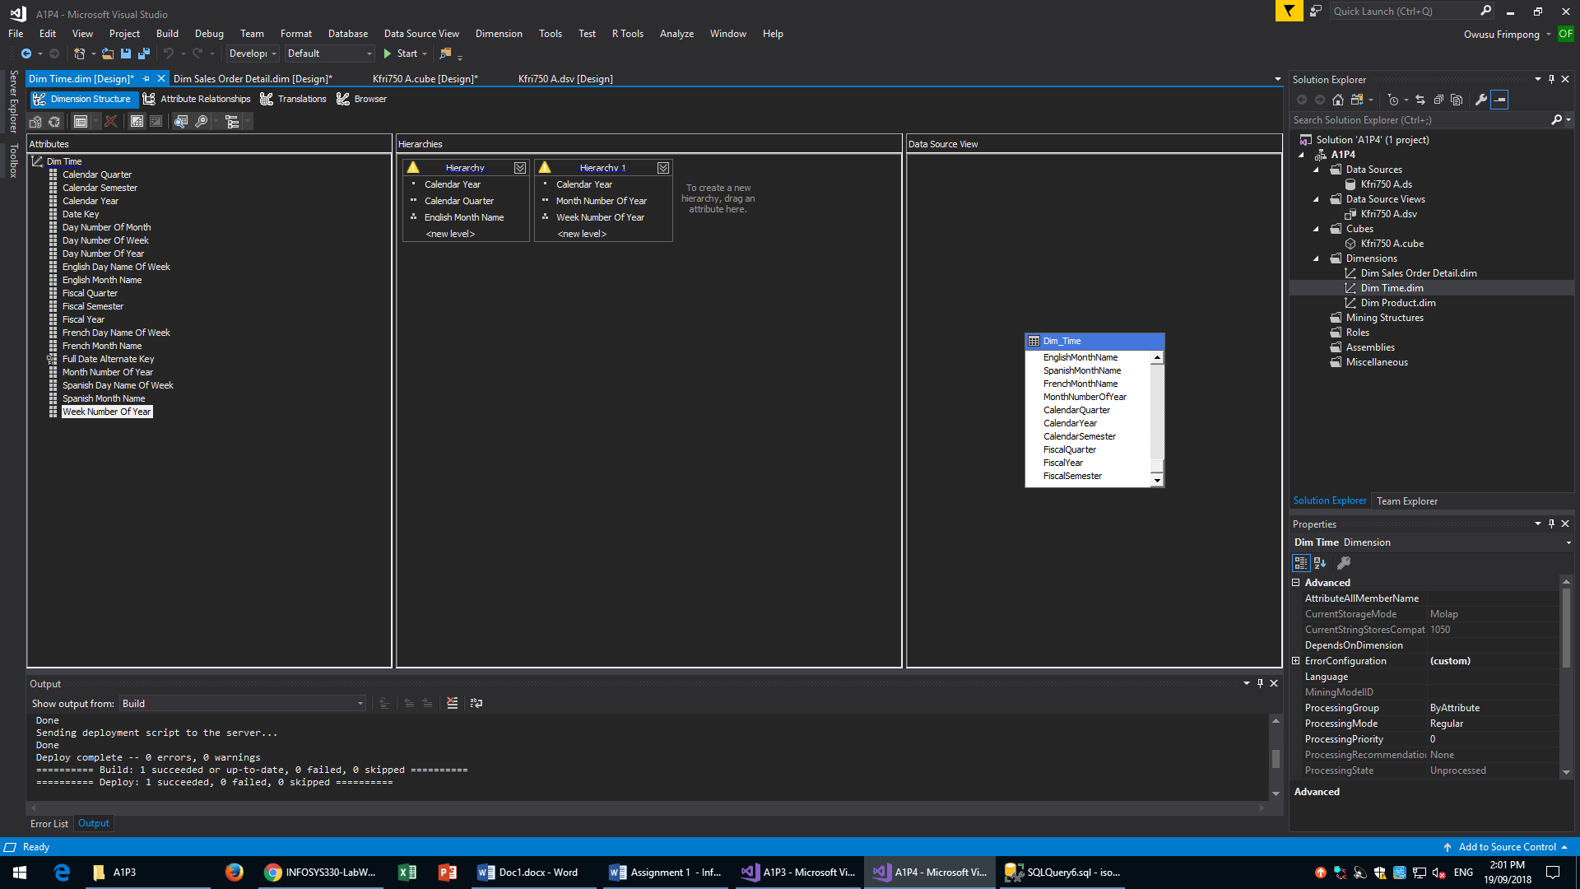

Here are the Hierarchies that I used. These allow me to arrange the data in chronological order and make analyses based on the time of year.

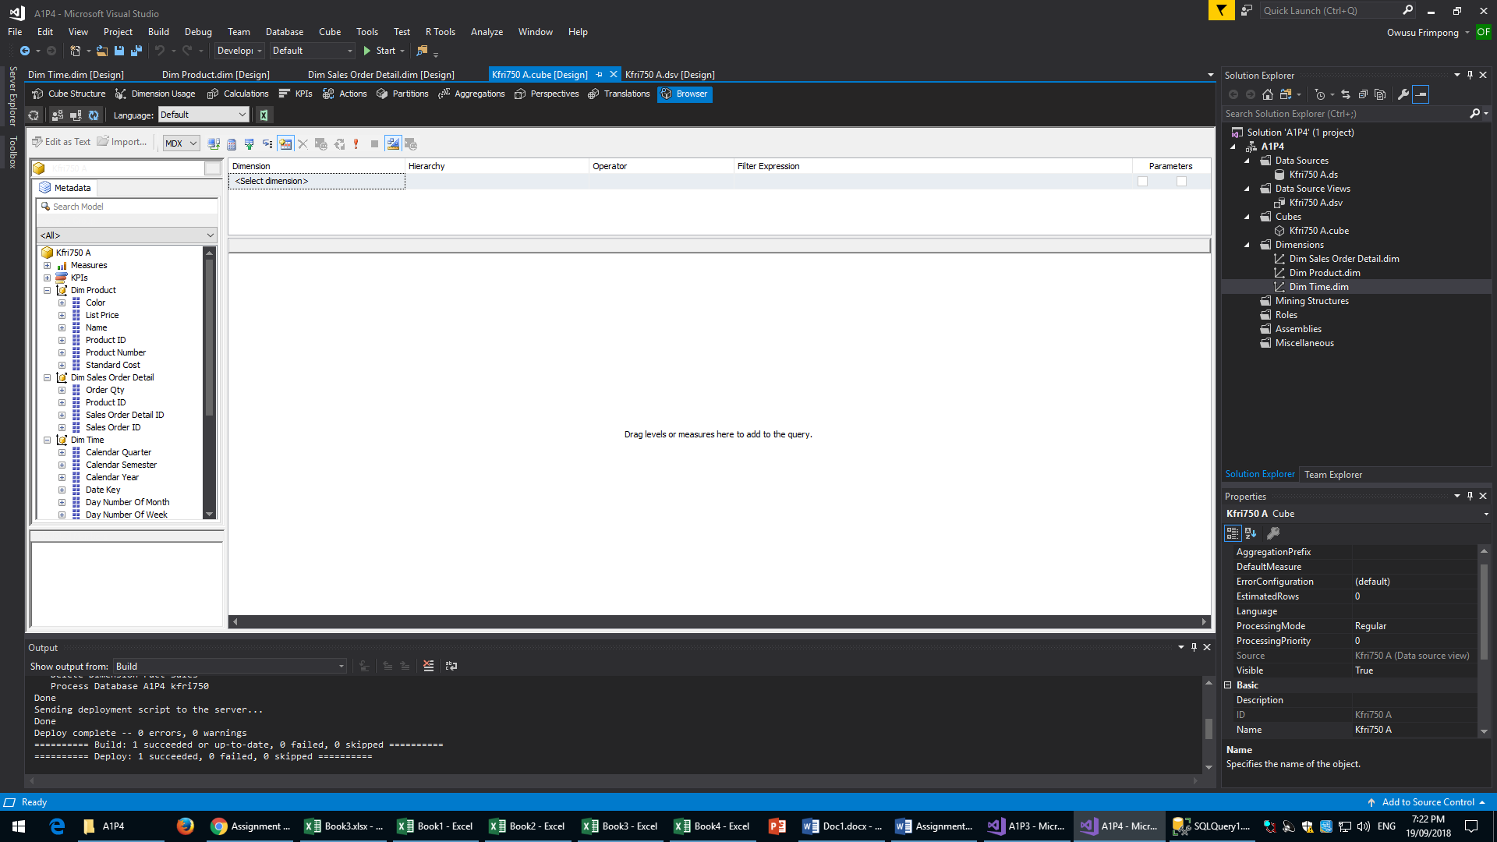

Post-deployment screenshot of cube and cube structure

### Task 5. DW Usage (browsing cubes)

#### Scenario 1

The user can use the cube to find the most profitable products

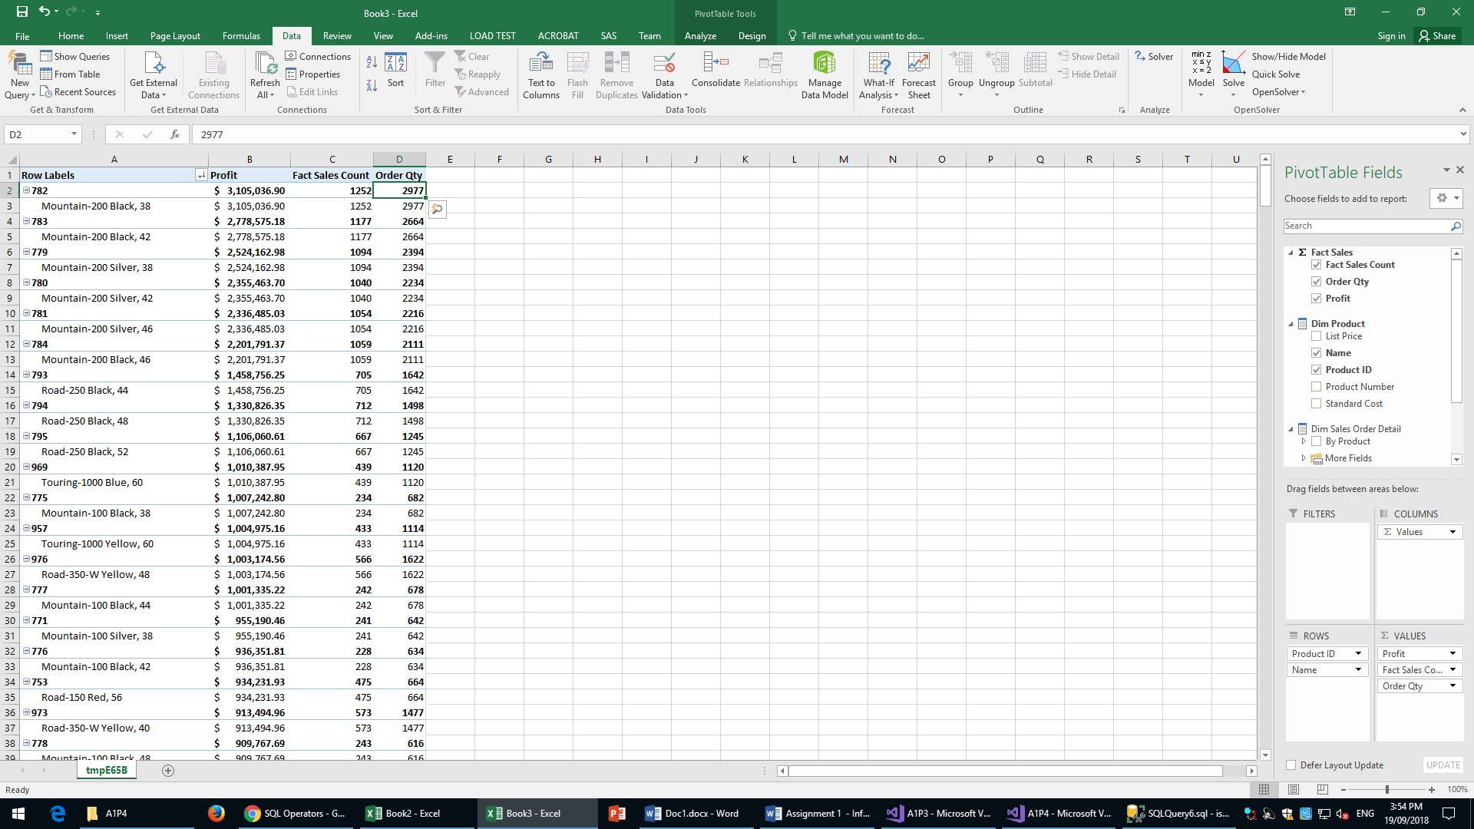

Here is the browser view of the cube in descending order of Profits. An assumption I have made here is that the price for each good is the list price from the Product table and the cost is StandardCost from the same table (The formula I used to calculate profits was (OrderQty*ListPrice)-(OrderQty*StandardCost)). This screenshot shows the most profitable products sold by AWC. Managerial staff can use this as a factor in deciding which products to increase production for.

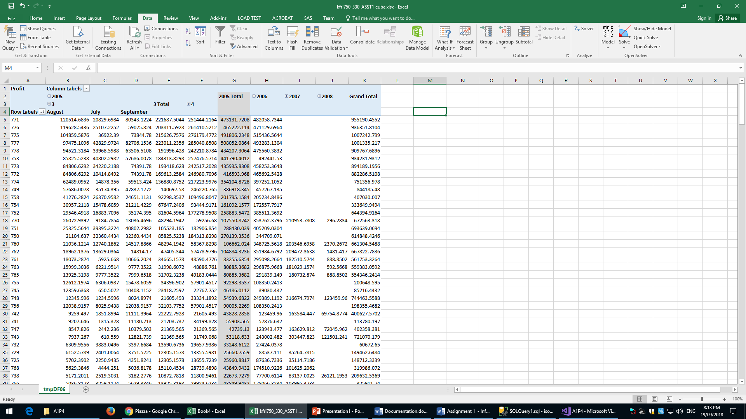

Here we can also drill down to particular times of the year. As an example, I have shown the most profitable products for the month of August 2005. This can be done with any month or even week using the hierarchies that I have included in the cube.

#### Scenario 2

Which products are the least profitable?

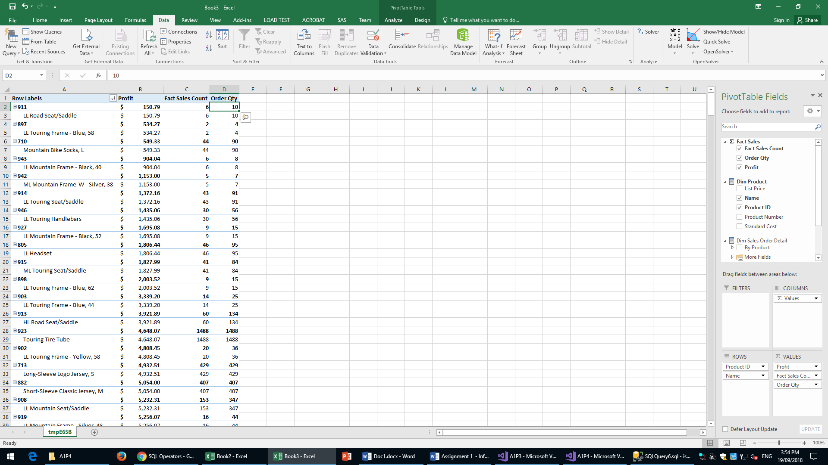

Here is the browser view of the cube in ascending order of Profits. This shows the least profitable products sold by AWC. We can see here that LL Road Seat/Saddle is the least profitable item.

Managerial staff can use this as a factor in deciding which products to decrease production for. Their marketing team can also use this information to create deals that will help increase the rate at which people purchase these products. They could bundle these goods with more profitable goods and have an overall discount.

#### Scenario 3

What are the most/least popular products? How do these correlate to revenue/cost? 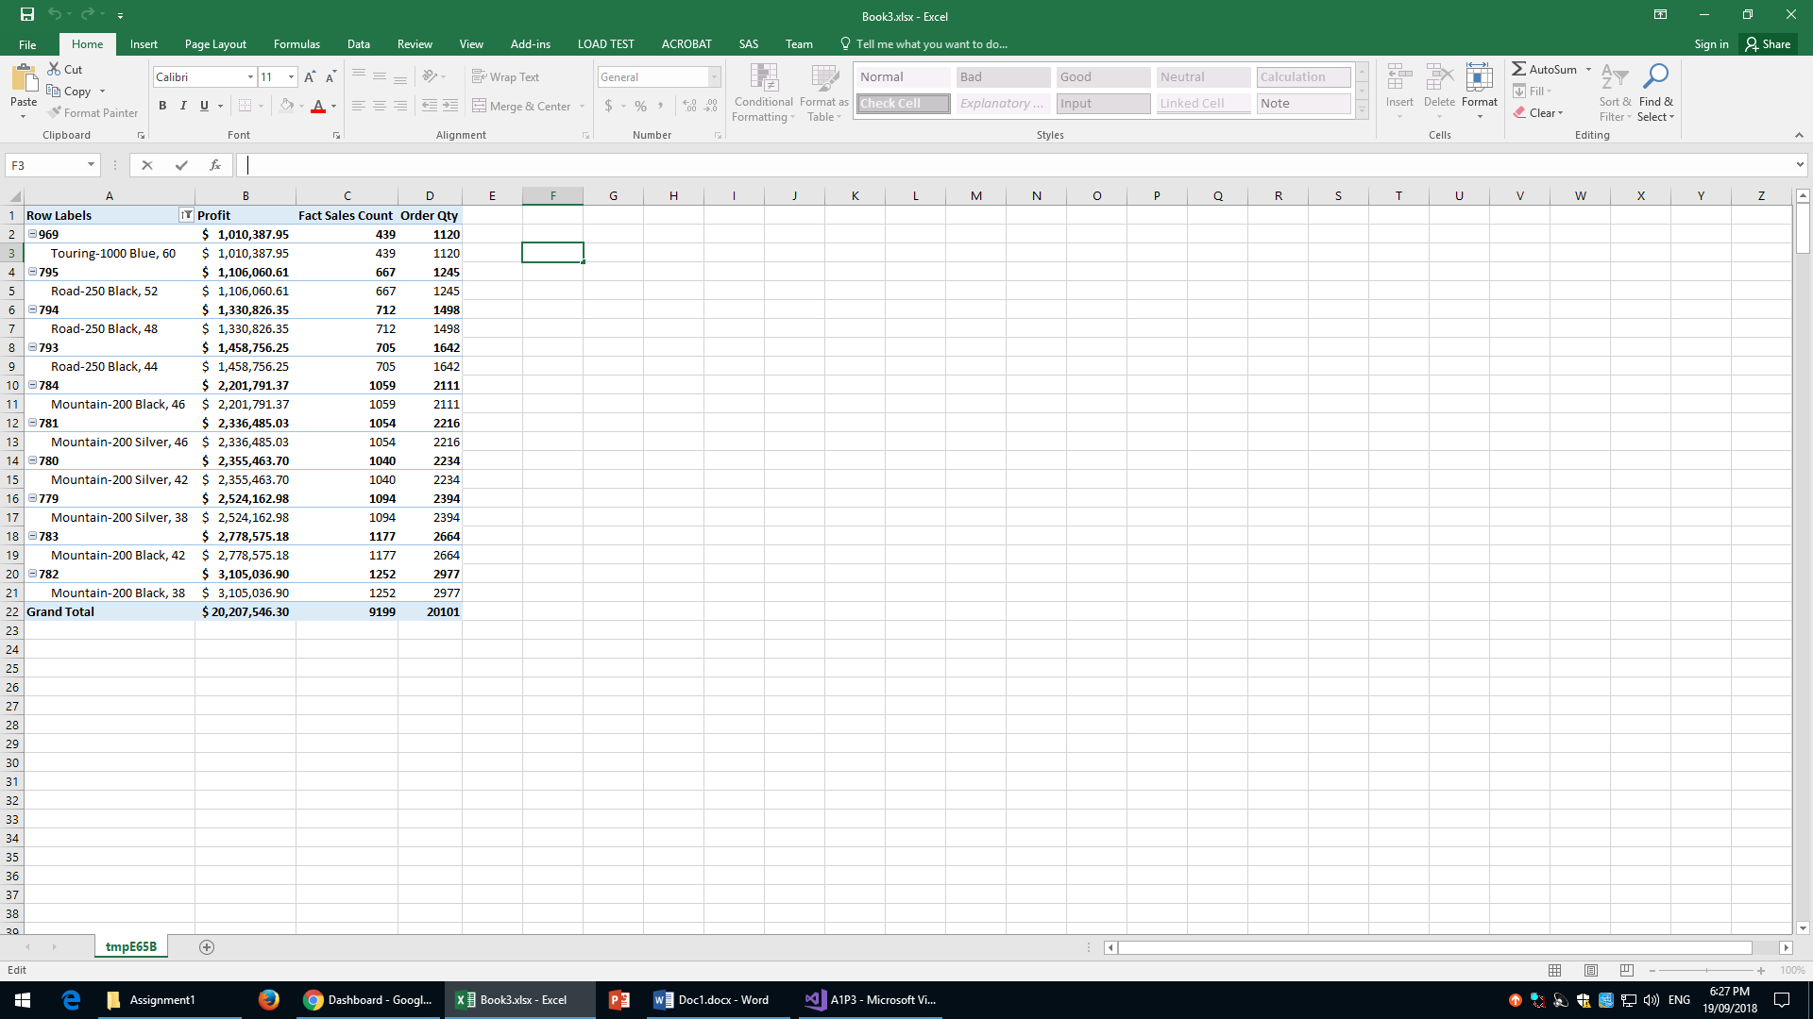

When limited to just the Top 10 products by profit we can see that there is a strong correlation between profit and order quantity. We can also see that Mountain-200 Black, 38 is the most popular product and also happens to have a very large profit margin.

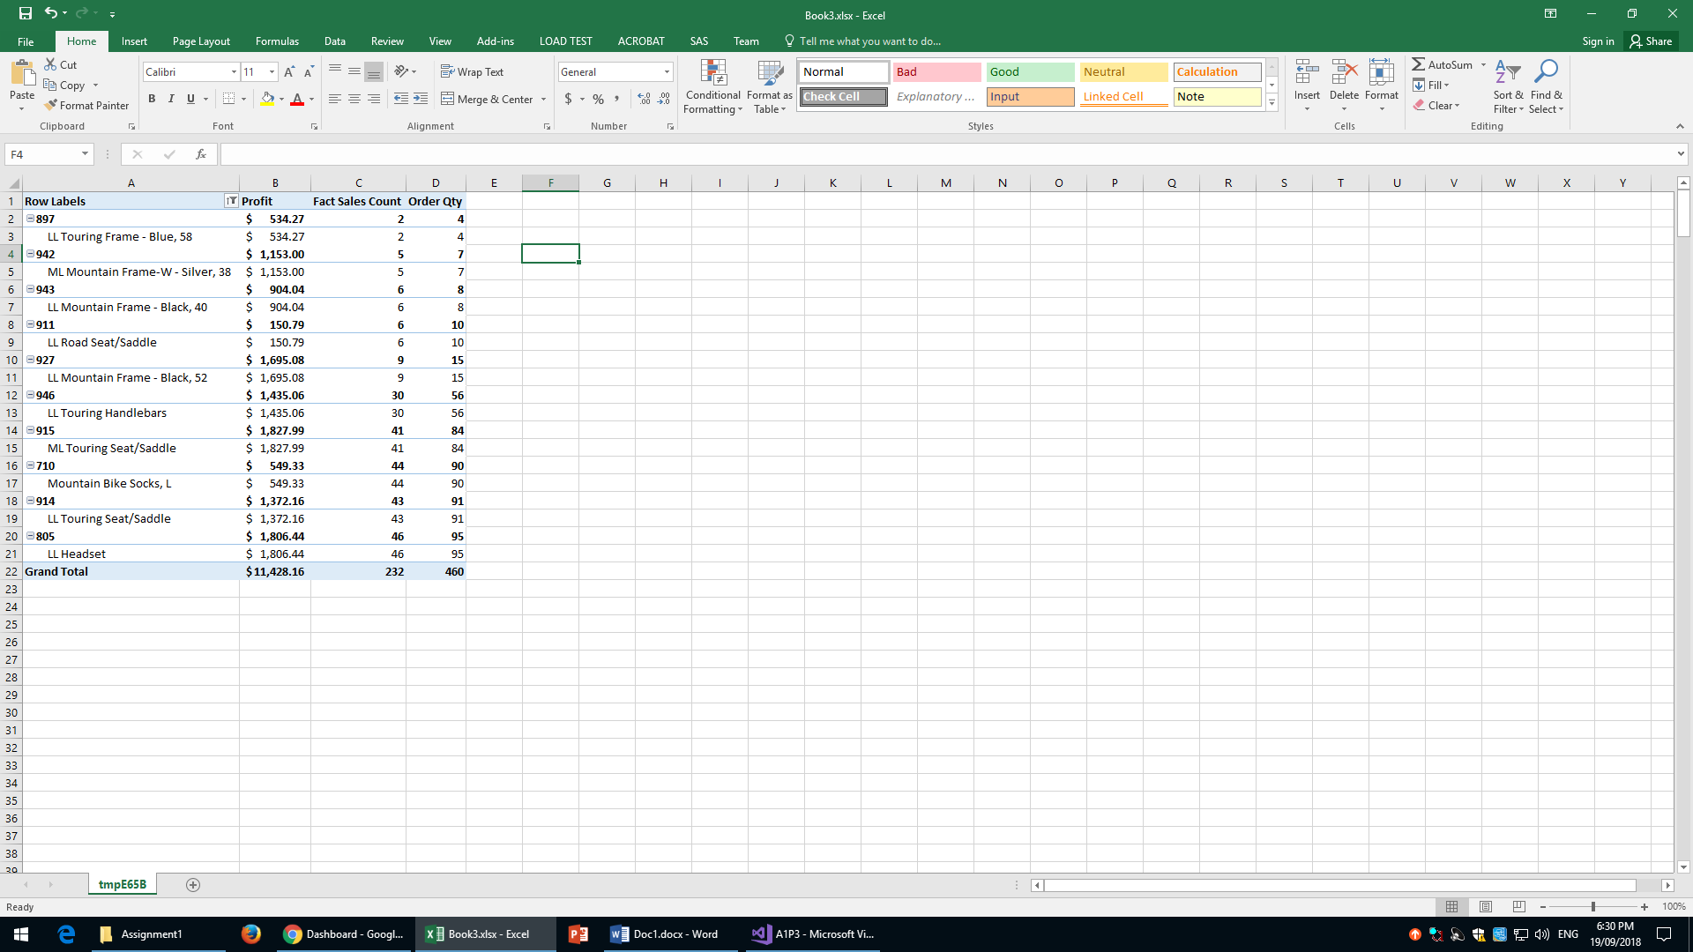

As seen in the top 10 there is a correlation between order quantity and profit. However, the correlation is much weaker in this case. We can see also that the least popular product is the LL Touring Frame – Blue, 58.

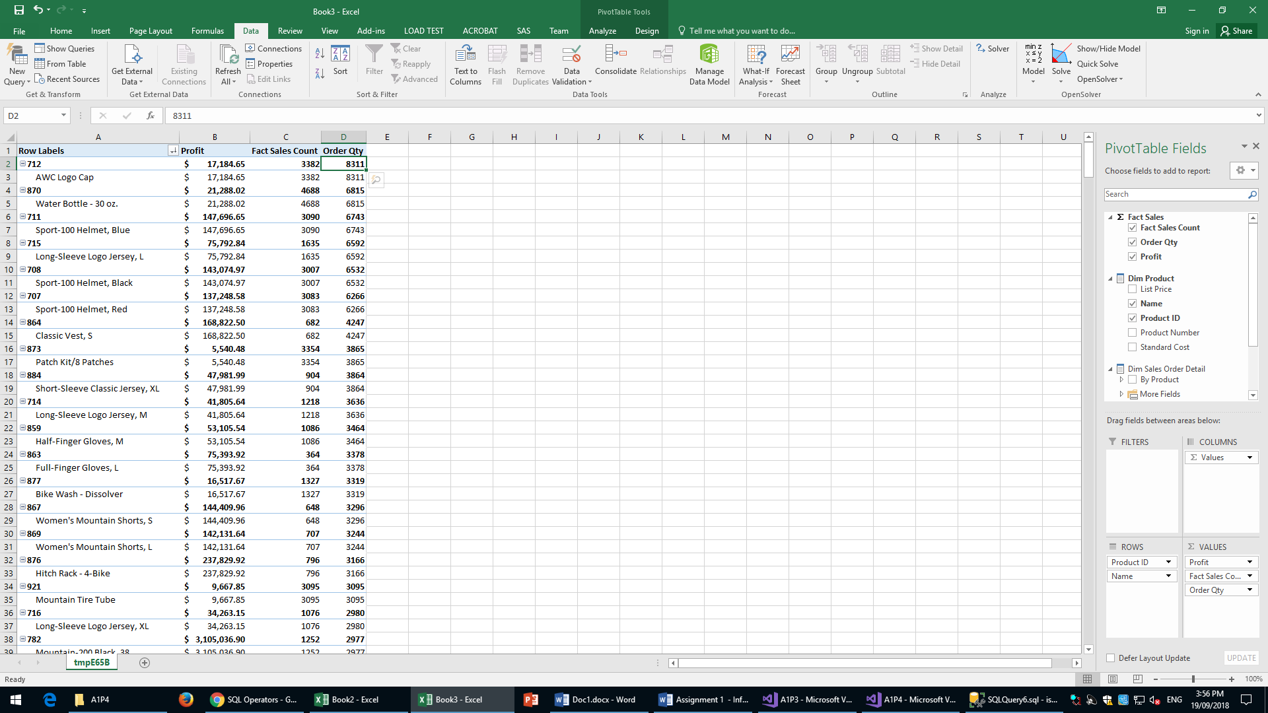

Here is the browser view of the cube in ascending order of Order Quantity. This shows the most popular products sold by AWC.

Managerial staff can use this as a factor in deciding which products to increase production for. The high amount of orders for those products could indicate that there is high demand for these goods, it could also indicate that these goods have lower responsiveness to changes in price as they may be more necessary to people who shop at this store. If this assumption is correct, AWC may be able to increase prices to increase revenues.

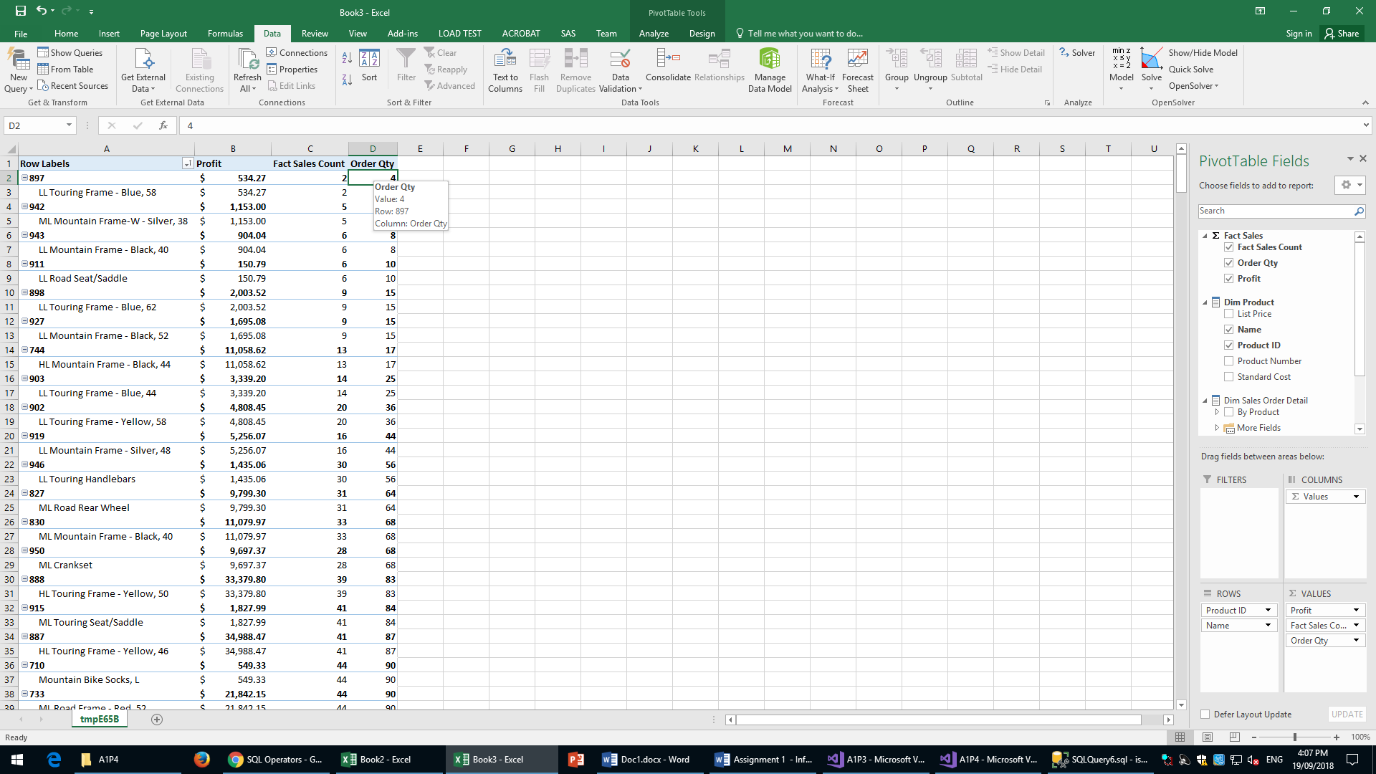

Here is the browser view of the cube in descending order of Order Quantity. This shows the least popular products sold by AWC.

Managerial staff can use this as a factor in deciding which products to decrease production for. It could also indicate that either customers are less reliant on these types of products or that the prices are too high, in response to this managerial staff may reduce prices to increase sales and in turn profit.

When the top 10 products are shown next to their total cost to produce there doesn’t seem to be any apparent correlation

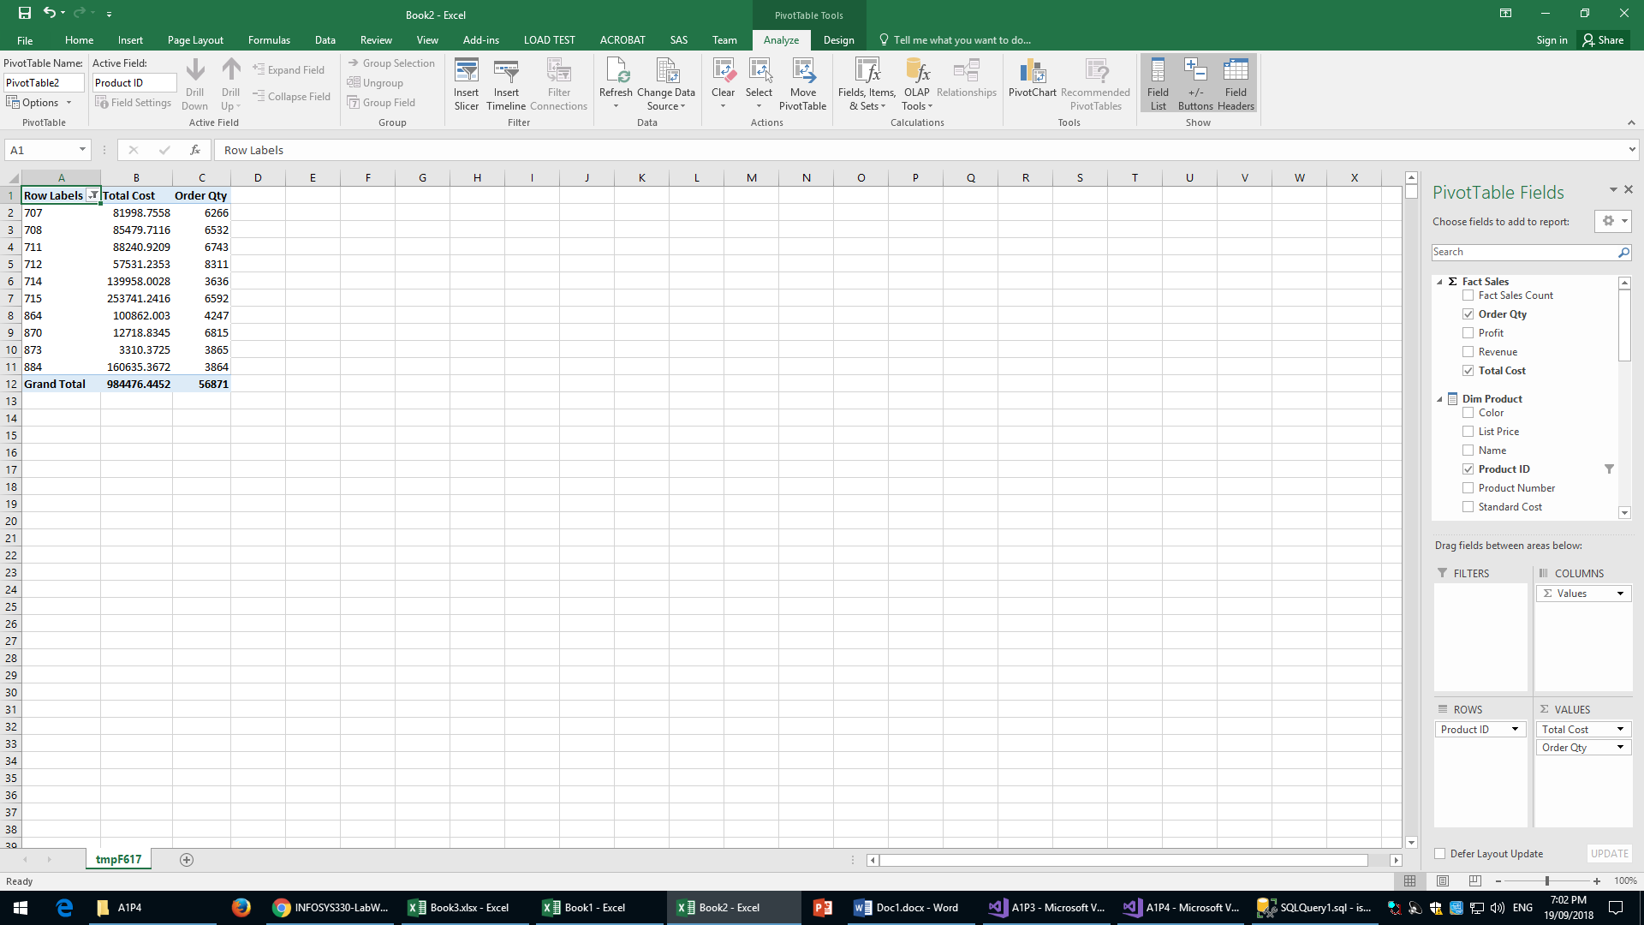

The same lack of correlation can be seen with the bottom ten products by order quantity as shown below.

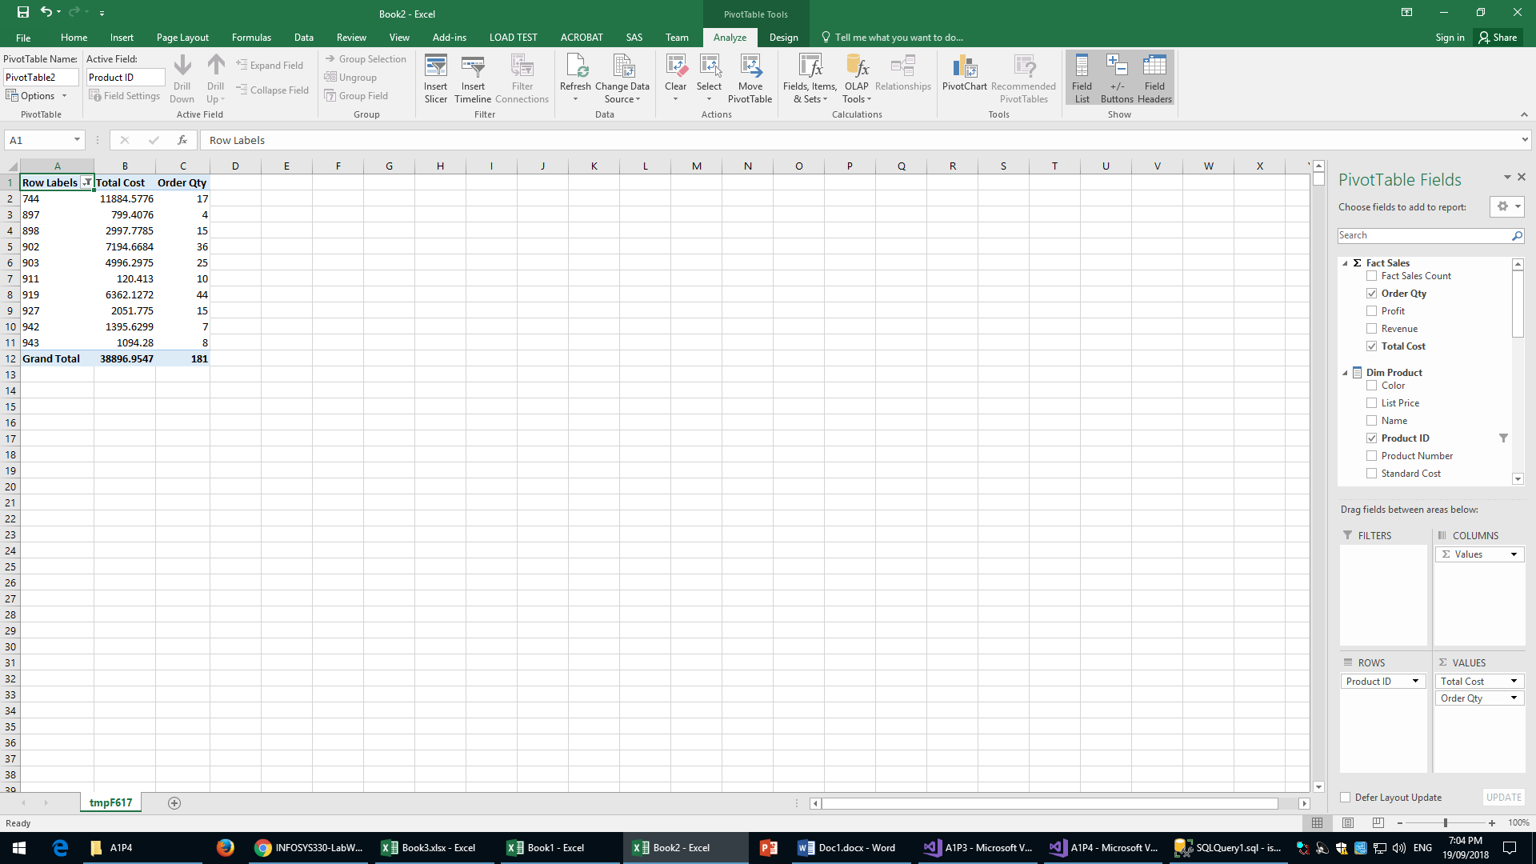

With this, we can make a graph showing the correlation between OrderQty and Total Profit made by each product as shown below.

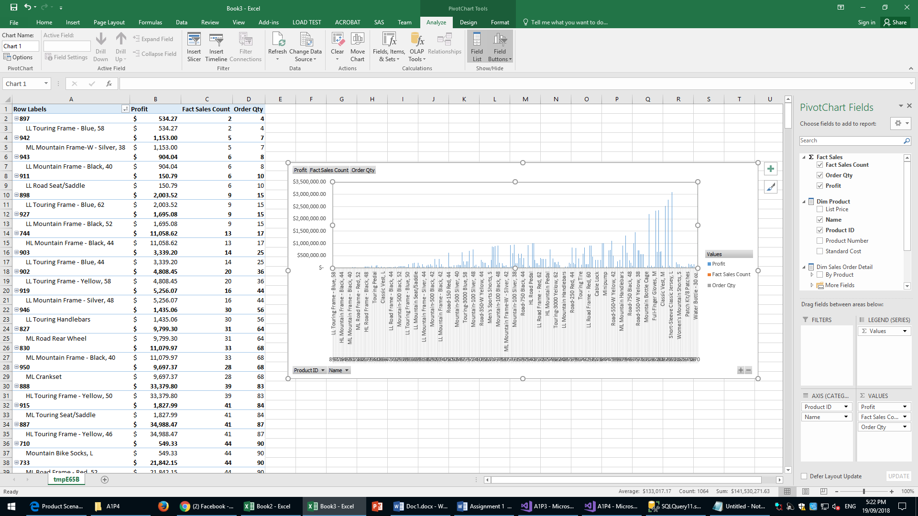

Overall, we can see that more profit is made when more items are sold. We can also see that some items’ profits are more responsive to changes in the quantity sold than others. Management can use this information to help increase revenue for more profitable products such as Short Sleeve Classic Vest, L because these products have higher prices but still remain popular in terms of items sold. This may show that there is an opportunity to increase prices slightly and increase revenue as the negative impact on quantity sold may not be as high as with other goods