Experiment 4 — Requirement Modelling Using Entity Relationship (ER) Diagram
Software Engineering Laboratory
Name: Pushkar Kumar Mishra
Register Number: 24BPS1128
Programme: B.Tech CSE — Cyber Physical Systems
Date: 4th Aug, 2026

1. Problem Statement
Orbital Sentinel is an early-warning health-monitoring system for satellite fleets. Each monitored satellite reports telemetry from several sensor channels. Readings from these channels are analysed by a detection model, which flags anomalies; each anomaly is attributed to the sensor channel(s) responsible for it, scored for severity, and may raise an alert that an operator acknowledges. Administrators configure which satellites are monitored and set the detection thresholds. The ER model must capture the satellites, their channels and readings, the detection model and its detections, the attribution of detections to channels, the alerts and users, and the monitoring configuration — without redundancy or ambiguity.

2. List of Identified Entities
- SATELLITE
- CHANNEL
- TELEMETRY_READING
- DETECTION_MODEL
- DETECTION
- ATTRIBUTION (associative / bridge entity)
- ALERT
- USER
- MONITORING_CONFIG

3. Entity Attributes
Attributes are classified as Simple, Composite, Multivalued, or Derived. Keys are noted in the last column.
Entity | Attribute | Attribute type | Key
SATELLITE | satellite_id | Simple | PK
 | name | Simple | —
 | norad_id | Simple | —
 | orbital_elements | Composite (tle_line1, tle_line2) | —
 | mission_tag | Multivalued | —
 | current_status | Simple | —
 | current_risk_level | Derived (from active detections) | —
CHANNEL | channel_id | Simple | PK
 | satellite_id | Simple | FK → SATELLITE
 | channel_name | Simple | —
 | unit | Simple | —
 | description | Simple | —
TELEMETRY_READING | reading_id | Simple | PK
 | channel_id | Simple | FK → CHANNEL
 | timestamp | Simple | —
 | value | Simple | —
DETECTION_MODEL | model_id | Simple | PK
 | model_name | Simple | —
 | model_type | Simple | —
 | threshold | Simple | —
 | trained_at | Simple | —
DETECTION | detection_id | Simple | PK
 | satellite_id | Simple | FK → SATELLITE
 | model_id | Simple | FK → DETECTION_MODEL
 | timestamp | Simple | —
 | anomaly_score | Simple | —
 | is_anomaly | Derived (score ≥ threshold) | —
 | severity_level | Derived (score & persistence) | —
 | persistence_count | Simple | —
ATTRIBUTION (bridge) | attribution_id | Simple | PK
 | detection_id | Simple | FK → DETECTION
 | channel_id | Simple | FK → CHANNEL
 | contribution_score | Simple | —
ALERT | alert_id | Simple | PK
 | detection_id | Simple | FK → DETECTION
 | risk_level | Simple | —
 | created_at | Simple | —
 | acknowledged_by | Simple | FK → USER (optional)
USER | user_id | Simple | PK
 | name | Composite (first_name, last_name) | —
 | role | Simple | —
 | contact_email | Multivalued | —
MONITORING_CONFIG | config_id | Simple | PK
 | satellite_id | Simple | FK → SATELLITE
 | set_by_user_id | Simple | FK → USER
 | persistence_threshold | Simple | —
 | severity_threshold | Simple | —
 | updated_at | Simple | —

4. Primary Keys and Foreign Keys
Entity | Primary Key (PK) | Foreign Keys (FK)
SATELLITE | satellite_id | —
CHANNEL | channel_id | satellite_id → SATELLITE
TELEMETRY_READING | reading_id | channel_id → CHANNEL
DETECTION_MODEL | model_id | —
DETECTION | detection_id | satellite_id → SATELLITE; model_id → DETECTION_MODEL
ATTRIBUTION | attribution_id | detection_id → DETECTION; channel_id → CHANNEL
ALERT | alert_id | detection_id → DETECTION; acknowledged_by → USER
USER | user_id | —
MONITORING_CONFIG | config_id | satellite_id → SATELLITE; set_by_user_id → USER

5. Relationship Description
- A SATELLITE has many CHANNELs; each channel belongs to one satellite.
- A CHANNEL records many TELEMETRY_READINGs; each reading belongs to one channel.
- A SATELLITE generates many DETECTIONs over time.
- A DETECTION_MODEL produces many DETECTIONs.
- A DETECTION is explained by one or more CHANNELs, and a CHANNEL may be implicated in many detections — a many-to-many relationship resolved by the ATTRIBUTION bridge entity.
- A DETECTION may raise one ALERT; each alert comes from exactly one detection.
- A USER (operator) acknowledges many ALERTs; acknowledgement is optional.
- A SATELLITE is configured by MONITORING_CONFIG entries, each set by a USER (administrator).

6. Cardinality and Participation Constraints
Relationship | Type | Cardinality / Participation
SATELLITE — has — CHANNEL | 1 : M | CHANNEL total, SATELLITE partial
CHANNEL — records — TELEMETRY_READING | 1 : M | READING total, CHANNEL partial
SATELLITE — generates — DETECTION | 1 : M | DETECTION total, SATELLITE partial
DETECTION_MODEL — produces — DETECTION | 1 : M | DETECTION total, MODEL partial
DETECTION — explained_by — CHANNEL | M : N | resolved by ATTRIBUTION (see below)
DETECTION — raises — ALERT | 1 : 1 | ALERT total, DETECTION partial
USER — acknowledges — ALERT | 1 : M | both partial (acknowledgement optional)
SATELLITE — configured_by — MONITORING_CONFIG | 1 : M | CONFIG total, SATELLITE partial
USER — sets — MONITORING_CONFIG | 1 : M | CONFIG total, USER partial

Resolving the M:N relationship. The only many-to-many relationship, DETECTION — explained_by — CHANNEL, is resolved by introducing the ATTRIBUTION associative entity. ATTRIBUTION holds its own key (attribution_id), the two foreign keys (detection_id, channel_id), and the descriptive attribute contribution_score, converting the M:N into two 1:M relationships (DETECTION 1:M ATTRIBUTION and CHANNEL 1:M ATTRIBUTION).

7. Final ER Diagram
The completed ER diagram, drawn in draw.io, is inserted below. The screenshot shows the modelling tool, the project title, and the system date & time in the taskbar as evidence of work.
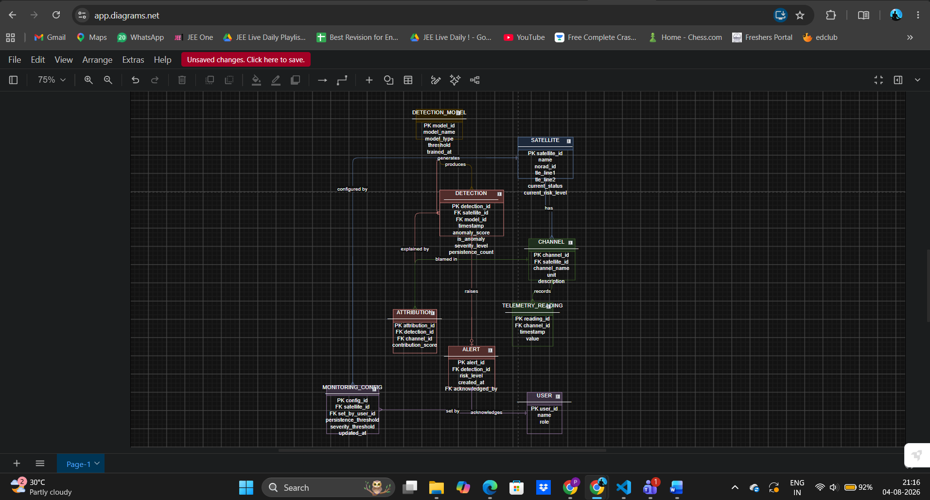

8. Brief Explanation of the Design
SATELLITE is the central entity: it owns CHANNELs whose TELEMETRY_READINGs are analysed by a DETECTION_MODEL to produce DETECTIONs. The many-to-many link between a detection and the channels responsible for it is resolved through the ATTRIBUTION bridge entity, which also records each channel's contribution score. Anomalous detections raise ALERTs that operators acknowledge, while administrators set MONITORING_CONFIG per satellite. Derived attributes (is_anomaly, severity_level, current_risk_level) are computed rather than stored redundantly, so the schema is normalised and free of redundancy while fully covering the problem statement.

