Experiment 5: State Transition Diagram — Behavioural Modelling

Tool used: StarUML
Diagram type: UML State Machine (Statechart) Diagram
Subject system: Satellite Telemetry Anomaly Detection System

Field | Value
Student name | Pushkar Kumar Mishra
Reg. number | 24BPS1128
Course | BCSE301P
Date of submission | 19th August, 2026
StarUML project file | State transition Digram.mdj

1. Aim

To model the behavioural (dynamic) view of the Satellite Telemetry Anomaly Detection System by identifying its discrete states, the events and guard conditions that trigger transitions between them, and to represent this as a State Transition Diagram in StarUML using standard UML notation.

2. Problem Statement (recap)

The system continuously ingests telemetry windows from monitored satellites. Each window is validated, scored by an anomaly detector, and — if the score exceeds a threshold — passed through a persistence filter to reject transient spikes. Anomalies that survive the filter are attributed to specific sensor channels, assigned a severity, and raised as alerts on the operator dashboard and risk ranking. An operator acknowledges the alert, after which the detection cycle is logged and closed.

3. Diagram

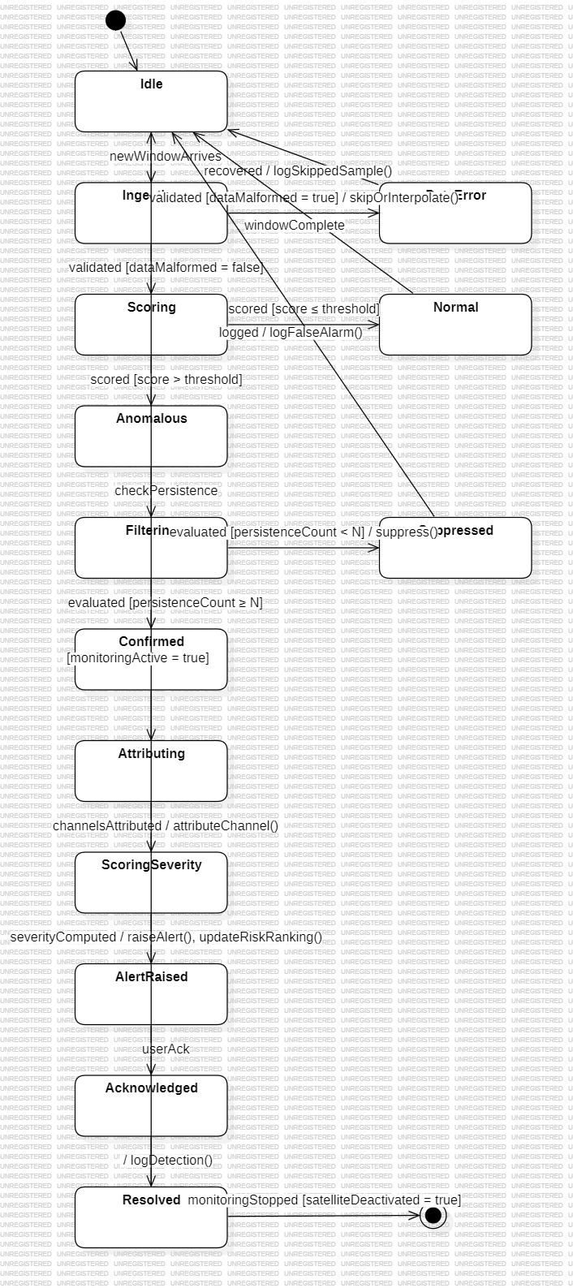
Figure 1: Detection Lifecycle — State Transition Diagram

4. Full-Screen Screenshot (with timestamp)

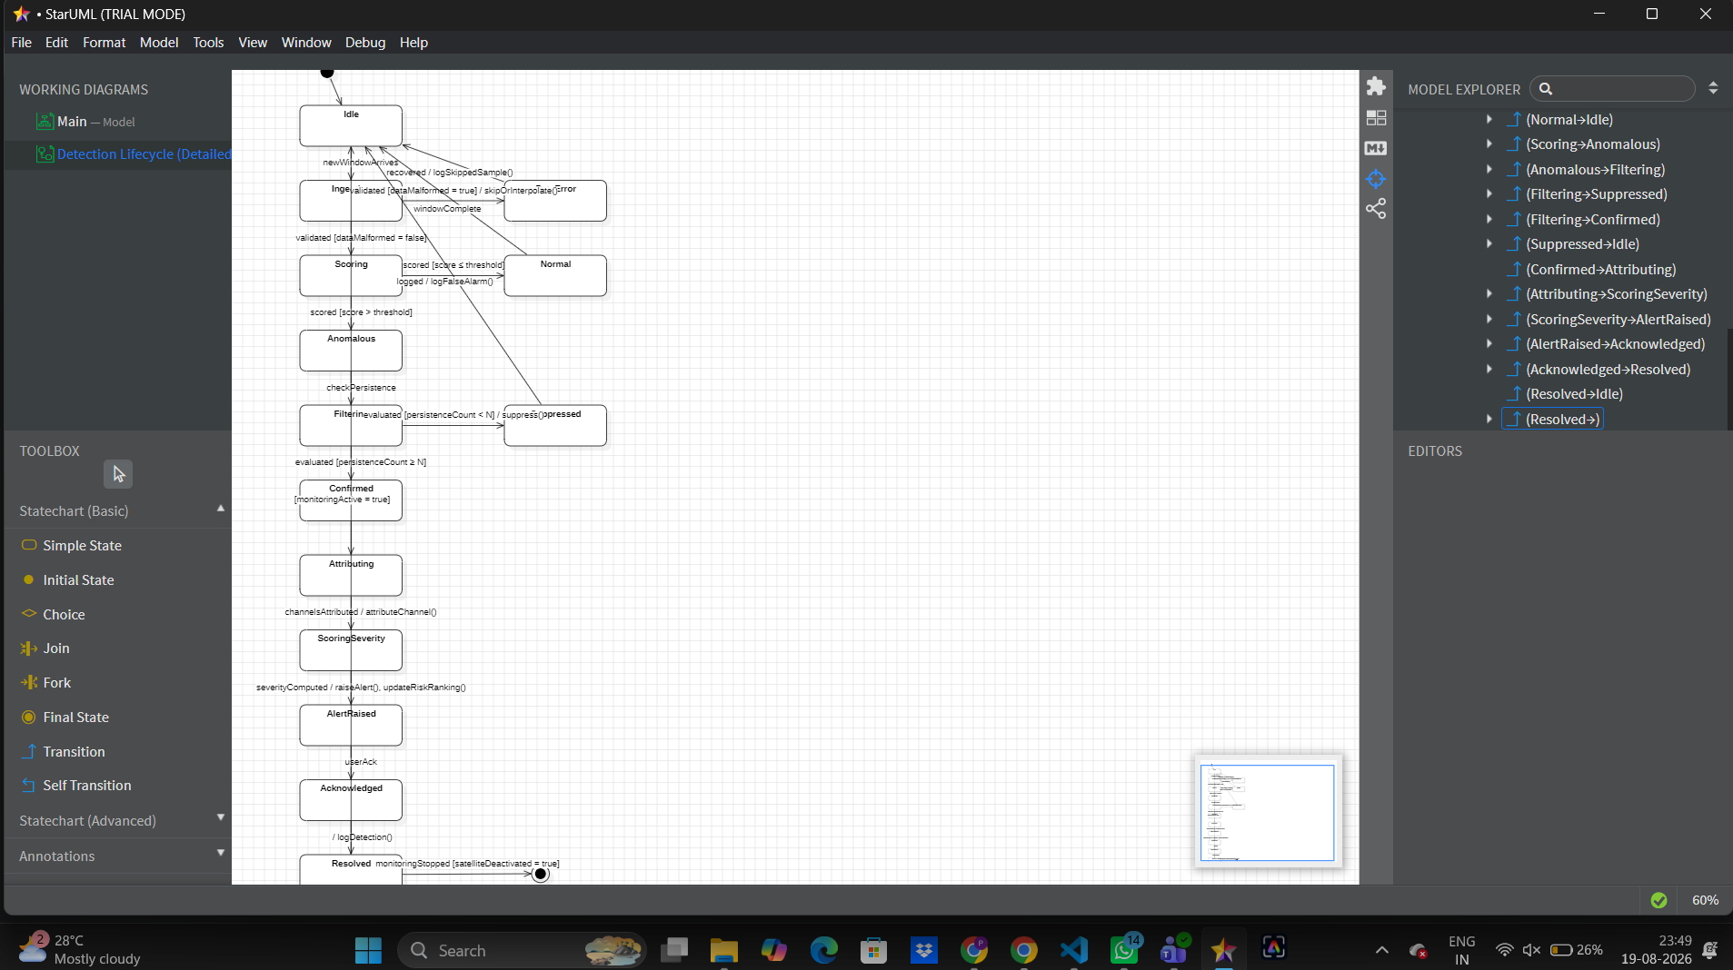Figure 2: Full-screen screenshot showing the diagram open in StarUML with system timestamp

5. States Identified

# | State | Description
— | Initial State | Entry point of the detection lifecycle.
1 | Idle | No active window; the satellite is being monitored but nothing is currently being scored.
2 | Ingesting | A telemetry window has arrived and is being loaded and normalised.
3 | DataError | The window failed validation due to missing or malformed values.
4 | Scoring | The detector is computing an anomaly score for the window.
5 | Normal | The score came back at or below the configured threshold.
6 | Anomalous | The window has just been flagged; persistence has not yet been checked.
7 | Filtering | The persistence filter is checking the consecutive-window count.
8 | Suppressed | The window failed the persistence check and is treated as a false alarm.
9 | Confirmed | The window passed the persistence check and is treated as a real anomaly.
10 | Attributing | Channel attribution is running to identify the responsible sensor(s).
11 | ScoringSeverity | A severity level is being computed from the score and persistence count.
12 | AlertRaised | An alert has been created and pushed to the dashboard and risk ranking.
13 | Acknowledged | An operator has seen and acknowledged the alert.
14 | Resolved | The detection cycle is closed and written to the detection log.
— | Final State | Monitoring has been stopped for the satellite; the lifecycle terminates.

6. Transitions, Events and Guard Conditions

# | Source | Target | Event / Trigger | Guard Condition | Effect (Action)
1 | Initial State | Idle | — | — | —
2 | Idle | Ingesting | newWindowArrives | — | —
3 | Ingesting | DataError | validated | [dataMalformed = true] | skipOrInterpolate()
4 | DataError | Idle | recovered | — | logSkippedSample()
5 | Ingesting | Scoring | validated | [dataMalformed = false] | —
6 | Scoring | Normal | scored | [score ≤ threshold] | —
7 | Normal | Idle | windowComplete | — | —
8 | Scoring | Anomalous | scored | [score > threshold] | —
9 | Anomalous | Filtering | checkPersistence | — | —
10 | Filtering | Suppressed | evaluated | [persistenceCount < N] | suppress()
11 | Filtering | Confirmed | evaluated | [persistenceCount ≥ N] | —
12 | Suppressed | Idle | logged | — | logFalseAlarm()
13 | Confirmed | Attributing | — | — | —
14 | Attributing | ScoringSeverity | channelsAttributed | — | attributeChannel()
15 | ScoringSeverity | AlertRaised | severityComputed | — | raiseAlert(), updateRiskRanking()
16 | AlertRaised | Acknowledged | userAck | — | —
17 | Acknowledged | Resolved | — | — | logDetection()
18 | Resolved | Idle | — | [monitoringActive = true] | —
19 | Resolved | Final State | monitoringStopped | [satelliteDeactivated = true] | —

7. Brief Explanation of the State Changes

The lifecycle begins at the Initial State and settles into Idle, the resting state in which the satellite is monitored but no telemetry window is under evaluation.

When the event newWindowArrives fires, the system moves to Ingesting, where the window is loaded and normalised. Validation then splits the flow on a guard: if dataMalformed = true the system enters DataError, performs skipOrInterpolate(), and returns to Idle after logging the skipped sample. This branch exists because malformed telemetry is a routine, expected condition in satellite downlinks rather than an exceptional failure, so it is modelled as a first-class state rather than an error escape.

If the data is clean, the system enters Scoring. The scored event again splits on a guard. A score at or below the threshold leads to Normal, which simply completes the window and returns to Idle — this is the common case and consumes no further processing. A score above the threshold leads to Anomalous.

Anomalous is a provisional state: the window has been flagged but nothing has been confirmed. Control passes to Filtering, where the persistence filter counts how many consecutive windows have been flagged. This is the key noise-rejection step. If persistenceCount < N, the flag is treated as a transient spike: the system enters Suppressed, calls suppress(), logs a false alarm, and returns to Idle. Only if persistenceCount ≥ N does the system reach Confirmed, establishing a genuine anomaly.

From Confirmed the system runs the diagnostic chain. Attributing identifies which sensor channel(s) are responsible, then ScoringSeverity derives a severity level from the anomaly score together with the persistence count. AlertRaised publishes the result: the alert is created, pushed to the operator dashboard, and the satellite's position in the risk ranking is updated.

The final segment is operator-driven. AlertRaised waits for the userAck event and moves to Acknowledged. The cycle then closes into Resolved, writing the completed detection to the detection log.

Resolved carries two outgoing transitions distinguished by guards. Under normal operation (monitoringActive = true) the system returns to Idle, making the lifecycle a continuous loop — one pass per telemetry window. If monitoring is stopped for the satellite (monitoringStopped with satelliteDeactivated = true), the machine reaches the Final State and terminates.

Three separate paths therefore return to Idle — the clean-data path via Normal, the bad-data path via DataError, and the false-alarm path via Suppressed — which reflects the design intent that the overwhelming majority of windows are disposed of cheaply, and only genuinely persistent anomalies proceed to the expensive attribution and alerting stages.

8. Assumptions Made

1. One state machine per telemetry window. The diagram models the lifecycle of a single window being evaluated. Concurrent windows from the same satellite are assumed to be processed as separate instances of this machine.
2. Persistence threshold N is a configured constant. Its value is set in system configuration and is not changed at runtime during a detection cycle.
3. The anomaly threshold is fixed for the duration of a window. Any adaptive re-thresholding is assumed to occur between cycles, not during one.
4. Data validation is binary. A window is either usable or malformed; partial-quality windows are handled inside skipOrInterpolate() and are not modelled as separate states.
5. Alert acknowledgement is manual and always eventually occurs. Timeout or auto-escalation of unacknowledged alerts is outside the scope of this diagram.
6. Channel attribution always succeeds. A failure path for attribution is not modelled; if no channel can be isolated the alert is still raised with attribution marked unknown.
7. The UnderEvaluation composite state has been flattened. In the source specification, the states Anomalous, Filtering, Suppressed and Confirmed were grouped inside a composite state named UnderEvaluation. They are drawn here as four top-level states. This preserves the exact semantics — the same transitions with the same guards — while keeping the diagram readable and avoiding nested-region notation.
8. The Final State represents decommissioning, not cycle completion. Because detection is continuous, the ordinary end of a cycle is a return to Idle. The Final State is reached only when monitoring for the satellite is stopped altogether.
9. Operator actions are atomic. Acknowledgement is treated as a single instantaneous event rather than a multi-step workflow.

9. Submission Checklist

- State Transition Diagram created using StarUML
- Initial and Final States included
- States and transitions correctly labelled
- Events and guard conditions specified where applicable
- Diagram checked for completeness and correctness
- StarUML project file saved (.mdj)
- Diagram exported as PDF or image
- Brief explanation included (Section 7)
- Full-screen timestamp screenshot attached (Section 4)

10. Result

The State Transition Diagram for the Satellite Telemetry Anomaly Detection System was successfully designed in StarUML using standard UML notation. All 14 operational states, together with the initial and final states, were identified and connected by 19 transitions carrying their respective events, guard conditions and effects. The behavioural model was verified for completeness and correctness.

