Experiment 6: Object-Oriented Design – Use Case Model and Class Model
Tool used: StarUML 7.1.1
Diagram types: UML Use Case Diagram, UML Class Diagram (domain model and detection pipeline)
Subject system: Orbital Sentinel – Satellite Telemetry Anomaly Detection System
Field | Value
Student name | Pushkar Kumar Mishra
Reg. number | 24BPS1128
Course | BCSE301P
Date of submission | 22nd October, 2026
StarUML project file | docs/uml/Exp6_UseCase_Class.mdj
Source code | https://github.com/ItsPM25/Orbital_sentinel

1. Aim
To analyse the problem statement of the Orbital Sentinel system and design its object-oriented models: a Use Case Diagram that captures who uses the system and for what, and a Class Diagram that captures the classes, their attributes and operations, and the relationships between them.

2. Problem Statement
Satellites stream telemetry from thousands of sensor channels, far more than an operator can watch. Orbital Sentinel learns what normal telemetry looks like for each channel with a small LSTM network, replays NASA's expert-labelled SMAP/MSL telemetry through those models and flags readings that deviate from what the model expected. Each anomaly is attributed to the channel that caused it, filtered so that one-off spikes do not raise alarms (persistence filter), given a severity and a 1–10 risk level, and ranked across the fleet. Analysts see a risk-ranked alert list, a health panel with the telemetry chart, and a live 3D globe that shows five real satellites at their current positions computed from public orbital data (TLEs from CelesTrak). Administrators run the monitoring sessions and set thresholds; evaluators review accuracy metrics and the detection log.
System boundary: everything inside the Orbital Sentinel web application and its FastAPI backend. CelesTrak (the public TLE service) is outside the boundary and is modelled as a secondary actor. The system detects anomalies; it does not forecast failures, and health telemetry is a replay.

3. Identified Actors
Actor | Type | Description
User | Abstract primary actor | Any signed-in person. Holds the use cases every role can perform (log in, view alerts, inspect health, track the fleet).
Analyst | Primary actor (specialises User) | Operator who watches the alert list and acknowledges alerts.
Evaluator | Primary actor (specialises User) | Read-only reviewer of accuracy metrics, the detection log and the trained models.
Administrator | Primary actor (specialises Analyst and Evaluator) | Runs monitoring sessions, sets thresholds and imports the dataset; inherits everything an Analyst and an Evaluator can do.
CelesTrak | Secondary actor «external system» | Public GP API that supplies Two-Line Element sets (TLEs) for the satellites.

4. List of Use Cases
ID | Use case | Actor(s) | Description | SRS ref.
UC-01 | Log in | User | Sign in with e-mail and password; a signed httpOnly cookie carries the role. | SRS 5.3
UC-02 | View risk-ranked alerts | User | Alert list ordered by risk with verdict, severity and attributed channel. | REQ-16
UC-03 | Inspect satellite health | User | Health panel: verdict, risk, anomaly score, attributed channels. | REQ-15
UC-04 | View telemetry chart | (extends UC-03) | Telemetry plot with flagged ranges shaded; channel selector. | REQ-17
UC-05 | Track fleet on 3D globe | User | Real positions from TLE + SGP4, coloured by risk. | REQ-12–14
UC-06 | Change simulation speed | (extends UC-05) | Live / 10× / 60× / 300× globe clock. | REQ-13
UC-07 | Fetch TLE data | CelesTrak (included by UC-05) | Download TLEs, cache them for 2 h, fall back to a bundled snapshot. | REQ-12
UC-08 | Acknowledge alert | Analyst | Moves an alert from AlertRaised to Acknowledged (Exp 5 state machine). | REQ-16
UC-09 | View accuracy metrics | Evaluator | Precision, recall, F1 and FPR, with and without the persistence filter. | REQ-5, REQ-11
UC-10 | Browse detection log | Evaluator | Every detection with timestamp, score, channel, severity and outcome. | REQ-18
UC-11 | View trained models | Evaluator | Model registry (MDL-LSTM-100-80, 81 channels). | REQ-3
UC-12 | Start/stop monitoring session | Administrator | Starts the per-satellite replay → LSTM → lifecycle pipeline. | REQ-1–4
UC-13 | Configure thresholds | Administrator | Persistence N and severity threshold per satellite. | REQ-8, REQ-9
UC-14 | Import dataset | Administrator | Register the NASA SMAP/MSL channels against the satellites. | REQ-1

5. Use Case Relationships
Relationship | From | To | Meaning
Association | Actors | Their use cases | The actor initiates the use case (14 associations).
«include» | Track fleet on 3D globe | Fetch TLE data | The globe always needs current TLEs.
«extend» | Inspect satellite health | View risk-ranked alerts | Optional drill-down from an alert row.
«extend» | Inspect satellite health | Track fleet on 3D globe | Optional: clicking a satellite on the globe opens its panel.
«extend» | View telemetry chart | Inspect satellite health | Optional: open the chart from the health panel.
«extend» | Change simulation speed | Track fleet on 3D globe | Optional change of the globe clock.
Generalization | Analyst, Evaluator | User | Both roles inherit the common signed-in use cases.
Generalization | Administrator | Analyst, Evaluator | The Administrator can do everything the other two roles can.

6. Use Case Diagram
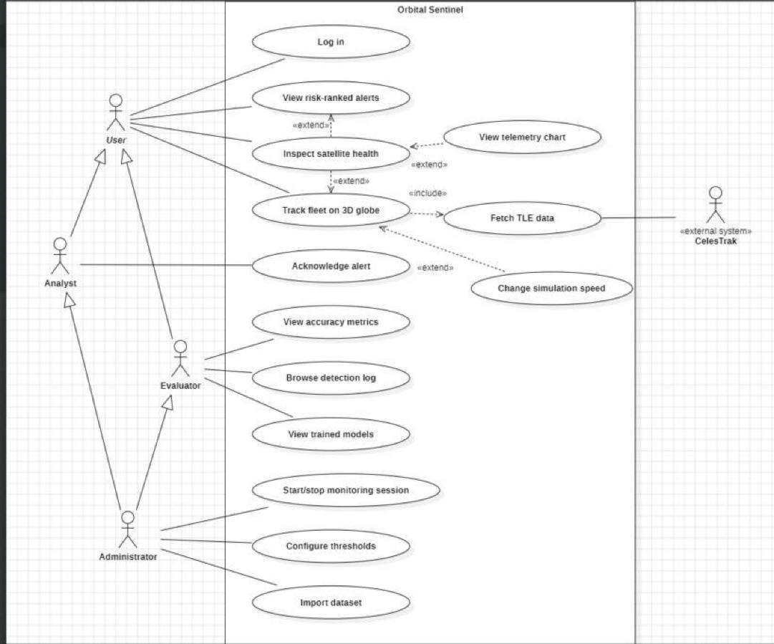
Figure 1: Use Case Diagram – Orbital Sentinel

7. Identified Classes
Nouns in the problem statement and the ER diagram (Exp 4) became the domain (entity) classes; the processing steps became the pipeline (control) classes. Every class maps to real code.
Class | Kind | Responsibility | Code
Satellite | Entity | A monitored spacecraft with its TLE and proxy flag. | models/tables.py
Channel | Entity | One telemetry sensor channel of a satellite. | models/tables.py
TelemetryReading | Entity | One timestamped value of a channel. | models/tables.py
DetectionModel | Entity | A trained detector (weights path, hyper-parameters). | models/tables.py
Detection | Entity | One scored anomalous window (score, severity, outcome). | models/tables.py
Attribution | Entity | Share of a detection blamed on one channel (top 3). | models/tables.py
Alert | Entity | An alert raised from a confirmed detection; carries the alert state. | models/tables.py
User | Entity | A person with one Role and an argon2 password hash. | models/tables.py
MonitoringConfig | Entity | Persistence N and severity threshold set for a satellite. | models/tables.py
Role, AlertStatus, SeverityLevel, DetectionOutcome | Enumerations | Fixed value sets; the names match the SRS and the Exp 5 state diagram. | models/tables.py
SessionRegistry | Control | Starts, stops and lists running monitoring sessions. | services/sessions.py
MonitoringSession | Control | Runs replay → score → lifecycle → store → publish for one satellite. | pipeline/session.py
ReplaySource, Normaliser, Windower | Control | Replay the dataset as a time-ordered stream of windows. | pipeline/ingest.py
Detector «interface» | Interface | score(window) → ChannelScores; lets stages be swapped and mocked. | pipeline/detect.py
LstmDetector, ScriptedDetector | Control | Real LSTM detector, and the test double used by pytest. | pipeline/detect.py
LstmPredictor | Control | PyTorch network: 2 LSTM layers × 80 units + linear head. | pipeline/lstm.py
StreamingThreshold | Control | Non-parametric dynamic threshold over the last 2,100 errors. | pipeline/detect.py
DetectionLifecycle | Control | The Exp 5 state machine (persistence filter, Confirmed/Suppressed). | pipeline/lifecycle.py
TelemetryWindow, ChannelScores | Data (value objects) | Data passed between the pipeline stages. | pipeline/types.py
Explain «utility» | Utility | Attribution, severity, risk label, fleet ranking. | pipeline/explain/
EventBus | Control | In-process publish/subscribe for live (SSE) updates. | services/events.py
CelesTrakClient «utility» | Boundary | Fetches and caches TLEs from the external CelesTrak API. | tracking/celestrak.py

8. Class Diagram
The class model is split into two diagrams in the same StarUML project so each stays readable: the domain model (persistent entities) and the detection pipeline (behaviour). The Satellite class appears on both diagrams as the same model element.
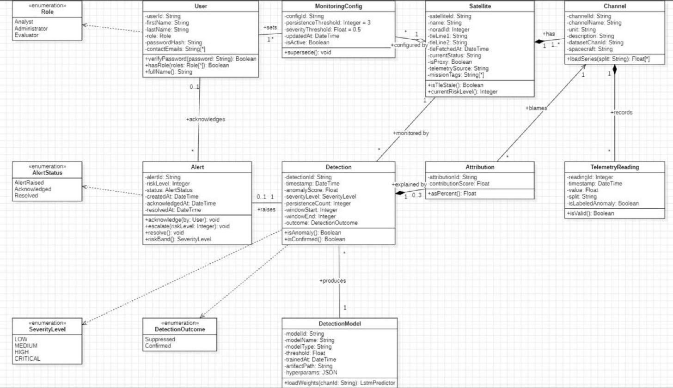
Figure 2: Class Diagram – Domain Model
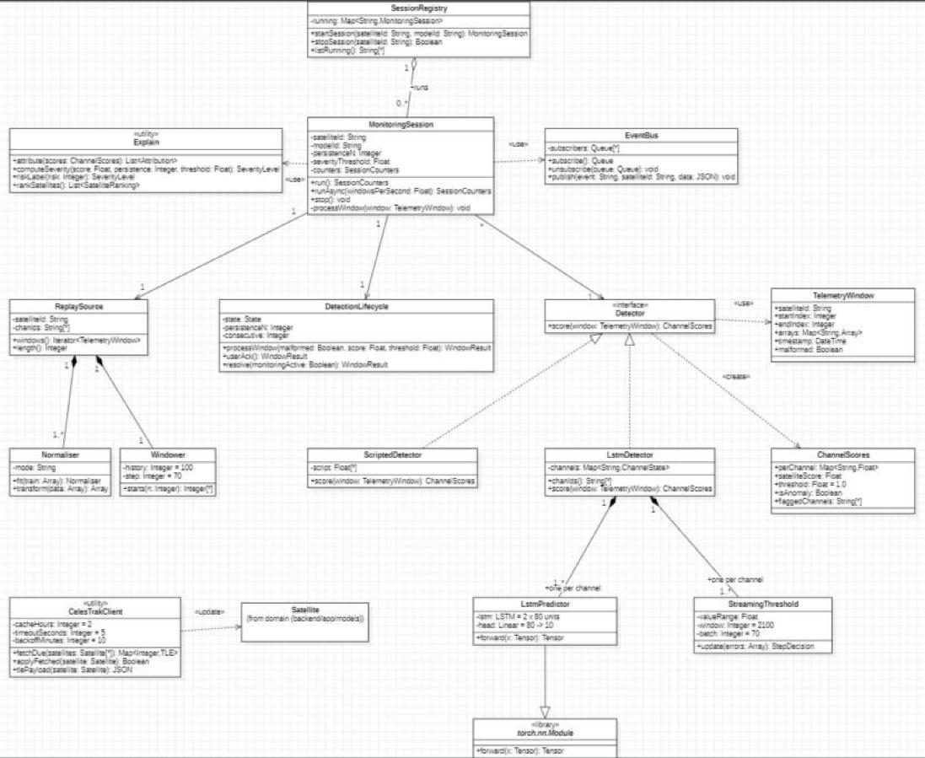
Figure 3: Class Diagram – Detection Pipeline

9. Relationships in the Class Model
From | To | Type | Multiplicity | Meaning
Satellite | Channel | Composition | 1 → 1..* | A channel cannot exist without its satellite.
Channel | TelemetryReading | Composition | 1 → * | Readings belong to one channel.
Detection | Attribution | Composition | 1 → 0..3 | Up to three blamed channels per detection.
Satellite | MonitoringConfig | Aggregation | 1 → * | Config history is kept; only the newest row is active.
Satellite | Detection | Association | 1 → * | Detections are made for a satellite.
DetectionModel | Detection | Association | 1 → * | Each detection records the model that produced it.
Attribution | Channel | Association (directed) | * → 1 | Each attribution blames one channel.
Detection | Alert | Association | 1 → 0..1 | A confirmed detection raises at most one alert.
User | Alert | Association | 0..1 → * | The user who acknowledged the alert.
User | MonitoringConfig | Association | 1 → * | The administrator who set the config.
SessionRegistry | MonitoringSession | Aggregation | 1 → 0..* | The registry holds the running sessions.
ReplaySource | Normaliser, Windower | Composition | 1 → 1..* / 1 | Ingestion helpers owned by the source.
LstmDetector | LstmPredictor, StreamingThreshold | Composition | 1 → 1..* | One predictor and one threshold per channel.
LstmDetector, ScriptedDetector | Detector | Realization | – | Both implement the Detector interface.
LstmPredictor | torch.nn.Module | Inheritance (generalization) | – | The network is a PyTorch module.
MonitoringSession | Explain, EventBus | Dependency «use» | – | Called per window; not stored as fields.
Detector | TelemetryWindow / ChannelScores | Dependency «use» / «create» | – | Input and output of score().
CelesTrakClient | Satellite | Dependency «update» | – | Writes fetched TLEs to the satellite row.

10. Brief Explanation of Design Decisions
Abstract User actor. All three roles share the signed-in use cases, so they sit on an abstract User actor. Analyst and Evaluator specialise User, and Administrator specialises both, which matches the server-side role checks (require_roles) without drawing duplicate association lines.
Log in as its own use case. Authentication is shown once, on User, instead of 13 «include» arrows from every use case; the rule that every request needs a session is enforced by the server on each call.
Include vs extend. Fetching TLEs is mandatory for the globe, so it is «include». Opening the health panel, the telemetry chart and changing the clock speed are optional user choices, so they are «extend».
Names traced to earlier experiments. Entity names are the ER diagram's (Exp 4) and the alert states are the state diagram's (Exp 5), so the design can be followed straight into the code.
Encapsulation. Entity attributes are private (–) and are changed only through operations such as Alert.acknowledge() and Alert.escalate(), which enforce the AlertRaised → Acknowledged → Resolved order.
Abstraction through an interface. MonitoringSession depends on the Detector interface, not on the LSTM. ScriptedDetector realises the same interface, so the whole pipeline is unit-tested without a trained model.
Composition only where lifetimes are bound. Channels, readings and attributions are destroyed with their owner, so they are compositions; monitoring configs keep their history, so the satellite only aggregates them.
Multivalued attributes. missionTags and contactEmails are shown as String[*] attributes; the database stores them in separate tables only to satisfy first normal form, which is an implementation detail.
No duplicate classes. Stateless helper functions (attribution, severity, ranking, CelesTrak access) are grouped into «utility» classes rather than invented as separate objects.

11. Full-Screen Screenshots (with timestamp)
Screenshots of StarUML with the project open; the Windows taskbar clock shows the date and time.
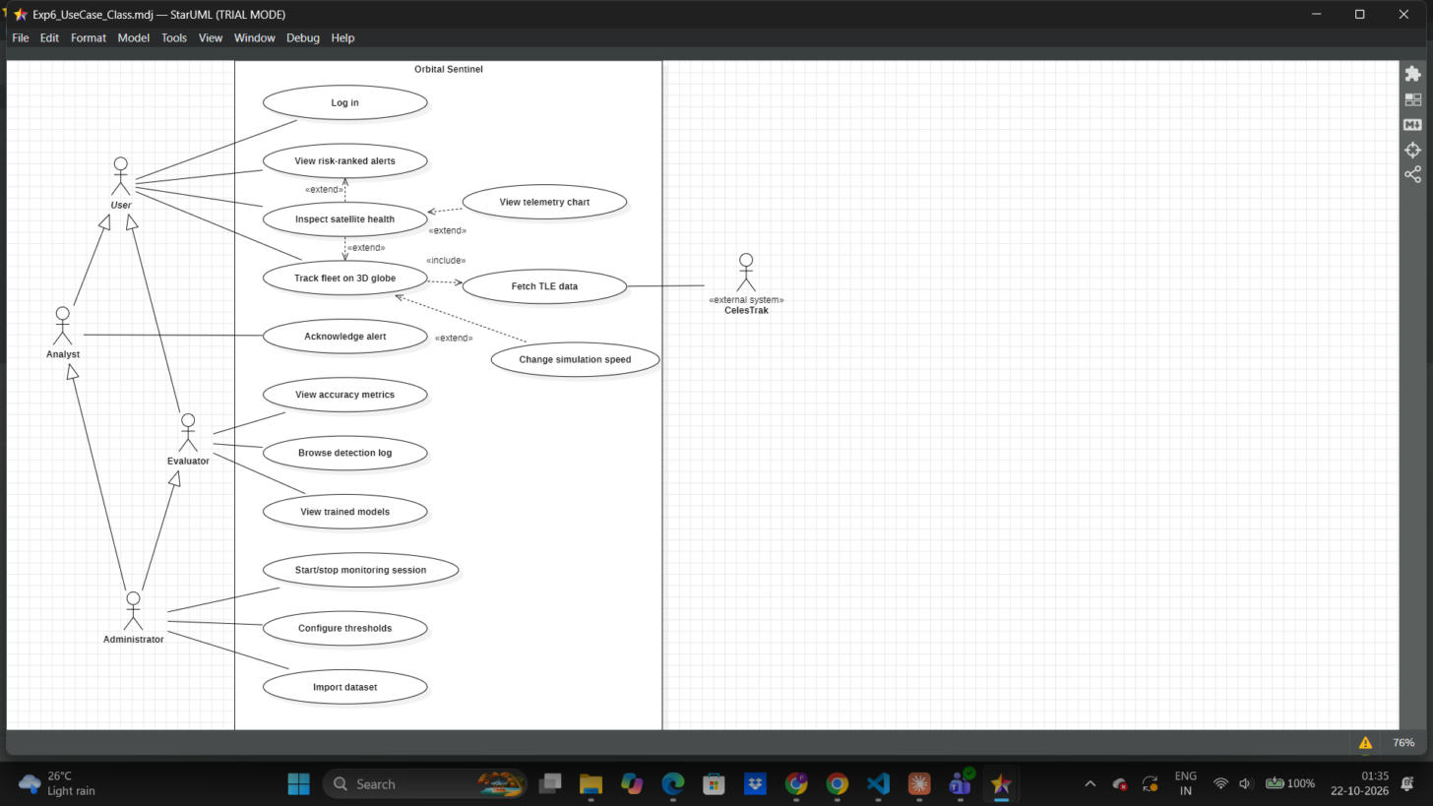
Figure 4: Use Case Diagram open in StarUML, with system timestamp
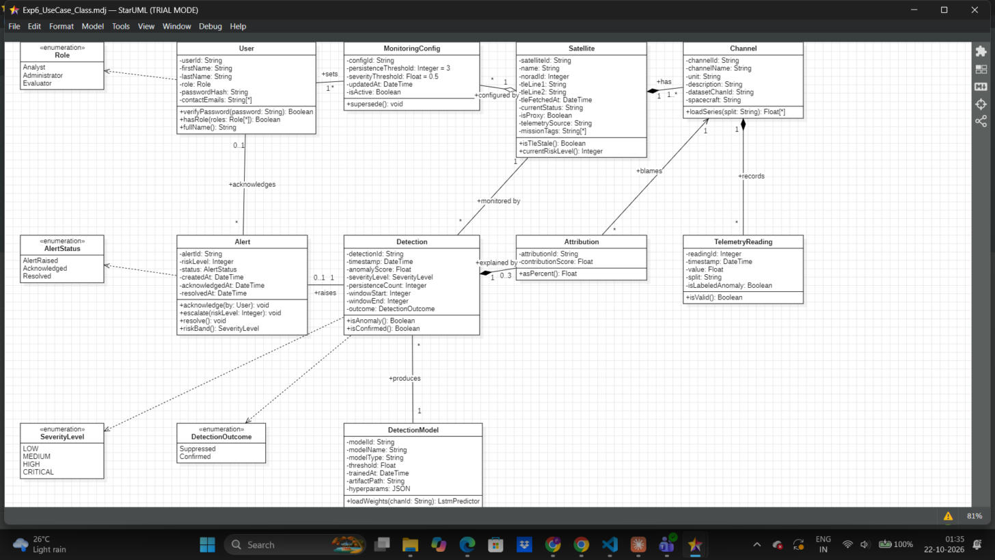
Figure 5: Domain Class Diagram open in StarUML, with system timestamp
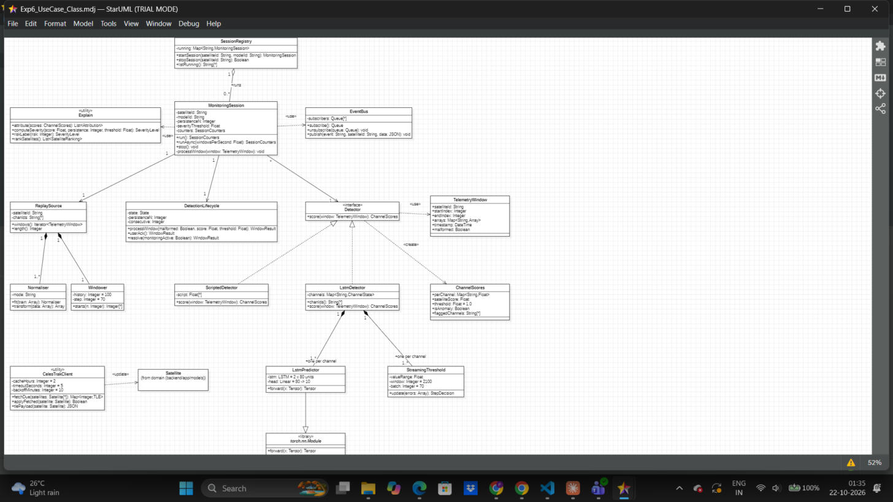
Figure 6: Detection Pipeline Class Diagram open in StarUML, with system timestamp

12. Submission Checklist
☑ Problem statement analysed and system boundary identified (Section 2)
☑ Actors identified, including a secondary external system (Section 3)
☑ Use cases listed and traced to the SRS requirements (Section 4)
☑ Use Case Diagram with association, include, extend and generalization (Figure 1)
☑ Classes identified with attributes and operations (Section 7)
☑ Class Diagram with association, aggregation, composition, inheritance, realization and dependency (Figures 2, 3)
☑ Design decisions explained (Section 10)
☑ Timestamp screenshots attached (Section 11)
☑ StarUML project file saved (docs/uml/Exp6_UseCase_Class.mdj)

13. Result
The Use Case Model and the Class Model of the Orbital Sentinel system were designed in StarUML using standard UML notation. The use case diagram shows 5 actors and 14 use cases with association, include, extend and generalization relationships. The class model shows 9 entity classes, 4 enumerations and 16 pipeline classes (plus the torch.nn.Module library class) with their attributes, operations and all required relationship types. Every class name matches the implementation in the project repository.

