Experiment 8: OO Design – Package, Component and Deployment Models
Tool used: StarUML 7.1.1
Diagram types: UML Package Diagram, UML Component Diagram, UML Deployment Diagram
Subject system: Orbital Sentinel – Satellite Telemetry Anomaly Detection System
Field | Value
Student name | Pushkar Kumar Mishra
Reg. number | 24BPS1128
Course | BCSE301P
Date of submission | 22nd October, 2026
StarUML project file | docs/uml/Exp8_Package_Component_Deployment.mdj
Source code | https://github.com/ItsPM25/Orbital_sentinel

1. Aim
To model the implementation and physical architecture of the Orbital Sentinel system: the packages of the code base and their dependencies (Package Diagram), the major software components and their interfaces (Component Diagram), and the hardware nodes, execution environments and deployed artefacts with the communication paths between them (Deployment Diagram).

2. System Overview
Orbital Sentinel is a web application with two parts. The frontend (Next.js 15 + React 19, port 3001) shows the alert dashboard, the health panel and a 3D globe. The backend (FastAPI on Python 3.12, port 8000) replays NASA SMAP/MSL telemetry through per-channel LSTM models, decides which windows are anomalous, explains and ranks them, stores the results in SQLite and pushes live updates to the browser with Server-Sent Events. Satellite positions are computed in the browser from TLEs that the backend fetches from CelesTrak.

3. Task 1 – Package and Component Model

3.1 Major functional modules
Module (package) | Folder | Function
web.app | web/app | Pages: login, alerts dashboard, globe, satellites, health panel, evaluation, administration.
web.components | web/components | Shared UI: app shell, page header, risk meter, shadcn/ui widgets.
web.lib | web/lib | Typed API client, SSE hook, request coalescing, SGP4 helpers, risk colours.
backend.app.api | backend/app/api | REST + SSE routers (auth, alerts, satellites, detections, ranking, stream, sessions, admin, evaluation, tle).
backend.app.schemas | backend/app/schemas | Pydantic request/response models (camelCase JSON).
backend.app.services | backend/app/services | sessions: running-session registry; events: publish/subscribe bus.
backend.app.pipeline | backend/app/pipeline | Dataset, ingest, LSTM, training, detection, lifecycle, monitoring session, fleet split.
backend.app.pipeline.explain | backend/app/pipeline/explain | Attribution, severity and risk ranking (the novelty layer).
backend.app.tracking | backend/app/tracking | CelesTrak client, TLE cache and bundled snapshot.
backend.app.evaluation | backend/app/evaluation | Metrics, baseline report, persistence-filter (REQ-11) reports.
backend.app.models | backend/app/models | SQLAlchemy tables, one class per ER entity.
backend.app.core | backend/app/core | db (SQLite, WAL), security (argon2, signed cookie, roles), settings (OS_* variables).
ml.spike | ml/spike | Phase 1 model-selection spike (throwaway prototype).

3.2 Package Diagram
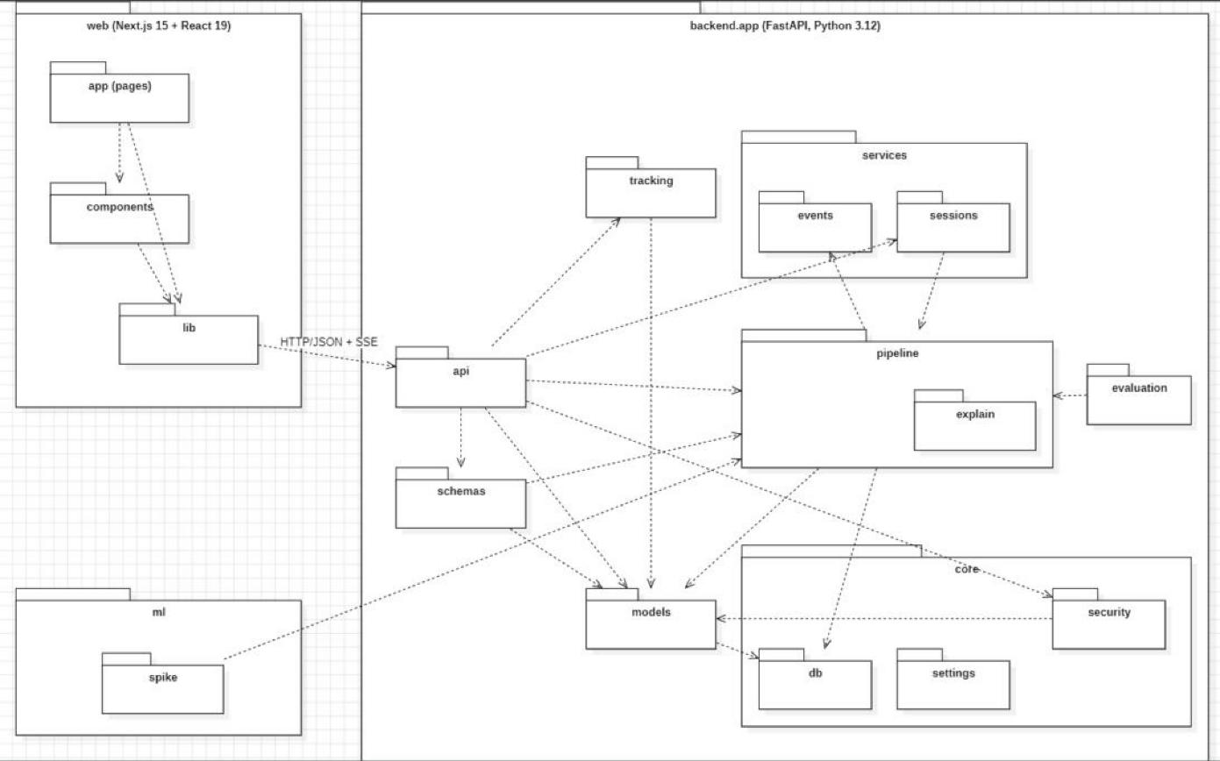
Figure 1: Package Diagram – Orbital Sentinel
Each dashed arrow is a dependency: the source package imports the target package. The table lists every dependency found in the code; the imports of core.settings and core.db by several packages are left off the drawing to keep it readable.
Package | Depends on | Why
web.app | web.components, web.lib | Pages are built from shared components and call the API client.
web.components | web.lib | Components use the risk helpers and formatters.
web.lib | backend.app.api (HTTP/JSON + SSE) | The only link between frontend and backend is HTTP through the /api rewrite.
api | schemas, services.sessions, services.events, pipeline, tracking, models, core.security/db/settings | Routers validate input, call services and return schemas.
schemas | models, pipeline.explain | Response models are built from ORM rows and ranking results.
services.sessions | pipeline, models, core | Starts MonitoringSession tasks.
pipeline | services.events, models, core.db, core.settings | Writes detections and alerts, and publishes live events.
evaluation | pipeline, core.settings | Re-uses the live scoring code to measure accuracy.
tracking | models | Caches fetched TLEs on the satellite rows.
models | core.db | Tables extend the declarative Base.
core.security | models | Loads the signed-in User.
ml.spike | pipeline (dataset) | The spike loads the same dataset files.

3.3 Component Diagram
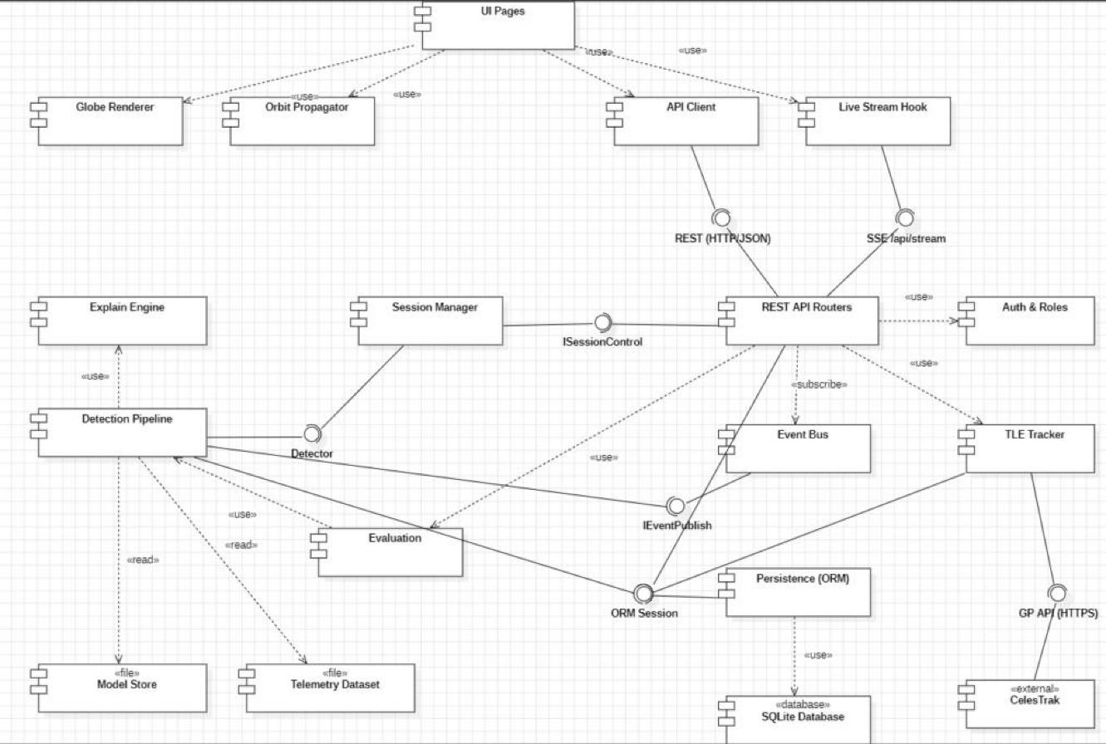
Figure 2: Component Diagram – Orbital Sentinel
Component | Provides | Requires / uses | Realised by
UI Pages | – | Globe Renderer, Orbit Propagator, API Client, Live Stream Hook | web/app
Globe Renderer | – | – | globe.gl 2.46 + three.js 0.186
Orbit Propagator | – | – | web/lib/sgp4.ts (satellite.js)
API Client | – | REST (HTTP/JSON) | web/lib/api.ts
Live Stream Hook | – | SSE /api/stream | web/lib/useStream.ts
REST API Routers | REST (HTTP/JSON), SSE /api/stream | ISessionControl, ORM Session, Auth & Roles, Event Bus, TLE Tracker, Evaluation | backend/app/api
Auth & Roles | – | – | core/security.py
Session Manager | ISessionControl | Detector | services/sessions.py
Detection Pipeline | Detector | IEventPublish, ORM Session, Explain Engine, Model Store, Telemetry Dataset | pipeline/
Explain Engine | – | – | pipeline/explain/
Event Bus | IEventPublish | – | services/events.py
TLE Tracker | – | GP API (HTTPS), ORM Session | tracking/celestrak.py
Evaluation | – | Detection Pipeline | evaluation/
Persistence (ORM) | ORM Session | SQLite Database | models/ + core/db.py
SQLite Database «database» | – | – | backend/orbital.db (WAL)
Model Store, Telemetry Dataset «file» | – | – | models/, data/
CelesTrak «external» | GP API (HTTPS) | – | celestrak.org

Provided interfaces are drawn as lollipops (realization) and required interfaces as sockets (dependency). Interfaces sit where one part of the system could be replaced: the Detector interface lets a different model replace the LSTM, and the ORM Session lets Postgres replace SQLite (OS_DATABASE_URL).

4. Task 2 – Deployment Model

4.1 Nodes and execution environments
Node | Stereotype | Contains
Analyst Workstation | «device» | Web Browser (Chrome / Firefox) «executionEnvironment»
Application Host (Windows 11 laptop: i5-13420H, 12 logical CPUs, 16 GB RAM) | «device» | Node.js 22 runtime, Python 3.12 venv (Uvicorn), Local file system «executionEnvironment»
CelesTrak Server | «device» (external) | GP API web service
Kaggle | «device» (external, one-off) | Dataset mirror
GitHub | «device» (external) | Repository and Actions CI runners

4.2 Deployed artifacts
Artifact | Deployed on | Notes
Next.js client bundle (JS), globe.gl + three.js, satellite.js (SGP4) | Web Browser | Downloaded from the Next.js server; SGP4 runs every frame in the browser.
web (Next.js server :3001) | Node.js 22 runtime | Production build (next start); rewrites /api/* to port 8000.
backend.app (FastAPI :8000) | Python 3.12 venv | REST + SSE, monitoring sessions.
PyTorch 2.14 CPU runtime | Python 3.12 venv | Inference capped at 2 threads per process.
MDL-LSTM-100-80 (81 .pt files) | Python 3.12 venv (models/ folder) | One LSTM per labelled channel, about 29 MB.
orbital.db (SQLite, WAL) | Local file system | Config (D1) and log (D2) data stores.
data/ SMAP-MSL .npy (248 MB) | Local file system | NASA expert-labelled telemetry, replayed.
GP API (gp.php) | CelesTrak Server | TLE source.
nasa-anomaly-detection-dataset-smap-msl | Kaggle | Downloaded once by scripts/get_data.*
Actions runners (Ubuntu, Windows) | GitHub | ci.yml: ruff, pytest, tsc, next build.

4.3 Communication paths
Between | Protocol | Purpose
Analyst Workstation ↔ Application Host | HTTP :3001 (JSON + SSE) | Pages, API calls and live events.
Node.js runtime ↔ Python venv | HTTP localhost:8000 | Next.js forwards /api/* to FastAPI (same origin for the browser).
Application Host ↔ CelesTrak Server | HTTPS | TLE download, cached 2 h, 5 s timeout, 10 min back-off.
Application Host ↔ Kaggle | HTTPS | One-off dataset download.
Application Host ↔ GitHub | HTTPS | git push; CI runs on every push.

4.4 Deployment Diagram
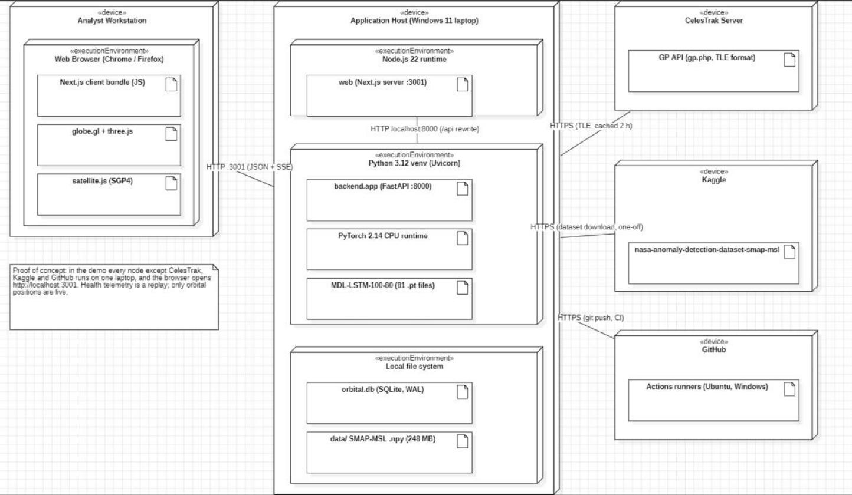
Figure 3: Deployment Diagram – Orbital Sentinel
The note on the diagram records the honest deployment: this is a proof of concept, so in the demo the workstation and the application host are the same laptop and the browser opens http://localhost:3001.

5. Procedure Followed
1. Opened StarUML and created a new project (saved as docs/uml/Exp8_Package_Component_Deployment.mdj).
2. Created a Package Diagram; added the web, backend.app and ml packages with their sub-packages, arranged in layers.
3. Connected packages with dependency relationships taken from the actual import statements in the code.
4. Created a Component Diagram; added the browser, backend, data and external components.
5. Added provided interfaces (lollipop) and required interfaces (socket), plus «use» and «read» dependencies.
6. Created a Deployment Diagram; added the device nodes for the workstation, the application host and the external services.
7. Placed the execution environments inside the nodes and the artifacts inside the execution environments.
8. Connected the nodes with communication paths labelled with their protocol.
9. Checked notation and relationships, re-arranged elements so that no line crosses a box, and saved the project.
Element creation was scripted through StarUML's extension API (source in docs/uml/staruml-extension/main.js) so that every name matches the code exactly; the layout was then checked and adjusted in StarUML.

6. Design Notes
Layering. Dependencies point downwards: api → services/pipeline → models → core. The browser reaches the backend only through the HTTP interface, never through shared code.
Cycles made visible and narrowed. At package level there are two import cycles (pipeline ↔ services and models ↔ core). Drawing the sub-packages shows that each is really between different modules (pipeline → services.events while services.sessions → pipeline; models → core.db while core.security → models), so no single module depends on itself. Moving events into its own top-level package would remove the cycle entirely.
main.py is not drawn. backend/app/main.py is a module (the FastAPI entry point that wires the routers), not a package, so it is not shown on the package diagram.
Replaceable components. The Detector and ORM Session interfaces are the planned replacement points (a different model; Postgres instead of SQLite).

7. Full-Screen Screenshots (with timestamp)
Screenshots of StarUML with the project open; the Windows taskbar clock shows the date and time.
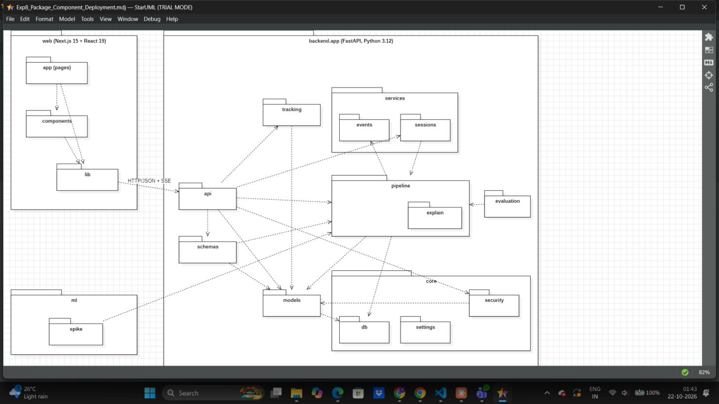
Figure 4: Package Diagram open in StarUML, with system timestamp
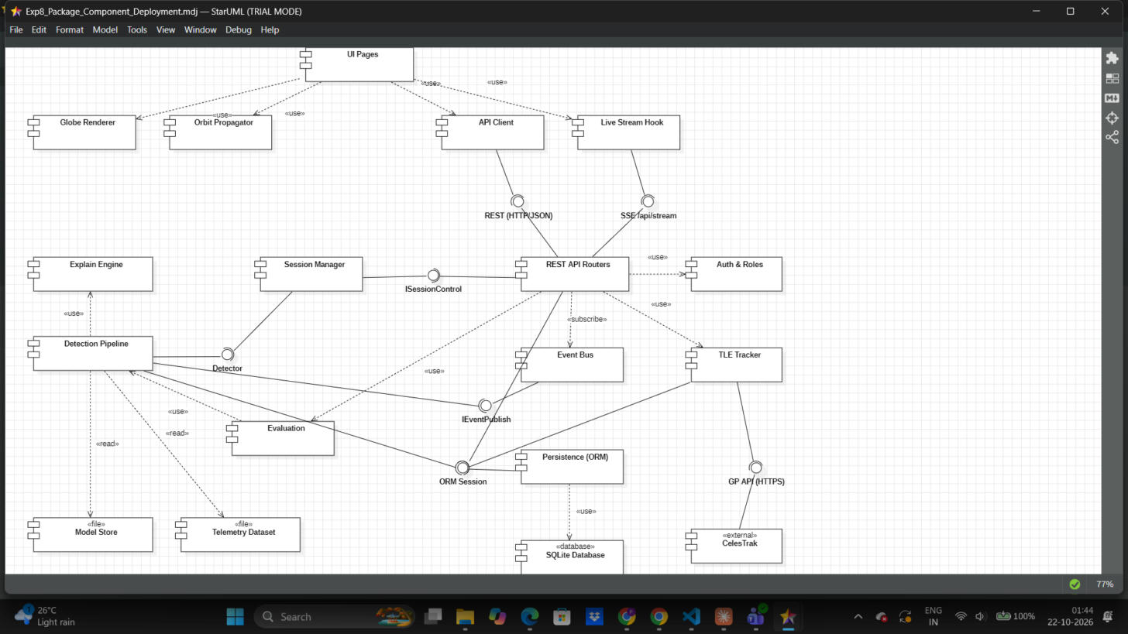
Figure 5: Component Diagram open in StarUML, with system timestamp
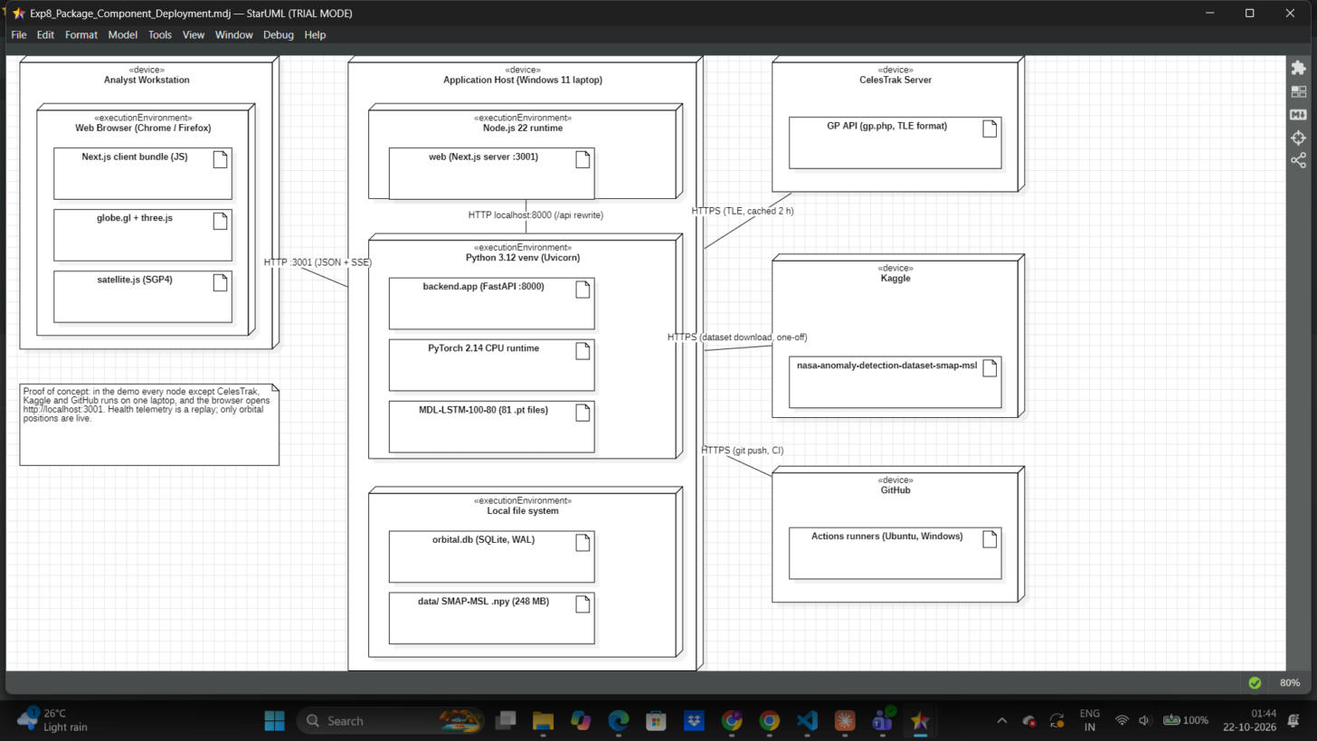
Figure 6: Deployment Diagram open in StarUML, with system timestamp

8. Submission Checklist
☑ Major functional modules identified (Section 3.1)
☑ Package Diagram with packages and dependencies (Figure 1)
☑ Component Diagram with components, interfaces and dependencies (Figure 2)
☑ Hardware/environment nodes identified (Section 4.1)
☑ Deployment Diagram with devices, execution environments, deployed artifacts and communication paths (Figure 3)
☑ UML notation and relationships checked
☑ StarUML project saved (docs/uml/Exp8_Package_Component_Deployment.mdj)
☑ Timestamp screenshots attached (Section 7)

9. Result
The Package, Component and Deployment models of the Orbital Sentinel system were designed in StarUML. The package diagram shows 3 top-level packages and 19 sub-packages with their real import dependencies; the component diagram shows 18 components and 7 interfaces; the deployment diagram shows 5 device nodes, 4 execution environments, 12 deployed artifacts and 5 communication paths. Together they describe how the code is organised, how the running parts talk to each other, and where each part runs.

