HALLOWTIDE
The Hollowing of Blackwood - Complete DM Campaign
A folk-horror Dungeons & Dragons campaign for 3-6 characters, levels 3-7. Designed for approximately eight 3-4 hour sessions.
Orange guards the threshold. Black announces His coming. White shall announce His end.
This book contains DM-only spoilers. Separate player-safe maps are included in the package.
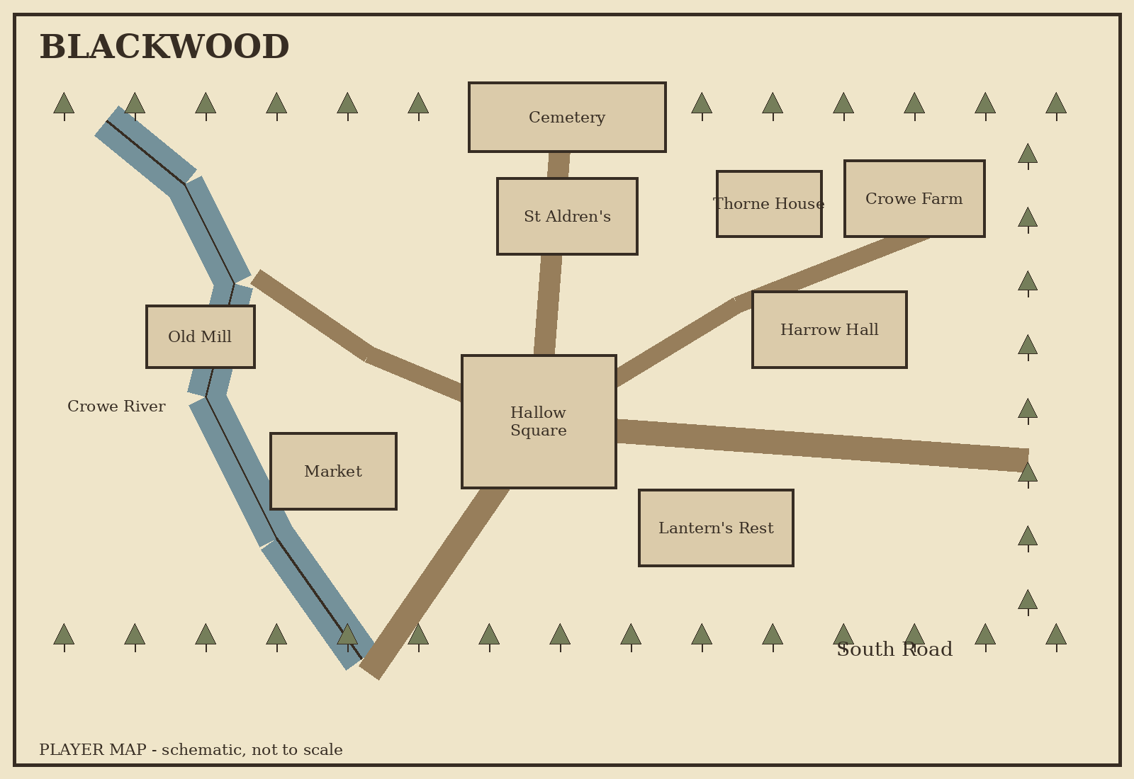

1. Campaign at a Glance
Element | Campaign Standard
System | D&D 5e / 2024-compatible homebrew
Party | 3-6 characters
Starting Level | 3
Ending Level | 7
Length | 8 sessions, approximately 3-4 hours each
Genre | Folk horror, mystery, supernatural survival, dark fantasy
Core Location | Blackwood, an isolated valley town
Primary Villain | The Hollow King, an ancient archfey
Human Antagonist | Professor Elias Wren / Elias Harrow
Core Choice | Rebind the King, bargain with him, or void the original contract and destroy him

Campaign Promise
Hallowtide begins as a warm autumn festival and gradually reveals that nearly every local Halloween custom is a fragment of an ancient containment ritual. The characters are not prophesied heroes. They are simply the first people in four centuries to hear the Fourth Warden's desperate call clearly enough to answer it.

Tone and Safety
The campaign uses missing persons, ghosts, body horror, grief, children in supernatural danger, identity theft, possession and dead loved ones. Before play, establish lines and veils. A player's deceased-loved-one hook should only be used if that player opts into it.

Milestones
After | Level
Campaign start | 3
Session 1 | 4
Session 3 | 5
Session 6 | 6
Before final Hollow King confrontation | 7

2. The True History of Hallowtide

The Long Harvest
Four centuries ago, autumn refused to end. For thirteen weeks an orange moon remained above Blackwood Vale. Crops ripened overnight and rotted by morning. Livestock vanished from locked barns. The dead were seen outside windows. Children disappeared from their beds.
An ancient archfey calling himself the Hollow King appeared and offered the starving settlement a bargain:
"Give me your dead, and I shall spare your living."
Silas Crowe accepted on behalf of the settlement. The King then revealed his interpretation: all mortals are destined to die, therefore all mortals are already his dead. The bargain had surrendered Blackwood.

The Four Wardens
Warden | Title | Discovery | Modern Tradition
Elspeth Blackwood | Warden of Flame | Harvest-fire protects thresholds | Hallow lanterns
Father Aldren Vale | Warden of Names | The remembered dead resist the King | Night of Names
Rowan Thorne | Warden of Masks | The King's servants recognize faces, not souls | Masks and costumes
Silas Crowe | Warden of the Forgotten | A forgotten true name cannot be commanded | Erased from history
The four created a binding around the Hollow Gate. Silas crossed into the Hollow Realm to close the gate from within. Blackwood erased his name so the Hollow King could never command him.

The Three Fires
Fire | Meaning | Use
Orange | Protection | Normal Hallowfire; seals functioning
Black | Corruption | The Hollow King's influence has entered the ritual
White | Purification | The King's claim has been severed; seen only at the First Hallowtide and the true ending
Orange guards the threshold. Black announces His coming. White shall announce His end.

3. Immutable Rules of the Hollow King
- The Hollow King must honor the exact wording of a freely accepted bargain. He may exploit ambiguity, but he cannot rewrite agreed terms.
- A properly kindled Hallow flame denies his lesser servants free passage across a protected threshold.
- He cannot fully claim or command a dead soul whose identity remains actively remembered by the living.
- True names create leverage. If he knows and speaks a true name through a person or place bound to him, he can exert supernatural command over that being.
- A mask consecrated by the old rite prevents his servants from identifying the wearer's true identity by sight alone.
- The Hollow King cannot permanently cross the Hollow Gate while all four seals function.
- He cannot create life. His servants are stolen, imitated, reassembled or animated things.
- He may imitate voices and memories but cannot invent a personal memory he has never taken from a victim.
- His original claim over Blackwood is the legal foundation of his immortality within the vale. If the bargain is proven void, he becomes killable.
- White flame is not a weapon by itself; it is the visible consequence of a purified binding or a severed claim.

4. The Four Seals - Playable Mechanics
Seal | Player-facing power | Failure effect
Flame | A lit Hallow Lantern grants advantage on saves against fear within 10 ft; lesser Hollow servants cannot cross its protected household threshold without invitation or extinguishing it. | Lantern Men may enter homes; fear effects strengthen.
Names | Speaking a threatened spirit's full remembered name as an action gives it a new save against possession/claiming. | Forgotten Dead gain resistance to turning and spirit corruption spreads.
Masks | A consecrated mask grants advantage on checks/saves against Mummer impersonation and identity-reading. | Mummers gain easier access to memories and social infiltration.
Forgotten | Silas cannot be commanded while his true name remains unknown to the King. | If broken, Silas becomes Bound and the Hollow Gate can fully open.

Using the Seals in the Finale
During Phase III of the Hollow King battle, the party must restore or invoke at least three seal principles while also resolving the bargain. Each successful seal objective removes one Legendary Resistance or one lair action from the King. Invoking all four before voiding the bargain causes the First Lantern to flash white and grants the party inspiration.

5. The Hollowing Meter
Track Hollowing secretly from 1 to 10. It measures how much Blackwood overlaps the Hollow Realm. It changes the town but does not replace the core story.
Score | Manifestation
1 | Unease - animals refuse certain streets; lantern flames bend toward Hallow Square.
2 | Whispers - names are heard in empty rooms.
3 | Watching - scarecrows and carved pumpkins subtly change orientation.
4 | The Dead Dream - residents dream of deceased relatives.
5 | The Roads Turn - attempts to leave may return to Blackwood.
6 | The Wandering - ghosts openly appear.
7 | No Door - no mundane route leaves the vale.
8 | The Long Harvest - crops grow and rot rapidly; buildings flicker into older forms.
9 | Overlap - Hollow Blackwood physically intersects the town.
10 | The Hollowing - the gate is open and both Blackwoods occupy the same space.

Typical Changes
- +1: a major ritual fails; a named NPC is claimed; Wren secures a Warden artifact; a functioning Hallow Lantern is deliberately destroyed; a seal is badly damaged.
- -1: a seal is restored; a Warden artifact is recovered; a major ritual is successfully protected; a trapped spirit is released correctly; the party performs an original rite discovered through investigation.
- Hollowing cannot normally fall below 1 before the true ending. The Fourth Seal breaking sets Hollowing to at least 9.

6. Blackwood
Blackwood has roughly 700 permanent residents and swells during Hallowtide. It lies in a bowl-shaped valley surrounded by old forest. The Crowe River enters from the northwest and leaves through a southern gorge. The town is compact: most locations are within a 15-20 minute walk.


Hallow Square
Festival heart, market stalls and the Hearthstone supporting the Hallowfire.
DM Secret: The Hearthstone is the upper face of the Hollow Gate. Four seal symbols ring it; the fourth was chiselled away.

Lantern's Rest
Warm inn run by Mara Blackwood; ideal party headquarters.
DM Secret: Elspeth's First Lantern hangs above the hearth as a family heirloom.

Saint Aldren's Chapel
Small stone chapel and repository of Vale family records.
DM Secret: Its altar sits above the Seal of Names and four underground Warden chambers.

Blackwood Cemetery
Much larger than the town's population requires.
DM Secret: Four paths meet at Silas's symbolic empty grave, forming part of the Forgotten Seal.

Thorne House
Agatha's home and informal Hallowtide museum.
DM Secret: A tapestry physically had a fourth Warden cut from it.

Harrow Hall
Mayor's home and municipal archive.
DM Secret: Records can connect Professor Wren to the Harrow family.

Bell Bakery
Clara Bell's busy bakery.
DM Secret: After her disappearance, the bakery becomes an emotional anchor for Daniel and Samuel Bell.

Blackwood Market
Festival stalls and ordinary townsfolk.
DM Secret: Recurring minor NPCs met here can later aid the finale.

Old Mill
Abandoned riverside mill.
DM Secret: Wren uses it as a hidden ritual workshop.

Crowe Farm
Ruined farm surrounded by corn.
DM Secret: Silas lived here; the Harvest Man forms in the fields.

Blackwood Forest
Ancient woods enclosing the valley.
DM Secret: At Hollowing 7, every path out returns to town.

The Hollow Gate
Thin point between worlds beneath Hallow Square.
DM Secret: It is not a door but an overlap of places.

7. Cast of Blackwood

Mayor Eleanor Harrow
Presentation: Controlled, practical, protective.
Wants: Protect Blackwood and prevent panic.
Secret: Professor Wren is her estranged brother Elias Harrow; she received a letter six months ago.
Campaign role: Breaks when she learns Elias caused the crisis.

Agatha Thorne
Presentation: Warm, stubborn, encyclopedic about traditions.
Wants: Preserve Hallowtide.
Secret: She is not intentionally hiding anything; she knows rituals without understanding their purpose.
Campaign role: Becomes the party's best ritual interpreter.

Father Matthias Vale
Presentation: Gentle but tense; speaks carefully.
Wants: Maintain the Seal of Names.
Secret: His family knows the Night of Names is real magic.
Campaign role: Can anchor the cemetery defense if saved.

Gideon Graves
Presentation: Gruff, superstitious, uncomfortable around actual ghosts.
Wants: Keep the cemetery quiet.
Secret: Graves were disturbed three weeks before Clara vanished.
Campaign role: Can fortify cemetery routes in the finale.

Mara Blackwood
Presentation: Direct, hospitable, fearless when protecting guests.
Wants: Protect family and inn.
Secret: Her grandmother made her promise never to discard the First Lantern.
Campaign role: Can awaken Elspeth's legacy.

Sheriff Thomas Reed
Presentation: Dry, skeptical, methodical.
Wants: Maintain order.
Secret: None; his skepticism is sincere.
Campaign role: Skeptic-to-monster-hunter arc; excellent finale ally.

Lily Vale
Presentation: Curious nine-year-old who dislikes being talked down to.
Wants: Help 'Mr. Nobody.'
Secret: She has spoken to Silas for months.
Campaign role: Leads the party toward the Hollow Realm.

Clara Bell
Presentation: Generous baker; appears briefly before vanishing.
Wants: Protect her family.
Secret: She recently heard her dead father's voice.
Campaign role: Her living capture proves the King violated the bargain.

Daniel Bell
Presentation: Exhausted, loyal, angry after Clara vanishes.
Wants: Find Clara.
Secret: None.
Campaign role: Humanizes the cost of the mystery.

Samuel Bell
Presentation: Six, observant, frightened.
Wants: Get his mother back.
Secret: Saw his dead grandfather outside.
Campaign role: Key Session 2 witness.

Professor Elias Wren / Elias Harrow
Presentation: Charming historian, funny, self-deprecating, sincerely helpful.
Wants: Recover his dead wife Amelia.
Secret: He is sabotaging the seals and using the party to discover Silas's name.
Campaign role: May be redeemed or become the Hollow King's Herald.

Recurring Townsfolk
NPC | Role | Finale payoff
Bran Cooper | Blacksmith; jovial competition judge | Arms a militia barricade
Tilly Moss | Herbalist and fortune-teller | Provides anti-fear incense
Old Man Wick | Candlemaker | Produces emergency Hallow candles
Rosa Finch | Mask-maker | Consecrates emergency masks
Mira and Milo Fenwick | Teenage pranksters | Know roofs, alleys and shortcuts
Nell Archer | Retired hunter | Organizes rooftop archers
Pip Holloway | Festival champion, age 12 | Becomes a brave messenger
Bess Cooper | Cook and market organizer | Runs civilian shelter at Lantern's Rest

8. Elias Wren - Secret Timeline
Time | What Wren did
7 years before | Amelia dies. Elias becomes obsessed with death folklore.
3 years before | Finds references to the Hollow Realm and concludes claimed souls persist there.
1 year before | Returns secretly to Blackwood research under the surname Wren.
6 months before | Writes Eleanor without revealing his full plan; asks about sealed family records.
8 weeks before | Finds the Old Mill and begins ritual experiments.
3 weeks before | Disturbs old graves searching for evidence of the Fourth Warden. Gideon notices.
10 days before | Learns Aldren's remains are a key to weakening the Seal of Names.
3 days before | Alters the Hallowfire preparation so the first ritual flame will corrupt black.
Session 1 | Poses as a visiting scholar. Observes the PCs and recognizes their unusual resonance with the seals.
Session 2 | Encourages investigation and covertly studies Clara's pumpkin. Moves ritual materials to the mill.
Session 3 | Recognizes the four-Warden medallion and lies. Searches Crowe Farm after the party leaves if able.
Session 4 | Steals or arranges the theft of Aldren's remains during the Night of Names crisis.
Session 5 | Follows the party's discoveries; searches the Forgotten Chamber before or after them depending on timing.
Session 6 | Uses the failing Masks seal and Mummer chaos to cover Lily's disappearance and his own movements.
Session 7 | Waits for the party to return with Silas's name. The Hollow King has increasingly direct access to him.
Session 8 | If unredeemed, becomes the King's mouthpiece and speaks Silas's name. If redeemed, the King uses the bond already forged in Wren to rip the name from his memory and speak through him anyway.
If exposed early, Wren flees rather than fighting to the death. The Hollow King continues using him remotely. The campaign never depends on Wren remaining socially trusted.

9. Clue Matrix
Revelation | Independent clues
There were Four Wardens | Harvest Man medallion; Thorne tapestry; four undercroft chambers; cemetery geometry; children's rhyme.
Names have power | Aldren prayer; Night of Names behavior; disappearing undercroft names; ghost testimony; Silas.
Wren is Elias Harrow | Harrow portrait; family letter; Old Mill possessions; Eleanor recognizes his effects; childhood slip.
Silas made the bargain | Crowe Farm remnants; journal fragments; Hollow Realm echoes; Silas; original contract.
The King violated the bargain | Exact wording; Aldren commentary; Clara captured alive; King's own boast; Silas testimony.
White fire means purification | Ancient mural; Elspeth writing; First Lantern flash; Silas memory; Hollow Realm painting.
Rule of three: no mandatory revelation should rely on a single check. A failed check may cost time, raise Hollowing, or reveal a clue incompletely, but it should not permanently remove the only path forward.

10. Session 0 - Character Hooks
Characters begin at level 3. Every character needs an ordinary reason to attend the famous Hallowtide festival. After creation, assign one private supernatural hook. Silas has been broadcasting a desperate call through the weakening barrier; the PCs are the first people in centuries to hear it clearly enough to act.
Hook | Private text
The Dreamer | For three nights you dreamed of an orange moon and a faceless man saying, 'When the fourth bell rings, do not speak my name.'
The Descendant | You inherited an iron key from a relative who refused to discuss Blackwood.
The Mourner | You received a letter in the handwriting of someone dead: 'Meet me in Blackwood on the Night of Names.'
The Marked | A lifelong mark on your body resembles symbols carved over old Blackwood doors.
The Forgotten | An old family portrait contains a figure whose face was deliberately scratched away.
The Hunter | You once saw a man with a burning jack-o'-lantern for a head. Rumors led you here.
The Listener | You sometimes hear a bell no one else hears. It has been getting louder.
The Keeper | A cheap-looking lantern you bought years ago lights itself whenever Blackwood is mentioned.
The Masked | You own a mask you cannot remember acquiring. Its inside bears Rowan Thorne's mark.
The Nameless Letter | A sealed note addressed to you contains only: 'Please remember me.'
The White Spark | Once, during a near-death experience, you saw white fire. A Hallowtide poster depicts the same shape.
The Returning Road | You have never visited Blackwood, yet you can sketch its main square from memory.
Also privately collect, with consent: one deceased loved one, one fear, one regret, one treasured memory, and one living person the character would protect at great cost.

11. Session 1 - Keep the Light

Goals
- Make players like Blackwood.
- Introduce all major NPCs without exposition dumps.
- Let Wren notice the PCs.
- Seed four-Warden imagery without explaining it.
- End with Clara's impossible disappearance and the Fourth Bell.

Opening Read-Aloud
The road drops through copper and crimson forest, and Blackwood appears below like a lantern cupped between dark hills. Smoke curls from chimneys. Red and gold ribbons cross the streets. Hundreds of carved gourds watch from windowsills, each waiting for sunset. Somewhere below, a fiddle starts a reel and a crowd cheers. For a town famous for ghosts, Blackwood looks remarkably alive.

Festival Scenes
Scene | Mechanic | NPCs / payoff
Pumpkin Carving | Dexterity (artisan tools) or Performance DC 12; best margin wins. | Clara Bell, Samuel, Agatha. Prize: Hallow candle.
Archery at the Crow | 3 attacks vs AC 13; two hits earns prize. | Nell Archer, Sheriff Reed. Prize: black-feather token granting one reroll on a later navigation check.
Mask Maker's Booth | No check; choose or describe a mask. | Rosa Finch. A properly fitted mask later grants advantage on first Mummer identification check.
Fortune Tent | Insight or Arcana DC 13 to notice Tilly's genuine alarm. | Tilly Moss gives one PC a cryptic seal-specific omen.
Cider & Story Contest | Performance/Persuasion DC 12. | Mara and Wren; ideal social introduction.
Children's Rhyme | Perception DC 11 while passing children. | First fragment of 'Four stood where one should fall.'

Wren's First Contact
Wren introduces himself as a visiting folklorist. He should solve one small historical question for the party, then ask what brought them to Blackwood. If a PC mentions a supernatural hook, he becomes intensely interested but disguises it as academic curiosity.

The Lighting Ceremony
At dusk, every street empties toward Hallow Square. Agatha Thorne stands before a pyre stacked higher than a man. Hundreds of unlit lanterns surround you. She raises a taper. 'One flame.' The town answers, 'A thousand lights.' She calls, 'One darkness.' The reply comes like a promise: 'No door.'
Agatha lights the first lantern from the Hallowfire. The flame turns black. Every other flame in Blackwood dies at once.
Darkness. Then the chapel bell: once. Twice. Three times. A breath passes through the crowd. The bell rings a fourth time.
When light returns, Clara Bell is gone. Her hand is no longer in Daniel's. A carved pumpkin sits where she stood, bearing Clara's face.

Immediate Checks
Check | DC | Result
Arcana/Religion | 13 | The pumpkin carries both fey and necromantic residue.
Medicine | 12 | A human tooth inside is fresh and matches an adult.
Perception | 14 | Wren looks toward the Hearthstone before he looks toward the missing woman.
Investigation | 12 | The black flame left four radial scorch marks around the Hearthstone.

Sound Cues
- Warm festival crowd and fiddle ambience.
- Bonfire crackle under Agatha's call-and-response.
- Hard silence when flame turns black.
- Three normal bells, 2 seconds apart.
- 3-second silence, then a deeper fourth bell.
- Single distant scream; low sub-bass drone under aftermath.

Failure / Divergence
If the party immediately attacks Wren, he is innocent-looking and protected by witnesses. If they attempt to leave, roads still function at Hollowing 2-3. If they refuse to investigate, Daniel Bell personally asks for help and Sheriff Reed deputizes capable outsiders. The campaign does not require them to trust any NPC.
Milestone: level 4 at session end.

12. Session 2 - A Gift for the Wandering

Opening
The town refuses to cancel Hallowtide. Mayor Harrow argues that panic and abandoned rituals may be more dangerous than continuing. Three leads are available in any order: Bell residence, Clara's pumpkin, cemetery.

Bell Residence
The Bell home still smells of flour and cinnamon. A child's coat hangs beside the door. Muddy footprints begin beneath the bedroom window, cross the floorboards, and stop beside Clara's bed. There are no prints leading back out.
Samuel says his dead grandfather stood outside and asked, 'Does your mother remember me?' A gentle Persuasion DC 11 gets the full story; intimidation shuts him down and raises Daniel's hostility.

Pumpkin
Inside are Clara's tooth and seeds that have germinated impossibly fast. Nature DC 13 reveals roots grew in minutes. Arcana DC 14 reveals the roots are tracing part of the Seal of Names.

Cemetery
Gideon initially lies that disturbed graves appeared after Clara vanished. Insight DC 12 reveals the timeline is false. Kindness or evidence gets the truth: digging began three weeks ago. Several graves show inward digging. One unnamed grave reads REMEMBER ME NOT.

Act II Opening Ceremony - The Wandering
At twilight, masked children drift from door to door carrying little baskets. At each threshold comes the same question: 'A gift for the wandering?' Laughter follows, sweets change hands, and for a little while Blackwood almost feels normal.
At Lantern's Rest, three knocks sound. Mara opens the door. No one stands outside.
From somewhere below the porch comes a child's whisper: 'You forgot one.'
Three knocks strike every door on the street simultaneously. Dead residents begin walking silently toward the cemetery.

Encounter: Procession of the Wandering
This is initially a social/navigation challenge, not combat. The party must keep frightened townsfolk from attacking peaceful ghosts. Run 4 successes before 2 failures using Persuasion, Religion, Insight, Medicine or creative magic, DC 13. Failure causes a panic injury and +1 Hollowing. Success reveals a ghost pointing toward Aldren's chapel and whispering, 'Names first.'

Sound Cues
- Night insects, distant children's laughter, soft festival tune.
- Three isolated knocks.
- Child whisper: 'You forgot one.'
- Mass simultaneous knocks.
- Music cuts; low wind and slow footfalls begin.

13. Session 3 - The Corn Remembers

Hook
A farmhand disappears near Crowe Farm. The medallion clue and disturbed land point toward the old fields.

Cornfield Exploration
Run as a five-zone navigation dungeon. Each transition requires Survival, Perception or Investigation DC 13. Two failures trigger a separation scare or minor encounter but never permanently split the party.
Zone | Feature
1. Dead Rows | Corn is ripe on one side and rotten on the other.
2. Whisper Lane | Each PC hears a familiar voice from a different direction.
3. Scarecrow Cross | Three scarecrows; one changes pose whenever unobserved.
4. Crowe Marker | A boundary stone marked S.C.; nearby child's height marks survive on ruined timber.
5. Old Circle | Harvest Man lair and four-Warden medallion.

Boss: Harvest Man
Use the Harvest Man stat block in the Bestiary. At 50% HP its burlap torso tears open, revealing several centuries-old skeletons bound into its frame. Destroying or consecrating the heart-knot suppresses its Regeneration.

Major Clues
- Silver medallion depicts four Wardens.
- Children's rhyme in a rotted field journal.
- Crowe Farm contains scratched-away family names and initials S.C.
- Wren recognizes the rhyme; Insight DC 15 catches the lie.
Milestone: level 5.

14. Session 4 - The Night of Names

Preparation
Father Matthias insists the Night of Names must proceed. The party may help secure the cemetery, interview families, or investigate the Vale Mausoleum. Each preparation success grants one advantage token usable during the defense.

Ceremony
Hundreds of candles turn the cemetery paths into rivers of gold. One by one, families speak names into the cold. The bell tolls for those lost this year. Then a woman gasps. Beside a grave stands a translucent man in an old coat, smiling through tears.
Allow quiet roleplay. If a player opted into the deceased-loved-one hook, their person appears. They may offer one truthful but incomplete clue.
An elderly ghost looks toward the Vale Mausoleum. 'There are fewer names,' she says.
Aldren's tomb opens. His remains are gone. Corruption spreads through the spirits.

Cemetery Defense
Three objectives occur simultaneously: protect civilians, keep Matthias reading names, and prevent Forgotten Dead from reaching the unnamed grave. Completing 2/3 prevents +1 Hollowing; 3/3 reduces Hollowing by 1.

Revelation
Matthias admits his family has maintained real protective rites for generations. He knows the Seal of Names exists but not the complete four-Warden history.

15. Session 5 - Beneath Saint Aldren's
Aldren's records and the cemetery geometry reveal a hidden stair beneath the chapel. This is the campaign's principal dungeon.

Central Crypt
A circular chamber connects four cardinal rooms. A mural shows four silhouettes around white fire; one face and name have been chiseled away.

Flame Chamber
Puzzle: three braziers labeled Hearth, Harvest and Hunger. Only Harvest may light the old lantern. Nature/History DC 13 identifies grain-oil residue. Lighting correctly awakens Elspeth's First Lantern; a wrong choice releases two Harvest Scarecrows.

Names Chamber
Thousands of names cover the walls. Several fade while watched. Speaking a fading name aloud restores it. Investigation DC 13 finds Aldren's commentary: 'No claimant may take the living while sworn to spare them.' This is a true-ending clue.

Masks Chamber
Illusions create duplicates of the PCs. To open the exit, each character must identify an ally using a memory or fact unrelated to appearance. Failure triggers a Mummer Echo encounter.

Forgotten Chamber
The southern door opens onto deliberate destruction. Every inscription has been hammered flat. At the center, only one sentence survives: WHAT IS FORGOTTEN CANNOT BE COMMANDED.
Journal fragments reveal that one Warden crossed the gate and demanded erasure. Fresh bootprints prove someone else has searched here recently.

Reward
- Elspeth's First Lantern.
- Aldren's Commentary fragment.
- Rowan's half-mask, found behind the Masks altar.
- A fragment of the original contract bearing the phrase 'spare your living.'

16. Session 6 - Another Wears You

Night of Masks
Despite fear, the final public celebration begins because Agatha and Matthias believe abandoning the rite would accelerate the collapse. Everyone wears masks.

Mummer Rules
A Mummer can imitate appearance and stolen surface memories but cannot invent an unobserved personal memory. Players should be able to test suspected impostors through relationships rather than arbitrary Insight checks.

Masquerade Set Piece
The music stops in the middle of a dance. A masked guest stands in the doorway. Something wet hangs from one hand. They lift it into the lantern light. It is their own face.
Run a social deduction scene followed by combat with 2-4 Mummers depending on party size. Saving Rosa Finch allows emergency consecration of masks.

Lily's Disappearance
During the chaos Lily vanishes. Her room is undisturbed except for an open window and words traced across the wall in soot: BRING ME MY NAME.
Clues point toward the Hearthstone and a temporary Hollow crossing. Matthias fears Lily has been taken; in truth Silas pulled her across to protect her from Wren and the Mummers.
Milestone: level 6.

17. Session 7 - The Man Without a Name

Crossing
Using the First Lantern, Rowan's mask and a spoken remembered name, the party can force a temporary crossing beneath Hallow Square.
Blackwood is still there when your vision clears. But the buildings are wrong. The roofs sag under four centuries of age. Lanterns burn without warmth. Above everything hangs an enormous orange moon, motionless in the sky.

Hollow Realm Rules
- Time does not progress normally; the original Hallowtide repeats in fragments.
- A character reduced to 0 HP hears the King offer immediate safety in exchange for their true name.
- Long rests are impossible; a short rest may be taken once in a remembered safe home.
- Maps of modern Blackwood remain useful, but locations contain historical echoes.
- A personal memory willingly spoken aloud can stabilize a location for 10 minutes.

Historical Echoes
Let the party witness, not merely hear about: Silas accepting the bargain; Elspeth discovering harvest-fire; Aldren reading names through the night; Rowan masking defenders; and Silas entering the gate.

Silas Crowe
"I have called for help every Hallowtide for longer than your kingdoms have existed," the masked man says. "You are simply the first who heard me."
Silas explains that he called the PCs indirectly. He gives his name only after concluding the party must understand the bargain to defeat the King. He warns them not to let the King hear it through anyone bound to him.

Lily
Lily is unharmed and calls Silas 'Mr. Nobody.' She confirms the voice contacting Wren is not the same presence she hears from Silas.

Exit
The party returns to a Blackwood at Hollowing at least 7. Wren is waiting or has left evidence drawing them to the Old Mill.

18. Session 8 - One Darkness, No Door

Wren Revealed
At the Old Mill or Hallow Square, the party confronts Wren. He admits the sabotage. His motive is Amelia. He believed the Hollow Realm preserved her and that he could open and close the gate safely.

Redemption Challenge
Before combat, allow a three-success social challenge, DC 15, using evidence about Amelia, the King's deceptions, Eleanor, or the harm already caused. Success redeems Wren. Failure turns him into the Herald. Either way, the King has enough access through Wren's long-term bond to seize the newly learned name.
Wren's mouth opens, but the voice that emerges is not his. 'Silas Crowe.'
The Fourth Seal breaks. Set Hollowing to at least 9.

Battle of Blackwood
Stage | Objective | Earlier choices
1. Hallow Square | Hold streets against Lantern Men. | Saved Bran/Nell/Reed provide militia support.
2. Restore Flame | Bring First Lantern to corrupted Hallowfire. | Mara/Elspeth clues reduce checks.
3. Speak the Dead | Protect Matthias/Book of Names. | Gideon and cemetery preparations help.
4. Break the Masquerade | Expose Mummers among defenders. | Rosa and Rowan's Mask help.
5. Free Silas | Defeat Bound Silas without killing him. | Forgotten clues reveal name-breaking ritual.
Milestone: level 7 before the Hollow King fully manifests.

Hollow King - Three Phases

Phase I: King of Harvest
Roots, Lantern Men and physical battlefield control. Destroying the Harvest Crown brazier removes his regeneration.

Phase II: King of the Dead
The battlefield becomes the cemetery. The King manifests dead loved ones and stolen memories. Speaking true remembered names can free spirits and remove his temporary hit points.

Phase III: King of Hallowtide
Blackwood and Hollow Blackwood overlap. Damage cannot reduce him below 1 HP until the bargain is resolved. Players must invoke the seal principles and choose an ending.

Ending A - The New Warden
A willing character replaces Silas beyond the gate. Their name slowly disappears from records and memory. Blackwood survives, but the cycle continues.

Ending B - The King's Night
The party bargains away one night each year. From sunset to sunrise on the final night of Hallowtide, Blackwood belongs to the King. Everyone remains inside until dawn.

Ending C - The White Flame
If the party reconstructs the bargain and proves the King claimed a living person despite promising to spare the living, the contract is void. His immortality in Blackwood ends. He must still be killed.
The black Hallowfire flickers. At its center appears a pinprick of white. It spreads until brilliant white flame consumes the pyre. Across Blackwood, every lantern changes with it. The dead exhale as one. The Hollow King's crown cracks.
"It's done," Silas says as he removes his featureless mask. For the first time in four centuries, someone sees his face. He looks toward the white fire. "We're free."
At sunrise, Hallowtide becomes only a festival.

19. The Original Bargain - DM Text and Handout
The complete contract is written in archaic form. Players may assemble fragments before finding the whole text in the Hollow Realm or Wren's research.
Let it be witnessed beneath harvest moon and before hearth-fire: the people of Blackwood Vale, by the voice of Silas Crowe freely given, grant unto the Hollow King their dead, those passed beyond mortal breath and laid within the keeping of the Vale. In return the Hollow King shall spare the living of Blackwood Vale from his hand, his hunt, his servants and his claim, and shall permit the harvest to end. No living soul of the Vale shall be taken as payment under this covenant. What is granted shall be granted; what is spared shall remain beyond claim. By breach of either promise, the covenant and all rights arising from it are forfeit.
The King's original fraud was interpretive: he asserted everyone destined to die counted as 'dead.' But the final sentence and explicit 'No living soul' clause defeat that reading. Clara's living capture supplies undeniable breach evidence.

20. Magic Items and Rewards
Item | Effect
Elspeth's First Lantern | While lit with Hallow flame, 10-ft aura grants advantage vs fear. Once per long rest, reveal a Hollow creature's true form for 1 minute. In finale it can purify the Hallowfire.
Rowan's Half-Mask | Advantage on saves/checks against identity theft, charm by Mummers and magical face-reading. Once per long rest, become unrecognizable to Hollow servants for 10 minutes.
Aldren's Book of Names | Action: speak a known full name to give a spirit within 60 ft a new save against possession/claiming. 3 charges, regains 1d3 at dawn.
Silas's Iron Key | Does not open mundane locks. Once per day it can stabilize or open a known Hollow threshold for 1 minute.
Hallow Candle | Burns 1 hour. Lesser Hollow spirits cannot willingly enter its 5-ft bright light unless they succeed on a Wisdom save.
Black Feather Token | Festival prize. Crush to reroll one failed Survival or Perception check in Blackwood Forest.
Masker's Ribbon | Festival prize. Once, gain advantage on a Deception or Performance check while masked.

21. Bestiary

Lantern Man - CR 2
AC 14 | HP 45 (6d8+18) | Speed 30 ft
STR 15 | DEX 12 | CON 16 | INT 6 | WIS 11 | CHA 8

Traits
Lantern Head. Bright light 10 ft. If extinguished by radiant damage, the Lantern Man loses Frightful Glow until end of next turn.
Frightful Glow. A creature starting within 10 ft must succeed DC 12 Wis save or cannot willingly move closer until next turn.
Threshold Bound. Cannot cross a threshold protected by Hallow flame unless invited or the flame is extinguished.

Actions
Hooked Blade. Melee +4, 1d8+2 slashing plus 1d4 necrotic.
Ember Spit (Recharge 5-6). Ranged 30 ft, +4, 2d6 fire; target's nonmagical open flame is extinguished.

Harvest Scarecrow - CR 1
AC 13 | HP 33 (6d8+6) | Speed 30 ft
STR 14 | DEX 12 | CON 12 | INT 5 | WIS 10 | CHA 6

Traits
False Appearance. While motionless among farm debris, indistinguishable from an ordinary scarecrow.
Dry Straw. Vulnerable to fire, but fire damage causes it to deal +1d4 fire on melee attacks until end of next turn.

Actions
Claw. Melee +4, 1d8+2 slashing.
Terrifying Twitch. One creature within 30 ft DC 11 Wis save or frightened until end of its next turn.

Mummer - CR 3
AC 15 | HP 60 (8d8+24) | Speed 30 ft
STR 12 | DEX 16 | CON 16 | INT 11 | WIS 13 | CHA 16

Traits
Wear the Face. After 1 minute touching a creature or corpse, assumes its appearance and surface mannerisms.
Stolen Memory. Has advantage on Deception to impersonate a copied creature, but cannot answer questions about private events it never observed or stole.
Mask Ward. A creature wearing a consecrated Hallow mask has advantage against the Mummer's charm and memory effects.

Actions
Silvered Fingers. Melee +5, 2d6+3 psychic.
Steal Surface Memory (Recharge 5-6). DC 13 Wis save; on failure target loses one recent memory chosen by DM for 10 minutes and Mummer gains it.
Reveal True Face. Each creature within 15 ft DC 13 Wis save or frightened until end of next turn.

Forgotten Dead - CR 2
AC 13 | HP 52 (8d8+16) | Speed 0 ft, fly 40 ft
STR 7 | DEX 14 | CON 14 | INT 9 | WIS 12 | CHA 15

Traits
Incorporeal Movement. May move through creatures and objects as difficult terrain.
Remember Me. If a living creature speaks its full name within 30 ft, it loses resistance to all damage until end of next turn and may repeat a save against Hollow control.

Actions
Withering Touch. Melee +4, 2d8+2 necrotic.
Erase Name (Recharge 6). DC 13 Cha save; target cannot speak its own name or benefit from Bardic Inspiration until end of next turn.

Hollow Hound - CR 2
AC 14 | HP 42 (5d10+15) | Speed 50 ft
STR 16 | DEX 15 | CON 16 | INT 5 | WIS 14 | CHA 7

Traits
Scent of Grief. Advantage to track a creature that has failed a fear save in the last 24 hours.
Pack Terror. Deals +1d6 damage if an allied Hollow Hound is within 5 ft of target.

Actions
Bite. Melee +5, 1d10+3 piercing plus 1d6 necrotic.
Bay of the Hollow (Recharge 5-6). Creatures within 30 ft DC 12 Wis save or frightened until end of next turn.

Harvest Man - CR 5
AC 15 | HP 115 (10d10+60) | Speed 30 ft
STR 19 | DEX 10 | CON 22 | INT 7 | WIS 12 | CHA 9

Traits
Heart-Knot Regeneration. Regains 10 HP at start of turn unless it took fire/radiant damage since last turn or its exposed heart-knot has been destroyed (AC 14, 15 HP after it falls below half HP).
Field Walker. Ignores difficult terrain caused by plants.

Actions
Multiattack. Two Reaping Hook attacks.
Reaping Hook. Melee +7, reach 10 ft, 2d8+4 slashing.
Crow Burst (Recharge 5-6). 15-ft cone, DC 14 Dex save, 4d6 piercing and blinded until start of Harvest Man's next turn on failure; half damage on success.

Herald Wren - CR 6
AC 16 | HP 110 | Speed 30 ft
STR 10 | DEX 14 | CON 16 | INT 18 | WIS 13 | CHA 17

Traits
Borrowed Voice. Advantage on saves against charm/fear; the Hollow King may speak through him.
Scholar of the Seals. Once per round, Wren can impose disadvantage on a check involving a seal unless a PC presents a clue Wren did not know.

Actions
Hollow Bolt. Ranged spell +7, 120 ft, 3d8 necrotic.
Name Lash. One creature 60 ft DC 15 Cha save or 3d6 psychic and restrained by shadow until end next turn.
Black Flame (Recharge 5-6). 20-ft radius at point within 90 ft, DC 15 Dex, 5d6 fire/necrotic split.

Silas Bound - CR 7
AC 17 | HP 135 | Speed 30 ft
STR 18 | DEX 16 | CON 18 | INT 13 | WIS 16 | CHA 12

Traits
Reluctant Guardian. A PC can use an action to invoke a true memory or recovered Crowe artifact; DC 15 Persuasion/Religion. Three total successes end the King's control.
Forgotten Armor. Resistance to necrotic and psychic.

Actions
Warden Blade. Melee +7, 2d8+4 slashing plus 1d6 psychic.
Seal Break. One magical ward within 30 ft is suppressed until end next turn.
Commanded Step (Legendary, 2/round). Move up to half speed or make one Warden Blade attack.

The Hollow King - Finale
Run as three consecutive forms; do not make the party chew through three full unrelated HP pools. Suggested for 4-5 level-7 PCs: 150 HP Phase I, transition at 100 HP; 100 temporary spirit HP in Phase II; Phase III at 80 HP but cannot drop below 1 until the bargain is resolved. Scale HP by roughly -20% for 3 PCs and +20% for 6 PCs.

Core Statistics
AC 18 | Speed 40 ft | Saves: Str +8, Dex +7, Con +9, Wis +8, Cha +10 | Legendary Resistance 3/day | Immune frightened/charmed; resistant necrotic, psychic, nonmagical B/P/S.

Phase I Actions
- Antlered Blade: +9, reach 10 ft, 2d10+5 slashing + 1d8 necrotic, two attacks.
- Root the Living (Recharge 5-6): 20-ft radius, DC 16 Str save or restrained; 2d6 necrotic at start of restrained creature's turn.
- Call Lantern Men: summon 1 Lantern Man (2 for 6 PCs), once per phase.

Phase II Actions
- Stolen Face: manifest a dead loved one; target DC 16 Wis or charmed until end next turn. Speaking a specific true memory grants advantage.
- Claim the Forgotten: one Forgotten Dead appears; if its name is spoken it instead turns against the King for 1 round.
- Grave Wind: 30-ft cone, DC 16 Con, 5d8 necrotic, half on success.

Phase III Actions
- Rewrite the Street: move one creature up to 30 ft as the two Blackwoods overlap, DC 16 Cha negates.
- No Door: until a seal objective is completed, teleportation and planar travel fail.
- Crown of Hallowtide: at initiative 20 choose black roots, dead hands, extinguish mundane lights, or summon a Mummer Echo.

Legendary Actions
- Step Between Lanterns: teleport 30 ft between dim-light spaces.
- Whisper a Name: one target DC 16 Wis or disadvantage on next save.
- Harvest Strike (2 actions): one Antlered Blade attack.

22. Encounter Scaling
Party | Guideline
3 PCs | Reduce boss HP ~20%; use minimum listed minions; give one extra ally token in major defenses.
4 PCs | Use baseline.
5 PCs | Baseline plus one lesser minion in set pieces.
6 PCs | Increase boss HP ~20%; add one lesser minion or environmental hazard per major encounter.
Hallowtide is investigation-forward. Avoid exhausting the party with random combat. Most sessions should contain one major fight and perhaps one short danger scene.

23. Death in Blackwood
A PC who dies while Hollowing is 5+ does not immediately depart. Their spirit remains visible to the party for up to 10 minutes. The dead PC can move 30 ft and speak but cannot manipulate objects. At the end of each minute, the Hollow King makes a Claim attempt; the PC makes a DC 12 Charisma save, increasing by 1 each attempt. Speaking the PC's full name and a true memory grants advantage. Revivify and similar magic work normally before a successful Claim. If Claimed, resurrection requires freeing the spirit in the Hollow Realm.
Use this rule only if the table is comfortable with it; otherwise use normal D&D death rules.

24. DM Contingencies
Players do this | Campaign response
Leave Blackwood early | Before Hollowing 5 they can leave, but their hooks worsen and Silas's call follows them. News of disappearances can draw them back. At 7, roads physically return.
Expose Wren in Session 1-3 | He flees to the Old Mill/Hollow Realm. Evidence replaces his social manipulation; the King continues the plan.
Kill Wren | The Hollow King loses his preferred vessel but can speak through a claimed Mummer or Clara. Wren's research still leads to the same mystery.
Refuse a ritual | Hollowing +1 and the ritual's protective benefit is lost, but alternate clues remain.
Lose the First Lantern | It can be recovered from a Hollow servant or relit from Elspeth's chamber at a cost; finale becomes harder until recovered.
Matthias dies | Aldren's Book of Names can substitute, but requires a PC to lead the rite.
Lily dies | Silas's connection becomes unstable; her role is replaced by her spirit, if table safety allows. Prefer capture over lethal danger.
Party attacks peaceful ghosts | Hollowing +1; later spirits are less cooperative, but Names clues remain in Aldren's records.
Miss the true-ending clues | Warden and King's Night endings remain valid. The DM should never hand them the white-flame solution for free.
Solve Wren immediately | Reward it. The mystery shifts from 'who' to 'how do we stop the damage already done?'

25. Sound Design Plan
Sequence | Layers
Festival Arrival | Crowd, fiddle, light wind, occasional laughter.
First Lighting | Crowd -> bonfire -> call-and-response -> total silence -> 3 bells -> pause -> deep fourth bell -> scream -> drone.
Gift for the Wandering | Night insects, children, distant music -> three knocks -> whisper -> mass knocks -> footfalls.
Night of Names | Wind, candle crackle, soft bell -> near silence as ghosts appear -> low choir texture during corruption.
Undercroft | Stone room tone, drips, distant sub-bass; white-flame clue gets a clean glass-like tone.
Masquerade | Waltz/reel -> abrupt stop -> wet drop/cloth sound -> sting -> combat percussion.
Hollow Realm Entry | Wind reverses/fades -> single sustained tone -> old festival music distorted and distant.
Wren Reveal | Mill creaks and river -> Amelia-like whisper -> black-flame swell -> Silas name spoken -> gate rupture.
Hollow King Arrival | All ambience cuts -> crown/metal crack -> deep breath -> low pulse.
White Flame Ending | Final strike -> silence -> fire building -> ethereal swell -> mass exhale -> crown crack -> wind -> birds at dawn.
For the eventual HTML app, keep ambience loops separate from one-shot cues and scripted sequences. Silence should be an intentional cue, not an absence of design.

26. Player Handouts

Hallowtide Invitation
BLACKWOOD WELCOMES YOU TO HALLOWTIDE - Three nights of lanterns, remembrance and masks. Keep the light. Remember the dead. Wear your mask. A gift for the wandering.

Children's Rhyme
Four stood where one should fall. Three returned beyond the wall. One remained where shadows dwell. Speak him not, or break the bell.

Aldren Prayer
Remember those who came before, that Death may know them nevermore.

Elspeth Fragment
Orange guards the threshold. Black announces His coming. White shall announce His end.

Silas's Journal Fragment
If this succeeds, they must forget me. Not in anger. Not in shame. Entirely. Let my children curse the empty place at their table if they must, but let no tongue carry my name to Him.

Original Bargain
Use the complete bargain from Chapter 19 as the final investigation handout.

27. Player Maps
The package contains eight player-safe schematic maps. They intentionally omit secret doors, monster placements, Wren's hideouts within rooms and seal solutions.

01 Blackwood Player Map

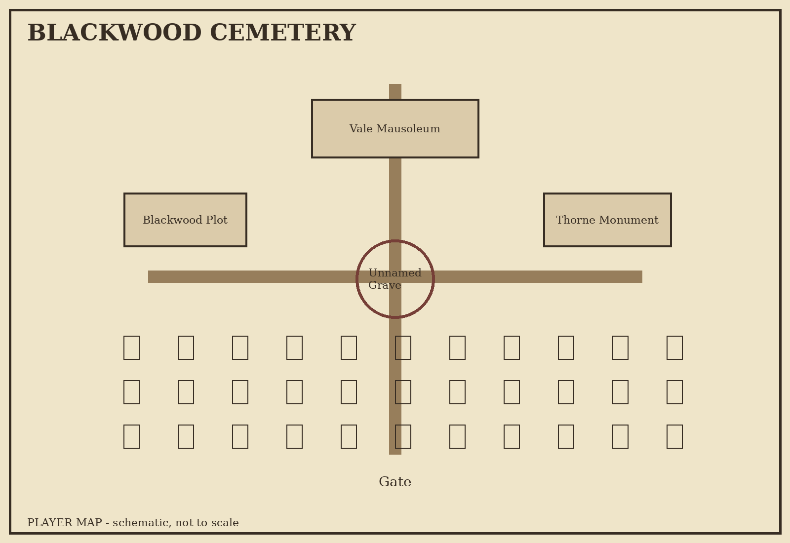
02 Cemetery Player Map

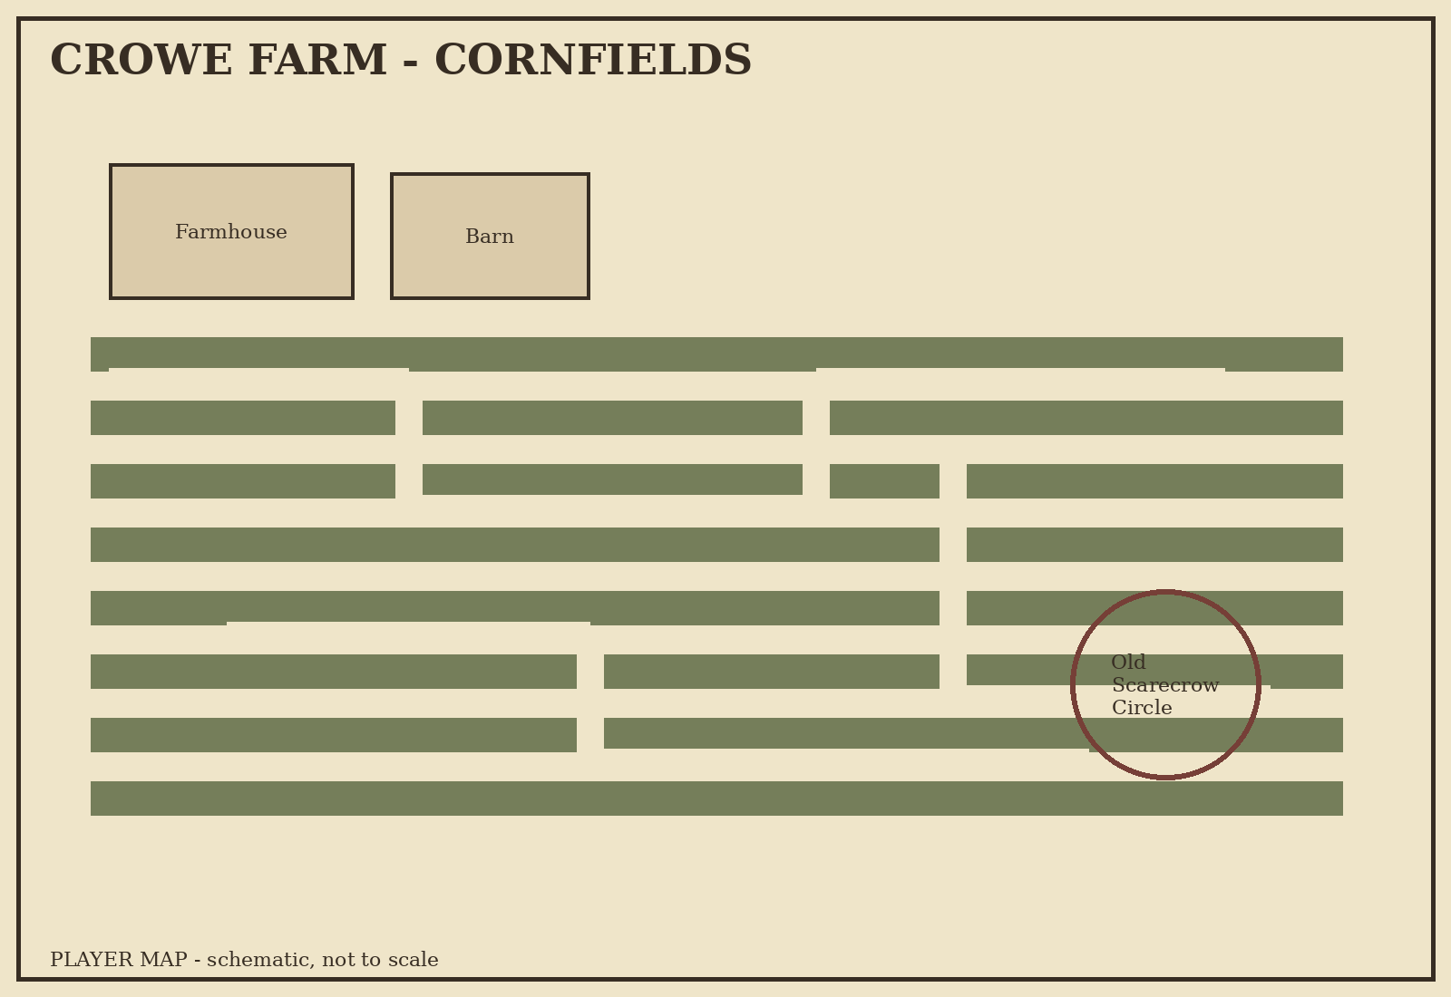
03 Crowe Farm Player Map

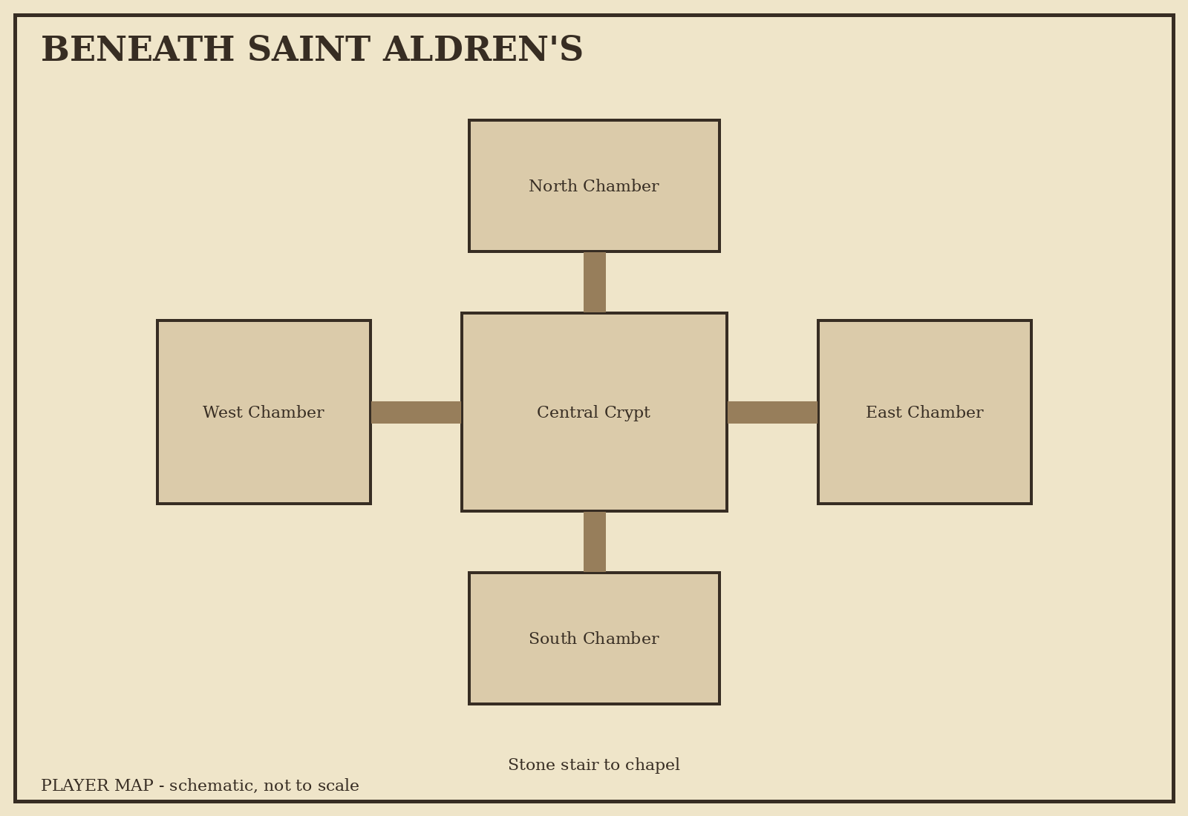
04 Chapel Undercroft Player Map

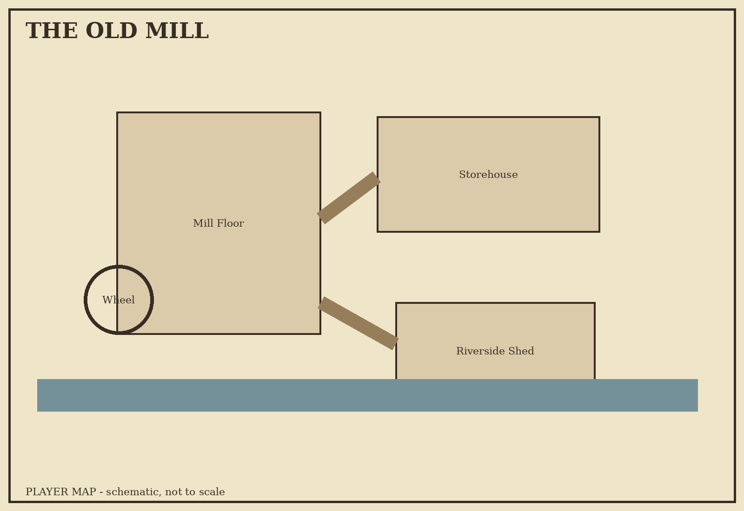
05 Old Mill Player Map

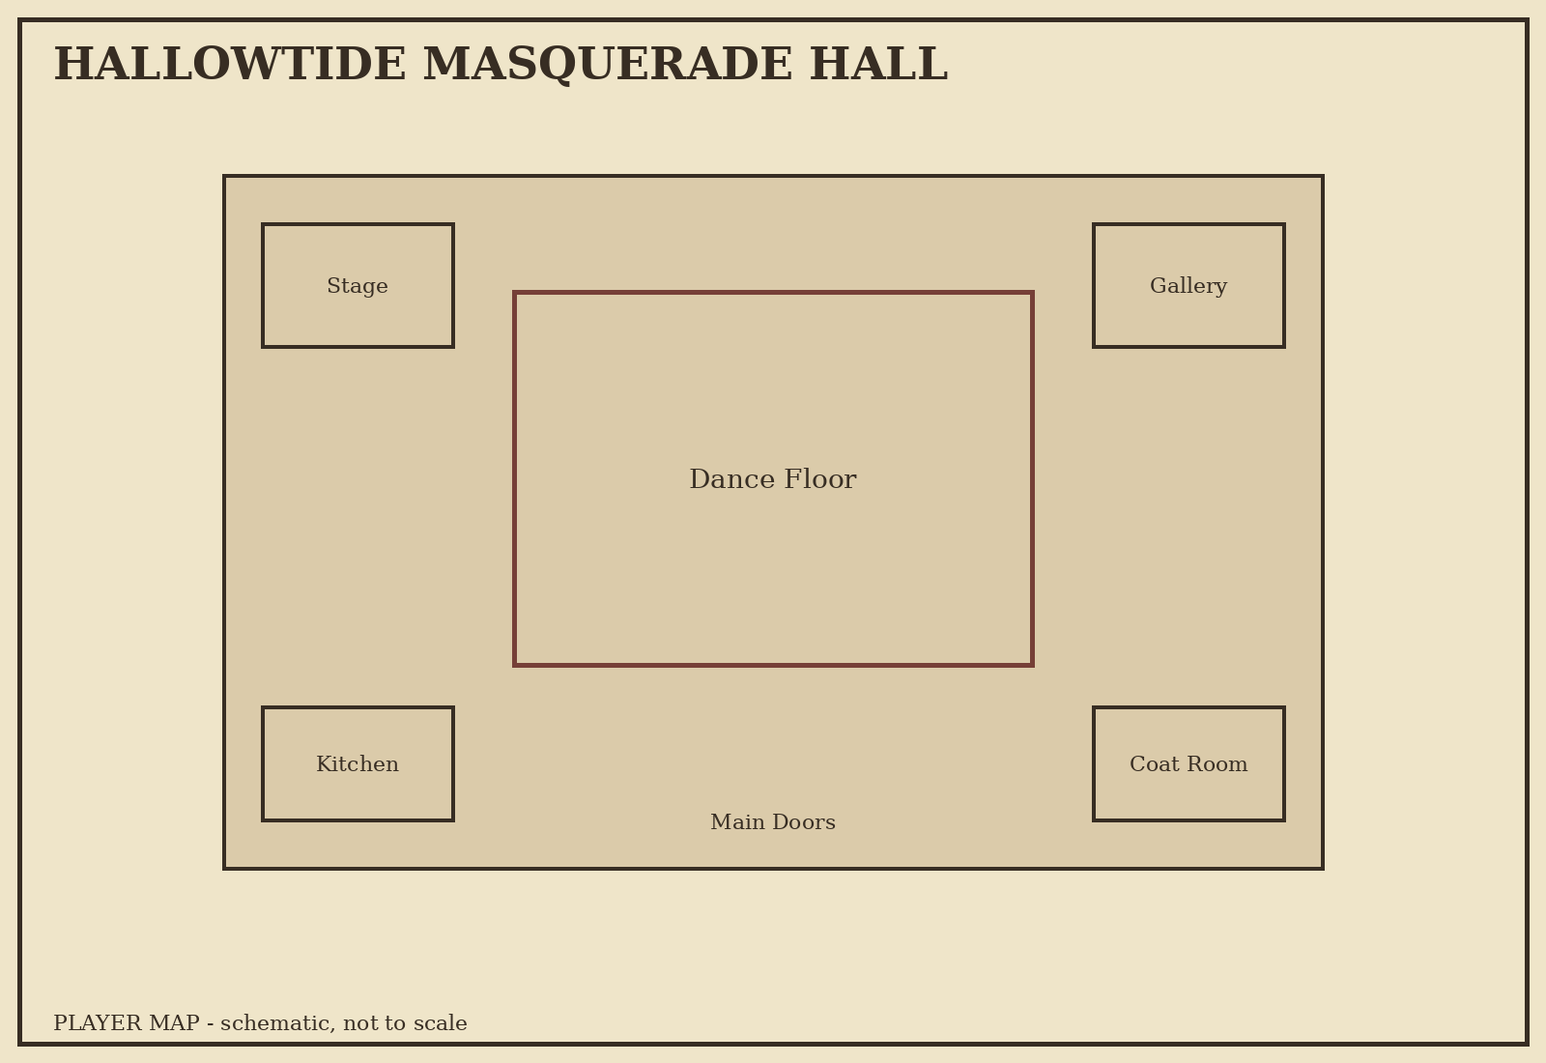
06 Masquerade Hall Player Map

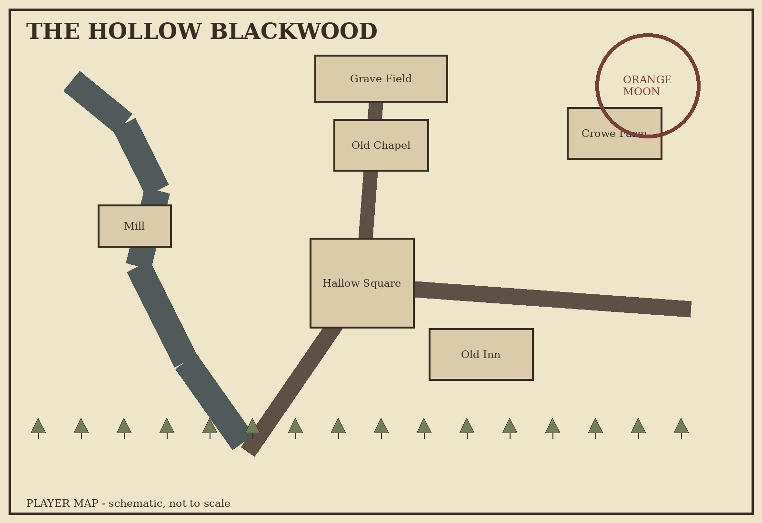
07 Hollow Blackwood Player Map

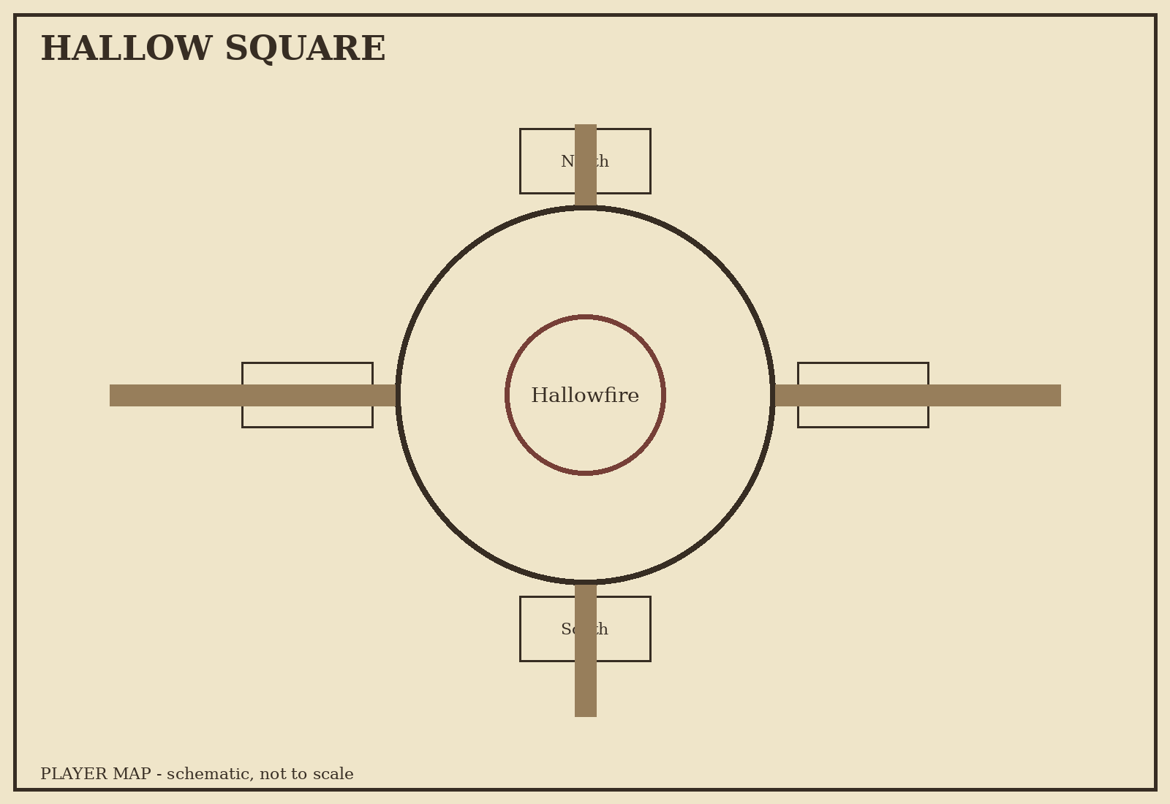
08 Hallow Square Player Map

28. Campaign Closing Notes
The emotional arc depends on contrast. Do not make Blackwood sinister from the first minute. Let players win games, eat pastries, tease NPCs and develop favorites. Horror becomes effective when the familiar town changes around them.
Do not conceal essential information behind single rolls. Checks determine speed, cost and clarity, not whether the campaign can continue. Reward players who infer the rules early.
Wren should remain human even when wrong. His grief explains him but does not excuse him. Redemption is possible because the party can prove that the voice he has followed is exploiting Amelia's memory.
The Hollow King should feel arbitrary only until the players understand him. Once they learn the rules, the campaign shifts from surviving horror to mastering it. The white flame ending is satisfying because the players defeat him with the exact laws he spent four centuries abusing.

