JULY 2026
Performance Report
Prepared for Fazal Elahi
MONTH AT A GLANCE
Expanded CreatorX visibility through a Bitget AMA, on-ground representation at Binance’s “Built By You” event, and a new partnership with Moon Rush.

KEY HIGHLIGHTS
01 BITGET EXCHANGE AMA  Represented CreatorX as a guest speaker in a Bitget Pakistan X Space on crypto and stock-market diversification.  View Bitget post → | 02 BINANCE “BUILT BY YOU”  Represented CreatorX at Binance’s physical community event, strengthening visibility and industry relationships.  View event post →
03 CREATORX TEAM PRESENCE  Supported CreatorX team representation and relationship-building with creators and ecosystem stakeholders at the Binance event. | 04 MOON RUSH PARTNERSHIP  Advanced a partnership with the Moon Rush project to support future collaboration and ecosystem growth.  View partnership post →

ACTIVITY SNAPSHOTS
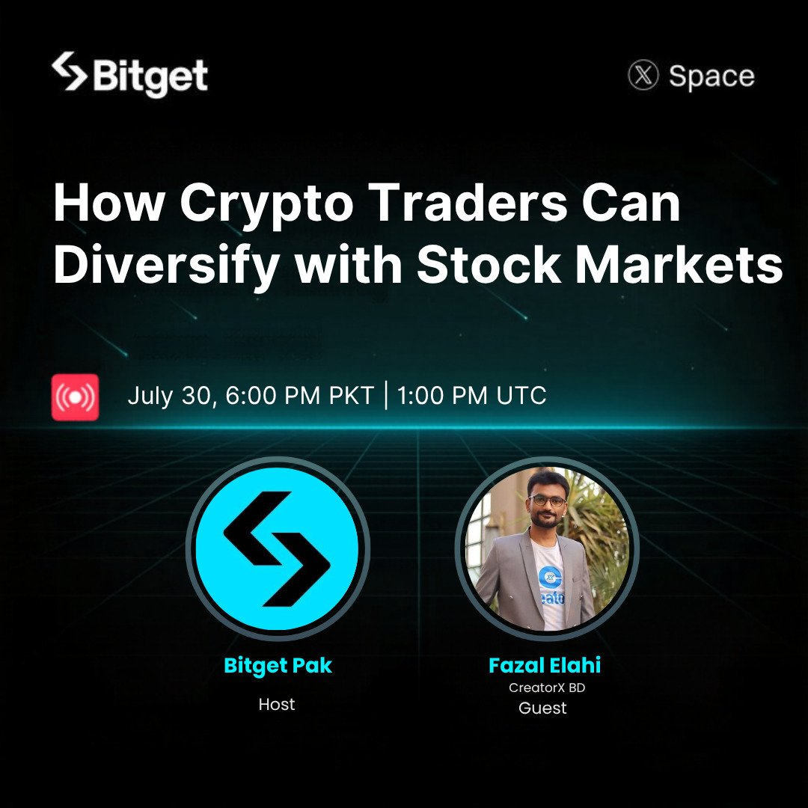  BITGET PAKISTAN AMA | 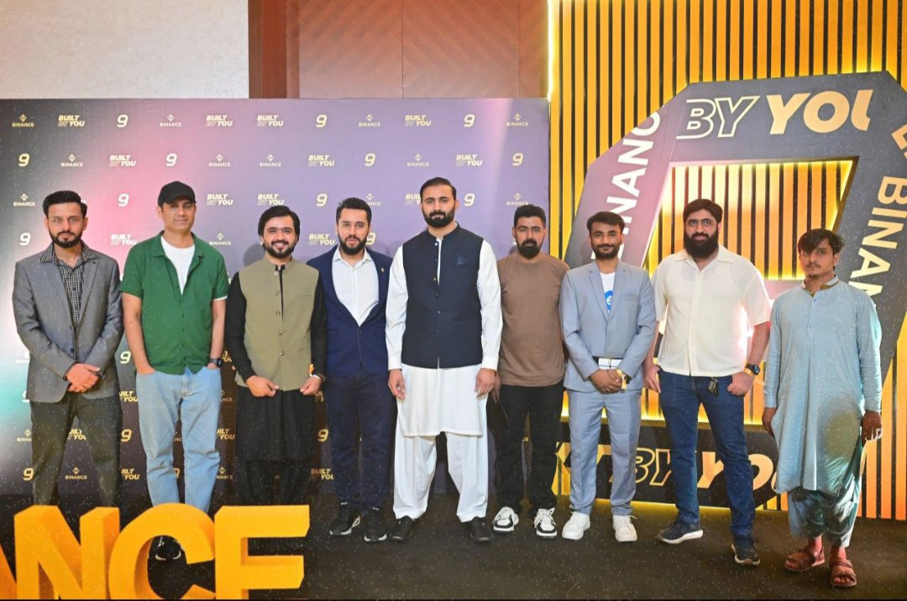  BINANCE “BUILT BY YOU” EVENT

NEXT STEPS
01 Build a 3–5 person team next month, subject to approval. | 02 Publish 5–7 X posts in line with campaign demand.
03 Continue representing CreatorX across relevant platforms. | 04 Pursue international event representation, where feasible.
FOCUS: Maximize available opportunities and continue creating measurable value for CreatorX.

