**1) Abstract:** The provided C++ program implements a simple chat application using object-oriented programming principles. The application allows users to create accounts, join a chat room, exchange messages, and save the chat history. It includes features such as user authentication, message formatting, and basic user status tracking. The program is designed to run in a console environment and utilizes file handling to store user profiles and chat history persistently. Future iterations could explore integrating more advanced features like multimedia support, real-time updates, and enhanced security measures.

**2) Introduction:** The chat application is designed to facilitate communication between users within a chat room. Users can create accounts with unique usernames and passwords, join the chat room, exchange messages, and view the chat history. The program focuses on encapsulation by utilizing classes for users, messages, and the chat room. It incorporates file handling for user profile and chat history storage, ensuring persistent data across program executions. As communication technology evolves, the program provide0s a foundational structure that can be expanded to meet the demands of more sophisticated chat applications.

**3) Existing System:** The existing system comprises a console-based chat application with basic functionality. Users can create accounts, join a chat room, send messages, and view chat history. User profiles and chat history are stored in text files. The system lacks advanced features and may have limitations in terms of scalability and user interaction. It uses a basic user authentication mechanism and handles messages without extensive formatting. While the existing system serves as a starting point, it opens the door for enhancements to better align with modern user expectations.

**4) Drawbacks of Existing System:**

* **Limited user interaction:** The system lacks a comprehensive user interface, relying on console input and output, hindering a more engaging user experience.
* **Basic authentication:** User authentication is based solely on usernames and passwords, without additional security measures, leaving the system vulnerable to potential security threats.
* **Minimal message formatting:** The system does not support rich message formatting, limiting expressive communication and the ability to share diverse content.
* **Lack of user status tracking:** The existing system does not provide real-time information on user online/offline status, limiting the awareness of users' availability.
* **Limited scalability:** The program may face challenges in handling a large number of users or messages efficiently, hindering its adaptability to growing user bases.

**5) Proposed System:** The proposed system aims to enhance the existing chat application by introducing new features and improvements. It includes:

* **Improved user interface:** Implementing a graphical user interface (GUI) for a more user-friendly experience, encouraging user engagement.
* **Enhanced authentication:** Introducing more robust authentication mechanisms, such as multi-factor authentication (MFA) and encryption, for improved security.
* **Rich message formatting:** Supporting multimedia elements, emojis, and other expressive features in messages for a more engaging communication experience.
* **Real-time user status:** Providing real-time information on user online/offline status for improved social interaction and responsiveness.
* **Scalability improvements:** Optimizing the program for better performance with a larger user base and message volume to accommodate potential growth.

**6) Advantages of Proposed System:**

* **Enhanced user experience:** The proposed system offers a more intuitive and visually appealing interface, fostering a positive and enjoyable user experience.
* **Improved security:** The introduction of advanced authentication mechanisms enhances user account security, protecting user data from potential threats.
* **Rich communication:** Users can express themselves more effectively through features like multimedia and emojis, enabling more dynamic and engaging conversations.
* **Real-time interaction:** Real-time user status updates provide a more dynamic and responsive chat experience, improving the overall sense of connectedness.
* **Scalability:** The system is designed to handle a larger user base and message volume efficiently, ensuring smooth operation even as the user community expands.

**7) Modules - Coding Modules:** The program consists of several key modules:

* **Message Class:** Represents individual chat messages, including formatting and display methods. It may be extended to support multimedia content in the future.
* **User Class:** Manages user information, including sending messages and user connectivity status. It could be expanded to include additional user-related functionalities.
* **ChatRoom Class:** Handles the overall chat environment, including user authentication, chat history management, and file operations. Future iterations might include real-time features and advanced security measures.
* **File Handling:** Manages reading and writing of user profiles and chat history to persistent files. This module could be enhanced to support additional data storage and retrieval functionalities.
* **Main Function:** Implements the program's execution flow, menu-driven user interactions, and the overall chat experience. Future developments may involve transitioning to event-driven programming for a more responsive interface.

**8) Architecture/Design:** The program follows an object-oriented design with three main classes: Message, User, and ChatRoom. The classes encapsulate their respective functionalities, promoting code modularity and reusability. The program utilizes file handling for persistent data storage, ensuring user profiles and chat history are preserved across sessions. The main function serves as the entry point, orchestrating the overall program flow through a menu-driven interface. The design aims for clarity, extensibility, and maintainability, providing a foundation for future enhancements and improvements. Considerations for future architectural improvements may include adopting a client-server model for real-time communication and employing design patterns for more flexible and scalable code structures.

**9)Sample Code:**

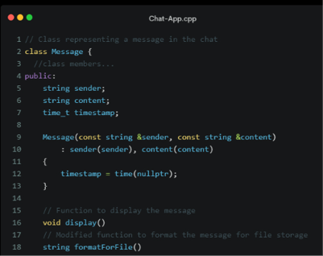 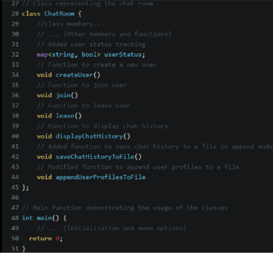

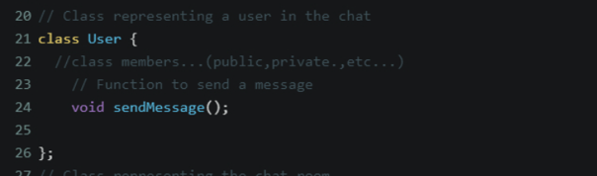

**10)Test Cases:**

1. **User Authentication:** Verify the system's ability to authenticate users securely.
2. **Real-Time Messaging:** Test the delivery and synchronization of messages in real-time.
3. **Chat Backup:** Unleash the power of worry-free communication with our fail-safe and rock-solid chat backup feature.

**11)ScreenShots:**

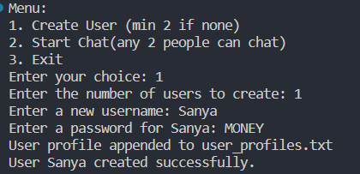 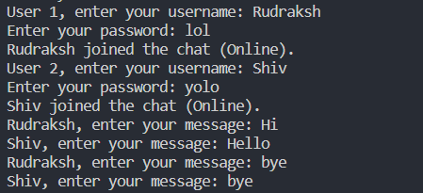

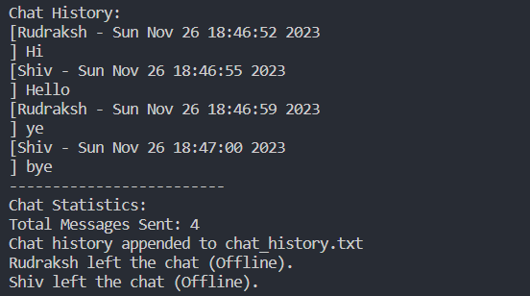

**12) Conclusion:** In conclusion, the chat application provides a fundamental framework for user interaction and communication in a chat room setting. The existing system, while functional, has certain limitations that can be addressed through the proposed enhancements. The introduction of features such as a graphical user interface, advanced authentication mechanisms, rich message formatting, real-time user status updates, and scalability improvements would significantly enhance the user experience and security of the application. The modular design of the program allows for future expansions and adaptations to evolving technological requirements. As the landscape of communication technology continues to evolve, this chat application can serve as a starting point for the development of more sophisticated and feature-rich chat systems.

**13) References:** The development of this chat application drew inspiration from various programming concepts and practices. While no specific external references were directly used in the creation of this application, the following general resources are recommended for those interested in exploring related topics:

1. Stroustrup, B. (2013). *Programming: Principles and Practice Using C++.* Addison-Wesley.
2. Meyers, S. (2014). *Effective Modern C++: 42 Specific Ways to Improve Your Use of C++11 and C++14.* O'Reilly Media.
3. Josuttis, N. M. (2012). *The C++ Standard Library: A Tutorial and Reference.* Addison-Wesley.
4. Gamma, E., Helm, R., Johnson, R., & Vlissides, J. (1994). *Design Patterns: Elements of Reusable Object-Oriented Software.* Addison-Wesley.

These resources cover essential aspects of C++ programming, object-oriented design, and software development principles that contribute to the understanding and improvement of the presented chat application.