**EMERGING PUBLISHERS**

**HOME**

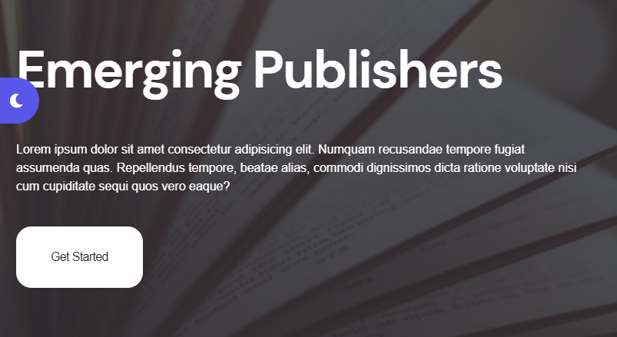

**Publishing Services**

Join forces with us for a professional open-access publication. Let us support your journal by handling online peer review, production, and international distribution through Emerging Publishers Insight.

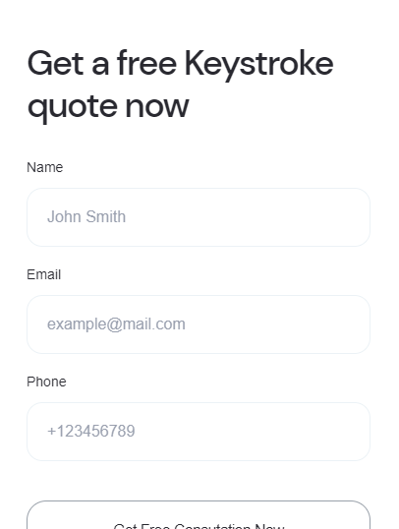

**We Provide Quality To You!**

Name:

Your Email:

Phone Number:



**Take A Look At The Companies We've Published For!**

Our platinum journals are published in collaboration with universities and organizations that address various topics.

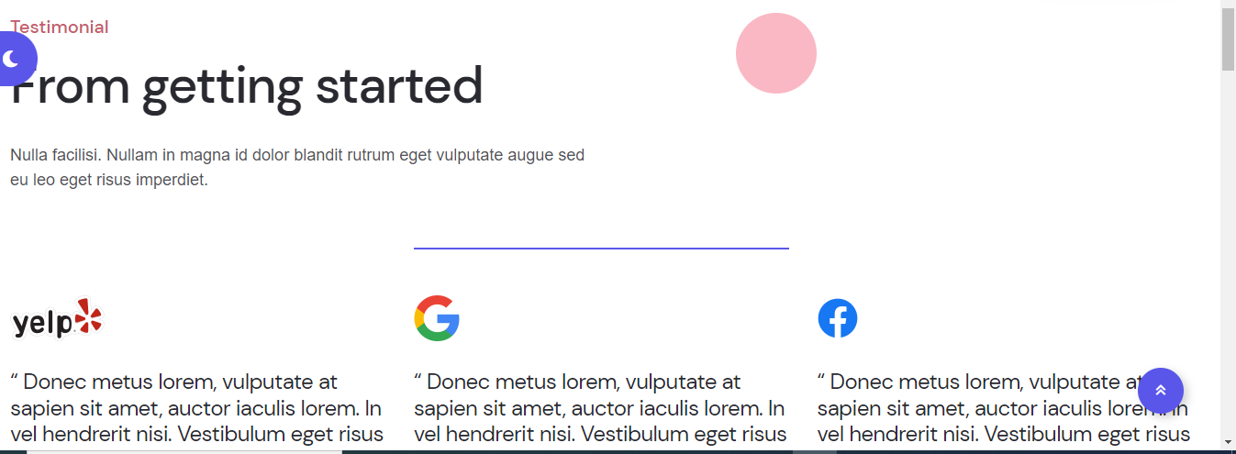

**Our Satisfied Clients**

We guarantee that every client is happy and their demands are met. Please have a look at some of them.

There is no publisher we could have asked for better. Although the publishing crew is competent, their knowledge and suggestions set them apart. They are simply extraordinary individuals to work with.

**Ian Yeoman**

My goal has always been to transcribe this book. But I didn't know how to do it until the day I picked up the phone and phoned you. I can't express to you how much I valued that phone call. I realized for the first time that my dream might come true. Your assistance and knowledge have been beneficial all along the road.

**Helen Kelly**

I had the farfetched good fortune to come upon Emerging Publishers when I looked for the best approach to publish my book. This organization comprises knowledgeable, compassionate, talented, and moral writers, editors, and marketers. They keep up with the most recent trends and gently but firmly assist authors in publishing their publications. I'm grateful and highly suggest the business and its employees!

**Rita Sommers**

We publishers prefer long-term partnerships. Working with peers who have held positions at some companies and gone through similar industry shifts, work processes, and technological trials is a significant benefit. There is a level of comfort at Emerging Publishers.

**Nancy Hoagland**

We have a lot of faith in the Emerging Publishers team, with whom we work, to uphold the high standards for which they are renowned in our textbook and reference materials. The crew is dedicated to completing our assignments with the utmost care and professionalism and is professional in every way.

**Larry Klein**

Emerging Publishers handled duties we quickly requested of them, and they did an excellent job for us. We are delighted with their adaptability, quick turnaround times, focus on quality, and capacity to work with us on various project methods depending on the available resources. Response times and quality of project management have been excellent.

**Louise Cameron**

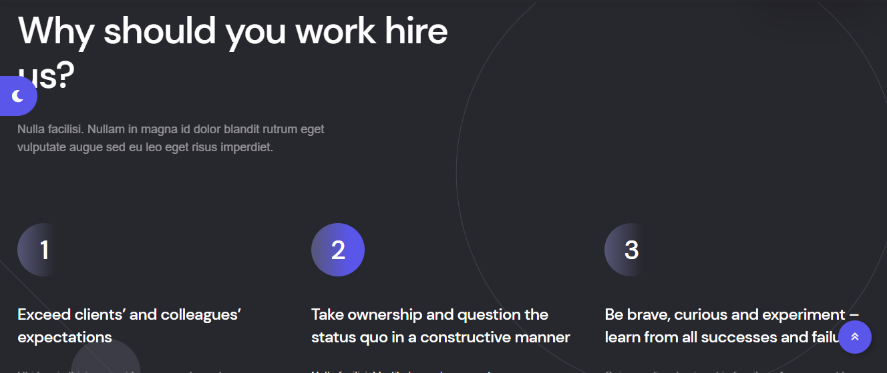

**Why hire Us?**

**Quality**

Independent peer reviewers evaluate books for quality, validity, and relevance. Numerous journals in our portfolio are indexed in our organization.

**Ethics**

Emerging Ghostwriter upholds the highest standards of ethical publication. We adhere to ICMJE, COPE, and GPP-3 standards.

**Reach**

One of the top publishers is Emerging Ghostwriter. Emerging Ghostwriter is one of the most popular publishing platforms in the world.

**Expertise**

Our publications offer contributors direct, timely communication with internal editorial experts.

**Industry peers**

Leading corporations publish their research through Emerging Ghostwriters.

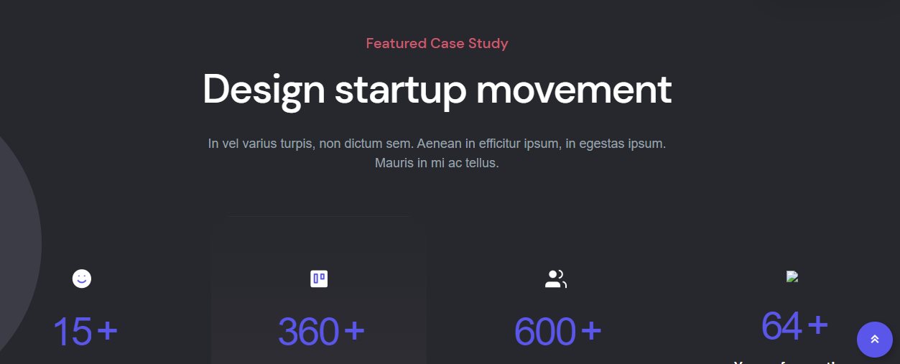

**The Best And Affordable**

We provide a publishing service to assist your organization, helping you showcase the caliber and scope of research conducted in your area.



**Would You Like To Publish Your Work?**

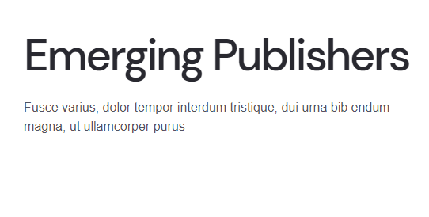

**Emerging Publishers**

We are pleased to state that Emerging Publishers was created, is owned by, and is operated by skilled authors and editors.