Module description:

Happy_Coding Module Diagram
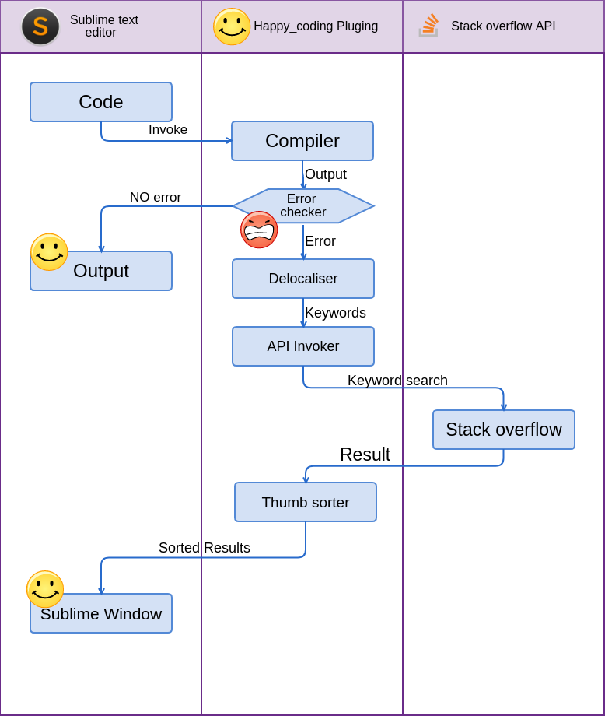
This project consists of seven modules. They are
- Compiler
- Error checker
- Delocaliser
- Api invoker
- Stack overflow API
- Thumbs Sorter
- Sublime window

1 – Compiler
Input : Code
Output : Error / Output
Description: This module takes in the code and complies it using the default compiler in the system. The compiler is identified using the build system in the text editor

2 – Error checker
Input : Error / Output
Output : Redirection
Description: This module takes in the output from the

3 – Delocaliser
Input :
Output :
Description:

4 – API invoker
Input :
Output :
Description:

5 – Stackover flow API
Input :
Output :
Description:

6 – Thumbs Sorter
Input :
Output :
Description:

7 – Sublime window
Input :
Output :
Description:

Methodology followed:

