|  |  |
| --- | --- |
| [Unit Code] Assignment 1 Report | Version: 1.0 |
| Team Name: SEB | Date: [2006-10-01] |
| Title: | |

# Introduction

[Brief introduction to the website: background and objectives]

## Scope of the website

SEB Hardware was established in Kuching, Sarawak in 2005, with the primary responsibility of providing sales, support, service and spare parts (4S) for the local industries. SEB hardware is a hardware company that offers a wide range of high quality products and services for both commercial and industrial projects. With 15 years of experiences in the industry, the company comprises a team of highly-skilled and talented professionals in tune with current trends.

The objectives of SEB Hardware are:

To increase the exposure of the company all around the world

To provide our customers with products and services at a competitive price

To strengthen customer’s knowledge by providing information on equipments and tools

## Intended audience

Our intended audience are employees at factories. A needs assessment was conducted to determine the expectations of our target audience. Our target audience would want to know what promotions the company is offering, the equipments and tools available, and the price range.

**2.0 Webpage Design and Structure**

**2.1 Website Layout Mock ups**

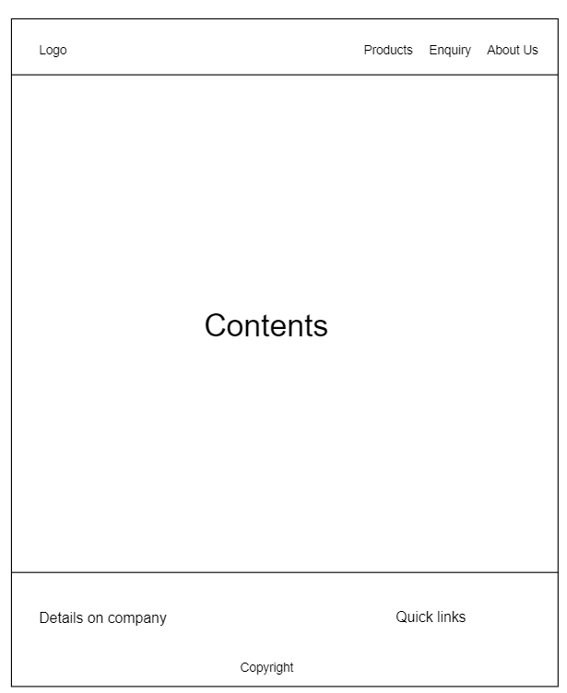

The navigation bar has links that link to other web pages and has the company logo on the left side. The content section includes information related to the company and products available. The footer consists of details related to the company such as operating hours and address of corporate office on the left side. On the right side, there will be quick links that links to other webpages.

**2.2 Website structure**

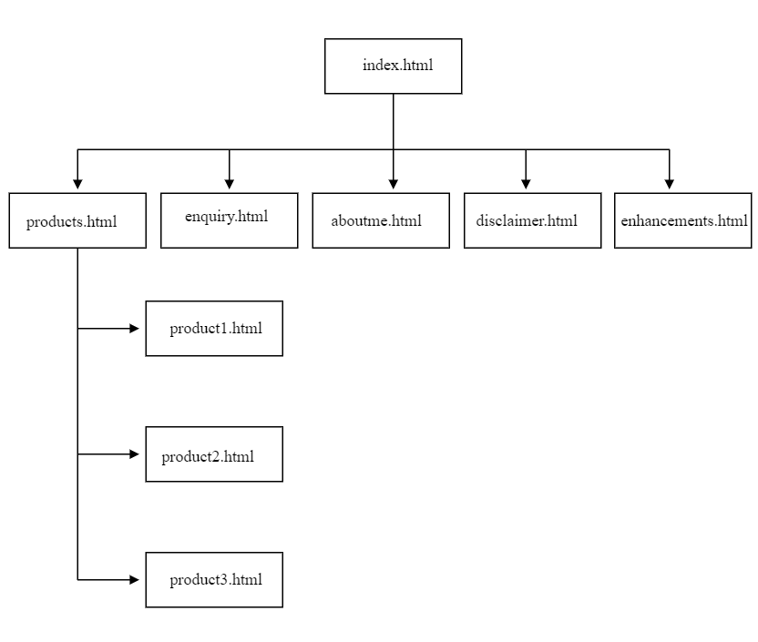

Hierarchical structure is used for the website. Webpages are organised into categories and subcategories.

**3.0 End Product**

**3.1 Actual User Interface**

[Provide screenshots of the websites. Justify and explain the design used based on webpage design principles. Do some reading online for design principle guidelines]

Our website uses symmetrical balance as web elements are centered so that users feel more comfortable when viewing the website.

The website design fulfils the proximity principle. White spaces are added below the headings and images to make the content of the website organized and more readable.

Contrast principle is used in the website to attract the attention of users. In our website, black and white is used. The content in the website is black while the background colour is light green. The content can be seen easily due to high contrast between the content and the background colour. As for the navigation bar, the background colour is ebony clay while the text is white.

Unity and visual identity are also shown in the website. The logo of the company is shown on the navigation bar of every webpage to show unity and visual identity. The font type and font size for headings and paragraphs are consistent to show unity. The font family used for all headings are Roboto Slabs while all contents uses Open Sans font. The footer of every web page also has the same content and same design.

**3.2 Enhancement**

[Describe the enhancements if any]

**4.0 Contribution**

|  |  |
| --- | --- |
| **Team Member 1** | **Bjorn** |
| **Contribution (%)** | **35%** |
| **List of Contribution** | * Write HTML codes for enhancements.html, products.html, product1.html * Style the pages above * Plan and draw wireframe * Write about enhancements |

|  |  |
| --- | --- |
| **Team Member 2** | **Simon** |
| **Contribution (%)** | **32.5%** |
| **List of Contribution** | * Write HTML codes for enquiry.html, aboutus.html, product3.html * Style the pages above * Plan sitemap * Write about webpage design and structure |

|  |  |
| --- | --- |
| **Team Member 3** | **Emily** |
| **Contribution (%)** | **32.5%** |
| **List of Contribution** | * Write HTML codes for index.html, disclaimer.html, product2.html * Style the pages above * Plan and draw sitemap * Write about introduction and actual user interface for report |

**5.0 Group Reflection**

[Describe the challenges (with regards to development and team work) faced and what you have learnt through this assignment as a group. Identify areas of improvement]

In the past few weeks, we work together to complete this assignment. Along the way, we faced some challenges. In terms of teamwork, we had some communication problems. Since this is our first time working together as a team, we lack understanding towards each other. We also couldn’t carry out face to face discussion due to the movement control order. In terms of development, we had problems in the design of our website as all of us lack knowledge on design. Hence, we did some web research on other hardware company websites to gain ideas on our website design. We couldn’t choose a color theme for our website so we decided to use a colormind.io to find the suitable color palette.

We have learned a lot through this assignment. We learn to understand and tolerate each other. We learn to respect and accept others’ opinions and thoughts. Besides that, we also learn how to solve disagreements which is by discussing and carrying out voting.

We can improve on our web design by gaining more knowledge on design so that we will be able to design a more attractive website in the future.