**MySQL Functions**

Ian Spresney

CSD310

Module 5.2 – MySQL Functions

November 12, 2023

**\*All the following functions were sourced from the course provided link at W3schools.com.**

**Year Function**

‘YEAR()’

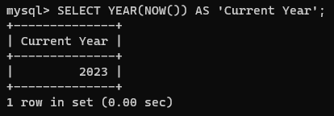This function extracts the year from a date. This function can be useful when you want to analyze or filter data based on the year component.

**Date Add Function**

‘DATE_ADD()’

This function is used to add a specified time interval to a date. This is good for when you need to calculate future or past dates based on a given reference date.

**Now Function**

‘NOW()’

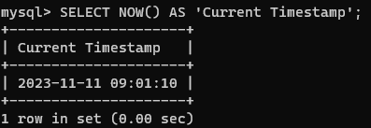This is a great function that will return the current date and time in the format as 'YYYY-MM-DD HH:MI:SS'. It can be used when you need to record the exact timestamp of an event.