TABLE OF CONTENTS
S.No | Content Title | Page No
1 | Introduction | 9
1.1 | Background and motivation | 9
1.2 | Problem statement | 9
1.3 | Objectives | 9
1.4 | Scope and constraints | 9
1.5 | Skill sets demonstrated | 10
1.6 | Organisation of the report | 10
2 | Planning and preparation | 11
2.1 | Goal formulation | 11
2.2 | Requirements | 11
2.3 | Technology and tool selection | 11
2.4 | Dataset planning | 12
2.5 | Work plan and timeline | 12
2.6 | Design principles | 13
2.7 | Risk plan | 13
3 | Key components of the identified skill sets | 15
3.1 | System architecture | 15
3.2 | Agent roles and responsibilities | 15
3.3 | Multi-agent orchestration | 16
3.4 | Synthetic data generation and attack storyline | 19
3.5 | Event normalisation (Ingest agent) | 20
3.6 | Correlation agent and attack chain | 20
3.7 | Fact builder | 21
3.8 | Narrator agent | 21
3.9 | Verifier and independent judge | 22
3.10 | Report builder | 23
3.11 | Implementation summary | 23
3.12 | Mapping to the evaluation parameters | 24
4 | Proofs of outcome and feedback | 25
4.1 | Testing | 25
4.2 | Evaluation design | 25
4.3 | Results | 26
4.4 | Proof of outcome: the generated report | 28
4.5 | Troubleshooting and issues resolved | 30
4.6 | Feedback and actions taken | 31
4.7 | Limitations and threats to validity | 32
4.8 | Conclusion and future work | 32
5 | Powerpoint Presentation | 33
5.1 | Slide outline | 33
5.2 | Demonstration plan (seven minutes) | 33
5.3 | Anticipated questions | 34
6 | Certification | 35
6.1 | Supporting evidence | 35
6.2 | Certificates | 35
6.3 | Statement on data and tool use | 35
LIST OF FIGURES
Figure | Title | Page No
1 | End-to-end architecture of EvidenceWeave | 15
2 | Agent orchestration: controller, eight agents, and the shared artifact store | 17
3 | Sequence of one verification and repair cycle | 18
4 | Attack storyline of case02 as logged (UTC), with the decoy lane | 19
5 | Attack chain of case02: how findings link, and what stays out | 21
6 | The four verification layers and their failure codes | 22
7 | Attack steps and attacker entities present in the final narrative (mean of four cases) | 26
8 | Report header, summary tiles and timeline for case02 | 29
9 | Executive summary and the brute-force stage card with facts, verified sentences and cite chips | 30
LIST OF TABLES
Table | Title | Page No
1 | Scope and constraints of the project | 9
2 | Skills addressed by the project | 10
3 | Goal decomposition and success criteria | 11
4 | Functional and non-functional requirements | 11
5 | Tools and technologies | 11
6 | Generated cases used in the project | 12
7 | Phase plan and outputs | 13
8 | Risks and planned mitigations | 13
9 | The eight agents | 16
10 | Orchestration design decisions | 17
11 | Attack stages in case02 | 19
12 | Normalised event schema | 20
13 | Correlation rules and default thresholds | 20
14 | Verification layers | 22
15 | Command-line interface | 23
16 | Where each evaluation parameter is addressed | 24
17 | Passing tests after each phase | 25
18 | What the tests cover | 25
19 | Arms and metrics | 25
20 | Chain detection on the four evaluation cases | 26
21 | Cost of the approaches | 27
22 | Raw-mode versus fact-sheet narration (Phase 5b, development cases) | 27
23 | Held-out corruption test (pooled over two cases) | 27
24 | Audit labels versus the verifier decision | 28
25 | Defects seen in the first model output and the layer that handled them | 30
26 | Issues found during the project and how they were fixed | 30
27 | Feedback and resulting actions | 31
28 | Presentation outline | 33
29 | Timed demonstration script | 33
30 | Questions and short answers | 34
31 | Evidence available for verification | 35
32 | Certificate record | 35

1. INTRODUCTION

1.1 Background and motivation
When a server is compromised, investigators receive evidence from several systems at once: Linux authentication logs, web-server access logs and Windows event logs. Each source has its own format, its own clock and thousands of routine lines that hide the few lines that matter. Reconstructing the attack means reading all of them together, linking events across hosts and writing down what happened in a way that another person can check.
Large language models can summarise logs fluently, but in forensic work fluency is not enough. A model may invent an address, change a time, or claim an action that no log line shows. A single unsupported sentence in an incident report can mislead an investigation. The question behind this project is therefore not "can an LLM describe an attack?" but "how can a small local model be allowed to describe an attack only when every statement can be traced to evidence?".

1.2 Problem statement
To design, build and evaluate EvidenceWeave, an autonomous log-correlation system that reads mixed log sources, reconstructs the multi-stage attack chain, and produces a plain-English incident narrative in which every sentence is either verified against the cited log lines or removed. The whole system must be free and local: it may use only open models served by Ollama on a laptop and no paid API.

1.3 Objectives
- Read three log formats (Linux auth.log, nginx access log, Windows event JSON Lines) and convert every line into one event with a traceable identifier such as AUTH-L342.
- Detect a six-stage attack chain with deterministic rules, deriving the attacker address, user and payload URL from the data instead of hard-coding them.
- Keep decoys and unrelated events out of the chain, and report missing evidence honestly instead of guessing.
- Use a local language model only to explain facts that the rules have already established.
- Verify every generated sentence with deterministic checks and an independent second model, repair what can be repaired and drop the rest.
- Deliver the result as one offline HTML report with clickable evidence.
- Measure the system against known ground truth, including a baseline, a held-out hallucination test and a manual-style audit.

1.4 Scope and constraints
Table 1: Scope and constraints of the project
Aspect | Decision
Log sources | Linux authentication log, nginx combined access log, Windows security events as JSON Lines.
Models | Local only through Ollama: qwen2.5:7b-instruct (narrator) and llama3.1:8b (judge). No paid API.
Data | Synthetic cases generated with a seed, each with a hidden answer key. No real personal or organisational data is used.
Language and platform | Python 3.12 on Windows, command-line tool plus a self-contained HTML report.
Out of scope | Real-time monitoring, memory or disk images, real-world log collections, automatic correction of clock skew.

1.5 Skill sets demonstrated
The skill-based evaluation allows several generic skills to be selected. The work in this report exercises the following ones; the later sections show where each appears.
Table 2: Skills addressed by the project
Skill | How it is demonstrated
Programming Skills | A modular Python package (generator, parsers, correlation, narrator, verifier, report), a command-line interface and 212 automated tests.
Data Analysis | Parsing and normalising 3,907 events in the hard case, rule-based correlation, precision and recall against ground truth, Wilson confidence intervals.
Software Kit/Tool Operation | Ollama with two local models, git and GitHub, pytest, a deterministic HTML report generator.
Troubleshooting | Diagnosis of 47 failing sentences, clock-skew handling, a hung model request, and nine other issues recorded in Section 4.
Integration of Theory and Practice | Digital-forensics principles (traceable evidence, reproducibility, no overstated conclusions) applied through agent orchestration and verification.

1.6 Organisation of the report
Section 2 describes the planning and preparation. Section 3 describes the key components, including the architecture and the agent orchestration. Section 4 gives the proofs of outcome, the evaluation results and the feedback that shaped the design. Section 5 outlines the presentation and demonstration. Section 6 lists the supporting evidence and certification items.

2. PLANNING AND PREPARATION

2.1 Goal formulation
The top-level goal of the system is: given a folder of raw logs, produce a verified incident narrative and an evidence report without human help. The goal was decomposed into six sub-goals, each with a measurable success criterion, so that progress could be checked at the end of every phase.
Table 3: Goal decomposition and success criteria
Goal | Sub-goal | Success criterion
G1 | Ingest all logs into one event schema | Every non-blank line becomes exactly one event; zero silently dropped lines.
G2 | Detect the attack chain | All six stages found; recall and precision against the answer key; decoy kept out of the chain.
G3 | Explain the chain in plain English | Sentences cite event IDs and restate only established facts.
G4 | Verify every sentence | No unsupported sentence appears in the final narrative; failures are repaired, dropped or replaced by facts.
G5 | Present the result | One offline HTML report with timeline, clickable evidence, attempts-only and could-not-prove sections.
G6 | Measure honestly | Evaluation on new cases against a baseline, a held-out hallucination test and an audit, with limits stated.

2.2 Requirements
Table 4: Functional and non-functional requirements
Type | Requirement
Functional | Parse three log formats; correlate across hosts; derive entities from data; build facts; narrate with a local LLM; verify; repair; render a report; run one command end to end.
Functional | Work without an LLM (--no-llm) so that a deterministic report is always available.
Non-functional | Free and local; deterministic where possible (seeded, sorted, byte-identical reruns); every statement traceable to a file and line number.
Non-functional | Safe handling of hostile text: log lines are attacker-controlled, so the report must never execute them as HTML or script.
Non-functional | No overfitting: analysis code never reads the answer key and never hard-codes case values.

2.3 Technology and tool selection
Table 5: Tools and technologies
Tool | Role | Reason for choice
Python 3.12 | Implementation language | Standard library is enough for parsing and rules; few dependencies.
requests, jinja2, pytest | HTTP client, report template, tests | Only three third-party packages are needed.
Ollama | Local model server | Free, offline, reproducible options (temperature, seed, context size).
qwen2.5:7b-instruct | Narrator agent | Follows strict JSON formats well and answered fastest in the setup check.
llama3.1:8b | Judge agent | A different model family from the narrator, so the judge is independent of it.
git and GitHub | Version control | One commit per phase; the repository serves as the audit trail.
Claude Code | AI coding assistant | Implemented each phase from written specifications and prompts prepared by the team; all outputs were reviewed and tested.
HTML, CSS, JavaScript | Report format | A single offline file that can be e-mailed or printed.

Two different models are used on purpose. If the same model wrote a sentence and then judged it, it would tend to accept its own mistakes. The system warns loudly and records judge_independent = false whenever both roles are given the same model.

2.4 Dataset planning
Real incident logs rarely come with a trustworthy description of what actually happened, and sharing them raises privacy problems. A seeded synthetic generator was therefore planned. It writes the three log files, a host inventory and a hidden answer key that records the exact file and line number of every attack line. Because the key is hidden from the analysis code, it can be used to score the system objectively.
Table 6: Generated cases used in the project
Case | Difficulty | Seed | Log lines (auth / nginx / Windows) | Purpose
case01 | Easy | 42 | 265 / 426 / 96 (787) | Development; low noise, all evidence present.
case02 | Hard | 7 | 1,111 / 2,338 / 458 (3,907) | Development and demonstration; about five times the noise.
eval_e1, eval_e2 | Easy | 101, 102 | generated at evaluation time | Evaluation only (new seeds never used before).
eval_h1, eval_h2 | Hard | 201, 202 | generated at evaluation time | Evaluation only (new seeds never used before).

The hard difficulty adds a decoy address that attacks but never gets in, interleaved benign events, a +90 second clock skew on the Windows host, and one deliberately deleted evidence line (the creation of a backdoor account). These three traps test whether the system avoids false alarms, copes with unsynchronised clocks and admits what it cannot prove.

2.5 Work plan and timeline
The work was split into phases. After each phase the results were reviewed before the next phase was specified, and each phase ended with a git commit.
Table 7: Phase plan and outputs
Phase | Work | Main output | Commit
0 | Setup | Folder structure, virtual environment, model check, project log (CLAUDE.md) | eb435ca
1 | Synthetic generator | Three log types, planted attack, answer key, hosts.json | f49f848
2 | Parsers and schema | One event schema, deterministic event IDs, clock-offset option | 13767ac
3 | Correlation rules | Six rules, chain builder, findings.json and chain.json | c138335
4 | LLM narrator and baseline | Cited narrative per stage; naive baseline on raw events | 27c9a31
5 | Verifier and repair loop | Structure, entity, semantic and judge layers; repair rounds | 97d5cf7
5b | Hardening | Fact-sheet narration, quote-checked double judge, run metadata | 0c02a0f
6a | Analyze command and report | One-command pipeline, offline HTML report, README and demo kit | 47dd7d5
6b | Evaluation | Held-out hallucination pool, harness, audit kit, RESULTS.md | bd45452, 8a0d702
6b+ | Audit in results | LLM-labelled audit added to the results, clearly marked | 7b806fc

2.6 Design principles
- Rules decide, the model explains. The attack chain is found by deterministic rules. The language model never decides what the attack is; it only rewrites established facts.
- Never trust a model to grade itself. Final verdicts are derived in code from quoted evidence, and a second model that differs from the narrator does the judging.
- No overfitting. The analysis code never reads the answer key (a static test checks this). After the evaluation cases were generated, a freeze rule forbade changing any rule, prompt or threshold to improve a number.
- Be honest about absence. Missing evidence is reported as unprovable, and unprovable facts are never invented to make a story complete.
- Reproducibility. Seeds, sorted outputs, recorded model digests and a code hash allow a run to be repeated and checked.

2.7 Risk plan
Table 8: Risks and planned mitigations
Risk | Mitigation
The model hallucinates an entity or claim | Four-layer verifier; sentences that fail are repaired, dropped or replaced by verbatim facts.
Rules are tuned to the generated data | Entities derived from events only; new seeds for evaluation; a frozen held-out hallucination pool; code-hash comparison at the end.
Local models are slow | Batched rounds to limit model swaps; --reuse to rebuild a report in seconds; --no-llm fallback.
Host clocks disagree | A 300 second tolerance for cross-host links; an explicit offset flag; skew is never guessed.
A model request hangs | A 600 second timeout on every request, and a resumable evaluation harness.
Hostile text in logs reaches the report | Data embedded as escaped JSON and rendered with textContent; URLs shown as plain text; an injection test.

3. KEY COMPONENTS OF THE IDENTIFIED SKILL SETS

3.1 System architecture
Figure 1 shows the complete pipeline. Raw logs enter on the left of the diagram and a verified report leaves at the bottom. Blue boxes are rule-based components, orange boxes are LLM-driven agents, the green box is the verification stage, and grey boxes are data. The dashed path shows that the answer key is read only by the evaluation harness, never by the pipeline.
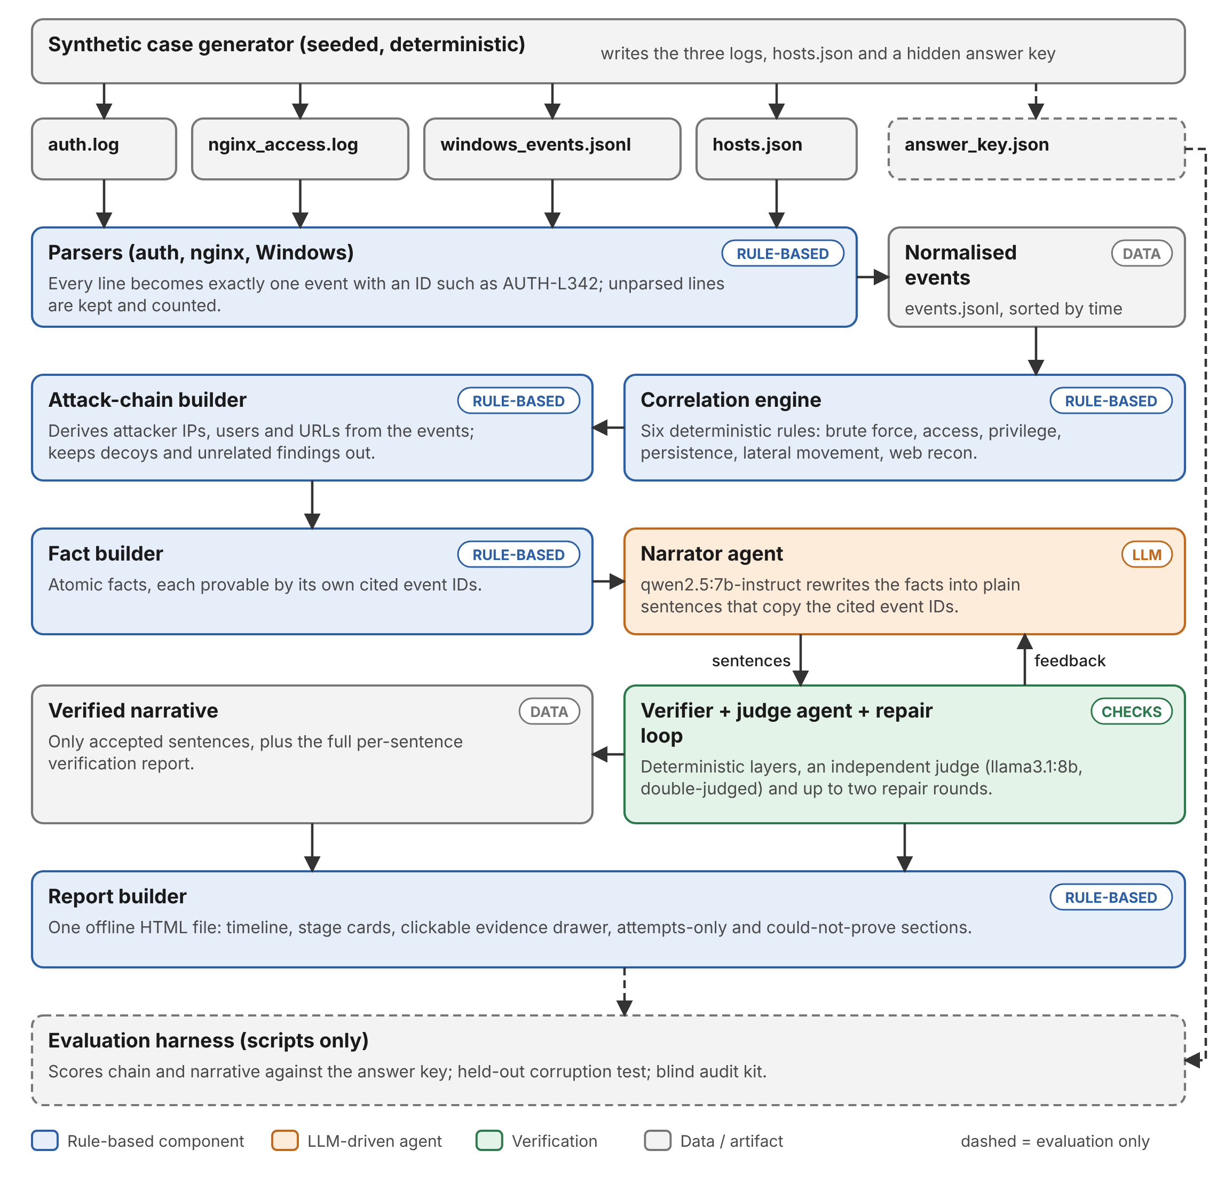
Figure 1: End-to-end architecture of EvidenceWeave

3.2 Agent roles and responsibilities
The pipeline is organised as eight cooperating agents. Each has a single responsibility, a defined input and output, and a contract with its neighbours. Six of them are deterministic programs; only the Narrator and the Judge call a language model.
Table 9: The eight agents
No. | Agent | Type | Responsibility | Input → Output
1 | Ingest | Rule-based | Parse the three log formats into one schema; never drop a line; keep unparsed lines and count them. | raw logs, hosts.json → events.jsonl
2 | Correlation | Rule-based | Apply six rules; build the attack chain from shared entities; separate decoys and unlinked findings. | events → findings.json, chain.json
3 | Fact | Rule-based | Turn each stage into atomic facts, each provable from its own cited events. | chain, events → facts per stage
4 | Narrator | LLM (qwen2.5:7b) | Rewrite facts into plain sentences that copy fact IDs and cite event IDs. | facts → sentences (JSON)
5 | Verifier | Rule-based | Run structure, entity and semantic checks; derive the verdict in code. | sentences → verdicts
6 | Judge | LLM (llama3.1:8b) | Split each sentence into claims and quote one exact log line per claim; run twice. | sentence + cited lines → claims, quotes
7 | Repair controller | Control logic | Send failed sentences back with reasons (at most two rounds); choose the best attempt; fall back to facts. | failures → feedback, final narrative
8 | Report | Rule-based | Build the offline HTML report with evidence index. | verified narrative, facts → report.html

3.3 Multi-agent orchestration
Figure 2 shows how the agents are coordinated. A deterministic pipeline controller (the analyze command) invokes the agents in a fixed order and enforces the limits. The agents never call one another directly. Each reads files written by the previous agent and writes its own files to a shared artifact store (output/<case>/), which makes every hand-over inspectable and every step repeatable.
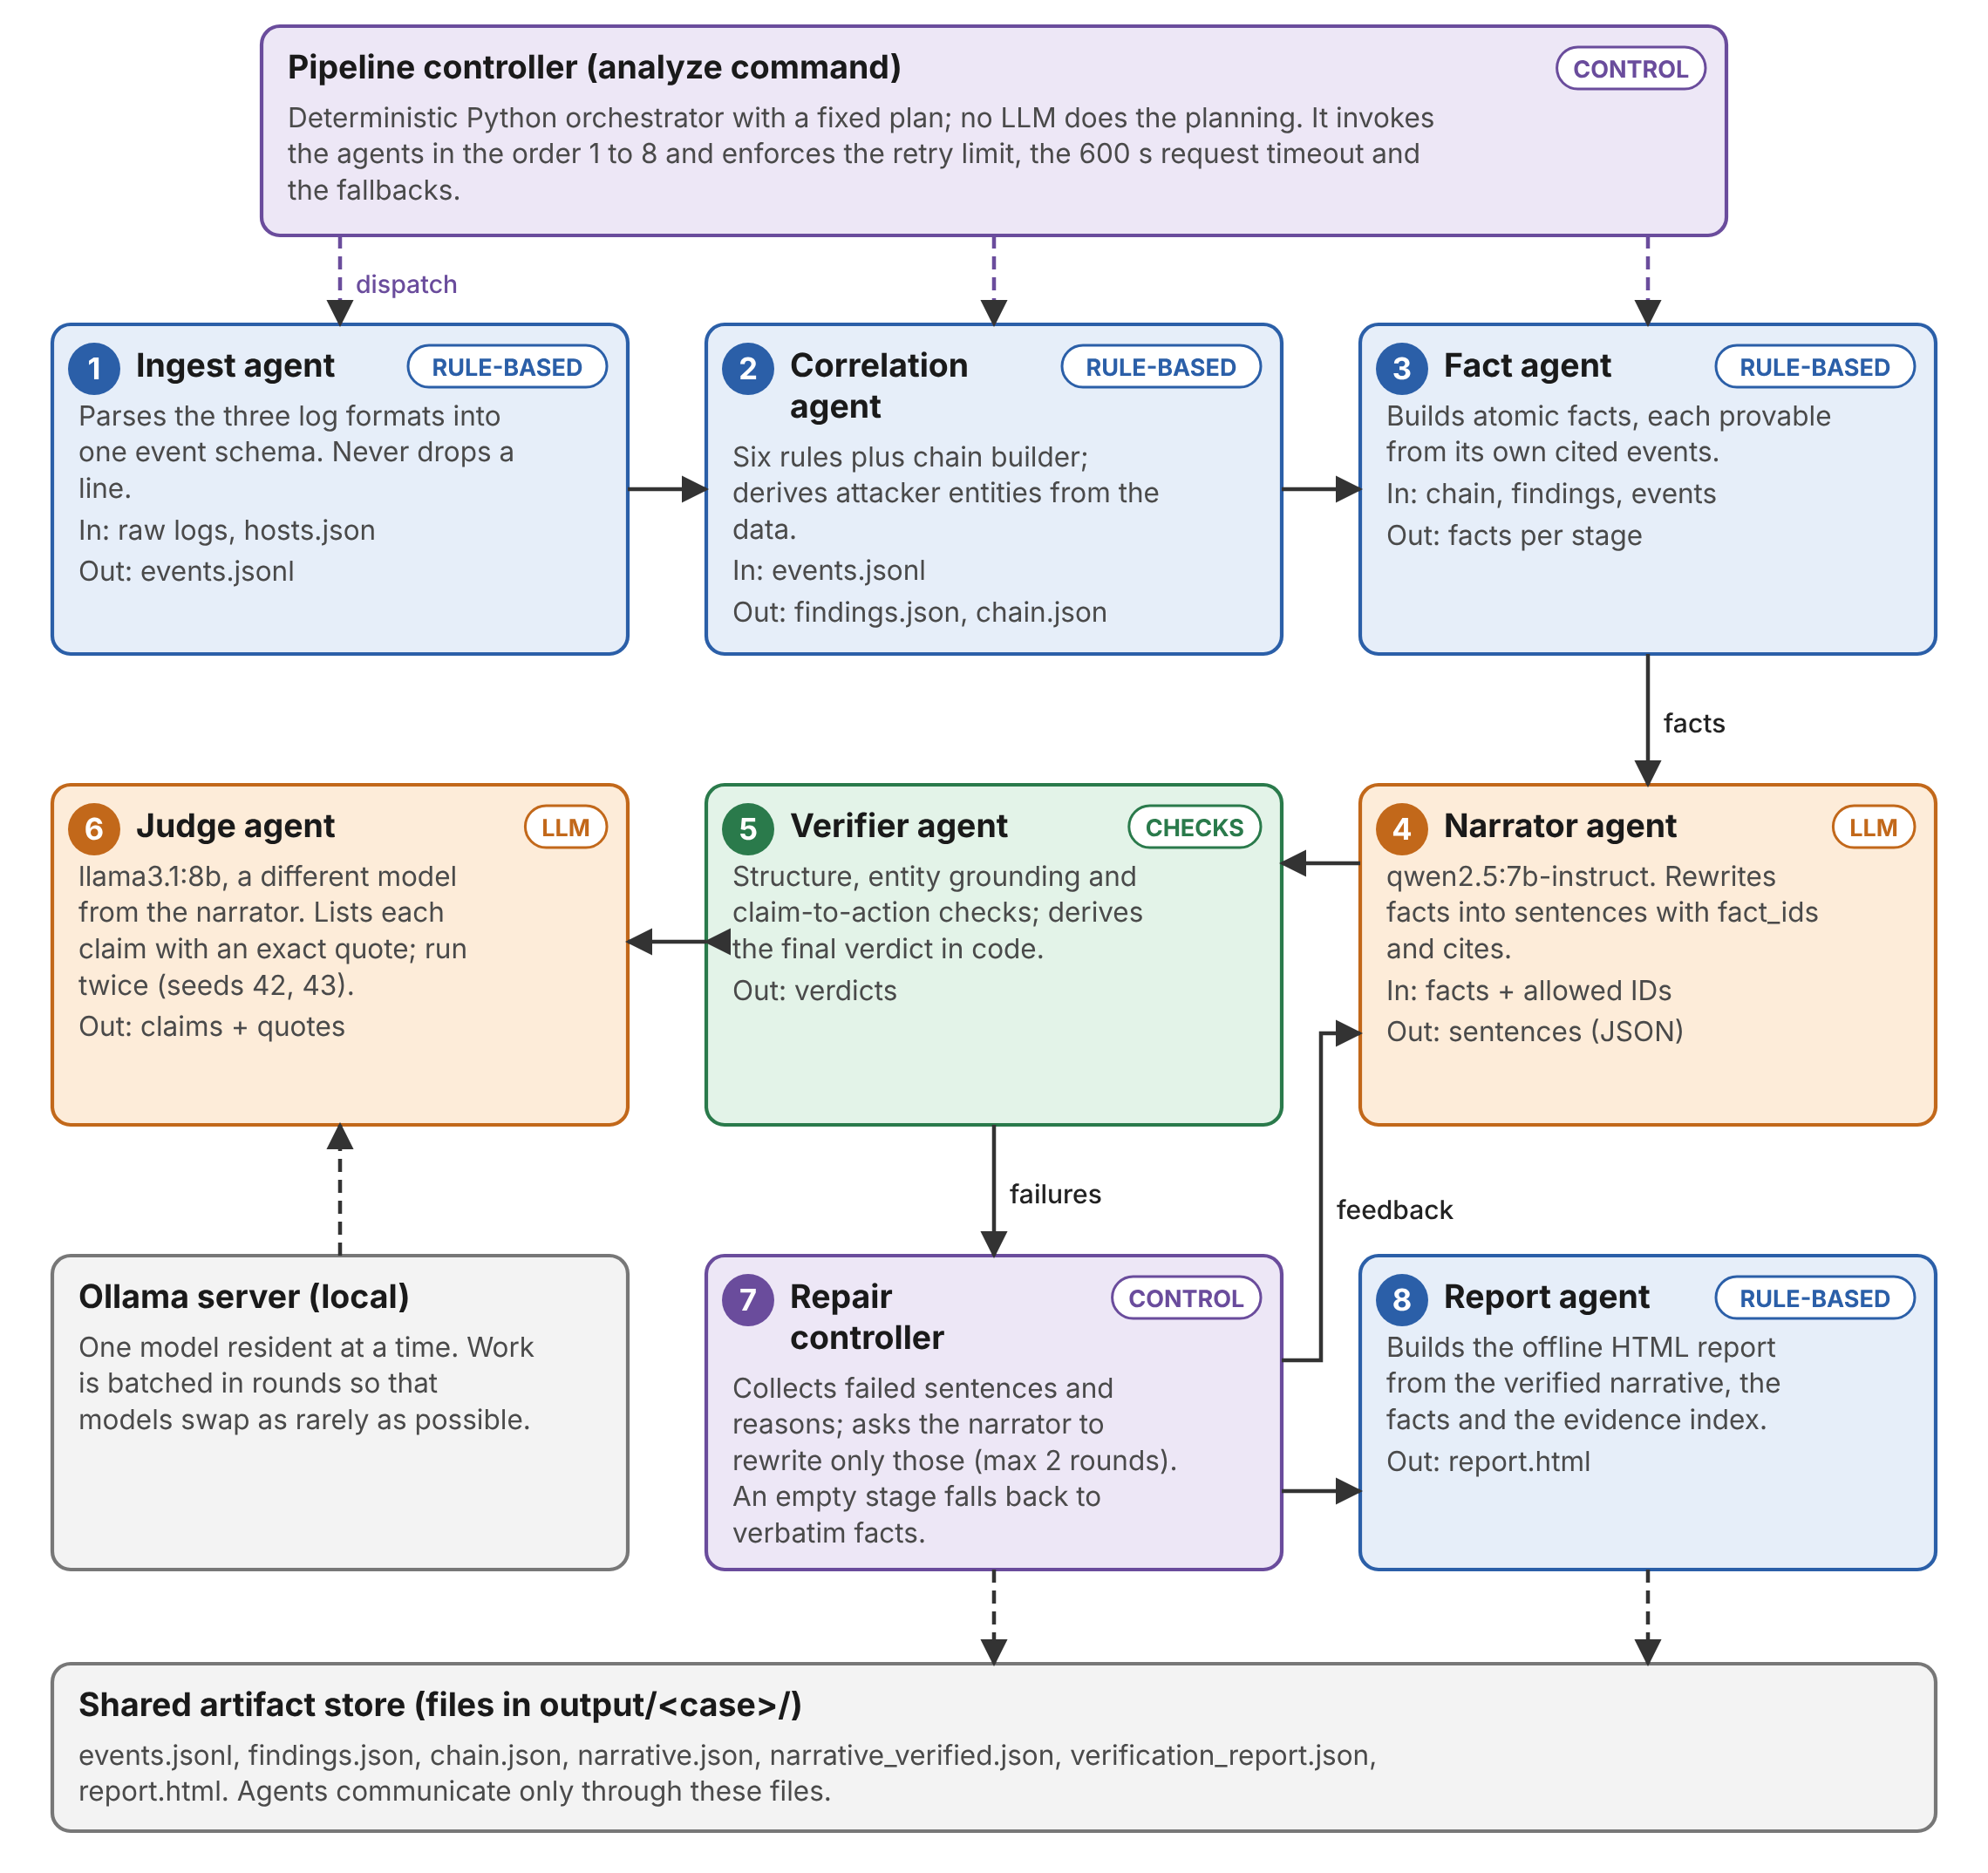
Figure 2: Agent orchestration: controller, eight agents, and the shared artifact store
The numbers on the cards give the invocation order. Agents 1 to 3 run once. Agents 4, 5 and 6 form the generate-and-check loop, and agent 7 closes the loop by sending failures back to agent 4. Agent 8 runs last. The Ollama server in the lower left holds only one model in memory at a time, which drives the batching rule described below.
Table 10: Orchestration design decisions
Decision | What was chosen | Why
Planning | A fixed plan executed by a deterministic controller; no LLM planner. | Forensic work must be repeatable. A model choosing its own steps would make runs differ and be hard to audit.
Communication | Agents exchange files in a shared artifact store. | Every hand-over can be opened and checked; stages can be re-run or skipped (--reuse).
Coordination of models | Batched rounds: all narrator calls of a round come before that round’s judge calls. | Ollama swaps models in memory; batching limits swaps to at most one per round.
Independence | Narrator and judge are different models. | A model tends to approve its own mistakes.
Termination | At most two repair rounds; the best attempt per stage is kept. | Guarantees the loop ends; progress is never lost because accepted sentences are kept.
Failure handling | One retry for unparseable JSON; 600 s request timeout; a stage with no accepted sentence falls back to verbatim facts; --no-llm mode. | The pipeline always produces a usable, honest report.

A note on the word "agent"
Only the Narrator and the Judge use a language model. The other components are called agents because each has one responsibility, its own input and output, and a defined contract with the rest of the system. The orchestration is a fixed controller, not an autonomous planner. This was a deliberate choice for reliability and is discussed again under limitations.

The repair loop in detail
Figure 3 shows one full verification cycle as a sequence diagram. In round 0 the narrator writes the first draft at temperature 0. The verifier applies the deterministic layers and sends only the survivors to the judge, which runs twice. In each repair round the controller returns only the failed sentences, with failure codes written in plain words, to the narrator. Repair calls use temperature 0.3 and a new seed so that the model can actually change its answer; accepted sentences from earlier attempts are kept unchanged.
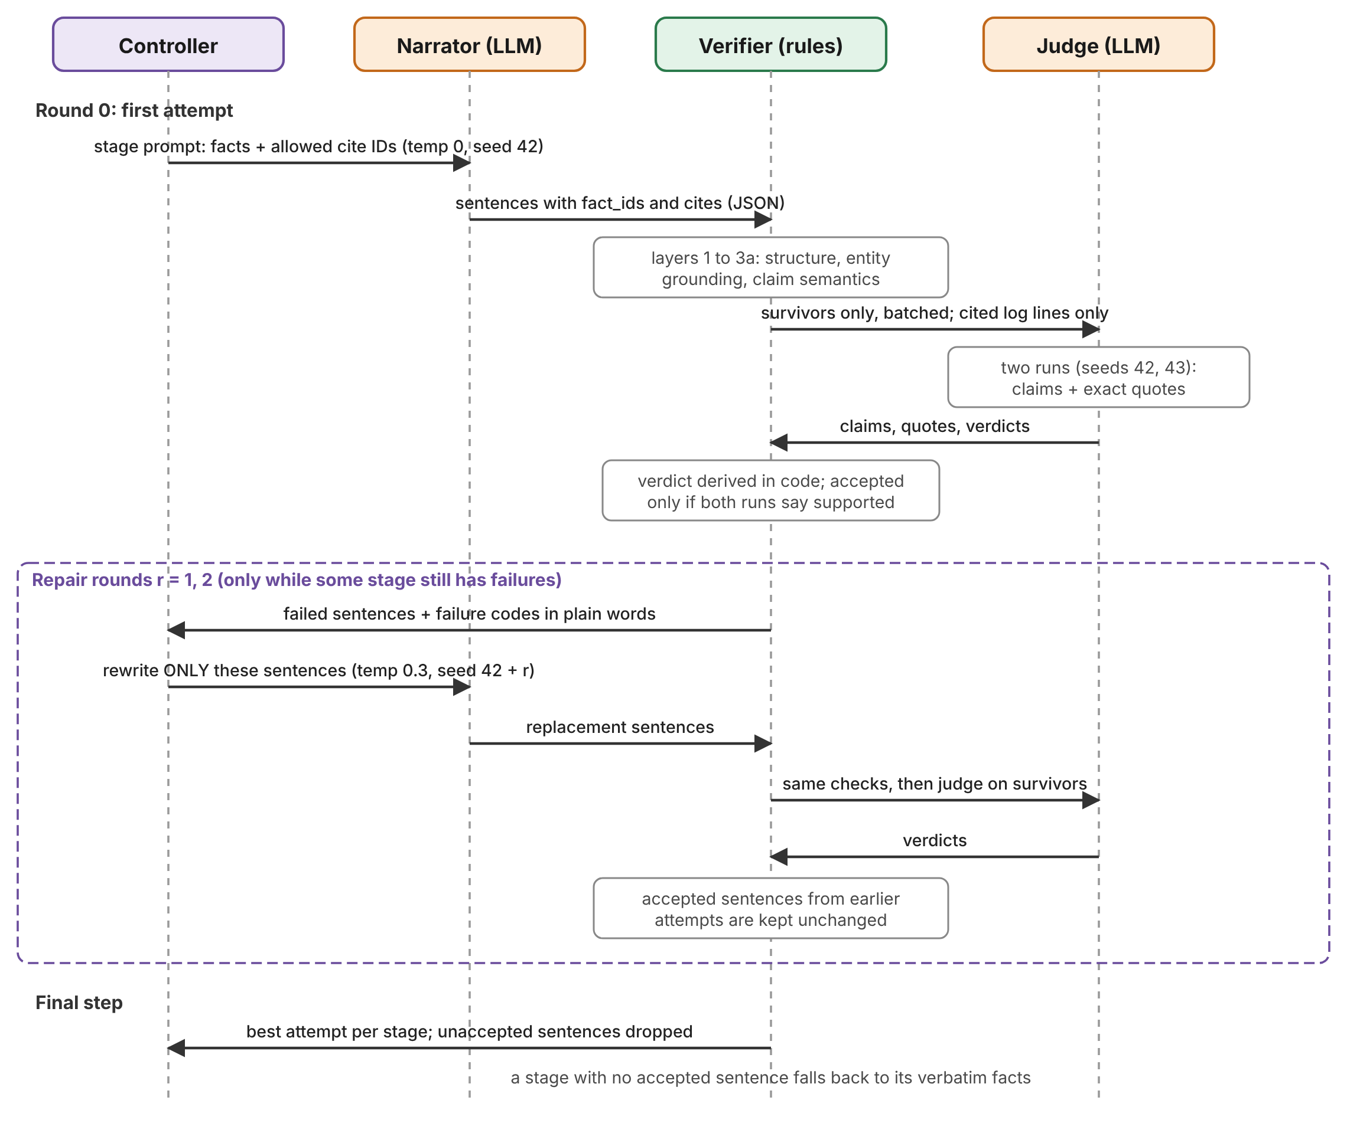
Figure 3: Sequence of one verification and repair cycle

3.4 Synthetic data generation and attack storyline
The generator plants the same six-stage attack, carried out by one attacker address, into every case and surrounds it with realistic benign activity: normal SSH sessions, administrator sudo use, scheduled jobs, web traffic from many addresses and ordinary Windows logons. Figure 4 shows the hard case as it appears in the logs.
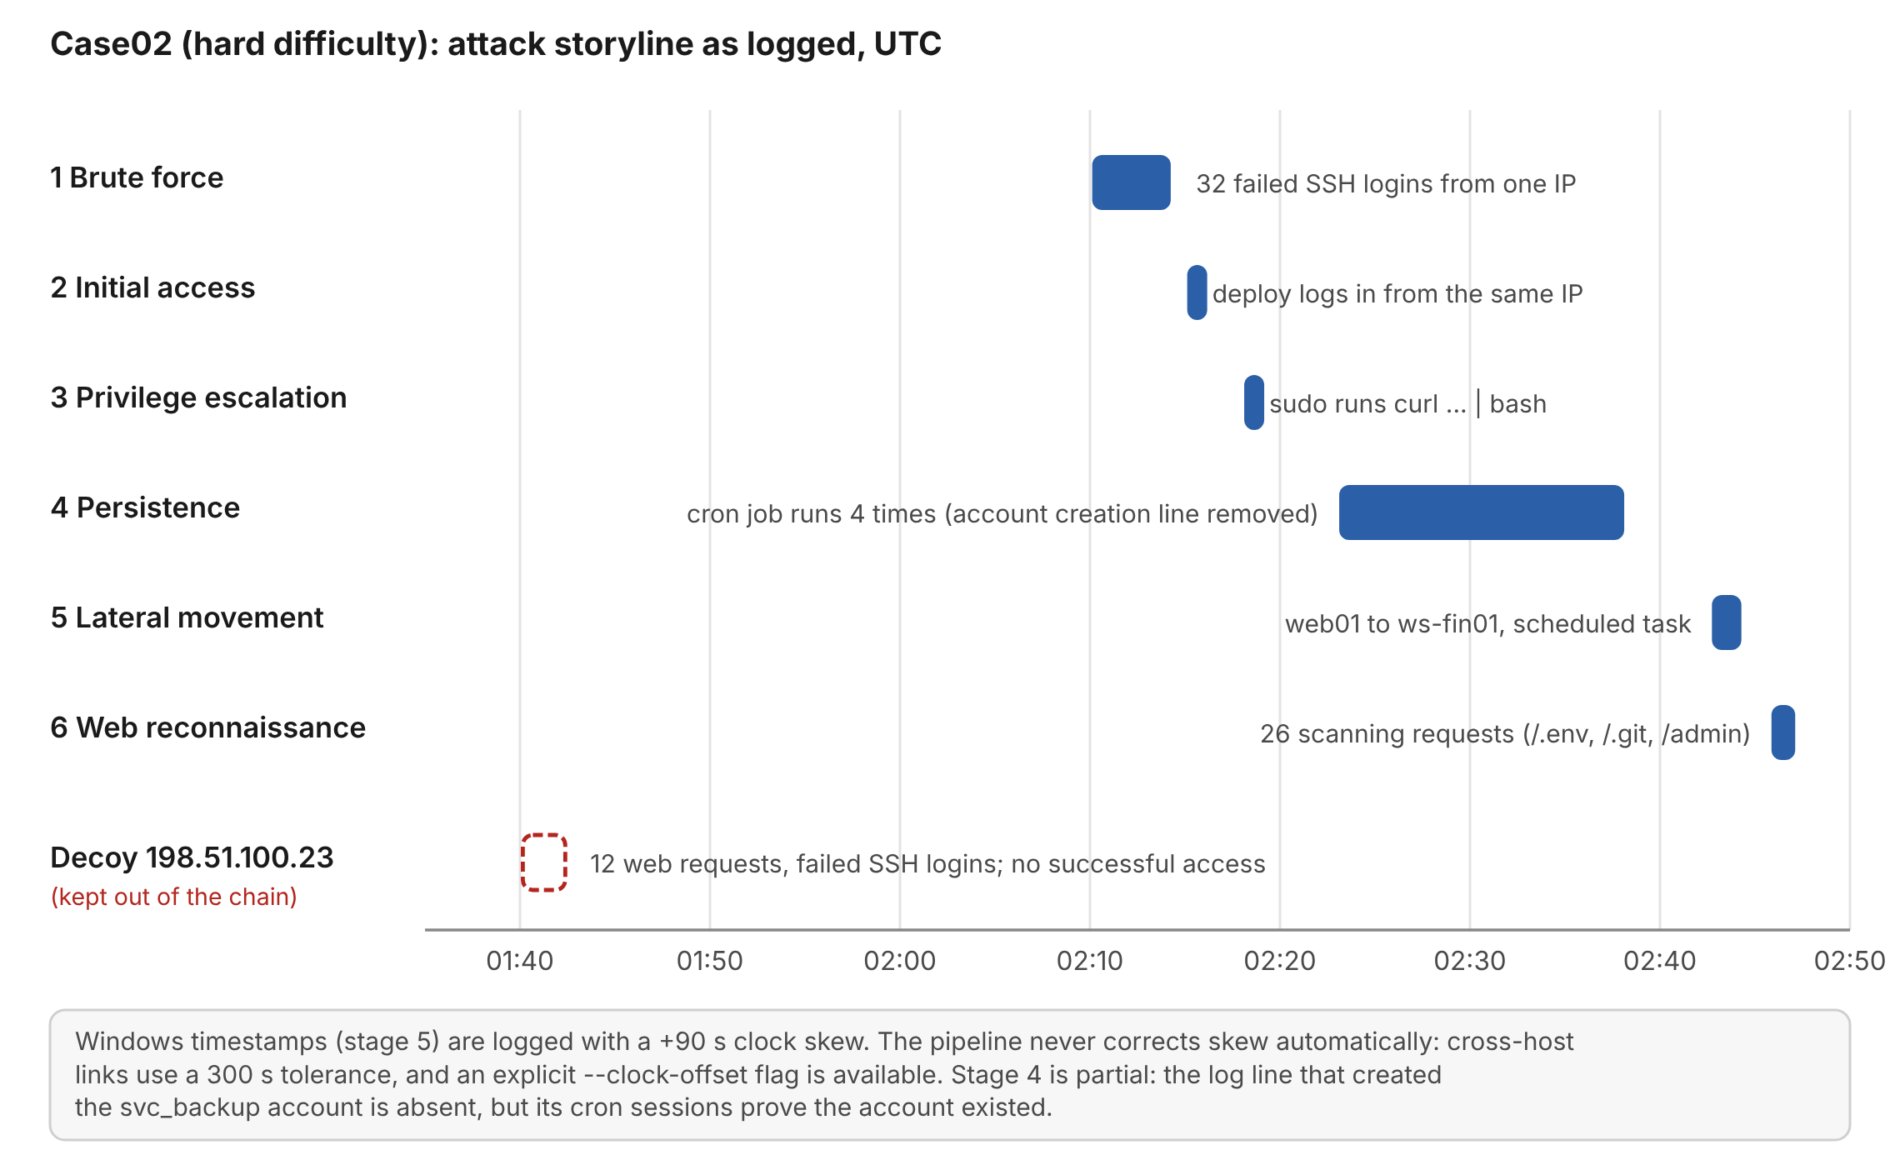
Figure 4: Attack storyline of case02 as logged (UTC), with the decoy lane
Table 11: Attack stages in case02
Stage | Name | Logged time (UTC) | Evidence lines | What happens
1 | Brute force | 02:10:07 – 02:14:15 | 32 | Many failed SSH logins from one external address, mixing invalid names and the valid user "deploy".
2 | Initial access | 02:15:07 | 1 | A successful SSH login as deploy from the same address.
3 | Privilege escalation | 02:18:07 | 1 | deploy runs sudo with a download-and-run command (curl piped to bash).
4 | Persistence | 02:23:07 – 02:38:07 | 12 | A new account svc_backup runs a cron job four times. The line that created the account was deleted from the log.
5 | Lateral movement | 02:42:44 – 02:44:17 | 7 | From web01 (10.0.0.5): failed and then successful network logon on ws-fin01, special privileges, encoded PowerShell, scheduled task.
6 | Web reconnaissance | 02:45:52 – 02:47:07 | 26 | The attacker address scans for /.env, /.git/config, /admin and similar paths.

The Windows host clock runs 90 seconds ahead, so stage 5 is logged at 02:42:44 although it happened at 02:41:14. The decoy 198.51.100.23 produces failed SSH logins and web scans but never logs in.

3.5 Event normalisation (Ingest agent)
Each parser turns one log line into one event. The identifier is built from the source and the line number, so that any sentence can be traced to the exact raw line: AUTH-L342 is line 342 of the auth log, NGX-L560 is line 560 of the nginx log and WIN-L88 is line 88 of the Windows log. Nothing is dropped silently: a line that cannot be parsed becomes an event with action unparsed, and blank lines are counted separately. In both generated development cases every line parsed, so the unparsed count was zero.
Table 12: Normalised event schema
Field | Meaning
event_id | Deterministic ID from source and line number (AUTH-L342, NGX-L560, WIN-L88).
timestamp / raw_timestamp | Corrected UTC time used for sorting, and the time exactly as logged.
clock_corrected | True only if an explicit clock offset was applied to this host.
host, user, src_ip, dst_ip | Where the event happened, who did it and from which address (or none).
source_type, action | auth, nginx or windows; and one of 18 fixed actions such as ssh_login_failed, ssh_login_success, sudo_command, user_created, cron_command, web_request, win_logon_success, win_process_created, win_task_created.
raw_file, raw_line, raw_text | The original line, unmodified, with its file and line number.
extra | Source-specific details such as the command, status code or logon type.

Clock-skew policy. Skew is never corrected automatically, because no reliable anchor event exists to measure it. An analyst may pass --clock-offset HOST=SECONDS; otherwise the raw time is used and cross-host links tolerate a 300 second difference.

3.6 Correlation agent and attack chain
Six independent rules each take the events and return findings. Thresholds are configurable and were fixed before the evaluation cases were generated.
Table 13: Correlation rules and default thresholds
Rule | Fires when | Default
Brute force | Many failed logins from one address within a time window. | 8 failures in 600 s
Initial access | A successful login from an address whose brute-force burst ended shortly before. | within 1,800 s
Privilege escalation | A sudo command matching a suspicious pattern (download piped to a shell, encoded payloads, reverse shells) by the compromised user. | pattern list
Persistence | A user created after access, a cron command with a suspicious pattern or URL, or a scheduled task. If the cron user has no creation event, a missing-evidence finding is added. | pattern list
Lateral movement | A network logon from the address of an inventory host that is already compromised, followed by special privileges, a suspicious process and a scheduled task on the target. | 900 s window
Web reconnaissance | Many requests with a high share of 403/404 answers, or several distinct sensitive paths. | 15 requests, 60% errors, 900 s; or 3 sensitive paths

The chain builder then links findings. It starts from the addresses that both brute-forced and logged in, learns the compromised user, and grows the attacker set through shared entities: payload URLs and the addresses inside them, and the pivot host recorded in the host inventory. A finding joins the chain only if it shares an entity with that set and fits the time order. Figure 5 shows the result for case02, including what was deliberately left out.
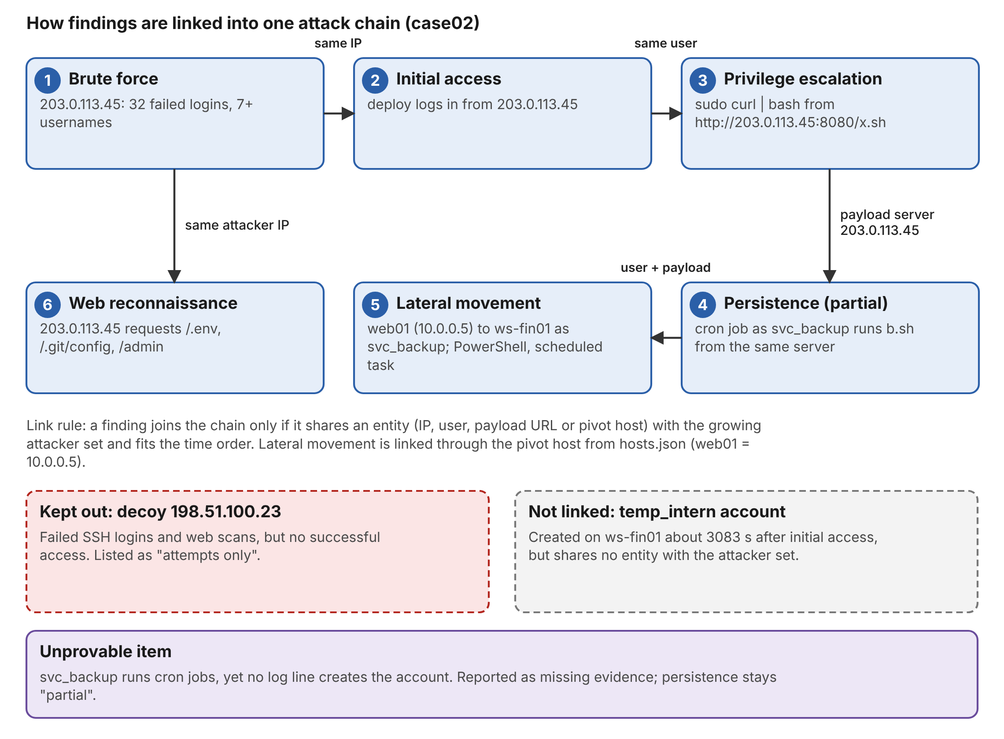
Figure 5: Attack chain of case02: how findings link, and what stays out
Anti-overfitting rules
The analysis code never reads the answer key or the attack information in the manifest, and never contains the attacker address, user names or payload URL of the generated cases. A test copies a case, deletes the key and checks that the chain is identical. A static test checks that no module of the package contains the text "answer_key". Rules were tested on three further seeds in both difficulties, and none was changed afterwards to improve a result.

3.7 Fact builder
For every stage the fact builder produces up to eight atomic facts in a fixed priority order: time window, main actor, key action, counts, links, and status. Each fact is a deterministic sentence that makes exactly one checkable claim and cites the events that prove it by themselves. For example, the privilege-escalation stage contains the fact that the user ran a sudo command on web01 and quotes the command exactly as logged, citing AUTH-L330. Facts about failed attempts cite failure events, facts about a success cite the success event, and a partial stage carries a fact stating what could not be shown. Every fact must itself pass the deterministic verification layers; a fact that fails is treated as a bug in the builder.

3.8 Narrator agent
The narrator is qwen2.5:7b-instruct, called through Ollama with temperature 0, seed 42 and a 16,384-token context. It receives the numbered facts of one stage together with the list of allowed cite IDs, and must return JSON of the form {"sentences": [{"text", "fact_ids", "cites"}]}. Its instructions forbid adding any information, number, time or entity that is not in the facts. One call is made per stage plus one for the executive summary, because small prompts work far better with a 7B model than one large prompt.
An earlier design, raw mode, gave the model the stage evidence lines and let it describe them. A diagnosis of 47 failing sentences showed that 33 failed because the prompt invited claims that no allowed citation could support. This led to the fact-sheet design above, which is now the default. Raw mode is kept so that the two approaches can be compared.

3.9 Verifier and independent judge
Every sentence passes through up to four layers (Figure 6). The deterministic layers are cheap and catch most errors; the judge handles what rules cannot see. A sentence is accepted only if it passes every layer.
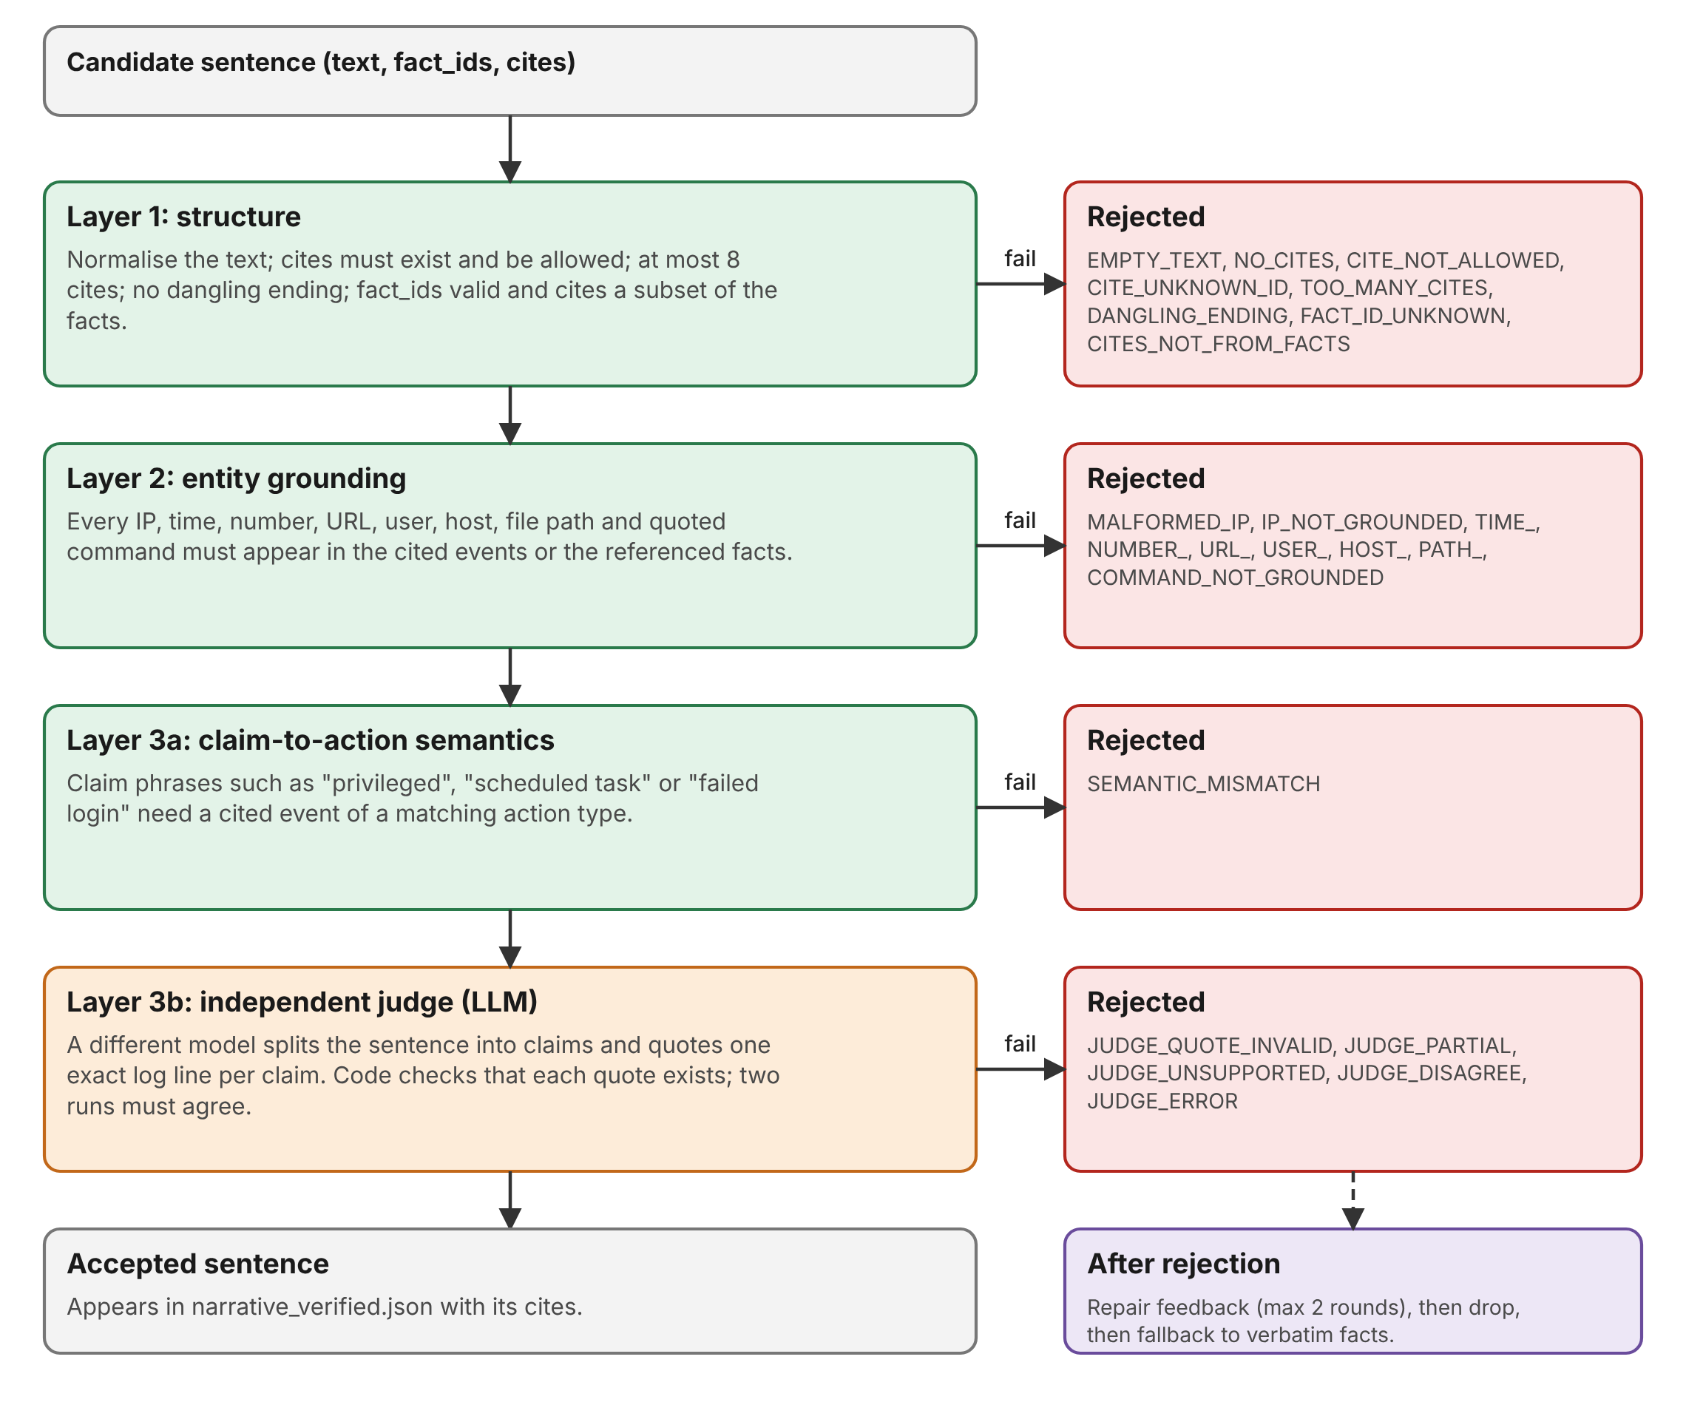
Figure 6: The four verification layers and their failure codes
Table 14: Verification layers
Layer | What it checks | Example of an error it catches
1 Structure | Cites exist and are allowed; at most 8 cites; fact IDs valid; cites are a subset of the facts; no dangling ending; junk characters normalised. | A sentence that ends in "as shown by."
2 Entity grounding | Every IP, time, number, URL, user, host, file path and quoted command must appear in the cited events or the referenced facts. | An address with a dropped dot, such as 203.0113.45; an invented path.
3a Semantics | Claim phrases need a cited event of a matching action type (a table that is easy to extend). | Calling a plain logon a "privileged logon".
3b Judge | A second model lists the claims and quotes one exact log line for each; code checks that every quote exists in the cited lines; two runs (seeds 42 and 43) must both say supported. | A claim with no checkable entity, such as "the attacker wiped the history".

The final verdict is derived in code, not taken from the judge’s own answer. If the judge says a claim is supported but its quote does not occur in the cited lines, the sentence is rejected with JUDGE_QUOTE_INVALID. Acceptance is conservative: partial, unsupported, disagreeing and errored judgements all lead to rejection.

3.10 Report builder
The report agent produces one self-contained HTML file with no external fonts, scripts or network requests, so it works offline and can be e-mailed. It contains a header verdict built only from chain counts, a timeline with a separate lane for attempts-only actors, an executive summary, one card per stage showing established facts and verified sentences side by side, a drawer that shows the raw log line, file name, line number and neighbouring lines when an event ID is clicked, an attempts-only section, a "what could not be proven" section, and a method-and-limits panel.
Because log lines are attacker-controlled, all log text is embedded as escaped JSON and displayed with textContent; URLs from logs are shown as plain text; and a test injects script and HTML strings into every field to confirm that none becomes executable. Re-running with the same inputs and the same timestamp produces a byte-identical file.

3.11 Implementation summary
evidenceweave/
generator/ synthetic cases, answer key, host inventory
parsers/ auth, nginx, Windows parsers; pipeline
correlation/ six rules, findings, chain builder, configuration
narrator/ facts, prompts, Ollama client, narrate, baseline
verifier/ structure, entities, semantics, judge, repair, corruption tests
report/ HTML report builder
scripts/ check_ollama, check_against_key, evaluate_cases, audit tools
tests/ 212 automated tests (no test calls a real model)
docs/ README, demo script, RESULTS.md, sample reports

Table 15: Command-line interface
Command | Purpose
generate | Create a synthetic case with a seed and a difficulty.
parse | Normalise the logs into events.jsonl (optional --clock-offset).
correlate | Run the rules and the chain builder; write findings.json and chain.json.
narrate | Write the narrative in facts or raw mode, or the naive baseline.
verify | Verify and repair the narrative; run the baseline and corruption tests.
analyze | Run the whole pipeline in one command and open the report; --no-llm and --reuse available.
report | Rebuild the HTML report from existing outputs without any model call.
evaluate | Run the evaluation harness (delegates to the scripts folder).

Every output file records run metadata: the Ollama version, model digests, all model options, prompt versions, the git commit and the date. Tests use a fake language model, so the suite runs in seconds without Ollama.

3.12 Mapping to the evaluation parameters
Table 16: Where each evaluation parameter is addressed
Evaluation parameter | Where addressed
Agent Planning and Goal Formulation | Section 2.1 (goal decomposition), 2.6 (design principles), Section 3.3 (fixed plan and its rationale).
Agent Architecture and Integration | Section 3.1 (architecture), 3.2 (agent roles), 3.5 to 3.10 (components and their contracts).
Multi-Agent Orchestration | Section 3.3 (controller, artifact store, batched rounds, repair loop, termination and failure handling).
Implementation and Functionality | Section 3.11 (implementation, commands), Section 4.4 (working report).
Testing and Performance Evaluation | Section 4.1 to 4.3 (tests, evaluation design and results).
Innovation | Rules decide and the model explains; fact-sheet narration; quote-checked double judge; held-out hallucination pool; honest missing-evidence handling.
Presentation and Viva | Section 5 (presentation outline, demo script, questions).
Report Preparation | This report.

4. PROOFS OF OUTCOME AND FEEDBACK

4.1 Testing
The project has 212 automated tests. None of them calls a real language model; a scripted fake model stands in for both the narrator and the judge, so every test is fast and repeatable. The number of passing tests grew with every phase.
Table 17: Passing tests after each phase
Phase | 0–1 | 2 | 3 | 4 | 5 | 5b | 6a | 6b
Tests | 13 | 37 | 68 | 95 | 140 | 169 | 190 | 212

Table 18: What the tests cover
Area | Examples of what is tested
Generator | Same seed gives byte-identical files; every answer-key line number really contains its marker; hard case has a missing line that truly is absent.
Parsers | Every line becomes exactly one event; garbage and truncated lines never raise; clock offset changes only the corrected time.
Correlation | Each rule fires on a positive and not on a near-miss; benign mistyped passwords do not trigger; recall of at least 0.9 on three extra seeds in both difficulties; the analysis never reads the key.
Narrator | Evidence caps, retry on bad JSON, citation problems left untouched for the verifier, template sections not produced by the model.
Verifier | Each layer and failure code; the judge prompt contains only the sentence and its cited lines; batched call order; fallback behaviour; corruption generators.
Report | All sections present; no external resources; injection strings never become markup; every cite chip resolves to an evidence entry; byte-identical rebuilds.
Evaluation | Strict versus loose coverage, entity matching, Wilson intervals, resumable stages, audit sampler and scorer.

4.2 Evaluation design
Four new cases (two easy, two hard, seeds 101, 102, 201 and 202) were generated after the code was frozen. The following arms and measures were used.
Table 19: Arms and metrics
Item | Definition
Chain detection | Evidence lines found by the rules compared with the answer key: recall, precision, decoy and benign-looking lines kept out, missing evidence detected.
Chain arm | Rules and chain, facts-mode narrator, four-layer verifier with repair (narrator qwen2.5:7b-instruct, judge llama3.1:8b).
Baseline arm | The same narrator model given the raw sorted events in chunks of 120, with no rules and no chain, asked to write a cited incident narrative.
Strict step coverage | A step counts as covered if a final sentence with at most 8 cites cites at least one of that step’s key evidence lines. Loose coverage removes the cite limit.
Entity coverage | Share of attacker entities (address, user, payload host, pivot host) that appear as exact tokens in the final text.
Held-out corruption test | Clean accepted sentences are corrupted with 14 invented claims without entities and 10 invented entities that the verifier’s authors never saw; the share rejected is measured, with clean controls for false rejection.
Role swap | Narrator and judge models exchanged on two cases to check that results do not depend on one pairing.
Audit | A sample of 32 sentences labelled as supported, partly supported or unsupported using only the cited log lines.

4.3 Results

Chain detection
Table 20: Chain detection on the four evaluation cases
Measure | Result
Key evidence lines found | 329 of 329
Extra lines not in the key | 0
Recall and precision | 100% and 100% on every case
Decoy address and benign-looking lines in the chain | None
Missing evidence (hard cases) | Detected and reported as unprovable

Perfect detection must be read with care: the cases come from the same generator that the rules were written against, so this shows that the rules work across the generator’s variations, not that they work on real logs.

Chain narrative versus baseline
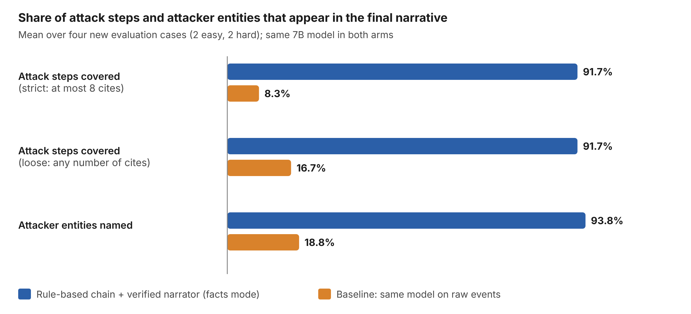
Figure 7: Attack steps and attacker entities present in the final narrative (mean of four cases)
With the same 7B model, the baseline lost most of the attack: strict step coverage was 8.3% against 91.7% for the chain arm, and none of the baseline’s accepted sentences covered a step. Even when the cite limit was removed, the baseline reached only 16.7%. The baseline also labelled routine cron jobs and internal logins as threats. This is the main justification for letting rules find the attack.

Efficiency
Table 21: Cost of the approaches
Run | Time | Tokens | Model calls
Chain narrator, raw mode, case01 (Phase 4) | 48.5 s | 9,919 | 7
Baseline on raw events, case01 (Phase 4) | 212.1 s | 100,824 | 8
Full analyze with verification, case02 (live) | 1,009 s (narrate 74.6 s, verify and repair 934.2 s) | not recorded | many
analyze with --no-llm, case02 | about 0.3 s | 0 | 0

Without verification the chain narrator is about four times faster than the baseline and uses about ten times fewer tokens. Verification with the double judge and repair is the expensive part: a live run takes about 17 minutes. This is why the demonstration uses a saved report or the --no-llm mode.

Verification behaviour
Table 22: Raw-mode versus fact-sheet narration (Phase 5b, development cases)
Case | Measure | Raw mode | Facts mode
case01 | Accepted sentences | 2 | 14.7 (range 14–15, 3 runs)
case01 | Fallback units | 5 | 0
case02 | Accepted sentences | 6 | 15 (3 runs, identical)
case02 | Fallback units | 1 | 0

In the live case02 run, 27 sentences were generated. Eight were accepted at the first attempt, and repair added four and then three more, giving 15 accepted and 12 dropped. Judge self-agreement was 0.80. The higher acceptance in facts mode partly reflects an easier task, because the model restates pre-verified facts, and should not be read as a smarter model.

Hallucination test on a held-out pool
Table 23: Held-out corruption test (pooled over two cases)
Measure | Result
Corrupted sentences rejected | 119 of 120 (99.2%, 95% confidence interval 95.4–99.9%)
Clean control sentences wrongly rejected | 2 of 28 (7.1%)
Corrupted sentence that was accepted | "The attacker wiped the shell history afterwards." appended to a clean sentence (no checkable entity)

Every corruption that contained a checkable entity (a changed address, time or number, a non-existent or foreign cite, an invented path) was caught by the deterministic layers. The one miss is a claim with no entity, which only the judge can reject, and it did not. On the earlier development pool the corresponding results were 25 of 27 in Phase 5 and catch rates of 0.957 and 1.000 on the two cases in Phase 5b.

Role swap
Swapping the narrator and judge models on the other two cases gave similar numbers, and the judge stayed independent in both runs. On eval_h2 the swapped pairing was worse, covering 5 of 6 steps and 3 of 4 entities against 6 of 6 and 4 of 4 with the default pairing, so the choice of pairing does matter.

Audit of 32 sentences
Important notice
The 32 audit labels were produced by an LLM from the same model family as the narrator. No human labelled them, so they are not independent ground truth and the results are indicative only. A human audit remains to be done.

Table 24: Audit labels versus the verifier decision
Verifier decision | Supported (S) | Partly supported (P) | Unsupported (U) | Total
Accepted | 20 | 4 | 0 | 24
Rejected | 5 | 2 | 1 | 8

Of the 24 accepted sentences, 20 were labelled supported (83.3%, interval 64.1–93.3%) and all 24 were labelled supported or partly supported (100%, interval 86.2–100%); none was labelled unsupported. The four accepted sentences labelled "partly supported" overstate what their cited lines show: three claim that failed attempts "ended" at a time, which one line cannot prove, and one calls events "related to persistence", which is an interpretation. Of the 8 rejected sentences, 5 were labelled supported, so some rejections look unjustified; the sample is too small (interval 30.6–86.3%) to say how often.

4.4 Proof of outcome: the generated report
Figures 8 and 9 show pages of the report that EvidenceWeave produced for case02 in the live run. The header verdict reads: "Compromise confirmed: 5 of 6 stages established, 1 stage partially unprovable; 1 actor with attempts only and no successful access." The timeline places the decoy in its own lane, and each stage card separates deterministic facts from verified sentences, with clickable event IDs.
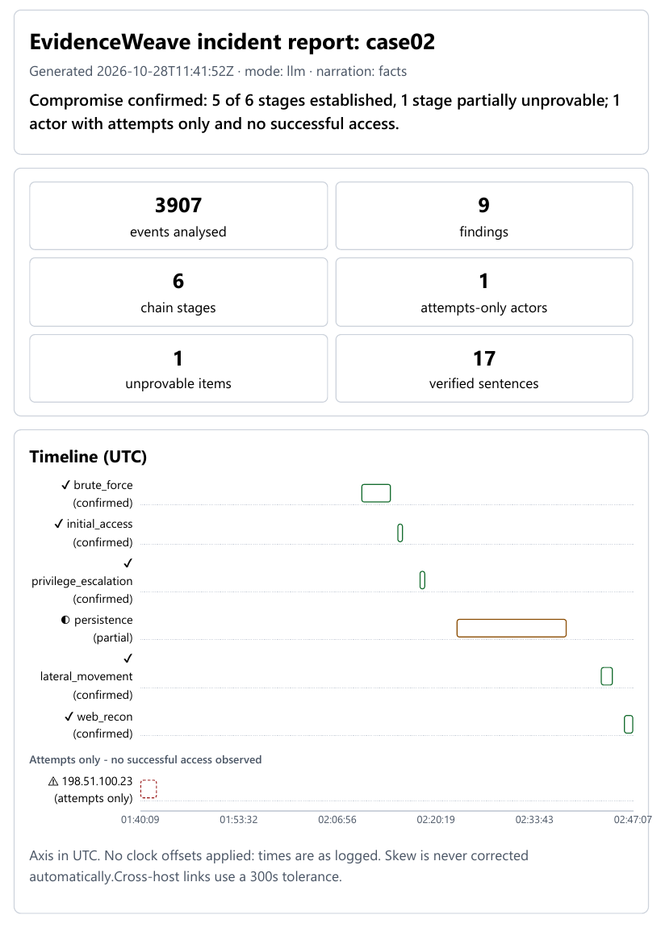
Figure 8: Report header, summary tiles and timeline for case02
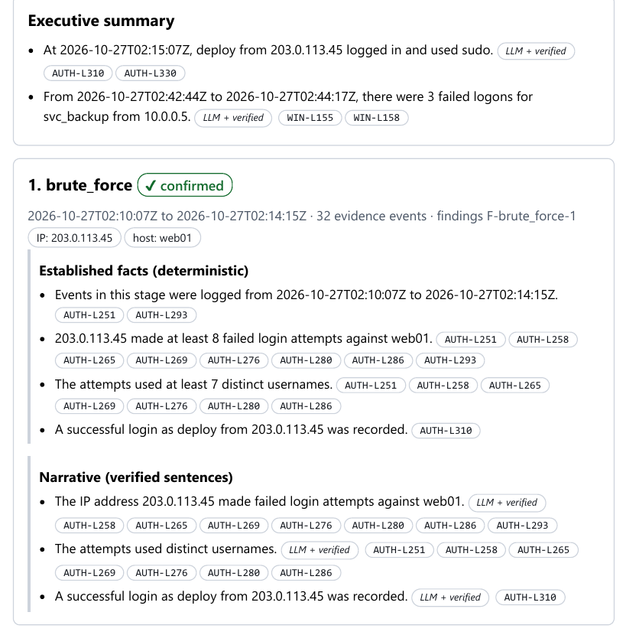
Figure 9: Executive summary and the brute-force stage card with facts, verified sentences and cite chips
Other sections of the same report: the "attempts only" section states that no successful access from 198.51.100.23 was observed; the "what could not be proven" section states that account svc_backup runs cron jobs but no event creating it appears in the logs; and the "not linked" list explains that the temp_intern account shares no entity with the attacker set.

Defects in model output caught by the verifier
Table 25: Defects seen in the first model output and the layer that handled them
Defect | Handled by
An address written as 203.0113.45 (a dot dropped) | Layer 2 (MALFORMED_IP); repaired in round 1.
A sentence ending in stray quote characters | Layer 1 normalisation.
A plain logon described as a "successful privileged logon" | Layer 3a (SEMANTIC_MISMATCH); sentence dropped because it was not fixed.
Event IDs written inside the sentence text | Layer 1 moved them into the cites.

4.5 Troubleshooting and issues resolved
Table 26: Issues found during the project and how they were fixed
Issue | Cause | Fix
Virtual environment had no Scripts folder | The Python on the PATH was an MSYS2 build (3.14). | Rebuilt the environment from standard Python 3.12.4.
Windows events appeared 90 s late | The Windows host clock is skewed. | 300 s cross-host tolerance and an explicit --clock-offset flag; skew is never guessed.
Mismatched times between events and chain | events.jsonl held corrected times while chain.json held raw times. | The pipeline now stores its offsets in pipeline_meta.json.
Answer key missed four attack lines | Cron "session closed" lines were not tagged. | Key fixed; log files verified byte-identical.
Closing quote deleted from a command | Junk-quote clean-up removed a legitimate quote. | Balanced-quote rule with tests.
Sentence ending "as shown by." | Inline ID removal left a dangling phrase. | Dangling-ending check (DANGLING_ENDING).
Ordinary words treated as user names | The user-name extractor was too loose. | Suffix rule and a larger stop list.
Repair returned near-identical text | Temperature 0 with the same seed. | Repair at temperature 0.3, new seed, sentence-level feedback.
Most failures were unfixable | 33 of 47 failures were prompt-design problems. | Fact-sheet narration became the default.
Evaluation stalled for about 57 minutes | A model request hung. | 600 s request timeout (logged); resumable harness.
HTML template broke the report styles | A CSS rule collided with the template comment syntax. | Changed the comment delimiters.

4.6 Feedback and actions taken
Feedback came from three sources: the automated checks and diagnosis, the audit, and a review of the generated report. The table lists what was found and what was done. Under the freeze rule, nothing found after the evaluation cases were generated was fixed in the code; these items are documented as known limits instead.
Table 27: Feedback and resulting actions
Finding | Source | Action
Most Phase 5 failures came from the prompt, not the model | Diagnosis of 47 failures | Redesigned to fact-sheet narration before the evaluation.
The judge disagrees with itself in 4–20% of cases and its own verdict often differs from the code-derived one | Phase 5b live runs | Verdict derived in code from quoted lines; double judging.
Counts, absence claims and interpretations can be accepted although the cited lines do not fully show them | Audit | Documented as a known verifier gap; not tuned away.
One accepted corruption: a claim with no entity | Held-out test | Documented; the held-out pool was not edited afterwards.
A cut-off sentence ending in a backslash passed all deterministic layers (rejected only by the judge) | Audit | Recorded as an open issue; not fixed because of the freeze rule.
Header says 17 verified sentences while statistics say 15 accepted | Report review | Both are right: 15 model sentences plus 2 template sentences; to be relabelled.
The executive summary is thin and one sentence attaches the login time to the later sudo action | Report review | Documented; stage cards carry the full story.

Class teacher feedback
Space reserved for the evaluator’s comments after the presentation.

4.7 Limitations and threats to validity
- All cases come from one synthetic generator. The results do not show performance on real logs.
- Sample sizes are small and each setting was run once, so differences are indicative. The judge is not perfectly reproducible even at temperature 0.
- The models are small (7B and 8B) and local; larger models may behave differently.
- The audit labels come from an LLM and are not independent ground truth.
- Fact-sheet narration is deliberately plain. The narrator mostly restates verified facts, so its higher acceptance rate partly reflects an easier task. Only about half of the facts appear in accepted sentences.
- Baseline sentences cite wide ranges of events, which inflates loose coverage and lowers strict coverage; both are reported.
- The held-out pool was frozen before the runs, but the verifier was designed knowing the original pool.
- Known verifier gaps: overstated sentences (counts, absence, interpretation), claims without a checkable entity, and a time attached to the wrong action in one sentence.
- Code hash: one file changed during the evaluation (the model request timeout was reduced from 1,800 s to 600 s). It changes no rule, prompt or threshold and is logged.
- Absence of evidence in logs is not proof of absence.

4.8 Conclusion and future work
EvidenceWeave shows that a small local model can be useful in forensic reporting when it is constrained by the right architecture. The rules found all 329 attack evidence lines in the four evaluation cases with no false additions, kept the decoy and the unrelated account out of the chain, and reported the deleted evidence as unprovable. The verifier rejected 119 of 120 deliberately corrupted sentences, and the final narrative covered 91.7% of attack steps where the same model without the rules covered 8.3%. The costs are time, a plain narrative, and a judge that is not fully reliable.
Future work: test on real or public log collections; add a human audit; strengthen checks for counts, absence claims and interpretations; improve the executive summary; estimate clock skew when a reliable anchor event exists; and compare larger models.

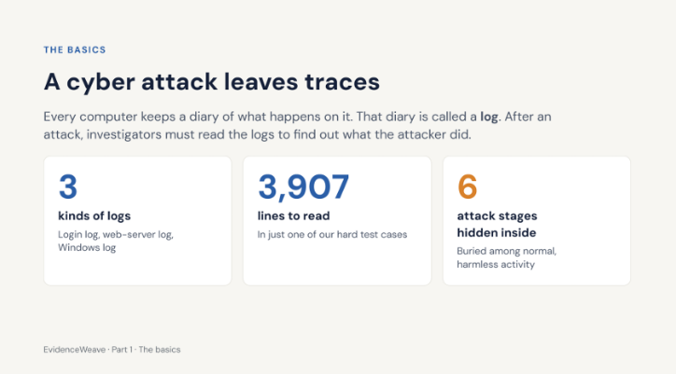
5. POWERPOINT PRESENTATION


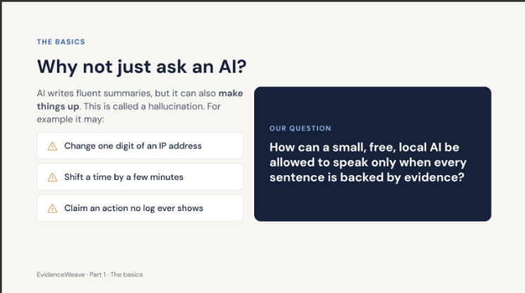
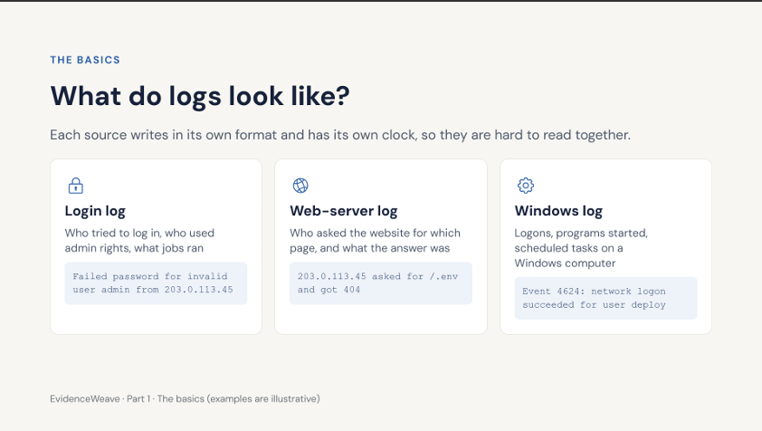
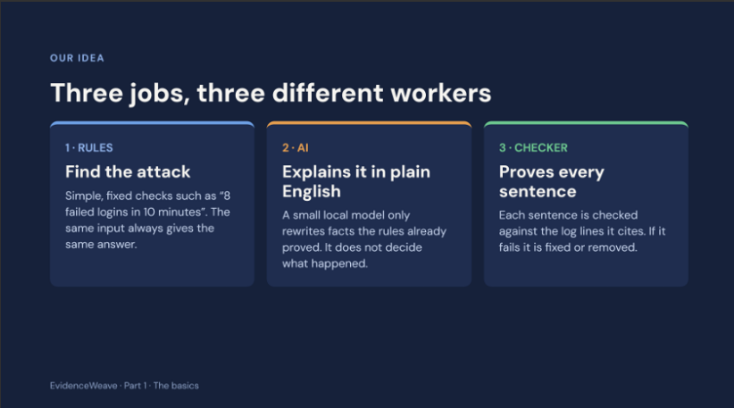
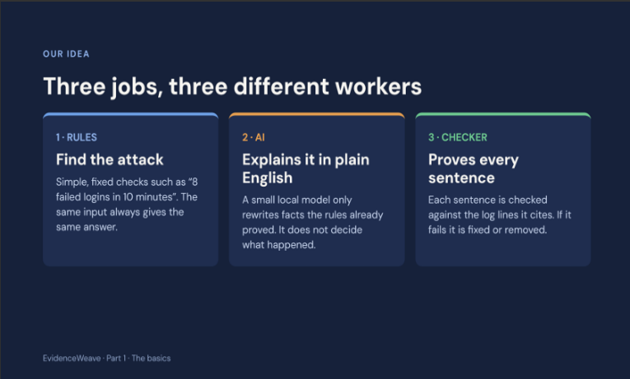

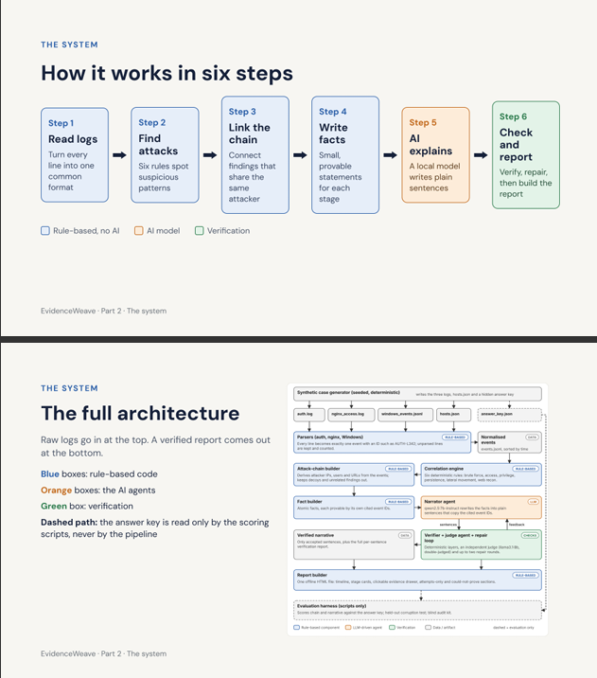
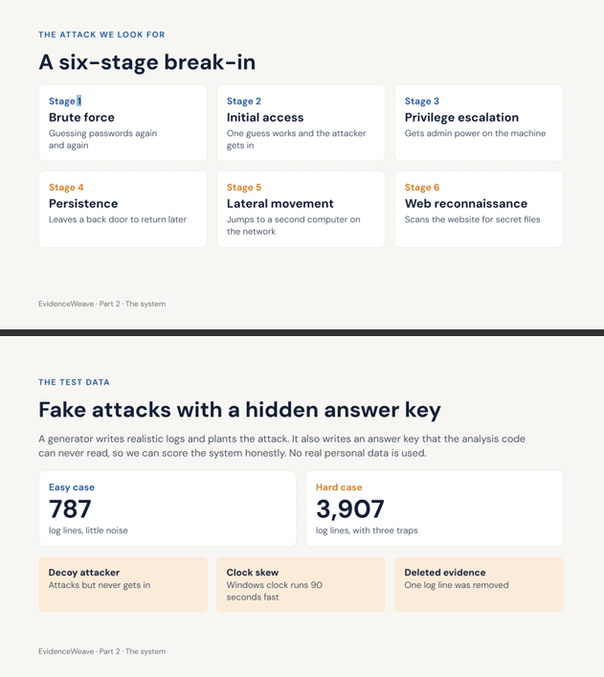

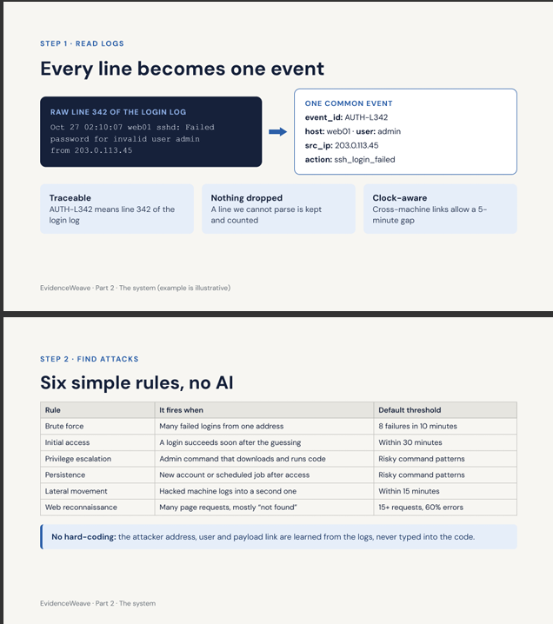
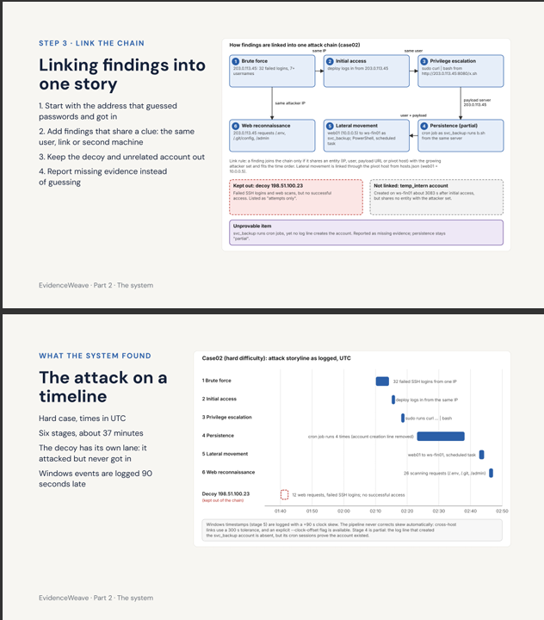

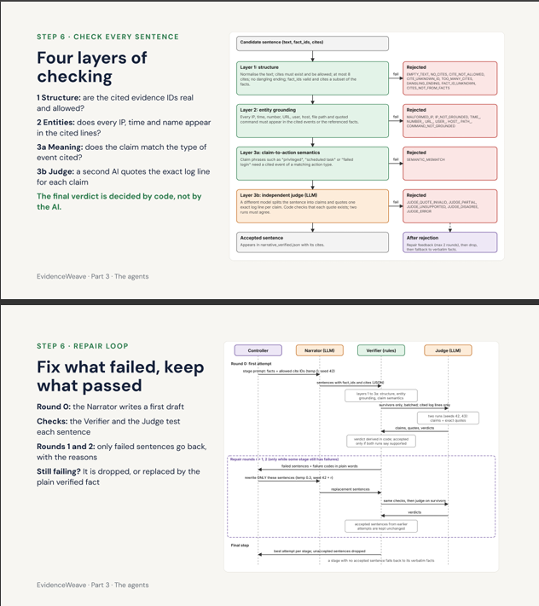
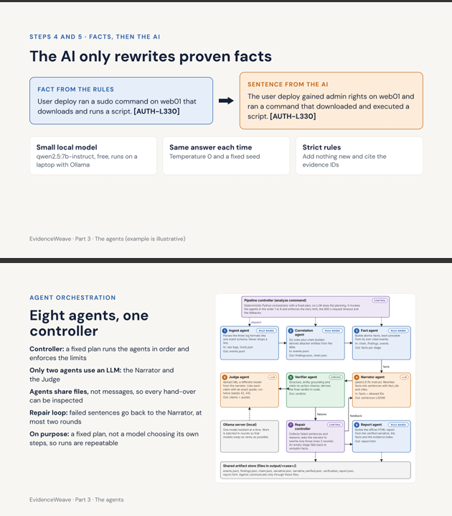

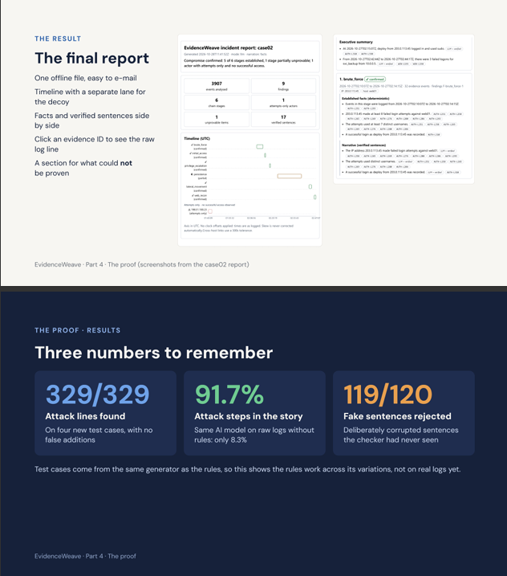
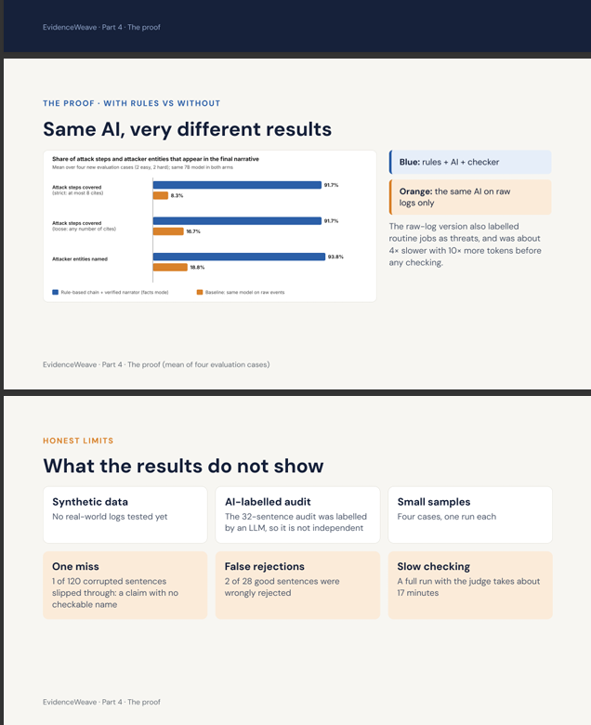

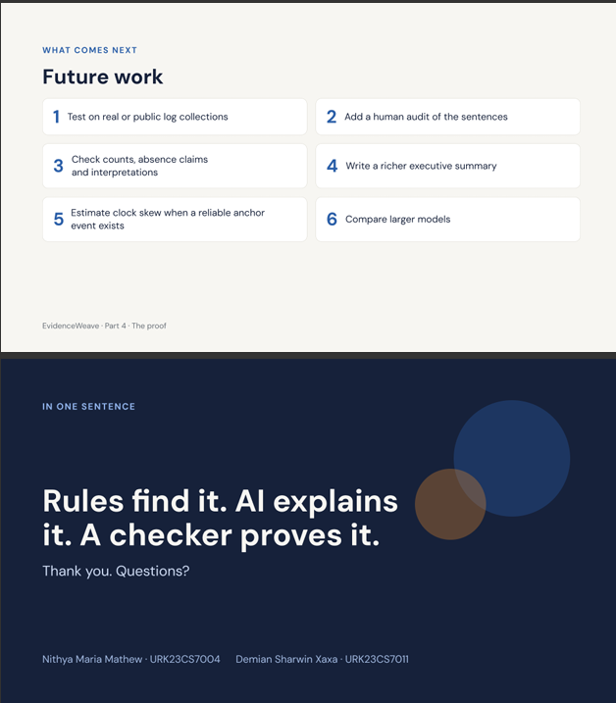

6. CERTIFICATION



