Week 1: Planning & Analysis

Griffin Yates

Project & Portfolio IV

3/3/18

**Content Requirements:** This website requires a navigation bar for quickly going back to the homepage, searching for answers, and modifying your profile and settings. Listed below are the colors, fonts, and logo I am using to create this website.

**Colors:** Main Branding: #469BC7

Secondary Gray: #EFEFEF

Font Color: #707070

**Fonts:** Helvetica Neue – Light, Regular, & Bold

24-40px Headers

20px Main Content

**Logo:** 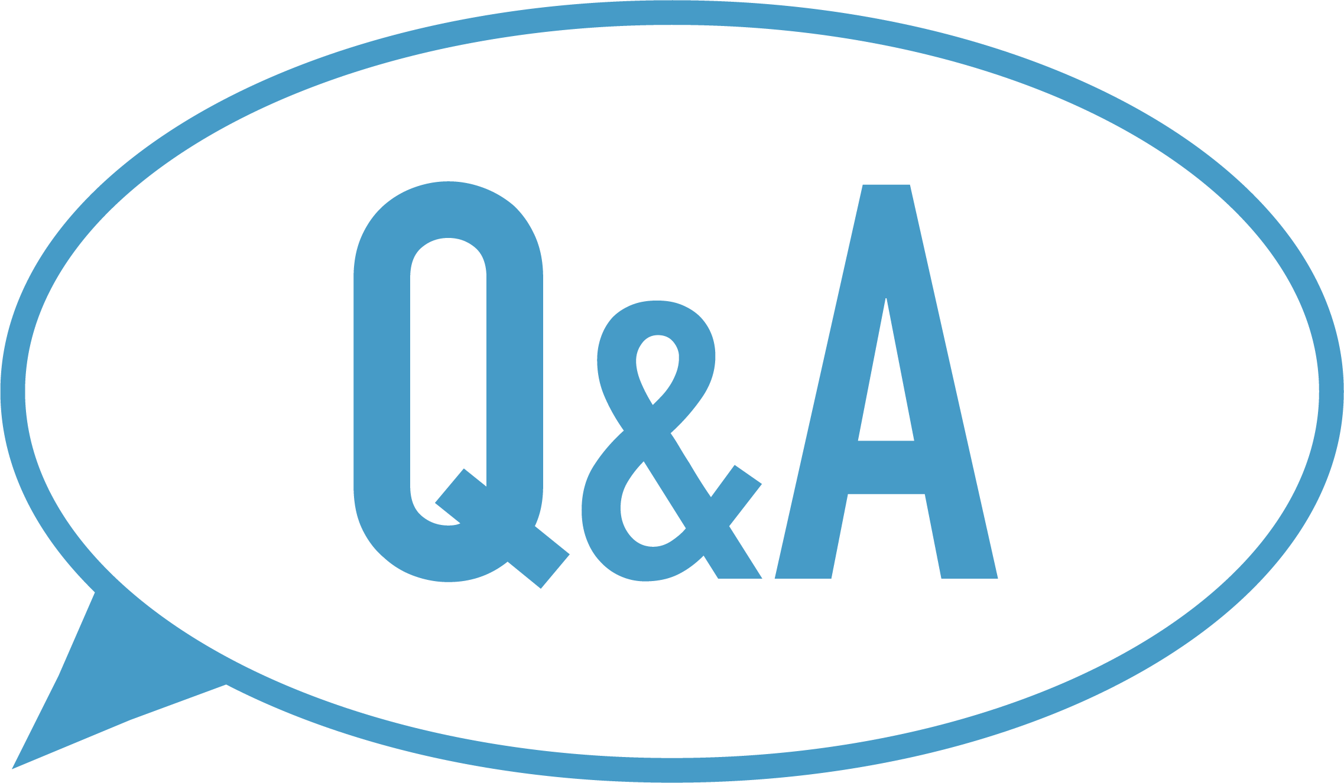

**Functionality Requirements:** The website will allow users to view, post, and answer questions about various topics.

**Competitors Websites:** I wanted to take Quora.com and strip it down to the essentials. It is a question and answer website. Those two tasks are the most important features. When first viewing the website, I noticed it looked a bit outdated. I made it my mission to provide a new modern take with a focus on asking, answering, and viewing questions.

**Estimate Costs:** Although I am not registering this website, the cost to purchase a domain name from godaddy.com is $0.99 with a promotional code. If you purchase hosting first, the domain name is free. The hosting costs an additional $53.88 per year.