WARNING BAND

**INTRODUCTION / PROBLEM STATEMENT**

We all are concerned on our health. It’s our responsibility to take care of ourself but todays pandemic condition makes us all weak by mentally and physically. All we can do is to take vaccinations against the corona virus and stay safe and the main issue within it is the unavailability of vaccination to each and everyone, the other possibility is to stay safe under our shelters but most of us should do ran errands to meet the day-by-day needs. But we can stay away if we found that space is not good for us (physically).

7 in 10 who got affected shows fever temperature (greater than 38.50 C) in common. So temperature (fever temperature) or more than it, can be taken as a main symptom and if we can find those people advancely , we can move away from them.

**OUR SOLUTION**

We - “ACCESS DENIED”, introducing our innovative idea ‘**SHABDKOSH**‘ , a wrist band which detect and warns us when there is hot bodies within 1 m of range. And it doesn’t consider the surrounding medium temperature.

**Working**

The band consists of a mini thermal camera having a range of 1m which inturn coupled with balck body and FLIR system that helps to detect the temperatures of bodies other than measuring the room temperature. This mainly uses the IR radiation for detection. Connecting the thermal camera to a customized temperature senor, mainly the RTDs / thermocouple sensors; a non contact temperature sensor which is widely used in most of the appliances for temperature measurements and it also converts and uses the radiations for measuring temperature. Here we are using the convert type sensor which convert IR signals from the thermal camera and detect if it is more than normal body temperature says 370 C to 38.20 C. After detecting the high temperature it give instruction to the electric motor used for giving the vibration. Hence the user come to know whether he is surrounded by hot bodies or not.

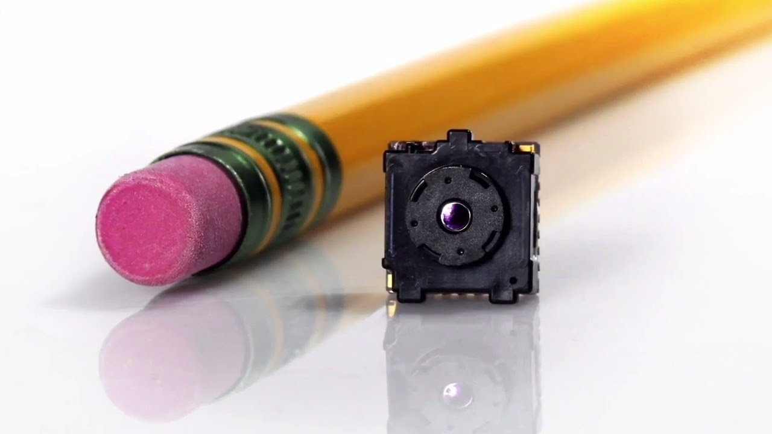 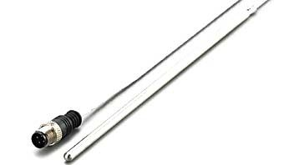

**THERMAL CAMERA RTD**

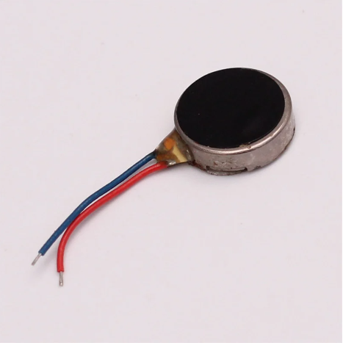

**ELECTRIC MOTOR**

**EXISTING SOLUTION**

Infrared Thermometer is widely used for non contact temperature measurements but it can only monitor one person at a time and have a range of nearly 10 cm.

Shabdkosh is far more better than using such thermometers as it is compactable, easy to carry on distances and can consider more than one at a time.

**Estimated price**

Thermal camera = 7000₹

RTD = 200₹

Electric motor = 90₹

Total cost is about 8000₹ .

**CONCLUSION**