**Selected project**

|  |  |
| --- | --- |
| **Name** | **Id** |
| **يوسف محمد احمد محمد** | **202001102** |
| **عبد الرحمن مصطفى احمد محمد امام** | **202000537** |
| **دافيد عادل نعيم** | **202000290** |
| **ماريا عادل فوزي** | **202000696** |
| **كريم صابر عبدالمنعم** | **202000665** |
| **عبدالله مصطفي نصر الدين محمد** | **202000553** |
| **عمر احمد عبد القوى احمد** | **202000585** |

**FACUTLY NAME: faculty of computer and information Helwan uni.**

**SUBJECT : Selected 2**

**TEAM ID : 31**

**Paper details**

* **Author Name** : Anfal Bin Durayhim.
* **Paper Name** : Children’s Arabic Handwriting Recognition via

Deep Learning.

* **Publisher Name**: Anfal Bin Durayhim, Isra Al-Turaiki and Najwa Altwaijry.
* **Publish Year**: 29 January 2023.
* **Datasets Used**:

**First dataset**: Arabic Handwritten Characters

**dataset link:** <https://www.kaggle.com/datasets/mohamed0hassan/arabic-handwritten-characters>

**Project Description Document**

**Dataset used:** Malaria Cell Images Dataset

**Dataset link:**

<https://www.kaggle.com/datasets/iarunava/cell-images-for-detecting-malaria>

**Total number of samples:** 27,560 images

**The dimension of images:** height = 150 width = 150

**Number of class:** 3

**The label of classes:** Parasitized, Uninfected, cell images

**the ratio used for training, validation:**

**Training:**  80%, 44093 images

**Validation:** 20%, 11023 images

**hyperparameters used in the model:**

model = Sequential([

  layers.Rescaling(1./255, input_shape=(img_height, img_width, 3)),

  layers.Conv2D(16, 3, padding='same', activation='relu'),

  layers.MaxPooling2D(),

  layers.Conv2D(32, 3, padding='same', activation='relu'),

  layers.MaxPooling2D(),

  layers.Dropout(0.2),

  layers.Conv2D(64, 3, padding='same', activation='relu'),

  layers.MaxPooling2D(),

  layers.Flatten(),

  layers.Dropout(0.2),

  layers.Dense(128, activation='relu'),

  layers.Dense(1, activation = 'sigmoid')

])

model.compile(optimizer='adam',

              loss='binary_crossentropy',metrics=['accuracy'])

**Results details:**

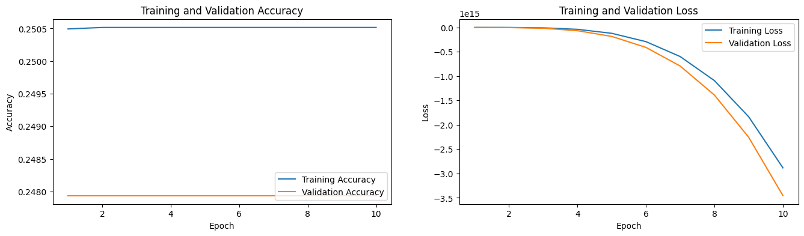

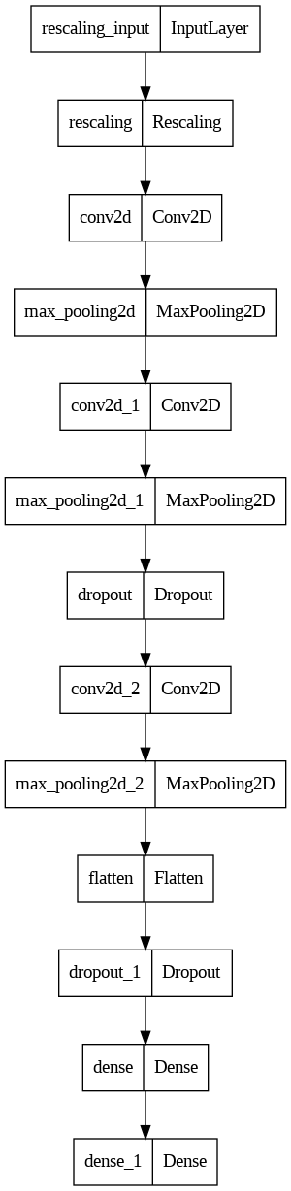

**Block diagram:**

صورة تحتوي على نص, لقطة شاشة, الخط, التصميم

تم إنشاء الوصف تلقائياً