Laplacian operator and Gaussian blur
The goal of this assignment was to compare the differences when using a Gaussian Blur on a Laplacian operation.
I used a build in function to blur the image but the Laplacian operator was self made (Inspiration)
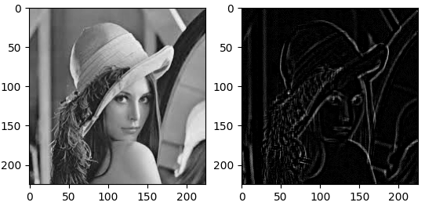
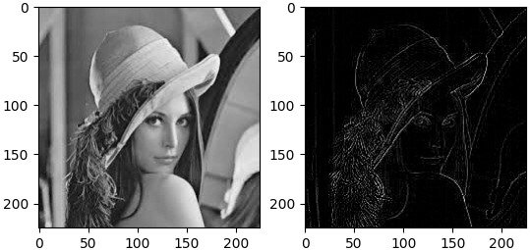
The right image here is the result after using the Laplacian operator on a blurred image, we can clearly see the edges appearing as white outlines.
On this second set of image we didn’t apply a Gaussian blur. We can clearly see that the lines are way sharper as are the overall details. But we can see fewer details in the background. Overall the details are finer too
To conclude we can conclude that the Gaussian filter can be used to see the overall shapes of an image with it’s background. But if we are not using the Gaussian we get finer details in the foreground and fewer in the back

