**OOP Lab 11**

|  |  |
| --- | --- |
| Due Date: | November 29, 23 : 59 |

* **Submit your assignment using the following file format:**
* LabNumber_StudentName_Student_ID.zip

Example: Lab11_Hongkildong_201620505.zip

* The zip file will contain two types of files, namely:
* Report file with file format “**Report_Lab number**” (eg. report_11) to answer theory questions and to write the screen shot of your program.
* Source code file that contains codes of classes to answer programming questions.

**Objectives**

* **How to use generic classes and interfaces that implements the basic data structures in computer Science**
* **Understand the advantage and disadvantage of each generic data structure classes**

**Exercises (7x5 =35%)**

**Q1**.Modify lines **16-25 in Fig. 16.3** by using **asList()** method of **Arrays** class . This method converts static array **colors** and **colors2** into generic data structure such as LinkedList**.**  After converting **color** and **color2 arrays,** the LinkedList () constructor uses them as an argument to initialize **list1** and **list2** reference variables.

=> In case of list2, I used asList() method of Arrays class. Then at ‘list1’ I added elements of list2 to list1, so the first printList(list1)’s result represent list1’s elements and then list2’s elements.

=> And by the method like ‘ConverToUppercaseStrings’, ‘removeItems’, and ‘printReversedList’, the results shows like above screen shot.

**Q2**. Write a program that reads in a series of **first names** and eliminates duplicates by storing them in a Set. Allow the user to search for a first name. **The partial code is given in the file “ Q2Code”. Hence, complete the partial code by adding your own code.**

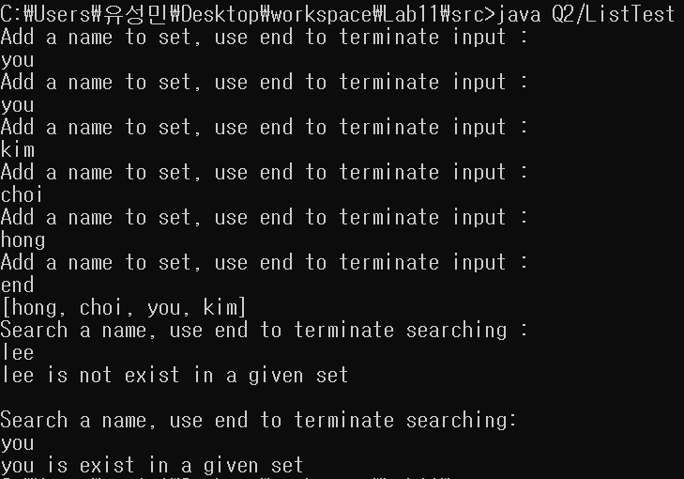

* At getNames() method, I added different names to “Set names” and if “end” is entered by scanner, then break from while block.
* At searchNames() method, if there are same names at ‘Set’, I made appropriate println sentences.

**Q3**. Use a **HashMap** to create a reusable class for choosing one of the **13 pre-defined colors** in a class Color. The names of the colors should be used as keys, and the predefined Color objects should be used as values. Place this class in a package that can be imported into any Java program. Use your new class in an application that allows the user to select a color and draw a shape in that color. **The partial code is given in the file “Q3Code”. Hence, complete the partial code by adding your own code.**

* I made getColor() method which return the selected color and getKeySet() method which return all the color names.
* At getKeySet() method , I added all keys of hashMap to Set collection and then return Iterator of each string of Set.

**Q4** Write an application to implement the three Set operations: interaction, union, and difference. You should build three methods corresponding to the operations. In your main method, test these methods on two **HashSets** of strings. **The partial code is given in the file”Q4Code”. Hence, complete the partial code by adding your own code.**

* Firstly, at union set, this set represents all members of two teams. So at the union set code, I made new TreeSet ‘union’ that contains ‘s1’ and then added elements of ‘s2’ to the ‘union’.
* Secondly, at intersection set, this set represents those who take part in both two teams. So like union set, I made TreeSet ‘inter’ that contains ‘s2’, and then by using retainAll() method, I can get the common elements of two set ‘s1’ and ‘s2’.
* At difference set, I made two TreeSets ‘differ’ and ‘inter’. The ‘inter’ set has same function as I have made above. The ‘differ’ set contains s1’s elements and s2’s elements. Then I removed common elements of two set from ‘differ’ set.

**Q5.** Write a program that has a method **ListConcatenate**() which receives two objects of LinkedList, and returns a new LinkedList that contains elements of the first list followed by elements of the second list. In the main method, test this method on two LinkedLists of strings.**The partial code is given in the file “Q5Code”. Hence, complete the partial code by adding your own code.**

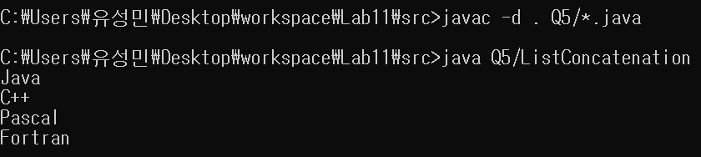

* I made new Linkedlist ‘newlist’ which contains list1. Then by using addAll method, I can get the result.

**Q6**. Write a program that uses a String method split to tokenize a line of text input by the user and places each token in a TreeSet. Print the elements of the TreeSet. [Note: This should cause the elements to be printed in ascending sorted order). **The partial code is given the file “Q6Code”. Hence, complete the partial code by adding your own code.**

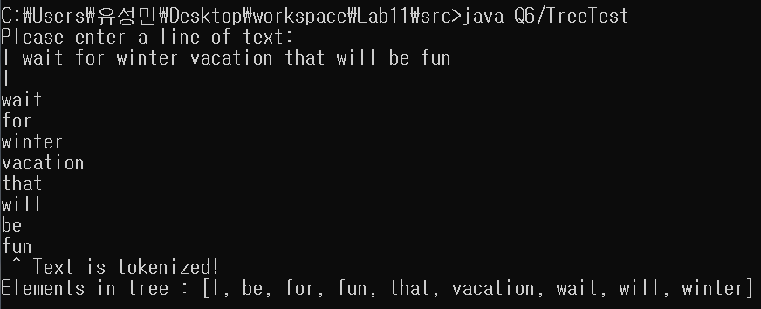

* First, after input text, I made string array to store input text. Then by using split method of String class, I divided words by “space bar”. And I added each words to TreeSet and changed set to array. Then sorted array to ascending order.
* As you can see the screen shot, I entered text, and divided with element words, then these words are sorted with ascending order.

**Q7**. The output of Fig. **16.15** shows that PriorityQueue orders Double elements in ascending order. Rewrite Fig. 16.15 so that it orders Double elements in descending order (i.e., 9.8 should be the highest-priority element rather than 3.2). **The partial code is given the file “Q7Code”. Hence, complete the partial code by adding your own code.**

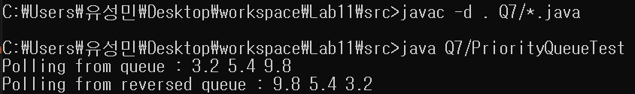

* First I made ‘rqueue’ with 3 elements that follow DoubleComparator(). And added queue’s elements to ‘rqueue’. So (3.2, 9.8, 5.4) is added to ‘rqueue’ and these values will follow ‘DoubleComparator’.
* At class ‘DoubleComparator’ I overrided compare method of Comparator for descending order of the values.