**OOP Lab 12**

|  |  |
| --- | --- |
| Due Date: | Dec 7, 23 : 59 |

**Submit your assignment using the following file format: LabNumber_StudentName_Student_ID.zip**

**Example: Lab12_Hongkildong_201620505.zip.**

**Q1**. The source code of an application that draws a series of eight concentric circles is given in the files “**CirclesJPanel.java” and** “**Circles.java”** in the folder “**CodeQ1”.** The circles are separated by 10 pixels. Hence, complete the partial source code in the file “Circles.java”. After your completed the code, the following figure should be displayed when you run the program.

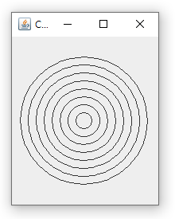

* **Requirement 1:** the title for the frame is “Concentric Circles”.
* **Requirement 2**: the size for the frame is 200 x 250.
* **Requirement 3**: The number of circles are 8
* **Requirement 4**: The distance between two adjacent circles is 10 pixels.

=>

At circles constructor, I made frame which has name “Concentric Circles”, and then set size of frame to (200,250). As you can see, I made instance of “CirclesJPanel” to add circles to frame I made.

As a result, a added cp(instance of “CirclesJPanel” which shows 8 circles) to frame by using ‘add’ method. Then I can get the result like above screen shot.

**Q2**. **Modify** your solution to **Q1** to draw the **ovals b**y using **Ellipse2D.Double** class and **draw** () method of

**Graphics2D** class. Hence, complete the codes in files “**Concentric.java**” and “CirclesJPanel.java” under the folder **CodeQ2**. When you run the code after completing the code, the following figure is displayed.

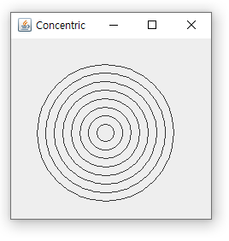

* **Requirement 1: the title for the frame is “Concentric Circles”.**
* **Requirement 2: the size for the frame is 250 x 250.**
* **Requirement 3: The number of circles are 8**
* **Requirement 4: The distance between two adjacent circles is 10 pixels.**
* **Hint 1**: refer the constructor of **Ellipse2D.Double() s** from **java.awt.geom package** ;
* **Hint 2: refer the draw** () method of  **Graphics2D class from java.awt.geom package**

**=>**

Unlike quesiton1, at this code, I used graphics2d class with draw method. By using ellipse2d.double method, I can get the same result with question1. Ellipse 2d’s function is drawing oval, but I set the parameters to make circle.

**Q3.**  The source code of an application that draws **ten** nested rectangles using **Rectangle2d.Double** class is given. The rectangles are separated by 10 pixels on all sides. Complete the partial source code in the files “DrawRectangles.java” and **“**RectanglesPanel.java” under the folder **CodeQ3.** When you run the code, the following figure is displayed.

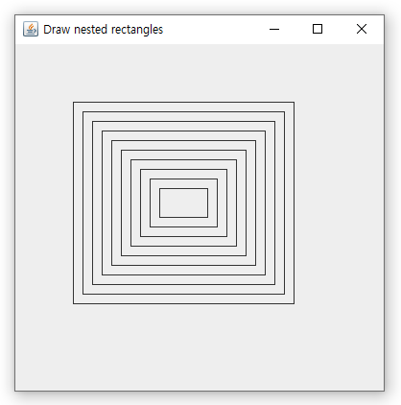

* Requirement 1: the title for the frame is “**Nested Rectangles**”.
* Requirement 2: the size for the frame is 400 x 400.
* Requirement 3: The number of rectangles are 10
* Requirement 4: The distance between two adjacent rectangles is 10 pixel

**=>**

Similarly, I used draw method of graphics 2d to draw rectangles. By using Rectangle2d.double method, I can get the above result. (Parameters of Rectangle2D.double x and y is point(x, y) of up-left vertex.)

**Q4.** The source code of an application that asks the user to **input the radius** of a circle as a floating-point number and then display the values of the circle’s diameter, circumference and area. Use the value 3.14159 for **п**. Complete the partial source code in the file **“Circle.java” under CodeQ4.** When you run the code, the following 4 figures are displayed sequentially.

* When you run the code, first, figure in (a) is displayed.
* When you click “Ok” button after entering the value of radius, the figure in(b) is displayed,
* When you click “Ok” button after entering the value of x-coordinate , the figure in(c) is displayed,
* **When you click “Ok” button after entering the value of y-coordinate, the figure in (d) is displayed.**

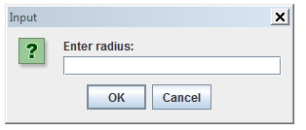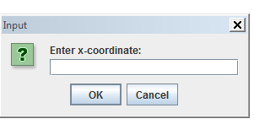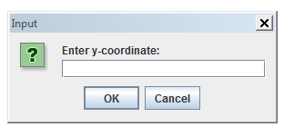

1. **b) c)**

**d)** 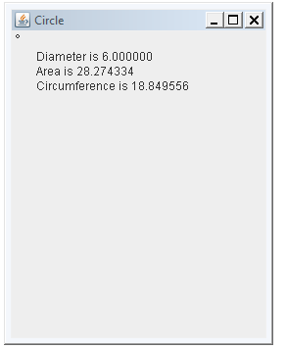

**=>**

By using JOptionPane, I made 3 Option pane that asks 3 values(radius, x-coordinate, y-coordinate). Then I changed input values(string) to number(integer or double). Then by using these values to parameter of CirclesPanel, I can get the above result.