**OOP Lab 13**

|  |  |
| --- | --- |
| Due Date: | **Dec 14, 23 : 59** |

**Submit your assignment using the following file format:**

* LabNumber_StudentName.zip (eg. Lab13_Hongkildong.zip).

**Q1.** The Skeleton code to create the following GUI without any functionality is given. Hence, complete the skeleton code in files “Align.java” and “AlignFrame.java” under the folder CodeQ1. After completing the code, when you run the program, the following window is displayed.

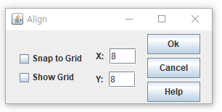

**Requirement 1:** The title of the frame is Align

**Requirement 2:** The size of the frame is 300x140

**Hint:** Steps to put the above GUI components in a frame

Step 1: **Creating two Check boxes**

1. Create the two Check boxes:”Snap to Grid" and “Show Grid".
2. Put them inside “**panel_1”** which uses GridLayout( 2,1) as its layout manager.

Step 2.1: creating Jlabel **and JTextField**

1. Create Text Field with 8 and its label X ..
2. Put them inside “**panel_2”** which uses “**FlowLayout”** as its layout manager

Step 2.2: creating Jlabel **and JTextFiled**

1. Create Text Field with 8 and its Jlabel Y .
2. Put them inside “**panel_3”** which uses “**FlowLayout”** as its manager

Step 2.3: Put p**anel_2** and **Panel_3** inside **Pane_4** which uses **Borderlayout()** as its layout manager**.** So, put **panel_2** inside **panel_4** at North and **panel_3** inside **panel_4 at** South.

**Step 3: Creating three Buttons**

1. Create “**Ok”** button.
2. Create “**Cancel”** button
3. Create “**Help” button**
4. Put them inside “**pane1_5”** which uses “**GridLayout(3,1,10,5)** as its layout manager

**Step 4: Put Panel_1, panel_4 and panel_5** inside the frame using **FlowLayout**(FlowLayout.CENTER, 10, 5));

**=>**

**I followed the steps you gave. Two checkboxes are in panel1, ‘label_x’ and text field of ‘x’ are in panel2, ‘label_y’ and text field of ‘y’ are in panel3, panel2 and panel3 are in panel4, and 3 buttons are in panel5. At last add panel1,4,5 in frame, so I can get the above result.**

**At “Align” class, there are constructor of the “Align” class and there are “AlignFrame” object. At main method of the class, I made new object “Align”, so we can get the frame.**

**Q2**. The Skeleton code of an application that converts from **Fahrenheit** to Celsius is given. The Fahrenheit temperature should be entered from the keyboard via a **JTextField**. A J**Label** should be used to display the converted temperature as shown in the following figure. Use the following formula for the conversion: **Celsius = (5/9)*(Fahrenheit – 32). Complete the skeleton codes in files “Convert.java” and “ConverFrame.java” under “Code Q2” folder**. After completing the code, you will get the following window when you run it.

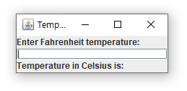

* **Requirement 1:** The title of the frameTemperature converter
* **Requirement 2**:The size of the frame is 225 x 90
* **Requirement 3:** The frame uses BorderLayout manager to put the following three components
* **Requirement 4**: Put JLabel with “**Enter Fahrenheit temperature**” at north location
* **Requirement 5**: Put JTextField( blank space) at Ceneter location and its length is 10
* **Requirement 6** : Put JLale with “Temperature in Celsius is: “ at south location
* **Requirement 7:** After entering value of **Fahrenheit and press “enter key” .**Then the output will be displayed on the above window

**case1 : int**

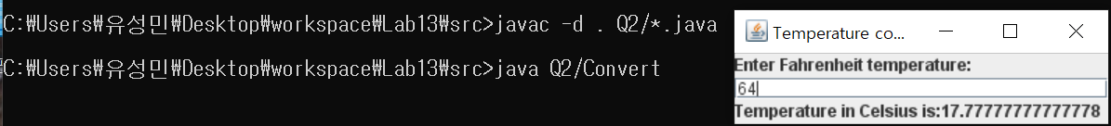

**case2 : double**

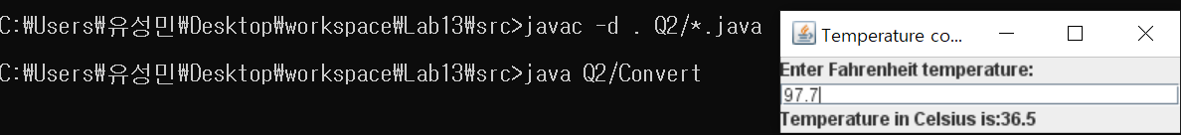

**case3 : negative number**

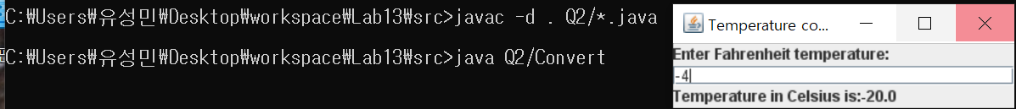

**=>**

**I set frame and label1 which asks to enter Fahrenheit temperature, and label2 that shows the converted temperature. At text field, by press key “enter”, the actionlistener is executed and the Fahrenheit temperature is converted to Celsius temperature. As a result, I can get the above result.**

**Q3**. **Program with one Event Handler class that implements many types of Listener Interfaces.**

* The program display the events that occur during the execution of an application.
* This can help you to understand when the events occur and how they’re generated.
* The source code of an application that enables the user to generate and process every event discussed in this chapter is given in files “Events.java” and EventsFrame.java.
* The application provides methods from the following interfaces to display messages when the events occur. **toString()** method is used to convert the event objects received in each event handler into **Strings** that can be displayed. **toString (**) method creates a String containing all the information in the **event** object.

1. **ActionListener** Interfcae
2. ItemListener Interface
3. ListSelectionListener Interface
4. MouseListener Interface
5. MouseMotionListener Interface
6. KeyListener interfaces
7. **Complete the partial code in the file in** “Events.java” under “CodeQ3” folder.

* **Requirement 1**: The title of the frame is Events
* **Requirement 2**: The size of the frame is 375 X325
* 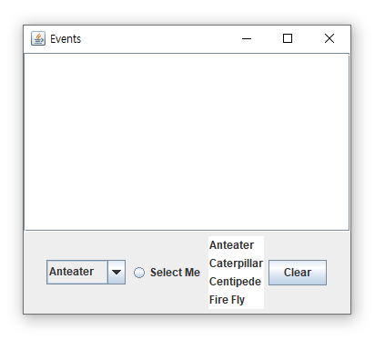**Requirement 3**: After completing the code in the file “**Events.java**”, when you run the program the following figure will be displayed.

**=>**

**At EventsFrame class, I added some methods setSize() to set size of the frame, setDefaultCloseOperation() to exit the operation when close the frame and setVisible() method to show frame at screen.**

1. After **answering question (a), answer the following questions.**
2. 스크린샷이(가) 표시된 사진

   자동 생성된 설명 Select from **Combox** box and then add the screen shot in your file.
3. Click the “**clear”** button and then add the screen shot in your file.

c) Click the ”**select me**” radio button and then add the **screen shot** in your file.

d)Select from “**list**” and then add the screen shot in your file.

* **Note :** Since you have no time, the source code in the “EventsFrame.java” is given to you instead of asking you to write it. This source code helps you to under chapter 11 and chapter 12 .

Good Luck for Your Final Exam