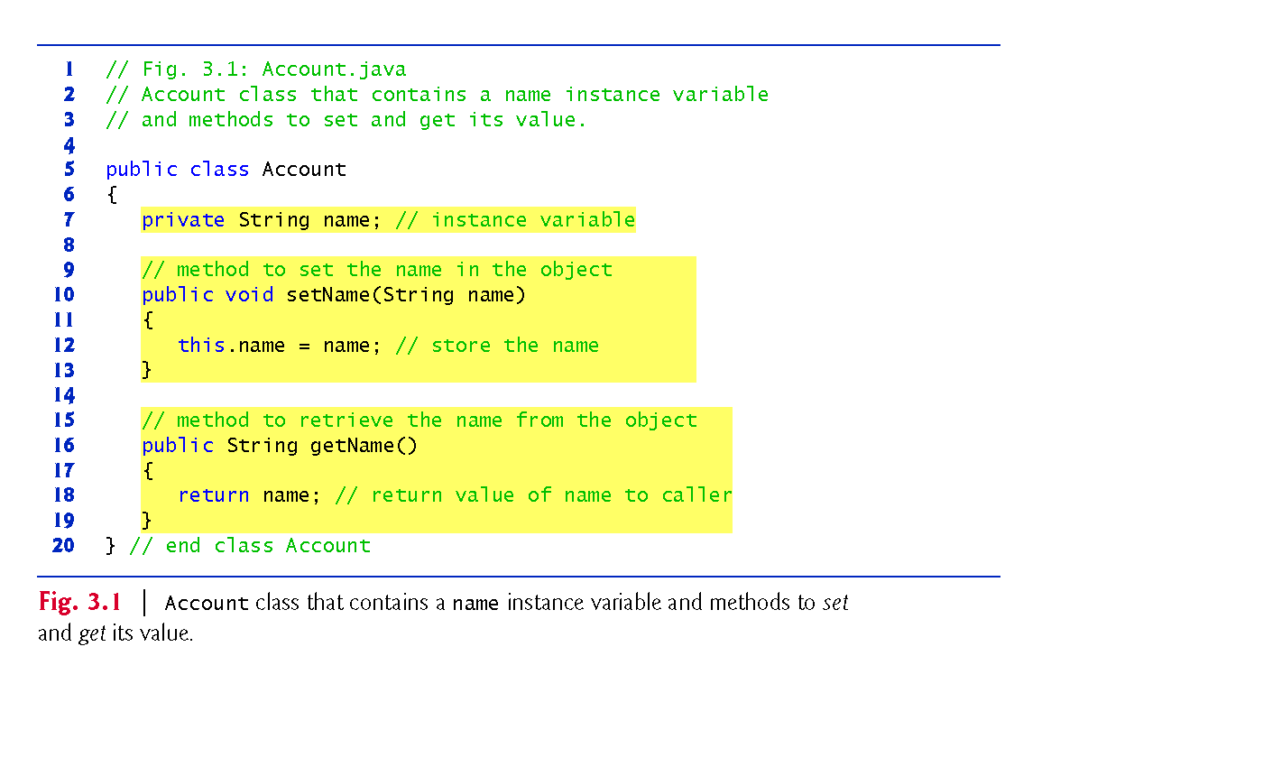

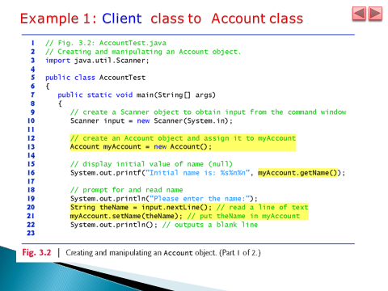

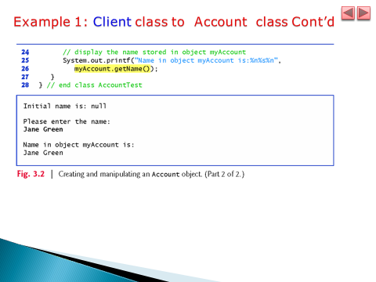

**Note**:

* A Single java application can contain one or more packages.
* Each package can contain one or more classes
* The access modifier of a class can be public or default
* If a class has no package name, the class belongs to default package
* **The name of the file of the source code is affected by the class modifier**
* **The communication between a client class and a server class is affected by class modifier and package names**.
* The following tasks helps you to understand the above facts by compiling and running on the command window.

**Instructions of Task 1:**

1. Create a folder (directory) on **D** drive with name **Source1**.
2. Write the Fig.3.1 and Fig.3.2 on notepad and save them in S**ource1** directory by file names: **Account.java** and **AccountTest.java**
3. Compile the source codes from command line and check that corresponding class files **Account.class**  and **AccountTest.class are** created in the **Source1** directory.
4. Run the application from command line and attach the screen shot

**Instructions of Task 2 (about class name and .java file name)**

1. Create a folder (directory) on D drive with name **Source2**.
2. Write Fig.3.1 on notepad and save it as **ACCOUNT.java** in Source2 Directory
3. Write Fig.3.2 on notepad and save it a**s AccountTest.java in** Source2 directory
4. Compile the source codes. Is there a completion error? If you say yes, what is the cause of the error and how do you fix the error? Fix the error and attach the screenshot of the program

**Instructions of Task 3 (about class name and .class file name)**

1. Create a folder (directory) on D drive with name **Source3.**
2. **Modify**  Fig.3.1 on notepad by **deleting** the “public” modifier of the **class** and

Save the file **Account.java** in Source3 directory

1. Write Fig.3.2 on notepad and save it a**s AccountTest.java Source3 directory**
2. Compile the source codes from command line. Is there compilation error? If you say no, why there is no compilation error?
3. If there is no compile time error, run the program from command line and attach the screen shot

**Instructions of Task 4(about setting ClassPath)**

1. Create a folder (directory) on D drive with name **Source4 and Source_4**.
2. Write Fig.3.1 and Fig.3.2 on notepad and save them in Source4 by file names: **Account.java** and **AccountTest.java**
3. Compile the source codes from command line.
4. **Change** the current directory of the command prompt to **Source_4 directory** that does not contain the class files (.class) generated by step 3.
5. Run the application from the command line under Source_4 directory. **Did you get runtime error**? What is the cause of the error? Fix the error and attach the screenshot of the program

**Instructions of Task 5:(communication between a class in one default package and a public class in another non-default package)**

1. Create a folder (directory) on D drive with name **Source5**
2. Write Fig.3.1. on notepad without any modification and save in Source5 Directory
3. Re-write Fig.3.2 by adding **package** name **called “AccountTestPachage” and save in Source5 directory**
4. Compile the source codes. Did you get compile error? What is the cause of the error? Fix the error and attach the screenshot of the program

**Instructions of Task 6: (communication between a class in a non-defualt package and a public class in another non-default package)**

1. Create a folder (directory) on D drive with name **Source6**
2. Rewrite Fig.3.1. on notepad by adding **package** name **called “AccountPackage” and save it in Source6 directory**
3. Re-write Fig.3.2 by adding **package** name **called “AccountTestPachage” and save it in Source6 directory**
4. Compile the source codes. Did you get compile error? What is the cause of the error? How did you correct the error? Fix the error and attach the screenshot of the program

**Instructions of Task 7 :( communication between a class in a non-defualt package and a defualt class in another non-default package)**

1. Create a folder (directory) on D drive with name **Source7**
2. Rewrite Fig.3.1. on notepad

* by adding **package** name **called “AccountPackage”**
* **deleting the public modifier of the class and save in Source7 directory**

1. Re-write Fig.3.2 by adding **package** name **called “AccountTestPachage” in source7 directory**
2. Compile the source codes. Did you get compile error? What is the cause of the error? How did you correct the error? Fix the error and attach the screenshot of the program