**OOP Lab3**

Name : yoo seong min; Department : software;

Student ID: 201520908; Room_Number: 318;

Due Date: Sep 20,2019

* **Submit your assignment using the following file format:** Week_Number_RoomNumber_StudentName.zip (eg. 3_328_Hongkildong.zip).
* This zip file will contain **two** files, namely:

1. report file with file format **“Report_Week number**” (eg. report_2) to answer theory questions and to write the screen shot of your program.
2. Source code file to answer programming questions.

**I. Objectives (total score: 25)**

1. Learning basic operations and execution flow of control in java program using the following concepts

a) **Sequential** Flow of Control

b) **Selection** Flow of Control: if …/ if…else…/if…else if…else if…../else

c) **Iterative** (repeated) flow of control: **for…Loop**, **while…Loop**, **do …while** Loop

2. Learning the **eight basic** primitive data types such as boolean, char, short, int, long, float and double as well as the most frequently used **array** (object reference variable).

3. Learning how to write **a procedure-oriented** program using java.

4. Learning how to use **input/output libraries** of Java language from java.lang and java.util packages

5. being familiar with java programming development environment (JDK).

**II. Exercises**

1. Modify the program in **Fig. 2.7**(Addition.java) which accepts two double numbers from the user and display their sum to the screen.

Hint:  **to accepting input from user via keyboard, use the methods of “Scanner object” and to display the output on the screen use methods of the “System.Out” object( 5pts)**

**Screen shots**

Source code that is modified Fig.2.7

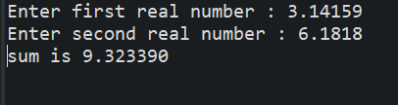**Result**

2. In **Fig.6.3, t**he Class, has two methods, namely main () and maximum (). Modify this program by adding a third method called **average ()** that computes the average of three numbers. Modify also the body of main () method so that it will display the average value on the screen (5pts)

**Screen shots**

Source code that is modified Fig..6.3

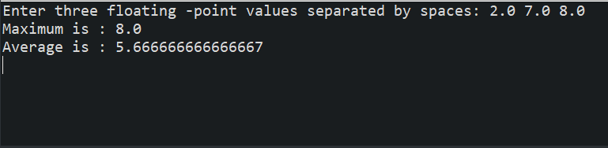**Result**

**III. Programming Problems**

1. Problem Description

We want to develop a program which manages the purchasing of products. There are 10 different types of products in a stock. Each product has a unique identification number from 1 to 10. We want to maintain the price of each product type, the identification number of each product type and the number of items of each kind of product that are purchased. A customer can buy several products at once. For example, you can show purchasing information such as:

* 1 item from product type 5,
* 4 items from product 2,
* 7 items from product type 1.

Given the above information of a product, the program should perform the following functions.

**1**. View the unit price of a product

2. Add an item to the information system when a product is purchased

3. Calculate the total price of a product

1. **Detailed Description of each function:**
2. **View the unit price of a product:** Scan the product identification number and show the price of the product( 5pt)
3. **Add a purchasing product to the system(5pt)**:

* Scan the product identification number and save the price of the item of the purchased product.
* If this product is already in a purchasing list, add the quantity (number) of the product.
* Subtract the number (quantity) of the purchased product in stock.
* If the quantity of a selected product in the stock is not sufficient (the total stock of the product is less than the **number of products** to be purchased), display the error message “**the product is out of stock**” on the screen.

1. **Calculate the total price (5pt)**: Display the total price of the purchased items and exit the program.
2. **User Interface Requirements:**

* Once the program starts, the program should display to the user the **menu** to select one of the above three function.
* “View the unit price” and “Add a purchasing product” function can be performed **repeatedly**.
* Finally selecting **“Calculate the total price**” function and terminate the program

e.g.

**int[]** unit_price;

void **view_unit_price**(...) { ... }

* Initial value of product price information or stock information can be used and configured in program.
* How to use **basic array** in java ?

e.g.

a)  int[] unit_price = {10, 20, 30, 40, 50, 60, 70, 80, 90, 100};

// when initialize integer array, assign the size.

b)  **i**nt[] unit_price = new int[10]; **// create array to save 10 integer dynamically**

Question: Write the entire program and attach the screen shot of the running program.

**Screen shots**

Source code

**Result**

