Dustin Strop

Feb 21, 2020

Foundations of Programming: Python

Assignment05

# Printing, adding, deleting and saving with Dictionaries & List

Introduction

This paper will cover how to write a program that allows users to call on their To Do List and view content, add new content, delete content and save changes. This code utilizes dictionaries and lists to organize the data in a user friendly way.

Topic I: Header & Pseudocode & Declaring the Variables

Begin by opening a new project in PyCharm and typing out the header. This code contains more pseudocode than previous scripts, see Figure 1 below. Starting at line 14 we start declaring the variables, objFile and strFile are the variables that Python uses to call the To-Do List. The pseudo to the right of the script documents the declared variables use and intention.

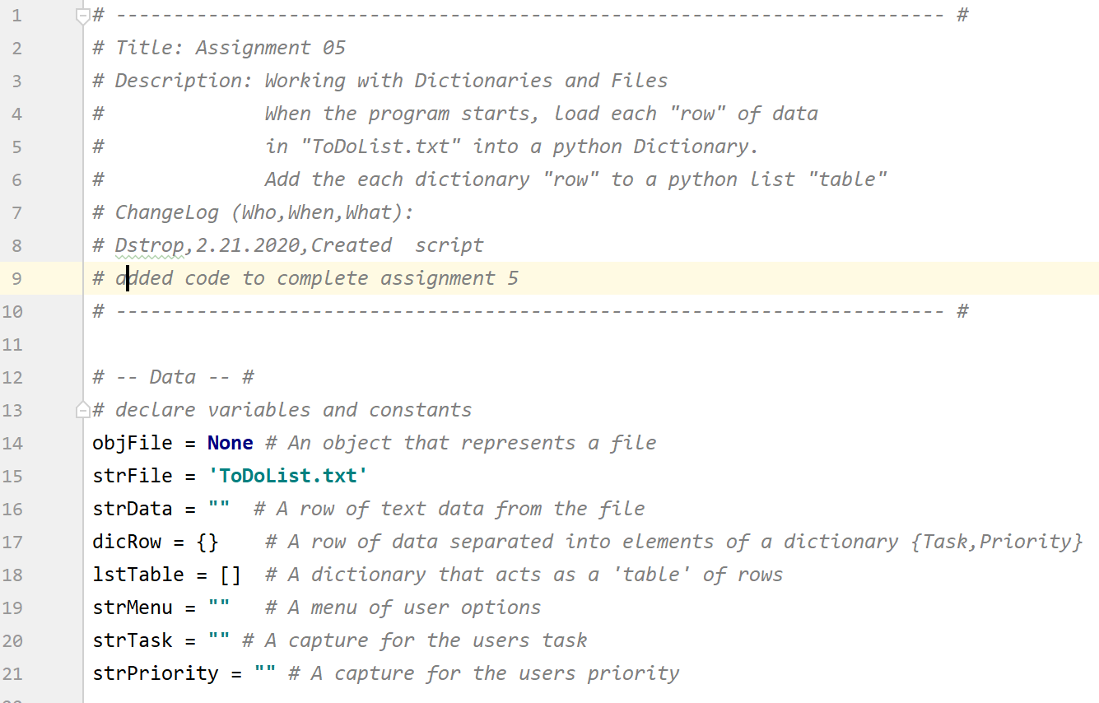

***Figure 1: Example of pseudocode and declared variables.***

Topic II: Display a Menu and the While Loop

The first objective is to display menu options to the user and allow the user to choose an option 1,2, 3, 4 or 5. You’ll see in Figure 2, the script requires the establishment of a while loop starting on line 37. This tells the program that while the program is running, display this menu until a user enters a number. On row 46 the script allows for a user to input a number and this variable is named strChoice. When the user enters the number, the program shows current data in the To Do List. To do this, we use the open function to open the to do list, also named strFile, and use the r, for read, command to read the data inside the file. We use a for loop on line 52 which essentially tells the program to read and print each row. We see the use of dictionaries at row 54 using the {} captions.

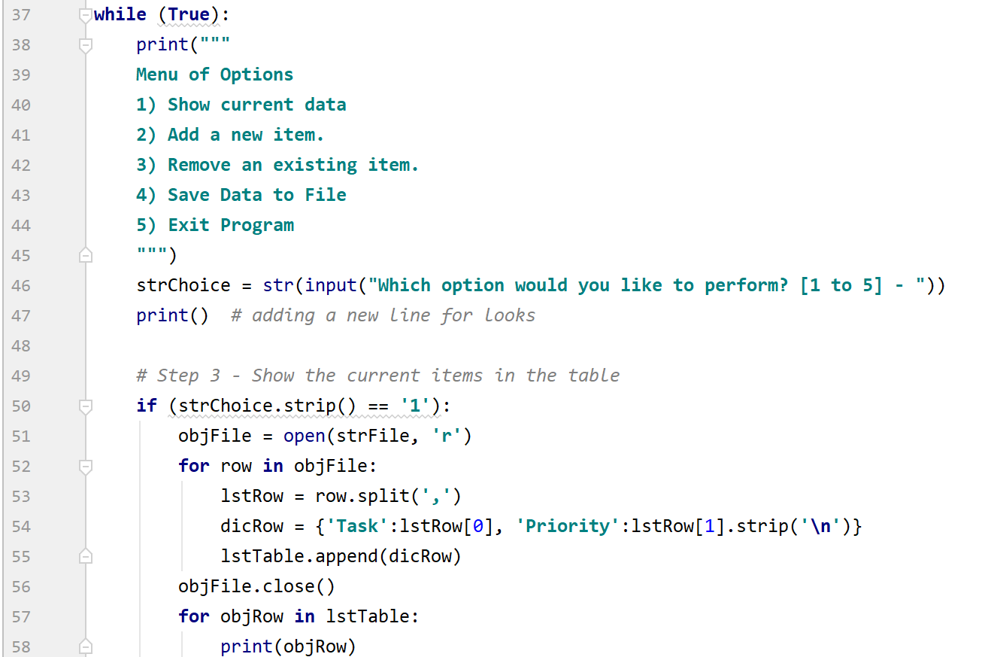

***Figure 2: dicRow is used to organize data with user friendly titles like Task & Priority***

Topic III: Adding User Data to a List

Subtopic I: Collecting the data

This example asks the user two questions and collects their answers: ‘Enter a task, and ‘Enter the priority.’ This is accomplished through two input functions that have been assigned the identification of strTask and strPriority.

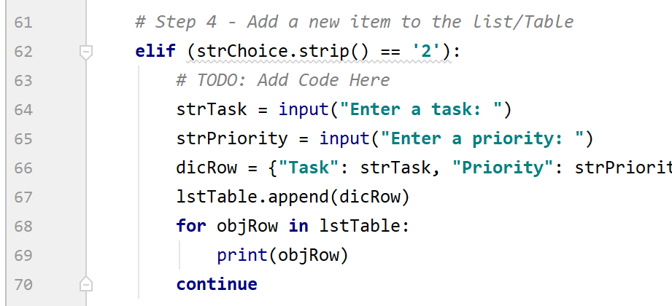

***Figure 3: User data being organized as a dictionary element.***

In line 66 the script is appending the users input as a dictionary row to the List Table. The append method adds value to the end of a list.

Topic III: Removing a Row from the To Do List

Figure 4 documents the code that allows a user to remove a row of data from the To Do List. The code below is calling the objFile and reading it. Line 76 uses the remove command to removed the last dictionary row. This is followed by a print statement letting the use know the item has been deleted.

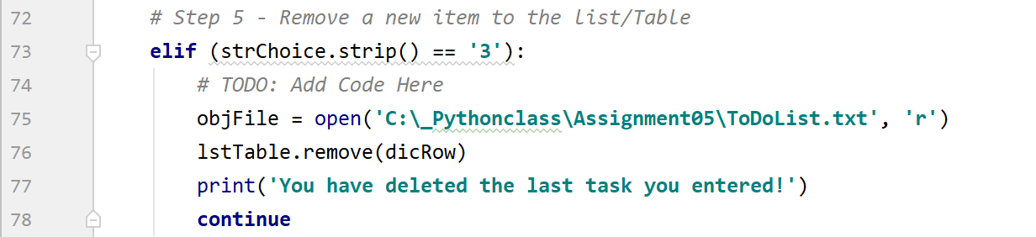

***Figure 4: An example of removing a data row***

Topic IV: Saving Data to a List & Exiting the Program

The following block of code uses an open command and the append command that and save the data changes to the To Do List. In Figure 5, 83 line to line 87 is telling the computer to a text file named ToDoList.txt, and the ‘a’ stands for append, which tells the program to write and/or append the specified data in this script to the ToDoList.txt file. In this scenario we’re writing to-do task item data and that was collected in lines 64 and 65 to the text file, objFile is the name that has been assigned to the script file commands.

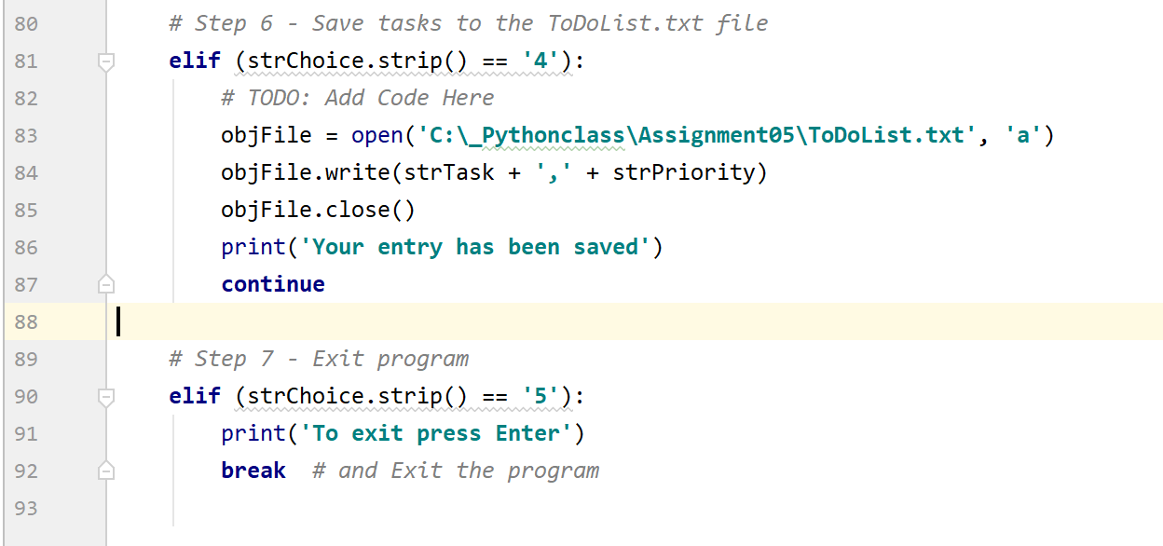***Figure 5: Example of saving and closing a program script***

Topic IV: Exiting and Saving the File

Figure 5 outlines the last choice in the example program which is directing the computer to exit. To begin, we utilize an elif clause (else if) and essentially reads if the users chooses options 5, jump to line 91 and execute the following lines of code.

Topic V: Running from the Command Window

To run from the command window type CMD in the search engine of your machine. From there enter the folder path of the file you wish to run. In this example the path is c:\_Pythonclass\Assignment05\Assignment5.py. Figure 9 displays how the command window should display after choosing each option. **I was unable to get the command window to print the file data.**

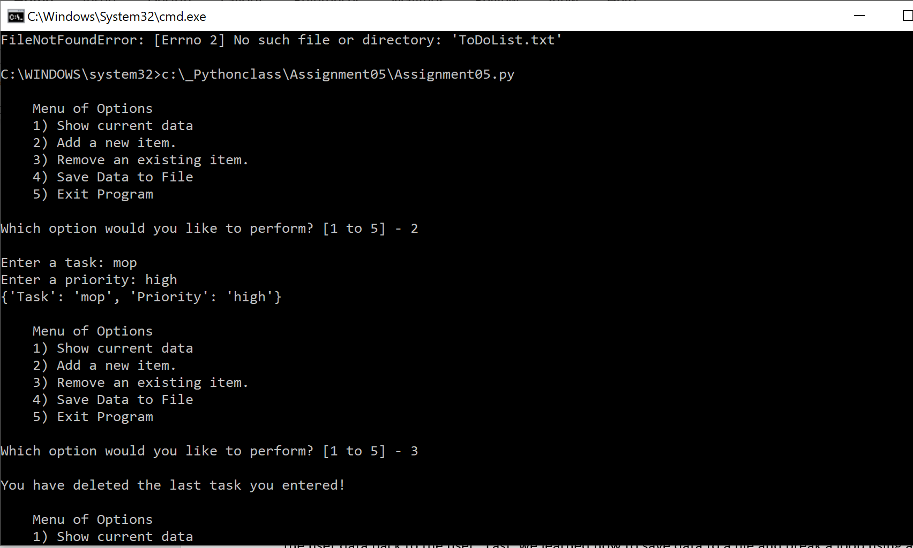

***Figure 9: Options 2 and 3 in the command window.***

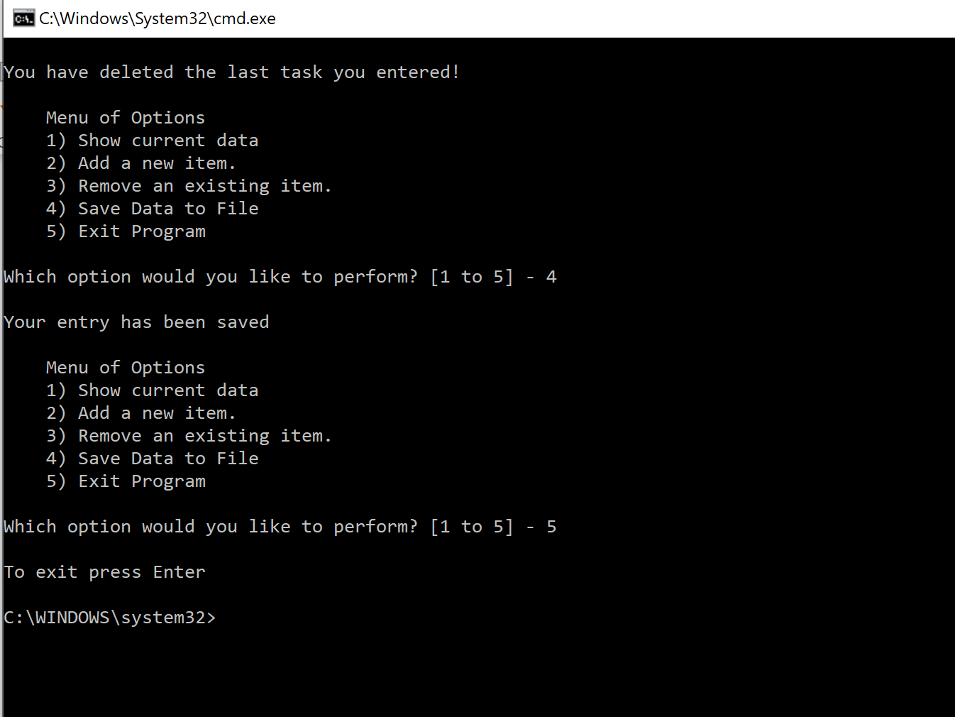

***Figure 10: Options 4 & 5 in the command window.***

Topic VI: Summary

In this paper we have covered several broad capabilities of the Python coding and in doing so have introduced some new functions. We have created a program that takes user data and stores it in a list and organizes as a dictionary. This paper highlights the dictionary and list methods. The while loop tells the program that while something is true continue processing. In this example the program continued to ask the user for data or display data until told not to. We also used the for loop which tells the program to read and process a sequence of values until there is no more to read, this was used to print, or display the user data back to the user. Last, we learned how to save data to a file and break a loop using a break statement.