Secure AI Systems: Red and Blue Teaming an MNIST Classifier
Oct 24, 2026
Team members: (Satyasheel Singh, cs26resch02001) · (Priya Agrawal, cs26mtech02008)
We built a small convolutional neural network in PyTorch that classifies the clean MNIST test set with 99.09% accuracy, and then attacked and defended it. A white-box PGD attack at ε = 0.3 brought its accuracy down to 0.00%. Poisoning 5% of the training data planted a backdoor that fired on 99.94% of triggered digits, while clean accuracy stayed the same. PGD adversarial training brought accuracy under the same attack back up to 90.34% (83.30% against the strongest attack we tried), for a cost of 0.55 points of clean accuracy. Activation clustering found 95.4% of the poisoned images, and after retraining without them the backdoor worked on only 0.18% of triggered digits.
All code, models, datasets and results are in our repository, github.com/ItseXec/mnist-secure-ai. Every figure in this report is taken from files committed there, mainly in results/ and scans/. We produced them on one machine: Ubuntu, Python 3.12.3, PyTorch 2.14.1 (CPU only, 4 threads) and the Adversarial Robustness Toolbox (ART) 1.20.1. All random seeds are fixed, so the commands in the README reproduce the same numbers.

1. CNN implementation for MNIST (GitHub repository)
Our classifier is a small two-block convolutional network with 225,034 trainable parameters. We wrote it in PyTorch and trained it for 5 epochs, which took 74.5 seconds on a laptop CPU.
Repository: https://github.com/ItseXec/mnist-secure-ai
Part | File
Model definition | src/model.py
Data download, integrity checks, train/validation split | src/data.py
Training | src/train.py
Evaluation (metrics, confusion matrix, inference time) | src/evaluate.py
Trained model (weights only) and its SHA-256 | models/baseline.pt, SHA-256 ee46209e…bba28
Baseline results | results/baseline/
We normalise the input inside the model itself, so images enter in the raw 0–1 pixel range. This keeps every attack strength (ε) in this report in pixel units. The layers are:
Layer | Output shape | Parameters
Normalise (MNIST mean 0.1307, std 0.3081) | 1 × 28 × 28 | 0
Conv 3×3, 32 filters + ReLU | 32 × 26 × 26 | 320
Max-pool 2×2 | 32 × 13 × 13 | 0
Conv 3×3, 64 filters + ReLU | 64 × 11 × 11 | 18,496
Max-pool 2×2, flatten | 1,600 | 0
Fully connected + ReLU + dropout 0.25 | 128 | 204,928
Fully connected (output) | 10 | 1,290
We split the 60,000 MNIST training images into 55,000 for training and 5,000 for validation (seed 42), and kept the 10,000-image test set for evaluation only. Training used the Adam optimiser with a learning rate of 0.001, batches of 128 and cross-entropy loss. After the fifth epoch the model reached 99.00% on the validation set. The MNIST files are downloaded over HTTPS and checked against pinned SHA-256 hashes before use; this is one of the SAST fixes described in Section 4.

2. Performance metrics of classification
On the clean test set of 10,000 images the baseline got 9,909 right (99.09%), with a cross-entropy loss of 0.0297. A single prediction takes about 0.23 ms on the CPU.
Metric | Value
Accuracy | 99.09% (9,909 of 10,000)
Loss (cross-entropy) | 0.0297
Macro precision / recall / F1 | 99.09% / 99.07% / 99.08%
Inference time, one image at a time | 0.229 ms median, 0.330 ms 95th percentile
Throughput, batches of 256 | 9,344 images per second
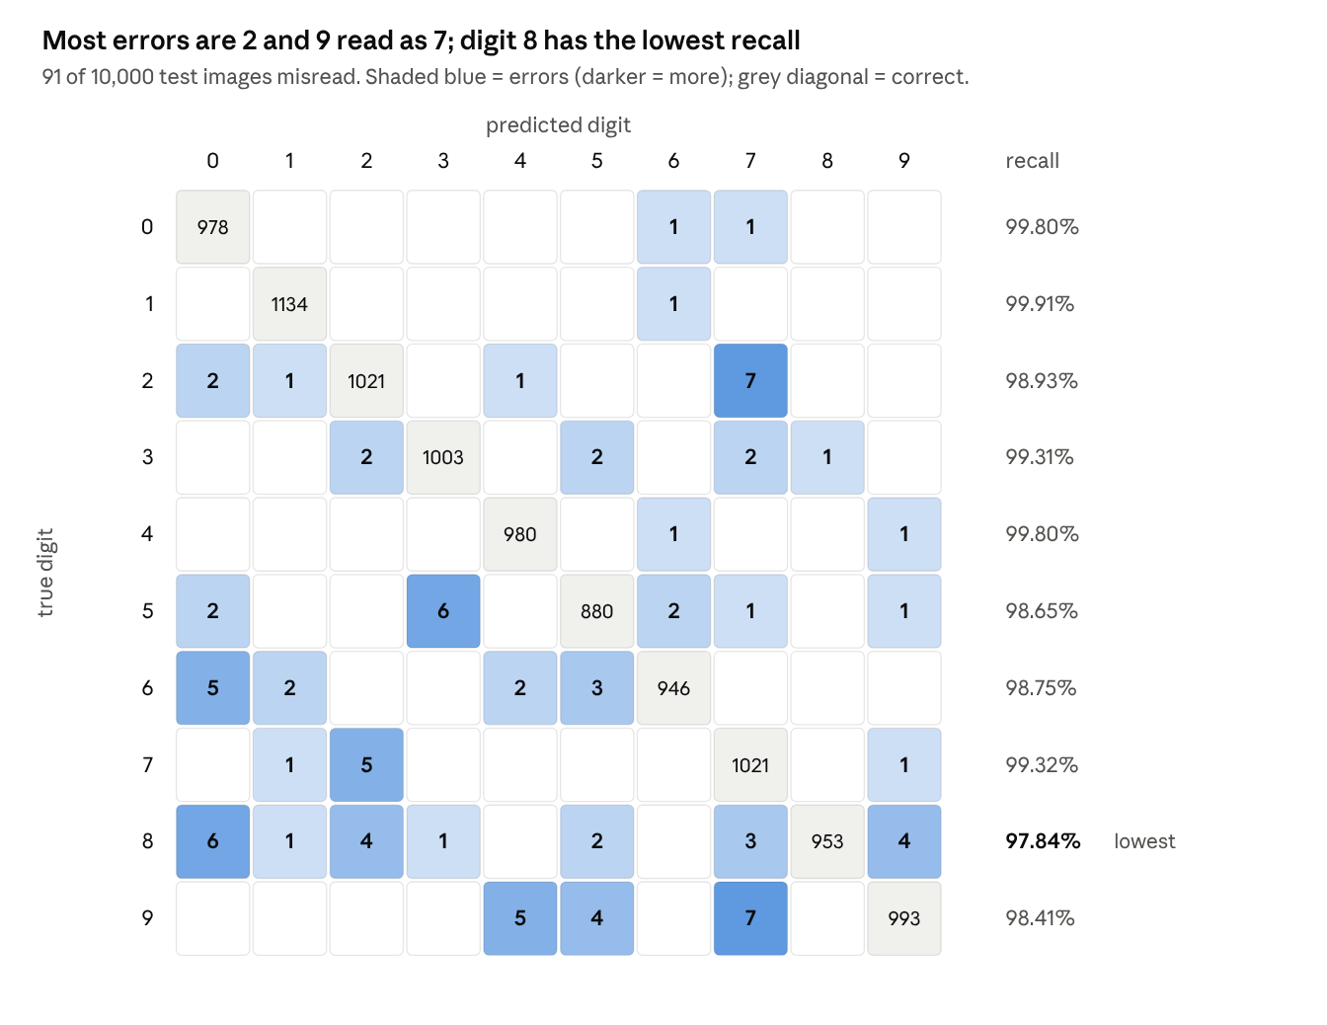
results/baseline/metrics.json · baseline model on the 10,000-image MNIST test set
Most of the 91 mistakes are between digits that look alike. Digit 8 has the lowest recall at 97.84%, and six of its 21 errors were read as 0. Digit 7 has the lowest precision (97.98%) because some 2s and 9s were predicted as 7, while digit 1 was almost never missed (99.91% recall).
For inference time we report the median of 500 single-image predictions after a short warm-up, using 4 CPU threads. The same model measured anywhere from 0.229 to 0.37 ms depending on what else the laptop was doing. The final figures therefore come from scripts/timing.py, which times all five models in this report together over five interleaved rounds.

3. Threat model
We modelled the system as a data flow and asked where an attacker could get in. Two entry points come with the design itself: the images sent for prediction and the data used for training. We attacked both (Section 5) and defended both (Section 7). The remaining threats concern the files the pipeline loads, such as model files, datasets and packages, and four of these were fixed through the SAST work in Section 4. The full threat model is in docs/THREAT_MODEL.md.

3.1 System, real-world version and trust boundaries
MNIST on its own is a toy problem. To make the threats concrete, we imagined our classifier as the core of a service we call DigitRead, which a bank could use to read the handwritten amount on scanned cheques. DigitRead would be retrained from time to time on new samples labelled by an outside contractor. Compared with our lab setup, it adds a network API, real customers' handwriting and an external data supplier.
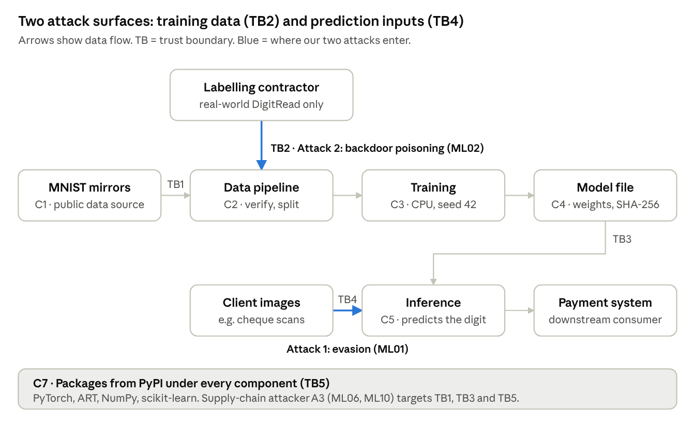
data-flow diagram · components C1–C7, trust boundaries TB1–TB5
The diagram shows two routes into the system that do not require touching any code: the training data (TB2) and the images sent for prediction (TB4). The model file (TB3) and the downloaded data and packages (TB1, TB5) are supply-chain routes, which we addressed through SAST.
Boundary | What crosses it | Why it matters
TB1 Internet → data pipeline | Raw training and test data | A spoofed or compromised mirror could deliver altered data
TB2 Contributors → training set | New labelled samples | Whoever supplies data can poison it (Attack 2)
TB3 Storage → inference | The model file | Loading a pickled model file can execute code
TB4 Client → inference | Images to classify | Every input is attacker-controlled (Attack 1)
TB5 Package registry → environment | Libraries (PyTorch, ART, NumPy, scikit-learn) | A compromised package runs with full privileges

3.2 Attacker model
 | A1: Evasion attacker | A2: Poisoning attacker | A3: Supply-chain attacker
Exercised by | Attack 1 (ML01) | Attack 2 (ML02) | SAST findings (ML06, ML10)
Goal | Any wrong prediction for a chosen input (untargeted) | A hidden backdoor: trigger → digit 9, while clean accuracy stays normal | Run code on, or alter the model in, the training or inference host
Knowledge | White-box: architecture and weights (worst case, also covers a leaked model). Black-box transfer tested separately | None of the model or code; knows the task and the labels | The file formats the pipeline loads
Capability | Changes each pixel by at most ε (L∞ norm) at prediction time | Controls 5% of the training set (2,750 images) | Can replace one model, dataset or mirror file
Entry point | TB4 | TB2 | TB1, TB3, TB5
Cost | 1 (FGSM) to 20 (PGD) gradient computations per image | Labelling a few thousand images | Getting one file into the pipeline
We left two attackers out of scope: an insider with write access to the source code, and anyone with physical access to the hardware.

3.3 STRIDE, interpreted for machine learning and mapped to the OWASP ML Top 10
ID | STRIDE | Threat (ML interpretation) | OWASP ML | Mitigation | Status
T1 | Spoofing | A fake or compromised mirror serves altered MNIST files | ML02, ML06 | HTTPS-only download, SHA-256 pinned per file | Fixed
T2 | Spoofing | A substituted model file is loaded as the genuine one | ML10 | SHA-256 verified before loading | Fixed
T3 | Tampering | Adversarial inputs: small pixel changes cause wrong predictions | ML01 | PGD adversarial training | Attacked and mitigated
T4 | Tampering | Backdoor poisoning of the training data | ML02 | Activation clustering, then retraining | Attacked and mitigated
T5 | Tampering | Model weights altered in storage | ML10 | Checksum on load; signing recommended | Partly fixed
T6 | Tampering | Predictions altered on the way to the payment system | ML09 | Integrity-protected transport, signed responses | Recommended
T7 | Tampering | Gradual drift from manipulated feedback used in retraining | ML08 | Review and rate-limit feedback; monitor drift | Recommended
T8 | Repudiation | No record of who supplied which samples, so poison cannot be traced | ML02 | Per-sample provenance; data and model hashes recorded per run | Partly done (model hash recorded)
T9 | Information disclosure | Model inversion reconstructs training samples | ML03 | Labels-only output; differential privacy (DP-SGD) | Recommended
T10 | Information disclosure | Membership inference reveals whether a person's sample was used | ML04 | DP-SGD; limit output precision | Recommended
T11 | Information disclosure | Model theft through repeated API queries | ML05 | Authentication, rate limits, labels-only output | Recommended
T12 | Denial of service | Oversized or endless download fills the disk or hangs the job | ML06 | 30 s timeout, 20 MB size limit | Fixed
T13 | Denial of service | Request flooding of the prediction API | — | Rate limits, input size checks | Recommended
T14 | Elevation of privilege | Pickled model file runs code when torch.load opens it | ML06, ML10 | Weights-only saving, weights_only=True, PyTorch ≥ 2.10 | Demonstrated, then fixed
T15 | Elevation of privilege | Dataset file with pickled objects runs code on np.load | ML06 | allow_pickle=False, content checks | Fixed
T16 | Elevation of privilege | Compromised or vulnerable dependency | ML06 | Pinned versions, pip-audit, minimum safe versions | Partly fixed (hash locking recommended)
T14 is more than a theoretical risk. One of our tests in tests/test_security.py creates a model file whose hidden payload runs as soon as the version 1 loader opens it. It then shows that the fixed loader refuses the same file.

3.4 OWASP Machine Learning Security Top 10 coverage
Risk | Applies? | Treatment in this project
ML01 Input Manipulation | Yes: every input crosses TB4 | Attack 1 (FGSM, PGD); Defense 1 (adversarial training)
ML02 Data Poisoning | Yes: training data crosses TB1 and TB2 | Attack 2 (backdoor); Defense 2 (activation clustering); SHA-256 pinning at TB1
ML03 Model Inversion | Real-world version | Discussed (T9, LINDDUN)
ML04 Membership Inference | Real-world version | Discussed (T10, LINDDUN)
ML05 Model Theft | Real-world version | Discussed (T11)
ML06 AI Supply Chain | Yes: downloaded data, model files, PyPI packages | SAST fixes (T1, T12, T14, T15) and dependency audit
ML07 Transfer Learning | No: trained from scratch, no pre-trained weights | Not applicable
ML08 Model Skewing | Real-world version | Discussed (T7)
ML09 Output Integrity | Real-world version | Discussed (T6)
ML10 Model Poisoning | Yes: the weights file can be replaced | Checksum on load (T2, T5)

3.5 LINDDUN privacy threats in the real-world version
MNIST contains no personal data, so LINDDUN only becomes relevant for DigitRead, where every image is a crop of a real customer's handwriting.
Threat | How it arises in DigitRead | Mitigation
Linkability | Handwriting style links cheques to the same writer, even with names removed | Store only the digit crop; delete images after processing
Identifiability | Handwriting is a behavioural biometric; scans may include signatures, names or account numbers | Crop to the amount box before storage; mask other fields
Non-repudiation | Stored images plus predictions tie a person to each document longer than the bank needs | Retention limits; keep the decision, not the image
Detectability | Membership inference (ML04) can reveal that a person's cheques were in the training data | Differential privacy in training; labels-only output
Disclosure of information | A model that memorises samples can leak them through inversion (ML03); training stores hold raw scans | Encrypt and restrict training data; DP-SGD; no confidence scores exposed
Unawareness | Customers do not know their handwriting is kept to train models | Notice at account opening; an opt-out from training use
Non-compliance | India's Digital Personal Data Protection Act, 2023 requires notice, consent, purpose limitation and erasure on request; erasing a person from a trained model is hard | Documented purpose, retention schedule, retraining that can exclude erased records
STRIDE and LINDDUN overlap at ML03 and ML04. A model that memorises its training data is a security problem for its owner and, at the same time, a privacy problem for the people whose handwriting it learned from.

4. SAST findings and fixes
The three scanners found 8 issues in version 1 of our code. Three of them would have let a downloaded file run code through Python's pickle format. We fixed all 8 in version 2, and a final scan of the whole repository came back clean: no Bandit findings, no Semgrep findings and no known vulnerable packages. We also wrote a test for each fix, because a scanner going quiet does not prove that a problem is gone. The full write-up is in docs/SAST.md, and the raw scanner output is in scans/.

4.1 Tools and process
Tool | Version | What it checks | Source
Bandit | 1.9.4 | Python security anti-patterns | OWASP Source Code Analysis Tools list
Semgrep | 1.182.1, rule packs p/python and p/trailofbits (192 rules) | Pattern rules, including Trail of Bits' rules for pickle use in PyTorch and NumPy | OWASP Source Code Analysis Tools list
pip-audit | 2.10.1 | Known vulnerabilities in installed packages | Added for dependency checking, as OWASP's Component Analysis guidance recommends; not itself on an OWASP list
We committed each stage separately, so the code before and after the fixes can be compared on GitHub:
Stage | Commit | Evidence
Version 1, code as first written | 2c96180
Scans of version 1 ("before") | 4b24ea2 | scans/before/
Version 2: fixes, security tests, scans ("after") | 03d8c31 | scans/after/
Whole repository, including attack and defense code, scanned again | 51dfd4d | scans/final/

Tool | Version 1 (6 files) | Version 2 (9 files) | Final (20 files)
Bandit | 4 (2 Medium, 2 Low) | 0 | 0
Semgrep | 4, all marked blocking | 0 | 0
pip-audit | 6 advisories in 2 packages; torch not auditable | 0; torch checked separately: 0 | 0; torch: 0

4.2 Findings and fixes
# | Finding | Found by | Version 1 location | Fix | Proven by
F1 | Model file can run code when loaded (CWE-502) | Bandit B614; Semgrep pickles-in-pytorch | src/evaluate.py:29 torch.load(path, weights_only=False); src/train.py:110 torch.save(model, …) | Save weights only plus a SHA-256 file; verify the checksum, then load with weights_only=True into the known architecture | Test runs a payload through the v1 loader, then shows the fixed loader refusing the same file; tamper and missing-checksum tests
F2 | weights_only=True can be bypassed on PyTorch before 2.10 (CVE-2025-32434, CVE-2026-24747) | Dependency review with pip-audit's advisory data; invisible to both code scanners | The F1 fix itself | Loader refuses to run on PyTorch older than 2.10; the project uses 2.14.1 | Version-guard tests (5 cases)
F3 | Dataset loaded with pickle enabled (CWE-502) | Semgrep pickles-in-numpy (Bandit has no rule) | src/evaluate.py:149 np.load(…, allow_pickle=True) | Checksum on save; on load verify it, allow_pickle=False, check shape, type, pixel range and labels | Pickled-object dataset refused; 4 malformed datasets rejected
F4 | Download accepts any URL scheme and never checks the content | Bandit B310 | src/data.py:35 urlretrieve(mirror + name, path) | HTTPS-only client, SHA-256 pinned per file, 30 s timeout, 20 MB limit, atomic write | Non-HTTPS refused; no handler for file://; tampered MNIST file rejected
F5 | assert used for input checks; python -O deletes them (CWE-703) | Bandit B101 (2) | src/data.py:47, :55 | Explicit checks that raise an error | Code compiled as python -O compiles it: the v1 check lets a bad header through, the fixed checks still reject it (4 tests)
F6 | DataLoader memory pinning (performance, not security) | Semgrep automatic-memory-pinning | src/train.py:41 | Pin memory only when a GPU is present | Triaged
F7 | Vulnerable dependencies: filelock 3.32.3 (3 CVEs), setuptools 78.1.0 (3 advisories) | pip-audit | Pulled in by torch from the PyTorch CPU index | Minimum safe versions in requirements.txt, installed from PyPI (now 4.2.4 and 84.2.1) | pip-audit after: 0
F8 | PyTorch not auditable under its local name 2.14.1+cpu | pip-audit skip message | Environment | Audit the release number torch==2.14.1 directly | 0 known vulnerabilities
The fixes changed how the model is saved and loaded, but not what it learns. When we retrained with version 2 we got exactly the same results as version 1 (accuracy 0.9909, loss 0.0297, macro F1 0.9908), and even the confusion matrix file was byte-for-byte identical. All 22 security tests pass.

4.3 What the scanners missed
Running the scanners also showed us where they fall short. Bandit missed the NumPy pickle problem (F3) and the torch.save of a whole model object (F1). Semgrep's Trail of Bits rules caught both, so using more than one tool paid off. Semgrep's rules, however, look at the shape of the code rather than what it does. Our first F1 fix was already safe but stayed flagged until we passed the load directly into load_state_dict. The same rule also accepts weights_only=True on PyTorch versions where that option is known to be broken (F2).
Two gaps were easy to miss. Inside a git repository, Semgrep's built-in ignore list silently skipped our tests/ folder, so the first "after" scan covered 7 files instead of 9. We only noticed because we checked the file count, and a project .semgrepignore fixed it. Bandit, for its part, stopped reporting F4 as soon as urlretrieve was gone, even though our first replacement still accepted file:// URLs. Only a test caught that.
Two deliberate exceptions remain, both in the tests, where two lines recreate the version 1 attack to prove that it was real. They are marked with nosec / nosemgrep comments that explain why. A Semgrep run with suppressions turned off reports exactly those two lines and nothing else.

5. Attack code and adversarial / poisoned datasets
We picked two attacks from the OWASP ML Top 10 and implemented both with IBM's Adversarial Robustness Toolbox (ART) 1.20.1. The first, evasion (ML01), attacks the model at prediction time through its inputs. The second, backdoor poisoning (ML02), attacks it at training time through its data.
Item | Link
Attack code (folder) | attacks/
Attack 1: evasion with FGSM and PGD | attacks/evasion.py
Attack 2: backdoor poisoning | attacks/poison.py
Stronger attacks used to check the defense (Section 7) | attacks/robustness_checks.py
Adversarial and poisoned datasets (folder) | datasets/

5.1 Attack 1: evasion with adversarial examples (OWASP ML01, Input Manipulation)
This attack exercises ML01, Input Manipulation. An attacker who controls an input image changes its pixels slightly, often by an amount a person would not notice, and the model predicts the wrong digit. For DigitRead, that would mean a cheque amount being read as a different number.
We chose it because every input to a deployed classifier is under the attacker's control (boundary TB4). That makes it the most direct threat to the system, and it needs no access to the training process. We ran it white-box, with full knowledge of the weights. This is the worst case for the defender, so it gives an upper bound on the damage and the hardest possible test for our defense.
We used two methods. FGSM (Fast Gradient Sign Method) takes a single step of size ε in the direction that increases the loss:
PGD (Projected Gradient Descent) is the stronger, iterative version. It starts from a random point within ε of the image and takes 20 smaller steps, projecting back into the allowed range after each one:
Both attacks are untargeted, so any wrong digit counts as a success. Both are bounded in the L∞ norm, meaning no pixel may change by more than ε on the 0–1 scale. They use the true labels and run on all 10,000 test images at ε = 0, 0.05, 0.10, 0.15, 0.20, 0.25 and 0.30. We stopped at 0.3 because that is the standard benchmark strength for MNIST (Madry et al., 2018). When we report attack success rate, we count only the images the model got right before the attack.
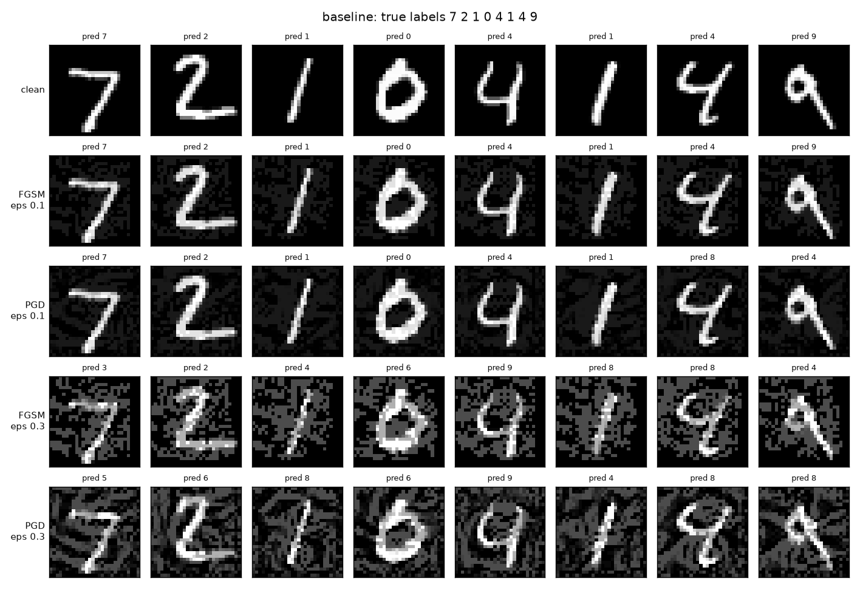
At ε = 0.1 the changes look like faint background noise, yet PGD already flips two of these eight digits. At ε = 0.3 PGD gets all eight wrong, although a person can still read every one of them easily.

5.2 Attack 2: backdoor data poisoning (OWASP ML02, Data Poisoning)
This attack exercises ML02, Data Poisoning. Someone who supplies part of the training data hides a rule inside the model. In our case the rule is that any digit carrying a small trigger pattern is read as a 9.
We chose it because it targets the other half of the system, training (boundary TB2), and needs no access to the model or the code. It also fits a realistic supply chain, since DigitRead relies on an outside labelling contractor. Backdoors are stealthy: clean accuracy stays the same, so normal testing does not reveal them. Finally, it needs a completely different defense from evasion, which gave the blue team two separate problems to solve.
We built a BadNets-style backdoor using ART's PoisoningAttackBackdoor with add_pattern_bd, which turns a small 4-pixel pattern near the bottom-right corner white. We randomly picked 2,750 training images (5% of 55,000) from digits other than 9, added the trigger and relabelled them as 9. The victim model was then trained with exactly the same code, data split and seed as the baseline, so the poison is the only difference between the two.
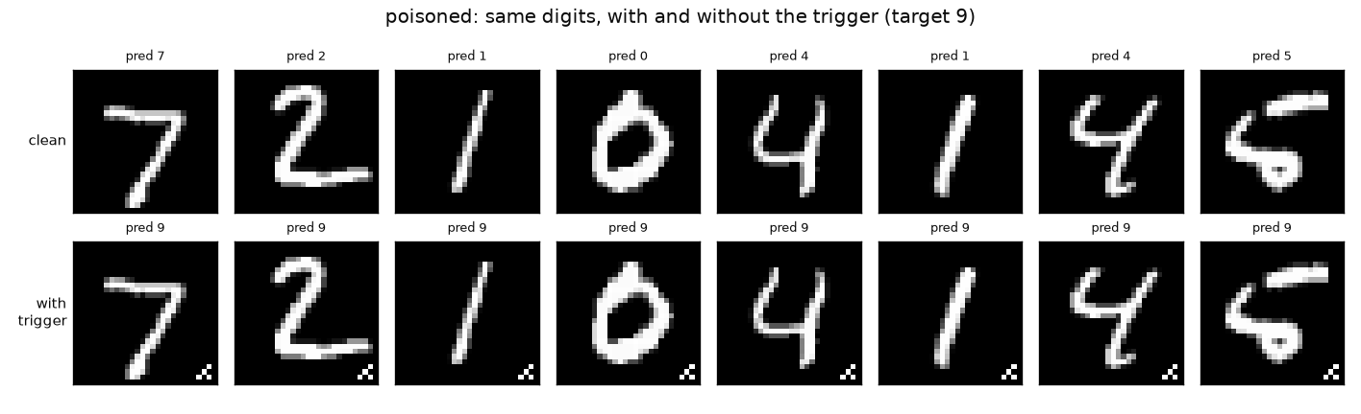
Without the trigger, the poisoned model reads all eight digits correctly. With it, every one of them becomes a 9.

5.3 Datasets
Each dataset is saved as a NumPy .npz file with a .sha256 checksum file next to it. They should be loaded with src.data.load_dataset(path), which checks the checksum, refuses pickled objects, and validates shapes, value ranges and labels.
File | Contents | Size | SHA-256 (first 16 characters)
baseline_fgsm_eps0.10.npz | 10,000 test images after FGSM, ε = 0.1, against the baseline; true labels | 4.2 MB | 1cec3c2ce74a7808
baseline_fgsm_eps0.30.npz | The same, ε = 0.3 | 3.9 MB | 70e01badf2302ada
baseline_pgd_eps0.10.npz | 10,000 test images after 20-step PGD, ε = 0.1 | 9.9 MB | 688b30b9a0a1c7dd
baseline_pgd_eps0.30.npz | The same, ε = 0.3 | 10.5 MB | 4459db4944c6c531
poisoned_train.npz | 55,000 training images, 2,750 of them triggered and relabelled 9; also stores which images were poisoned and their original labels | 14.5 MB | 778216425f3c4f1a
poisoned_triggered_test.npz | The 8,991 test images that are not 9, each with the trigger; true labels | 2.4 MB | 54d5da730a89df7c

6. Performance metrics with adversarial and poisoned data
Under attack the baseline falls apart. PGD at ε = 0.3 takes its accuracy from 99.09% to 0.00%, and FGSM brings it down to 10.29%. The poisoned model keeps 99.10% accuracy on clean digits, but sends 99.94% of triggered digits to 9.

6.1 Adversarial test data (Attack 1)
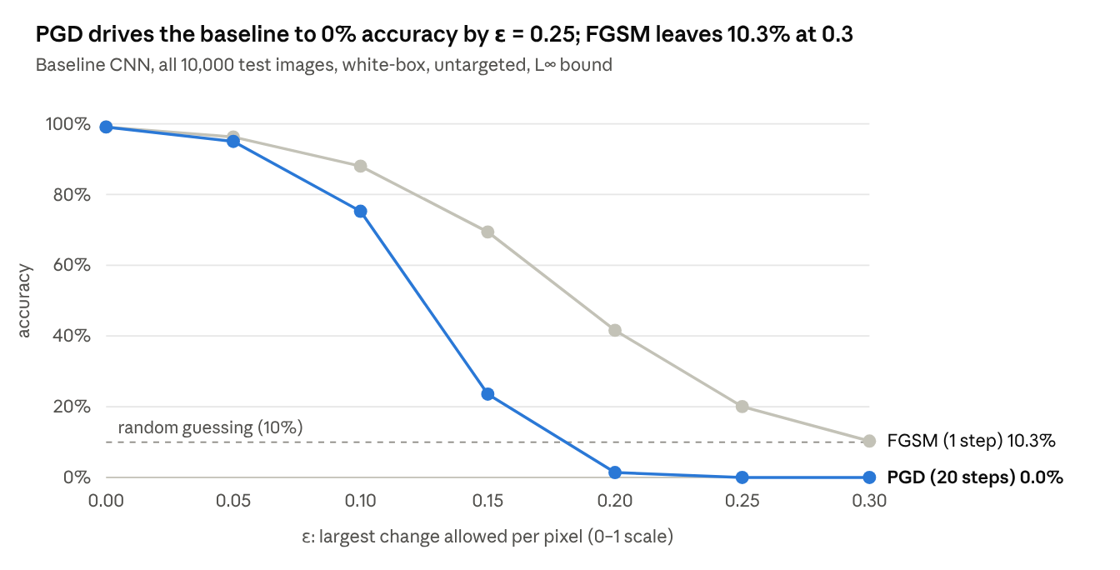
results/baseline/evasion.json · 7 attack strengths × 2 attacks, 10,000 test images each
The table below gives the full metrics for the four adversarial test sets we saved. Confusion matrices and per-class reports for each are in results/baseline_*.
Test set (10,000 images) | Accuracy | Loss | Macro F1 | Attack success | Weakest digit (recall)
Clean, for reference | 99.09% | 0.030 | 99.08% | — | 8 (97.84%)
FGSM, ε = 0.1 | 88.02% | 0.386 | 87.88% | 11.17% | 9 (77.60%)
FGSM, ε = 0.3 | 10.29% | 3.98 | 10.65% | 89.62% | 1 (0.09%)
PGD, ε = 0.1 | 75.27% | 0.813 | 74.97% | 24.04% | 9 (49.26%)
PGD, ε = 0.3 | 0.00% | 15.6 | 0.00% | 100.00% | every digit (0%)
PGD is stronger than FGSM at every ε, which is what we expected: twenty projected steps find mistakes that a single step misses. This also served as a sanity check on our implementation. The loss tells a similar story. It rises from 0.03 to 15.6, which means the model is not merely uncertain on these images but confidently wrong.
We also checked whether the attack needs our weights at all. The PGD images made against the baseline fooled two other models that we trained separately with the same architecture. The poisoned model scored 0.00% on them and the cleaned model 1.38% (Section 7). In other words, an attacker with a similar model of their own could produce working adversarial examples without ever seeing ours.

6.2 Poisoned training data (Attack 2)
Model and test set | Images | Accuracy (true labels) | Loss | Read as 9
Baseline, clean test set | 10,000 | 99.09% | 0.030 | —
Poisoned model, clean test set | 10,000 | 99.10% | 0.028 | —
Poisoned model, triggered test set (no 9s) | 8,991 | 0.06% | 13.98 | 99.94%
What makes the backdoor dangerous is how well it hides. On clean data the poisoned model matches the baseline to within 0.01 points, and even its weakest digit is the same (8, at 97.84% recall), so an accuracy check before release would pass it. The backdoor works for every source digit, from 99.69% for digit 4 up to 100%. To make sure the effect came from the poison and not from the pattern itself, we also stamped the trigger onto test images for the clean baseline. Only 0.08% of them turned into a 9.

7. Blue team: defenses and performance compared with the baseline
Both defenses worked, and neither cost much. PGD adversarial training raised accuracy under PGD at ε = 0.3 from 0.00% to 90.34% (83.30% against the strongest attack we tried) and lowered clean accuracy by 0.55 points. Activation clustering cut the backdoor's success rate from 99.94% to 0.18%, for a drop of 0.18 points in clean accuracy.
One result surprised us. Training once on FGSM images, which is the most literal reading of the task, produced a model that looks robust against the baseline's own attack images. When attacked directly, however, it does worse than the undefended baseline.
Item | Link
Defense 1: adversarial training (static and PGD) | defenses/adversarial_training.py
Defense 2: activation clustering, then retraining | defenses/activation_clustering.py
Comparison table and charts | scripts/compare.py, results/comparison.md
Complete output of the blue-team run | results/blue_team.log

7.1 Defense 1: adversarial training (against ML01)
The task asks us to train on adversarial samples together with clean data. We tried two ways of doing this, and the difference between them turned out to be one of our main findings:
 | Static (adversarial data added once) | PGD adversarial training (Madry et al., 2018)
Adversarial samples | FGSM, ε = 0.3, made once against the baseline for all 55,000 training images | Fresh 7-step PGD, ε = 0.3, made against the model as it trains, for half of every batch
Training data | 110,000 images (clean + adversarial), 5 epochs | 55,000 images, half adversarial per batch, 8 epochs
Training time (CPU) | 164 s | 572 s (baseline: 74.5 s)
In both cases the adversarial samples were made from the training images, not taken from the adversarial test sets in Section 5, so that no test image was ever seen during training and the retest stays fair. For the PGD version, we generated the training attacks with our own PGD code but evaluated the model with ART's implementation, so the defense was never judged by the same code that trained it. Its accuracy on validation images under PGD went up after every epoch, from 54.4% after the first to 90.1% after the eighth.
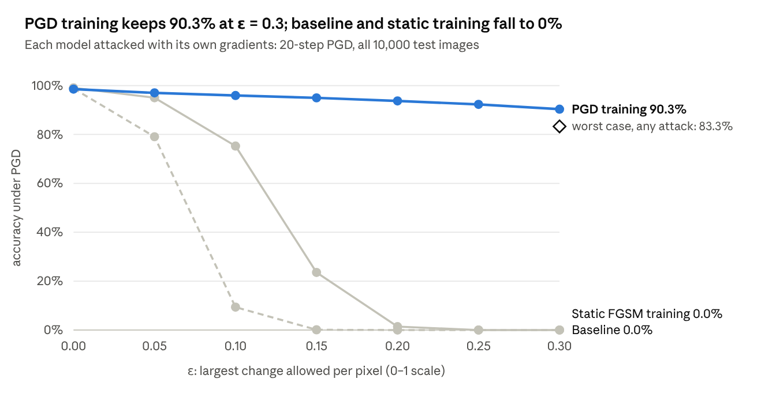
results/{baseline,adv_static,adv_pgd}/evasion.json and results/adv_pgd/robustness_checks.json
The static model learned to recognise the particular FGSM perturbations it had seen. On the baseline's PGD images at ε = 0.3 it scores 90.05%, against 0.00% for the baseline. But when we attacked it with its own gradients, it broke down faster than the baseline did, falling to 9.37% under PGD at ε = 0.1 where the baseline still had 75.27%. Its training images were made for a different model, so it seems to have learned to spot one fixed pattern instead of becoming robust. The PGD-trained model behaved very differently: it kept 95.93% at ε = 0.1, 90.34% at ε = 0.3, and 94.02% under FGSM at ε = 0.3.

7.2 Is that robustness real? Checks for gradient masking
A defense can look robust simply because it hides or distorts its gradients. Gradient-based attacks then fail even though the model is still easy to fool, which is known as gradient masking. To check for this, we ran three tests suggested by Carlini et al. (2019), "On Evaluating Adversarial Robustness", on the first 1,000 test images:
Attack on the PGD-trained model | Accuracy | Check
None (clean) | 98.20%
PGD, 20 steps, 1 start, ε = 0.3 (main evaluation) | 88.90%
PGD, 100 steps, 5 random starts, ε = 0.3 | 86.70% | Pass: a 5× stronger attack gains only 2.2 points
Square Attack (black-box, no gradients), ε = 0.3 | 83.30% | Fail: beats every gradient attack
PGD, 50 steps, ε = 0.5 | 0.00% | Pass: a large enough budget breaks it completely
The black-box Square Attack, which never uses gradients, did better than every gradient attack. That points to some gradient masking. The model is still far more robust than the baseline, but on these images its true robust accuracy is at most 83.30%, not the 88.90% that PGD alone suggests. We therefore report 83.30% as its robust accuracy.

7.3 Defense 2: activation clustering (against ML02)
Activation clustering (Chen et al., 2018; ART's ActivationDefence) relies on a simple observation. Poisoned images reach their label because of the trigger rather than the shape of the digit, so inside the network they look different from genuine images of the same class. For each class, we took the poisoned model's activations on its training images, reduced them to 10 dimensions with PCA and split them into two clusters with k-means. A cluster holding less than 35% of its class was treated as poison, and we retrained the model on everything that was not flagged. ART uses the output layer by default, so we compared it with the hidden layer, each with three different rules for deciding which cluster is the poison:
Layer | Rule for the poison cluster | Images flagged | Precision | Recall
Hidden (128 units) | Relative size (under 35% of the class) | 2,624 | 99.9% | 95.4%
Hidden | The smaller cluster in every class | 23,739 | 11.1% | 95.4%
Hidden | Silhouette score | 8,219 | 33.5% | 100%
Output (ART default) | Relative size | 5,951 | 39.4% | 85.3%
Output | The smaller cluster in every class | 22,111 | 10.6% | 85.3%
Output | Silhouette score | 13,661 | 20.1% | 100%
With the setting we chose, 2,624 images were flagged, all of them in class 9. Of these, 2,622 really were poisoned and only 2 were clean, while 128 of the 2,750 poisoned images slipped through. After retraining on the remaining 52,376 images, the model scores 98.91% on clean data. The backdoor now works on only 0.18% of triggered digits (at most 0.71% for any single source digit), so the 128 missed images were not enough to bring it back. The choice of layer made a big difference: on ART's default output layer, more than half of the flagged images were actually clean.

7.4 All models compared with the baseline
Model | Clean accuracy | FGSM ε = 0.1 | FGSM ε = 0.3 | PGD ε = 0.3 | Baseline's PGD ε = 0.3 images | Backdoor success | ms per image | Training time
Baseline | 99.09% | 88.02% | 10.29% | 0.00% | 0.00% | 0.08% (control) | 0.229 | 74.5 s
Poisoned (5%) | 99.10% | — | — | — | 0.00% | 99.94% | 0.233 | 73 s
Poison removed (activation clustering) | 98.91% | — | — | — | 1.38% | 0.18% | 0.226 | 68 s + detection
Adversarial training, static FGSM | 98.80% | 57.03% | 3.87% | 0.00% | 90.05% | — | 0.226 | 164 s
Adversarial training, PGD | 98.54% | 96.56% | 94.02% | 90.34% (83.30% worst case) | 95.19% | — | 0.225 | 572 s
In the FGSM and PGD columns each model is attacked with its own gradients (white-box). The "baseline's images" column instead replays the adversarial test set made against the baseline, which is a black-box transfer test. Inference time is the same for every model within measurement noise, because they all share one architecture; the defenses cost training time, not prediction time. A dash means we did not measure that value for the model.

8. Conclusion and observations
Our main takeaway is that high accuracy says very little about security. The baseline scored 99.09% on clean data and 0.00% under a white-box attack, and the backdoored model passed the same accuracy check as the clean one. Both attacks can be defended against without slowing down prediction, but only if the defense itself is tested with adversarial methods.

Observations
- Accuracy did not reveal either attack. Evasion needed no access to training, only pixel changes of at most 0.3 that are barely visible. Poisoning 5% of the training data planted a backdoor that worked 99.94% of the time, while clean accuracy even went up by 0.01 points. Robustness and data provenance have to be tested in their own right.
- The most obvious defense can make things worse. Adding FGSM images made once against the baseline gave a model that resists those exact images (90.05%) but is weaker than the undefended baseline under a direct attack (9.37% against 75.27% at ε = 0.1). Real robustness only came from PGD adversarial training, which keeps attacking the model while it learns and reached 90.34% under PGD at ε = 0.3.
- A single attack is not enough to evaluate a defense. The black-box Square Attack beat every gradient attack against the PGD-trained model (83.30% against 86.70% for 100-step PGD), so we report 83.30% as its robust accuracy. Quoting only the PGD result would have overstated it by 5.6 points on the same images.
- Default settings deserve a second look. Activation clustering on the hidden layer found the poison with 99.9% precision, but on ART's default output layer 60% of what it flagged was clean data. ART 1.20.1's own relative-size rule also failed with an error under NumPy 2, so we applied the rule ourselves to ART's clusters.
- The defenses cost training time rather than prediction time. Every model predicts in 0.225–0.233 ms per image. Clean accuracy dropped by 0.55 points with PGD training and by 0.18 points with poison removal, and PGD training took 572 s compared with 74.5 s for the baseline.
- The most serious code issues were specific to machine learning. Three of the eight SAST findings were ways for a model or dataset file to execute code through pickle, and it was the Trail of Bits ML rules, not Bandit, that caught them. Each scanner also had a blind spot: Semgrep skipped the tests folder and ignores the PyTorch version, and Bandit went quiet on a download fix that still accepted file://. That is why we treat the tests, not the scans, as the evidence that a fix works.
- Dependencies need their own audit. Installing PyTorch from its CPU index pulled in outdated versions of filelock and setuptools with six known advisories between them. PyTorch itself could only be audited once we checked its release number directly.

Limitations
- We only tested L∞ perturbations up to ε = 0.3. Adversarial training gives no guarantee beyond the attacks we tried; that would need a certified defense.
- Activation clustering is designed for BadNets-style backdoors that form their own cluster. Clean-label attacks, or triggers spread across the whole image, might get past it.
- Each configuration was trained once, with seed 42, on a single CPU. Differences of a few tenths of a point, such as 99.10% against 99.09%, are within normal run-to-run variation.
- The checksum files are stored next to the files they protect. They catch corruption and casual tampering, but not an attacker who can replace both; signing the files would close that gap.
If we were deploying DigitRead for real, we would use the PGD-trained model, run activation clustering on every batch of contractor data before retraining, and keep a record of where each training sample came from. We would also sign the model files, and add differential privacy, rate limiting and label-only responses to deal with the privacy threats from Section 3.5.

