

Software Requirements Specification (SRS)
Skool-Comm – School-Parent Communication App
Prepared for: Wilgehof Primary School
Course: ITC327W – Software Engineering Project

GitHub Link https://github.com/Itshepeleng/SKOOL-COMM

Group Members
PRECIOUS MCHUNU 222078878
KWANELE MDOLO | 223088602
TSIETSI SEBOGODI | 223060143
LESEGO MOCHAI | 222046558
AVHASEI RAMBULANA | 221007752
NOTHABILE JOKAZI | 223060076
ITSHEPELENG KARABO LERATO | 221030790
LEBOHANG SEEKOEI | 221045394

Contents
Software Requirements Specification (SRS) ......................................................................................................... 0
1. Project Introduction 5
2. Stakeholder Profile and Current Process 6
2.1 Stakeholder Profile 6
2.2 Current Process 6
Who Participates: 6
What Information is Communicated: 7
2.3 Problems Experienced 7
2.4 How the Problem Affects Users 8
Current Communication Diagram 9
3. Problem Statement 10
Current Problem: 10
Impact: 10
Proposed Solution: 10
4. Project Aim and Objectives 11
4.1 Project Aim 11
4.2 Objectives 11
5. Project Scope 12
6. Stakeholder Needs 15
6.1 Interview Findings 15
6.2 Summary of Stakeholder Needs 16
7. Definitions and Abbreviations 16
8. Stakeholders and User Groups 16
9. Main Product Functions 18
10. Functional Requirements 19
11. Non-Functional Requirements 20
12. System Requirements 21
14. Integration Requirements 21
15. Requirements Prioritisation 22
16. Requirements Change Log 25
17. Refined Project Scope 27
17.1 Changes Made 27
17.2 Refined Scope 28
Feasibility Study 29
Introduction 29
Review of Current Project 29
Technical Feasibility 29
Operational Feasibility 30
Economic Feasibility 31
Schedule Feasibility 31
Legal Feasibility 32
Ethical Feasibility 32
Feasibility Summary 33
Overall Feasibility Conclusion 34
18.Project Risk Register 35
Proposed Changes to the Project Scope 37
Appendices 38
Appendix A: Stakeholder Interview Questions 38
Appendix B: Stakeholder Responses 38
Appendix C: Evidence of Stakeholder Engagement 39
Appendix D: Stakeholder Confirmation of Findings 40
Appendix E: Scope Confirmation Letter 41
Appendix F: Supabase 43
Appendix G: GitHub README 44
System Architecture 45
1. Main System Architecture 45
2.System Architecture Diagram 47
UML and Database Design 49
1.Use Case Diagram 49
2.Sequence Diagrams 51
3.Entity Relationship Diagram (ERD) 53
Alignment Across the Designs 54
ASP.NET web interface designs 55
ASP.NET web interface designs 56
STAKEHOLDER FEEDBACK 58
MICROSOFT PROJECT PLAN 60

1. Project Introduction
Skool-Comm is a digital platform designed to improve communication between Wilgehof Primary School and parents. It will provide a central place where parents can access important school information, announcements, in-app reminders, attendance information, school events, and the year plan.
Wilgehof Primary School is a public, Quintile 5 (fee-paying) primary school located in Wilgehof, Bloemfontein. The school has 900+ learners and 35 educators. The school currently lacks a centralized system for parent communication, presenting a clear opportunity for a digital communication project.
Currently, parents often struggle to stay informed about what is happening at their children's school. Important information such as parent meetings, school events, announcements, and school requirements may be communicated through learners, printed notices, or different messaging platforms. Learners may forget to tell their parents about important information received at school.
Parents also struggle with technology, may lose or change phones, and often receive short notice about school events. The proposed Skool-Comm platform will provide a centralized platform where parents can easily access school information. The school will be able to publish announcements, upcoming meetings, events, and other important notices. Parents will be able to receive information directly instead of relying only on their children to communicate it.
The main stakeholders of the project are school administrators, teachers, and parents or guardians. The system aims to improve school communication, help parents stay informed, reduce unnecessary school visits, and make school-related information easier to access.
Commercial school-communication platforms such as ClassDojo and Remind already exist and offer similar messaging and notification features. However, these are general-purpose products that are not tailored to Wilgehof Primary School's specific context, including its existing manual points system, limited parent technology literacy, and current lack of any centralized digital record-keeping. Skool-Comm is not intended to compete with these commercial platforms, but rather to deliver a purpose-built prototype for this specific stakeholder, using a Flutter, ASP.NET, and Supabase stack that the group can realistically design, build, and test within a single semester.

2. Stakeholder Profile and Current Process

2.1 Stakeholder Profile
ELEMENT DETAILS
ORGANIZATION NAME AND  TYPE | Wilgehof Primary School – Public, Quintile 5 (fee-paying) primary school in Wilgehof, Bloemfontein
STAKEHOLDER'S NAME OR  ROLE | Nokulunga Nxusa (Teacher), Paseka Manamela (Teacher)
ORGANIZATION'S MAIN  ACTIVITIES | Providing primary education to learners from Grade R to Grade 7
CONTACT PERSON | Nokulunga Nxusa
CONTACT DETAILS | Phone: 067 168 5856, Email: Nxusanp@ufs.ac.za

2.2 Current Process
The school currently uses a combination of methods to communicate with parents. Teachers and administrators create information or announcements, which are then
sent through one of several channels including Facebook, WhatsApp, letters, or
phone calls. Parents may or may not receive the message. If parents have a response or query, they contact the school through one of these same channels. There is no central tracking system for either the school or the parents.

Who Participates:

PARTICIPANT ROLE
TEACHERS | Send academic updates, behavioural concerns, and communicate with parents via WhatsApp, letters, and phone calls
ADMINISTRATORS | Send school-wide announcements, event information, and urgent notifications via Facebook, letters, and WhatsApp
PARENTS/GUARDIANS | Receive information, raise concerns, and respond to communications
LEARNERS | Deliver physical letters/notices home (often lost or forgotten)

What Information is Communicated:

INFORMATION HOW IT IS COMMUNICATED TYPE
ACADEMIC | Report cards, test results (via letters or WhatsApp)
Attendance | Attendance is recorded internally but is not consistently communicated to parents.
BEHAVIOURAL | Wilgehof Primary School uses a demerit point system to monitor learner behaviour.  Discipline reports use a demerit point system to monitor learner behaviour: 50 points = detention, 75 points = meeting, and 100 points = parents called in.
SCHOOL EVENTS | Sports days, parent meetings, school closures (letters, WhatsApp, Facebook)
SCHOOL  REQUIREMENTS | Letters, WhatsApp, Facebook
PARENT MEETINGS | Letters, WhatsApp, Facebook
STATEMENTS | Currently paper-based

2.3 Problems Experienced
PROBLEM DESCRIPTION
PARENTS LOSE PHONES | Parents change phones or lose contact numbers
INTERNET CONNECTIVITY | Some parents do not have reliable internet access
WHATSAPP NOT USER-FRIENDLY | Elderly parents struggle to use WhatsApp effectively
SHORT NOTICE MESSAGES | Parents do not always receive enough time to prepare
NO REMINDERS | Parents do not receive reminders about meetings and events
NO YEAR PLAN | Parents would like a year plan to prepare in advance
MANUAL POINTS RECORDING | Behavioural points are recorded manually
PAPER-BASED STATEMENTS | Statements are printed and distributed physically

2.4 How the Problem Affects Users
AFFECTED GROUP IMPACT
TEACHERS | Spend time on manual communication and points recording instead of teaching
PARENTS | Miss important updates; struggle with technology; feel disconnected from the school
ADMINISTRATORS | Overwhelmed by parent queries; cannot track communication effectively
LEARNERS | Inconsistent parental support due to poor communication
SCHOOL  REPUTATION | Parent satisfaction decreases when communication is poor

Current Communication Diagram

Teacher / Admin Parent
│ │
│ 1. Information/ │
│ Announcement │
│ is created │
│ │
▼ │
┌───────────────┐ │
│ Channels │ │
│ • Facebook │─── 2. Sent ──────►│ 3. May or may
│ • WhatsApp │ via │ not receive
│ • Letters │ channel │ the message
│ • Phone │ │
└───────────────┘ │
│ │
│ 4. Response/Query │
│ │
▼ ▼
┌───────────────┐ ┌───────────────┐
│ No Central │ │ No Central │
│ Tracking │ │ Tracking │
│ System │ │ System │
└───────────────┘ └───────────────┘

3. Problem Statement

Current Problem:
Wilgehof Primary School currently uses a combination of Facebook, WhatsApp, letters, and phone calls to communicate with parents. This fragmented approach makes it difficult to ensure that valuable information reaches parents on time.

Impact:
This results in missed messages, no tracking of message delivery, no centralized record of communication, and no reminders or year plan for parents. Teachers and school administrators spend additional time on manual communication and points recording, while parents may miss important updates and struggle with existing communication methods. There is also no reliable record of what information was communicated or received.

Proposed Solution:
An improved solution is needed to centralize school-parent communication. The proposed system will provide in-app reminders, a digital year plan, and a digital record-keeping system for learners and parents, helping the school communicate information more effectively and giving parents easier access to important school information.

4. Project Aim and Objectives

4.1 Project Aim
To develop an integrated mobile and web prototype that improves communication between Wilgehof Primary School and parents.

4.2 Objectives
OBJECTIVE DESCRIPTION
OBJECTIVE 1 | Allow parents to access attendance information, school events, announcements, and other relevant school updates.
OBJECTIVE 2 | Allow teachers to send announcements and track parent engagement
OBJECTIVE 3 | Allow administrators to manage communication.
OBJECTIVE 4 | Provide reminders and a year plan for parents
OBJECTIVE 5 | Create a digital record-keeping system for learners and parents

5. Project Scope
Scope Element | Group Response
Project Aim | To develop an integrated mobile and web prototype that improves communication between Wilgehof Primary School and parents.
Main Objectives | Allow parents to register and create a profile and receive attendance and school event updates.
Deliverables | Flutter mobile app for parents; ASP.NET web dashboard for teachers and administrators; Supabase backend connecting both apps; SRS document; final project presentation.
Acceptance Criteria | Parents can securely register, log in, and view attendance records and school events. Parents can view announcements, access in-app reminders, and view the year plan calendar. Teachers and administrators can securely access the ASP.NET web dashboard to manage communication and perform their assigned functions. Access to learner information must be restricted according to user roles and approved learner profiles. Both applications must connect to the shared Supabase backend. The prototype must run successfully using test data.
Exclusions | Full integration with the school's existing admin systems; financial/payment systems (except uniform shop link); AI-powered features; SMS, email and push notifications (in-app only); academic results and report cards.
Constraints | Project must be completed within one semester, must use Flutter, ASP.NET, and Supabase; requires stakeholder availability; no real student data without permission; interface must be simple for elderly parents.
Assumptions | Stakeholder will be available for meetings; school will provide feedback; sample/test data can be used; technical resources remain available; parents have access to smartphones.

6. Stakeholder Needs

6.1 Interview Findings
A stakeholder interview was conducted on 21 August 2026 with teachers Nokulunga Nxusa and Paseka Manamela at Wilgehof Primary School. The following findings were recorded:
QUESTION STAKEHOLDER RESPONSE
1. HOW DOES THE SCHOOL CURRENTLY COMMUNICATE WITH PARENTS? | Facebook, WhatsApp groups, letters, phone calls
2. WHAT INFORMATION DO PARENTS REQUEST MOST FREQUENTLY? | Academic results, school events, meeting dates
3. WHAT CHALLENGES HAVE YOU EXPERIENCED WITH THE CURRENT COMMUNICATION METHODS? | Parents lose phones, internet issues,  WhatsApp not user-friendly for elderly
4. WHAT COMPLAINTS DO PARENTS COMMONLY HAVE? | Short notice, no reminders, no year plan
5. DO PARENTS STRUGGLE TO ACCESS THEIR CHILDREN'S ACADEMIC RESULTS? | Yes – currently via letters/WhatsApp only
6. HOW ARE SCHOOL EVENTS  COMMUNICATED TO PARENTS? | Letters, WhatsApp, Facebook
7. HOW DO TEACHERS CURRENTLY COMMUNICATE WITH PARENTS? | WhatsApp groups, letters, phone calls
8. WHAT ADMINISTRATIVE TASKS TAKE UP UNNECESSARY TIME? | Manual points recording, printing  letters, distributing statements
9. WHAT WOULD MAKE  COMMUNICATION BETWEEN THE SCHOOL AND PARENTS EASIER? | Online system, reminders, year plan, online statements
10. IF WE COULD ONLY HELP WITH ONE THING, WHAT WOULD BE MOST VALUABLE? | Record-keeping system for learners and parents

6.2 Summary of Stakeholder Needs
PRIORITY NEED
MUST HAVE | Record-keeping system for learners and parents
COULD HAVE | Online statements for parents
MUST HAVE | Reminders for meetings and events
MUST HAVE | Digital year plan for parents
SHOULD HAVE | Points tracking system
COULD HAVE | Online uniform shop

7. Definitions and Abbreviations

TERM OR ABBREVIATION MEANING
SRS | Software Requirements Specification
FLUTTER | Framework used to develop the mobile application
ASP.NET | Framework used to develop the web application
SUPABASE | Shared online backend and database
WIL | Work-Integrated Learning
UI | User Interface
RLS | Row Level Security (Supabase)
POPIA | Protection of Personal Information Act

8. Stakeholders and User Groups

STAKEHOLDER OR USER ROLE IN THE PROPOSED SYSTEM
WILGEHOF PRIMARY SCHOOL | External stakeholder providing requirements and feedback
PARENTS/GUARDIANS | Mobile application users – Register, automatically create and link learner profiles, then view learner information, receive information and access school updates
TEACHERS | Web application users – send announcements, record attendance and behavioural points, track engagement.
SCHOOL ADMINISTRATORS | Web application users – Manage user accounts, manage events and the year plan, track communication.
LEARNERS | Indirectly affected – benefit from improved parental support

9. Product Perspective
The proposed prototype will include a Flutter mobile application for parents and an ASP.NET web application for teachers and administrators. Both applications will connect to the same Supabase backend and share information in real time.
Parents will use the Flutter mobile application to register an account and immediately create a learner profile. The system uses automation to link the learner to the parent instantly. Upon submission, the app checks the unique IDNumber against the LEARNER table. If the learner exists, the app creates a new PARENT_LEARNER link. If the learner does not exist, the app creates the learner and then the link. The profile is immediately active, and parents can instantly view attendance, behavioural points, and announcements without waiting for manual approval
Teachers and administrators will use the ASP.NET web application to create, update, and delete announcements, record attendance, record and track learner behavioral points, manage school events and the year plan, manage users and parent contact details, track parent engagement, manage communication.
When a teacher or administrator publishes an announcement through the web dashboard, it will be available to parents through the mobile application. When a parent views an announcement, the engagement will be tracked and displayed in the web dashboard. Supabase will provide the shared database, authentication, role-based access control, and real-time synchronization between the two applications.
.
The prototype will use test data. In-app reminders will be supported, but external SMS, email, and phone push notifications will not be implemented. Online statements and payment reminders are excluded from the current prototype.

9. Main Product Functions

COMPONENT MAIN FUNCTIONS
FLUTTER MOBILE APPLICATION | Register, log in, create learner profiles (automatic linking), view attendance records, view behavioural points, view school events/announcements, receive in-app reminders, view the year plan, and update contact information.
ASP.NET WEB APPLICATION | Manage user accounts, create/update/delete announcements, track parent engagement, record learner attendance, record behavioural points, manage school events and the year plan, view communication history.
SUPABASE BACKEND | Store user profiles, link parents to learners, store announcements, attendance, behavioural points, and engagement logs. Provide secure authentication and Row Level Security (RLS).

10. Functional Requirements

ID | Requirement | Priority
FR1 | Academic results functionality removed from the current project scope. | Removed
FR2 | Parents must be able to view attendance records | Must Have
FR3 | Teachers and administrators can create, update, and delete announcements, while parents can view them | Must Have
FR4 | Parents must receive reminders for meetings and events | Must Have
FR5 | Parents must be able to view the year plan | Must Have
FR6 | Parents must be able to view behavioral points | Should Have
FR7 | Teachers must be able to track parent engagement (viewed/read) | Should Have
FR8 | Administrators must be able to manage communication and generate reports | Must Have
FR9 | Teachers must be able to record and track learner points | Should Have
FR10 | The system must securely store all announcements and communication records in Supabase | Must Have
FR11 | The system must provide a record-keeping system for learners and parents | Must Have
FR12 | Parents must be able to update their contact information | Must Have
FR13 | Administrators must manage users (create, update, delete accounts) | Must Have
FR14 | The system should provide parents with a link to the school's uniform/stationery supplier | Could Have
FR15 | Parents must be able to register an account and then create a learner profile. | Must Have
FR16 | Administrators must be able to review, fact-check, and approve or reject learner profiles | Removed
FR17 | Only approved learner profiles may grant access to learner information | Removed

11. Non-Functional Requirements

ID REQUIREMENT PRIORITY
NFR1 | Only authorized parents may view their child's information | Must Have
NFR2 | Only authorized teachers and administrators may send announcements | Must Have
NFR3 | Error messages must be clear and understandable | Must Have
NFR4 | The mobile interface must display correctly on Android smartphones | Must Have
NFR5 | The prototype must use test data (no real student data without permission) | Must Have
NFR6 | The system must be easy to use for parents with basic smartphone skills | Must Have
NFR7 | The interface must be simple enough for elderly parents | Must Have
NFR8 | Parent submitted profiles must be verified against school records before approval | Removed
NFR9 | Rejected profiles must notify the parent with a reason | Removed

12. System Requirements

ID REQUIREMENT PRIORITY
SR1 | The mobile application must be developed using Flutter | Must Have
SR2 | The web application must be developed using ASP.NET | Must Have
SR3 | The shared backend must use Supabase | Must Have
SR4 | The source code must be stored in GitHub | Must Have
SR5 | The project must be completed within one semester (15 weeks) | Must Have

14. Integration Requirements

iD | Requirement | Priority
IR1 | Information entered through Flutter must be stored in Supabase | Must Have
IR2 | Records stored in Supabase must be available to the ASP.NET application | Must Have
IR3 | Updates made through ASP.NET must be reflected in Flutter where applicable | Must Have
IR4 | Announcements sent through ASP.NET must appear in the Flutter app | Must Have
IR5 | Authentication data must be shared between Flutter and ASP.NET using Supabase Authentication | Must Have
IR6 | Learner profiles created in Flutter must be visible in the ASP.NET dashboard for approval | Must Have
IR7 | Approval decisions made in ASP.NET must be reflected in Flutter | Must Have

15. Requirements Prioritisation

ID REQUIREMENT TYPE PRIORITY RELATED
STAKEHOLDER
NEED
FR1 | Academic progress functionality removed from the current project scope | Functional | Removed(10 october 2026) |  | Requirement was initially included but later removed due to how confusing it was to the Stakeholder
FR2 | Parents must be able to view attendance records. | Functional | Must Have |  | The school needs a digital attendance record-keeping system.
FR3 | Teachers and administrators can create, update and delete announcements, while parents can view published announcements. | Functional | Must Have |  | Parents miss information because communication is inconsistent.
FR4 | Parents must be able to view online statements. | Functional | Excluded from current prototype |  | Online statements and payment reminders are deferred.
FR5 | Parents must be able to access in-app reminders. | Functional | Must Have |  | Parents need timely reminders about school information.
FR6 | Parents must be able to view learner behavioural points. | Functional | Should Have |  | Parents need visibility of learner behaviour and points.
FR7 | Parents must be able to view the school year plan | Functional | Must Have |  | Parents want to plan for school activities
FR8 | The system must track parent engagement with announcements and communication. | Functional | Should Have |  | The school needs to know whether parents have viewed important information.
FR9 | Teachers and administrators must be able to record and track learner behavioural points. | Functional | Should Have |  | The school needs a digital way to manage learner points.
FR10 | The system must maintain communication records in Supabase | Functional | Must Have |  | The school needs a record of communication sent and received.
FR11 | The system must provide digital record-keeping for learners and parents. | Functional | Must Have |  | what was sent or received
FR12 | Parents must be able to update their contact information. | Functional | Must Have |  | Stakeholder's top priority
FR13 | School administrators need controlled user accounts | Functional | Must Have |  | Staff accounts need to be controlled
FR14 | The system should provide parents with a link to the school's uniform/stationery supplier. | Functional | Could have |  | Parents currently must visit the school office to get uniform pricing information
FR15 | Parents must be able to register an account and then create a learner profile. | Functional | Removed |  | Data privacy
FR16 | Administrators must be able to approve or reject learner profiles. | Functional | Removed |  | Verification
FR17 | Only approved parent profiles with appropriate permissions may access linked learner information. | Functional | Must Have |  | Security
NFR1 | Only authorized Non-functional parents view child's info |  | Must Have |  | Protect learner information
NFR2 | Only authorized Non-functional staff send  announcements |  | Must Have |  | Control who communicates with parents
NFR3 | Error messages Non-functional must be clear |  | Must Have |  | Parents may struggle with technology
NFR4 | Mobile interface Non-functional must work on  Android |  | Must Have |  | Most parents use Android phones
NFR5 | Prototype must Non-functional  use test data |  | Must Have |  | No real student data without permission
NFR6 | System must be Non-functional easy to use |  | Must Have |  | Parents have basic smartphone  skills
NFR7 | Interface must Non-functional be simple for elderly |  |  | Must Have | Elderly parents struggle with  WhatsApp
SR1 | Mobile app must System  use Flutter |  |  | Must Have | Course requirement
SR2 | Web app must use System  ASP.NET |  |  | Must Have | Course requirement
SR3 | Backend must use  Supabase | System |  | Must Have | Course requirement
SR4 | Source code | System |  | Must Have | Course
 | must be in GitHub |  |  |  | requirement
SR5 | Project must be completed in one semester | System |  | Must Have | Course timeline
IR1 | Flutter information stored in Supabase | Integration |  | Must Have | System components must share data
IR2 | Supabase records available to  ASP.NET | Integration |  | Must Have | Staff need to see parent reports
IR3 | ASP.NET updates  reflected in Flutter | Integration |  | Must Have | Parents need to see staff updates
IR4 | Announcements from ASP.NET appear in Flutter | Integration |  | Must Have | Parents need to receive announcements
IR5 | Flutter & ASP.NET Authentication |  |  | Must Have | Secure access  for all users

16. Requirements Change Log

DATE CHANGE REASON
27 AUGUST 2026 | Online statements changed from "Must Have" to "Could Have" | We do not have permission yet to tap into the school database
27 AUGUST 2026 | Points tracking system changed from "Must Have" to "Should Have" | It’s one of the requirements the stakeholder asked for
27 AUGUST 2026 | Academic progress requirement (FR1) added | Was accidentally omitted from initial requirements list
27 AUGUST 2026 | Online uniform shop confirmed as "Could  Have" | identified as a potential feature during stakeholder engagement and changed from Could-Have; will be developed only if time permits after Must-Have and Should-Have features are complete.
28 September 2026 | Profile creation added (FR15) | Parents register and create profile
 | Admin approval added (FR16,17) | Admins fact-check and approve profiles
 | NFR8 and NFR9 added | Verification and rejection notification requirements.
10 October 2026 | FR1 removed  FR2 Record Summary added
  Stakeholders indicated that implementing academic progress functionality would involve too much work within the available project time. The FR1 identifier is retained in the change history and is not reused.
27 October 2026 | Manual approval workflow  FR16, FR17, NFR8, NFR9 Removed | Lecturer and Stakeholder feedback: Manual approval creates a bottleneck. The system is updated to automatically accept and link profiles upon registration using the unique ID number.

17. Refined Project Scope

17.1 Changes Made
CHANGE DESCRIPTION
SIMPLIFY THE INTERFACE | The system must be designed for elderly parents who struggle with technology.  This is now a key design constraint.
PRIORITISE FEATURES | Must-Have features (registration, communication, attendance, announcements, in-app reminders, year plan, and record-keeping) will be developed first. Academic results functionality has been removed from the current project scope. Should-Have features, such as points tracking and parent engagement tracking, will be added if time permits. Could-Have features, such as the uniform shop link, will only be added if time permits.
ALLOCATE TIME FOR LEARNING | The group will spend the first week of Phase 3 learning Supabase integration and real-time synchronization.
USE TEST DATA ONLY | No real student data will be used without permission.
DOCUMENT LIMITATIONS | Any incomplete features will be documented as known limitations in the final submission.
Approval workflow | Parents register and create profiles, Admins fact-check and approve

17.2 Refined Scope

SCOPE ELEMENT DETAILS
IN SCOPE | The project includes a Flutter mobile application for parents to register accounts, create learner profiles, access approved learner information, view attendance records and behavioral points, view school events and announcements, access in-app reminders and the year plan, and update contact information. It also includes an ASP.NET web dashboard for teachers and administrators to record attendance, manage announcements, school events and the year plan, record and track learner behavioral points, manage users and parent contact details, track parent engagement, manage communication. Both applications will connect to a shared Supabase backend that provides authentication, role-based access control, data storage, and real-time synchronization. The prototype will use test data. Online statements and payment reminders are deferred (Could-Have) and excluded from the current prototype. External SMS, email, and phone push notifications are excluded; reminders will be available within the application.
OUT OF SCOPE | Online statements and payment reminders are excluded from the current prototype.
This refined scope ensures the project can be completed within the available semester while delivering a meaningful prototype that addresses the stakeholder's core needs.

Feasibility Study

Introduction
This feasibility study evaluates whether the Skool-Comm project can be successfully completed within the available time, resources, and skills. The study considers six areas: technical, operational, economic, schedule, legal, and ethical feasibility. Each area is assessed based on the stakeholder's needs, the group's capabilities, and the project constraints.

Review of Current Project
The main problem being addressed is that Wilgehof Primary School currently uses fragmented communication methods including Facebook, WhatsApp, letters, and phone calls. This results in missed messages, no tracking of delivery, no centralized record of communication, and no reminders or year plan for parents. The problem affects teachers, parents, and school administrators because teachers spend time on manual communication and points recording, parents miss important updates and struggle with technology, and there is no accountability for what was communicated or received.
The proposed solution is a digital platform called Skool-Comm, which includes a Flutter mobile application for parents and an ASP.NET web application for teachers and administrators. Both applications will connect to a shared Supabase backend. The mobile application will allow parents to view attendance records, school events, announcements, in-app reminders, and the year plan. Academic results functionality has been removed from the current project scope. Online statements are considered a Could-Have feature and will only be developed if time permits.
The web application will allow teachers to send announcements, track parent engagement, manage communication, manage parent contact details, and record learner points. Supabase will manage user profiles, communication records, announcements, and academic and attendance data.
The functions that appear most difficult include real-time synchronization between Flutter and ASP.NET and tracking parent engagement (viewed/read). The functions that require skills the group still needs to develop include Supabase integration, real-time synchronization, and implementing in-app reminders. The functions that may require more time than is available include the points tracking system, online uniform shop, and full reporting suite.

Technical Feasibility
The group has foundational skills in Flutter and ASP.NET from previous coursework. Members are familiar with the basic concepts of mobile and web development and have experience working with version control systems. The group can work with Supabase, as it is a beginner-friendly platform with extensive documentation and we also did it in first semester. Flutter and ASP.NET can both connect to the same Supabase backend using official SDKs and REST APIs, making integration technically possible. 1
All group members have suitable development computers, and Android smartphones are available for testing. Reliable internet access is available through campus Wi-Fi and personal data.
However, some technical skills still need to be learned. The group needs to develop proficiency in Supabase Row Level Security (RLS) policies, Flutter state management, and API integration. The most technically challenging functions include real-time parent engagement tracking, which requires Supabase Real-time, and implementing in-app reminders within the Flutter application.
Based on the assessment, the project is considered feasible with changes. The group has the foundational skills required for Flutter and ASP.NET development. The main technical challenge is Supabase integration and real-time synchronization, which can be learned using online tutorials and documentation. The prototype will focus on core functions and avoid advanced features that require more expertise than the group currently possesses.

Operational Feasibility
The prototype directly addresses the stakeholder's problem by centralizing communication and providing tracking and accountability features that are currently missing. The mobile application will be used by parents and guardians of learners at Wilgehof Primary School, while the web application will be used by teachers and school administrators. Most parents have access to smartphones, and the school can confirm this. However, some parents struggle with internet access and WhatsApp, which is a recognised risk.
The proposed solution will fit the organization's current activities by complementing existing communication methods. However, users will require guidance and training, especially elderly parents who struggle with technology. The interface must be designed to be simple enough for elderly parents, and this is a key design requirement.
Based on the assessment, the project is considered feasible with changes. The solution addresses the stakeholder's problem directly, but the system must be designed with simplicity in mind for elderly parents. Some parents with limited internet access may need alternative communication options, but the app will be designed to work on basic smartphones.

Economic Feasibility
All group members have access to internet access and data, either through campus Wi-Fi or personal mobile data. Transport to the stakeholder is available, and the group will travel together for safety. All group members have suitable development computers, and Android smartphones are available for testing. The required software includes Flutter, ASP.NET, and Supabase, all of which are freely available. The Supabase free tier is sufficient for the prototype, and presentation resources are available on campus.
No additional budget is required for this project, as all tools and resources are either freely available or already owned by group members.
Based on the assessment, the project is considered feasible. The project requires only free development tools and personal equipment that group members already own. No additional budget is required, and the free tiers of all services are sufficient for the prototype.

Schedule Feasibility
The Microsoft Project schedule allocates time for system design, development, integration, testing, and corrections across Phases 2 and 3. Development activities include Flutter, ASP.NET, and Supabase integration, followed by system testing, bug corrections, and stakeholder evaluation. The schedule provides sufficient time for the core features, but some additional features may need to be postponed if development takes longer than expected.
This timeline is adequate for the core features of the system. Supabase integration is planned throughout the development phase, and stakeholder feedback sessions are included at key milestones.
However, some features may be ambitious for the available time. The online uniform shop and advanced reporting functions may require more time than is available. The group has therefore prioritized Must-Have features such as attendance, announcements, in-app reminders, the year plan, and record-keeping. Academic results functionality has been removed from the current project scope.
Based on the assessment, the project is considered feasible with changes. The core communication features can be completed within the semester, but some features like online statements and the uniform shop may need to be postponed or simplified. The group will prioritize Must-Have functions first and add additional features only if time permits.

Legal Feasibility
The prototype will collect personal information, including parents' contact details and learners’ attendance and behavioral information . However, all information collected is necessary for the prototype's functionality. Access to information will be restricted to authorized users only: parents will only be able to view their own child's information, while teachers and administrators will have appropriate access levels.
Test data will be used during development, and no real student data will be used without permission. Passwords and private keys will be protected using environment variables and will never be stored in source code or uploaded to GitHub. No confidential stakeholder information will be included in the prototype.
Based on the assessment, the project is considered feasible. The project will use only test data during development and will not store real student or parent information without permission. Passwords and API keys will be stored in environment variables and never uploaded to GitHub. The project complies with POPIA guidelines using test data and role-based access control.

Ethical Feasibility
The stakeholder fully understands the purpose of the project and agreed to participate after being informed of the project's scope and objectives. The project does not collect unnecessary personal information, and all information collected is essential for the prototype's functionality. The proposed solution will not negatively affect intended users; instead, it is designed to help parents and staff by improving communication and accountability.
Information will be used only for its intended purpose of school-parent communication. The proposed prototype accurately reflects stakeholder needs, as requirements were gathered directly from the stakeholder during the interview process. All users will be treated fairly and responsibly, with the system being designed to be inclusive for elderly parents who struggle with technology.
Based on the assessment, the project is considered feasible. The stakeholder was fully informed of the project's purpose and agreed to participate. The project does not collect unnecessary personal information and will treat all users fairly and responsibly.
The prototype is designed to address legitimate stakeholder needs.

Feasibility Summary

FEASIBILITY DECISION MAIN REASON CHANGE AREA REQUIRED
TECHNICAL | Feasible with changes | Foundational skills exist;  Supabase integration needs learning | Allocate time for learning and  training
OPERATIONAL | Feasible with changes | Addresses the problem; interface must be simple for elderly parents | Simplify interface design
ECONOMIC | Feasible | Free tools and existing equipment are sufficient | None required
SCHEDULE | Feasible with changes | Core features achievable; some features may need postponement | Prioritise  MustHave features
LEGAL | Feasible | Test data only; credentials kept secure | None required
ETHICAL | Feasible | Stakeholder informed; fair treatment of users | None required

Overall Feasibility Conclusion

The proposed Skool-Comm project is feasible with changes.
The group has access to the required development tools (Flutter, ASP.NET, Supabase, GitHub) and has foundational skills in each technology. The stakeholder is willing to participate and provide feedback. The core communication functions can be completed within the semester timeline.
However, several changes are required to ensure successful completion. The interface must be simplified for elderly parents who struggle with technology. Features must be prioritized, with Must-Have features developed first and CouldHave features added only if time permits. The group must allocate time for learning Supabase integration and real-time synchronization. Only test data will be used, and no real student data will be used without permission. Any incomplete features will be documented as known limitations.
The main strengths of the project are its direct alignment with stakeholder needs, the availability of free development tools, and the group's foundational skills in the required technologies. The main limitations are the need for additional learning in Supabase integration and the risk of schedule delays due to ambitious features.
To ensure that the project can be completed within the semester, the group will priorities Must-Have features first, postpone or simplify Could-Have features, allocate time for learning, and maintain close communication with the stakeholder throughout the development process.

18.Project Risk Register

The Project Risk Register identifies potential risks that may affect the successful completion of the Skool-Comm project. The risks were identified based on the project's scope, technology, schedule, stakeholder involvement and available resources. Each risk is assessed according to its likelihood and impact, with mitigation and contingency actions assigned to an appropriate project role.
The Risk Manager, Lebohang Seekoei, is responsible for compiling, maintaining and reviewing the Project Risk Register, while individual risks are assigned to the team member best positioned to monitor and implement the appropriate mitigation and contingency actions.
 | Highest Risk | Why is this important? | What must the group do now?
1 | R01- Stakeholder does not approve the proposed solution or design. | This is important because rejection of the proposed solution or design could require changes to the project and delay progress. | We can design based on feedback, escalate to lecture if needed
2 | R02- Stakeholder becomes unavailable or unresponsive | This is important because the team may not receive the feedback or decisions needed to continue with the project. | The group can use documented findings to proceed, note  limitations in final report
3 | R05- Scope creep- The stakeholder adds additional features | It is important because additional features could increase the project scope and make it difficult to complete the project within the available time and resources | The group can reevaluate priorities, cut "Should have" features
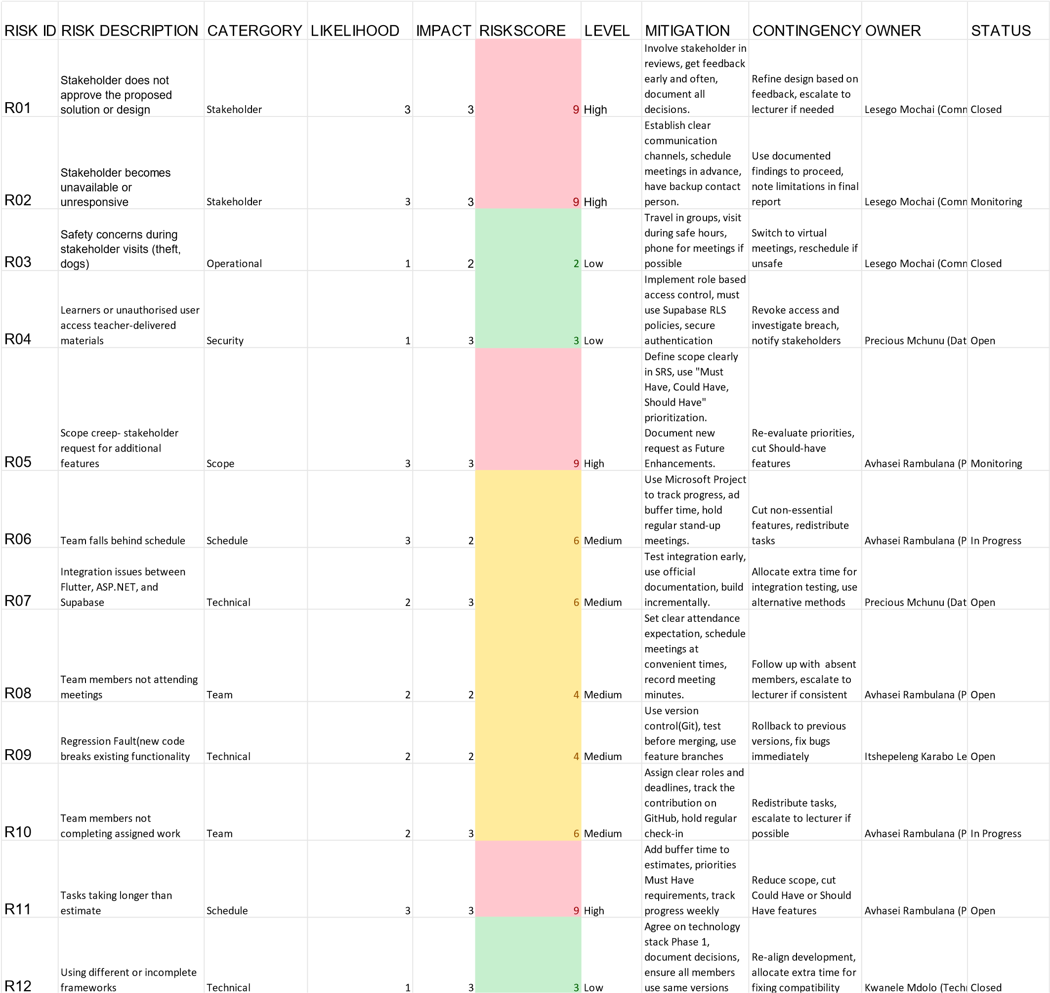

Proposed Changes to the Project Scope
Based on the feasibility analysis, the following changes are proposed:
- Simplify the interface – The system must be designed for elderly parents who struggle with technology. This will be a key design constraint.
- Prioritize features – Must-Have features (attendance, announcements, in-app reminders, year plan, and record-keeping) will be developed first. Academic results functionality has been removed from the current project scope. Should-Have features such as points tracking and parent engagement tracking will be added if time permits. Could-Have features such as the uniform shop link will only be added if time permits.
- Use test data only – No real student data will be used without permission.
- Document limitations – Any incomplete features will be documented as known limitations in the final submission.

Appendices

Appendix A: Stakeholder Interview Questions

How does the school currently communicate with parents?
What information do parents request most frequently?
What challenges have you experienced with the current communication methods?
What complaints do parents commonly have?
Do parents struggle to access their children's academic results?
How are school events communicated to parents?
How do teachers currently communicate with parents?
What administrative tasks take up unnecessary time for teachers or administrators?
What would make communication between the school and parents easier?
If we could only help with one thing, what would be most valuable?

Appendix B: Stakeholder Responses

QUESTION STAKEHOLDER RESPONSE

1. HOW DOES THE SCHOOL CURRENTLY COMMUNICATE WITH PARENTS? | FACEBOOK, WHATSAPP GROUPS,  LETTERS, PHONE CALLS
2. WHAT INFORMATION DO PARENTS REQUEST MOST FREQUENTLY? | Academic results, school events, meeting dates
3. WHAT CHALLENGES HAVE YOU EXPERIENCED WITH THE CURRENT COMMUNICATION METHODS? | Parents lose phones, internet issues,  WhatsApp not user-friendly for elderly
4. WHAT COMPLAINTS DO PARENTS COMMONLY HAVE? | Short notice, no reminders, no year plan
5. DO PARENTS STRUGGLE TO ACCESS THEIR CHILDREN'S ACADEMIC RESULTS? | Yes – currently via letters/WhatsApp only
6. HOW ARE SCHOOL EVENTS  COMMUNICATED TO PARENTS? | Letters, WhatsApp, Facebook
7. HOW DO TEACHERS CURRENTLY COMMUNICATE WITH PARENTS? | WhatsApp groups, letters, phone calls
8. WHAT ADMINISTRATIVE TASKS TAKE UP UNNECESSARY TIME? | Manual points recording, printing letters, distributing statements
9. WHAT WOULD MAKE  COMMUNICATION BETWEEN THE SCHOOL AND PARENTS EASIER? | Online system, reminders, year plan, online statements
10. IF WE COULD ONLY HELP WITH ONE THING, WHAT WOULD BE MOST VALUABLE? | Record-keeping system for learners and parents

Appendix C: Evidence of Stakeholder Engagement

ELEMENT DETAILS
MEETING DATE | 21 August 2026
MEETING LOCATION | Wilgehof Primary School
ATTENDEES | Itshepeleng, Avhasei, Lesego, Precious,  Nothabile, Tsika, Kwanele, Lebo
STAKEHOLDERS | Nokulunga Nxusa and Paseka  Manamela
PURPOSE | To understand current communication methods and identify stakeholder needs
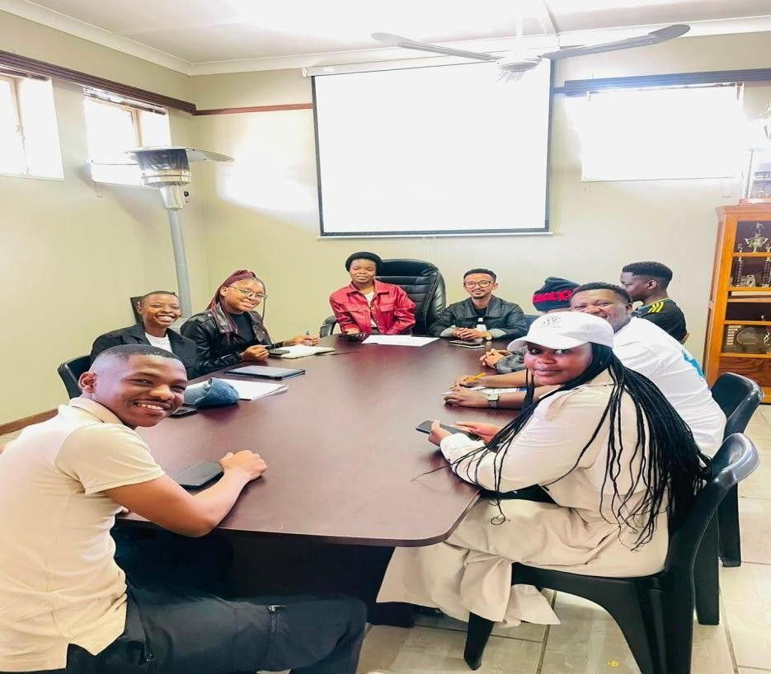

Appendix D: Stakeholder Confirmation of Findings
THE STAKEHOLDER CONFIRMED THAT THE MAIN FINDINGS WERE ACCURATE, INCLUDING:

CURRENT COMMUNICATION METHODS (FACEBOOK, WHATSAPP, LETTERS,
PHONE CALLS)

KEY CHALLENGES (LOST PHONES, INTERNET ISSUES, ELDERLY PARENTS
STRUGGLING WITH WHATSAPP)

PRIORITY NEEDS (RECORD
-
KEEPING SYSTEM, ONLINE STATEMENTS, REMINDERS,
YEAR PLAN)

Appendix E: Scope Confirmation Letter
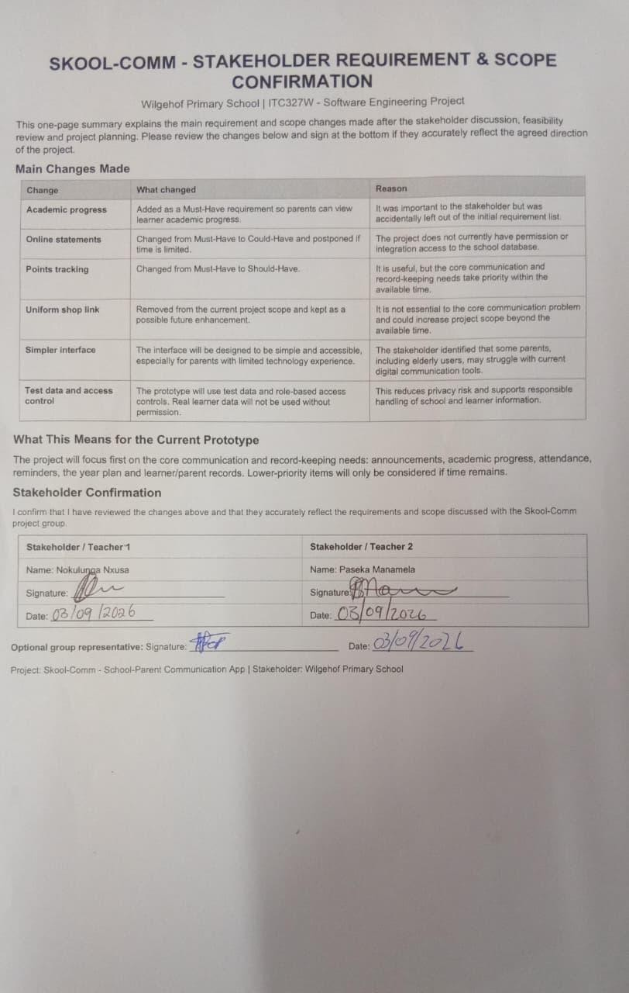

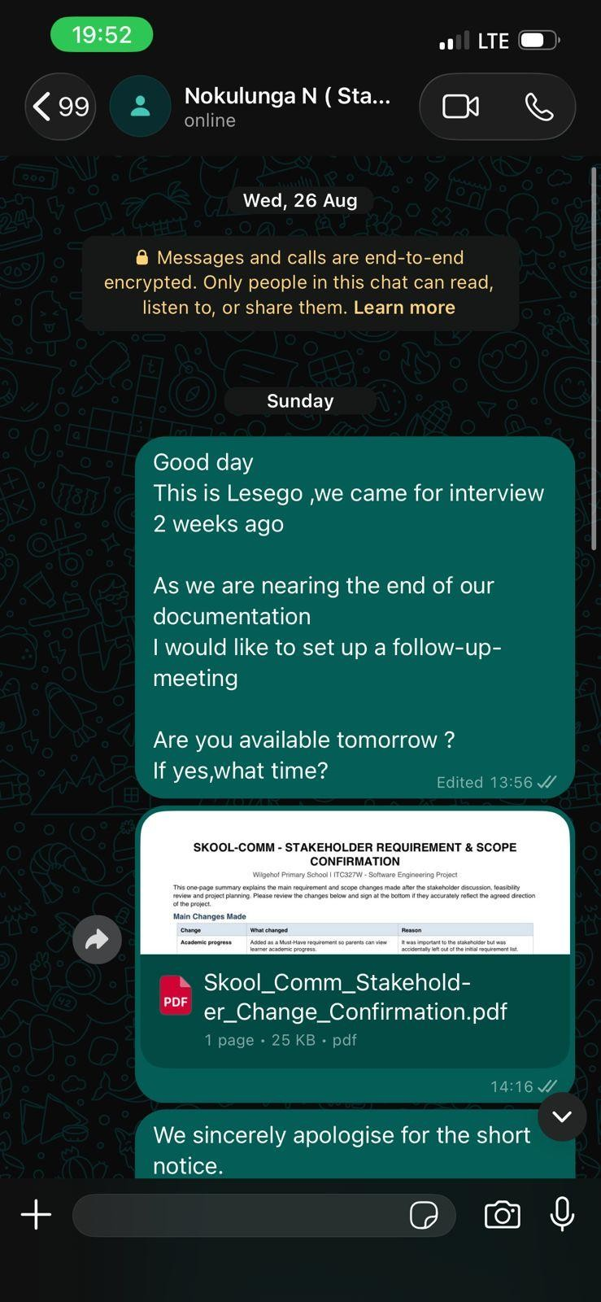

Appendix F: Supabase
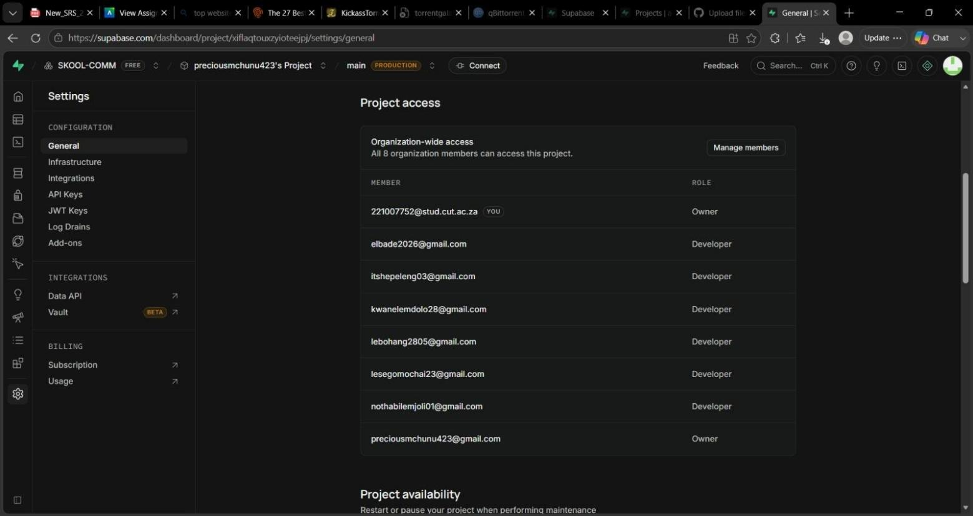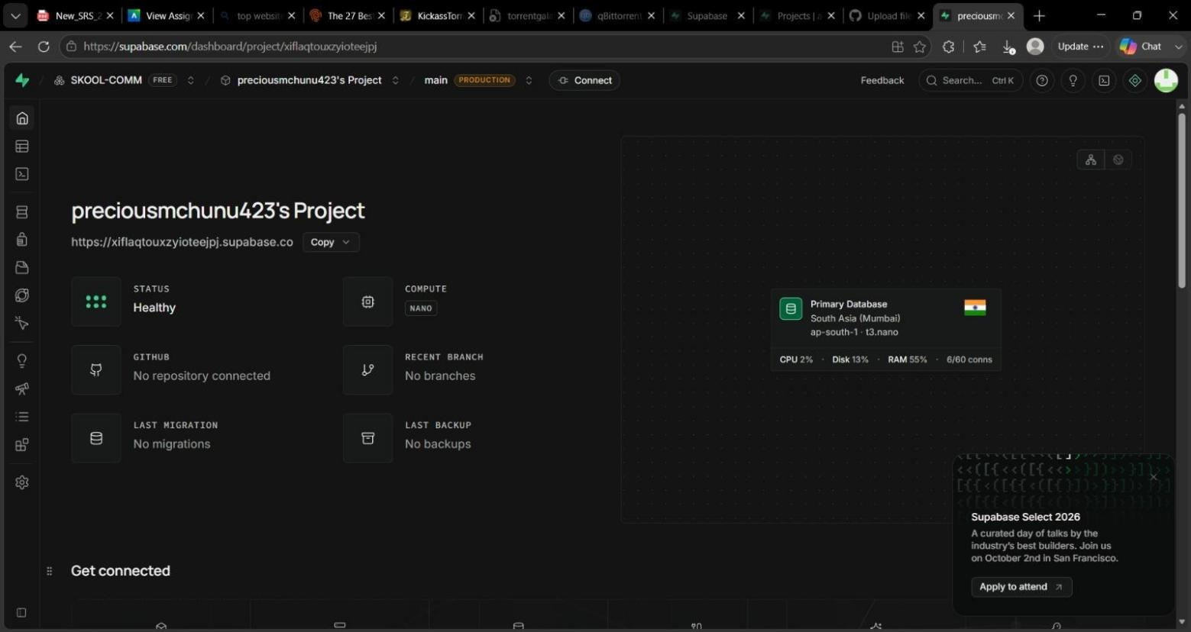

Appendix G: GitHub README

https://github.com/Itshepeleng/SKOOL-COMM

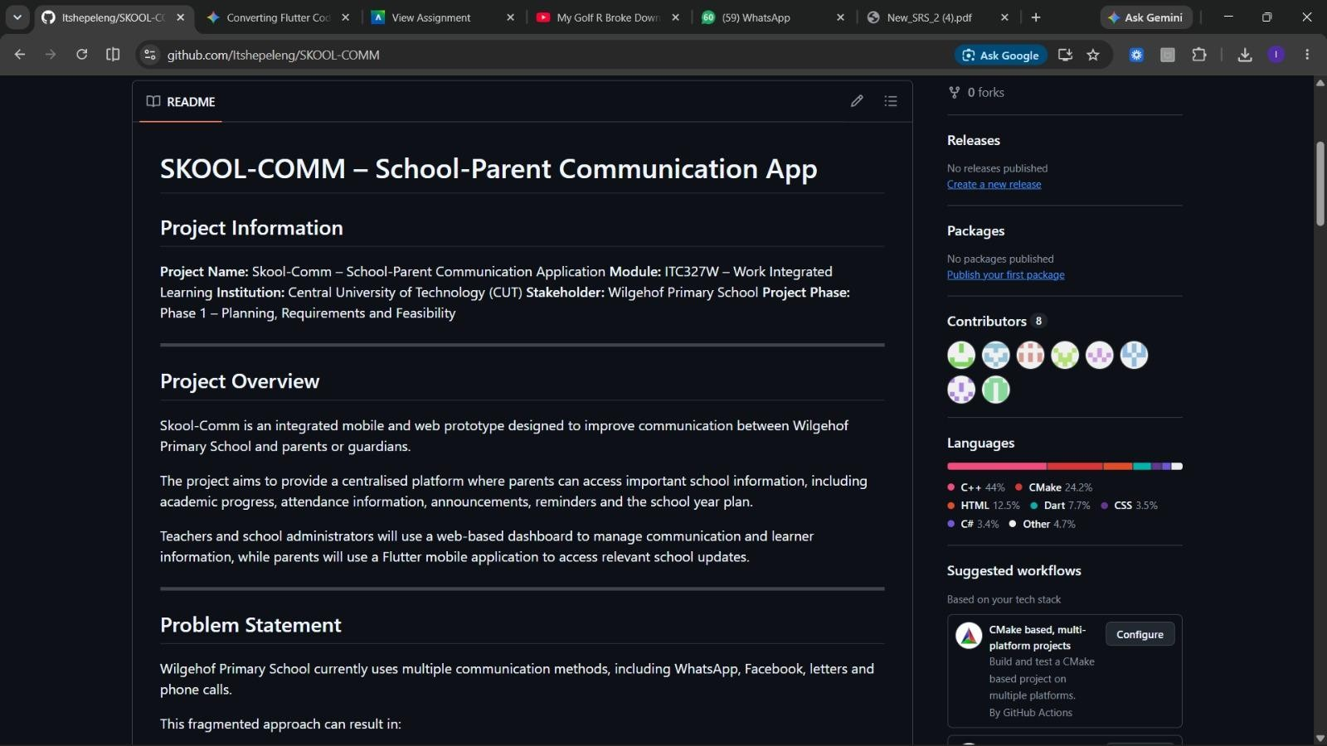

System Architecture

1. Main System Architecture

Component | Purpose
Flutter Mobile Application | Parent-facing mobile interface for registering, creating a learner profile inside their own account, viewing announcements, attendance, behavioural points, events, receive reminders, the year plan and update contact details.
ASP.NET Web Application | Staff-facing web interface for managing announcements, recording attendance and behavioural points, managing events and the year plan, managing user accounts, and tracking parent engagement.
Supabase Authentication | Secure login and role-based access control for parents, teachers and administrators.
Supabase Database | Central storage of all shared data: users, learners, announcements, attendance, points, events and the year plan.
Supabase Storage | Secure storage of PDF statements, and event attachments.

Who Uses Each Components

USER/ROLE | USES FLUTTER? | USES ASP.NET? | MAIN PURPOSE
Parents / Guardians | Yes | No | Register, log in, create learner profile(s), view announcements, events, reminders, year plan, attendance, behavioural points, and update contact information.
Teachers | No | Yes | Log in, manage announcements, record attendance, and behavioural points, communicate with parents.
School Administrators | No | Yes | Log in,manage users, manage announcements, manage events and year plan.

Responsibility of Each Component

COMPONENT | MAIN RESPONSIBILITIES
FLUTTER | Provide the mobile interface for parents. Allow parents to register and create learner profile inside their own account, allow login, viewing of announcements, attendance, behavioural points, events, year plan, and push notifications.
ASP.NET | Provide the web interface for teachers and administrators. allow creation of announcements, recording of attendance and behavioural points. Administrators manage user accounts, manage the year plan, manage events,
SUPABASE AUTHENTICATION | Authenticate users and enforce role-based access so parents, teachers and administrators only see the features allowed for their role.
SUPABASE DATABASE | Store all core data shared by both applications: user accounts, learner profiles with approval status, parent-learner links, announcements, events, attendance records, behavioural points, and engagement logs.
SUPABASE STORAGE | Store files and documents (PDF statements, event attachments) and make them securely available to both Flutter and ASP.NET.

Main Data Flows

FROM | TO | INFORMATION EXCHANGED
Parent (Flutter) | Supabase Auth | Registration details (name, email, password)
Supabase Auth | Parent (Flutter) | Account created confirmation
Parent (Flutter) | Supabase Database | Create learner profile
Parent (Flutter) | Supabase Auth | Login credentials
Supabase Auth | Flutter & ASP.NET | Authentication token and role
Parent (Flutter) | Supabase Database | Request to view learner information (attendance records, behavioural points, announcements, calendar, events, reminders)
Supabase Database | Flutter | Return approved learner data
Flutter | Supabase Database | Record announcement view (FirstOpenedAt, LastOpenedAt, OpenCount)
Teacher (ASP.NET) | Supabase Auth | Login credentials
Supabase Auth | Teacher (ASP.NET) | Authentication token and role
Teacher (ASP.NET) | Supabase Database | Manage announcements, record attendance, record behavioural points
Supabase Database | ASP.NET | Confirmation and engagement data
Administrator (ASP.NET) | Supabase Database | Manage user accounts, manage year plan, manage events
Supabase Database | ASP.NET | Return data for communication history
Flutter & ASP.NET | Supabase Storage | Upload and retrieve files (event attachments, profile pictures)

2.System Architecture Diagram
https://lucid.app/lucidchart/b4083da3-88e3-4f0e-93cf-b5ef9fce978b/edit?viewport_loc=-404%2C-106%2C2196%2C866%2C0_0&invitationId=inv_703f1e63-ede6-4cbf-9030-08cff282b3da

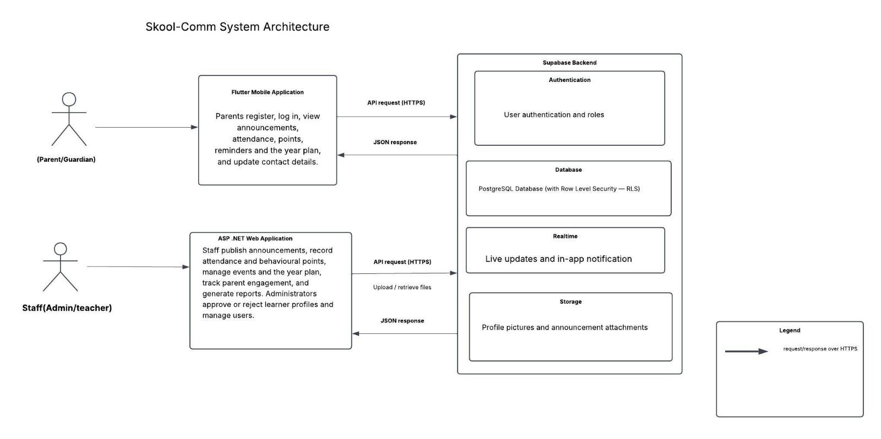

Explanation of Architecture

Who uses the Flutter application
Parents and guardians use the Flutter mobile application. They register an account, log in, and create learner profiles inside their own account. Once the administrator approves the learner profile, the parent can log in to view school announcements, attendance summary, merit points, reminders, the year plan, and events. They can also update their contact information.
Who uses the ASP.NET application
Teachers and school administrators use the ASP.NET web application. Teachers publish announcements, record attendance, record merit points, track parent engagement, and record learner progress. Administrators manage user accounts, manage the admin profile, manage events and the year plan.
What Supabase is responsible for
Supabase acts as the shared backend. Authentication manages secure registration, login, and role-based access. The Database stores all core information used by both applications. Realtime delivers live updates and in-app notifications. Storage holds files such as profile pictures and announcement attachments and makes them securely available to both Flutter and ASP.NET.
How Flutter communicates with Supabase
The Flutter application sends HTTPS API requests to Supabase. It registers the parent, stores the learner profile with a Pending status, authenticates the parent after approval, then retrieves and displays the relevant data and files as JSON responses. Realtime updates are received when new announcements or notifications are pushed. No parent-facing feature is accessible without a valid authentication token.
How ASP.NET communicates with Supabase
The ASP.NET application also communicates with Supabase over HTTPS. Administrators retrieve pending learner profiles, review them, and update the approval status. Teachers and administrators create or update data, which is written to the shared database and storage. Realtime updates are received when new engagement or attendance data is available. No staff-facing feature is accessible without a valid authentication token.
How the two applications form one integrated solution
Both the Flutter mobile app and the ASP.NET web app share the same Supabase backend. When a parent submits a learner profile in Flutter, it appears immediately in the ASP.NET dashboard for administrator approval. Once approved, the parent can view learner information in Flutter. Any information entered by a teacher or administrator is immediately available to parents on their mobile devices, and vice versa. This creates a single, consistent source of truth for school-parent communication.

UML and Database Design

1.Use Case Diagram
Actors
Actor | What the Actor Needs to Do
Parent / Guardian | Register and create learner profile, View announcements, attendance, behavioural points, events, update contact info, and receive notifications.
Teacher | Manage announcements, record attendance and points, track parent engagement.
School Administrator | Manage announcements, events, year plan, users.
Staff user | Generalised actor for Teacher and Administrator.

Main Use Cases
Actor | Use Cases
Parent / Guardian | Register, create learner profile, View Announcements, Attendance, Behavioural Points, Events & Year Plan, update contact, Receive Notifications.
Teacher | Manage Announcement, Record Attendance and Behavioural Points, View Parent Engagement.
School Administrator | Manage Announcements, Manage Events & Year Plan, Manage Users.
Shared | Login, Authenticate User, Display Login Error

Relationships Used
Relationship | Example in Skool-Comm
Association | Parent linked to Register; Teacher linked to Record Behavioural Points; Administrator linked to Approve Learner Profile
<<include>> | All main use cases include Authenticate User.
<<extend>> | Display Login Error extends Authenticate User (only when login fails).
Generalization | Teacher and School Administrator are specialised versions of Staff User.

https://lucid.app/lucidchart/fae8c636-c4c7-4d36-bf0a-111403297811/edit?viewport_loc=-871%2C- 844%2C4228%2C2575%2C0_0&invitationId=inv_b3543c79-614c-4a38-861c-548e3c1b406e
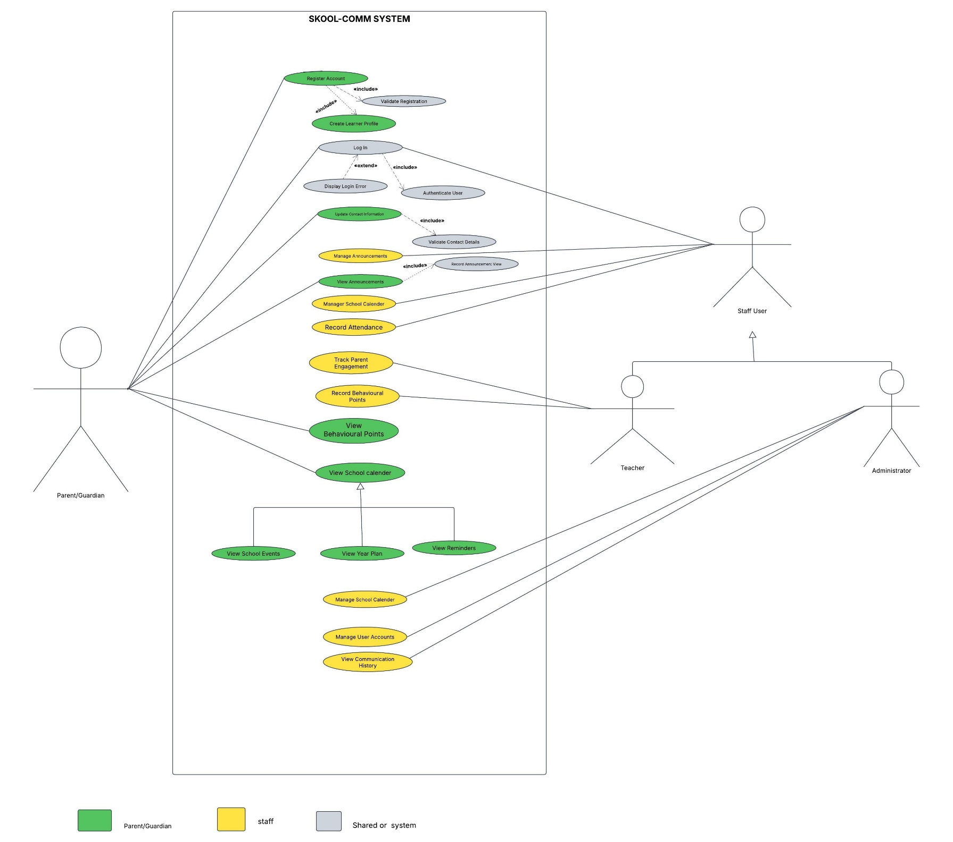

2.Sequence Diagrams

Process 1: Parent Logs in and Views Attendance Summary (Flutter)

Participant | Role
Parent/Guardian | Logs in and views attendance summary
Flutter App | Sends login request and retrieves data
Supabase | Authenticates the parent and returns summary data

https://lucid.app/lucidchart/4c292847-3ab0-4166-9015-d44f8e8a80d1/edit?viewport_loc=-288%2C-322%2C1956%2C1192%2C0_0&invitationId=inv_f69f29df-7b36-48a9-b3b4-6a8cec7d90fc

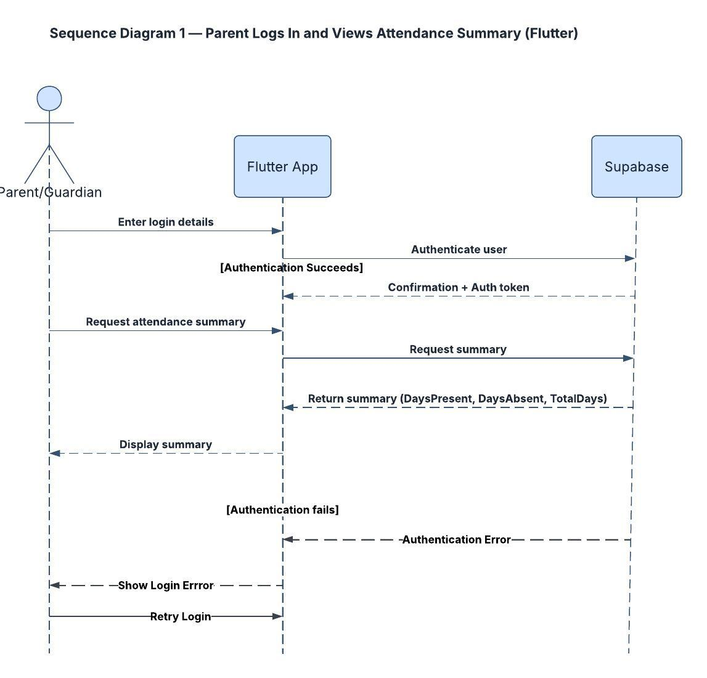

Process 2: Teacher Logs In, Manages Announcements, and Tracks Parent Engagement (ASP.NET)
Participant | Role
Teacher | Logs in, creates an announcement, and views engagement
ASP.NET App | Displays pages and sends requests to Supabase
Supabase | Verifies credentials and returns token and role; stores announcements; returns engagement data

https://lucid.app/lucidchart/4c292847-3ab0-4166-9015-d44f8e8a80d1/edit?viewport_loc=-366%2C-211%2C2248%2C1369%2CoLFCkZ0aGwoS&invitationId=inv_f69f29df-7b36-48a9-b3b4-6a8cec7d90fc
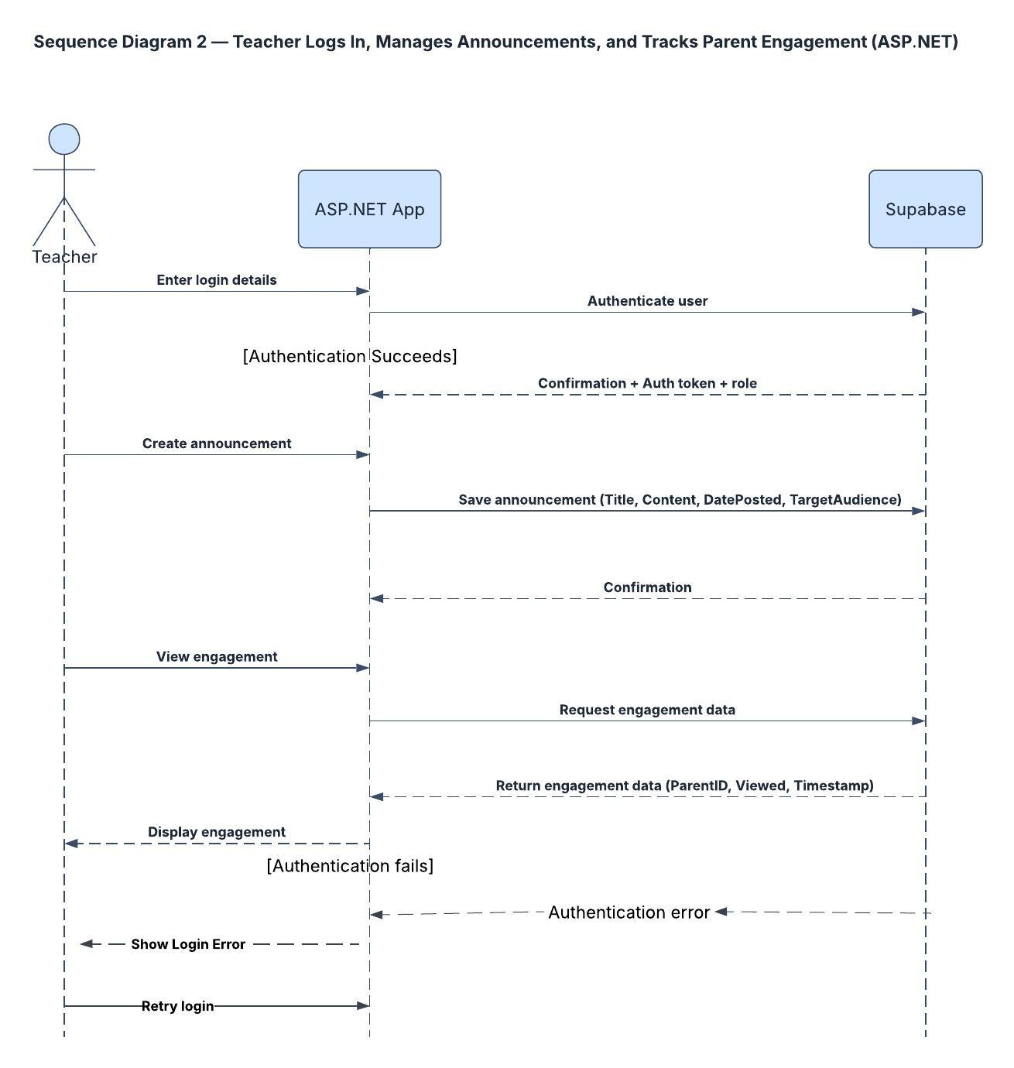

3.Entity Relationship Diagram (ERD)

https://lucid.app/lucidchart/b60932d0-19e0-45a2-b34b-af937c1e102c/edit?viewport_loc=138%2C-948%2C2879%2C1753%2C0_0&invitationId=inv_a200ec40-02b0-4056-997f-4ee00e5a403c

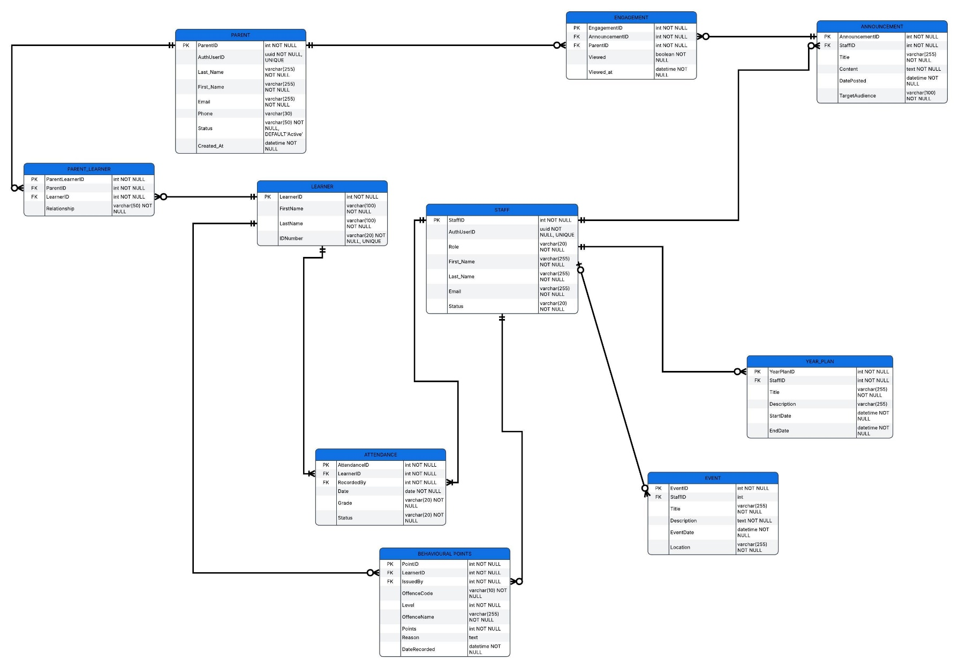

Alignment Across the Designs

REQUIREMENT | USE CASE DIAGRAM | SEQUENCE DIAGRAM | ERD SUPPORT
Parent registers | Register Account <<include>> Validate Registration Details | Parent → Flutter → Supabase | PARENT (Status)
Parent logs in | Log In <<include>> Authenticate User | Process 1 | PARENT (Email, Status)
Login fails | Display Login Error <<extend>> Log In | Process 1 (alt flow) | —
Parent creates learner profile | Create Learner Profile | Parent → Flutter → Supabase | LEARNER, PARENT_LEARNER (Status)
Parent views attendance summary | View Attendance Summary | Process 1 | ATTENDANCE (Date, Status)
Parent views merit points | View Behavioural Points | Parent → Flutter → Supabase | Behavioural_POINTS (Points, Reason, DateRecorded)
Teacher manages announcements | Manage Announcements | Process 2 | ANNOUNCEMENT
Teacher tracks parent engagement | Track Parent Engagement | Process 2 | ENGAGEMENT (Viewed, Viewed_at)
Teacher records attendance | Record Attendance | Teacher → ASP.NET → Supabase | ATTENDANCE
Teacher records merit points | Record Behavioural Points | Teacher → ASP.NET → Supabase | BEHAVIOURAL_POINTS
Administrator manages year plan | Manage Year Plan | Admin → ASP.NET → Supabase | YEAR_PLAN
Administrator manages events | Manage Events | Admin → ASP.NET → Supabase | EVENT
Administrator manages school calendar | Manage School Calendar | Admin → ASP.NET → Supabase | YEAR_PLAN, EVENT
Administrator manages user accounts | Manage User Accounts | Admin → ASP.NET → Supabase | PARENT, STAFF
Administrator manages admin profile | Manage Admin Profile | Admin → ASP.NET → Supabase | STAFF
Administrator views communication history | View Communication History | Admin → ASP.NET → Supabase | ANNOUNCEMENT, ENGAGEMENT
Parent views announcements | View Announcements <<include>> Record Announcement View | Parent → Flutter → Supabase | ANNOUNCEMENT, ENGAGEMENT
Parent views calendar/events/year plan/reminders | View School Calendar, View School Events, View Year Plan, View Reminders | Parent → Flutter → Supabase | YEAR_PLAN, EVENT

ASP.NET web interface designs

Design | Flutter interface design
Tool | Figma
Source link | https://www.figma.com/design/4SaETQ5IginJJN0UCTfDRv/Skool-Comm-Mobile-App?node-id=7-764&t=GzPXu01P1aILIkN9-1
Page name | ASP.NET web
Access checked | verified

The required flutter screens
Flutter Screen | User | Purpose | Related Requirement / Use Case
Splash / Login | Parent/Guardian | Authenticate the parent and provide access to the app | NFR1, FR3 (Authentication)
Create Account | Parent/Guardian | Allow new parents to register on the app | FR12 (User registration)
Home (Dashboard) | Parent/Guardian | Provide quick access to main functions and latest news | FR2, FR3, FR5, FR6
My Children | Parent/Guardian | View and manage children linked to the parent account | FR11 (Record-keeping)
Create Child Profile | Parent/Guardian | Add a child to the parent's account | FR11 (Record-keeping)
Attendance Records | Parent/Guardian | View attendance summary and recent absences | FR2 (Attendance records)
Reminders | Parent/Guardian | Receive reminders for meetings and events | FR5 (Reminders)
Messages | Parent/Guardian | View messages and announcements from teachers and admin | FR3 (Announcements)
Calendar | Parent/Guardian | View the school year plan and upcoming events | FR6 (Year plan)
Documents | Parent/Guardian | Download report cards, letters, and forms | FR4 (Online statements)
Profile | Parent/Guardian | View and update personal contact information | FR12 (Update contact info)
Edit Information | Parent/Guardian | Edit contact details and emergency contact | FR12 (Update contact info)
Demerit Tracking | Parent/Guardian | View learner demerit points and conduct history | FR9 (Points tracking)
Notifications | Parent/Guardian | View all app notifications in one place | FR5 (Reminders)
Settings | Parent/Guardian | Manage app preferences and notifications | NFR6, NFR7 (Usability)

ASP.NET web interface designs

Design | ASP.NET web interface design
Tool | Figma
Source link | https://www.figma.com/proto/RhwwIGHVqs9ddYo6JCxjLW/Skool-Comm-Web-UI?node-id=20-2188&p=f&t=0cCOmfcydrrMRCVF-1&scaling=scale-down&content-scaling=fixed&page-id=0%3A1&starting-point-node-id=7%3A124&show-proto-sidebar=1
Page name | ASP.NET web
Access checked | verified

The required asp.net screens

Page | User | Purpose | Related Requirement / Use Case
Login | Teacher / Admin | Authenticate staff members | NFR2 (Authorized staff)
Dashboard | Teacher / Admin | View summary stats and recent activity | FR8 (Manage communication)
Create Announcement | Teacher / Admin | Create and send announcements to parents | FR3, FR7 (Announcements)
Track Engagement | Teacher / Admin | View which parents have viewed announcements | FR7 (Track engagement)
Record Points | Teacher / Admin | Record merit points for learners | FR9 (Points tracking)
Manage Users | Admin | Create, update, and delete user accounts | FR13 (Manage users)
Communication History | Teacher / Admin | View all past announcements and messages | FR10 (Store records)

Navigation between the screens

Starting Screen | User Action | Next Screen
Splash | Tap "Login" | Login
Splash | Tap "Create Account" | Create Account
Login | Enter credentials → Tap "Log In" | Home (Dashboard)
Login | Tap "Create Account" | Create Account
Login | Tap "Forgot Password?" | Password Reset (future)
Create Account | Fill form → Tap "Create Account" | Home (Dashboard)
Create Account | Tap "Log In" | Login
Home | Tap "Attendance Records" | Attendance Records
Home | Tap "Reminders" | Reminders
Home | Tap "Messages" | Messages
Home | Tap "Merits" | Demerit Tracking
Home | Tap Bottom Nav "News" | Messages
Home | Tap Bottom Nav "Alerts" | Reminders
Home | Tap Bottom Nav "Profile" | Profile
My Children | Tap on child card | Child Profile / Academic Progress
My Children | Tap "Add a Child" | Create Child Profile
Academic Progress | Tap "Download Report" | (File Downloads)
Academic Progress | Tap Back | Home
Attendance Records | Tap "View Full Calendar" | Calendar
Reminders | Tap Back | Home
Messages | Tap on message | Message Detail (future)
Documents | Tap download icon | (File Downloads)
Calendar | Tap Back | Home
Profile | Tap "Edit Contact Information" | Edit Information
Profile | Tap "My Children" | My Children
Profile | Tap "Log Out" | Splash / Login
Edit Information | Tap "Save" | Profile (updated)
Edit Information | Tap Back | Profile

Mobile and Web Integration

Flutter Action | Supabase Data | ASP.NET Action
Parent submits child profile | Child record created in children table | Teacher views learner record
Parent views attendance | Attendance records retrieved from attendance table | Teacher marks attendance
Parent views announcements | Announcements retrieved from announcements table | Teacher/Admin creates announcement
Parent views reminders | Reminders retrieved from reminders table | Teacher/Admin creates reminder
Parent updates profile | User record updated in users table | Admin views updated parent details
Parent views merit points | Behavioural records retrieved from demerit_records table | Teacher records new Behavioural points
Parent views year plan | Year plan retrieved from year_plan table | Admin updates year plan
Parent views documents | Documents retrieved from documents table | Teacher/Admin uploads documents

STAKEHOLDER FEEDBACK

Item | Details
Date of feedback | Friday ,09 October 2026
Designs shown | Splash, Login, Create Account, Home, My Children, Academic Progress, Attendance, Reminders, Messages, Calendar, Documents, Profile, Edit Information
Stakeholder comments | “I am happy, I love the app and I think the school would appreciate this app”
Changes requested | Requested to remove academic progress, Attendance weekly record summary, Use the school Behavioural points Template and to update the demerit point system
Changes made | Removed the academic and used the school Behavioural points template
Evidence available | Meeting notes, Images, WhatsApp follow-up confirmation

Update the System Design

Design Artefact | Change Made | Reason
Architecture | Removed academic results and PDF statements; added attendance weekly summary, | Stakeholder changes
Use Case Diagram | Removed "Record Academic Results" and "Upload Academic Results" | Stakeholder changes
Sequence Diagram | Removed academic-results sequence | Alignment with new use cases
ERD | Removed ACADEMIC_RESULT; renamed MERIT_POINT to BEHAVIOURAL_POINTS; added attendance summary fields, kept single STAFF table | Stakeholder changes and alignment
Flutter Interface | Removed Academic; added Attendance Summary, Behavioural Points (school template) | Stakeholder changes
ASP.NET Interface | Removed academic results upload; Attendance Summary | Stakeholder changes

Citation

Developing Use Case. (n.d.) Scribd. Available at: https://www.scribd.com/presentation/736394505/Developing-Use-Case (Accessed: 13 October 2026)

4.1 Database tables and Fields
Entity / Table | Purpose | Main fields | Data Types / Keys
PARENT | Store parent/guardian profile info | ParentID, AuthUserID, FirstName, LastName, Email, Status | ParentID (PK), AuthUserID (FK to Supabase Auth)
LEARNER | Store learner info | LearnerID, FirstName, LastName, Grade, Class | LearnerID (PK)
PARENT_LEARNER | Link parents to their children | ParentID, LearnerID, Relationship | ParentID (FK), LearnerID (FK)
ANNOUNCEMENT | Store school announcements | AnnouncementID, Title, Content, CreatedAt, StaffID | AnnouncementID (PK), StaffID (FK)
ATTENDANCE | Store daily attendance records | AttendanceID, LearnerID, Date, Status | AttendanceID (PK), LearnerID (FK)
BEHAVIOURAL_POINTS | Store demerit points | PointID, LearnerID, Points, Reason, DateRecorded | PointID (PK), LearnerID (FK)
ENGAGEMENT | Track when parents read announcements | EngagementID, AnnouncementID, ParentID, ViewedAt | EngagementID (PK), AnnouncementID (FK), ParentID (FK)

4.1 Prepare the backend for both applications
Application | Information it will send or retrieve
Flutter | Sends: New parent registrations, new learner profiles.  Retrieves: Announcements, Attendance records, Behavioural points, Year plan events.
ASP.NET | Sends: New announcements, attendance updates, behavioural point updates.  Retrieves: Parent/learner profiles, engagement tracking data.

Check | Result | Action required
Required tables have been created | Pass | None
Primary keys are configured | Pass | None
Foreign keys and relationships work | Pass | None
Test records can be added | Pass | None
Test records can be retrieved | Pass | None
Records can be updated where required | Pass | None
Authentication works, where required | Pass | None
Access permissions are appropriate (RLS) | Pass | Parents can only read their own linked learner data.
4.1 Initial Backend checks

4.2 Mobile Functions
Mobile function | Related requirement or use case | Required screen
Register and create profile | FR14, FR15 | Create Account
Log in | Authenticate User | Splash / Login
Create learner profile | Create Learner Profile | Create Child Profile
View announcements | View Announcements | Messages / Home
View attendance | View Attendance | Attendance Records
View behavioural points | View Behavioural Points | Demerit Tracking
View calendar/year plan | View Calendar/Events | Calendar

4.2 Perform Initial Function Checks
Function or check | Result | Action required
Application launches successfully | Pass | None
Main screens display correctly | Pass | None
Navigation works | Pass | None
Forms validate input (e.g., required fields) | Pass | Added validation to Create Account form.
Mobile application connects to Supabase | Pass | None
Required records can be saved (Learner Profile) | Pass | None
Required records can be retrieved (Announcements) | Pass | None
Authentication works, where required | Pass | None
Access restrictions work as intended | Pass | RLS ensures parents only see their own linked child.

4.3 Web Functions
Web function | Related requirement or use case | Required page
Staff sign-in | Log In | Login
View summary stats | View Dashboard | Dashboard
Create/manage announcements | Manage Announcements | Create Announcement
Track parent engagement | Track Engagement | Announcement Detail
Record behavioural points | Record Behavioural Points | Record Points
View/Manage users | Manage User Accounts | Manage Users

4.3 Perform Initial Function Checks
Function or check | Result | Action required
Web application launches successfully | Pass | None
Main pages display correctly | Pass | None
Navigation works | Pass | None
Forms validate user input | Pass | Fixed empty form submission bug.
Web application connects to Supabase | Pass | None
Required records can be retrieved | Pass | None
Records can be created/updated | Pass | None
Authentication works, where required | Pass | None
User access restrictions work as intended | Pass | Only Staff can access the web portal.

4.4 Shared Processes
Shared process | Action in Flutter | Action in ASP.NET | Shared information
Process 1: Announcement Broadcast | Parent logs in and views the latest announcements on the Home screen. | Teacher creates a new announcement on the dashboard. | Announcement Title, Content, Date, and Teacher ID are stored in the ANNOUNCEMENT table.
Process 2: Learner Profile Creation | Parent registers and enters their child's name and grade. | Teacher/Admin views the newly created learner profile in the web portal. | Parent ID and Learner details are stored and linked in PARENT_LEARNER.
Process 3: Behavioural Points | Parent views their child's current demerit points. | Teacher records a new behavioural point deduction for a learner. | Point value and reason are stored in BEHAVIOURAL_POINTS, updating the Flutter view.

4.4 Check Authentication and Access Across the System
User role | Expected action | Result
Mobile User (Parent) | Access their permitted functions and information (e.g., view own child's attendance). | Pass - RLS restricts access to linked learner only.
Web User (Teacher/Admin) | Access their permitted functions and information (e.g., record points). | Pass - JWT token verifies staff role before allowing database writes.
Unauthorised user | Cannot access restricted records or functions. | Pass - Attempting to access ASP.NET pages without logging in redirects to Login.

4.4 Record and Correct Integration Problems

Integration problem | Possible cause | Action taken
New announcements didn't show in Flutter | Flutter app wasn't fetching fresh data on load. | Implemented a manual refresh pull-down on the Flutter Home screen.
Teacher couldn't record points | Supabase RLS policy blocked the write action. | Updated RLS policy to allow users with the staff role to insert into BEHAVIOURAL_POINTS.
Learner profiles displayed incorrectly | Different field names used in Flutter vs ASP.NET. | Standardized the ERD field names (e.g., FirstName, LastName) across both codebases.

Microsoft Project Screenshot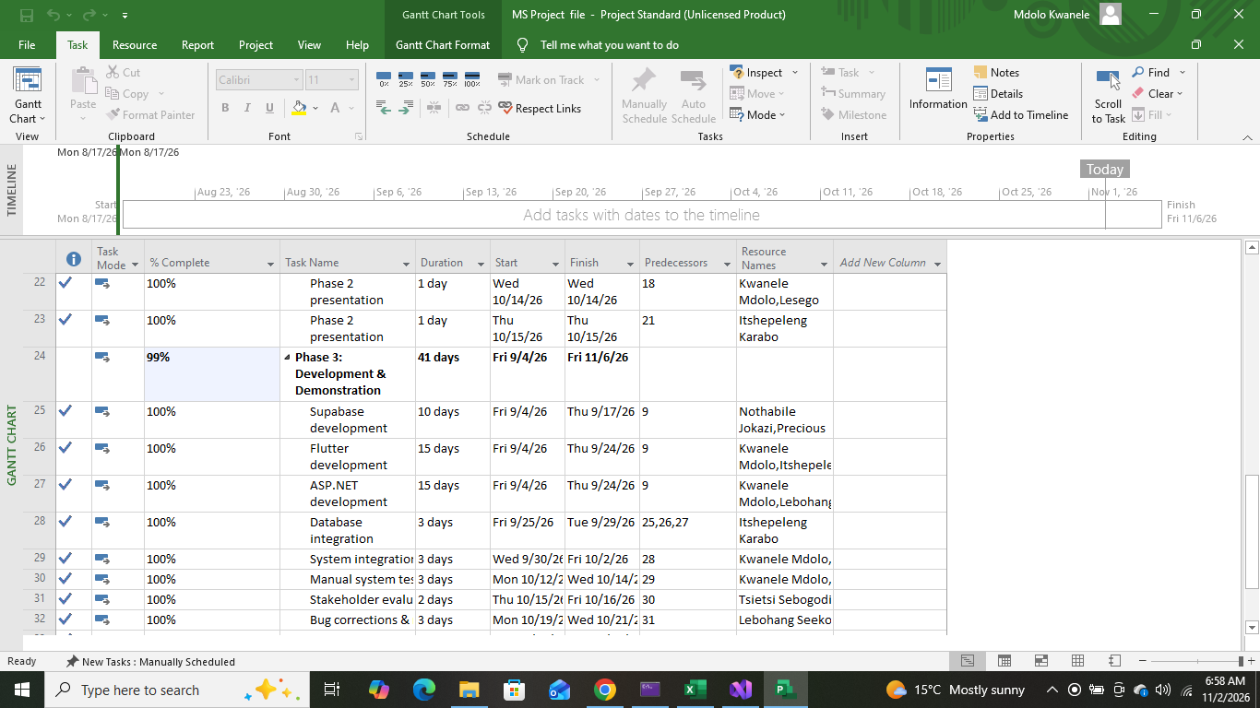

Supabase Screenshots
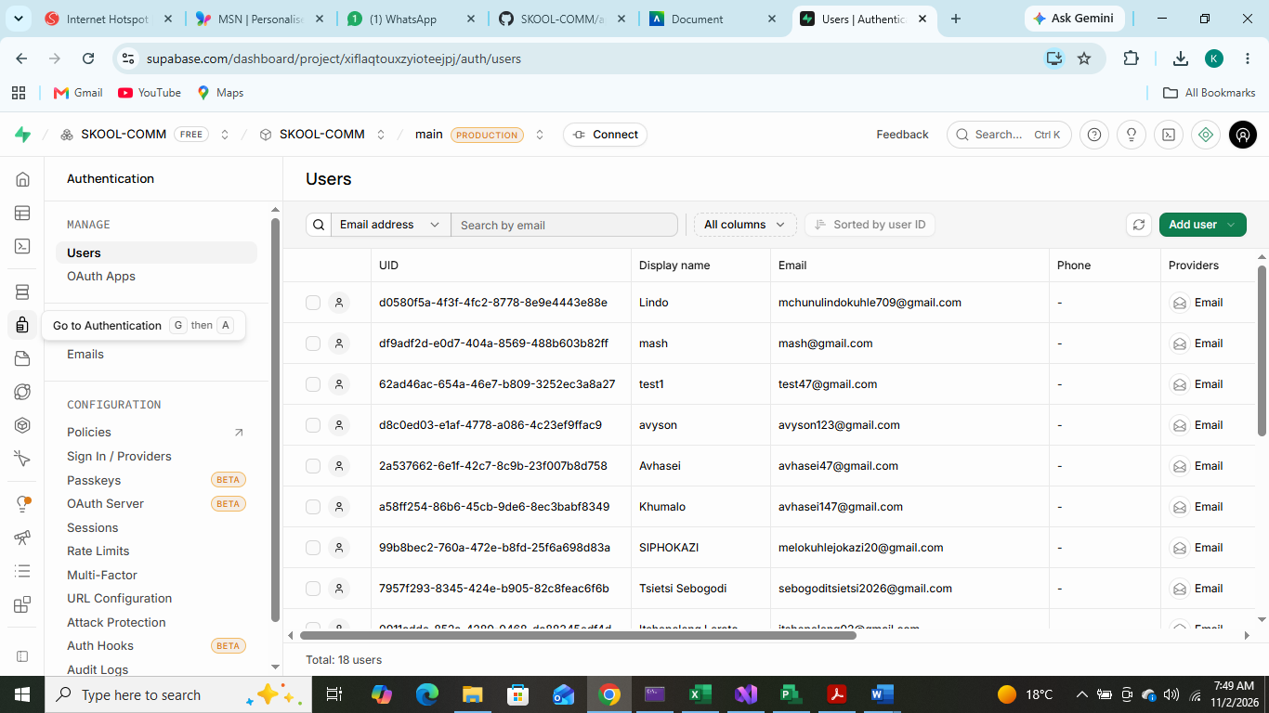
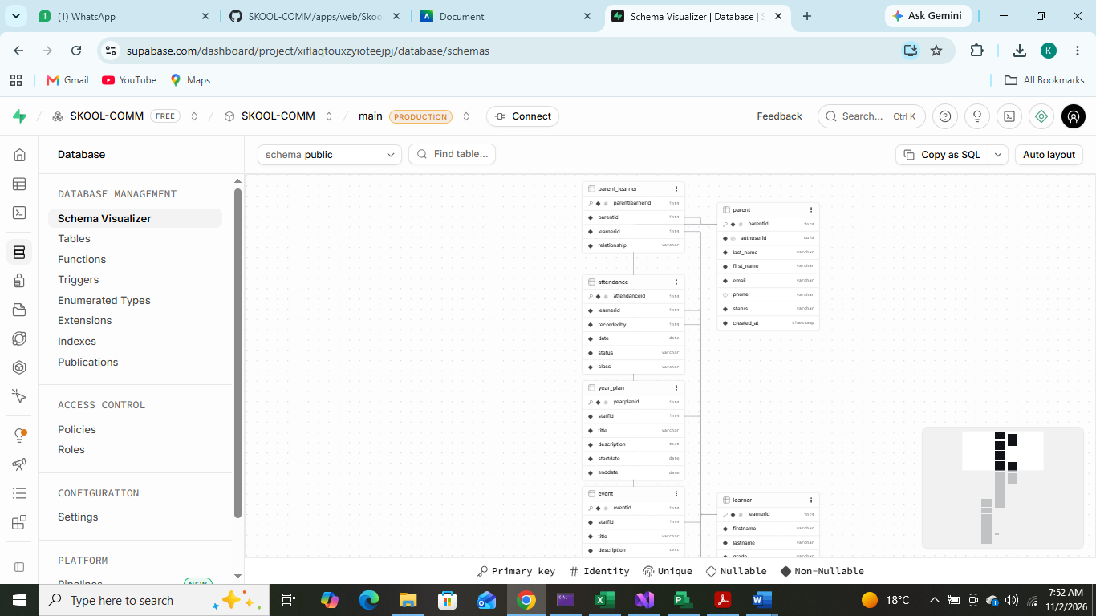

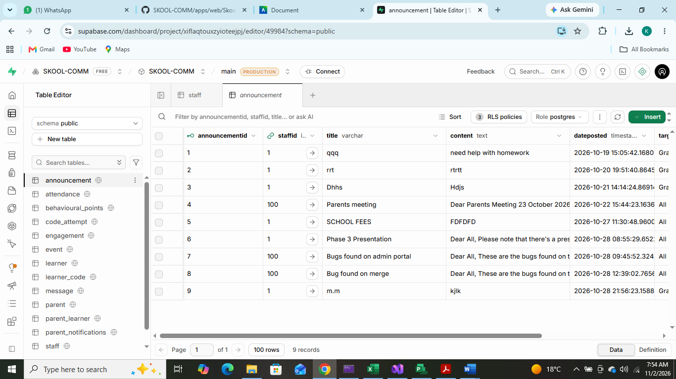

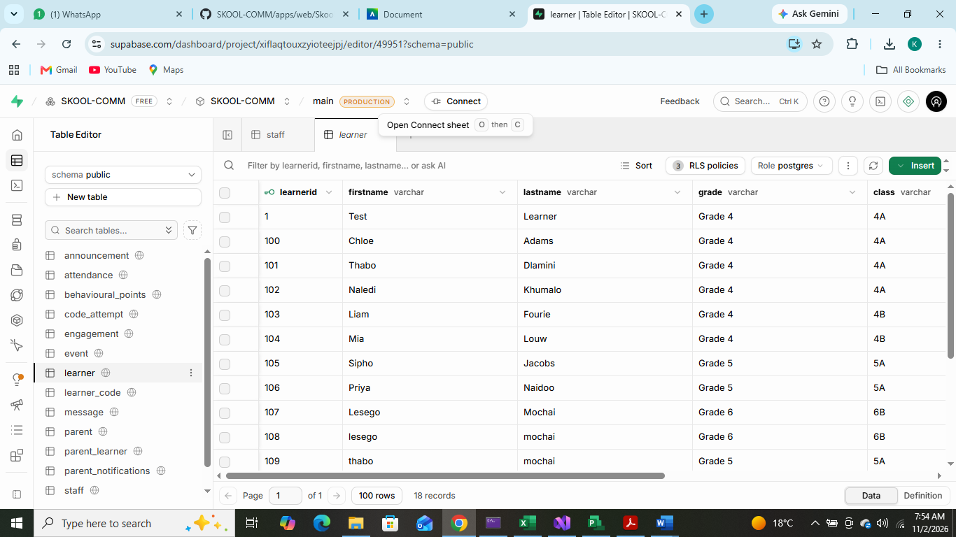

Flutter Mobile App Screenshots
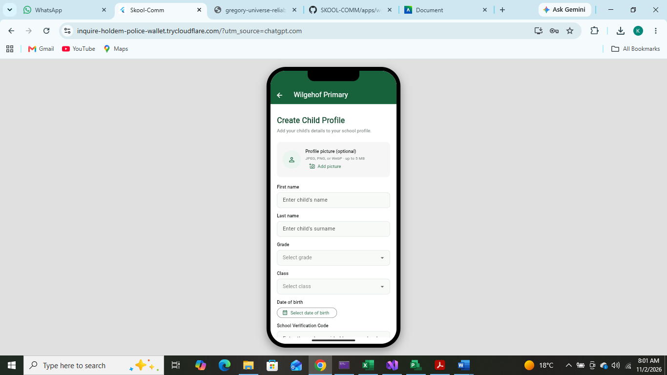

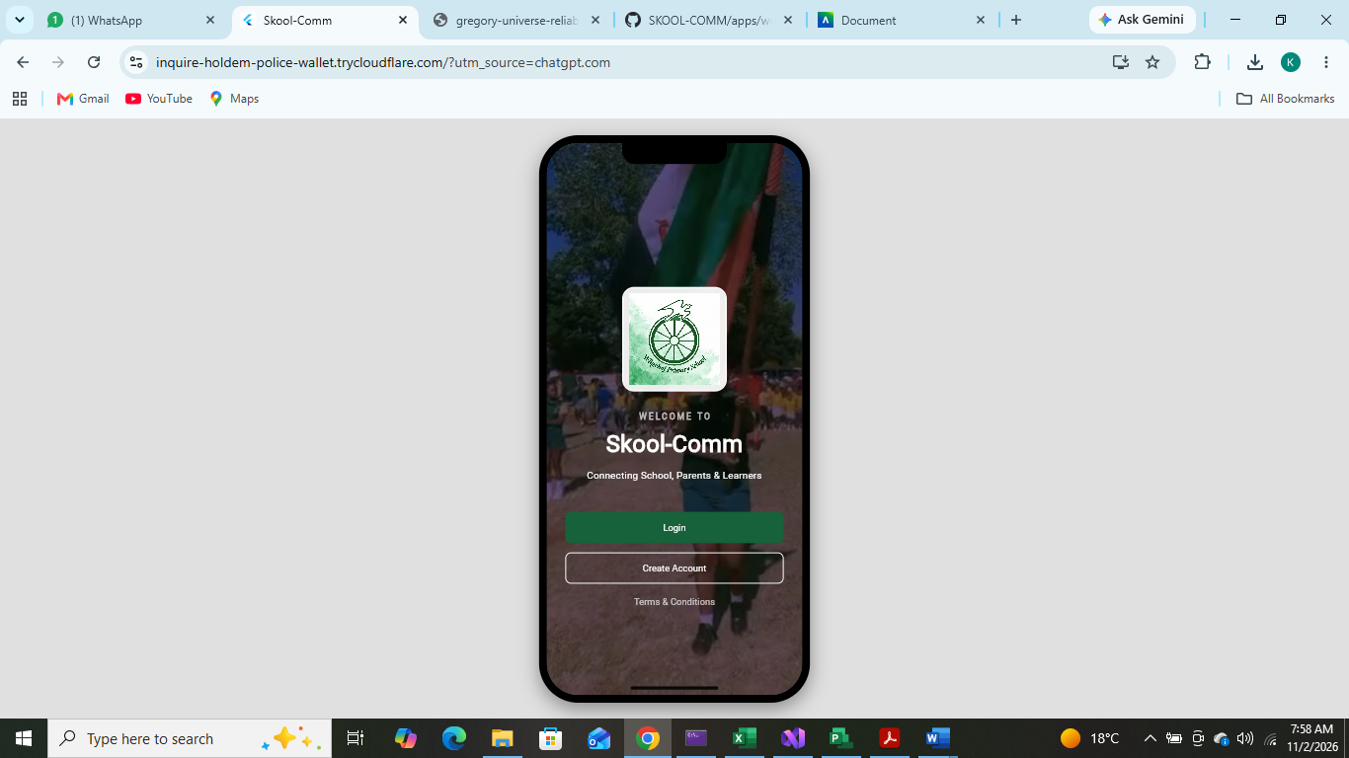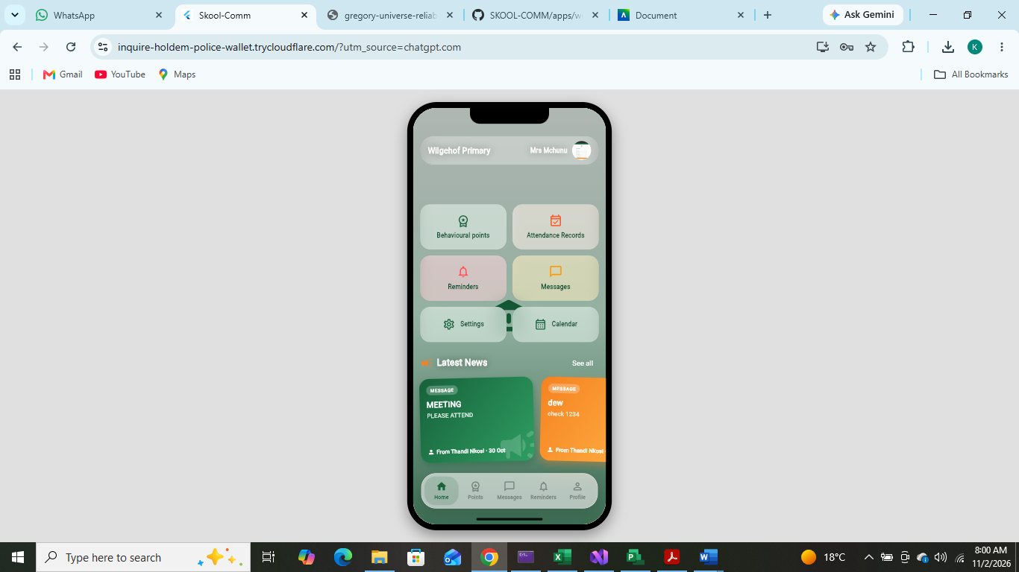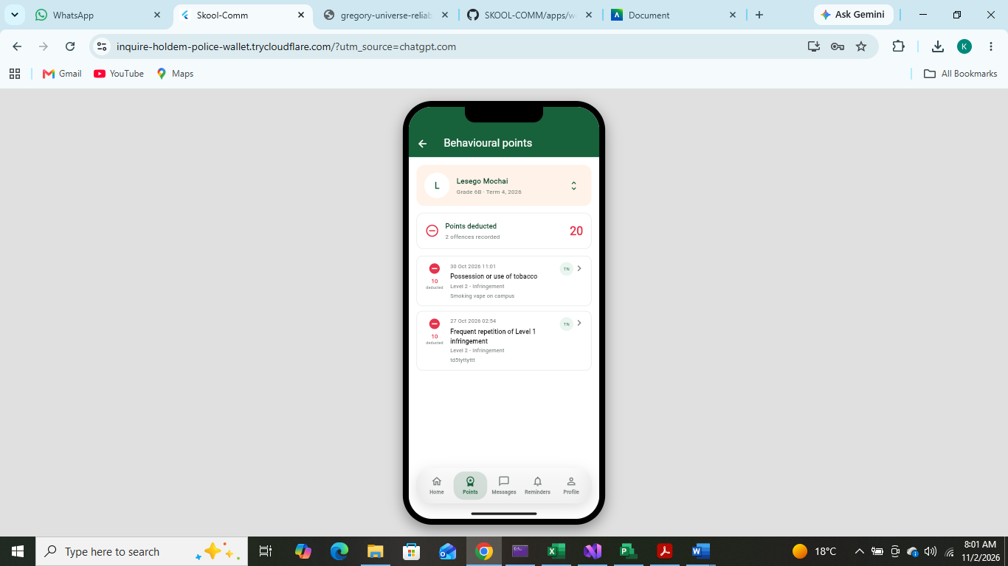

ASP.NET WEB APP Screenshots
Teacher Side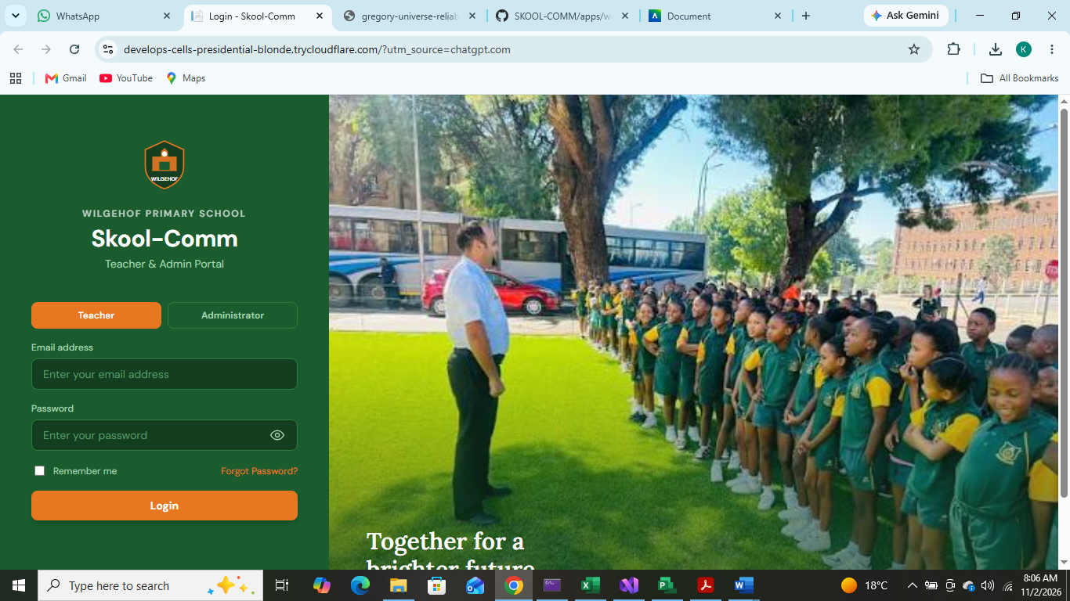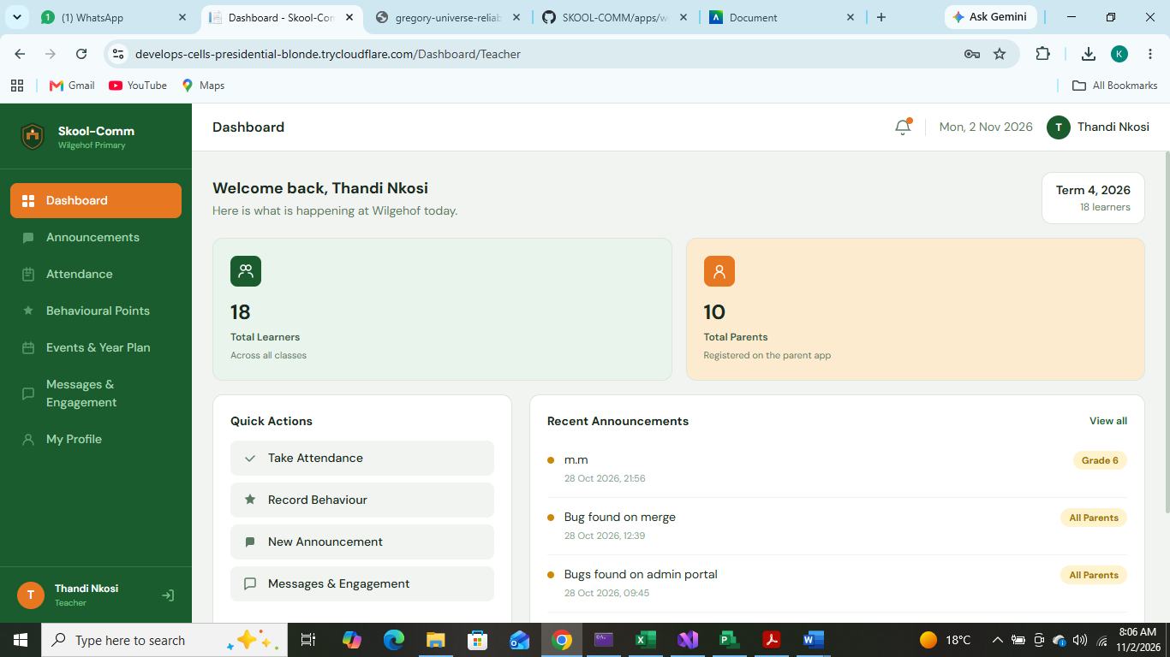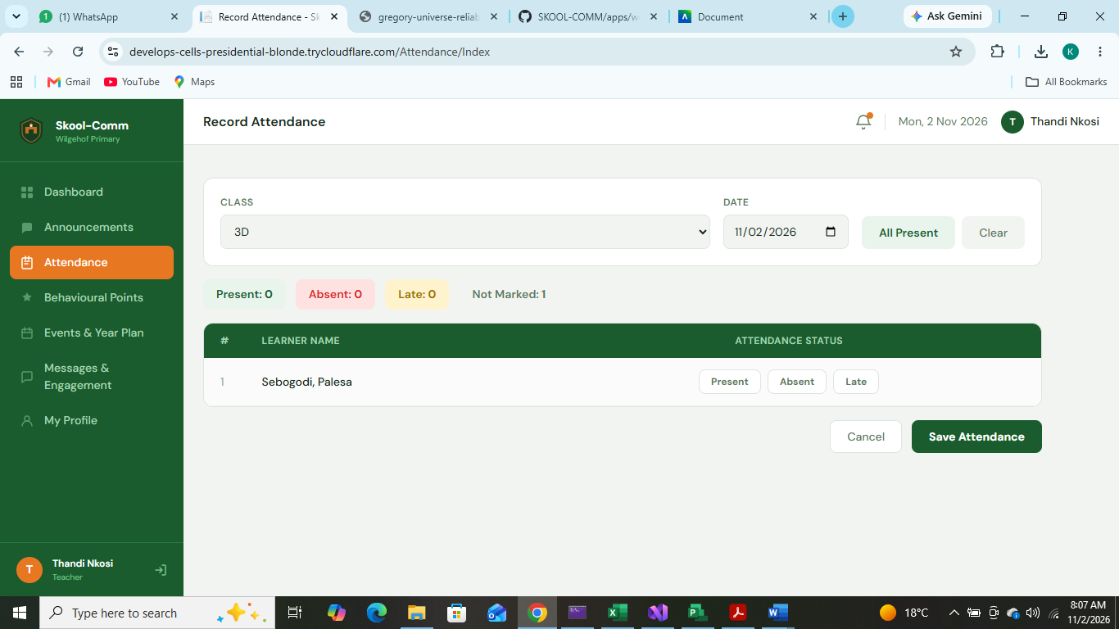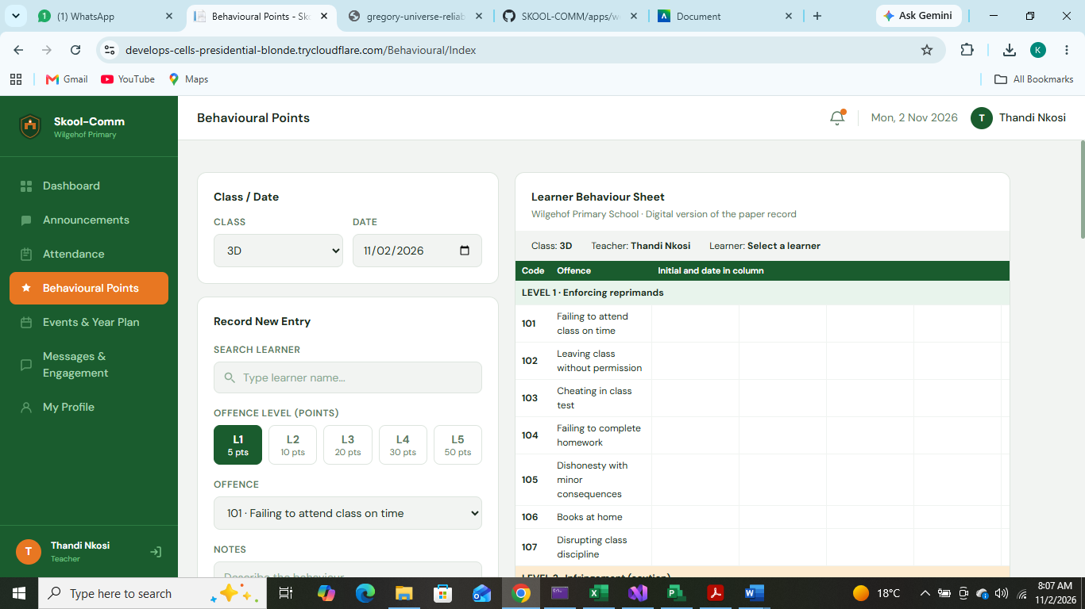

Admin Side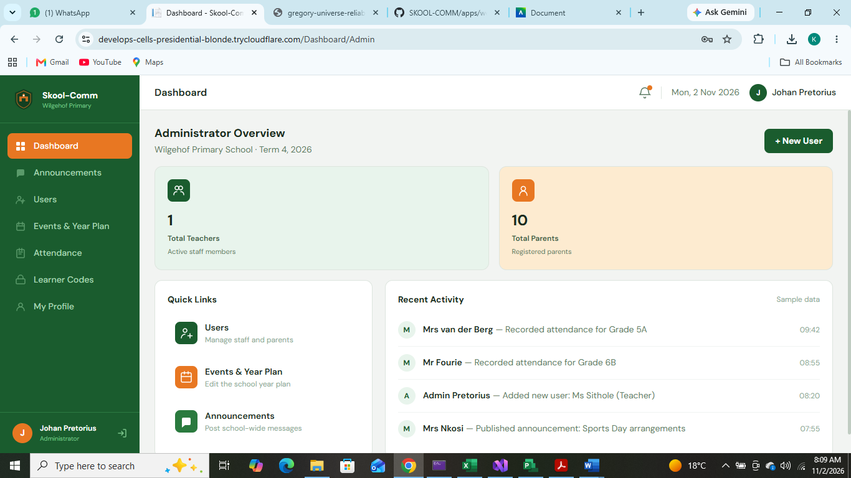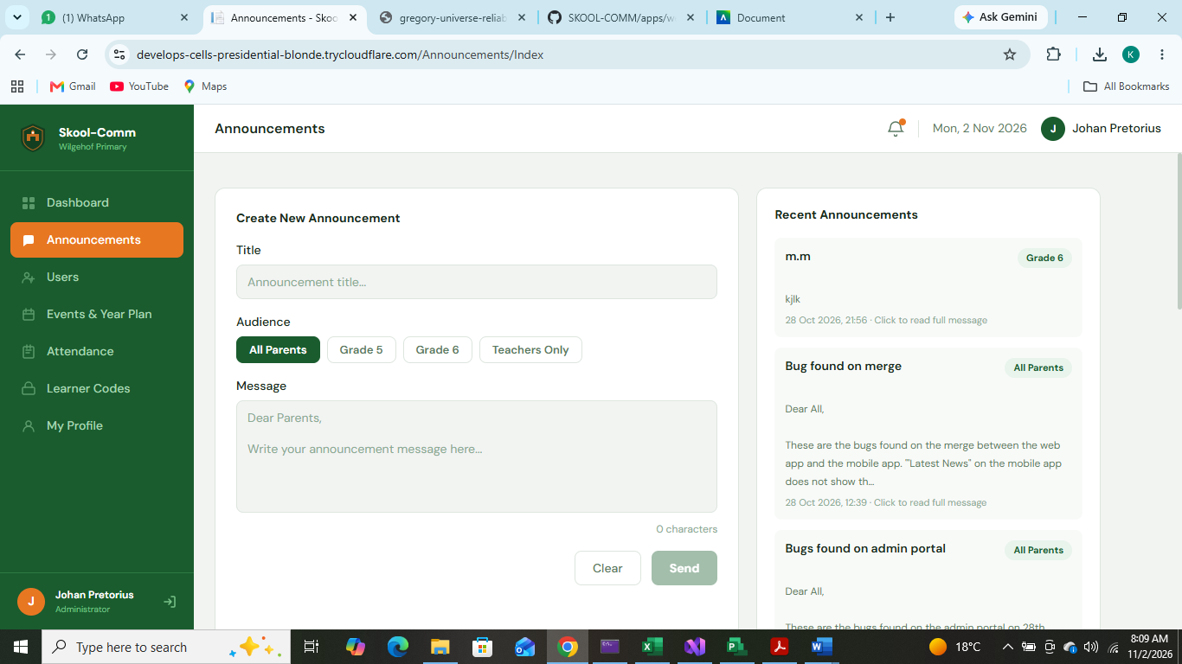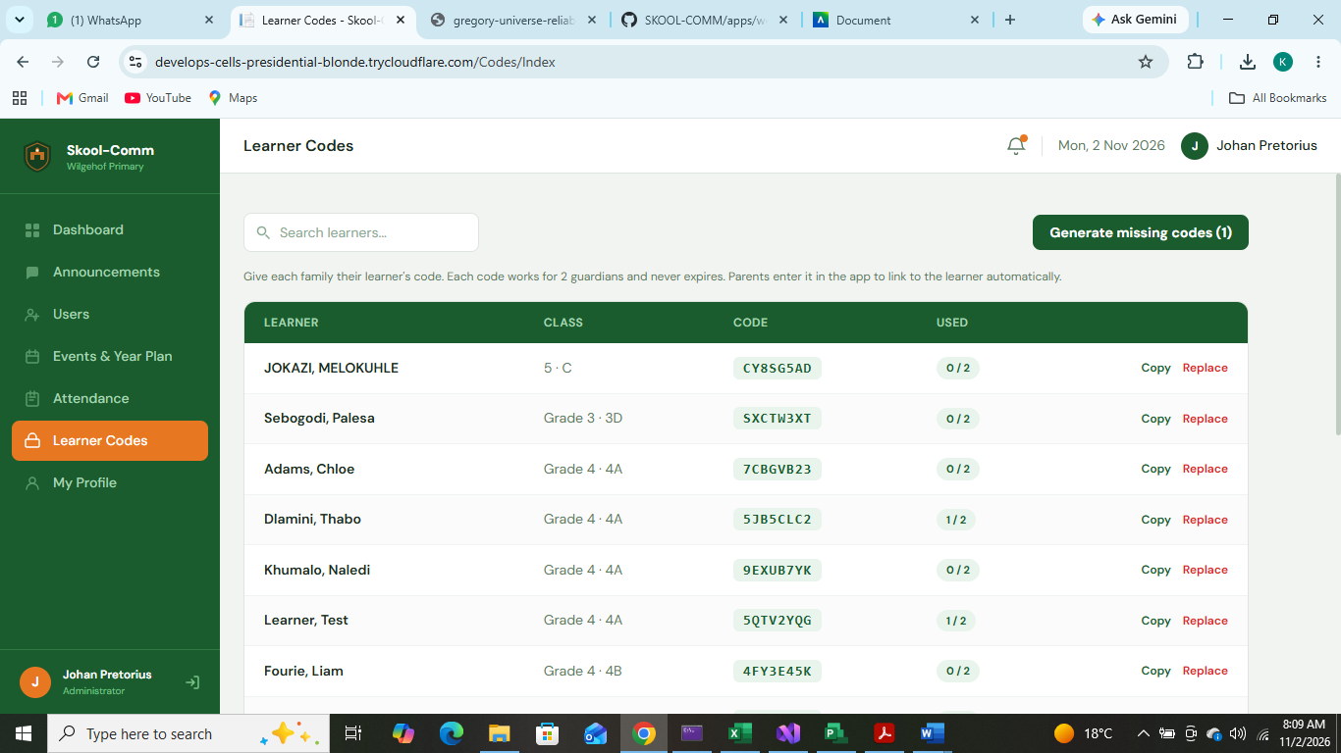

Integration 1
Messages and Engagement to Messages on parent side
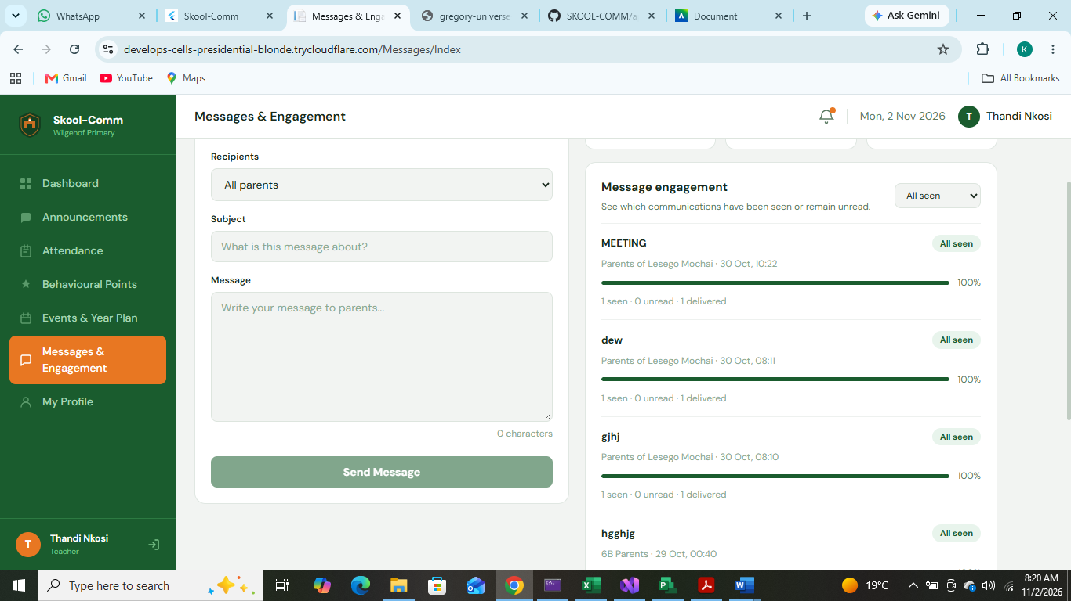

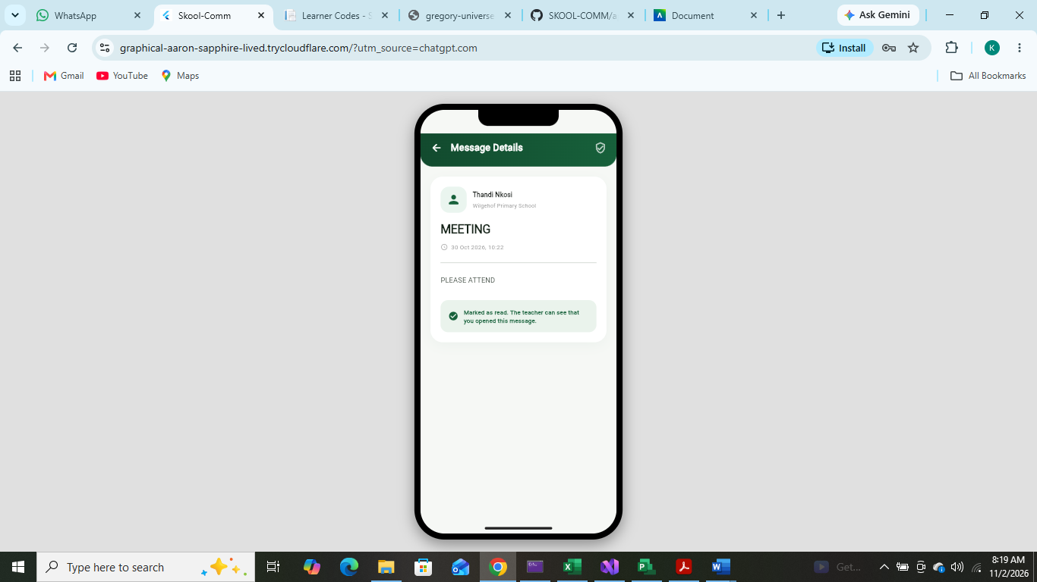

Integration 2
Behaviourial Points recorded on Teacher side to show up on parent app



