Assignment 2: The Cost of Being Wrong
DSA 8401 MSc Data Science and Analytics.
Njogu, Sharon Wanjiru
Admission Number: 103511.

1. Evaluation plan
The dataset is the honest, 17-feature mobile-money table from Assignment 1 (180,000 transactions, 3,991 customers, ts spanning Feb 2025 to Jul 2026). Is_fraud is treated as the adverse outcome, the analogue of a loan default, at a base rate of 8.4%, imbalanced enough that PR-AUC and a cost-based cut-off matter far more than accuracy or the default 0.5 threshold. ROC-AUC is diluted by the large negative class: a model can look strong on ROC-AUC while its ranked list of flagged cases is still mostly wrong, because false positives barely move the false positive rate against 92% negatives. PR-AUC tracks precision against the minority class directly, so it does not get that free credit.
Rows are sorted by ts and split into 5 expanding-window, purged and blocked folds (35% initial train, walking forward), with a 3-day embargo dropped from the end of train immediately before each test block. A full customer purge (dropping every training row for any customer who also appears in the test block) was tested and removes over 99% of the training data, because customers transact throughout the whole 18-month window. This is a structural property of Assignment 1's RFM features: they are computed once per customer over that customer's entire pre-scoring history, so an early transaction already carries information from as late as mid-2026. Since Assignment 1's features are used unchanged, the evaluation uses time-blocking with an embargo rather than a full group purge, and the measured customer overlap between train and test (99.5 to 99.9% across the 5 folds) is reported rather than hidden. This is disclosed as a limitation in Section 7.

2. Ensemble models
Three model families were trained on the identical 5 purged and blocked folds: regularised logistic regression, a random forest, and gradient-boosted trees (XGBoost).
Model | PR-AUC (mean) | PR-AUC (std) | ROC-AUC (mean)
Logistic regression (balanced) | 0.1351 | 0.0027 | 0.6254
Random forest | 0.1393 | 0.0052 | 0.6277
XGBoost (untuned) | 0.1357 | 0.0039 | 0.6228

Logistic regression has the highest bias and the lowest fold-to-fold variance, since a linear boundary on transformed features has no capacity to chase noise. Random forest lowers bias by averaging many decorrelated trees, and that averaging keeps its variance in check. Gradient boosting builds shallow trees sequentially to correct residual error, usually giving the lowest bias of the three, at the cost of being the most sensitive to hyperparameters; untuned, it lands close to the other two here. All three sit in a narrow band because the honest feature set is only weakly predictive (best single-feature correlation about 0.07), a ceiling set by the data, consistent with Assignment 1's honest ROC-AUC of about 0.63.
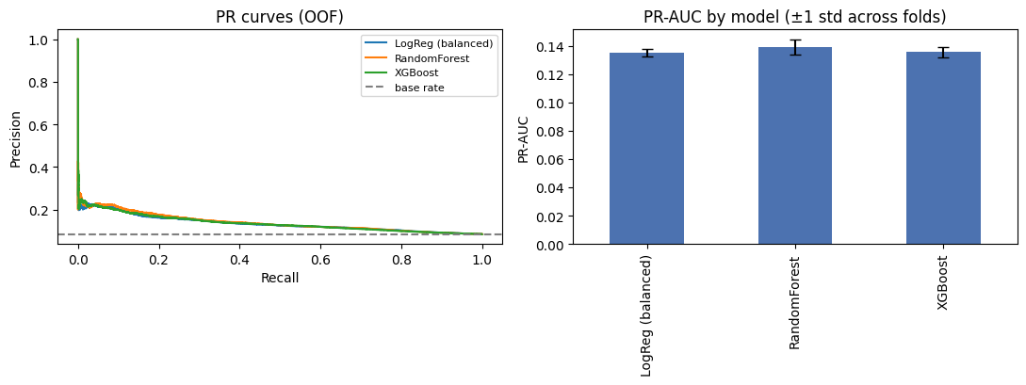
Figure 1. Out-of-fold PR curves and PR-AUC by model, with the base rate shown as a dashed line.

3. Cost-based decisions
A missed default (false negative) costs KES 10,000; a wrongly rejected good borrower (false positive) costs KES 800. Sweeping the untuned XGBoost out-of-fold probabilities for the threshold that minimises total expected cost gives a cost-optimal threshold of 0.08, versus the naive 0.5 cut-off:
Threshold | Total cost (KES) | FN | FP
0.08 (cost-optimal) | 74,644,400 | - | -
0.50 (naive) | 98,634,800 | 9,863 | 6

This is a saving of about KES 205,000 per 1,000 applications. The naive 0.5 threshold almost never flags anything (FP=6) because raw scores rarely cross 0.5 at an 8.4% base rate, so it misses nearly every real default; moving the threshold down trades a modest rise in wrongful rejections for a large fall in missed defaults, which the 12.5x cost asymmetry rewards heavily. This threshold is revisited after tuning and calibration in Section 5.

4. Imbalance handling and tuning

4.1 Imbalance
Two approaches were compared, both correctly inside the purged CV folds: class_weight="balanced", and SMOTE oversampling refit inside each fold. A third run resamples with SMOTE before splitting, outside any fold, to quantify how much that leaks.
Approach | PR-AUC (mean) | PR-AUC (std)
class_weight (in-fold, honest) | 0.1357 | 0.0039
SMOTE (in-fold, honest) | 0.1372 | 0.0041
SMOTE (outside fold, leaky) | 0.9776 | 0.0003

Resampling before the split lets SMOTE synthesise minority points from neighbours that then land on both sides of a fold, so a synthetic point interpolated from a test-fold neighbour is not genuinely unseen. PR-AUC inflates from about 0.14 (honest, either technique) to 0.98 (leaky), a similar order of inflation to the two planted leaks in Assignment 1. class_weight and in-fold SMOTE perform similarly honestly; class_weight is used going forward since it is cheaper and avoids synthesising data.

4.2 Tuning
An Optuna study of 60 trials tuned XGBoost only, over tree depth, learning rate, subsample and column subsample ratios, min_child_weight, L1/L2 regularisation, and scale pos weight. The objective is mean PR-AUC across the last 2 purged folds, each capped at 50,000 training rows with preprocessing fit once and cached per fold, so only classifier hyperparameters vary between trials; this keeps the study inside a sane time budget without touching the evaluation logic. Pruning uses a MedianPruner, reporting PR-AUC after each of the 2 folds so a clearly-behind trial stops early (2 of 60 trials were pruned). The study is persisted to optuna study.db so it can be reopened.
Best tuning-objective PR-AUC: 0.1427 (versus 0.1357 untuned). Best parameters: n_estimators=308, max_depth=3, learning_rate=0.017, subsample=0.87, colsample_bytree=0.61, min_child_weight=7, reg_lambda=4.46, reg_alpha=2.15, scale_pos_weight=7.72.

5. Calibration
The tuned XGBoost was refit on all 5 purged and blocked folds. Inside each fold, the training block was further split chronologically (80/20) and a Platt (logistic) calibrator fit on the held-back 20%, never on the test fold itself, giving out-of-fold raw and calibrated probabilities for every scored row.
Metric | Raw | Calibrated
Brier score | 0.1762 | 0.0756
PR-AUC | 0.1419 | 0.1414
Cost-optimal threshold | 0.40 | 0.10
Savings per 1,000 vs naive 0.5 | KES 96,639 | KES 224,381

Calibration moved the threshold substantially. Scale pos weight in the tuned model pushes raw scores above their true probability to compensate for the 8.4% base rate during training, so a raw score of 0.40 and a calibrated probability of 0.10 can represent the same underlying risk. Platt scaling maps the raw score back to an actual probability, so the calibrated threshold is the one that means what it says,
"flag if P(default) is at least this", and is the one that should ship. A reviewer reading threshold = 0.40 off the raw model would badly misjudge how conservative the policy actually is. Achievable minimum cost is nearly identical either way, since calibration is rank-preserving within a fold; only the threshold's label changes.
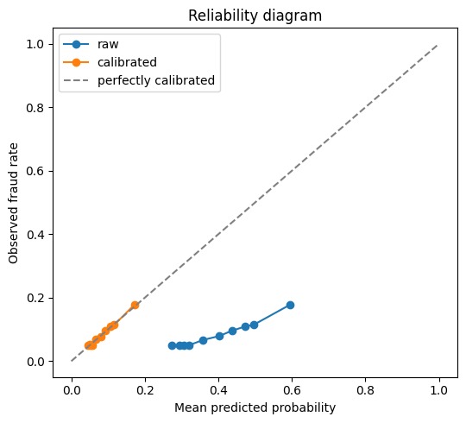
Figure 2. Reliability diagram, raw versus calibrated out-of-fold probabilities.

6. Explainability and fairness
Global and local SHAP explanations were produced on the tuned model refit on the full honest feature set. The strongest global drivers are transaction- and behaviour-level features such as amount, night-transaction share, and the pay-bill cascade proxy, consistent with what a case-level reason for an individual decline would reference (for example, "flagged due to unusually high night-time transaction share and a rapid pay-bill cascade").
Approval rate and false-negative rate were computed at the calibrated cost-optimal threshold, split by region and by segment:
Region | Approval rate | False-negative rate
Kampala | 0.457 | 0.285
Mwanza | 0.441 | 0.279
Arusha | 0.455 | 0.276
Nairobi | 0.447 | 0.272
Kigali | 0.450 | 0.269
Mombasa | 0.450 | 0.266
Nakuru | 0.445 | 0.266
Dar es Salaam | 0.449 | 0.265
Jinja | 0.449 | 0.263
Eldoret | 0.447 | 0.260

Segment | Approval rate | False-negative rate
Retail | 0.448 | 0.272
Merchant | 0.454 | 0.267
Agent | 0.454 | 0.242

The spread across regions (0.260 to 0.285) and segments (0.242 to 0.272) is modest but not zero. region and segment are not fed to the model as protected attributes, but region correlates with the agent_id missingness pattern identified in the audit (Section 1 of the notebook) and could act as a proxy for something a regulator would want disclosed.
The Central Bank of Kenya (Digital Credit Providers) Regulations, 2022 place the onus on a lender to carry out due diligence on a customer's ability to repay before advancing credit, and were introduced largely in response to consumer-protection failures such as opaque pricing and lending decisions borrowers could not question. That expectation implies a working model needs to support an individual, case-level reason for a decline, not just an aggregate accuracy number, which is what the local SHAP explanation is for. Any region or segment with a materially higher false-negative rate than the rest is worth a second look before deployment, not because the model is necessarily unfair, but because an underwriting policy that misses one group's genuine defaults more often than another's is a discrimination risk regardless of intent.

7. Reproducibility
All preprocessing (imputation, Yeo-Johnson power transform, robust scaling, one-hot encoding) is refit inside every CV fold via a single ColumnTransformer plus Pipeline, so no statistic crosses a train and test boundary. The Optuna study is persisted to optuna_study.db and the honest pipeline is saved with joblib and reloaded to confirm it scores cleanly. The one limitation carried forward from Section 1 is that the RFM features summarise each customer's whole pre-scoring history, so the purged and blocked CV here controls for split structure but not for that feature-level hindsight; a genuinely rolling feature store would be needed before this evaluation number could be quoted to a regulator as an unbiased forward-looking estimate.

Recommendation
The model recommended for deployment is the tuned, Platt-calibrated XGBoost from Sections 4 and 5. It matches or beats the untuned ladder's PR-AUC, its probabilities are genuinely interpretable after calibration (Brier score roughly halved, from 0.176 to 0.076), and it is the only one of the three models with both a working SHAP explainer and the flexibility to be re-tuned as new data arrives. The recommended threshold is the calibrated cost-optimal cut-off of 0.10, not the naive 0.5: it directly minimises the KES 10,000 versus KES 800 cost asymmetry and saves an estimated KES 224,381 per 1,000 applications over the naive threshold. Before this pairing goes live, the customer-overlap limitation in Section 1 and the regional false-negative spread in Section 6 should both be re-checked against a feature pipeline that does not summarise a customer's full history in a single snapshot.

