**Brand Philosophy (Core Identity) for Ideal Construction**

**Vision: With the will of Allah, we build with Ihsan (Allah sees all that we do) — crafting spaces with sincerity, trust, and excellence, knowing that every structure we create is a responsibility before Him and a service to humanity.**

**Mission: Our mission is to implement the will of Allah Almighty in all our business dealings by consistently meeting our customers’ expectations in the services we offer. Guided by Shariah-based business practices and ethics, we deliver high-quality, transparent, and cost-effective construction solutions. With a team of skilled architects and professionals, we ensure precision in design, verified material quality, and efficient project management, creating durable and trusted spaces that meet our clients' needs.**

**Values:  
✅ Ihsan – Doing everything with excellence, sincerity, and the awareness that Allah sees all that we do.**

**✅ Honesty – Truthfulness in every promise, every price, and every project update.**

**✅ Trustworthiness – Fulfilling every commitment as a sacred trust, whether to clients, partners, or our team.  
✅ Fairness & Justice – Ensuring fairness in pricing, treatment, and decisions — for both clients and laborers.**

**✅ Gentleness & Kindness– Dealing with clients, workers, and suppliers with compassion and respect.**

Our services

✅ **Project Management & Consultancy**  
(Design & Build) Complete supervision and project execution from planning to delivery with proper timelines.

✅ **Residential Construction**  
Custom home building – from foundation to finishing – for 5 Marla, 7 Marla, and larger properties.

✅ **Architectural & 3D Design Services**   
3D rendered front elevations and complete architectural planning by certified architects.

✅ **Renovation & Remodeling**  
Upgrade and remodel existing properties with modern design and durable materials.

Jan da investor paternship program paky add k

✅ **Investor Partnership Program**

**💼🏡 Invest with Us: Let’s Build Dreams Together in Islamabad!**

💼 Ideal Construction brings you a smart investment opportunity: 👉 Buy land, build homes, and sell for profit — all with us! ✨ We take care of everything — from project planning to construction and sales. 💸 You invest, we manage. We split the profit 60/40. Let’s team up to turn empty plots into dream homes — and shared success!

Tagline

*“Ideal Construction — Built with Ihsan. Built for Life.”*

**Color Palette:**

**Primary colors:**

**#0a284e | #157a6e**

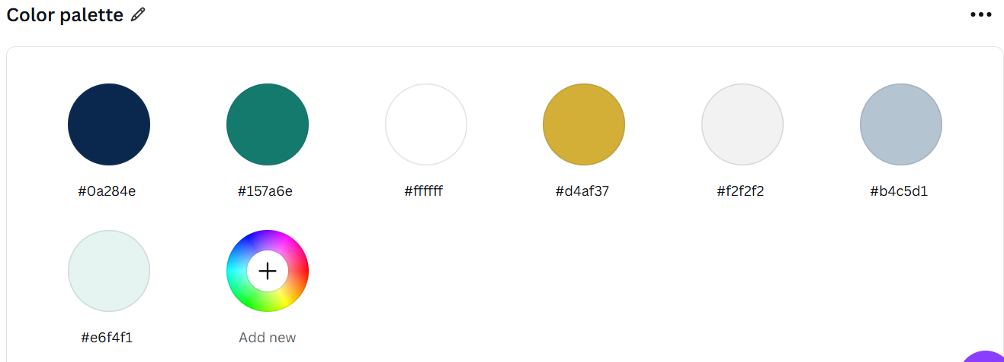

**Typography:**

Title 🡪 Montserrat Bold

**Subtitle 🡪 Poppins Medium**

**Body 🡪 Roboto Regular**

**Quote 🡪 Playfair Display**

**The Problems Ideal Constructions Solve**

**🏗️ Unclear Planning & Design  
Many clients start construction without a proper plan. We offer expert architectural design and detailed planning to avoid costly mistakes.**

**🔍 Material Quality Uncertainty  
Most builders don’t disclose the quality of materials used. We share certified lab reports for materials like steel and bricks — so you know exactly what you're getting.**

**💸 Low Quality at High Prices  
Many clients pay premium prices but receive poor quality work. At Ideal Construction, we ensure high-quality craftsmanship with fair and transparent pricing.**

**⏳ Delays & Poor Time Management  
Projects often get delayed due to poor coordination. We use proper planning tools to ensure on-time delivery with efficient resource management.**

**💬 Lack of Trust & Communication  
We keep you informed at every stage of your project. No surprises, no hidden costs — just honest updates and complete transparency.**

**About Me**

I'm Sanood Anwar, a business enthusiast with a natural drive for innovation and leadership. From an early age, I knew my path was business—not just as a career, but as a mindset. That mindset led me to pursue my education in Entrepreneurship and Business Innovation from Islamia University of Bahawalpur, after completing my intermediate studies at Islamia College Peshawar.

Adaptability and forward thinking have always been second nature to me—key traits that shape my entrepreneurial approach. I strongly believe in **effectual entrepreneurship**—the idea that great businesses start with what you already have, not waiting for perfect conditions. It's about being flexible, making smart use of your resources, and building success step by step.

Currently, I serve as the Chief Operating Officer at Ideal Constructions, where I apply strategic insight and creative problem-solving to help the company grow in a competitive market.

My core skills include design thinking, business plan development, market research, effective communication, and leadership. I also bring entrepreneurial strengths such as risk-taking, opportunity recognition, resilience, strategic networking, and a relentless focus on innovation.

I'm passionate about building solutions that create real impact—and I'm always open to meaningful collaboration and fresh challenges.

Contacts details

**77 Square, E-block, Multi-Garden B-17, Islamabad**

**0320-9840974**

**Idealconstructionsic@gmail.com**