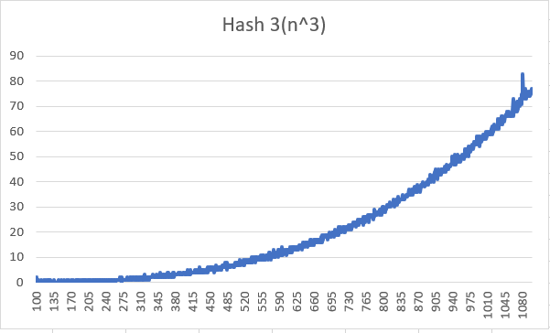

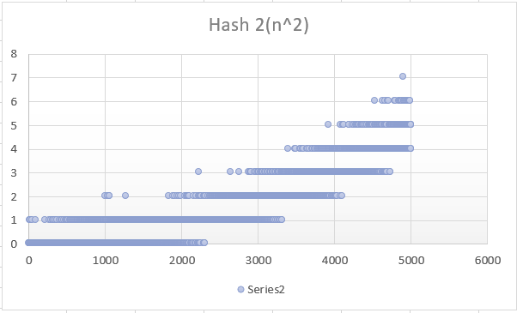

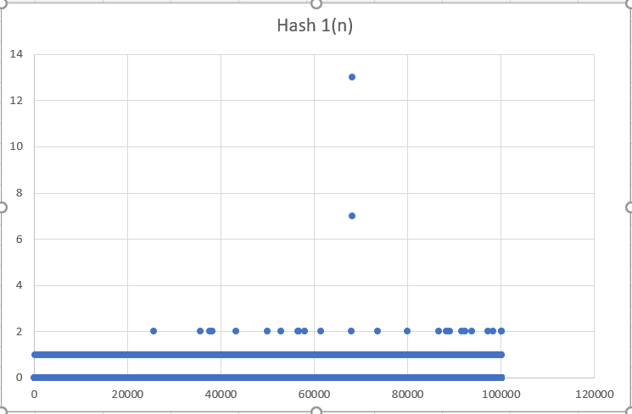

These values are suitable despite a few outliers as the method for getting them was through calling system time before and after for every hash. As seen, all the lines seem to grow with respect to their function, minus my own system clock.