Software Requirements Specification

for

Centauri

**Version 1.0 approved**

**Prepared by Liam Blair, Ashley Drexler, Adam Green, Aaron Schanck, Lakshmana Silva**

**SepTech**

**2/24/2021**

**Table of Contents**

**Introduction** **1**

**Purpose** **1**

**Document Conventions** **1**

**Intended Audience and Reading Suggestions** **1**

**Product Scope** **2**

**References** **2**

**Overall Description** **2**

**Product Perspective** **2**

**Product Functions** **3**

**User Classes and Characteristics** **4**

**Operating Environment** **4**

**Design and Implementation Constraints** **4**

**User Documentation** **4**

**Assumptions and Dependencies** **4**

**External Interface Requirements** **5**

**User Interfaces** **5**

**Hardware Interfaces** **5**

**Software Interfaces** **5**

**Communications Interfaces** **6**

**System Features** **6**

**Accounts** **6**

**Description and Priority** **6**

**Stimulus/Response Sequences** **7**

**Functional Requirements** **7**

**Payment Methods** **8**

**Description and Priority** **8**

**Stimulus/Response Sequences** **8**

**Functional Requirements** **9**

**Item Cart** **9**

**Description and Priority** **9**

**Stimulus/Response Sequences** **9**

**Functional Requirements** **10**

**Item Catalog** **10**

**Description and Priority** **10**

**Stimulus/Response Sequences** **10**

**Functional Requirements** **11**

**Reviews** **11**

**Description and Priority** **11**

**Stimulus/Response Sequences** **11**

**Functional Requirements** **12**

**Bidding** **12**

**Description and Priority** **12**

**Stimulus/Response Sequences** **12**

**Functional Requirements** **13**

**Purchase History** **13**

**Description and Priority** **13**

**Stimulus/Response Sequences** **13**

**Functional Requirements** **13**

**Recommendations** **14**

**Description and Priority** **14**

**Stimulus/Response Sequences** **14**

**Functional Requirements** **14**

**Search Function** **15**

**Description and Priority** **15**

**Stimulus/Response Sequences** **15**

**Functional Requirements** **15**

**Administrative Privileges** **16**

**Description and Priority** **16**

**Stimulus/Response Sequences** **16**

**Functional Requirements** **17**

**Chat** **17**

**Description and Priority** **17**

**Stimulus/Response Sequences** **17**

**Functional Requirements** **18**

**Order Tracking** **18**

**Description and Priority** **18**

**Stimulus/Response Sequences** **18**

**Functional Requirements** **19**

**Other Nonfunctional Requirements** **19**

**Performance Requirements** **19**

**Safety Requirements** **20**

**Security Requirements** **20**

**Software Quality Attributes** **21**

**Business Rules** **21**

**Other Requirements** **21**

**Revision History**

|  |  |  |  |
| --- | --- | --- | --- |
| **Name** | **Date** | **Reason For Changes** | **Version** |
| Preliminary Draft | 2/28 | Version 1: first turn in | 1.0 |
| Second Draft | 3/12 | Modifications as noted in Deliverable 1 | 1.1 |

# Introduction

## Purpose

The main purpose of this application is to give users the ability to buy and sell products from the touch of their phone. This gives users the freedom to choose from a large range of products, finding the product that fills their needs by using the filter widget to specify their needs. A user can also sell any product of their wishing at any quantity and set a buy out price, and if they wish set a starting bid price as well. A user can view reviews for any product or seller which can help them with which product to buy. If a buyer is satisfied or dissatisfied with their purchase then they can leave a review for the product/seller.

The secondary purpose of this application is to allow new users to create an account, and if they wish to pay a monthly fee then their account is upgraded to a premium account with additional features which include faster shipping times, higher priority in customer service, higher accuracy in searches, and an email model for deal’s including discounts and etc. By just creating an account a user can store their preferences and previous purchases, and the user is able to save their cart. As a user you can also contact other users through the application with a chat box.

## Document Conventions

For organization and reference, sections are numbered and titled. Bolded text of font size 18 denotes section headings and bolded text of font size 14 denotes section subheadings. Italicized text will be used to differentiate from standard text and give emphasis on explanations or captions.

Requirements naming scheme: Requirements are denoted by FR/NFR-{SECTION ACRONYM}-{NUMBER}, for example, FR-UI-1 denotes the first requirement of the UI (User interface: 3.1) section. In the event that a requirement is referenced outside of the location that it is defined in, a clickable link will be provided along with the requirement.

## Intended Audience and Reading Suggestions

The software requirements specification document is intended to be read by the development team, project managers, marketing staff, product testers, and documentation writers. Stakeholders, third-parties providing resources towards the development of the product, distributors to market the finished product, and users may read the document for an understanding of the project and its requirements.

The documentation has been organized to be read in increasing order, beginning with the Introduction and concluding with Other Requirements. It is required for the development team and project managers to read the complete document and be familiar with all the requirements. The following are to read the SRS as such:

*Marketing Staff*: Members of the marketing staff are to read the Overall Description and familiarize themselves with the product. It is also critical for them to understand the product enough to market the app effectively.

*Product Testers*: Testers will need to thoroughly read through the System Features in order to create meaningful test cases for the product and provide valuable feedback to the development team.

## Product Scope

Our product aims to be a middleman between buyers and sellers, allowing for simplification of the e-commerce process. By being in the format of an application on one’s phone, we hope that our product is usable in all settings.

## References

[*https://gdpr.eu*](https://gdpr.eu)

[*https://leginfo.legislature.ca.gov/faces/codes_displayText.xhtml?division=3.&part=4.&lawCode=CIV&title=1.81.5*](https://leginfo.legislature.ca.gov/faces/codes_displayText.xhtml?division=3.&part=4.&lawCode=CIV&title=1.81.5)

# Overall Description

## Product Perspective

Centauri is a product that is a part of the “Shopping” category of mobile applications. Other examples of applications that fall under this category are: Amazon, Etsy, eBay, and Alibaba. The final iteration of Centauri will be a self-contained product. The aim of Centauri is to procure an app with the best characteristics of competitive apps and focus on a transparent shopping experience where the user is able to assess the credibility and quality of both items and sellers through reviews. The main features of Centauri include:

* The system allows the user to create an account. This feature gives the user the ability to save personal information and preferences to an account for future repeat uses. This also allows the user to consider the option of upgrading their account from a regular account to a premium account with additional member perks.
* The system allows the user to view item listings. This is one of the most critical functions of the mobile application, giving the user the ability to browse and shop for items they are interested in. This feature branches off into subfeatures, such as viewing items by filters or keywords.
* The system allows the user to purchase using payment methods. Under this function, the user can purchase the items in their cart, subscriptions, and gift cards. The user will be able to pay using their credit card and also save their information for future use, if authorized.

## Product Functions

The mobile application Centauri contains the following key functions, which can be explored further in Section 4:

* Accounts: The system shall allow the user to create accounts, giving them the ability to store personal information or preferences.
* Payment Methods: The system shall allow the user to pay for items through payment methods, such as credit cards, and to save their payment methods to their account.
* Item Cart: The system shall allow the users to save items they are interested in purchasing to an item cart.
* Item Catalog: The system shall display an item catalog for users to view item listings created by sellers.
* Reviews: The system shall display reviews created by customers given to both items and sellers, regarding the quality of the item and shopping experience with the seller.
* Bidding: The system shall allow the user to bid on active auctions of items, rather than purchasing items at a set price.
* Purchase History: The system shall allow the user to view their own purchase history.
* Search Function: The system shall allow the user to search for items in the item catalog using keywords or filters, such as rating, price, etc.
* Administrative Privileges: The product shall allow administrators of the application to access areas of the application not available to users, in order to uphold and enforce security and the Terms of Service.
* Chat: The system shall allow communication between users and sellers so that they may communicate with each other on a purchase. The system shall also allow users or sellers to contact administrators in the case of an unresolved issue.
* Order Tracking: The system shall allow the user and seller to track the status of an order.

## User Classes and Characteristics

The initial users of the app are those who are familiar with operating an application on an Android device and comfortable with making purchases online. Initial users will also be those that have an interest in selling items on an app platform. Users may take a brief moment to accustom themselves to the user interface of the application but ideally, the process should require minimal adjustments.

Users must be 18 years or older to purchase and sell items using the application, unless given permission from a parent or guardian.

The mobile application is not concerned with meeting the needs of those that are not interested in shopping online.

## Operating Environment

The software will be compatible with Android devices running Android Version 6.0 or later. This will allow our app to be compatible with 85% of all Android devices. Specifically devices released after 2015. The app will be able to utilize the device’s clipboard to copy and paste between applications.

## Design and Implementation Constraints

The team will be using primarily Java for the development of the app. As such, the team will only develop for Android mobile platforms. The final product will be released only in the language of English and only to be used in the American market. Implementation of payment methods must follow the protocol of payment card industry standards. The application will only be released in the Google Store or as an Android package file.

## User Documentation

A README.md will be included on the code repository that will describe building and executing the product in the development environment. Along with this, we have aims to include a user manual that will layout how to traverse the application when

## Assumptions and Dependencies

We are assuming that PostgreSQL will work well with our product, along with the fact that DigitalOcean will be a suitable cloud host. In the case that they are not, we will change our implementation ideas.

[TBD]

# External Interface Requirements

## User Interfaces

FR-UI-1: The system shall display a button to login when the user is not logged in.

FR-UI-2: The system shall display a button that allows the user to view their account settings.

FR-UI-3: The system shall display a button that allows the user to go back a page.

FR-UI-4: The system shall display all items returned in a search in a top-down scrollable interface.

FR-UI-5: The system shall display a button to show search filter options to the user.

FR-UI-6: The system shall display the option to Create an Account on app open.

FR-UI-7: The system shall display the option to Sign In on app open.

FR-UI-8: The system shall display the option to Continue as Guest on app open.

FR-UI-9: The system shall display a magnifying glass to toggle the search filter options pane.

FR-UI-10: The system shall display a button on the bottom toolbar that allows a user to initiate a chat with a seller.

FR-UI-11: The system shall display a button on the bottom toolbar that allows a user to initiate a chat with SepTech customer service.

FR-UI-12: The system shall display a button on the bottom toolbar that will allow the user to open their cart.

FR-UI-13: The system shall display a button on the bottom toolbar that opens the notifications window.

**UI Mockup: See Appendix D.**

## Hardware Interfaces

FR-HI-1: The system shall be compatible with Android devices running Android version 6.0 or greater.

FR-HI-2: The system shall communicate with the database using HTTP.

[Others TBD.]

## Software Interfaces

FR-SI-1: The system shall be able to retrieve user details from the database.

FR-SI-2: The system shall be able to store user details into the database.

FR-SI-3: The system shall be able to retrieve product information from the database.

FR-SI-4: The system shall be able to store product information into the database.

FR-SI-5: The system shall be able to push notifications onto Android devices running version 6.0 or greater.

[Others TBD.]

## Communications Interfaces

FR-CI-1: The system shall send a confirmation email relating to when a user creates a new account.

FR-CI-2: The system shall send a confirmation email when a user changes/deletes payment method.

FR-CI-3: The system shall send a confirmation email when a user performs a password/username/email change.

FR-CI-4: The system shall send an email to a user when a purchase/sale is done

FR-CI-5: The system shall send an email to a user when they designate that they forgot password/account details.

FR-CI-6: The system shall send an email to a user when a user receives a message sent through the application.

FR-CI-7: The system shall send an email to a user when an item in their cart is selling out

FR-CI-8: The system shall send an email to a user when they’ve been outbid on an item in their cart.

FR-CI-9: The system shall send a confirmation email when an item has been refunded/returned.

FR-CI-10: The system shall send an email to the user when an update has happened to their order.

FR-CI-11: The system shall allow a user to send a direct message.

FR-CI-12: The system shall allow a user to send a direct message to customer service.

FR-CI-13: The system shall use Cloud as the communication protocol.

# System Features

## Accounts

### Description and Priority

The system shall offer a personalized account to record the user’s personal information for ease of access to different features of Centauri. This system feature is of high priority, as the system will work on the accounts system for storing settings for users and also saving the items in their carts. Guest accounts or unauthorized users are included in this subsystem.

|  |  |  |  |
| --- | --- | --- | --- |
| Benefit | Penalty | Cost | Risk |
| 9 | 9 | 6 | 7 |

### Stimulus/Response Sequences

1. Signup
   1. Upon request for a new account, the system shall send the user to a designated account signup window.
   2. The system shall prompt the user to input contact and security information.
   3. The system shall record and remember this information for future sign-ins.
   4. The system shall allow a user to have two accounts under the same information, one as a consumer account and the other a seller account.
2. Return User
   1. The system shall prompt a return user to sign in using the information recorded during signup.
   2. While a user is signed-in, the system shall allow the user to edit the information provided at signup.
   3. While a user is signed-in, the system shall allow the user to logout of their account on their current device.
   4. While a user is signed-in, the system shall allow the user to logout of their account on all devices.
3. Premium
   1. The system shall allow the user to upgrade their account status to a premium account.
   2. The system shall grant users with premium accounts the ability to choose a faster delivery time than the standard rate.
   3. The system shall grant users with premium accounts access to more specific filters for more accurate item searches.
   4. The system shall grant users with premium accounts higher priority access to customer services.
   5. The system shall allow premium users to automatically pay monthly premium fees for their convenience.
   6. The system shall email a billing statement to premium members upon confirmation of payment.
   7. The system shall allow premium users to cancel their subscription at any time.

### Functional Requirements

FR-ACC-1: The system shall allow the user to login to an authorized account with their credentials.

FR-ACC-2: The system shall allow the user to logout of an authorized account.

FR-ACC-3: The system shall allow the user to logout of an authorized account on all platforms.

FR-ACC-4: The system shall allow the user to create an account with user input credentials.

FR-ACC-5: The system shall allow the user to upgrade to a premium account.

FR-ACC-6: The system shall allow the user to modify their password of their account.

FR-ACC-7: The system shall allow the user to modify their email address of their account.

FR-ACC-8: The system shall allow the user to modify their stored payment methods on their account.

FR-ACC-9: The system shall allow the user to modify preferences/settings on their account.

## Payment Methods

### Description and Priority

The system shall allow users to purchase products/subscriptions through payment methods. This feature is of high priority, as it is necessary for users to be able to purchase a premium account and purchase items listed on the site.

|  |  |  |  |
| --- | --- | --- | --- |
| Benefit | Penalty | Cost | Risk |
| 9 | 9 | 3 | 9 |

### Stimulus/Response Sequences

1. Checkout
   1. The system shall prompt the user to select a payment method when the option exists.
   2. The system shall prompt the user to enter a new payment method when no saved payment methods are detected.
   3. The system shall save the payment method when authorized by an authorized user.
   4. The system shall display an order review page before submitting the order.
   5. The system shall display a confirmation page of the order after payment completion.
2. Subscription Purchase
   1. After a payment, if the user is not a subscribed member of Centauri, the system will suggest that the user subscribed for their convenience.
   2. If the user opts to purchase a subscription, the system will display options to subscribe on a monthly subscription or a yearly subscription, with a discount.
   3. The user will be notified that their payment method will be saved and used for recurring payments.
   4. The system shall display an order review page before subscribing.
   5. The system shall display a confirmation page of the order after subscription has been confirmed.

### Functional Requirements

FR-PAY-1: The system shall allow a user to purchase a premium membership account.

FR-PAY-2: The system shall allow a user to purchase items in their item cart.

FR-PAY-3: The system shall save payment methods when authorized.

FR-PAY-4: The system shall allow users to delete a payment method.

## Item Cart

### Description and Priority

The system shall allow users to save specified items for later viewing and purchase. This feature is medium priority, as it is not integral to the main functionalities of Centauri but allows for ease of use for return users and the purchase of multiple items at once.

|  |  |  |  |
| --- | --- | --- | --- |
| Benefit | Penalty | Cost | Risk |
| 7 | 4 | 5 | 4 |

### Stimulus/Response Sequences

1. View Cart
   1. The user can click on a button which will allow them to view their cart. This button will exist on every page within the application.
2. Inside Cart
   1. The user can check out with the items in their cart from within their cart’s page.
   2. Users can remove items from their cart within their cart page.
   3. The user’s cart will save upon exiting.
   4. The system shall display a “continue shopping” option when inside of the user’s cart (if the user doesn’t want to check out yet)

3. Cart Interactions

3.1. Users can add items to their cart by clicking on the “add to cart” button on an item.

3.2. The cart will update whenever an update is made to it (removal/addition of item).

### Functional Requirements

FR-CART-1: The system shall allow the user to add an item to their cart.

FR-CART-2: The system shall allow the user to remove an item from their cart.

FR-CART-3: The system shall allow the user to remove all items from their cart at once.

FR-CART-4: The system shall allow the user to purchase only a select number of items from their cart.

FR-CART-5: The system shall alert the user when the inventory of an item in the cart is running low.

FR-CART-6: The system shall remove an item automatically from the cart when it is sold out.

FR-CART-7: The system shall notify the user when an item has been removed from their cart.

FR-CART-8: The system shall alert the user when the price of an item in the cart has changed.

## Item Catalog

### Description and Priority

The system shall allow users to view the items available for purchase that business owners display on Centauri. This is the application’s main functionality and therefore is high priority.

|  |  |  |  |
| --- | --- | --- | --- |
| Benefit | Penalty | Cost | Risk |
| 9 | 9 | 7 | 1 |

### Stimulus/Response Sequences

1. Display
   1. The system shall display an assortment of products on the home page when the app is first opened.
   2. The system shall display the name, price, and image of each product.
2. Interaction
   1. The user can scroll through the catalog to browse through the products.

### Functional Requirements

FR-CAT-1: The system shall display images of the item.

FR-CAT-2: The system shall display the name of the item.

FR-CAT-3: The system shall display the price of the item.

FR-CAT-4: The system shall allow the user to scroll through the products.

## Reviews

### Description and Priority

The system shall allow users to post a review for an item they purchased or for the seller they did business with. This feature is medium priority because it is not required to use the application but they provide vital information for other users.

|  |  |  |  |
| --- | --- | --- | --- |
| Benefit | Penalty | Cost | Risk |
| 5 | 4 | 5 | 2 |

### Stimulus/Response Sequences

1. Item Review:
   1. The user must navigate to an item that they have previously purchased.
   2. The user must click on a tab labeled “Reviews”.
   3. The user must click a button labeled “Leave a Review”.
   4. The System redirects to a page with text boxes for a title, rating, and description.
   5. The user must enter text for each category and then click a button labeled “Leave Review” to post the review to the public.
2. Seller Review:
   1. The user must navigate to the profile of a seller that they have done business with.
   2. The user must click on a tab labeled “Reviews”.
   3. The user must click a button labeled “Leave a Review”.
   4. The System redirects to a page with text boxes for a title, rating, and description.
   5. The user must enter text for each category and then click a button labeled “Leave Review” to post the review to the public.

### Functional Requirements

FR-REV-1: The system shall allow authorized users to post a review for an item they have purchased.

FR-REV-2: The system shall allow authorized users to post a review for a seller they have purchased from.

FR-REV-3: The system shall allow a user to see reviews for a specific item.

FR-REV-4: The system shall allow a user to see reviews for a seller.

## Bidding

### Description and Priority

The system shall allow users to bid on prices of seller specified items rather than paying a flat rate for the same item. The user with the highest bid at the end of a time period specified by the seller will pay the bid amount for the item. This feature is high priority, as it is an integral feature of the application.

|  |  |  |  |
| --- | --- | --- | --- |
| Benefit | Penalty | Cost | Risk |
| 7 | 5 | 3 | 4 |

### Stimulus/Response Sequences

1. View Bid
   1. The system shall display the current price to bid for all items that are using bidding.
   2. The system shall display time left to bid for all items that are using bidding.
   3. The system shall allow the user to select any item using bidding to place a bid.
2. Place Bid
   1. The system shall allow the user to place a bid after selecting it.
   2. The system shall display how many other people have bidded on the item.
   3. The system shall update the timer to 1 minute if an user placed a bid on an item with less than one minute left on the timer.

### Functional Requirements

FR-BID-1: The system shall allow a user to place a bid on an item.

FR-BID-2: The system shall allow a seller to specify whether an item is able to be bid on.

## Purchase History

### Description and Priority

The system shall allow the user to view the items they have previously purchased on Centauri. This is low priority as it is not a necessity to the overall implementation of the system but is helpful for ease of use for return users.

|  |  |  |  |
| --- | --- | --- | --- |
| Benefit | Penalty | Cost | Risk |
| 5 | 2 | 1 | 2 |

### Stimulus/Response Sequences

1. Display
   1. The user can open the purchase history by clicking on the purchase history button contained within their account button
   2. The items listed are items purchased previously by the user, denoted by whether they were a bid or a buyout.
   3. The items listed are in chronological order.
2. Interaction
   1. The user can click on an item in their purchase history. In doing so, they will go to the item’s main page.
   2. The items that have not been shipped out will contain a refund button, allowing the user to initiate a refund for that specific item.

### Functional Requirements

FR-PHI-1: The system shall display the purchase history when the user has hit the button to request it.

FR-PHI-2: The system shall display the items in chronological order, from when they were bought.

FR-PHI-3: The system shall allow the user to filter their purchase history.

FR-PHI-4: The system shall allow a user to refund an item that is currently on the purchase history.

FR-PHI-5: The system shall only allow a user to refund an item if it has not been shipped out already.

FR-PHI-6: The system shall open an item’s main page when they click on the item in the purchase history.

## Recommendations

### Description and Priority

The system shall recommend items that it perceives the user may be interested in purchasing based on their purchase history and viewed items. This feature is of low priority since it is not critical to the performance of the application and due to its severity of implementation.

|  |  |  |  |
| --- | --- | --- | --- |
| Benefit | Penalty | Cost | Risk |
| 6 | 2 | 9 | 7 |

### Stimulus/Response Sequences

1. Purchasing
   1. When a user purchases an item, the following items may be more closely related to the previously purchased item.
2. Configuration
   1. By clicking on the “Show related products” setting in the account settings page of the application, the user can disable or enable the use of this system.

### Functional Requirements

FR-REC-1: The system shall display a list of items relevant to the user’s previous purchases.

FR-REC-2: The system shall allow a user to enable/disable this feature.

## Search Function

### Description and Priority

The system shall allow users to search for item listings and sellers. This feature is of high priority, as it greatly improves user experience to be able to seek out items that users are looking to purchase or a specific seller. Filtered searches are included in this subsystem.

|  |  |  |  |
| --- | --- | --- | --- |
| Benefit | Penalty | Cost | Risk |
| 8 | 6 | 3 | 2 |

### Stimulus/Response Sequences

1. Initial Search
   1. The user must type a keyword into the search bar to initiate a search.
   2. The system will return listings that contain the keyword in its listing name.
   3. The system will return listings that contain the keyword in its listing description.
   4. The system will return listings that are tagged with the keyword by the seller.
2. Filtered Search
   1. The user filters a search using criterias provided by the system.
   2. The user filters a search using ratings, pricing, and/or popularity.
   3. The system will return listings filtered by the user.
3. Premium Search
   1. The system will give premium users a greater option of filters to choose from.
   2. The system will return listings in order of most relevant to least relevant.

### Functional Requirements

FR-SER-1: The system shall allow the user to search using keywords.

FR-SER-2: The system shall allow the user to sort item listings by price.

FR-SER-3: The system shall allow the user to sort item listings by popularity.

FR-SER-4: The system shall allow the user to sort item listings by item rating.

FR-SER-5: The system shall allow the user to sort item listings by seller rating.

FR-SER-6: The system shall be able to filter searches based on criteria given by the user.

## Administrative Privileges

### Description and Priority

The system shall allow users with administrative privileges to access systems not available to users in order to uphold security and enforce Terms of Service (TOS). This is integral to the security and safety of the system and is therefore high priority.

|  |  |  |  |
| --- | --- | --- | --- |
| Benefit | Penalty | Cost | Risk |
| 9 | 9 | 2 | 7 |

### Stimulus/Response Sequences

1. Ban Accounts
   1. Administrators must first navigate to the profile of the user who has broken the terms of service.
   2. On their profile page, there will be an options menu which will display a button labeled “ban user” once clicked.
   3. Once the ban button is clicked, the system will redirect to a page with a text box for the reasoning behind the ban and another button labeled ban user.
   4. After a reason is inputted and the button is clicked, the user will be notified when they try to login that they have been banned from using Centauri.
2. Delete Products
   1. Administrators must first navigate to the profile of the seller who has broken the terms of service.
   2. On their profile page, there will be an options menu which will display a button labeled “Delete Products” once clicked.
   3. Once the delete products button is clicked, the system will redirect to a page that displays a list of all the products from the seller, a text box for the reasoning, and a button labeled “ Delete Selected Products”.
   4. The administrator can then choose to select one or more items that violate the terms of service.
   5. After the items are selected and a reasoning is inputted, the administrator can click the “Delete Selected Products” button to permanently delete the products.
3. Monitor Chat Logs
   1. Administrators will see a category labeled “Reports” in their main menu.
   2. Once the “Reports” button is clicked, the system will display a list of all the buyers or sellers that have been reported and the reason for why they were reported.
   3. The administrator can click on one of the reports to show the relevant chat logs.
   4. Once the chat logs are reviewed, the administrator will have the option to ban the user/seller or to dismiss the report.

### Functional Requirements

FR-ADM-1: The system shall allow users with administrative privileges to ban accounts in the event they break the terms of service.

FR-ADM-2: The system shall allow users with administrative privileges to delete products from a seller that has breached the terms of service.

FR-ADM-3: The system shall allow users with administrative privileges to monitor the chat logs if a buyer reported a seller.

FR-ADM-4: The system shall allow users with administrative privileges to monitor the chat logs if a seller reported a buyer.

## Chat

### Description and Priority

The system shall allow users to communicate with vendors and administrators directly through a chat box. This functionality is low priority, as it is a luxury item and not a necessity to the system.

|  |  |  |  |
| --- | --- | --- | --- |
| Benefit | Penalty | Cost | Risk |
| 3 | 2 | 1 | 5 |

### Stimulus/Response Sequences

1. Buyer
   1. On a listing of an item and after a purchase, the buyer is given an option to contact the seller through a chat box.
   2. When a message is sent to the seller through the chat box, the seller will receive a push notification and/or email notification.
   3. When the seller replies back to the buyer, the buyer will receive a push notification and/or an email notification.
2. Seller
   1. After a purchase, the seller is given an option to contact the buyer through a chat box.
   2. When a message is sent to the buyer through the chat box, the buyer will receive a push notification and/or email notification.
   3. When the buyer replies back to the seller, the seller will receive a push notification and/or an email notification.
3. Customer Service
   1. On a dedicated area of the application, all users will be able to contact customer service using a chat box.
   2. When a response is received, notifications will be pushed to a users’ mobile device or to their email inbox.
   3. Upon conclusion of a conversation, the user is prompted in the chat to rate the quality of customer service received.

### 

### Functional Requirements

FR-CHAT-1: The system shall allow the buyer to contact a seller through a chat box.

FR-CHAT-2: The system shall allow the seller to contact a buyer through a chat box.

FR-CHAT-3: The system shall the seller to contact customer service through a chat box.

FR-CHAT-4: The system shall allow the buyer to contact customer service through a chat box.

FR-CHAT-5: The system shall push notifications to users if they receive a message through chat.

FR-CHAT-6: The system shall send an email regarding an unread message in a chat box.

FR-CHAT-7: The system shall allow the user to disable notifications on unread messages.

## Order Tracking

### Description and Priority

The system shall allow users to view the stage of progress their order is currently in the process of. This functionality is low priority, as it is a luxury item and not a necessity to the system.

|  |  |  |  |
| --- | --- | --- | --- |
| Benefit | Penalty | Cost | Risk |
| 6 | 5 | 6 | 4 |

### Stimulus/Response Sequences

1. Notifications
   1. In the event that an item crosses a threshold of shipping, such as it being shipped out initially to the user, a notification will be sent to the user. These notifications will be in email or notifications within the app, to be specified by the user or by implementation efforts.
2. Display
   1. An item’s geographical location will be shown if the user hits the “Show item location” under their purchase history tab. In the case that the item is no longer being shipped, this button will not be present.

### Functional Requirements

FR-TRK-1: The system shall display a map to the user to track an item geographically.

FR-TRK-2: The system shall notify a user when an item has been shipped out.

FR-TRK-3: The system shall notify a user when an item has been delivered to its destination.

# Other Nonfunctional Requirements

## Performance Requirements

NFR-PER-1: The system shall return search results to a query within 5 seconds or less, 99% of the time.

*Rationale: The system would seem too laggy if the user requested a search that didn’t turn up results in the aforementioned time, thus adding some form of parallelism or performance to the search mechanism is core.*

REQ-PER-2: The system shall login a querying user within 2 seconds of them clicking the login button with correct credentials, 90% of the time.

*Rationale: In the event that the user entered their login credentials correctly, the system shall at maximum take the time to traverse the database of user credentials, which will take at maximum the time specified in NFR-PER-3.*

NFR-PER-3: The system shall display that the user has entered incorrect credentials within 3 seconds of them clicking the login button with incorrect credentials.

*Rationale: The database connection and query should take no more than 3 seconds to check all user credentials. If it takes longer, it needs to be parallelized to ensure a user doesn’t wait too long.*

NFR-PER-4: The system shall be able to handle up to 10,000 users concurrently.

*Rationale: 10,000 users is a good baseline to start with. External communications will be limited to database communication and cloud communication; thus the limitations should be connections to these databases/clouds instead of servers to host web interfaces.*

NFR-PER-5: The system shall send all emails to users within 10 seconds 99% of the time.

*Rationale: No one likes waiting for emails, the only waiting mechanism should be the mail server under load, thus it is 99% of the time. In the event of no load, it should be near instantaneous to send to the user. In the event that the mail server is falling behind too often, multiple mail servers shall be used in order to offload the job.*

## Safety Requirements

NFR-SAF-1: The system shall be able to initiate a chargeback procedure in the case of a compromised credit card.

*Rationale: In the event that a credit card was compromised and used without the cardholder’s authorization, the system should protect the cardholder by initiating a chargeback.*

NFR-SAF-2: The system shall prevent unauthorized users from accessing stored payment methods.

NFR-SAF-3: The system shall hide sensitive information on the screen.

*Rationale: There is no reason to ever display sensitive information such as user credentials or detailed payment methods on the screen.*

NFR-SAF-4: The system shall allow a user to sign out of an account from all devices at once.

*Rationale: A user should be able to sign out of all accounts in case they no longer have personal access to a device.*

NFR-SAF-5: The system shall confirm that information for a password reset has been sent to an email address, regardless of whether the email exists or not.

*Rationale: In the case of a hacker attempting to trace an account through an email, this will make it difficult to do so.*

## Security Requirements

NFR-SEC-1: The system shall be compliant with the Payment Card Industry (PCI) standards.

NFR-SEC-2: The system shall be compliant with specifications set forth by GDPR for European residents.

NFR-SEC-3: The system shall be compliant with specifications set forth by CCPA for Californian residents.

NFR-SEC-4: The system shall have an optional method to securely store payment methods for future use in purchases.

NFR-SEC-5: The system shall have an optional method to securely store an account password for future use.

## Software Quality Attributes

NFR-SQA-1: The system shall be usable by a user who has finished reading the user manual included within the application. In the event that a user has completed reading the manual, the number of user errors within the application shall not exceed 1 error per hour, 99% of the time.

NFR-SQA-2: TBD

## Business Rules

NFR-BUS-1: The system shall only allow administrators to ban accounts in the event of a breach of the terms of service.

NFR-BUS-2: The system shall only allow administrators to monitor chat logs in the event of a breach of the terms and service.

NFR-BUS-3: The system shall only allow administrators to delete all the items from a seller who has breached the terms of service.

NFR-BUS-4: The system shall allow users to contact an administrator and send chat logs if they believe a seller has breached the terms of service.

NFR-BUS-5: The system shall allow sellers to contact an administrator and send chat logs if they believe a user has breached the terms of service.

NFR-BUS-6: The system shall allow authorized users to contact an administrator regarding a purchase if the seller does not respond or is not compliant.

# Other Requirements

TBD

**Appendix A: Glossary**

*Administrator*: A person who has administrative access to advanced settings.

*CCPA*: California Consumer Privacy Act

*GDPR*: General Data Protection Regulation

*GUI*: Graphical User Interface

*PCI*: Payment Card Industry

*SRS*: Software Requirements Specification

*TOS*: Terms of Service

*User*: any person using the mobile application

*FR: Functional Requirement*

*NFR: Non-Functional Requirement*

**Appendix B: Analysis Models**

TBD

**Appendix C: To Be Determined List**

Items to be determined later:

1. Section 2.7
2. Section 3.2
3. Section 3.3
4. Section 5.4
5. Section 6
6. Appendix B

**Appendix D: UI Mockup**

1. **Login Page (app startup)**

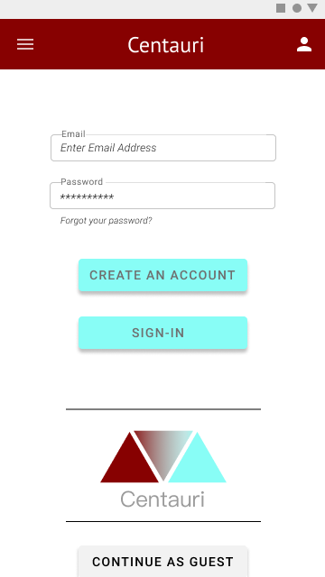

1. Forgot Password Page

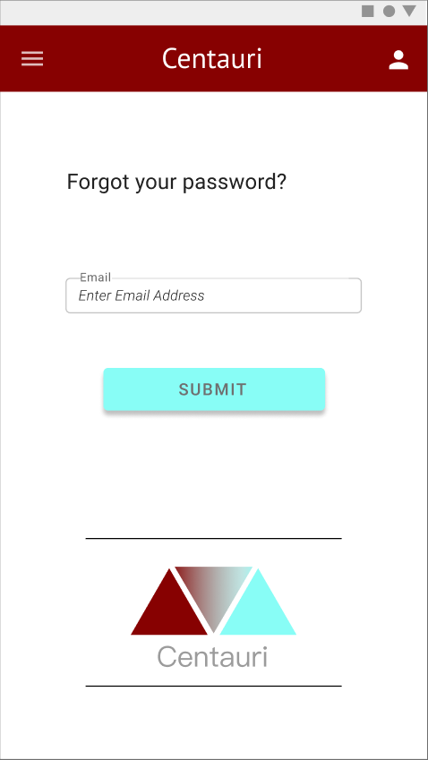

1. Email Verification Page

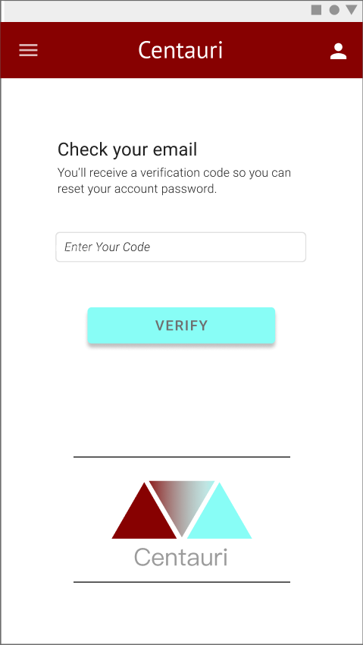

1. Seller Page with products

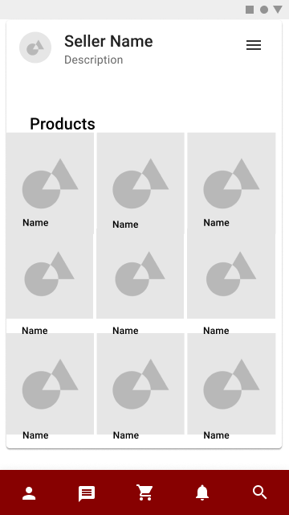

1. Cart Page

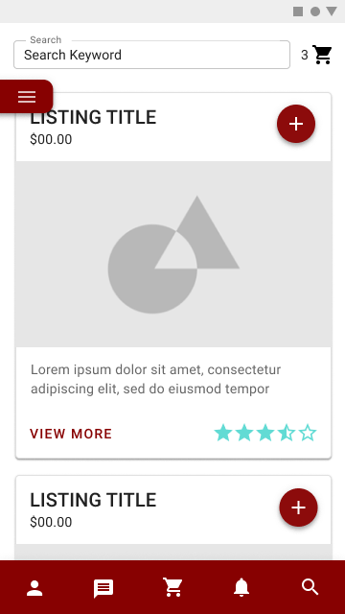

1. Filter options popout

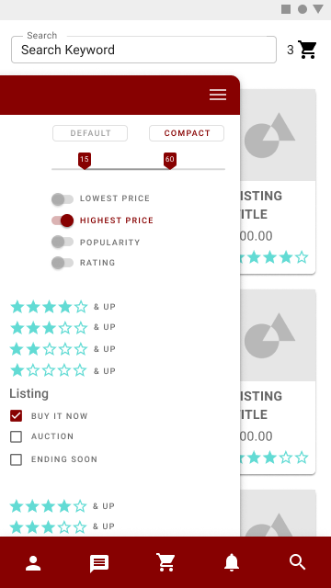

1. Main shopping page with products

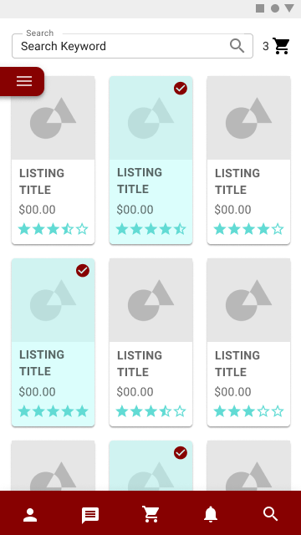

1. Larger visual size for items

