Online Auction System

K.Rishi Vardhan, shivansh shahee, M Mitun

Networking and Communication

SRM Institute of Science and Technology

Chennai-629 601,Tamil Nadu,India

rk7342@srmist.edu.in

ss5090@srmist.edu.in

mm5300@srmist.edu.in

**Abstract :-The Alarm Clock Python Project is a software application designed to provide a user-friendly and customizable alarm clock experience. This project utilizes the Python programming language and incorporates various libraries to enable users to set multiple alarms, customize alarm tones, and efficiently manage their daily schedules. The project leverages GUI (Graphical User Interface) components to create an intuitive and visually appealing interface. Users can set alarms with specific times, days of the week, and snooze options. When the alarms trigger, the program plays user-defined tones or music, providing a reliable and personalized wake-up experience. This project demonstrates the application of Python in creating practical, interactive applications and showcases the power of open-source libraries to enhance user experience and functionality. It serves as an example of how Python can be used to develop real-world applications, making it a valuable learning resource for Python enthusiasts and aspiring developers**

**Introduction:-**

The Alarm Clock Python Project is a fascinating endeavor that merges the simplicity and practicality of the traditional alarm clock with the power of modern programming. In an era dominated by digital technology and automation, the concept of an alarm clock has evolved from simple mechanical devices to sophisticated software applications. This Python project brings the world of coding and software development into our daily lives by offering an opportunity to create a customizable and interactive alarm clock experience. With Python's versatility and an array of libraries at our disposal, we can design an alarm clock that not only wakes us up at the desired time but also allows us to set multiple alarms, customize alarm tones, and manage our daily schedules efficiently. In this project, we'll explore the fusion of technology and everyday convenience, demonstrating how Python can be harnessed to develop a practical, user-friendly, and engaging application that meets a common yet timeless need.

**Working : -**

The working of an Alarm Clock Python Project involves several key components and functionalities. Here's a step-by-step overview of how such a project typically operates:

1. **\*\*User Interface (GUI)**: -** The project often begins by creating a graphical user interface (GUI) using Python libraries like Tkinter or PyQt. This interface allows the user to interact with the alarm clock software.
2. **2. *Setting Alarms*: -** Users can set alarms by specifying the desired time for the alarm to trigger. This information is typically entered through text fields or time picker widgets on the GUI.
3. **3. *Multiple Alarms*:-** The project can support the setting of multiple alarms. Users can add, edit, and delete alarms as needed. The alarms are usually stored in a data structure or a database for easy retrieval and management.

**4. *Alarm Scheduling*:-** The project includes a scheduler or timer mechanism to continuously check the current time against the set alarm times. It monitors the system clock to trigger alarms at the specified times.

**5. *Alarm Triggering*:-** When an alarm's scheduled time is reached, the project initiates the alarm action. This can include playing a specified sound or music file to wake the user.

**6. *Sound Playback*:-** The project leverages Python's audio libraries, such as pygame or playsound, to play the selected sound or music file. Users can often customize the alarm tone.

**7. *Snooze and Dismiss*:-** Once the alarm goes off, the user is typically presented with options to snooze or dismiss the alarm. The snooze functionality allows the user to delay the alarm for a set period.

**8. *User Interaction*:-** The GUI provides user-friendly buttons and controls for managing alarms, enabling or disabling them, and interacting with the alarm clock application.

**9. *Error Handling*:-** The project incorporates error handling to address issues such as incorrect input, invalid alarm times, or file not found errors for alarm sounds.

**10. *Background Execution*:-** The alarm clock project often runs continuously in the background, ensuring that alarms work even when the application is minimized or closed.

**11. *Settings and Customization*:-** Users can typically customize various settings, such as alarm volume, ringtone, snooze duration, and other preferences.

**12. *Persistence*:-** The project may save user settings and alarms to a configuration file or a database to retain them across application restarts.

Overall, the Alarm Clock Python Project seamlessly combines the power of Python's programming capabilities with a user-friendly interface to create a functional and personalized alarm clock application, enhancing the user's morning routine and ensuring they start their day on time.

**Constraints :-**

Constraints in an Alarm Clock Python Project typically refer to limitations, boundaries, or challenges that developers may encounter during the design and implementation of the project. Here are some common constraints to consider:

**1. *Platform Dependence*:-** The project may be limited to specific operating systems due to dependencies on platform-specific libraries or functionalities. Ensuring cross-platform compatibility can be a constraint.

**2. *Resource Utilization*:** - Alarm clock applications must be lightweight and efficient, as excessive resource utilization can impact system performance, especially on older or low-spec devices.

**3. *Sound File Formats*:-** Limitations in the types of sound file formats that can be played by the application can be a constraint. It's important to support a wide range of common audio formats.

**4. *Audio Output Devices*:-** The project may rely on system audio settings, and compatibility with various audio output devices (speakers, headphones, etc.) can be a challenge.

**5. *Localization*:-** Adapting the application to support multiple languages and date/time formats can be a constraint, especially if the project is intended for a global audience.

**6. *Limited Features*:-** Project scope may be constrained by time and resources, which could limit the number of features and customizations that can be included in the alarm clock.

**7. *Reliability*:-** Ensuring that alarms always trigger as expected, even in the presence of system updates or disruptions, can be a challenging constraint.

**8. *GUI Design*:-**Creating an intuitive and visually appealing graphical user interface (GUI) that is responsive across different screen sizes and resolutions can be a constraint.

**9. *Compatibility and Libraries*:**- Compatibility with different versions of Python and third-party libraries used in the project can be a constraint, as library updates or changes may affect the application's behavior.

**10. *Security*:-** If the project stores alarm settings or user preferences, data security and privacy can be a concern, especially when dealing with sensitive information.

**11. *Testing and Debugging*:-** Comprehensive testing and debugging of the application can be constrained by time and resources, potentially leading to undiscovered bugs or issues.

**12.*User Feedback*:-** Gathering user feedback for improvements and bug fixes can be a constraint, as not all users may provide feedback, and incorporating suggestions may take time.

Developers must carefully manage these constraints to create a robust and user-friendly Alarm Clock Python Project that meets the needs and expectations of its users.

**Modules : -**

To create an Alarm Clock Python project, you'll need to use various Python modules and libraries to implement the desired functionality. Here are some essential modules you can consider using in your project:

**1. Tkinter:-** Tkinter is a standard GUI library for Python that allows you to create the graphical user interface for your alarm clock application.

**2. datetime:-** The `datetime` module is crucial for handling date and time operations, including setting and managing alarms.

**3. threading or multiprocessing:-** These modules can be used to run background tasks, such as checking for alarm triggers, without freezing the user interface.

**4. pygame or playsound:-** These audio libraries can be used to play alarm sounds or music when the alarm goes off.

**5. sqlite3 or configparser:-** You can use these modules to store and manage user settings and alarm data persistently.

**6. time:-** The `time` module provides various time-related functions that can be useful for scheduling and handling alarms.

**7. os:-** The `os` module can be used for various system-related operations, such as playing audio files or managing files and directories.

**8. sys:-** The `sys` module allows you to work with command-line arguments and system-specific parameters.

**9. pytz (Python Time Zone library):-** If your project needs to handle time zones, `pytz` can be useful for converting and managing time in different time zones.

**10. subprocess:-** This module can be used to run external commands or applications, which might be useful for launching the alarm clock at system startup.

**11. configparser:-** If your project requires configuration settings, `configparser` can be used to read and write configuration files.

**12. Pillow (PIL):-** If your alarm clock has a feature to display images, you can use Pillow (Python Imaging Library) to handle image manipulation and display.

These modules provide the foundation for building an Alarm Clock Python project. Depending on your project's specific requirements, you may need additional libraries for features like weather integration, internet radio streaming, or integration with external hardware (e.g., LED displays or smart home devices). Your choice of modules will depend on the functionalities you want to incorporate into your alarm clock application.

**UML Diagram :-**

**1.Block diagram :-**

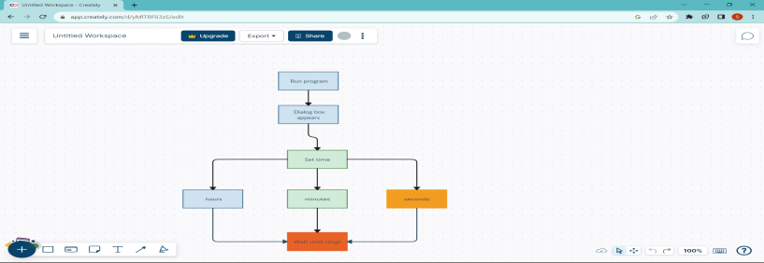

1. **Activitydiagram :-**

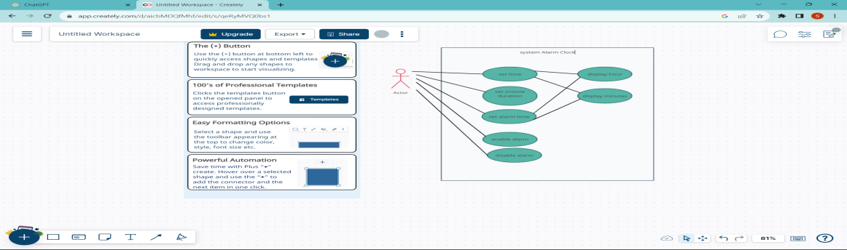

**LITERATURE STUDY :**

|  |  |  |  |  |
| --- | --- | --- | --- | --- |
| S.no | Paper Tittle | Author | Publisher | Year |
| 1 | Python Programming for the Absolute Beginner | Michael Dawson | CENGAGE | 2021 |
| 2 | Python Crash Course | Eric Matthe | NSP,US | 2021 |
| 3 | Development and implementation of microcontroller based Alarm system | Estune Dozo,Danlami Maliki | ICTA | 2023 |
| 4 | iWAKEUP | Jen-Ho Kuo , Y.Chen | CBE | 2021 |

**Implementation :-**

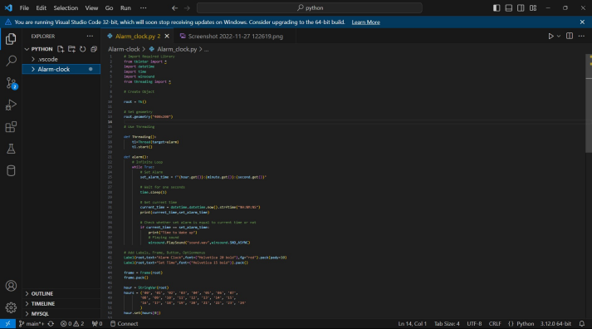

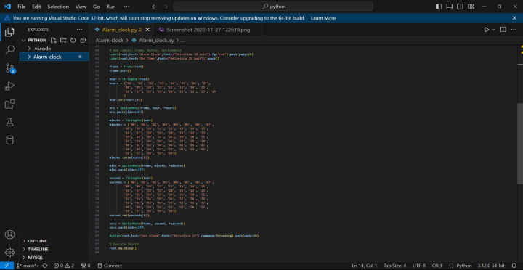

**Ouput:-**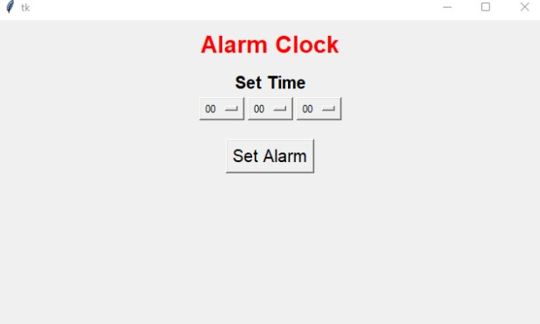

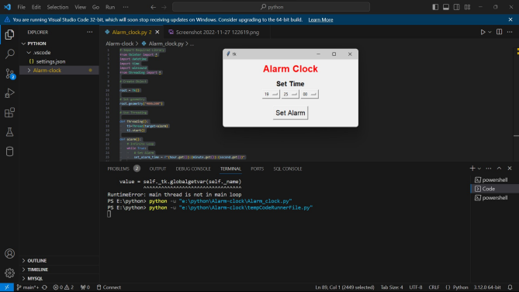

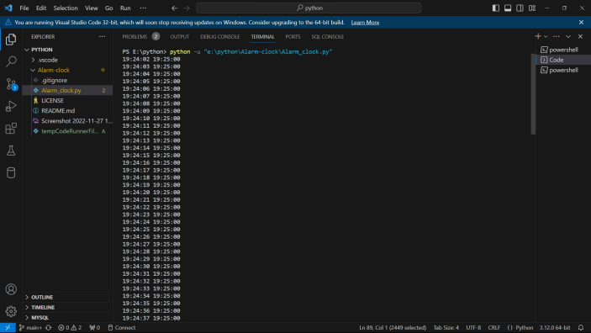

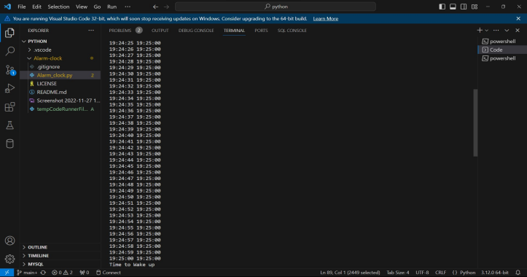

**Conclusion:-**In conclusion, the Alarm Clock Python Project exemplifies the dynamic fusion of modern programming with the enduring utility of a traditional daily companion. This project showcases how Python's versatility and an array of libraries can be harnessed to create a practical, user-friendly, and engaging application that meets a common yet timeless need.

By providing an intuitive graphical user interface, the project simplifies the process of setting and managing multiple alarms, allowing users to personalize their wake-up experience with custom tones and snooze options. It seamlessly integrates the precision of Python's datetime module with audio libraries to ensure that alarms trigger reliably, making it a dependable addition to one's daily routine.Despite the constraints, including platform dependencies, resource utilization, and the need for thorough testing, the Alarm Clock Python Project stands as a testament to the creativity and adaptability of Python developers. This project not only enhances the user's morning routine but also serves as an educational resource for those looking to explore software development and application design, underlining the enduring relevance of an age-old concept in a modern, digital world. It serves as a reminder that even in a rapidly evolving technological landscape, the most basic tools can find new life through innovation and coding.