**Title:** Criminalistics and Crime Database

**Team:**

### Mukund R (190948033)

Shreesha (190948034)

Nithin S.K (190948024)

**Schema Diagram:**

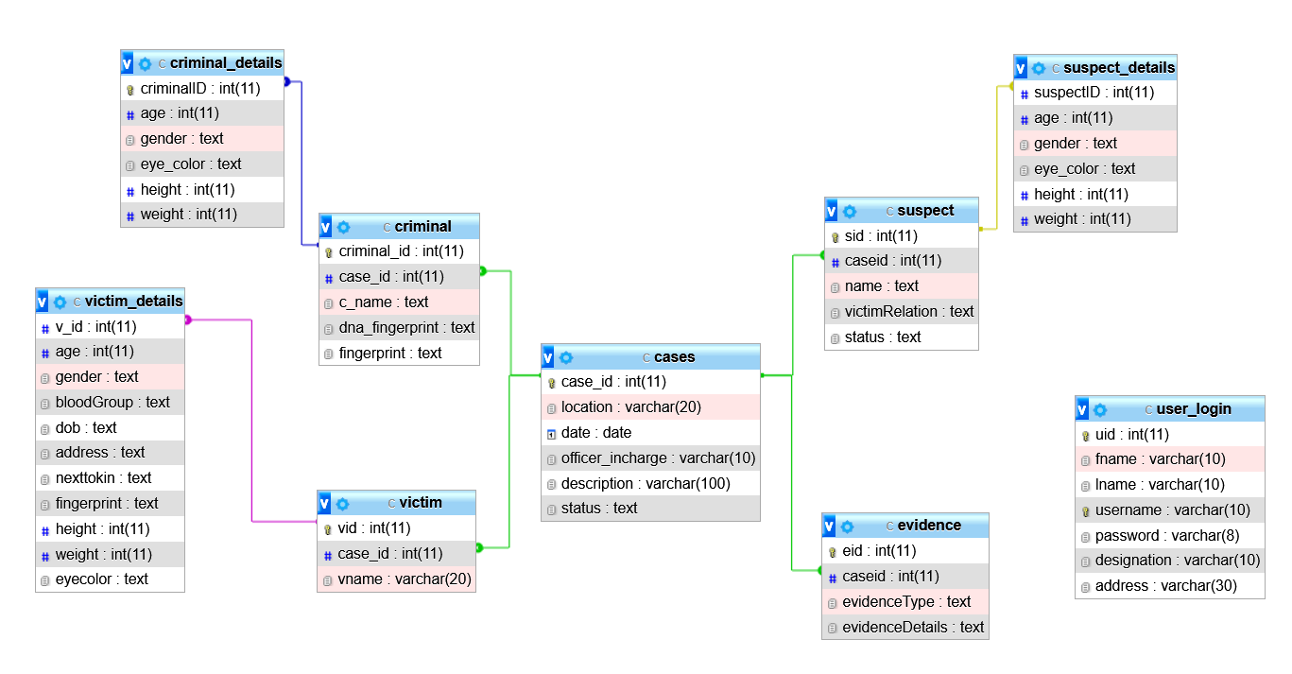

**Data flow Diagram**

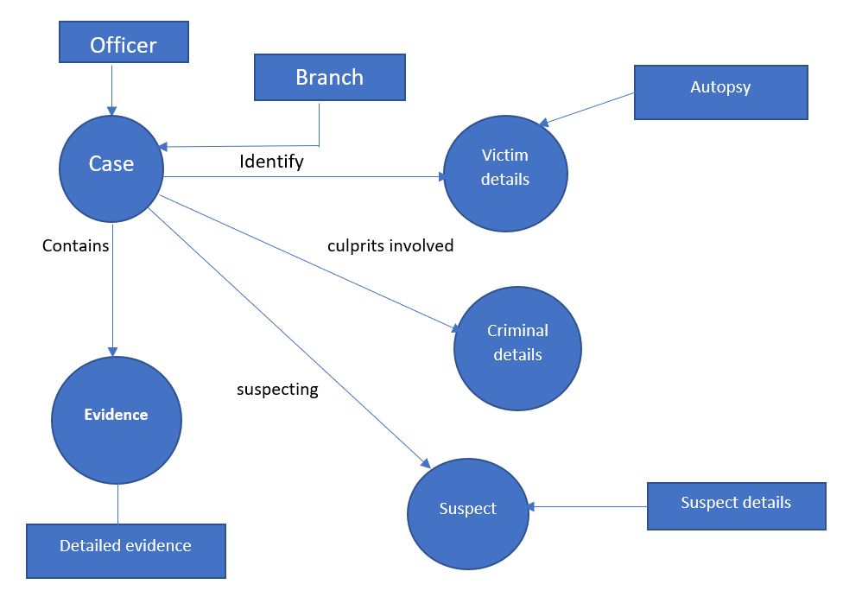

**ER Diagram**

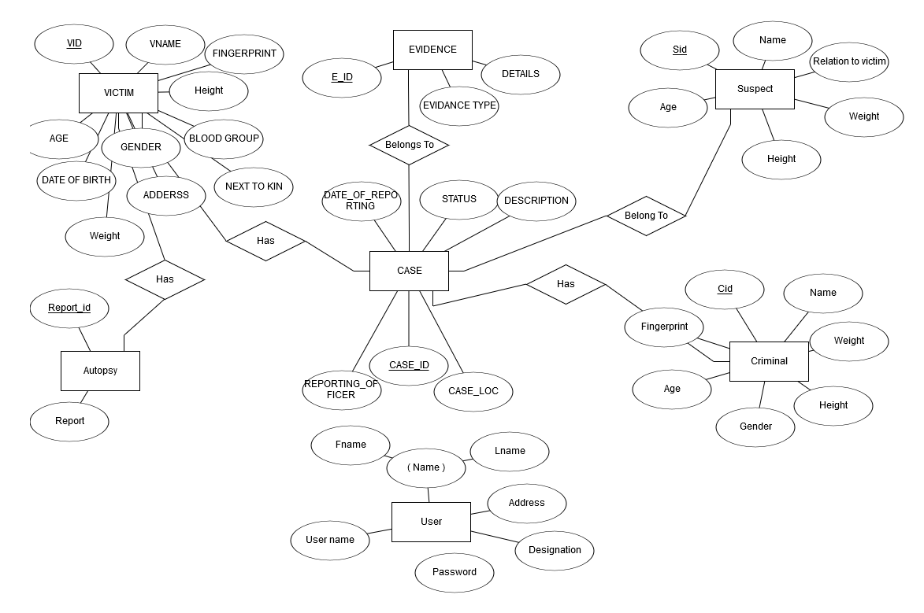

**Integrity constraints:**

|  |  |  |  |
| --- | --- | --- | --- |
| **SL. No.** | **Table Name** | **PK** | **FK** |
| 1 | cases | case_id |  |
| 2 | User_name | uid |  |
| 3 | criminal | Criminal_id | case_id |
| 4 | criminal_details |  | criminal_id |
| 5 | victim | vid | case_id |
| 6 | victim_details |  | vid |
| 7 | evidence | eid | case_id |
| 8 | suspect | sid | case_id |
| 9 | suspect_details |  | sid |

**Basic Quires**

**User Login**

1. select *

from user_login

where UserName = ?

1. select *

from user_login

where Password = ? and UserName = ?

**Cases**

1. select *

from cases

where case_id = ?

1. insert into cases

values(?,?,?,?,?,?)

1. DELETE FROM cases

WHERE case_id=?

1. UPDATE cases

set location = ?,date = ?,officer_incharge = ?,description = ?,status=?

WHERE case_id=?

1. select *

from cases

**Criminal and Criminal Details**

1. select *

from criminal,criminal_details

where criminal_id = ?

and criminalID = criminal_id

1. delete from criminal

where criminal_id = ?

1. UPDATE criminal

set c_name = ?

WHERE criminal_id=?

1. UPDATE criminal_details

set age = ?,gender = ?,eye_color = ?,height = ?,weight = ?

WHERE criminalID=?

1. insert into criminal(criminal_id,case_id,c_name)

values (?,?,?)

1. insert into criminal_details(criminalID,age,gender,eye_color,height,weight)

values (?,?,?,?,?,?)

**suspect and suspect details**

1. update suspect

set status = 'convicted'

where sid = ?

1. delete from suspect where sid = ?
2. insert into suspect(sid,caseid,name,victimRelation,status)

values (?,?,?,?,?)

1. insert into suspect_details (suspectID,age,gender,eye_color,height,weight)

values (?,?,?,?,?,?)

1. insert into suspect_details (suspectID,age,gender,eye_color,height,weight)

values (?,?,?,?,?,?)

1. select *

from suspect,suspect_details

where sid = ? and sid = suspectID

**Evidence**

1. delete from evidence where eid = ?
2. insert into evidence(eid,caseid,evidenceType,evidenceDetails)

values (?,?,?,?)

1. UPDATE evidence set caseid = ?, evidenceType = ?, evidenceDetails = ?

WHERE eid = ?

1. select *

from evidence

where eid = ?

**Victim and Victim Details**

1. select *

from victim v,victim_details vd

where vid= ? and v.vid = vd.v_id

1. delete from victim where vid = ?
2. insert into victim values(?,?,?)
3. insert into victim_details

values(?,?,?,?,?,?,?,?,?,?,?)

**Complex Quires**

**//On button convicted**

1. **TRIGGER**

CREATE TRIGGER `convicted` AFTER UPDATE ON `suspect`

FOR EACH ROW begin

INSERT INTO criminal(case_id,c_name)

SELECT caseid,name FROM suspect WHERE status = "convicted";

End

//When new user signup

1. **STORED PROC**

DELIMITER $$

CREATE DEFINER=`root`@`localhost` PROCEDURE `new_user`(IN `fname1` TEXT, IN `lname1` TEXT, IN `username1` TEXT, IN `pass1` TEXT, IN `designation1` TEXT, IN `address1` TEXT)

NO SQL

insert into user_login(fname,lname,username,password,designation,address)VALUES(fname1,lname1,username1,pass1,designation1,address1)$$

DELIMITER ;

//to increment the uid in user_login table

1. **MAX**

select MAX(uid) as uid

from user_login

//In finger print matching get max uid for iter

1. **ORDER BY DESC and Limit**

select *

from criminal

order by criminal_id desc limit 1

1. TODO