**22Week3**

**Research Blog**

When I think about the topic I would like to choose for the course final essay, the first thing came to my mind is to write down the key world and try divergent thinking based on my cognition, making connections and segmentation of these keywords.

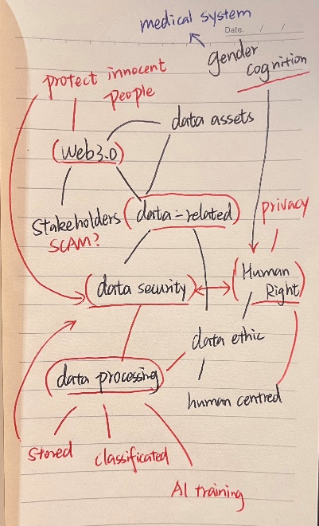

So here is my keywords sketch, it takes me about 20 minutes to clear out what I am interested in. After this keyword brainstorming, I open the google scholar website and try to search each keyword and their combination just like Helen Newing said in her book to find a more clear way.

By the way, I would like to add to this blog my rough ideas about the essay, honestly, I didn’t decide which one I will choose at last, but writing down these ideas is useful, and here they are:

* Many big companies mentioned that the Web 3.0 era is coming, but when I try to understand what is Web 3.0, I think it is a scam and they are trying their best to trade common people’s data. I would like to understand how those stakeholders get and trade the general or private data from the user in the legal gray area. And discuss what kinds of solutions and actions common users can do to defend our data and behavior to become a trader. I need some examples of some individuals and organizations tracking or defending personal data capitalizing, and advertising to people letting them realize the truth.
* Design achievement must need many data sets, and as a designer, how can we build trust with users and show them our responsibility when we process their data and human right?
* Data security and information presentation: For non-binary people, Denying their gender identity in the form will cause them to have negative emotions, but how can we as a medical system respect and understand their knowledge to create a safe data presentation system for them to help medical practitioners better provide treatment for them. (p.s. this topic was chosen for the other course named Design for responsible innovation, so I will choose the first two to become my Critical Study final project.)

The selected part in Helen Newing’s book talks about how can we deal with our keywords by searching them to marginated and narrow down our research, and here is this list of different ways to search the essays with keywords:

* *Combine keywords into a sentence:*

Introduction: With this method, we can find out the relevance we want between two keywords, and it is very convenient to find out some websites’ articles, organizations, and news in this way.

Finding:

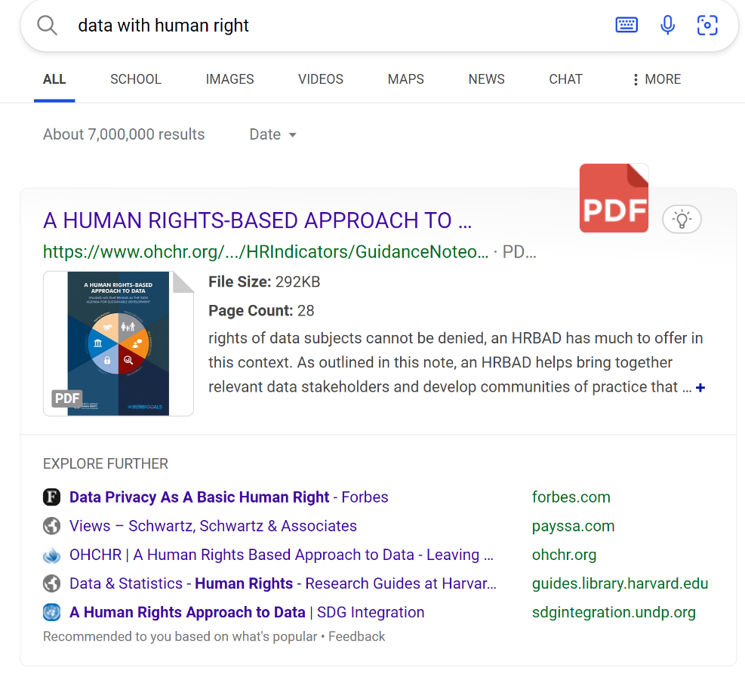

*Case 1*: The keywords are “data” and “human rights” if the relevant field It's been iterating for a while now, the output is substantial.

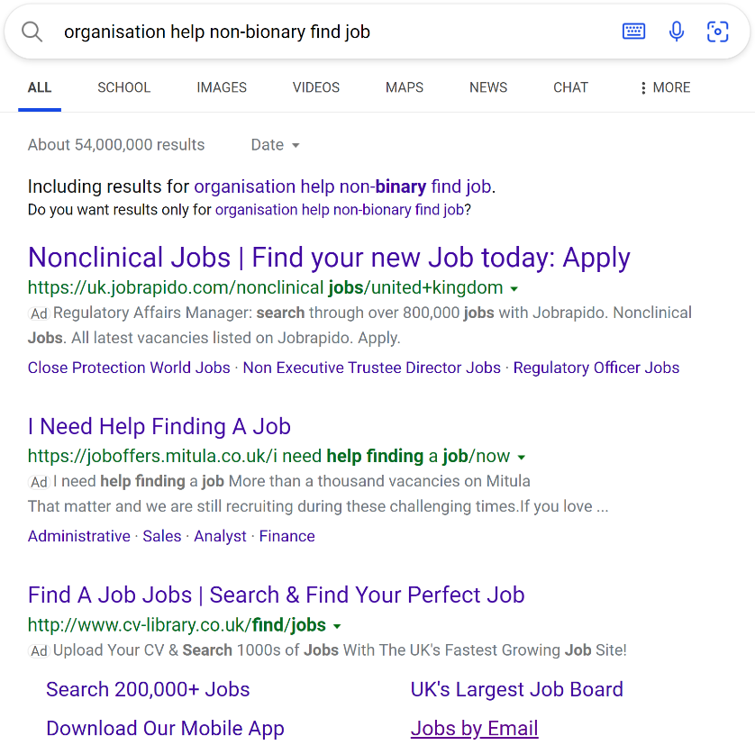

*Case 2*: The keywords in this case are “organization” “non-binary” and “find job”. This time, the output seems not as clear as Case 1’s.

* *Different truncation and Boolean operators between different Keyword:*

Introduction: According to different academic search software search engine decoding modes select different truncation and Boolean operators.

Finding:

*Case 1*: Using “blank space” to separate different keywords is fast and convenient.

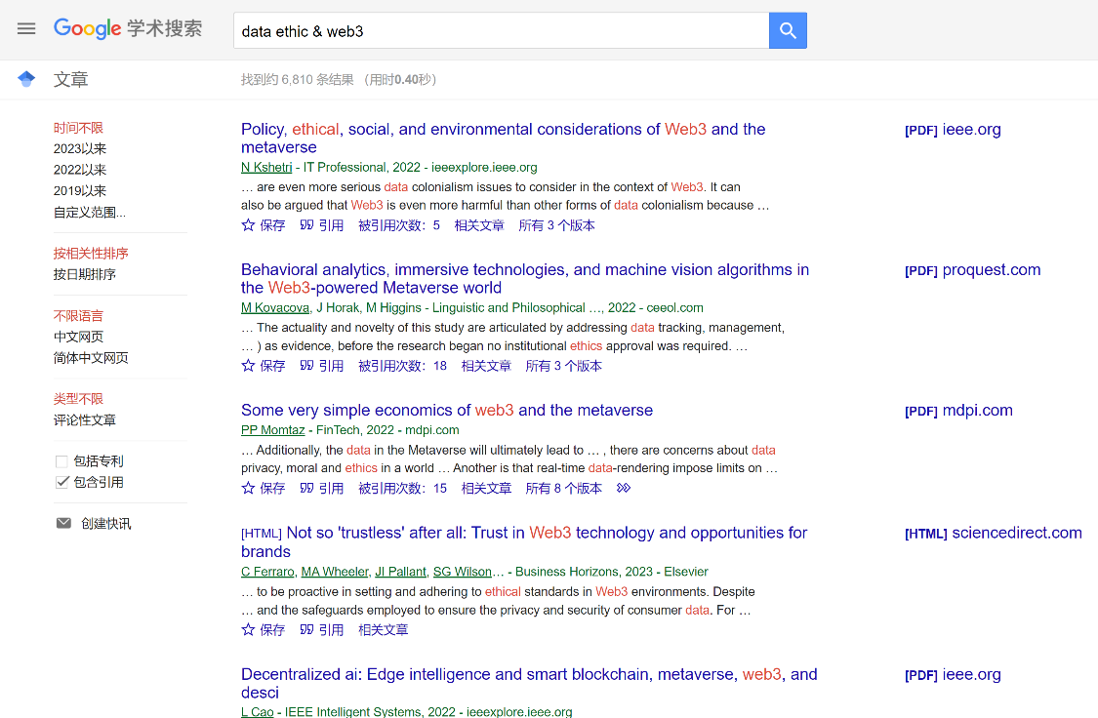

*Case 2*: Using “&” to separate different keywords the output is nice too. By the way, When we type in some words that have come up a lot in the last year, such as “Web 3.0” and “metaverse”, the output will be newer.

The ways above were mentioned in the books and provided by other lecturers before, and the ways below are my improvement depending on my background:

* *Redefine keywords presentation by searching relevant articles:*

Introduction:

As a non-native English speaker, I find that my simple search for keywords in English is not rigorous. Secondly, I will find a wide range of results without special knowledge of academic expressions in this field.

Therefore, I will select the article I want to read from the first search and then observe the way of expressing the keywords I want to search in the article.

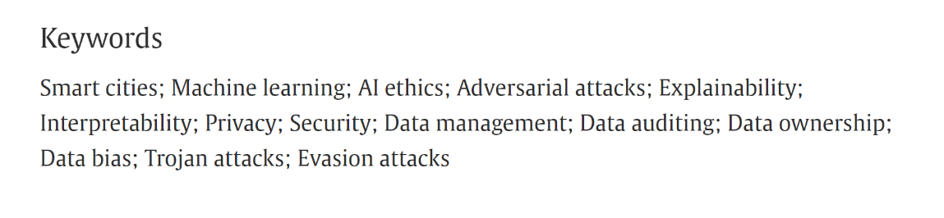

*Case:* The input keyword is “data”, and the keywords the essay shows give me more academic presentation and narrow down my search term.

* *Target the authors in relevant fields and follow their steps and cites*

Introduction: When I find authors in relevant research fields, I will follow their resumes and references to find more suitable research materials for my needs

**Story:**

**Oliver's Blog**

2018/6/21 2:00

Today with the previous day helping the family shop fix a customer's bike, microwave, and the little brother next door's mechanical contraption gun. Damn, I shouldn't have helped him with this, the sound emitting stereo on this thing is noisy as hell. It's 2 am and he's not letting anyone sleep, his parents' party every day ！！！！

2018/6/21 2:05

Oh my god, who sent the order at this hour

2018/6/22 14:00

It was someone called Hally who sent the order last night!!! And an expedited one too!!! Asked me to design a robotic arm for her and sent me the data for her arm. Strangely enough, she said she could use it as soon as she got the model built, they have a combined carbon and silicon production machine on their ship that can produce it for her, so strange I've never heard of such technology. I checked the news and we don't have any spaceships or technology like that yet. But it's not a dream, the 3d model file and the manuscript are there!!! I remember her!!!

2018/6/22 15:00

I don't want to stay up late all night but she gave me too much!

2018/7/23 2:05

Another rush order from her, she says she's sorry she got hit by an enemy on her right index finger today while fighting, because it was a laser gun so she says it was too fast to find 。。。。。。 Doesn't it hurt her?

Her time was much faster than mine but I'm glad she said she thought it worked well.

2018/12/12 1:00

This time it was the shoulder blade 。。。。。。 The bullet hit the shoulder.

Couldn't you have been more careful? I asked her. I even jokingly asked her to ask her to send me all the data directly to me I build a complete set directly to her to have on hand soon? She said her disability was a secret and that crippled soldiers would be eliminated. They would be sent out to do heavy labour until they got sick and died and were disposed of as space junk. Her connection to me was a string of email numbers she had sorted out from her parents' belongings, which was my email. Her parents, who were also brave soldiers in this war when they were alive, gave birth to her on this space ship, and now she has become a warrior like her parents, who wants to avenge her parents' death.

2018/12/12 11:00

She wasn't happy with the scapula I made and said it was just a normal scapula 。。。。。。 She said she needs more strength and she needs to make this scapula with me.

2018/12/13 2:00

We simulated a more powerful muscle group with a mechanical structure that can attack more swiftly and even it's made of a strong material that has cushioned air pockets on the side near the body [this was Hally's idea] that can withstand a not-so-subtle attack.

2018/12/13 3:00

I apologize for the joke I made earlier, I didn't want her to get hurt.

2018/12/13 2:00

We've simulated stronger muscle groups with mechanics that allow for swifter attacks, and it's even made of a sturdy material with cushioned airbags on the side near the body [this was Hally's idea] that can withstand not-so-subtle attacks.

2018/12/13 3:00

I apologize for the joke I made earlier, I didn't want her to get hurt.

2018/12/24 18:00

I got her a Christmas present, a model drawing of a diamond studded gloves, I designed the front end to be very pointed, she might be able to use this to deliver a fatal blow to her enemy when she is in danger without ammunition. It must be expensive to find so many diamonds of that size and quantity with our current technology, but I think that machine they have with that synthetic carbon structure could certainly do it.

2018/12/25 0:00

Merry Christmas! She told me she loved the gift, the gloves have won her many battles and she loves the shine of the diamond cut. She told me she had never seen this material before and I told her that diamonds have the hardest structure in nature.

She sent me a second email saying how much she liked being called "Diamond Girl" by her fellow soldiers, how she felt like a diamond herself, how hard she was, and how working with me because of her war disability made her even more gorgeous, like a diamond being cut.

Be safe. The knife used to cut the diamonds is also made of diamonds and the more beautiful folds you cut the more diamonds you will also consume.

2018/12/25 0:00

She didn't have an order this time, but she sent me a long, long email.

A lot has been happening on her end lately and the combat kit she and I designed for disabled fighters has been a big hit. All she had to do was change the stats to give everyone a more powerful "combat shoulder blade" and her diamond gloves have started a fashion trend that both able-bodied and disabled fighters love. She even told me that I had a flood of orders coming in.

I will try my best, alright?

2019/1/1 18:00

Got off work on time today! I've recruited a bunch of mechanics, designers, and some surgeons and rebuilds as consultants! A new wave of orders for the new year! Go for it!

Double happiness, Hally is excited to tell me that during this time they have formed the Diamond Club, a union of disabled warriors and other members of the ship who support them. They focus on how disabled members can be more active in life and in combat, with assistive prosthetics, combat aids, and even prosthetic styles and accessories becoming the focus of communication and creativity. My little workshop and team were the "Aladdin's lamp" that helped them realise these ideas.

Of course we can fulfil more than just three of their wishes.

2019/1/1 18:00

Is it something I'm worried about, I feel like they are getting more and more orders for prosthetic enhancements and designs [of course our team can handle it] and Hally doesn't send me any more messages, just a few sentences at a time: The soldiers are in high spirits today! We've won the battle again! I'm lucky to have your help!

But she hasn't spoken to me about how she's doing on her own for a long time.

Calm down, don't worry, Oliver, the war is heating up and everything is fine on their side! She's on her way to the ultimate victory!

2019/1/5 5:00

No other news, just an order for a prosthetic eye 。。。。。。

WinterSpoon Bar 2019/1/13 23:00

Mikey: You've been drinking a lot here for a while Oliver, I know their war is over. As well as giving help to the fleet in your sci-fi emails, we now give help to the disabled in our society to design prosthetics and aids don't we?

Oliver: I know, but she can't come back.

Mikey: Of course she can't come back, she's in another time and place, you'll never see her. Can't you communicate with her by email?

Oliver: There are no new emails after the order for the prosthetic eye.

Mikey: Maybe she was too busy on her triumphant return to send you a message. Yeah the prosthetic eye order was done by you alone and you sent us all back to rest that day.

Oliver: No, she didn't send the order for the prosthetic eye either, her comrades did. Hally was shot in the head and they wanted to make him a diamond eye and give her a proper funeral. Of course, the battle was won and the war was over, and Hally was able to avenge her parents' death and return to them.

Mikey: I'm sorry to hear that.

Oliver: I looked at all her physical stats and she's a small person, but she's very powerful. I'm sad that I met her the way I did 。。。。。。 I'm honoured that she's still using the Christmas present I gave her for her last battle 。。。。。。

Mikey: Poor friend, I'd have one more drink with you if you promised me you'd get better. She changed you didn't she? I know this is hard, but she will always live on in your heart. At least, what you are doing now, I mean our team, will keep on going, with a share of Hally! Didn't you? My friend?