SDN – Network controlled by software
SDN ka main idea yeh hai ki:
- Decision lene ka kaam (control plane)
- Packet bhejne ka kaam (data plane)
👉 alag-alag kar diya gaya hai
Is separation ki wajah se SDN ek naya aur powerful network design bana
Old way - switch decide kaha bhejna.. store routing + forwarding logic, hardware, hard to change
SDN - 1 central , all swtch follow , it change rule applied everywhere ,software
SDN Controller - master -control plane
SDN Switches – slave – data plane
- Attacker Goal:
  - Overflow the flow table of an SDN switch
Flow rules store hote hain:
👉 TCAM (special memory)
TCAM:
- Bahut fast hoti hai
- Bahut mehngi hoti hai
- Bahut limited hoti hai
SDN me Data Plane kya hota hai?
✅ Data Plane = Switch
- Packet receive karta hai
- Flow table check karta hai
- Rule mila → forward
- Rule nahi mila → controller se poochta
📌 Switch decision nahi leta
Isliye paper switch ko “dumb” bolta hai.

SDN me Control Plane kya hota hai?
✅ Control Plane = Controller
- Network ka dimaag
- Decide karta hai:
  - Packet kahan bhejna
  - Naya rule banana ya nahi
- Switch ko rules bhejta hai
📌 Controller decision leta hai
“Flow rule” hota kya hai?
Socho switch ek guard hai 🚪 Uske paas ek register / notebook hai 📒 Us notebook me likha hota hai:
“Agar aisa packet aaye → yahan bhej dena”
Yehi flow rule hai.

Flow rule kis cheez pe based hota hai?
Packet ke header pe (address info):
- Source IP
- Destination IP
- Port number
- Protocol (TCP/UDP)

Ab main process samjho (VERY IMPORTANT)
Step 1️⃣: Packet aaya switch pe
Switch check karta hai:
“Kya meri notebook me is packet jaisa rule already likha hai?”
Case A ✅ Rule mil gaya
- Switch fast forward karta hai
- Koi problem nahi
Case B ❌ Rule nahi mila
Ab dikkat shuru hoti hai 👇
Switch bolta hai:
“Mujhe nahi pata kya karna hai 😟
Controller se poochta hoon”
Step 2️⃣: Switch → Controller
Controller bolta hai:
“Is type ke packet ke liye yeh rule use karo”
Controller:
- Naya rule bana deta hai
- Switch ki notebook (flow table) me likh deta hai
📌 Yahin pe rule create hota hai
Case 1️⃣
RTT₀ > RTT₁ (rule is installed)
Easy meaning:
- First packet (RTT₀) slow tha
- Second packet (RTT₁) fast tha
Why?
- RTT₀ packet:
  - Rule match nahi hua
  - Controller se poocha → slow
- RTT₁ packet:
  - Rule ab install ho chuka
  - Direct forward → fast
📌 Conclusion:
Jo field tumne change kiya,
wo match field hai
Case 2️⃣
RTT₀ ≈ RTT₁ (no rule installed)
Easy meaning:
- Dono RTT almost same hain
- Koi extra delay nahi
Why?
- Field change se rule par koi effect nahi pada
- Switch ne same rule use kar liya
📌 Conclusion:
Jo field change hua,
wo match field nahi ha

Problems:
- Match Fields with Bitmasks Interference.
LOFT: “Flip each bit one by one”
Instead of changing full IP:
- Attacker har bit ko alag-alag test karta hai
🔁 Final correct order (write this in mind)
- 1. Pick a field (src IP / dst IP / port / protocol)
- 2. Change its value → observe RTT
- 3. If RTT changes → field confirmed
- 4. If RTT doesn’t change → do NOT discard
- 5. Flip bits inside the field
- 6. If any bit flip changes RTT → field + mask confirmed
- So mask probing is a refinement, not a prerequisite.

- Network Jitter Interference.
LOFT: t-test ko ultra-easy me samjho 🧠
So you get multiple RTTs
= Do RTT groups banao
- Group A: RTTs before field change
- Group B: RTTs after field change
Step 3️⃣: t-test apply karo
α (significance level):
- Ek threshold
- Example: α = 0.05
p-value:
- Probability ki difference random ho
Small p-value ⇒ real reason
Big p-value ⇒ random network jitter
Why p-value is needed here?
p < 0.05 | RTT difference REAL → rule installed
p ≥ 0.05 | RTT difference NOISE → no rule

- High RTT
DUDFTO:
- Fixed Attack Rate:
DUDFTO:
- Ipv4 Source Forged address
DUDFTO:

- Probing Stealthiness. As shown in Fig. 3, the probing activities may generate certain patterns such as fixed frequency and intervals. Hence, we generate random patterns in our probing activities to effectively increase the probing stealth iness. First, we randomly send extra packets during probing to perturb frequency and intervals. Particularly, we randomly inject extra packets within each interval when probing the timeout. Hence, there are no certain frequency and intervals during probing. Second, we carefully control the sending time of probing packets to proactively vary frequency and intervals during probing. For example, we randomly change the interval between sending two probing packets in Fig. 3a to a value less than one second when probing the timeout. We will show the implementation details in Algorithm 2 and 3.
Probing:
  - Probing match fields
LOFT:
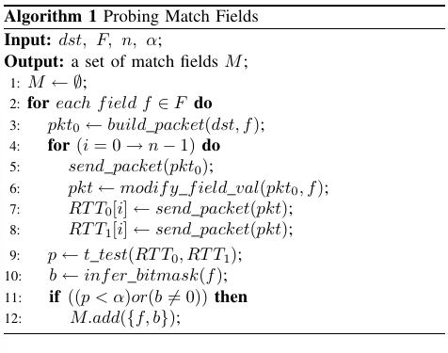
Algorithm 1 shows the pseudo-code of probing match fields. The inputs consist of the IP address of a probing destination dst, a set of fields F to be enumerated, the number of probing packets in a group n, and the significance level of the t-test α. Note that there are no general standards for using which match fields in flow rules to meet different network and application requirements. In reality, SDN controllers, applications, and network operators can configure which match fields are used in flow rules according to different network requirements. Hence, we feed all possible match fields in Algorithm 1 to accurately identify which match fields are actually used in the flow rules of the victim network. In other words, the input set of fields F includes all possible match fields defined in OpenFlow, e.g., MAC addresses, IP addresses, port numbers, etc. As shown in the algorithm, we can infer match fields and the bitmasks (if they exist) of flow rules by changing fields of probing packets.

  - Probing Hard timeout
LOFT:
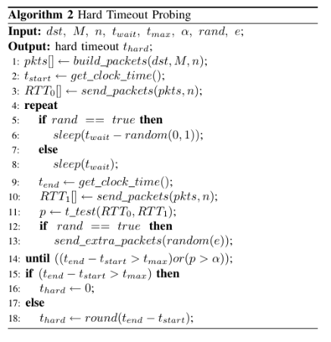
The pseudo-code of probing hard timeout val ues is shown in Algorithm 2. The inputs consist of the IP address of a destination dst, the match fields M inferred by Algorithm 1, n packets to be concurrently sent, the waiting interval twait, the maximal execution time of the algorithm tmax, the significance level of the t-test α, the flag of random rand, and the number of extra noise packets. Note that twait must be set to less than 1s to effectively eliminate the interference of the idle timeout. As shown in Algorithm 2, we generate a group of packets in each iteration to probe the hard timeout value (see steps 4-14). The hard timeout value will be inferred as 0 when the execution time reaches to tmax, which indicates the hard timeout is not set in the flow rule (see steps 15-17). If rand is set to be true, the algorithm randomly varies waiting intervals (see step 6) and randomly injects at most e extra noise packets (see step 13) to generate random probing patterns. Hence, the probing stealthiness is effectively increased.

  - Probing Idle timeout
LOFT:
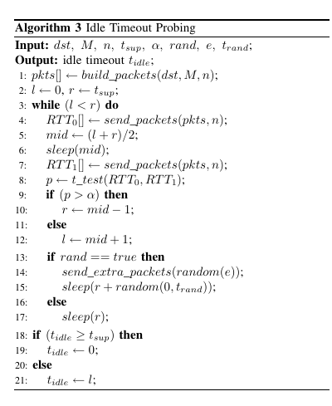
Algorithm 3 shows the pseudo-code of inferring the idle timeout values by applying the binary search. The inputs are similar to those used in Algorithm 2, where tsup denotes the upper bound of the algorithm execution time and trand denotes the upper bound of maximum waiting time during each round of probing. If the hard timeout value is not equal to zero, tsup is set to thard. Otherwise, it is set to a value larger than the possible maximum idle timeout value. We send two groups of packets in each iteration of binary search and measure their RTTs (see steps 3-17). In particular, step 13-17 aims to ensure that flow rules can be removed after each iteration. Thus, the interference of the hard timeout can be eliminated. Similar to Algorithm 2, If rand is set to be true, the algorithm randomly varies waiting intervals (see step 15) and randomly injects at most e extra noise packets (see step 14) to generate random probing patterns.

  - Probing Capacity left:
LOFT:
  - Step 1: Assume a number n
  - Step 2: Check if table is full (RTT test)
  - Step 3: RTT-based decision (KEY PART)
  - RTT spike = table full
Else case (table not full)
Table me abhi jagah hai

Why exact table size is NOT required
• Benign traffic:
o Rules add/remove karta rehta hai
• Table size fluctuating hai
👉 Exact C = moving target.

Table:
Occupy n rules
↓ |
Check RTT |
↓ |
If not full → repeat ->
↓
Eventually → FULL

Attack Phase:
  - Crafting Attack Packets
LOFT:
    - Each attack packet is crafted to install a unique flow rule.
    - Header fields are varied using info from the probing phase.
    - Packets needed = flow table size.
    - No real payload required; 64B packets are enough.
    - ~113 KB traffic can overflow a switch with 1,800 rules.
    - Multiple header fields + variable payload sizes are used to hide the attack.

  - Calculating the Minimum Attack Rate
      - thard = 0, tidle = 0: a flow rule will permanently exist in flow tables until the controller actively removes it;
      - thard = x, tidle = 0: a flow rule will be removed from flow tables after x seconds;

      - thard = 0, tidle = y: a flow rule will be removed from flow tables if the switch does not receive any packet matching the rule within y seconds;

LOFT:
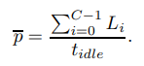
C → flow table capacity
t_idle → idle timeout
Lᵢ → i-th attack packet ka size (Bytes)

Burst bhejoge → suspicious ❌
Even spacing: Natural traffic jaisa lagta hai
Ek packet → thoda gap → ek packet → thoda gap
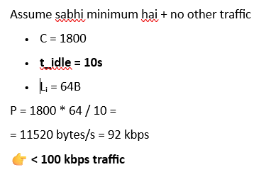
- Attacker must fill the flow table within the idle timeout, otherwise rules expire.
- Strategy: send C packets (C = flow table capacity) evenly within each idle timeout.
- Each packet installs a new rule; identical packets are resent to refresh rules.
- Minimum attack rate depends on flow table size, idle timeout, and packet size.
- Example: 1,800 rules, 20s idle timeout, 64B packets → only ~46 Kbps needed.
- In real networks, most flow table space is already used by benign flows, so attacker needs even fewer packets.
- Even for large switches, attack rate is much lower than brute-force flooding.
- Attack rate can be further reduced using distributed attackers or by targeting weaker switches.

      - thard = x, tidle = y: a flow rule will be removed from flow tables either after x seconds or after y seconds without any received packet.
Attacker ka average packet rate:
≈ C / t_idle
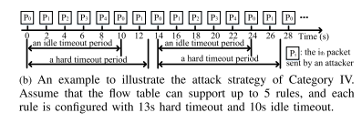

DEFENSE:
- LOFTGuard:
    - Normal operation starts
SDN switch works normally; all flows are installed in the pending region (TCAM).

    - Flow table utilization is continuously monitored
The monitor agent tracks flow table usage and its growth trend, not just absolute value.

    - Abnormal upward trend detected
A continuous increase in flow table utilization triggers LOFTGuard activation.

    - Vigilant flow rule manager is enabled
Flow table is logically divided into pending, confirmed, and cache regions.

    - Suspicious / inactive flows moved out of TCAM
Flow rules with low liveness (idle for long time) are migrated from TCAM to cache region.

    - TCAM saturation handled intelligently
When TCAM becomes full, new rules are installed in cache instead of TCAM.

    - Rate-based rule migration begins
High-rate flows are promoted to TCAM.
Low-rate flows (typical LOFT attack flows) are demoted to cache.

    - Controller analyzes long-term flow behavior
The malicious flow locator collects statistics and extracts features (rate, packet size, idle time).

    - Malicious flows are identified
A Random Forest classifier labels flows as benign or malicious.

    - Malicious flows are blocked permanently
Flow rules are deleted.
Flow IDs are added to blacklist.
Packet-in messages from malicious flows are dropped at the switch, preventing re-occupation.

